McMaster University Bachelor of Technology

Course Project:
Comparison of Classification Algorithms on Credit Card Fraud Detection
SFWRTECH 4DM3
Data Mining

Submitted by:
Tashy Jamal (ID: 400200002)
Suvash Sharma (ID: 400610662)
Date: April 15, 2026

Dataset Description
This project uses the Kaggle Credit Card Fraud Detection dataset, which contains transactions made by European cardholders. The dataset consists of 284,807 samples and 30 numerical features, with a binary target variable indicating whether a transaction is fraudulent (Class = 1) or legitimate (Class = 0). The goal of the project is to compare the performance of different classifiers and determine which algorithm is the most efficient one.
The creditcard.csv dataset is downloaded from Kaggle and stored in a Pandas Dataframe called df using read_csv function of Pandas. The count of the dataset based on class 1 and 0 showed that the dataset is highly imbalanced:
- Non-fraud: 284,315 (~99.83%)
- Fraud: 492 (~0.17%)
Due to computational constraints and the high cost of training certain models (particularly SVM), a subset of the training data was used:
- Training subset: 5,369 samples (5,000 non-fraud + 369 fraud)
- Test set: 71,202 samples (25% of original dataset)

2. Methodology

2.1 Data Preparation:
- The dataset is split into input features (x) and target label (y). X contains transaction attributes used to predict if the transaction is fraud or not, while y stores the labels.
- A 75/25 train-test split was used
- Because of the unbalanced nature of the dataset, stratified sampling was used to preserve the class proportions
- Features were standardized using StandardScaler such that they are on the same scale. This is important because features with larger magnitudes can dominate the model and skew the result if they are not scaled.
- Next we have set the USE_SUBSET flag to True, which creates a smaller training subset to speed up KNN and SVM training
- The code combines X_train and y_train data and splits into fraud_train and nonfraud_train groupd.
- fraud_train consists all faud samples in the training set and nonfraud_train contains all the non-fraud samples in the training set.
- From nonfraud category only 5000, data samples are taken which significantly reduces the computation time.
- Once the fraud and non-fraud records are sampled, the code combines them together to form the train test dataset.
- The dataset is then randomly shuffled such that the model will not see all fraud cases first and non-fraud cases later.
- Now the features and label is again separated in the down sampled dataset for training purposes

2.2 Classifiers Used
The three classification algorithms that we chose were:
- Logistic Regression
  - Linear model for binary classification. It is a linear classification algorithm that models the probability of a data point belonging to a particular class. It is efficient and works well when the relationship between features and the target is approximately linear. This model is simple, efficient and easy to interpret and we can use it as a baseline because it shows how well a linear decision boundary performs on the dataset.
log_reg_pipeline = Pipeline([
("scaler", StandardScaler()),
("model", LogisticRegression(max_iter=1000, random_state=42))
])
- K-Nearest Neighbors (KNN)
  - It is a distance-based classifier using majority voting. The key parameter in KNN is number of neighbors, k which controls how many nearby points participates in the decision. K is a hyper parameter so cross validation is used to test several values of K and select the one with the best ROC-AUC socre. KNN is useful as it captures the local patterns in the data but it can be computationally expensive during testing because every test points must be compared with many training points.
knn_pipeline = Pipeline([
("scaler", StandardScaler()),
("model", KNeighborsClassifier())
])
- Support Vector Machine (SVM) with RBF kernel
  - SVM is a nonlinear classifier using kernel transformation. SVM attempts to find optimal boundary between the two classes and the RBF kernel allows it to model more complex and curved decision boundaries rather than only straight line. SVM is well suited for problems where the classes are not linearly separable. The code performs cross-validation to choose the best values of c and gamma parameters. C controls the trade-off between margin size and classification error and gamma controls the influence of individual training points in the RBF Kernel.
svm_pipeline = Pipeline([
("scaler", StandardScaler()),
("model", SVC(kernel="rbf", probability=True, random_state=42))
])

2.3 Cross Validation
Cross-validation was used for parameter tuning for KNN and SVM. The purpose of cross-validation is to find out how well a model generalizes to unseen data and to avoid overfitting during the parameter selection process
- KNN parameter:
  - Number of neighbors (K)
  - Best value: K = 11
  - CV ROC-AUC: 0.9542
- SVM parameters:
  - C and gamma
  - Best values: C = 10, gamma = 0.01
  - CV ROC-AUC: 0.9836
A 5-fold stratified cross-validation approach was used.

3. Results
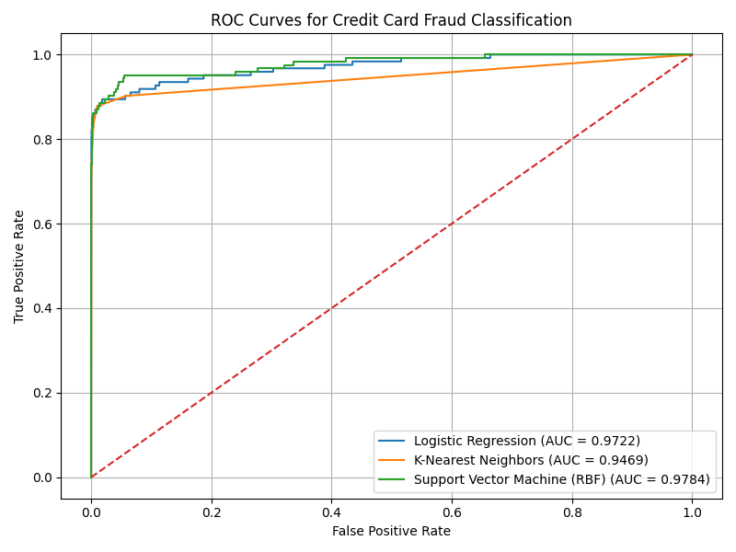
The ROC curve illustrates the performance of the three classifiers we used; Logistic Regression, KNN and SVM in classifying fraudulent and non-fraudulent transactions. All the curves lie above the diagonal line, which tells that all the models showed good performance. However, from the AUC values we can see the SVM model performs the best as it has the highest AUC value (0.9784). Logistic Regression performed close to SVM, which indicates that the data were almost linearly separable. KNN also performed well but to the degree of SVM and Logistic Regression.

3.1 Computational Time
Algorithm | Training Time (s) | Testing Time (s)
Logistic Regression | 0.0174 | 0.0306
KNN | 0.0020 | 0.5170
SVM (RBF) | 0.2497 | 1.5759

The time comparison table shows that KNN has the lowest training time, in fact this is true because KNN simply stores the data during training. Logistic Regression has low training time because it is a linear model with simple optimization. SVM has the highest training time because it performs complex optimization.

3.2 Computational Complexity (Approximate)
Algorithm | Training Complexity | Testing Complexity
Logistic Regression | O(n·d) | O(d)
KNN | O(1) | O(n·d)
SVM (RBF) | O(n²–n³) | O(#support vectors)

3.3 Confusion Matrices
Logistic Regression:
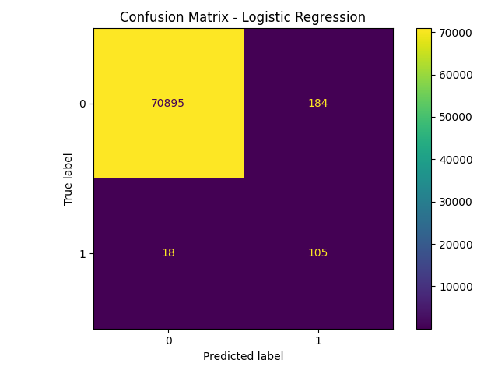
The confusion matrix for logistic regression shows that the True Negative (TN) =70895, which is very good while it flagged 184 transactions as fraud which in fact were not fraud. Likewise (FN) 18 transactions were wrongly classified as not fraudulent which in fact were fraudulent. Similarly, (TP) 105 fraudulent transactions were correctly detected.

KNN:
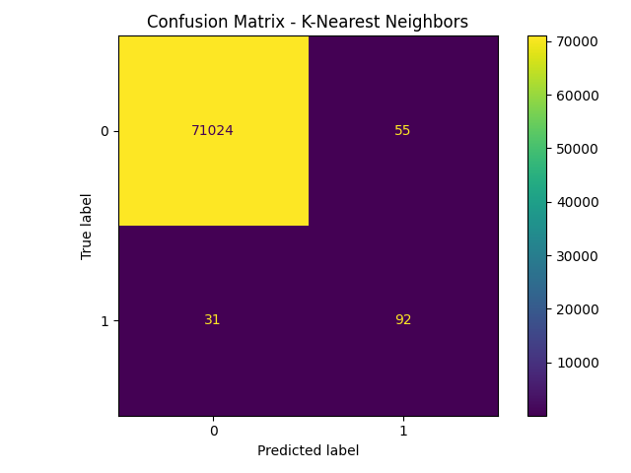
The confusion matrix for K-Nearest Neighbors shows that the True Negative (TN) = 71024, which is very good while it flagged 55 transactions as fraud which in fact were not fraud. Likewise, (FN) 31 transactions were wrongly classified as not fraudulent which in fact were fraudulent. Similarly, (TP) 92 fraudulent transactions were correctly detected.

SVM (RBF):
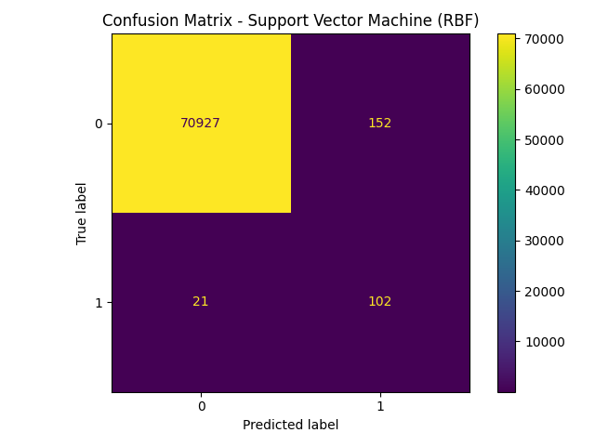
The confusion matrix for Support Vector Machine (RBF) shows that the True Negative (TN) = 70927, which is very good while it flagged 152 transactions as fraud which in fact were not fraud. Likewise, (FN) 21 transactions were wrongly classified as not fraudulent which in fact were fraudulent. Similarly, (TP) 102 fraudulent transactions were correctly detected.

The confusion matrices show that all three models perform very well in identifying non-fraudulent transactions, with high true negative values. However, they differ in their ability to detect fraud and avoid errors. Logistic Regression achieves the best fraud detection performance, with the highest true positives (105) and the lowest false negatives (18), but it also produces the highest number of false positives (184), making it more aggressive. KNN, on the other hand, is the most conservative model, producing the lowest false positives (55), but it misses the most fraud cases (31), making it less reliable for fraud detection. The SVM model provides a balanced performance, with strong fraud detection (102 true positives) and a moderate number of false positives (152), making it a good compromise between the two. Overall, while Logistic Regression is best at detecting fraud, SVM offers the most balanced and practical solution, whereas KNN is less suitable due to its higher number of missed fraud cases.

3.4 ROC-AUC Scores
Algorithm | ROC-AUC
Logistic Regression | 0.9722
KNN | 0.9469
SVM (RBF) | 0.9784

Analysis
All three classifiers performed significantly better than random classification, as indicated by ROC curves well above the diagonal baseline.
- SVM (RBF) achieved the highest ROC-AUC (0.9784), indicating the best ability to distinguish between fraud and non-fraud transactions.
- Logistic Regression performed similarly (0.9722), suggesting that a linear model is almost sufficient for the dataset.
- KNN had the lowest performance (0.9469), I assume it is due to sensitivity to high dimensionality and class imbalance.
In terms of computational efficiency:
- Logistic Regression was the fastest overall
- KNN had fast training but slow testing due to distance calculations.
- SVM had the slowest testing time due to kernel computations

