Computer Communications and Networks (COMN) Course, Spring 2014

Coursework: Results Sheet

Forename and Surname:
Matriculation Number:

Question 1 – Impact of retransmission timeout on number of retransmissions with stop-and-wait protocol.

Retransmission timeout (ms) | Number of  re-transmissions | Throughput  (Kilobytes per second)
10
20
30
40
50
60
70
80
90
100

Question 2 – How does the throughput behave when the retransmission timeout increases and why? What is the optimal value for retransmission timeout?

Question 3 – Experiments with Go-Back-N:

 | Throughput (Kilobytes per second)
Window Size | Delay = 10ms | Delay = 100ms | Delay = 300ms
Optimal Retransmission timeout(ms)
1
2
4
8
16
32
64
128
256

Use the results in the above table to make the following graph:

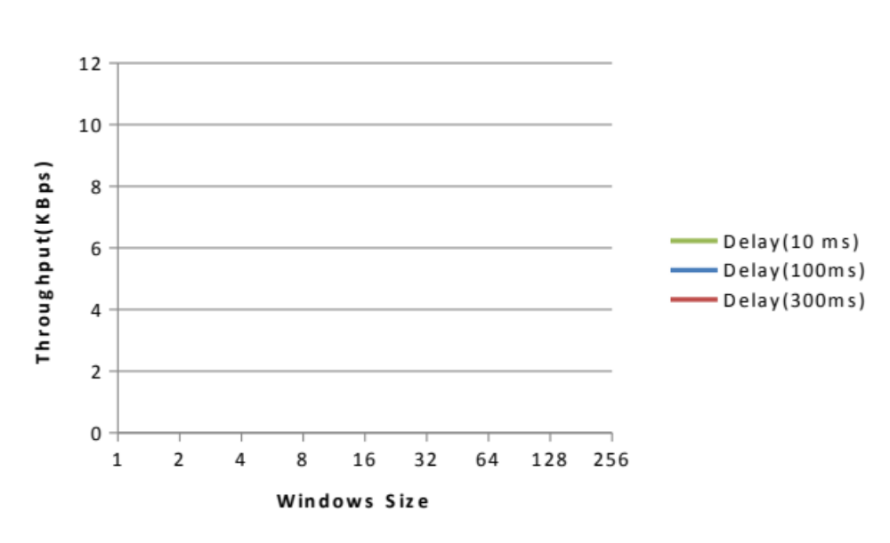

Question 4 – Explain your results from Question 3.

Question 5 – Experiments with Selective Repeat

 | Throughput (Kilobytes per second)
Window Size | Delay = 100ms
8
16
32
64
128
256

Question 6 - Compare the throughput obtained when using “Selective Repeat” with the corresponding results you got from the “Go Back N” experiment and explain the reasons behind any differences.

Question 7 – Experiments with iperf

 | Throughput (Kilobytes per second)
Window Size (KB) | Delay = 100ms
8
16
32
64
128
256

Question 8 - Compare the throughput obtained when using “Selective Repeat” and “Go Back N” with the corresponding results you got from the iperf experiment and explain the reasons behind any differences.

