**Bank Management System**

**Class diagram:**

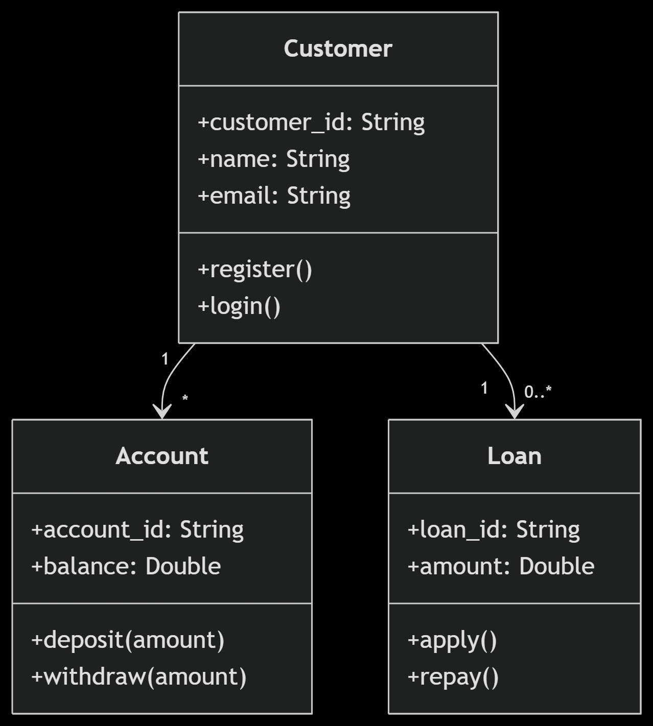

**Sequence Diagram:**

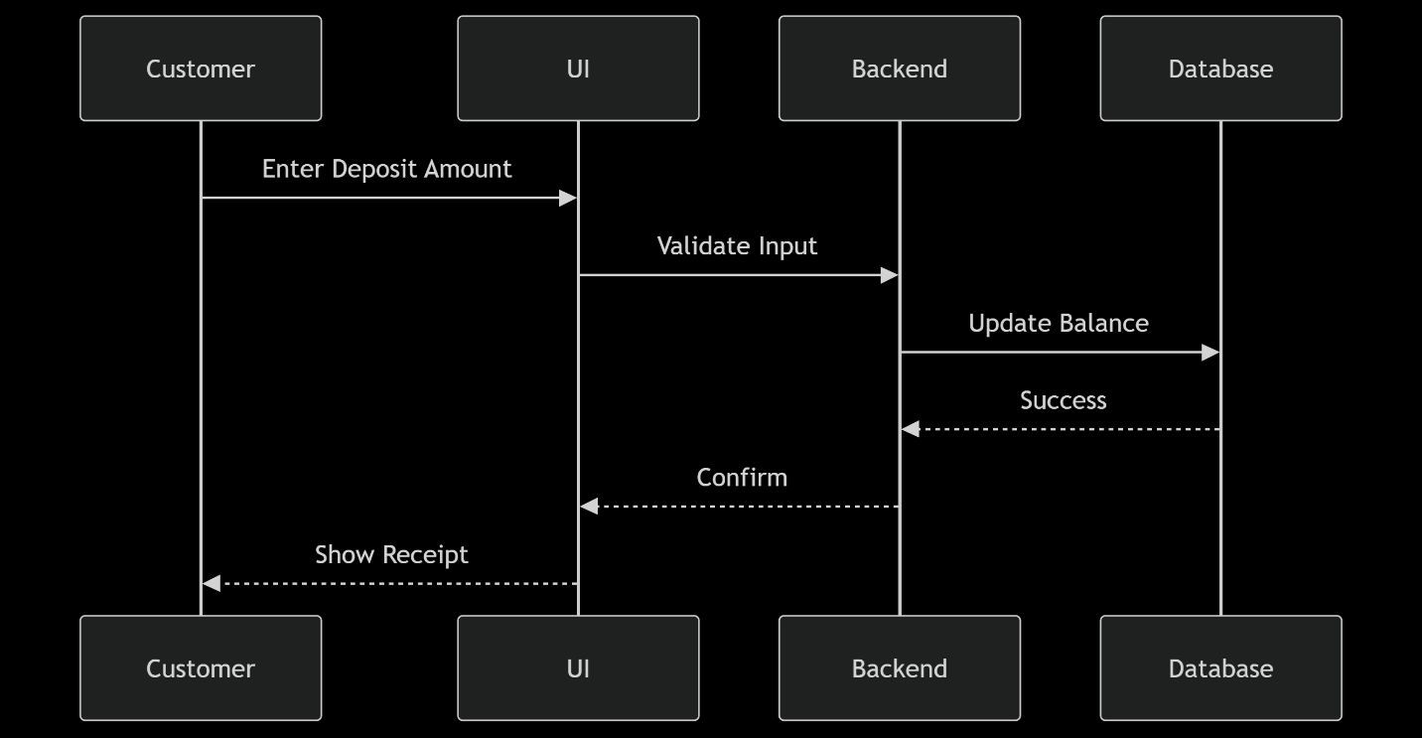

**ER diagram:**

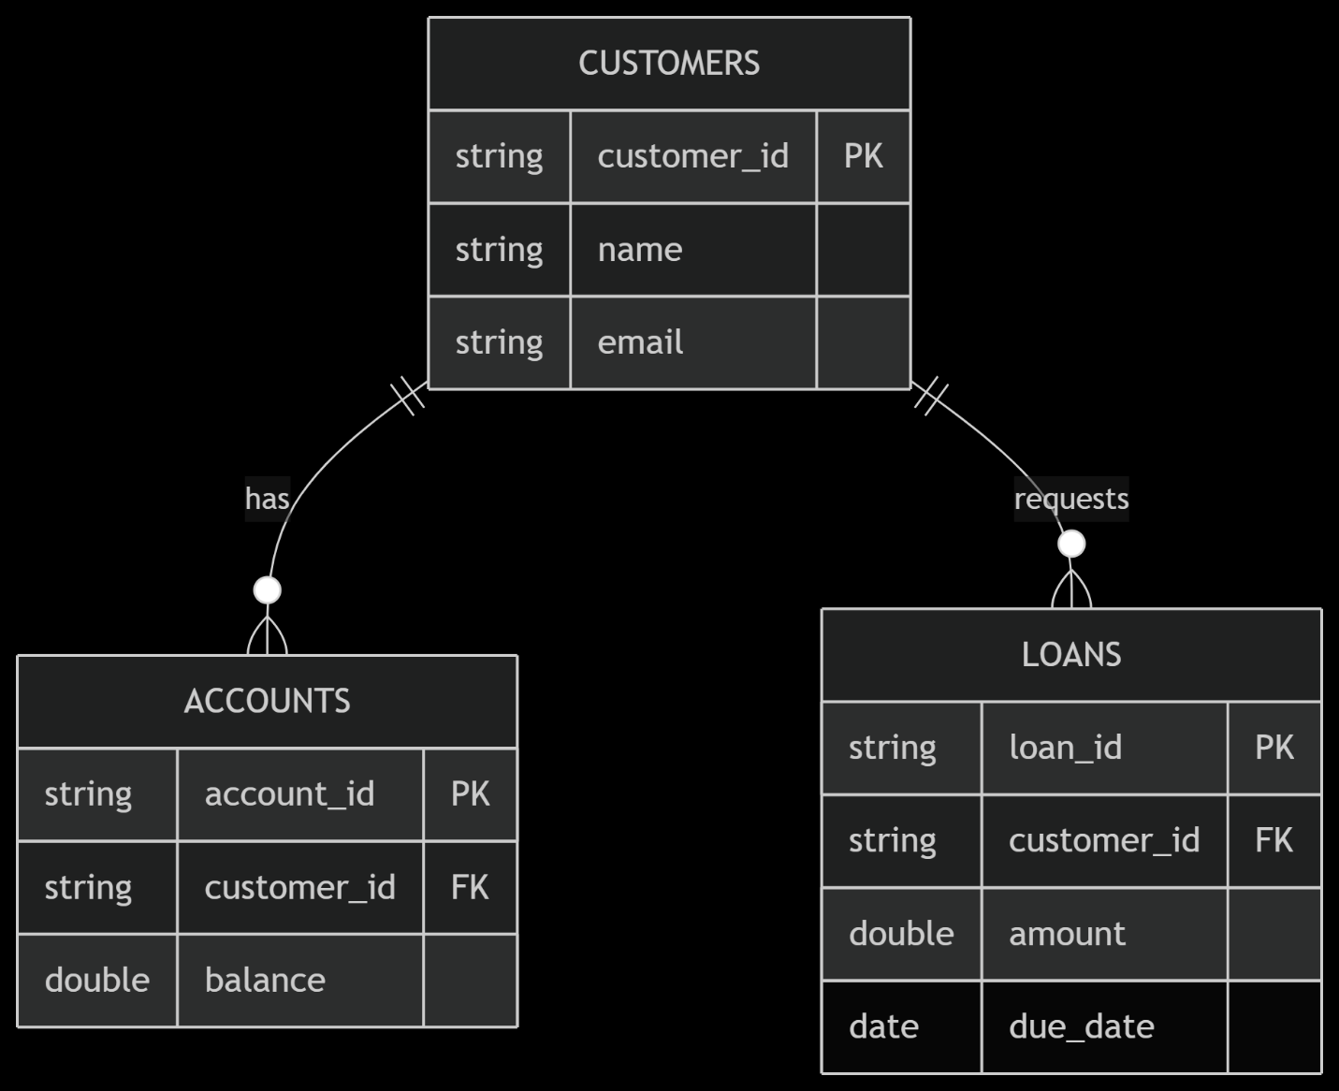

**Activity Diagram(Loan Approval):**

