A Dual-Stream Approach for Driver Drowsiness Detection using Vision Transformer and Facial Landmark Encoding
Arafat Rahim, Mohammad Mahamudul Hasan, Md Tasin Islam, Md Khaliluzzaman⁴
Department of Computer Science and Engineering, International Islamic University, Chittagong, Bangladesh
Abstract
One of the major causes of road collision is a driver's state of sleepiness, and it causes many serious injuries and fatalities around the globe. To address the challenges of handling complex and dynamic head movements and maintaining strong performance, this study presents a dual-stream deep learning system integrating a Vision Transformer (ViT) and a transformer-based facial landmark encoder for driver drowsiness detection. The visual stream detects features of the face, such as its appearance characteristics, and the landmark stream learns the spatial relationships between 468 facial landmarks detected by the MediaPipe Face Mesh. Furthermore, Eye Aspect Ratio (EAR) and Mouth Aspect Ratio (MAR) are added which give complementary physiological information of eye closure and yawning. Eyes opened, eyes closed, and yawning are the three classes that the driver's state is classified as. Features from both streams are fused to classify the driver's state. The suggested model was tested using the original data set and an augmented data set. The accuracy rate on the original dataset is 95.77% and for the augmented dataset it is 97.88%, and the proposed framework showed the precision, recall and F1-score of the dataset are also higher, which proves the proposed framework is effective to accurately and reliably detect driver drowsiness.
Keywords: Driver drowsiness detection, Vision Transformer, Facial landmark encoder, MediaPipe Face Mesh, Deep learning.

1. Introduction
Driver drowsiness is one of the primary reasons for road traffic accidents all over the world and is a serious concern in transportation safety. Fatigue decreases alertness and slows reaction time and judgment, which can lead to collisions. In 2025, a seven-person family on a microbus died when the driver fell asleep at the wheel and drove into a canal in Bangladesh [1]. Drowsy driving is responsible for similar tragedies all over the world – the U.S. National Safety Council estimates that some 6,400 people die annually in crashes caused by drowsy driving [2] – and in 2024 the NTSB ruled that drivers' fatigue caused the death of 334 people in a fatal commercial truck accident [3]. Driver fatigue is also a major public health problem and a significant cause of severe road traffic injuries, as recognised by the WHO [4].
There are three main categories of drowsy driving detection methods: physiological, vehicle-based and vision-based. Physiological techniques involve the measurement of signals like EEG, ECG, or heart rate to infer fatigue [26] but rely on the use of costly and intrusive wearables which are not suitable to be worn for everyday use [5]. Vehicle-based techniques are based on steering movement, lane deviation and vehicle dynamics but are usually identifying fatigue when it has already impacted on driving behavior, therefore preventing fatigue early is difficult [6].
Camera-based methods are more practical as they can determine alertness without touching the individual, by observing facial expressions, closing eyes, blinking, yawning, and head movements. CNNs and image processing have been shown to be effective in identifying facial patterns associated with fatigue [7][9][10][14][28] and vision systems based on deep learning have outperformed traditional machine learning in object detection, further demonstrating their potential in intelligent transportation [8].
In recent years, fusion of CNNs, Transformers and facial feature analysis has been studied to enhance detection accuracy. Venkateswarlu and Chirra [9] used CNN with ViT to obtain the accuracy of 99.76% and 98.21% with ResNet50-ViT and VGG19-ViT respectively but did not perform real-world testing. Sun et al. [10] proposed FFF-CNN which adopted a global facial stream and two local eye streams, a Feature Attention Module and a Stream Interaction Module, which achieved an accuracy of 98.35%, but with limited attention to yawning or facial geometry. Sengar et al. [11] proposed PoseViNet for multi-view driver behavior recognition, which achieved 97.55% validation and 90.92% test accuracy on SynDD1 dataset, but for distraction rather than drowsiness. Gupta and others [12] developed an online system that relies on the HOG-based face detection, SVM classification and dynamically adjusted EAR/mouth-landmark threshold. Pandey and Muppalaneni [13] proposed a model named DUMODDS which consists of the combination of YOLOv3-LSTM-TransGAN and InceptionV3-LSTM with 97.5% accuracy against 86% accuracy. For eye/mouth detection, Gupta et al. [14] evaluated the performance of 3 models: EfficientDet-D0, SSD MobileNetV2, and SSD ResNet50 V1, and concluded SSD ResNet50 V1 model is the best. Inspired by this, Li and Li [15] combined local facial features and global ViT representations with LSTM temporal modeling to achieve 93.15% accuracy on NTHU-DDD. Reddy et al. [16] integrated Viola Jones detection, Discrete Wavelet Transform (DWT) and RBFNN to achieve the recognition of 95.4% of fatigue cases.
In this paper, a dual-stream model using a Vision Transformer (ViT) for global visual feature extraction and a facial landmark representation for capturing geometric structure is proposed, supporting classification of three driver states (eyes-open, eyes-closed, yawning), to achieve high accuracy and low computation requirements suitable for intelligent transportation applications in the real world.

3. Methodology
The proposed driver drowsiness detection system has a dual-stream architecture [31] that combines facial appearance features with geometric landmark representations and handcrafted physiological measurements for a better driver state classification. The overall structure is shown in Fig. 1.
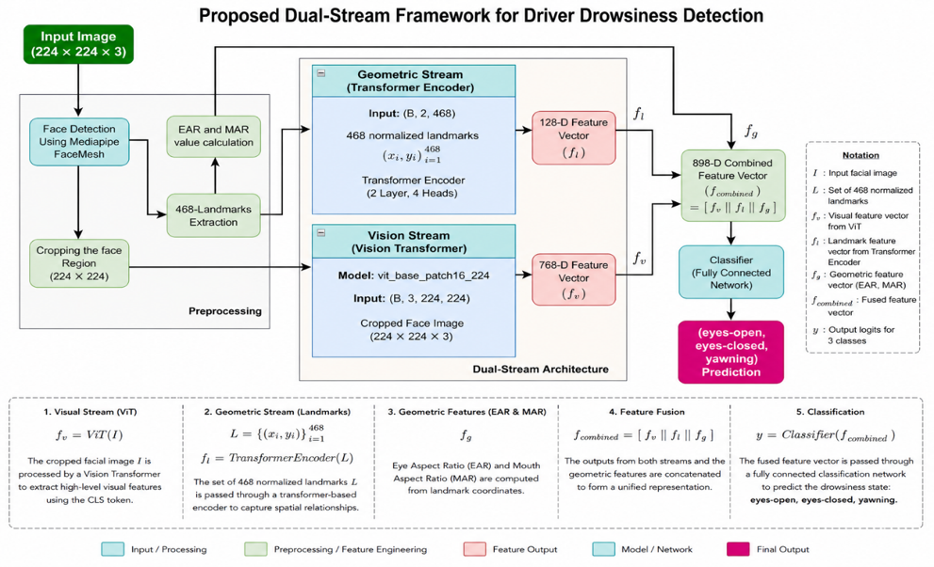
Fig. 1: Proposed dual-stream framework for driver drowsiness detection
MediaPipe FaceMesh [17][22][29] is applied to an input facial image (I) to detect the face and obtain 468 dense facial landmarks [21] representing the different facial regions, such as eyes, mouth, nose, eyebrows, and facial contour. The landmarks give geometric data about facial movements, and they are shown in Fig. 2.
Extracted landmarks are used for three purposes. First, they are employed to detect and cut out the facial area from the initial image to remove background distractions. On the other hand, the landmark coordinates are passed through a landmark encoder based on a transformer to learn the geometric relationships between the facial key points as the second step. Third, certain landmark subsets can be used to define the Eye Aspect Ratio (EAR) [22][27][30] and Mouth Aspect Ratio (MAR) [32], which can specifically indicate eye closure and yawning behaviour.
The cropped face is resized to 224 × 224 pixels and is passed to a Vision Transformer (ViT-B/16) [18][30] for obtaining high level visual representations. At the same time, the normalized facial landmark coordinates are fed into the landmark transformer encoder to obtain the geometry-aware facial features. In the meantime, the computed EAR [22][27][30] and MAR [32] values make up a compact physiological feature vector.
The results of the visual stream, landmark stream, and geometric feature extraction module are combined by concatenating features to create a single representation. The fused feature vector is then fed into a fully connected classification network which classifies one of three driver states: Eyes Open, Eyes Closed, or Yawning.
3.1 Data Preprocessing
The input data for feature extraction is preprocessed using a preprocessing pipeline to standardize the data and extract the relevant facial information. The pipeline has five stages: face detection, facial landmark detection, face cropping, landmark normalization, and computation of the geometric features. This will make sure that the subsequent teaching units are consistently and informatively represented with the driver's expression.
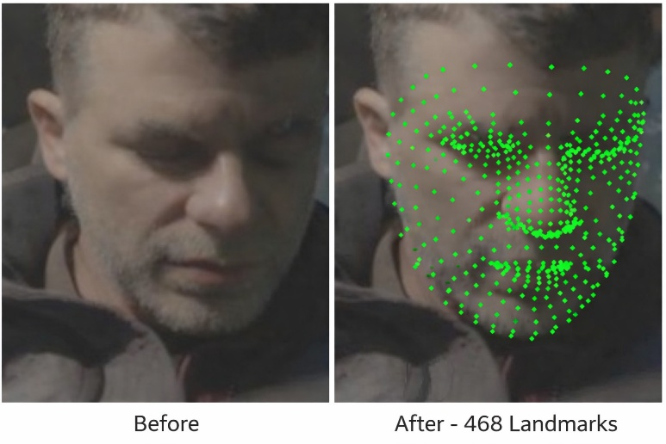
Fig. 2: Face shape with 468 facial landmarks extracted using MediaPipe FaceMesh.
1) Face Detection and Landmark Extraction: MediaPipe FaceMesh [17][22][29] is used for face detection and landmark extraction from each input image to obtain dense facial landmarks [21] and regions of the face. The framework includes 468 facial landmark points representing important facial areas such as eyes, mouth, nose, eyebrows and facial contour. FaceMesh is able to provide dense facial representations without losing real time performance when compared with traditional landmark detectors.
For each detected face, the landmark coordinates are represented as
$$L={\left\{\left(x_{i},y_{i}\right)\right\}}_{\left\{i=1\right\}}^{\left\{468\right\}}, L∈R^{\left\{468×2\right\}} Eq. \left(1\right)$$
Where (x_{i}, y_{i}) represents the normalized x and y coordinates of i^{th} landmark point. The obtained landmarks are then applied in face cropping, geometric feature computation and landmark-based feature learning. A face bounding box is first generated based on the landmarks detected and the face region is cropped and resized to 224 × 224 pixels before passing through the visual feature extraction network, to reduce background interference. At the same time, the landmark coordinates are normalized by the facial landmarks in the cropped facial region to achieve scale and position independence.
2) EAR and MAR Computation: Apart from facial landmarks, there are two geometric indicators computed from the facial landmarks [21]: Eye Aspect Ratio (EAR) [22][30] and Mouth Aspect Ratio (MAR) [32]. These measures offer clear physiologic feedback for eye closure and yawning behavior, both of which are well established signs of driver drowsy behavior. The EAR is calculated based on 6 landmark points that surround each eye and is defined as:
$$EAR=\frac{\left\|p_{2}-p_{6}\right\|+\left\|p_{3}-p_{5}\right\|}{2×\left\|p_{1}-p_{4}\right\|}, Eq.(2)$$
where $p_{1}$….$p_{6}$ the eye landmark coordinates. A lower EAR [22][27][30] value generally indicates a closed or nearly closed eye state
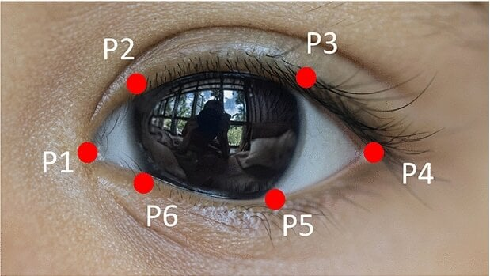
Fig. 3: Eye Aspect Ratio: the six landmark points around an eye and the computed distances.

Similarly, the MAR is calculated using landmark points around the mouth region as
$$MAR=\frac{\left|p_{upper}-p_{lower}\right|}{\left|p_{left}-p_{right}\right|}, Eq(3)$$
where $p_{upper}$and $p_{lower}$ denote the upper and lower lip landmarks, while $p_{left}$ and $p_{right}$ correspond to the mouth corners. Larger MAR [32] values typically indicate yawning behavior.
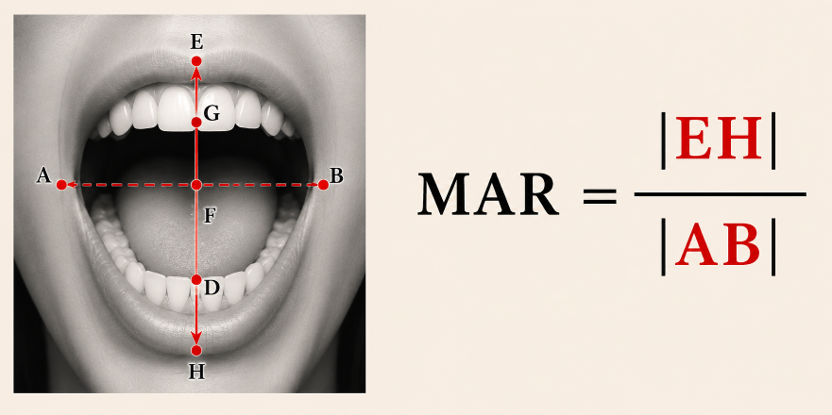
Fig. 4: Mouth aspect ratio: the upper lip, lower lip, and mouth corner landmarks used in the MAR calculation.
The computed EAR [22][27][30] and MAR [32] values are combined into a geometric feature vector,
$$f_{g}=\left[EAR;MAR\right]∈R^{2}, Eq\left(4\right)$$
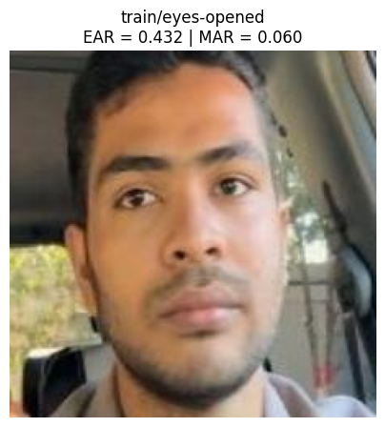
Fig. 5: Mouth Aspect Ratio: upper lip, lower lip, and mouth corner landmarks used in the MAR calculation.
which is later fused with the visual and landmark-based representations for final driver state classification.

3.2 Visual Stream
Vision Transformer The cropped facial image is resized to 224 × 224 × 3 and processed by a pretrained Vision Transformer vit_base_patch16_224 [18][30], as shown in Fig. 6. The image is partitioned into 16 × 16 patches, linearly embedded, and processed through the Transformer encoder stack. The CLS token produces a 768-dimensional visual feature vector $f_{v}$ = ViT(I), capturing high-level appearance cues including texture, skin and shadow patterns, and global facial configuration.
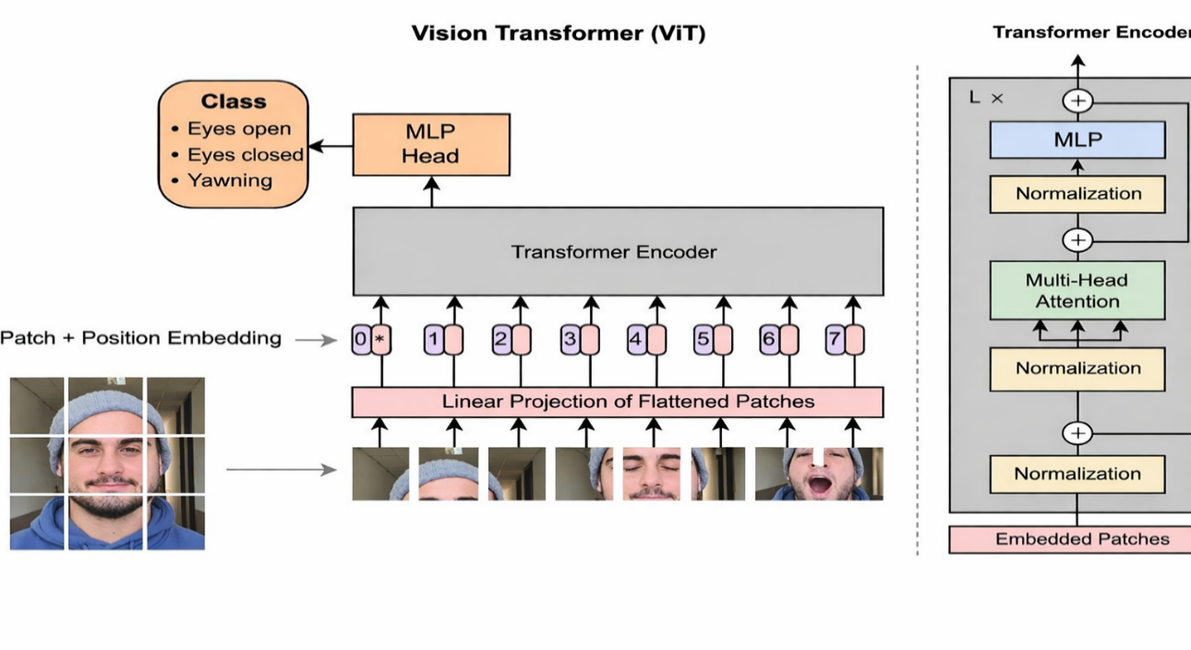
Fig. 6: Vision Transformer (ViT-B/16) architecture used for visual feature extraction.
3.3 Geometric Stream
Landmark Transformer Encoder, while the visual stream captures appearance-based information, the geometric stream focuses on learning spatial relationships among facial landmarks [21]. Facial landmark coordinates provide a compact and appearance-invariant representation of facial structure, making them less sensitive to variations in illumination, skin tone, and background conditions. This property is particularly useful for driver monitoring systems operating in diverse real-world environments. For each input image, MediaPipe FaceMesh [17][22][29] extracts 468 facial landmark points. After face cropping and normalization, the landmark set is represented as
$$L={\left(x_{i},y_{i}\right)}_{i=1}^{468}, L∈R^{468×2}, Eq(5)$$
where ($x_{i}$,$y_{i}$) denotes the normalized coordinates of the $i^{th}$ landmark. To project the low-dimensional landmark coordinates into a richer feature space, a linear embedding layer is first applied:
$$Z=LW+b, Eq\left(6\right)$$
where W and b are learnable parameters. In this work, the embedding dimension is set to 128, resulting in a feature sequence $L∈R^{468×2}$
The embedded landmark sequence is then processed by a transformer-based encoder consisting of multi-head self-attention and feed-forward layers. The self-attention mechanism enables each landmark point to attend to all other landmarks, allowing the model to capture both local facial structures and global facial geometry. The attention operation is defined as the self-attention mechanism enables each landmark point to attend to all other landmarks and is defined as
$$Attention\left(Q,K,V\right)=softmax\left(\frac{QK^{T}}{\sqrt{d_{k}}}\right)V Eq(7)$$
where Q, K, and V denote the query, key, and value matrices, respectively. After passing through the transformer encoder layers, a global landmark representation is obtained using mean pooling across all landmark tokens:

$$f_{l}=\frac{1}{468}\sum_{i=1}^{468}{Z_{i}^{\left(out\right)}} Eq(8)$$
where $Z_{i}^{out}$ represents the output feature of the $i^{th}$ landmark token. The resulting feature vector $f_{l}$ ∈ $R^{128}$serves as the geometric representation of the driver’s facial structure.
where Z ∗ $i^{out}$ represents the output feature of the $i^{th}$ landmark token. The resulting feature vector $f*l ∈ R^{128}$ serves as the geometric representation of the driver’s facial structure. By modelling the relationships among all facial landmarks [21] simultaneously, the proposed landmark transformer encoder can effectively capture geometric patterns associated with eye closure, mouth opening, and other facial behaviours related to driver drowsiness.
3.4 Feature Fusion and Classification:
To exploit complementary information from facial, appearance, landmark geometry, and physiological measurements, the features extracted from the two streams are fused before classification. Specifically, the visual feature vector f ∗ v obtained from the Vision Transformer, the landmark feature vector f ∗ l generated by the landmark transformer encoder, and the geometric feature vector $f_{g}$ containing the EAR [22][27] and MAR values are concatenated to form a unified represent
$$f_{fusion}=\left[f_{v} \right\| f_{l} \left\| f_{g}\right] Eq(9)$$
where ∥ stands for the concatenate operation. This fused feature vector combines all the global visual features, geometric facial features, and explicit physiological features related to drowsiness. The fused representation is then fed into a fully connected classification network with two hidden layers, where the hidden layers have Rectified Linear Unit (ReLU) as the activation function and dropout has been introduced for regularization.
The classification process can be expressed as:
$$h_{1}=ReLU\left(W_{1}f_{fusion}+b_{1}\right) Eq\left(10\right)$$
${ h}_{2}=ReLU\left(W_{2}h_{1}+b_{2}\right)$ $Eq\left(11\right)$
${ h}_{2}y=W_{3}h_{2}+b_{3}$ $Eq\left(12\right)$
where y is the output logits for the three driver states: Eyes Open, Eyes Closed, Yawning. The network is trained with the cross-entropy loss function during the training phase. The logits are converted to class probabilities with the SoftMax function during inference:
$$P\left(y_{i}\right)=\frac{e^{y_{i}}}{\sum_{j=1}^{3}{e^{y_{j}}}} Eq(13)$$
where P (y_{i}) is the probability of the i^{th} class. The result is the class with the greatest probability being chosen. The proposed fusion approach fuses the visual, geometric and physiological information in a single feature space, thus bringing more robust and discriminative driver state recognition than using a single feature modality.
4. Experimental Result
4.1 Dataset Description
Two datasets, original and augmented, were used to evaluate the proposed framework, both comprising the same three driving states: Eyes Open, Eyes Closed, and Yawning. The original dataset [19] combines facial images from real driving scenes, publicly available drowsiness datasets, and online sources. Its diversity in facial appearance, illumination, head pose, and driver characteristics enables the model to learn robust feature representations. Sample images are shown in Fig. 7.
Fig. 7: Sample images from the driver drowsiness dataset.
The total number of facial images in the original dataset [19] comes out to 1,888 facial images and are split into training, validation and testing sets with proportions of 70:20:10. Data augmentation methods such as horizontal flipping, random rotation (±15◦) and brightness change (±20%) were only applied to training set to enhance the robustness and the generalizing power of the proposed model. This results in an augmented dataset [20] with a size that is significantly larger but retains the original validation and testing sets. Table 1 shows the class distributions of the original and augmented datasets.
TABLE 1: Class Distribution of the Original and Augmented Datasets

Dataset | Class | Train | Validation | Test
Original | Eyes Closed | 439 | 125 | 64
 | Eyes Open | 441 | 126 | 64
 | Yawning | 440 | 125 | 64
Augmented | Eyes Closed | 1784 | 127 | 65
 | Eyes Open | 1764 | 126 | 64
 | Yawning | 1758 | 125 | 64

4.2 Experimental Settings
The proposed dual-stream model was trained using transfer learning with a two-stage optimization strategy. The Vision Transformer (ViT-B/16) [18] backbone was initialized with ImageNet pre-trained weights, while the landmark transformer encoder and classification network were trained from scratch. During the first stage, the ViT backbone remained frozen for 10 epochs, allowing only the landmark encoder and classifier to learn task-specific representations. In the second stage, the entire network was fine-tuned for an additional 5 epochs using a differential learning rate strategy. Table 2 summarizes the hyperparameters used throughout training.
TABLE 2: Training Hyperparameters
Hyperparameter | Value
Input Resolution | 224 × 224
Batch Size | 16
Training Epochs | 15 (10 + 5)
Optimizer | Adam
Weight Decay | 1 × 10⁻⁴
Frozen-Phase LR | 1 × 10⁻⁴
Fine-Tuning LR | 1 × 10⁻⁶
ViT Fine-Tuning LR | 1 × 10⁻⁸
Learning Rate Scheduler | Cosine Annealing
Loss Function | Cross-Entropy Loss
The key architectural configurations are summarized in Table 3.

TABLE 3: Architecture Configuration of the Proposed Model
Component | Configuration
Visual Backbone | ViT-B/16
ViT Feature Dimension | 768
Patch Size | 16 × 16
Landmark Points | 468
Landmark Embedding Dimension | 128
Transformer Encoder Layers | 2
Attention Heads | 4
Feed-Forward Dimension | 512
Fusion Feature Dimension | 898
Output Classes | 3

All experiments were conducted using the PyTorch framework on the Kaggle cloud platform with an NVIDIA Tesla T4 GPU (16 GB memory). The implementation was developed in Python and executed using Kaggle Notebook, ensuring reproducibility and efficient GPU-accelerated training.
4.3 Evaluation Metrics
Four classification metrics: accuracy, precision, recall and F1-score are employed to assess the performance of proposed driver drowsiness detection model.
The evaluation metrics are computed as follows:
$$Accuracy=\frac{TP+TN}{TP+TN+FP+FN} Eq. \left(14\right)$$

$$Precision=\frac{TP}{TP+FP} Eq. \left(15\right)$$

$$Recall=\frac{TP}{TP+FN} Eq. \left(16\right)$$

$${F1}_{score}=2×\frac{Precision×Recall}{Precision+Recall} Eq. (17)$$
where TP is the number of true positives, TN is the number of true negatives, FP is number of false positives, and FN is number of false negatives. These metrics are used to give a full picture of the proposed model for the three-class driver state classification task.
4.4 Training Performance Analysis
This was done by testing the training performance of the proposed model on both the original and extended datasets, examining the convergence behavior and the generalization capability of the model. The accuracy and loss curves for both datasets during training and validation are shown in figure 8. The proposed two-stage training scheme of training with the frozen backbone followed by fine-tuning was used in all experiments.
Fig. 8: Training and validation loss and accuracy curves of the proposed dual-stream model on the original and augmented datasets.
In the frozen training time, the augmented dataset [20] achieved a high validation accuracy of around 97.5% with rapid convergence, and fine-tuning further improved the best validation accuracy up to 97.82 percent. Original dataset [19] reached the maximum accuracy of 95.91% and converged slowly. Furthermore, the training and validation loss of the augmented dataset [20] was lower, showing that the network learns more from the data and generalizes better.
4.5 Quantitative Performance Evaluation
Table 4 presents the quantitative performance of the proposed dual-stream model [31] on the original [19] and augmented [20] datasets. The model trained on the augmented dataset outperformed the one trained on the original dataset across all evaluation metrics, confirming the effectiveness of data augmentation in improving classification accuracy and generalization.
As shown in Table 4, the proposed model achieved an overall test accuracy of 97.88% on the augmented dataset, 2.11 percentage points higher than the 95.77% achieved on the original dataset. Macro-average and weighted-average precision, recall, and F1-score were also higher for the augmented dataset, indicating more robust and balanced classification across all driver states.
The Eyes Closed class did not miss any of the closed-eye samples, with a 100% recall rate. The Yawning class showed good performance as well, with precision, recall and F1-scores all over 98%. The augmentation performed for the Eyes Open class did not improve the recall score significantly (95.24%), however, it significantly improved the precision score (98.36%) thus increasing the overall F1 score.

TABLE 4: Per-class performance comparison between original and augmented datasets

Class | Augmented Dataset |  |  | Original Dataset
 | Prec. | Rec. | F1 | Prec. | Rec. | F1
Eyes-Closed | 0.9692 | 1.0000 | 0.9844 | 0.9677 | 0.9375 | 0.9524
Eyes-Opened | 0.9836 | 0.9524 | 0.9677 | 0.9254 | 0.9688 | 0.9466
Yawning | 0.9841 | 0.9841 | 0.9841 | 0.9833 | 0.9672 | 0.9752
Accuracy | 0.9788 |  |  | 0.9577
Macro Avg | 0.9790 | 0.9788 | 0.9787 | 0.9588 | 0.9578 | 0.9581
Weighted Avg | 0.9790 | 0.9788 | 0.9787 | 0.9584 | 0.9577 | 0.9578
4.6 Class-wise Performance Analysis
To test the proposed dual stream model, the confusion matrices of the models trained with the original [19] and the augmented [20] are presented in Fig. 9 and the accuracy of classification of each model is presented in Fig. 10 respectively.
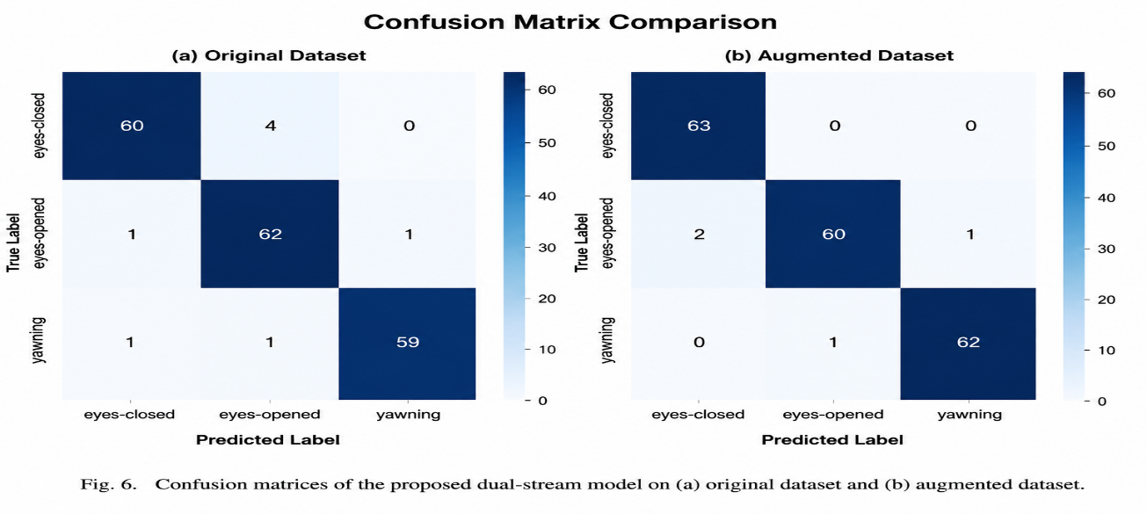
Fig. 9: Confusion matrices of the proposed dual-stream model trained on the (a) original dataset and (b) augmented dataset.
As it can be seen in Fig. 9, the confusion matrix for the augmented dataset [20] has more elements appearing along the diagonal and less elements appearing off the diagonal, suggesting that there is less misclassification and higher class separability. Interestingly, there were no false negatives, with the recognition accuracy of the Eyes Closed test being 100%. Yawning also did fairly well with very few misclassifications, and a few Eyes Open samples were misclassified, but classification was still very reliable.
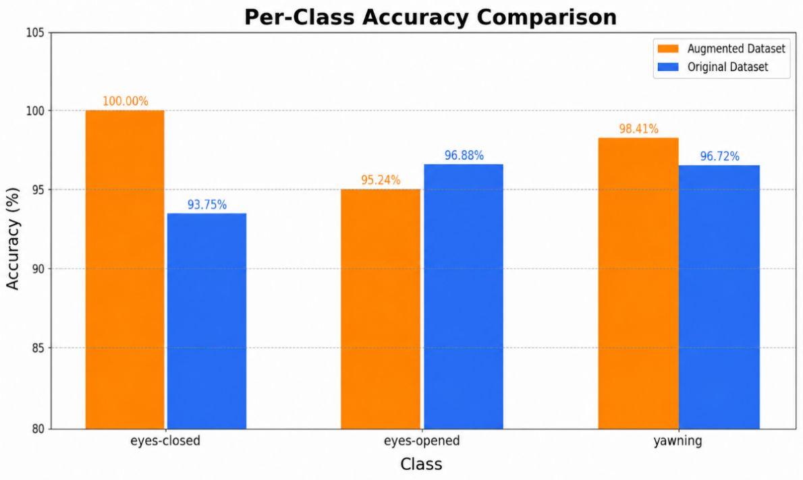
Fig. 10: Class-wise accuracy comparison of the proposed model on the original and augmented datasets.
The confusion matrix of the original dataset [19] reveals more off-diagonal elements, especially between the Eyes Open and Eyes Closed classes, indicating that the model is less effective in learning facial features from the small dataset, with different driving conditions.
The influence of the augmentation on each class is additionally demonstrated in Fig. 10. Eyes Closed accuracy improved from 93.75% to 100%, which was the highest increase for any class, and Yawning accuracy increased from 96.72% to 98.41%. Eyes Open's performance remained good but slightly lowered with 96.88% to 95.24% due to the small percentage of misclassifications.
In general, this class-wise analysis verifies the effectiveness of data augmentation for the proposed dual-stream model, variance added to the model helps to learn better visual and geometric representations.
4.7 Comparison with Existing Methods
Table 5 presents a comparison of the proposed dual-stream system with some illustrative driver drowsiness detection techniques from the literature, in addition to the baseline models used for this study. Previous methods use various techniques such as traditional machine learning, convolutional neural networks (CNNs), Vision Transformers (ViTs) and hybrid deep learning models. The most common approaches are based on facial appearance cues, eye movements or manually engineered physiological features.
TABLE 5: Comparison of the proposed method with existing models and driver drowsiness detection approaches
No. | Reference | Method | Main ROI | Dataset | Accuracy (%) | Difference (%)
1 | Sun et al. [10] | Facial Feature Fusion CNN (FFFCNN) | Eyes | CEW [23] | 98.35 | -0.47
2 | Pandey and Muppalaneni [13] | Model-A using YOLOv3 and Model-B with InceptionV3 | Eyes and Mouth | UTA-RLDD [24] | 97.50 | +0.38
3 | Sengar et al. [11] | PoseViNet (Multi-view Pose + ViT) | Pose / Driver Action | SynDD1[25] | 90.92 | +6.96
4 | Gupta et al. [12] | HOG + LBPH + SVM + EAR + MAR | Eyes and Mouth | Custom Dataset | 90.00 | +7.88
5 | Li and Li [15] | Vision Transformer + LSTM | Mouth, Eyes, Head Pose | NTHU-DDD | 93.15 | +4.73
6 | Reddy et al. [16] | Viola–Jones + DWT + RBFNN | Eyes | Custom Dataset | 95.40 | +2.48
7 | ResNet50 | ResNet50 | Eyes and Mouth | Augmented Dataset | 93.78 | +4.10
8 | EfficientNetB0 | EfficientNetB0 | Eyes and Mouth | Augmented Dataset | 94.30 | +3.58
9 | Proposed Work | Dual-Stream ViT + Landmark Transformer + EAR + MAR | Eyes and Mouth | Augmented / Original Dataset | 97.88 / 95.77 | —
4.8 Ablation Study
An ablation study was conducted on the augmented dataset to assess each component's contribution to the proposed dual-stream approach, progressively expanding the Vision Transformer (ViT) baseline to include the transformer-based landmark encoder, handcrafted geometric features (EAR and MAR), and the final feature fusion strategy. Results are presented in Table 6.
TABLE 6: Ablation study of the proposed framework on the augmented dataset

No. | Configuration | Acc. | Δ
1 | ViT | 95.53 | 0.00
2 | ViT + EAR + MAR | 96.74 | +1.21
3 | ViT + Landmark Tr. | 97.35 | +1.82
4 | ViT + Landmark Tr. + EAR + MAR | 97.88 | +2.35
As shown in Table 6, the ViT baseline achieved 95.53% accuracy. Integrating the transformer-based landmark encoder with visual features raised accuracy to 97.35%, indicating that facial geometric relations carry information complementary to visual appearance. Adding handcrafted physiological features (EAR and MAR) alone improved performance to 96.74%. The full dual-stream framework, combining visual features, landmark representation, and physiological measurements through feature fusion, achieved the highest accuracy of 97.88%, a 2.35 percentage-point gain over the ViT-only baseline. These results confirm that each component contributes positively, with their combination yielding the most complete drowsiness detection performance.
5. Conclusion
In this paper, a dual-stream deep learning model for driver drowsiness detection is proposed, which consists of a Vision Transformer (ViT), a transformer-based facial landmark encoder, and handcrafted physiological features based on the Eye Aspect Ratio (EAR) and Mouth Aspect Ratio (MAR). The framework successfully utilizes facial appearance, landmark geometry and fatigue related physiological clues to categorize three driver states: "Eyes Open", "Eyes Closed" and "Yawning".
The experimental results demonstrated that the proposed model outperforms the baseline model such as ResNet50, EfficientNetB0, and the ViT-only model with accuracy of 95.77% on the original dataset and 97.88% on the augmented dataset. The ablation study further confirmed that the landmark transformer and EAR/MAR features are complementary, jointly boosting overall performance. The results show the efficacy and power of multimodal feature fusion approach toward driver drowsiness detection.
Future work will involve its extension to deployment in real-time for in-vehicle applications, integration of temporal information from video sequences, and testing it on larger, more diverse, real-world driving datasets with the aim of further improving its robustness and generalization.
References
[1] S. U. Sanu, “Homecoming turns tragic: Oman returnee loses 7 family members in noakhali crash as microbus falls into ditch,” https://www.tbsnews.net/bangladesh/homecoming-turns-tragic-oman-returnee-loses-7-family-members-noakhali-crash-microbus, 2025, the Business Standard.
[2] National Safety Council, “Drivers are falling asleep behind the wheel,” https://www.nsc.org/road/safety-topics/fatigued-driver, 2024.
[3] T. Miller, “Ntsb wants stronger eld regs after fatal crash investigation,” Overdrive Online, August 2024. [Online]. Available: https://www.overdriveonline.com/regulations/article/15682883/ntsb-wants-stronger-eld-regs-after-fatal-crash-investigation
[4] W. H. Organization, “Global status report on road safety,” 2018.
[5] A. Sahayadhas, K. Sundaraj, and M. Murugappan, “Detecting driver drowsiness based on sensors: A review,” Sensors, vol. 12, no. 12, pp. 16 937–16 953, 2012.
[6] Y. Dong, Z. Hu, K. Uchimura, and N. Murayama, “Driver inattention monitoring system for intelligent vehicles: A review,” IEEE Transactions on Intelligent Transportation Systems, vol. 12, no. 2, pp. 596–614, 2011.
[7] S. Park and F. Pan, “Driver drowsiness detection system using image processing,” International Journal of Multimedia and Ubiquitous Engineering, vol. 11, no. 7, pp. 1–10, 2016.
[8] F. Wang, H. X. Zhang, Y. Wang, and X. Liu, “Driver drowsiness detection using deep learning: A review,” IEEE Access, vol. 7, pp. 105165–105177, 2019.
[9] M. Venkateswarlu and V. R. R. Chirra, “Cnn-vit: A multi-feature learning based approach for driver drowsiness detection,” Array, vol. 27, p. 100425, Jun 2025.
[10] Z. Sun, Y. Miao, J. Y. Jeon, Y. Kong, and G. Park, “Facial feature fusion convolutional neural network for driver fatigue detection,” https://doi.org/10.1016/j.engappai.2023.106981, 2023, engineering Applications of Artificial Intelligence.
[11] N. Sengar, I. Kumari, J. Lee, and D. Har, “PoseViNet: Distracted driver action recognition framework using multi-view pose estimation and vision transformer,” arXiv preprint arXiv:2312.14577, 2023. [Online]. Available: https://arxiv.org/abs/2312.14577
[12] I. Gupta, N. Garg, A. Aggarwal, N. Nepalia, and B. Verma, “Real-time driver’s drowsiness monitoring based on dynamically varying threshold,” in Proceedings of the 2018 Eleventh International Conference on Contemporary Computing (IC3), 2018, pp. 1–6.
[13] N. N. Pandey and N. B. Muppalaneni, “DUMODDS: Dual modeling approach for drowsiness detection based on spatial and spatio-temporal features,” Engineering Applications of Artificial Intelligence, vol. 119, Art. no. 105759, 2023. doi: 10.1016/j.engappai.2022.105759
[14] N. D. Gupta, R. Rajoo, and P. J. Jacob, “Driver drowsiness detection system through facial expression using convolutional neural networks (cnn),” Malaysian Journal of Computing, vol. 8, no. 1, pp. 1375–1387, Apr 2023.
[15] Li and Li, “A deep learning-based approach for driver sleepiness detection using local and global facial features,” https://link.springer.com/article/10.1007/s12652-024-04781-3, 2024, journal of Ambient Intelligence and Humanized Computing.
[16] C. V. R. Reddy, U. S. Reddy, and D. M. Babu, “An automatic driver drowsiness detection system using dwt and rbfnn,” https://www.ijrte.org/wp-content/uploads/papers/v7i5s4/E10080275S419.pdf, 2019, international Journal of Recent Technology and Engineering (IJRTE).
[17] Y. Kartynnik, A. Ablavatski, I. Grishchenko, and M. Grundmann, “Real-time facial surface geometry from monocular video on mobile gpus,” https://arxiv.org/pdf/1907.06724, 2019, arXiv preprint arXiv:1907.06724.
[18] A. Dosovitskiy, L. Beyer, A. Kolesnikov, D. Weissenborn, X. Zhai, T. Unterthiner, M. Dehghani, M. Minderer, G. Heigold, S. Gelly, J. Uszkoreit, and N. Houlsby, “An image is worth 16x16 words: Transformers for image recognition at scale,” https://arxiv.org/abs/2010.11929, 2021, presented at International Conference on Learning Representations (ICLR 2021).
[19] T. Islam, “Original split drowsiness dataset,” https://www.kaggle.com/datasets/c221037tasinislam/original-split-drawsiness-dataset.
[20] A. Rahim, “Split drowsiness dataset (augmented version),” https://www.kaggle.com/datasets/arafatrahim11/split-drawsiness-dataset.
[21] H. Arava and D. M. Sundaram, "Enhancing Driver Drowsiness Detection: A Fusion of Facial Landmarks and Modified YOLOv5 Architecture," International Journal of Intelligent Systems and Applications in Engineering, vol. 12, no. 11s, pp. 440–441, 2024.
[22] Y. Rahmawati, K. Woraratpanya, I. Ardiyanto, and H. A. Nugroho, "Evaluating the effectiveness of facial actions features for the early detection of driver drowsiness in driving safety monitoring system," Communications in Science and Technology, vol. 10, no. 1, pp. 179–189, 2025.
[23] A. Farouk, "CEW-Dataset," Kaggle, 2023. [Online]. Available: https://www.kaggle.com/datasets/ahamedfarouk/cew-dataset.
[24] "UTA Real-Life Drowsiness Dataset (UTA-RLDD)," Vision-Learning-Mining Lab, University of Texas at Arlington. [Online]. Available: https://sites.google.com/view/utarldd/home.
[25] I. Balappanawar, "SynDD1," Kaggle. [Online]. Available: https://www.kaggle.com/datasets/ishwarbalappanawar/syndd1.
[26] T. Fonseca and S. Ferreira, “Drowsiness detection in drivers: A systematic review of deep learning-based models,” Applied Sciences, vol. 15, no. 16, Art. no. 9018, 2025. doi: 10.3390/app15169018
[27] V. S. K. Rupani, V. V. S. Thushar, and K. Tejith, "Real-Time Drowsiness Detection Using Eye Aspect Ratio and Facial Landmark Detection," arXiv preprint, 2024.
[28] A. N. K. Zaman, P. Chatterjee, and R. Sharma, "Real-Time Drivers' Drowsiness Detection and Analysis through Deep Learning," arXiv preprint, 2025.
[29] A. G. Sawant, S. S. Kamble, R. S. Kanade, R. N. Kanugo, T. A. Kapse, and K. A. Bhapse, “A real-time driver drowsiness detection system using MediaPipe and eye aspect ratio,” arXiv preprint arXiv:2511.13618, 2025. [Online]. Available: https://arxiv.org/abs/2511.13618
[30] O. F. Hassan, A. F. Ibrahim, A. Gomaa, M. A. Makhlouf, and B. Hafiz, “Real-time driver drowsiness detection using transformer architectures: A novel deep learning approach,” Scientific Reports, vol. 15, Art. no. 17493, 2025. doi: 10.1038/s41598-025-02111-x
[31] Y. Li, H. Zhang, X. Wang, and Y. Chen, "A Novel Driver Fatigue Detection Method Based on Dual-Stream Swin-Transformer," IEICE Transactions on Information and Systems, vol. E108-D, no. 10, pp. 1270–1274, 2025.
[32] W. Xiao, H. Liu, Z. Ma, W. Chen, C. Sun, and B. Shi, "Fatigue Driving Recognition Method Based on Multi-Scale Facial Landmark Detector," Electronics, vol. 11, no. 24, Art. no. 4103, Dec. 2022, doi: 10.3390/electronics11244103.

* Email address of the Corresponding Author
* Email address of the Corresponding Author
* Email address of the Corresponding Author

