Contents
Update this field in Word

Phase 3 Production Hardening
This document exercises themes, Unicode, RTL, native equations, SVG conversion, and wide-table landscape sections while preserving native Word semantics.

Unicode and RTL
English: café, naïve, Δ, 中文内容, 日本語, 한국어, 🚀.
مرحبا بالعالم — هذا سطر عربي لاختبار خصائص Word ثنائية الاتجاه.

Native equation
$$\int_{0}^{∞}{e^{-x}} dx=1, A=\left[\begin{matrix}a & b \\ c & d\end{matrix}\right]$$

SVG architecture
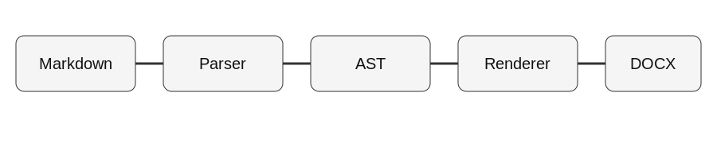
Markdown to native Word compiler

Wide table

Component | Input contract | Output contract | Security boundary | Caching | Diagnostics | Phase
Parser | Markdown | Canonical AST | No code execution | — | PARSE | 1
Math | LaTeX subset | OMML | No TeX execution | Per render | MATH | 2–3
Resources | Local/HTTPS image | Safe local bytes | Path/DNS/MIME/size checks | Optional disk | RESOURCE | 3
Renderer | Canonical AST | WordprocessingML | OOXML only | Math cache | DOCX | 1–3

Editable content
- Native numbering remains editable.
- Tables remain native Word tables.
- Equations remain Office Math rather than screenshots.
- Headings remain Word heading styles for TOC rebuilds.

