Contents
Update this field in Word

Phase 4 Operational Maturity
This document exercises native Word structure, reproducible packaging, Unicode, RTL text, editable equations, tables, SVG conversion, and ordinary Markdown semantics.
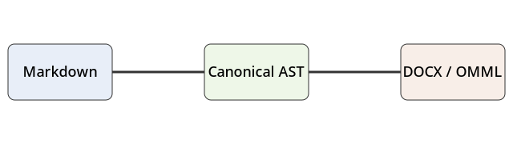
Compiler architecture

Editable mathematics
Inline math remains in the paragraph: $E=mc^{2}$ and $x_{i}^{2}$.
$$\sum_{i=1}^{n}{i}=\frac{n(n+1)}{2}$$
$$\int_{0}^{∞}{e^{-x}} dx=1$$

Native lists
- Parse Markdown.
- Build the canonical AST.
  - Preserve semantics.
  - Preserve source positions.
- Render WordprocessingML and OMML.

Unicode and RTL
English remains left-to-right. العربية تظل نصاً أصلياً قابلاً للتحرير داخل Word.

Wide table

Component | Parser | Normalizer | Renderer | Equations | Resources | Diagnostics | Validation
Representation | tokens | AST | OOXML | OMML | embedded media | JSON/SARIF | package XML
Editable | yes | yes | yes | yes | image object | n/a | n/a
Deterministic | yes | yes | yes | yes | policy-bound | yes | yes

Code remains editable
from mddocx import render
render("report.md", "report.docx")

Completion
The artifact should reopen as a normal DOCX and all semantic structures should remain native.

