Contents
Update this field in Word

Section 1: Professional Word Semantics

This acceptance report validates native references, captions, citations, endnotes, accessibility, and diagrams (Smith & Doe, 2025; Lee, 2026).
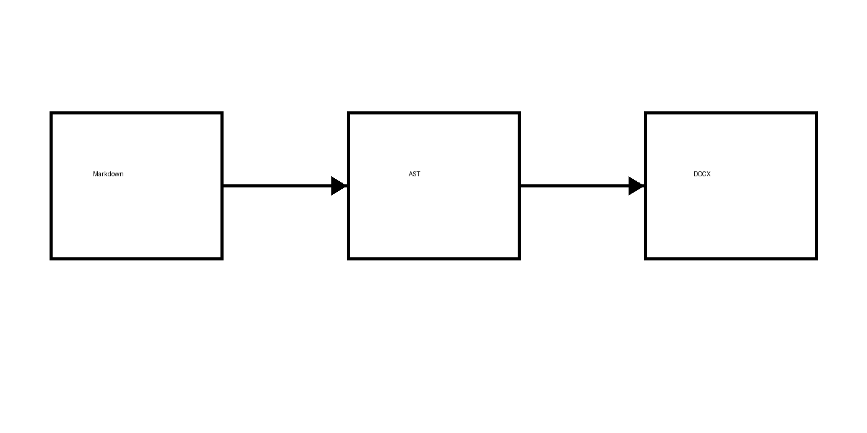
Figure 1 — Semantic Markdown-to-Word compilation pipeline
As shown in Figure 1, the compiler preserves semantic boundaries. See Section 2: Professional Word Semantics for numbered equations.

Section 2: Professional Word Semantics

Numbered native Office Math is cross-referenceable and remains editable.
$$E=mc^{2}$$ | (2.1)
$$\int_{0}^{∞}{e^{-x^{2}}} dx=\frac{\sqrt{π}}{2}$$ | (2.2)
See Equation 2.1 and Equation 2.2.

Section 3: Professional Word Semantics

Table 1 — Phase 5B semantic features
Feature | Native Word structure | Status
Equations | OMML | Pass
References | REF/SEQ fields | Pass
Notes | Endnotes part | Pass
The result matrix is summarized in Table 1.

Section 4: Professional Word Semantics

Listing 1 — Minimal rendering entry point
from mddocx import render
render("input.md", "output.docx")
The public entry point remains small; see Listing 1.

Section 5: Professional Word Semantics

Compiler
A deterministic program that maps Markdown semantics to native Word semantics.
Cross-reference
A field-backed link whose visible number or target updates with the document.
Bibliography
A generated reference list backed by BibTeX or CSL-JSON metadata.

Section 6: Professional Word Semantics

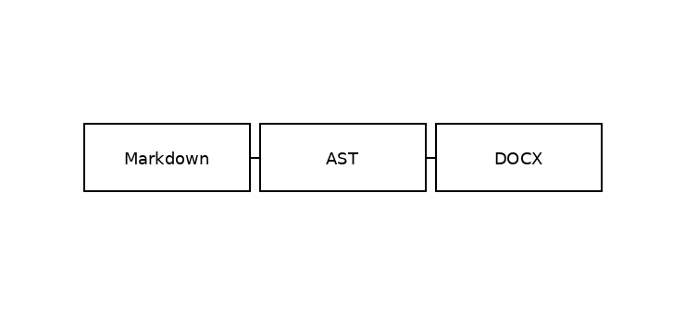
Figure 2 — Mermaid family acceptance diagram 1
The offline renderer produced Figure 2 without executing Markdown code.

Section 7: Professional Word Semantics

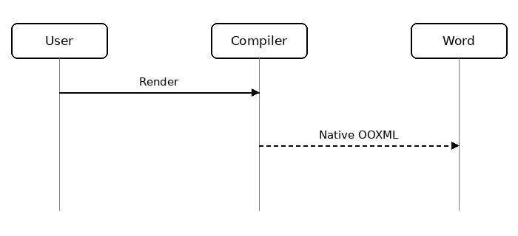
Figure 3 — Mermaid family acceptance diagram 2
The offline renderer produced Figure 3 without executing Markdown code.

Section 8: Professional Word Semantics

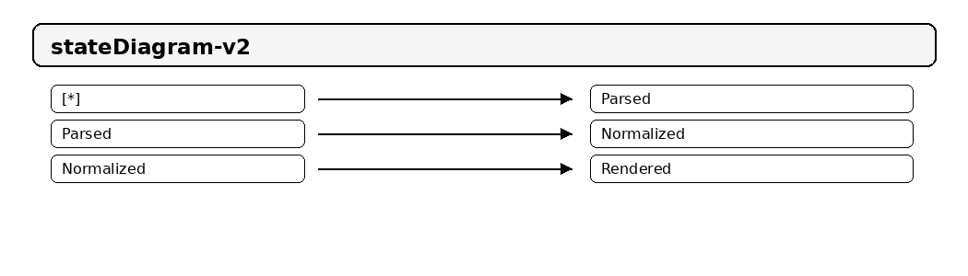
Figure 4 — Mermaid family acceptance diagram 3
The offline renderer produced Figure 4 without executing Markdown code.

Section 9: Professional Word Semantics

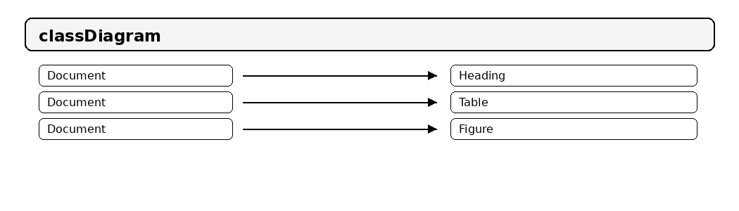
Figure 5 — Mermaid family acceptance diagram 4
The offline renderer produced Figure 5 without executing Markdown code.

Section 10: Professional Word Semantics

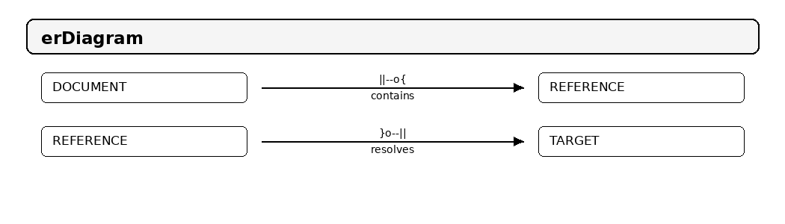
Figure 6 — Mermaid family acceptance diagram 5
The offline renderer produced Figure 6 without executing Markdown code.

Section 11: Professional Word Semantics

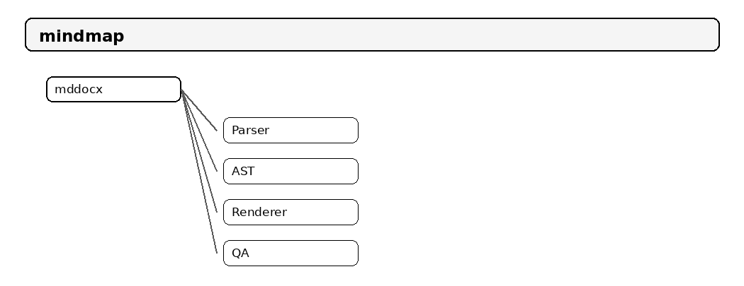
Figure 7 — Mermaid family acceptance diagram 6
The offline renderer produced Figure 7 without executing Markdown code.

Section 12: Professional Word Semantics

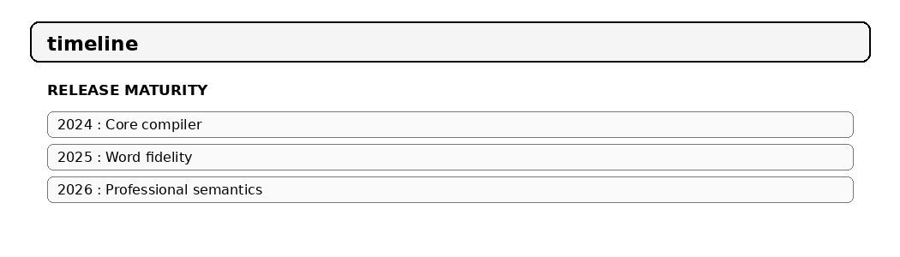
Figure 8 — Mermaid family acceptance diagram 7
The offline renderer produced Figure 8 without executing Markdown code.

Section 13: Professional Word Semantics

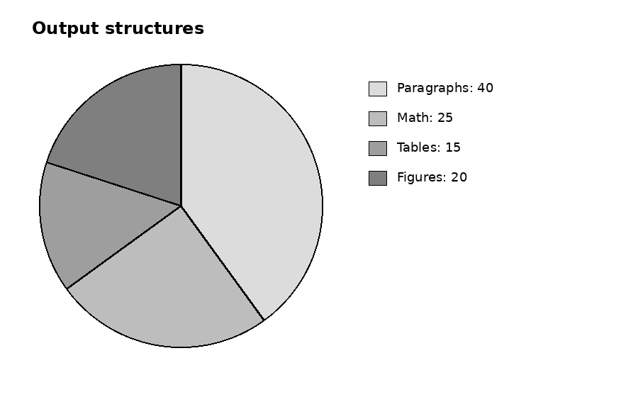
Figure 9 — Mermaid family acceptance diagram 8
The offline renderer produced Figure 9 without executing Markdown code.

Section 14: Professional Word Semantics

☒ Native Word checkbox
☒ Native numbering
☒ Native endnotes
☐ Future Microsoft Word build farm
Task controls remain editable Word content controls.

Section 15: Professional Word Semantics

This statement has a native endnote with inline math.
A second endnote includes bold, italic, and a URL label.

Section 16: Professional Word Semantics

Citation rendering is architecture-separated from DOCX rendering (Patel, 2024, p. 18).
The bibliography is generated on the final page.

Section 17: Professional Word Semantics

Section 17 is a pagination and reference stability fixture. It links back to Section 1: Professional Word Semantics and cites the document compiler literature (Smith & Doe, 2025).
$$f_{17}(x)=\sum_{k=0}^{17}{\frac{x^{k}}{k!}}$$ | (17.1)
Equation 17.1 is a section-scoped numbered OMML expression.
Table 2 — Section 17 metrics
Metric | Value
Section | 17
Equation terms | 18

Section 18: Professional Word Semantics

Section 18 is a pagination and reference stability fixture. It links back to Section 1: Professional Word Semantics and cites the document compiler literature (Smith & Doe, 2025).
$$f_{18}(x)=\sum_{k=0}^{18}{\frac{x^{k}}{k!}}$$ | (18.1)
Equation 18.1 is a section-scoped numbered OMML expression.
Table 3 — Section 18 metrics
Metric | Value
Section | 18
Equation terms | 19

Section 19: Professional Word Semantics

Section 19 is a pagination and reference stability fixture. It links back to Section 1: Professional Word Semantics and cites the document compiler literature (Smith & Doe, 2025).
$$f_{19}(x)=\sum_{k=0}^{19}{\frac{x^{k}}{k!}}$$ | (19.1)
Equation 19.1 is a section-scoped numbered OMML expression.
Table 4 — Section 19 metrics
Metric | Value
Section | 19
Equation terms | 20

Section 20: Professional Word Semantics

Section 20 is a pagination and reference stability fixture. It links back to Section 1: Professional Word Semantics and cites the document compiler literature (Smith & Doe, 2025).
$$f_{20}(x)=\sum_{k=0}^{20}{\frac{x^{k}}{k!}}$$ | (20.1)
Equation 20.1 is a section-scoped numbered OMML expression.
Table 5 — Section 20 metrics
Metric | Value
Section | 20
Equation terms | 21

Section 21: Professional Word Semantics

Section 21 is a pagination and reference stability fixture. It links back to Section 1: Professional Word Semantics and cites the document compiler literature (Smith & Doe, 2025).
$$f_{21}(x)=\sum_{k=0}^{21}{\frac{x^{k}}{k!}}$$ | (21.1)
Equation 21.1 is a section-scoped numbered OMML expression.
Table 6 — Section 21 metrics
Metric | Value
Section | 21
Equation terms | 22

Section 22: Professional Word Semantics

Section 22 is a pagination and reference stability fixture. It links back to Section 1: Professional Word Semantics and cites the document compiler literature (Smith & Doe, 2025).
$$f_{22}(x)=\sum_{k=0}^{22}{\frac{x^{k}}{k!}}$$ | (22.1)
Equation 22.1 is a section-scoped numbered OMML expression.
Table 7 — Section 22 metrics
Metric | Value
Section | 22
Equation terms | 23

Section 23: Professional Word Semantics

Section 23 is a pagination and reference stability fixture. It links back to Section 1: Professional Word Semantics and cites the document compiler literature (Smith & Doe, 2025).
$$f_{23}(x)=\sum_{k=0}^{23}{\frac{x^{k}}{k!}}$$ | (23.1)
Equation 23.1 is a section-scoped numbered OMML expression.
Table 8 — Section 23 metrics
Metric | Value
Section | 23
Equation terms | 24

Section 24: Professional Word Semantics

Section 24 is a pagination and reference stability fixture. It links back to Section 1: Professional Word Semantics and cites the document compiler literature (Smith & Doe, 2025).
$$f_{24}(x)=\sum_{k=0}^{24}{\frac{x^{k}}{k!}}$$ | (24.1)
Equation 24.1 is a section-scoped numbered OMML expression.
Table 9 — Section 24 metrics
Metric | Value
Section | 24
Equation terms | 25

Section 25: Professional Word Semantics

Section 25 is a pagination and reference stability fixture. It links back to Section 1: Professional Word Semantics and cites the document compiler literature (Smith & Doe, 2025).
$$f_{25}(x)=\sum_{k=0}^{25}{\frac{x^{k}}{k!}}$$ | (25.1)
Equation 25.1 is a section-scoped numbered OMML expression.
Table 10 — Section 25 metrics
Metric | Value
Section | 25
Equation terms | 26

Section 26: Professional Word Semantics

Section 26 is a pagination and reference stability fixture. It links back to Section 1: Professional Word Semantics and cites the document compiler literature (Smith & Doe, 2025).
$$f_{26}(x)=\sum_{k=0}^{26}{\frac{x^{k}}{k!}}$$ | (26.1)
Equation 26.1 is a section-scoped numbered OMML expression.
Table 11 — Section 26 metrics
Metric | Value
Section | 26
Equation terms | 27

Section 27: Professional Word Semantics

Section 27 is a pagination and reference stability fixture. It links back to Section 1: Professional Word Semantics and cites the document compiler literature (Smith & Doe, 2025).
$$f_{27}(x)=\sum_{k=0}^{27}{\frac{x^{k}}{k!}}$$ | (27.1)
Equation 27.1 is a section-scoped numbered OMML expression.
Table 12 — Section 27 metrics
Metric | Value
Section | 27
Equation terms | 28

Section 28: Professional Word Semantics

Section 28 is a pagination and reference stability fixture. It links back to Section 1: Professional Word Semantics and cites the document compiler literature (Smith & Doe, 2025).
$$f_{28}(x)=\sum_{k=0}^{28}{\frac{x^{k}}{k!}}$$ | (28.1)
Equation 28.1 is a section-scoped numbered OMML expression.
Table 13 — Section 28 metrics
Metric | Value
Section | 28
Equation terms | 29

Section 29: Professional Word Semantics

Section 29 is a pagination and reference stability fixture. It links back to Section 1: Professional Word Semantics and cites the document compiler literature (Smith & Doe, 2025).
$$f_{29}(x)=\sum_{k=0}^{29}{\frac{x^{k}}{k!}}$$ | (29.1)
Equation 29.1 is a section-scoped numbered OMML expression.
Table 14 — Section 29 metrics
Metric | Value
Section | 29
Equation terms | 30

Section 30: Professional Word Semantics

Section 30 is a pagination and reference stability fixture. It links back to Section 1: Professional Word Semantics and cites the document compiler literature (Smith & Doe, 2025).
$$f_{30}(x)=\sum_{k=0}^{30}{\frac{x^{k}}{k!}}$$ | (30.1)
Equation 30.1 is a section-scoped numbered OMML expression.
Table 15 — Section 30 metrics
Metric | Value
Section | 30
Equation terms | 31

References
Lee, Ada (2026). Reliable WordprocessingML Systems. Example Press.
Patel, Ravi (2024). Accessible Technical Documents. Publishing Systems.
Smith, Jane; Doe, John (2025). Semantic Document Compilation. Document Engineering.

The endnote contains editable mathematics $∇^{2}f=0$.
Endnotes preserve bold and italic inline formatting and visible link text OpenAI.

