Markdown Stress-Test Document
A comprehensive Markdown test file containing typography, nested lists, tables, code, mathematical notation, calculus, complex analysis, derivations, diagrams, and graph definitions.

1. Basic Markdown
This paragraph tests bold, italic, bold italic, strikethrough, inline code, and a Markdown link.

Blockquote
Mathematics is the language in which patterns can be expressed precisely.
Nested quotation: > This is a second-level blockquote.

Horizontal rule

2. Lists and Pointwise Content

Unordered list
- Algebra
  - Linear algebra
    - Vectors
    - Matrices
    - Eigenvalues
  - Abstract algebra
- Calculus
  - Differentiation
  - Integration
- Analysis
  - Real analysis
  - Complex analysis

Ordered list
- Define the function.
- Determine its domain.
- Compute the derivative.
- Locate critical points.
- Analyze the result.

Task list
☒ Test headings
☒ Test equations
☒ Test tables
☒ Test code blocks
☐ Test renderer-specific extensions

3. Mathematical Foundations

3.1 Algebraic identities
Inline mathematics:
$${(a+b)}^{2}=a^{2}+2ab+b^{2}$$
and
$$a^{n}-b^{n}=(a-b)\sum_{k=0}^{n-1}{a^{n-1-k}}b^{k}.$$

3.2 Piecewise / pointwise function
$$f(x)=\left\{\begin{matrix}x^{2}, & x<0, \\ sinx, & 0≤x≤π, \\ lnx, & x>π.\end{matrix}\right.$$
Pointwise convergence example:
$$f_{n}(x)=x^{n}, x∈[0,1].$$
Then
$$\lim_{n→∞}f_{n}(x)=\left\{\begin{matrix}0, & 0≤x<1, \\ 1, & x=1.\end{matrix}\right.$$

4. Calculus

4.1 Derivatives
For
$$f(x)=x^{x},$$
take logarithms:
$$lnf(x)=xlnx.$$
Differentiate:
$$\frac{f'(x)}{f(x)}=lnx+1.$$
Therefore,
$$\boxed{f'(x)=x^{x}(lnx+1)}.$$

Higher derivatives
$$\frac{d^{n}}{dx^{n}}x^{m}=\frac{m!}{(m-n)!}x^{m-n}, n≤m.$$

4.2 Integration
Basic indefinite integral:
$$\int{x^{n}} dx=\frac{x^{n+1}}{n+1}+C, n≠-1.$$
Gaussian integral:
$$I=\int_{-∞}^{∞}{e^{-x^{2}}} dx.$$
Squaring,
$$I^{2}=\int_{-∞}^{∞}{\int_{-∞}^{∞}{e^{-(x^{2}+y^{2})}}} dx dy.$$
Using polar coordinates,
$$I^{2}=\int_{0}^{2π}{\int_{0}^{∞}{e^{-r^{2}}}}r dr dθ.$$
Since
$$\int_{0}^{∞}{e^{-r^{2}}}r dr=\frac{1}{2},$$
we obtain
$$I^{2}=π ⟹ \boxed{I=\sqrt{π}}.$$

4.3 Integration by parts
$$\int{u} dv=uv-\int{v} du.$$
Example:
$$\int{x}e^{x} dx.$$
Let $u=x$ and $dv=e^{x}dx$. Then $du=dx$ and $v=e^{x}$:
$$\int{x}e^{x} dx=xe^{x}-\int{e^{x}} dx=e^{x}(x-1)+C.$$

4.4 Improper integral
$$\int_{0}^{∞}{e^{-ax}} dx={\left[-\frac{1}{a}e^{-ax}\right]}_{0}^{∞}=\frac{1}{a}, a>0.$$

5. Multivariable Calculus
Gradient:
$$∇f=\left(\frac{∂f}{∂x_{1}},\frac{∂f}{∂x_{2}},…,\frac{∂f}{∂x_{n}}\right).$$
Laplacian in Cartesian coordinates:
$$∇^{2}f=\frac{∂^{2}f}{∂x^{2}}+\frac{∂^{2}f}{∂y^{2}}+\frac{∂^{2}f}{∂z^{2}}.$$
Jacobian matrix:
$$J_{f}=\left[\begin{matrix}\frac{∂f_{1}}{∂x_{1}} & ⋯ & \frac{∂f_{1}}{∂x_{n}} \\ ⋮ & ⋱ & ⋮ \\ \frac{∂f_{m}}{∂x_{1}} & ⋯ & \frac{∂f_{m}}{∂x_{n}}\end{matrix}\right].$$

6. Linear Algebra
Matrix multiplication:
$$A=\left[\begin{matrix}1 & 2 \\ 3 & 4\end{matrix}\right], B=\left[\begin{matrix}5 & 6 \\ 7 & 8\end{matrix}\right].$$
Then
$$AB=\left[\begin{matrix}19 & 22 \\ 43 & 50\end{matrix}\right].$$
Eigenvalue equation:
$$Av=λv.$$
Characteristic polynomial:
$$det(A-λI)=0.$$
A determinant:
$$det\left[\begin{matrix}a & b \\ c & d\end{matrix}\right]=ad-bc.$$

7. Complex Numbers and Complex Functions
Let
$$z=x+iy, \overline{z}=x-iy, ∣z∣=\sqrt{x^{2}+y^{2}}.$$
Euler's formula:
$$e^{iθ}=cosθ+isinθ.$$
Hence
$$e^{iπ}+1=0.$$

7.1 Powers and roots
If
$$z=re^{iθ},$$
then
$$z^{n}=r^{n}e^{inθ}.$$
The $n$th roots are
$$z_{k}=r^{1/n}e^{i(θ+2πk)/n}, k=0,1,…,n-1.$$

7.2 Complex exponential
For $z=x+iy$,
$$e^{z}=e^{x}(cosy+isiny).$$

7.3 Complex sine and cosine
$$sinz=\frac{e^{iz}-e^{-iz}}{2i}, cosz=\frac{e^{iz}+e^{-iz}}{2}.$$

7.4 Cauchy-Riemann equations
If
$$f(z)=u(x,y)+iv(x,y),$$
analyticity requires
$$\frac{∂u}{∂x}=\frac{∂v}{∂y}, \frac{∂u}{∂y}=-\frac{∂v}{∂x}.$$

7.5 Contour integration
Cauchy's integral formula:
$$f(a)=\frac{1}{2πi}\oint_{γ}{\frac{f(z)}{z-a}} dz.$$
Residue theorem:
$$\oint_{γ}{f}(z) dz=2πi\sum_{k}{Res}(f,z_{k}).$$
Example:
$$\oint_{∣z∣=2}{\frac{e^{z}}{z}} dz=2πi.$$

8. Infinite Series and Limits
Geometric series:
$$\sum_{n=0}^{∞}{r^{n}}=\frac{1}{1-r}, ∣r∣<1.$$
Taylor expansion:
$$e^{x}=\sum_{n=0}^{∞}{\frac{x^{n}}{n!}}.$$
Sine:
$$sinx=\sum_{n=0}^{∞}{{(-1)}^{n}}\frac{x^{2n+1}}{(2n+1)!}.$$
A classic limit:
$$\lim_{x→0}\frac{sinx}{x}=1.$$

9. Differential Equations
First-order equation:
$$\frac{dy}{dx}+P(x)y=Q(x).$$
Integrating factor:
$$μ(x)=e^{\int{P}(x) dx}.$$
Second-order homogeneous ODE:
$$ay''+by'+cy=0.$$
Characteristic equation:
$$ar^{2}+br+c=0.$$
Simple harmonic oscillator:
$$\frac{d^{2}x}{dt^{2}}+ω^{2}x=0,$$
with solution
$$x(t)=Acos(ωt)+Bsin(ωt).$$

10. Probability and Statistics
Expectation:
$$E[X]=\sum_{x}{x} P(X=x)$$
or, for a continuous variable,
$$E[X]=\int_{-∞}^{∞}{x}f_{X}(x) dx.$$
Variance:
$$Var(X)=E[X^{2}]-E{[X]}^{2}.$$
Normal density:
$$f(x)=\frac{1}{σ\sqrt{2π}}exp\left(-\frac{{(x-μ)}^{2}}{2σ^{2}}\right).$$
Bayes' theorem:
$$P(A∣B)=\frac{P(B∣A)P(A)}{P(B)}.$$

11. Mathematical Tables
Function $f(x)$ | Derivative $f'(x)$ | Antiderivative $\int{f}(x),dx$
$x^{n}$ | $nx^{n-1}$ | $\frac{x^{n+1}}{n+1}+C$
$e^{x}$ | $e^{x}$ | $e^{x}+C$
$sinx$ | $cosx$ | $-cosx+C$
$cosx$ | $-sinx$ | $sinx+C$
$lnx$ | $\frac{1}{x}$ | $xlnx-x+C$

Alignment test
Left | Center | Right
alpha | 12.345 | 100
beta | 0.001 | 2,500
gamma | $e^{iπ}$ | $∞$

12. Logic and Set Theory
$$A∪B, A∩B, A∖B, A^{c}.$$
De Morgan's law:
$${(A∪B)}^{c}=A^{c}∩B^{c}.$$
Logical equivalence:
$$P→Q≡¬P∨Q.$$
Quantifiers:
$$∀x∈R, x^{2}≥0,$$
and
$$∃x∈C: x^{2}=-1.$$

13. Graphs

13.1 Mermaid flowchart
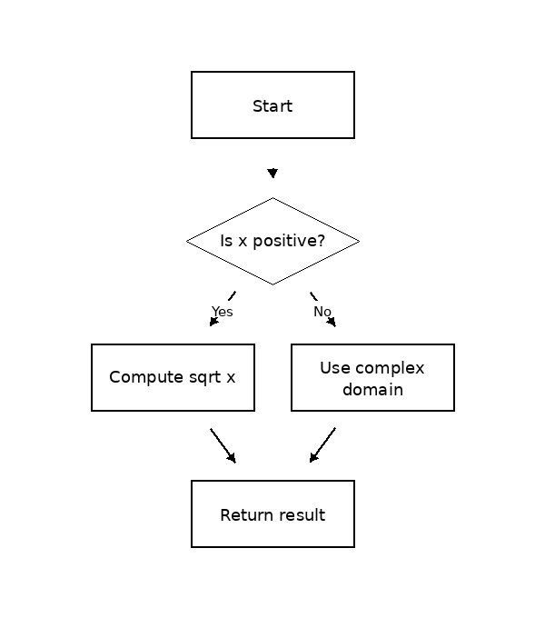

13.2 Mermaid graph
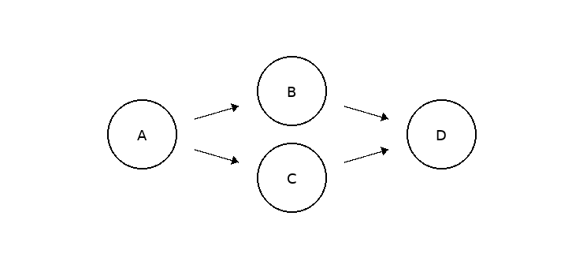

13.3 Mermaid sequence diagram
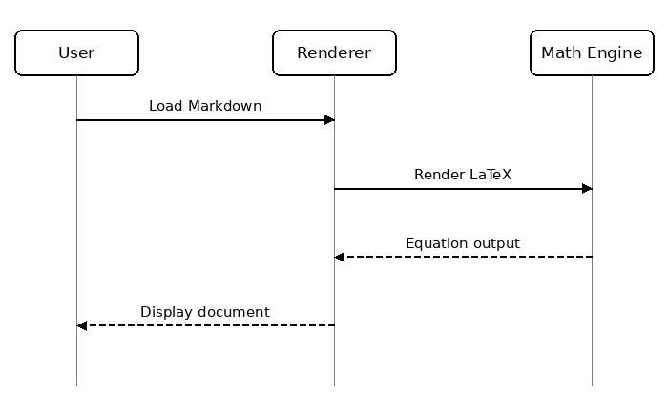

13.4 Function plot specification
Some Markdown renderers support function-plot extensions; others do not. This fenced block is intentionally included as a parser test.
y = sin(x)
y = cos(x)
y = x^2 / 10
domain = [-10, 10]

13.5 ASCII graph
y
^
4| * *
3| * * *
2| * *
1| *
0+--------------------> x
0 1 2 3 4 5

14. Code Blocks

Python
import numpy as np
import matplotlib.pyplot as plt
x = np.linspace(-2*np.pi, 2*np.pi, 1000)
y = np.sin(x) * np.exp(-0.1 * x**2)
plt.plot(x, y)
plt.xlabel("x")
plt.ylabel("f(x)")
plt.title("Damped sine function")
plt.grid(True)
plt.show()

JavaScript
const square = (x) => x ** 2;
for (let x = -3; x <= 3; x++) {
console.log(x, square(x));
}

JSON
{
"name": "markdown-stress-test",
"math": true,
"tables": true,
"mermaid": true,
"version": 1
}

15. Advanced Derivation: Fourier Transform of a Gaussian
Use the convention
$$\hat{f}(k)=\int_{-∞}^{∞}{f}(x)e^{-ikx} dx.$$
For
$$f(x)=e^{-ax^{2}}, a>0,$$
we have
$$\hat{f}(k)=\int_{-∞}^{∞}{e^{-ax^{2}-ikx}} dx.$$
Complete the square:
$$-ax^{2}-ikx=-a{\left(x+\frac{ik}{2a}\right)}^{2}-\frac{k^{2}}{4a}.$$
Therefore,
$$\hat{f}(k)=e^{-k^{2}/(4a)}\int_{-∞}^{∞}{e^{-a{(x+ik/(2a))}^{2}}} dx.$$
Under the standard contour-shift argument,
$$\boxed{\hat{f}(k)=\sqrt{\frac{π}{a}}e^{-k^{2}/(4a)}}.$$

16. Tensor / Indexed Notation
Einstein summation:
$$v_{i}=A_{ij}x_{j}.$$
Levi-Civita symbol:
$${(a×b)}_{i}=ε_{ijk}a_{j}b_{k}.$$
Metric contraction:
$$ds^{2}=g_{μν}dx^{μ}dx^{ν}.$$

17. Physics-Style Equations
Schrödinger equation:
$$iℏ\frac{∂}{∂t}Ψ(r,t)=\hat{H}Ψ(r,t).$$
Maxwell equations:
$$∇·E=\frac{ρ}{ε_{0}},$$
$$∇·B=0,$$
$$∇×E=-\frac{∂B}{∂t},$$
$$∇×B=μ_{0}J+μ_{0}ε_{0}\frac{∂E}{∂t}.$$

18. Footnotes
A Markdown footnote may look like this.
Another reference can point to a longer note.

19. Escaping and Special Characters
Literal Markdown characters:
*asterisks*, _underscores_, # hash, [brackets], and `backticks`.
HTML entities:
© & < > ---

20. Final Stress Equation
$$\boxed{\int_{∂Ω}{\left(∇u·n\right)} dS=\int_{Ω}{∇^{2}}u dV}$$
and a deliberately dense expression:
$$Z(β)=Tr\left(e^{-β\hat{H}}\right)=\sum_{n=0}^{∞}{e^{-βE_{n}}}, F=-\frac{1}{β}lnZ.$$

End of Test
If your Markdown engine successfully renders most of this document, it supports a broad set of Markdown, LaTeX/MathJax/KaTeX, fenced-code, table, and diagram features.

This is a basic footnote used to test footnote rendering.
Mathematical notation in footnotes may be renderer-dependent: $e^{iπ}+1=0$.

