Advanced Penetration Testing Engineer- Hands On
CYBERSECURITY PROJECT
ON
Vulnerability Assessment & Penetration Testing
Batch 14 | Instructor: Rashadul Islam

Student Name | Tasinur Rahman
Student ID | 2024000000313
Date | 17.8.2026
Instructor | Rashadul Islam
Lab Setup | Kali Linux + Metasploitable 2 on Host-Only Network
VA Tool | Nessus Essentials (free) – running on Kali Linux
Date of Submission
Time Allowed | 3 Days

GENERAL INSTRUCTIONS
- Read all tasks before starting. Do NOT skip ahead — tasks build on each other.
- Both VMs (Kali and Metasploitable 2) must be on the same Host-Only network/NAT Network.
- Take a screenshot of every key result. Screenshots are required for marks.
- Label screenshots clearly: e.g., va1_nessus_scan_complete.png
- Answers must be your own work. Do not share results with other students.

LAB SETUP (Complete Before Starting)
1. Metasploitable 2
- Download from: https://sourceforge.net/projects/metasploitable/
- Import into VirtualBox or VMware. Set network adapter to Host-Only.
- Default login — username: msfadmin | password: msfadmin
2. Kali Linux
- Also set to Host-Only adapter on the same virtual network.
- Find the target IP: run sudo netdiscover -r 192.168.x.0/24 on Kali.
3. Nessus Essentials (install on Kali)
- Register free at: https://www.tenable.com/products/nessus/nessus-essentials (you will receive a free activation code by email)
- Download the Kali .deb package from Tenable, then install: sudo dpkg -i Nessus-*.deb
- Start the service: sudo systemctl start nessusd
- Open browser on Kali and go to: https://localhost:8834 — complete the setup wizard with your activation code.
- Allow 10–15 minutes for Nessus to download plugins on first launch.

TARGET IP (fill in here and use throughout): ___________________________________

SECTION A: VULNERABILITY ASSESSMENT (50 marks)
In this section you will use Nessus Essentials to scan Metasploitable 2, analyse the results, and produce a structured VA report. You are identifying weaknesses — not exploiting them yet.

VA Task 1: Configure and Run a Nessus Scan | [20 marks]
What you need to do:
Log into Nessus Essentials, create a new scan targeting your Metasploitable 2 IP, run it, and record your observations.

- In Nessus, create a new Basic Network Scan. Fill in the details below:
Scan Name you gave it | Tasin
Target IP entered | 192.168.118.129
Scan Policy used | Basic Network Scan
Date & time scan started | 2:24 am
Date & time scan completed | 2:45 am
Total scan duration (approx.) | 21 minutes
(Screenshot required: va1_scan_config.png — show the scan settings page before running)
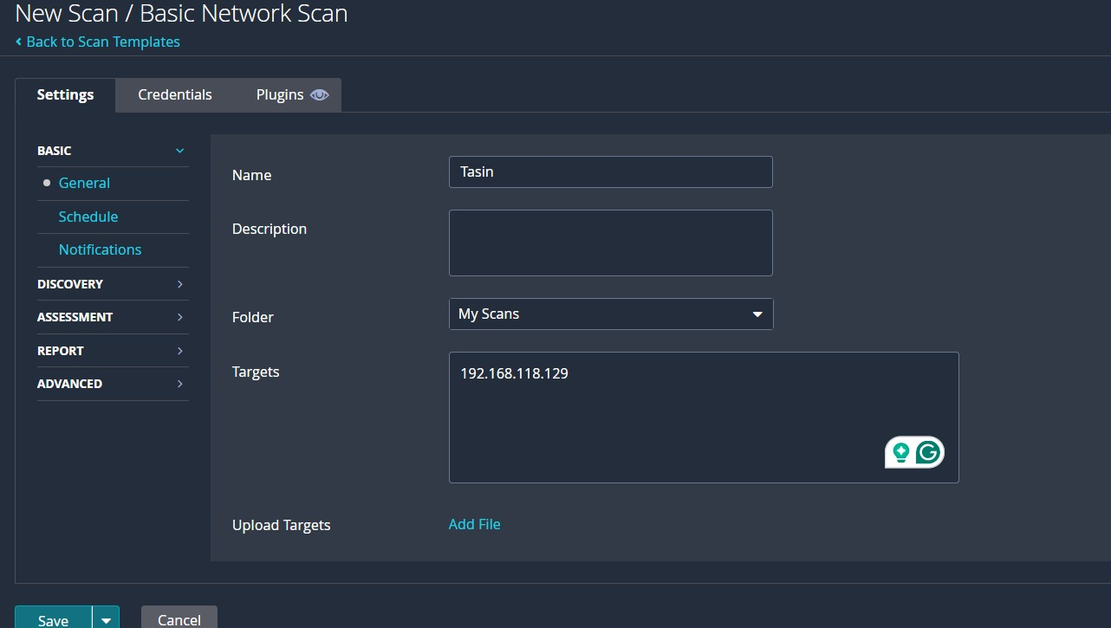
- Once the scan finishes, take a screenshot of the Nessus summary dashboard showing the coloured severity bars (Critical / High / Medium / Low / Info). Fill in the counts below:

Critical | High | Medium | Low | Informational
11 | 7 | 26 | 9 | 138
(Screenshot required: va1_scan_summary.png — the main results dashboard with severity counts)
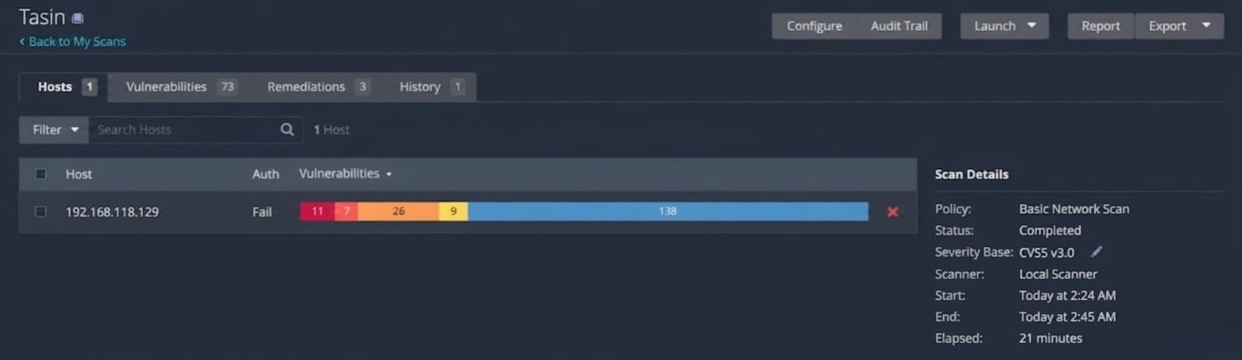
VA Task 2: Analyse Nessus Findings | [30 marks]
What you need to do:
Open the scan results in Nessus. Explore individual findings and record the details for the most important ones.

- From the scan results, identify ONE Critical or High severity vulnerability. Fill in the finding card:

Vulnerability Name | Canonical Ubuntu Linux SEoL (8.04.x)
Severity Level | Critical
CVE Number | no specific CVE number
Affected Port / Service | 80/tcp WWW
What does this vulnerability mean? | The system is running Ubuntu Linux 8.04, which reached its Security End of Life in May 2013. Since the operating system is no longer supported, it does not receive security updates
What could an attacker do with it? | Attackers may exploit unpatched vulnerabilities in the outdated operating system. This can lead to data theft, remote code execution, or full system takeover.
Fix / Recommendation | Upgrade the operating system to a currently supported Ubuntu version and regularly apply security updates.
(Screenshot required: va2_critical_finding.png — the Nessus detail page for this finding)
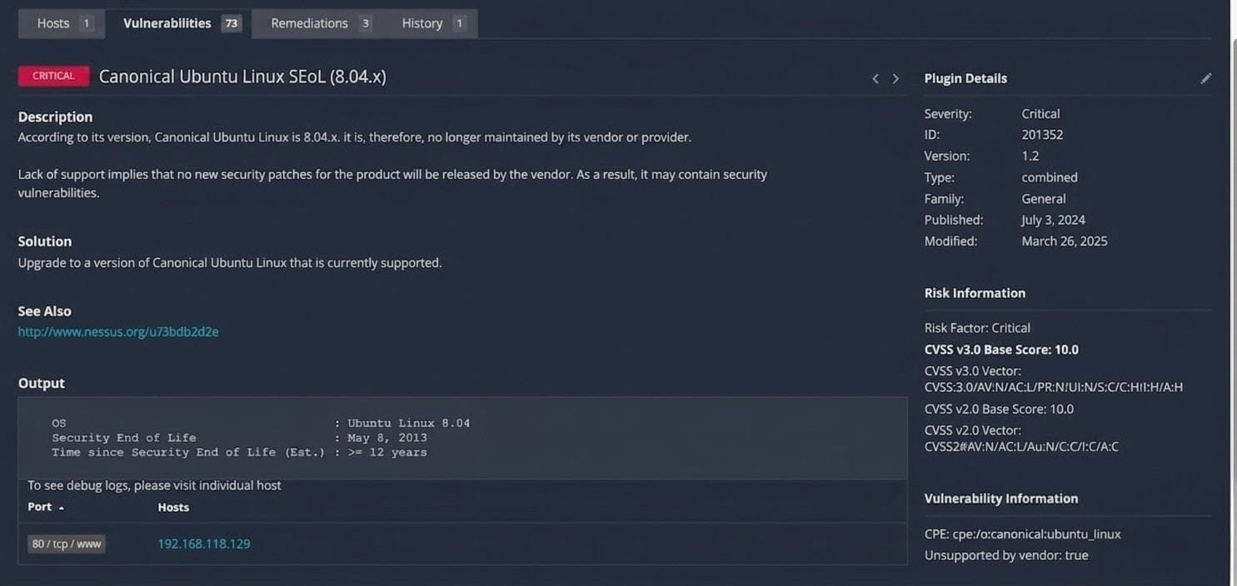
- Find ONE Medium severity vulnerability and fill in a shorter card:

Vulnerability Name | TLS Version 1.0 Protocol Detection
CVE Number | no specific CVE number
Affected Port / Service | 5432/tcp PostgreSQL, 25/tcp SMTP
Brief Explanation | The server supports TLS 1.0, which is an outdated encryption protocol with known cryptographic weaknesses.
Fix / Recommendation | Enable support for TLS 1.2 and 1.3, and disable support for TLS 1.0.
(Screenshot required: va2_medium_finding.png)
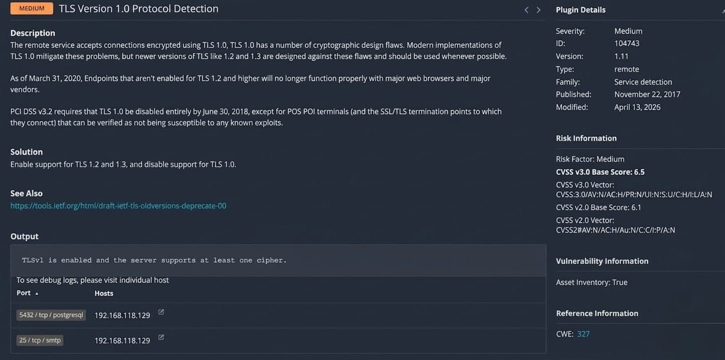
- Look at the full list of open ports and services that Nessus detected. List any SIX below:

Port | Service | Notes / Nessus Comment
21 | FTP | FTP service detected
22 | SSH | Secure shell enabled
23 | Telnet | Insecure remote login
25 | SMTP | Mail service running
80 | HTTP | Apache web server
5432 | PostgerSQL | Database service detected

- In your own words, explain the difference between a Vulnerability Assessment and a Penetration Test. (3–4 sentences)
A Vulnerability Assessment is a process used to find and list security weaknesses in a system or network. It mainly focuses on identifying vulnerabilities but does not actually exploit them. On the other hand, a Penetration Test goes further by trying to exploit those vulnerabilities to see how much damage an attacker could do. In simple words, Vulnerability Assessment finds the problems, while Penetration Testing checks if those problems can really be used to attack the system.

SECTION B: PENETRATION TESTING (50 marks)
Now you will use what you found in Section A and actively exploit a vulnerability on Metasploitable 2 using Metasploit Framework on Kali Linux. You will then document your findings as a short PT report.

PT Task 1: Exploitation with Metasploit | [30 marks]
What you need to do:
Use Metasploit Framework to exploit ONE of the vulnerabilities below. Step-by-step commands are provided as guidance. Follow them, record the outputs, and paste your screenshots.
Choose ONE exploit to attempt:

 | Target Service | Port | Metasploit Module
A | vsftpd 2.3.4 (FTP backdoor) | 21 | exploit/unix/ftp/vsftpd_234_backdoor
B | Samba (SMB) | 445 | exploit/multi/samba/usermap_script

My choice (circle or write A or B): _______

Guided Steps (run these commands in order on Kali):
# | Command to type | What happened / output you saw
1 | msfconsole | Open the Metasploit
2 | search vsftpd (or search samba) | Searching the vsftpd
3 | use exploit/unix/ftp/vsftpd_234_backdoor (or the Samba module) | Set a payload
4 | set RHOSTS <TARGET_IP> | Set the target ip
5 | run | Exploit run
6 | whoami (inside the shell)
Open Metasploit using msfconsole
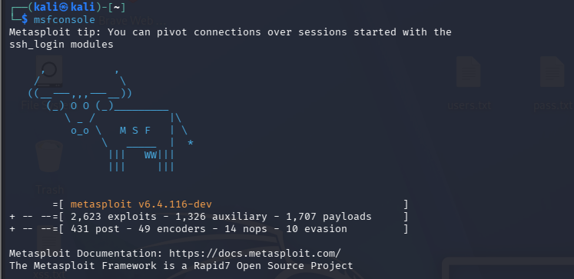
Searching the vsftpd
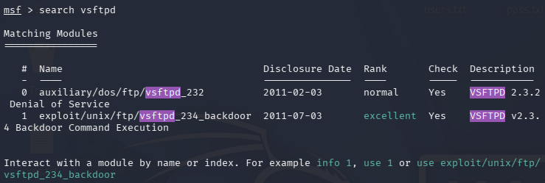
use exploit/unix/ftp/vsftpd_234_backdoor
set RHOSTS,LHOST
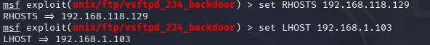
Run
(Screenshot required: pt1_exploit_result.png — show the shell prompt or result after running the exploit)
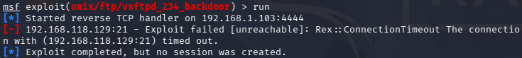
- Did the exploit succeed? Describe what happened in 2–3 sentences:
No, the exploit did not succeed. Metasploit was unable to connect to the target FTP service on port 21 because the connection timed out. As a result, no shell session was created on the target system.

- What user account did the shell give you access as (from the whoami output)? Why does this matter?
There was no shell because the exploit not succeed.

- What TWO simple commands could you run inside the shell to learn more about the target system? Write them below and explain what each one shows:
If I successfully exploit then I use command-
Command 1: uname -a — what it shows: Shows the operating system name, kernel version, and system architecture
Command 2: ifconfig what it shows: Shows network interface information and IP addresses of the target system
Command 3: cat /etc/passwd what it shows: Shows system all user account list

PT Task 2: Write a Short Penetration Test Report | [20 marks]
What you need to do:
Fill in the finding report card below for the exploit you just performed. This is the kind of report a real penetration tester would write for a client.

Finding Title | vsftpd 2.3.4 Backdoor Remote Command Execution
Severity | Critical
Affected Service & Port | FTP / Port 21
CVE Number | CVE-2011-2523
What is the vulnerability? | vsftpd 2.3.4 have a hidden backdoor which was added in the source code in 2011. If someone send a username with ":)" to the FTP server, it can open a root shell on port 6200. Because of this, an attacker can get full access of the system without login.
How was it exploited? | Metasploit Framework was launched on Kali Linux and the module exploit/unix/ftp/vsftpd_234_backdoor was selected. The target IP (192.168.118.129) was set as RHOSTS and the exploit was executed using the run command. The module successfully triggered the backdoor and attempted to open a command shell on the target.
What is the impact? | Attacker get root access using this vulnerability, they can steal, change, or delete important files from the system. They can also use the hacked machine to attack other systems in the network or install malware to keep access for long time.
Evidence | (list the screenshot filenames that prove the exploit worked)
Recommended Fix | The vsftpd service should be updated to a newer safe version or removed if it is not needed. Port 21 should be blocked from outside access using firewall. Regular vulnerability scan should also be done so old and vulnerable services can be found before attackers use them.

- Write a 4–6 sentence Executive Summary of this penetration test — write it for a non-technical manager who needs to understand the risk:
A penetration test was done on the Metasploitable 2 machine (192.168.118.129) from a Kali Linux attacker machine (192.168.1.103). During the test, a critical vulnerability was found in the FTP service running vsftpd 2.3.4. This version have a known backdoor (CVE-2011-2523) which can allow attackers to get access without any password. Using Metasploit Framework, the backdoor was triggered successfully and it gave root access to the target system. With root access, a real attacker can fully control the machine, steal important data, install malware, or attack other systems in the network. The organisation should update or disable the vulnerable FTP service and check all other services for old and insecure software.

MARKS SUMMARY
Task | Description | Max Marks | Marks Given
VA-1 | Configure and Run Nessus Scan | 20
VA-2 | Analyse Nessus Findings & Report | 30
PT-1 | Exploitation with Metasploit | 30
PT-2 | Short PT Report | 20
 | TOTAL | 100

Instructor Signature: ____________________________

SCREENSHOT SUBMISSION CHECKLIST
Attach all screenshots in a folder named: StudentID_Screenshots

Screenshot File | Required For | Included?
va1_scan_config.png | VA Task 1, Q1
va1_scan_summary.png | VA Task 1, Q2
va2_critical_finding.png | VA Task 2, Q1
va2_medium_finding.png | VA Task 2, Q2
pt1_exploit_result.png | PT Task 1
pt1_post_commands.png | PT Task 1, Q3

— END OF PROJECT QUESTION PAPER —

