Software Architecture and Design Specification
Project: Task Manager Application
Version: 1.0
Authors: Team #4 (Section C) — Chetana V Iyer (PES1UG24CS130), Dhadhal Rudra (PES1UG24CS146), Gagan B Sasalatti (PES1UG24CS164), Harsh Pandya (PES1UG24CS182)
Date: 07-10-2026
Status: Baseline Approved

Revision History
1.0 | 02-10-2026 | Team 4 Core Authors | Initial architectural baseline and component decomposition
1.1 | 07-10-2026 | Team 4 Core Authors | Integrated STRIDE threat model, sequence diagrams, and REST interface specifications

Approvals
Lead Software Architect | Chetana V Iyer (PES1UG24CS130) | Approved (07-10-2026)
Data & Storage Architect | Dhadhal Rudra (PES1UG24CS146) | Approved (07-10-2026)
Workflow & UI Architect | Gagan B Sasalatti (PES1UG24CS164) | Approved (07-10-2026)
Quality & Systems Lead | Harsh Pandya (PES1UG24CS182) | Approved (07-10-2026)
Faculty Evaluator | Department of CSE, PES University | Pending Academic Sign-Off

1. Introduction
1.1 Purpose
This document specifies the software architecture, design patterns, and interface models for Version 1.0 of the Task Manager Application. It establishes the technical blueprint guiding development teams, QA engineers, and faculty evaluators during sprint cycles.
1.2 Scope
Covers end-to-end task manager services: multi-tenant workspace isolation, role-based access control, task lifecycle CRUD with atomic cascading, subtask progress calculation, secure 10 MB file attachments, drag-and-drop Kanban workflow, sub-100ms full-text search, progress analytics, and immutable audit logs.
1.3 Audience
Developers, QA test engineers, security auditors, course instructors, and academic evaluators.
1.4 Definitions
JWT (JSON Web Token), RBAC (Role-Based Access Control), ADR (Architectural Decision Record), STRIDE (Threat Modeling), TLS 1.3, RTM, CRUD.

2. Document Overview
2.1 How to use this document
Provides architectural deliverables including tripartite UML component diagrams, ADRs, STRIDE threat models, sequence diagrams, and REST API design specifications.
2.2 Related Documents
Task Manager Application SRS v1.0, Task Manager Software Test Plan v1.0, Requirement Traceability Matrix (RTM).

3. Architecture
3.1 Goals & Constraints
Goals: secure multi-tenant isolation, 99.5% uptime availability, sub-200ms standard API response latency, sub-100ms search indexing, support for 50 concurrent active users per workspace. Constraints: strict RESTful architecture, stateless JWT session authentication, 10 MB individual file upload cap, WCAG 2.1 AA UI accessibility.
3.2 Stakeholders & Concerns
Workspace Admins: security, governance, billing, member role access control, audit accountability.
Project Contributors: responsive Kanban board, intuitive subtask checklists, fast search.
Guests / Viewers: read-only transparency without mutation rights.
Course Evaluators: modularity, architectural compliance, requirement traceability.

3.3 Component (UML) Diagram

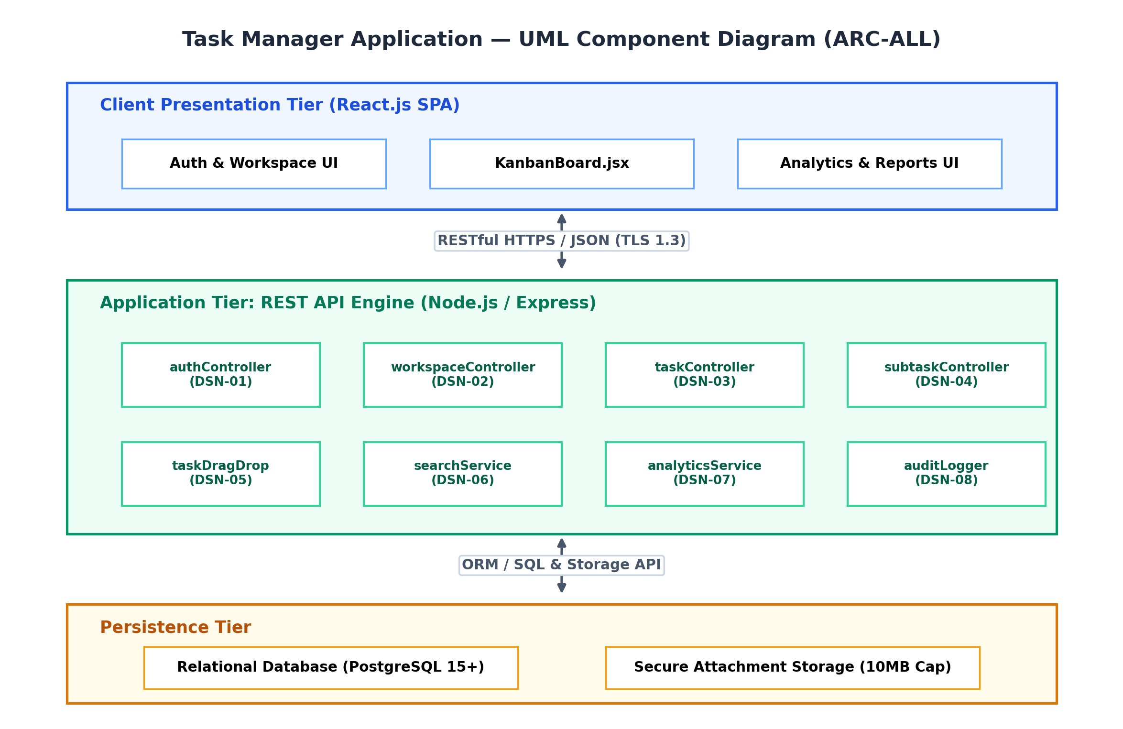
Figure 3.1: Task Manager UML Component Diagram (ARC-ALL)

3.4 Component Descriptions
- React SPA UI (KanbanBoard.jsx, Workspace Dashboard): responsive presentation tier with optimistic UI state sync.
- Auth Service (authController, authMiddleware): validates bcrypt salted credentials, issues 24h HMAC-SHA256 JWTs, handles 15-min password resets.
- Workspace Manager (workspaceController, rbacService): multi-tenant segregation, email invites, Admin role gatekeeping.
- Task Engine (taskController): CRUD lifecycle, Business Rule 3 future due date enforcement, atomic cascading deletion.
- Subtask & File Service (subtaskController, fileUploadService): checklist reordering, dynamic progress % roll-up, 10MB MIME-validated uploads.
- Kanban Engine (taskDragDrop): 4 workflow columns (To-Do, In-Progress, Review, Done), drag/drop sync, collaborator assignment.
- Search Service (searchService): sub-100ms full-text search indexing, multi-attribute filters, colored tags & sorting.
- Analytics & Report Engine (analyticsService, reportExporter): KPI calculations, sprint velocity, RFC 4180 CSV progress export.
- Notification & Audit Service (notifController, auditLogger): in-app notifications, 24h deadline alerts, append-only immutable audit trail.
- Database Store: normalized relational schema with atomic transactional guarantees and file storage.

3.5 Chosen Architecture Pattern and Rationale
A Layered Client-Server Architecture communicating over stateless RESTful HTTPS APIs was chosen. This pattern enforces clean separation of concerns (presentation, business controllers, services, and persistence), guarantees high unit testability with 100% coverage, and avoids the distributed latency overhead of premature microservices.

3.6 Technology Stack & Data Stores
Node.js v18 LTS runtime, Express.js REST API gateway, React.js 18 SPA, PostgreSQL 15+ relational database, Redis 7.0+ for session caching and rate-limiting, TLS 1.3 encryption with AES-256-GCM.

3.7 Risks & Mitigations
Risk: Cascading data loss on task deletion -> Mitigation: Transactional atomic cascade sweeps in database layer (REQ-3.3).
Risk: Oversized attachment denial of service -> Mitigation: Gateway byte-length filter strictly enforces 10 MB limit with HTTP 413 (REQ-4.3).
Risk: Privilege escalation by non-admins -> Mitigation: Centralized RBAC middleware restricting destructive mutations to Admins (REQ-2.3).
Risk: Stale Kanban board during concurrent edits -> Mitigation: Optimistic UI feedback backed by server-side transition validation.

3.8 Traceability to Requirements
REQ-1.1 to REQ-1.3 (Auth & RBAC) -> authController & authMiddleware (DSN-01)
REQ-2.1 to REQ-2.3 (Workspaces) -> workspaceController & rbacService (DSN-02)
REQ-3.1 to REQ-3.3 (Task CRUD) -> taskController (DSN-03)
REQ-4.1 to REQ-4.3 (Subtasks & Files) -> subtaskController & fileUploadService (DSN-04)
REQ-5.1 to REQ-5.3 (Kanban & Assignment) -> taskDragDrop & KanbanBoard.jsx (DSN-05)
REQ-6.1 to REQ-6.3 (Search & Filtering) -> searchService (DSN-06)
REQ-7.1 to REQ-7.3 (Analytics & Reports) -> analyticsService & reportExporter (DSN-07)
REQ-8.1 to REQ-8.3 (Notifications & Audit) -> notifController & auditLogger (DSN-08)

3.9 Security Architecture
Threat Modeling (STRIDE):
- Spoofing -> HMAC-SHA256 signed JWT tokens verified on private routes; salted bcrypt hashes (work factor >= 10).
- Tampering -> RBAC middleware gatekeeping destructive actions strictly to Admins; token-signed download links; immutable audit log.
- Repudiation -> Append-only audit logger recording actor_id, timestamp, entity target, and modification metadata.
- Information Disclosure -> Mandatory TLS 1.3 encryption with HSTS headers; password hash redaction; token authorization.
- Denial of Service -> 10 MB strict file size boundary (HTTP 413); sub-100ms indexed search queries; request rate limiting.
- Elevation of Privilege -> RBAC middleware enforcing Admin, Member, and Viewer permissions at the controller layer.

4. Design

4.1 Design Overview
The Task Manager Application is designed with modular controller and service layers enforcing separation of concerns, transactional consistency, and straightforward maintainability.

4.2 UML Sequence Diagrams
At least 2 sequence diagrams covering 2 flows specific to your project
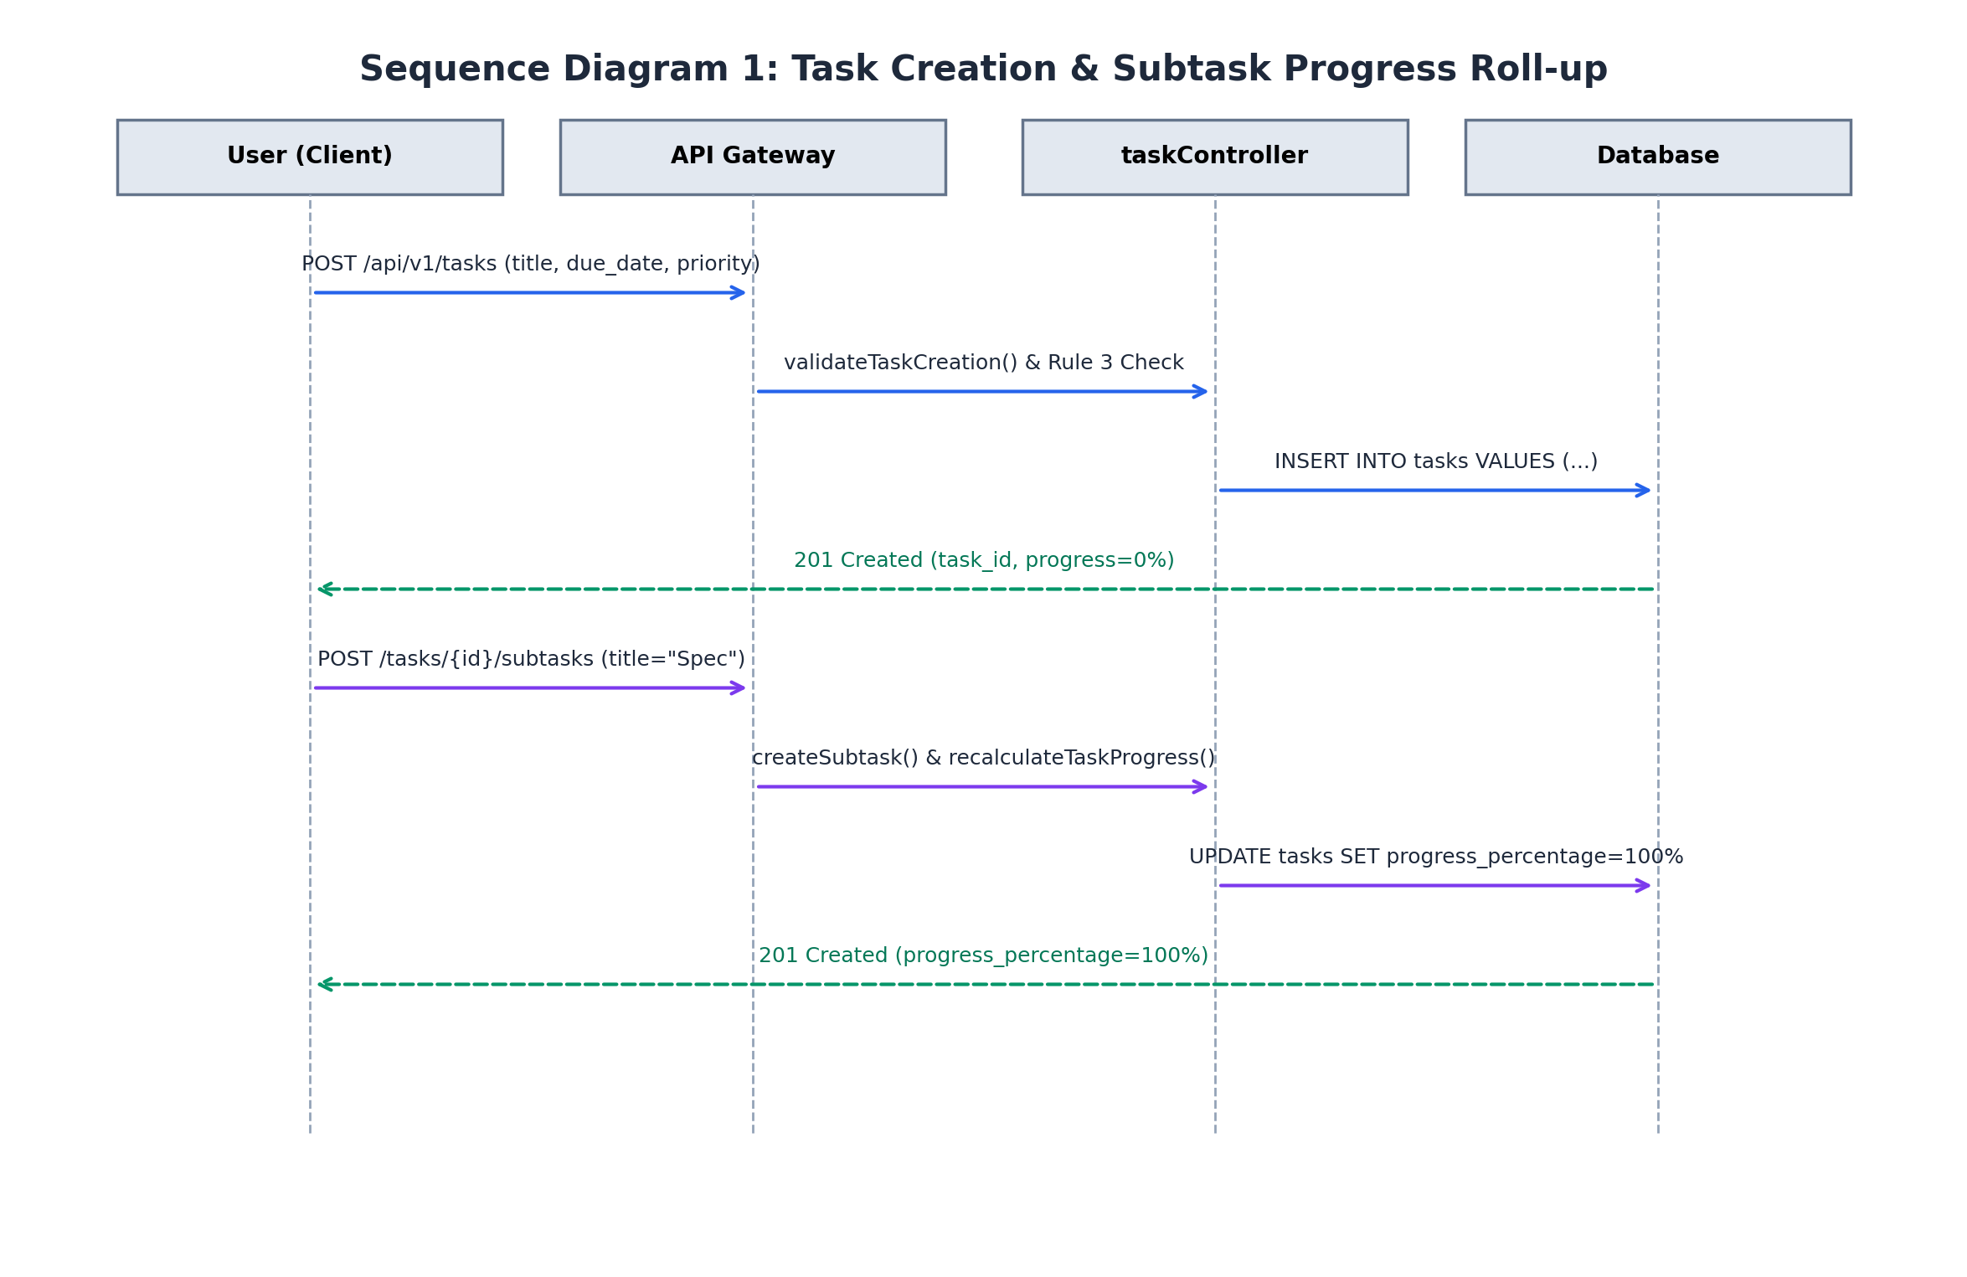
Figure 4.1: Sequence Diagram 1 — Task Creation & Subtask Progress Roll-up
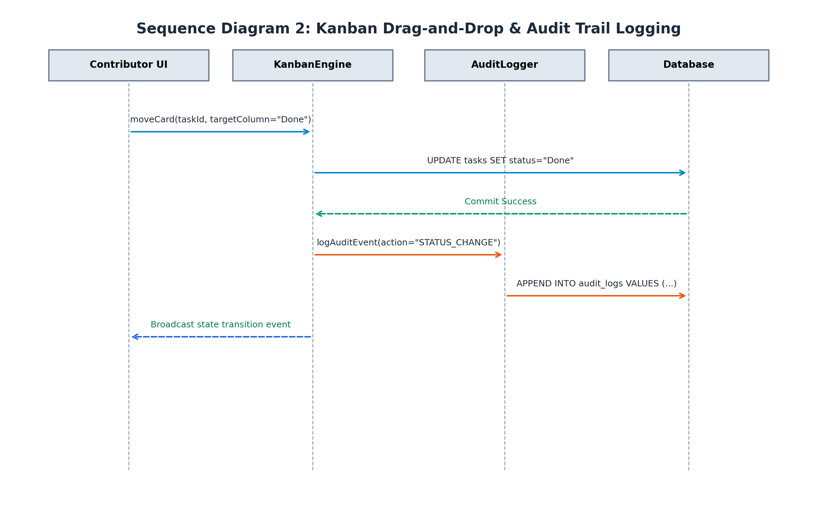
Figure 4.2: Sequence Diagram 2 — Kanban Drag-and-Drop & Audit Logging

4.3 API Design
Interface definition for at least 2 components.
Core Interface Definitions:
1. Task Creation Endpoint:
Endpoint: /api/v1/tasks
Method: POST
Request: {workspace_id, title, priority, due_date, created_by}
Response: {success: true, data: {task_id, title, priority, status: "To-Do", progress_percentage: 0}}
Errors: 400 Bad Request (missing required fields / Business Rule 3 past due date), 401 Unauthorized.
2. Kanban Drag-and-Drop Movement Endpoint:
Endpoint: /api/v1/tasks/:taskId/move
Method: POST
Request: {targetColumn: "Done", actorId: "usr_123"}
Response: {success: true, data: {task_id, previous_status: "In-Progress", new_status: "Done", transitioned: true}}
Errors: 400 Bad Request (invalid column), 404 Not Found.
3. Subtask Creation & Roll-up Endpoint:
Endpoint: /api/v1/tasks/:taskId/subtasks
Method: POST
Request: {title: "Verify API contracts", order_index: 0}
Response: {success: true, data: {subtask: {subtask_id, title}, task_progress_percentage: 100}}
Errors: 400 Validation Error, 404 Parent Task Not Found.
4. File Upload Endpoint:
Endpoint: /api/v1/tasks/:taskId/attachments
Method: POST
Request: {file_name: "architecture.pdf", file_size: 2097152, mime_type: "application/pdf"}
Response: {success: true, data: {attachment_id, secure_download_url: "/api/v1/attachments/download/:token"}}
Errors: 413 Payload Too Large (>10 MB), 415 Unsupported Media Type.

4.4 Error Handling, Logging & Monitoring
RFC 7807 standardized JSON error structures containing error code, message, and validation details. Zero sensitive information or stack traces exposed in client logs. Monitoring tracks API latency (<200ms), 5xx error rates, search execution times (<100ms), and 99.5% service uptime.

4.5 UX Design
Web user interface strictly conforms to WCAG 2.1 AA accessibility guidelines. Features high-contrast priority tags, intuitive drag-and-drop Kanban handles, responsive mobile layout, and zero formal training requirement for basic workflows.

4.6 Open Issues & Next Steps
Version 2.0 roadmap: bidirectional WebSocket synchronization across multiple active browser tabs, OAuth 2.0 / GitHub SSO integration, and AWS S3 direct pre-signed URL attachment storage.

5. Appendices
5.1 Glossary: JWT, RBAC, CRUD, RTM, SRS, SAD, STP, STRIDE, TLS 1.3, WCAG 2.1 AA.
5.2 References: IEEE Std 42010-2011, IEEE Std 830-1998, OWASP Top 10 (2021), NIST SP 800-160.
5.3 Tools: Node.js v18 LTS, Express, React 18, PostgreSQL 15, Redis 7, Git, Matplotlib, VS Code, Postman.

