Software Requirements Specification

Task Manager Application
Version 1.0 approved
Prepared by Team #4:
- Chetana V Iyer (PES1UG24CS130)
- Dhadhal Rudra (PES1UG24CS146)
- Gagan B Sasalatti (PES1UG24CS164)
- Harsh Pandya (PES1UG24CS182)
PES University, Department of Computer Science and Engineering
Software Engineering (UE24CS341A) — Semester 5 | Section C
October 07, 2026
Table of Contents
1. Introduction
1.1 Purpose
1.2 Scope
1.3 Definitions, acronyms, and abbreviations
1.4 References
1.5 Overview
2. Overall description
2.1 Product perspective
2.2 Product functions
2.3 User characteristics
2.4 Constraints
2.5 Assumptions and dependencies
3. Specific requirements
3.1 External Interface
3.2 Functional Requirements
3.3 Non-Functional Requirements
3.4 Design Constraints
Appendixes
Index

Revision History
Name | Date | Reason For Changes | Version
Team 4 Core Authors | 02/10/2026 | Initial baseline specification drafted per IEEE 830-1998 standard | 1.0
Team 4 Core Authors | 07/10/2026 | Updated with UML Use Case Diagram, Security Objectives, and Full RTM | 1.1

Introduction

Purpose
This Software Requirements Specification (SRS) defines the complete software requirements for Version 1.0 of the Task Manager Application. The document details the functional capabilities, external interfaces, data structures, and quality attributes required to guide developers, testers, and academic evaluators during sprint cycles.

Intended Audience
This document is intended for: (a) Course Instructors and Faculty Evaluators for academic milestone assessment; (b) The four Student Developers (Team 4) implementing frontend, backend, and database modules; (c) Quality Assurance and Peer Testers validating test cases against requirements; (d) End users seeking clear expectations of system operations and workflows.

Product Scope
The Task Manager Application is an agile, multi-tenant digital productivity and workspace management platform. It empowers individuals, student cohorts, and professional teams to create shared workspaces, organize complex projects into manageable tasks and subtasks, track progress dynamically through interactive Kanban boards, execute multi-parameter search/filters, and generate insightful productivity reports with automated notifications.

References
1. IEEE Std 830-1998: IEEE Recommended Practice for Software Requirements Specifications.
2. PES University Department of CSE: Software Engineering (UE24CS341A) Mini-Project Guidelines.
3. React.js & Node.js Official Engineering Specifications and Documentation.
4. OWASP Top 10 Application Security Risks (2021 Edition).

Overall Description

Product Perspective
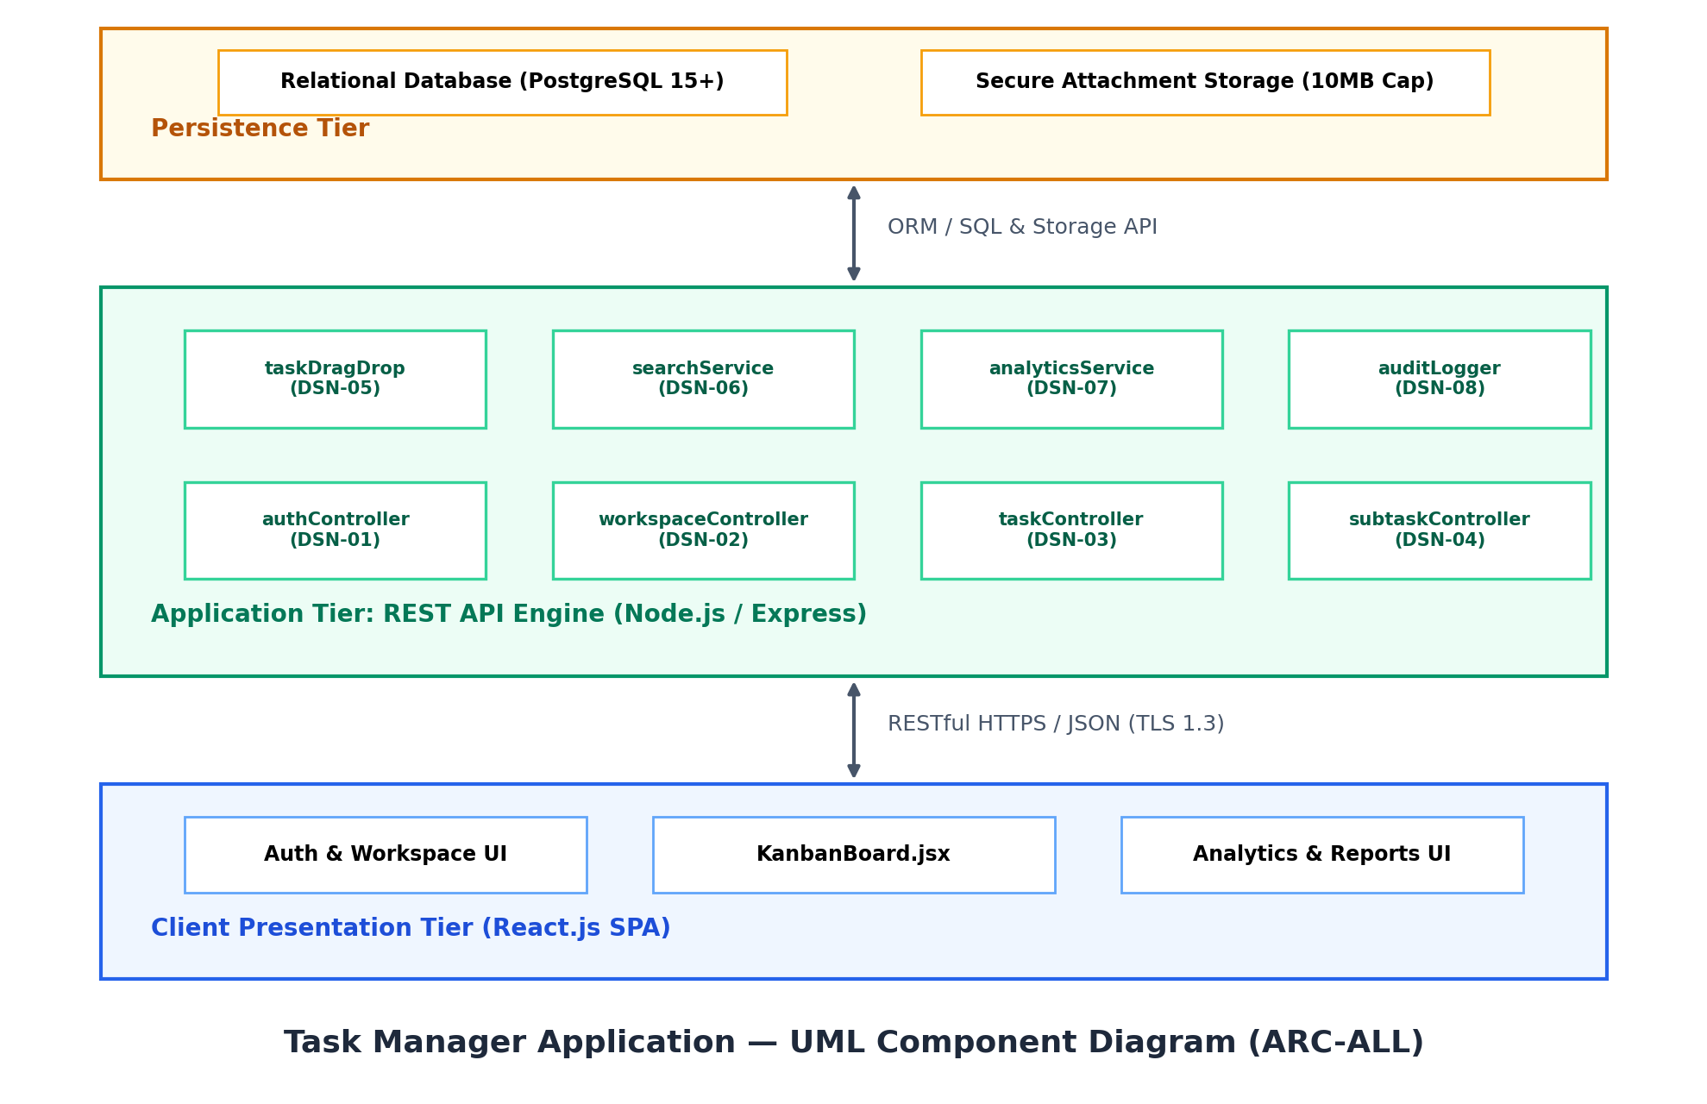
Figure 2.1: Task Manager Application — Overall Subsystem Architecture & External Interfaces
The Task Manager Application is a self-contained, web-based client-server software system. It operates via a modern single-page application (SPA) architecture communicating with a stateless RESTful backend API over HTTPS. Persistent state is maintained in a normalized relational database with integrated secure file storage for task attachments.
The system component architecture, major subsystem interconnections, and external interfaces are illustrated in Figure 2.1 below:

Product Functions
The system delivers eight central functional capabilities:
1. User Authentication & RBAC: Secure registration, salted bcrypt hashing, JWT-based login, password recovery, and role management.
2. Workspace & Team Management: Creation of isolated workspaces, member email invitation, and collaborative access control.
3. Task Lifecycle Management: Full CRUD lifecycle for tasks with priorities, deadlines, and multi-state workflows.
4. Subtasks & Attachment Handling: Granular subtask checklists with progress roll-up and multi-format document uploads.
5. Kanban Workflow & Assignment Engine: Drag-and-drop board state transitions and dynamic collaborator assignment.
6. Search, Filtering & Tagging Engine: Real-time full-text search, composite tag querying, and multi-field sorting.
7. Progress Analytics & Exportable Reports: Visual sprint completion velocity, workload distribution charts, and PDF/CSV export.
8. Notification & Audit Feed: Real-time in-app deadline alerts and immutable activity logs recording workspace mutations.

User Classes and Characteristics
1. Workspace Admin (High Privilege): Creates workspaces, manages team billing and settings, invites/removes members, assigns roles, and inspects immutable audit logs.
2. Project Contributor (Medium Privilege): Creates and updates assigned tasks, marks subtasks complete, uploads file attachments, moves Kanban cards, and views sprint analytics.
3. Guest / Viewer (Low Privilege): Inspects task progress, boards, and analytics without modification rights. Suitable for clients, evaluators, and stakeholders.

Operating Environment
Client-Side: Standard modern web browsers (Google Chrome 110+, Mozilla Firefox 115+, Microsoft Edge 110+, Apple Safari 16+) with JavaScript enabled.
Server-Side: Node.js runtime (v18+ LTS) operating on Linux (Ubuntu 22.04 LTS), macOS, or Windows 10/11.
Database Tier: PostgreSQL 15+ / MySQL 8.0+; Redis 7.0+ for session caching and rate-limiting.

Design and Implementation Constraints
1. RESTful Architectural Conformance: All client-server communications must follow strict REST principles with JSON data payloads.
2. Stateless Authentication: Secure JSON Web Tokens (JWT) signed with HMAC-SHA256 with 24-hour expiration.
3. Attachment Storage Limit: Individual file attachments are capped at 10 MB per file, restricted to standard MIME types (PDF, PNG, JPG, DOCX, ZIP).
4. Academic Deadlines: Software Architecture Document (SAD) and Test Plan due before October 7, 2026.

2.6 Assumptions and Dependencies
1. Continuous network connectivity is assumed between client browsers and the backend application server.
2. External SMTP relay service (e.g., SendGrid, Nodemailer SMTP) is assumed available for password reset and notification emails.

External Interface Requirements

User Interfaces
The web user interface follows a modern, responsive layout adhering to WCAG 2.1 AA accessibility guidelines. Core views include:
(a) Authentication Portal (Login, Registration, Password Reset);
(b) Workspace Dashboard (Overview of workspaces and quick actions);
(c) Interactive Kanban Board (Four visual columns: To-Do, In Progress, In Review, Done with drag-and-drop handles);
(d) Task Details Drawer/Modal (Rich metadata, subtask checkboxes, file upload zone, and comment stream);
(e) Analytics & Reporting View (Velocity graphs, status pie charts, and export action buttons).

Software Interfaces
Database Management System: Connected via ORM/ODM (Prisma / Sequelize for Node.js) handling pooled connections and schema migrations.
Email Dispatch Service: SMTP interface over TLS port 587 using RFC 5322 compliant message bodies.

Communications Interfaces
Transport Protocol: HTTPS (TLS 1.3) utilizing AES-256-GCM encryption.
Real-Time Event Channel: WebSocket (ws:// / wss://) or HTTP Server-Sent Events (SSE) for instantaneous board updates across active team sessions.

Standard hardware input/output interfaces supported by modern workstations, laptops, and tablets (keyboard, mouse, trackpad, touchscreen, display).

Analysis Models
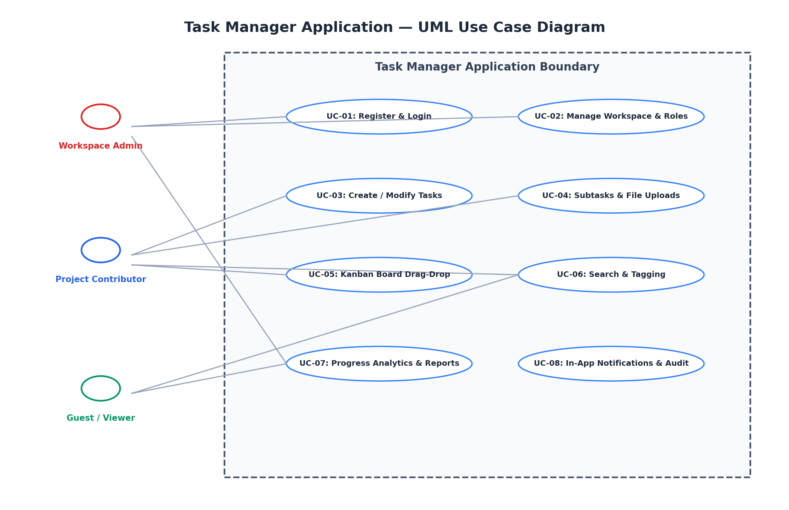
Figure 3.2: Task Manager Application — UML Use Case Analysis Model
The primary system interactions and actor boundaries are formally modeled in the UML Use Case Diagram shown below in Figure 3.2:

System Features
Functional features are partitioned equally among all 4 team members, providing full product ownership over two comprehensive modules per member:

4.1 Feature 1 — User Authentication & Role-Based Access Control (RBAC) [Owner: Chetana V Iyer | PES1UG24CS130]

4.1.1 Description & Priority
Provides secure onboarding, authentication, profile management, and granular permission enforcement. Priority: High.

4.1.2 Stimulus/Response Sequences
User supplies email and credentials -> System validates input constraints, verifies bcrypt hash, and returns an encrypted JWT -> Client stores token and initializes authorized session state.

4.1.3 Functional Requirements

REQ-1.1 (Account Registration): The system shall allow new users to register with full name, valid email, and password satisfying complexity rules (min 8 chars, 1 uppercase, 1 digit, 1 special char).
REQ-1.2 (Secure Authentication): The system shall authenticate users against salted bcrypt password hashes and issue a signed JWT upon successful credential validation.
REQ-1.3 (Password Recovery): The system shall provide an automated password reset flow generating a cryptographically secure, time-limited token (expiry 15 mins) transmitted via email.

4.2 Feature 2 — Workspace & Team Collaboration Management [Owner: Chetana V Iyer | PES1UG24CS130]
Description & Priority: Enables multi-tenant team segregation, role configuration (Admin, Member, Viewer), and member invitations. Priority: High.
Stimulus/Response Sequence: Admin inputs workspace details -> System creates workspace partition -> Admin issues email invitation -> Invitee accepts link and gains corresponding workspace permissions.
- REQ-2.1 (Workspace Creation): The system shall allow authenticated users to instantiate distinct workspaces with custom titles and team descriptions.
- REQ-2.2 (Member Invitation & Roles): The system shall allow Workspace Admins to invite users via email and assign explicit roles (Admin, Member, Viewer).
- REQ-2.3 (Access Enforcement): The system shall restrict destructive workspace mutations (settings update, deletion, member revocation) strictly to users holding the Admin role.
4.3 Feature 3 — Task Lifecycle & Core CRUD Operations [Owner: Dhadhal Rudra | PES1UG24CS146]
Description & Priority: Core entity creation, editing, scheduling, and deletion operations for project tasks. Priority: High.
Stimulus/Response Sequence: User clicks 'New Task', provides title, due date, priority -> System validates required fields and commits task record -> Task appears in workspace views.
- REQ-3.1 (Task Creation & Validation): The system shall enable authorized members to create tasks specifying title, detailed description, due date, and priority level (Low, Medium, High).
- REQ-3.2 (Task Modification): The system shall allow task authors and assignees to edit all task parameters, dynamically recording modification timestamps.
- REQ-3.3 (Task Archiving & Deletion): The system shall support soft-deletion (archiving) and permanent deletion of tasks, cascading updates to child subtasks atomically.
4.4 Feature 4 — Subtasks, Checklists & Attachment Handling [Owner: Dhadhal Rudra | PES1UG24CS146]
Description & Priority: Hierarchical decomposition of complex tasks into checklists and multi-format file attachment uploads. Priority: Medium.
Stimulus/Response Sequence: User adds subtask item to task modal -> System appends checklist element -> Toggling checkbox triggers automatic parent task completion percentage calculation.
- REQ-4.1 (Nested Subtask Management): The system shall allow users to add, reorder, check/uncheck, and delete nested subtask checklist items under any task.
- REQ-4.2 (Progress Percentage Calculation): The system shall automatically compute and display task completion percentage (Progress = Completed Subtasks / Total Subtasks * 100%).
- REQ-4.3 (Secure File Attachments): The system shall accept file uploads up to 10 MB per file, validating MIME types and providing secure download links.
4.5 Feature 5 — Task Assignment & Kanban Workflow Engine [Owner: Gagan B Sasalatti | PES1UG24CS164]
Description & Priority: Visual task lifecycle board facilitating drag-and-drop column transitions and collaborator assignments. Priority: High.
Stimulus/Response Sequence: Contributor drags task card from 'In Progress' to 'Done' -> System updates task status in database -> Real-time event broadcasts state change to other active viewers.
- REQ-5.1 (Collaborator Assignment): The system shall allow tasks to be assigned to one or more workspace members with visual avatar indicators.
- REQ-5.2 (Interactive Kanban Board): The system shall render tasks in four primary workflow columns: To-Do, In Progress, In Review, and Done.
- REQ-5.3 (Drag-and-Drop State Sync): The system shall support smooth drag-and-drop card movements between columns, updating backend state with optimistic UI feedback.
4.6 Feature 6 — Multi-Criteria Search, Filtering & Tagging Engine [Owner: Gagan B Sasalatti | PES1UG24CS164]
Description & Priority: High-speed search across task parameters with multi-attribute filtering and custom categorical tagging. Priority: Medium.
Stimulus/Response Sequence: User enters search keyword and selects 'High Priority' filter -> System queries indexed database -> Matching task cards are filtered within 100 ms.
- REQ-6.1 (Full-Text Search): The system shall provide instantaneous keyword search querying task titles, descriptions, and tag labels.
- REQ-6.2 (Multi-Attribute Filtering): The system shall allow simultaneous multi-criteria filtering by priority, status, assignee, and due date range.
- REQ-6.3 (Custom Tagging & Sorting): The system shall allow users to create colored tags and sort task lists by due date (ascending/descending) or priority level.
4.7 Feature 7 — Progress Analytics, Metrics & Exportable Reports [Owner: Harsh Pandya | PES1UG24CS182]
Description & Priority: Visual dashboard charts, team productivity KPIs, velocity metrics, and formal document exports. Priority: Medium.
Stimulus/Response Sequence: Admin navigates to Analytics tab -> System aggregates completion metrics over selected sprint date window -> Visual charts and CSV/PDF export options render.
- REQ-7.1 (KPI Dashboard): The system shall display aggregated metrics: Total Tasks, Completed Tasks, Overdue Tasks, and Team Velocity.
- REQ-7.2 (Visual Charting): The system shall render dynamic status distribution charts and member workload allocation bar graphs.
- REQ-7.3 (Report Export Engine): The system shall enable downloading structured progress summaries in CSV and PDF formats containing complete task execution metadata.
4.8 Feature 8 — Notification & Activity Audit Feed [Owner: Harsh Pandya | PES1UG24CS182]
Description & Priority: Proactive deadline reminders, task assignment notices, and an immutable workspace activity audit log. Priority: Medium.
Stimulus/Response Sequence: Task due date is within 24 hours -> Automated cron job triggers -> In-app notification badge increments and email alert is dispatched.
- REQ-8.1 (In-App Notification Center): The system shall notify users immediately upon task assignment, comment mention, or status change with read/unread tracking.
- REQ-8.2 (Automated Deadline Alerts): The system shall run scheduled background checks to dispatch email notifications for tasks approaching deadlines within 24 hours.
- REQ-8.3 (Immutable Activity Audit Log): The system shall maintain an append-only timeline documenting all workspace events (actor, action, target entity, timestamp).

Other Nonfunctional Requirements

Performance Requirements
• REQ-NFR-1 (Response Latency): 95% of standard API requests (task CRUD, status update, search) shall return responses within 200 ms under normal network conditions.
• REQ-NFR-2 (Concurrency Support): The system architecture shall support at least 50 concurrent active users per workspace without degradation in rendering performance.

Safety Requirements
• REQ-NFR-3 (Data Loss Prevention): The backend database shall perform automated daily snapshot backups. Critical task deletion actions shall require explicit user confirmation dialogs.

Security Requirements
5.3.1 Security Objectives:
1. Authentication Integrity: Ensure all user credentials, tokens, and passwords are protected against tampering, brute-forcing, and unauthorized session hijacking.
2. Multi-Tenant Data Segregation: Guarantee strict tenant data isolation, preventing cross-workspace entity leaks or unauthorized modifications.
5.3.2 Concrete Security Requirements:
• REQ-SEC-1 (Credential Protection): Passwords shall be hashed using bcrypt with a work factor of at least 10 before persistence.
• REQ-SEC-2 (Data in Transit): All network communication shall be forced over TLS 1.3 (HTTPS) with HSTS headers enabled.
• REQ-SEC-3 (Injection & Vulnerability Mitigation): API endpoints shall sanitize inputs against SQL/NoSQL injection and Cross-Site Scripting (XSS); JWT tokens shall be validated on every private route.
• REQ-SEC-4 (Attachment Security): Uploaded files are capped at 10 MB per file, restricted to approved MIME types (PDF, PNG, JPG, DOCX, ZIP), and served via cryptographically signed tokens.

Software Quality Attributes
• Availability: System shall target 99.5% uptime during evaluation and sprint cycles.
• Maintainability: Codebase shall follow modular architecture with comprehensive unit test coverage and clear documentation.
• Usability: The UI shall be intuitive, requiring zero formal training for users to create and track tasks.

Business Rules
• Rule 1: A user cannot be assigned to a task in a workspace they are not currently a member of.
• Rule 2: Deletion of a workspace automatically soft-deletes all associated tasks, subtasks, and files.
• Rule 3: A task cannot have a due date in the past upon initial creation.

Other Requirements
All date fields conform to ISO 8601 (YYYY-MM-DD). Database character encoding is strictly UTF-8 to support international multilingual task titles and descriptions.
Appendix A: Glossary
• SRS: Software Requirements Specification (IEEE 830-1998 standard)
• JWT: JSON Web Token for compact, URL-safe claim representations
• RBAC: Role-Based Access Control restricting system access based on assigned user roles
• Kanban: Agile visual workflow framework managing work items in staged columns
• CRUD: Create, Read, Update, Delete storage functions
• RTM: Requirement Traceability Matrix linking requirements to design, code, and test cases

Appendix B: Field Layouts
The data dictionary defines field constraints, lengths, data types, and nullability across database entities:
Table B.1: Tasks Entity Field Layout
Field | Length | Data Type | Description | Is Mandatory
task_id | 36 | UUID | Unique primary key identifier | Y
workspace_id | 36 | Foreign key referencing workspace |  | Y
title | 150 | Varchar | Summary title of the task | Y
description | 2000 | Text | Full markdown description of task | N
priority | 10 | Enum | Low, Medium, or High | Y
status | 20 | Enum | To-Do, In-Progress, Review, Done | Y
due_date | 8 | Date | Target completion deadline | N
created_by | 36 | UUID | Foreign key of authoring user | Y
Table B.2: Sample Report Requirements (Progress & Velocity Reports)
Sprint Task Progress Report | Member Workload & Velocity Report
Workspace ID | Workspace ID
Workspace Title | Team Member Name
Task ID | Member User ID
Task Title | Assigned Tasks Count
Priority Level | Completed Tasks Count
Current Kanban Status | In-Progress Tasks Count
Completion Progress % | Team Velocity (Tasks / Week)
Target Due Date | Sprint Overdue Count
Author User ID | Average Completion Time
Assignee Avatar Count | Sprint Window (Days)
Attachment Files Count | Report Generation Timestamp

Appendix C: Requirement Traceability Matrix
Sl. No | Requirement ID | Brief Description of Requirement | Architecture Reference | Design Reference | Code File Reference | Test Case ID | System Test Case ID
1 | REQ-1.1 | Account Registration | ARC-AUTH | DSN-01 | authController.js | UT-AUTH-01 | ST-AUTH-01
2 | REQ-1.2 | JWT Authentication | ARC-AUTH | DSN-01 | authMiddleware.js | UT-AUTH-02 | ST-AUTH-02
3 | REQ-1.3 | Password Recovery | ARC-AUTH | DSN-01 | authController.js | UT-AUTH-02 | ST-AUTH-02
4 | REQ-2.1 | Workspace Creation | ARC-TEAM | DSN-02 | workspaceController.js | UT-WS-01 | ST-WS-01
5 | REQ-2.2 | Member Roles (RBAC) | ARC-TEAM | DSN-02 | rbacService.js | UT-WS-02 | ST-WS-02
6 | REQ-2.3 | Access Enforcement | ARC-TEAM | DSN-02 | rbacService.js | UT-WS-02 | ST-WS-02
7 | REQ-3.1 | Task CRUD Creation | ARC-TASK | DSN-03 | taskController.js | UT-TASK-01 | ST-TASK-01
8 | REQ-3.2 | Task Modification | ARC-TASK | DSN-03 | taskController.js | UT-TASK-01 | ST-TASK-01
9 | REQ-3.3 | Task Archiving/Delete | ARC-TASK | DSN-03 | taskController.js | UT-TASK-01 | ST-TASK-01
10 | REQ-4.1 | Subtasks Checklist | ARC-TASK | DSN-04 | subtaskController.js | UT-TASK-02 | ST-TASK-02
11 | REQ-4.2 | Progress Calculation | ARC-TASK | DSN-04 | subtaskController.js | UT-TASK-02 | ST-TASK-02
12 | REQ-4.3 | File Uploads (10MB) | ARC-FILE | DSN-04 | fileUploadService.js | UT-FILE-01 | ST-FILE-01
13 | REQ-5.1 | Collaborator Assign | ARC-KANBAN | DSN-05 | taskDragDrop.js | UT-KB-02 | ST-KB-02
14 | REQ-5.2 | Kanban Columns | ARC-KANBAN | DSN-05 | KanbanBoard.jsx | UT-KB-01 | ST-KB-01
15 | REQ-5.3 | Drag-and-Drop Sync | ARC-KANBAN | DSN-05 | taskDragDrop.js | UT-KB-02 | ST-KB-02
16 | REQ-6.1 | Full-Text Search | ARC-QUERY | DSN-06 | searchService.js | UT-SRCH-01 | ST-SRCH-01
17 | REQ-6.2 | Multi-Attribute Filter | ARC-QUERY | DSN-06 | searchService.js | UT-SRCH-01 | ST-SRCH-01
18 | REQ-6.3 | Custom Tags & Sorting | ARC-QUERY | DSN-06 | searchService.js | UT-SRCH-01 | ST-SRCH-01
19 | REQ-7.1 | KPI Dashboard | ARC-RPT | DSN-07 | analyticsService.js | UT-RPT-01 | ST-RPT-01
20 | REQ-7.2 | Visual Distribution | ARC-RPT | DSN-07 | analyticsService.js | UT-RPT-01 | ST-RPT-01
21 | REQ-7.3 | Report Export (CSV) | ARC-RPT | DSN-07 | reportExporter.js | UT-RPT-02 | ST-RPT-02
22 | REQ-8.1 | In-App Notifications | ARC-NOTIF | DSN-08 | notifController.js | UT-NOTIF-01 | ST-NOTIF-01
23 | REQ-8.2 | Deadline Alerts (24h) | ARC-NOTIF | DSN-08 | notifController.js | UT-NOTIF-02 | ST-NOTIF-02
24 | REQ-8.3 | Activity Audit Log | ARC-NOTIF | DSN-08 | auditLogger.js | UT-NOTIF-02 | ST-NOTIF-02

