**Task Masters**

**Group Members: Joe Barrett, Stephen Casselman, Nathan Miller**

**High-Level Design**

**Overview**

The high-level design for the Task Masters task organizer is as follows. The intent is to examine what elements will be needed for completion of the project, broken down by component.

**Architecture**

We are using a three-tier architecture to separate presentation and data layers, as well as to allow for a logic layer to improve administrative corrections and modification if needed, and allow for aggregation of data. This will also allow the team to work on the client level and server level concurrently without affecting eachother.

**Security**

The system will utilize a two-factor authentication for account set-up which will require an email address to verify an account. The email will then be linked to the account and utilized for task reminders (if indicated by the user), as well as for app promotions. Once an account is created, app access will require username and password log-in. Users can elect to not require recurrent log-ins once the app is opened initially.

**Hardware**

The program will run on Android mobile devices. Future releases will target iPhone demographics.

**Data Flow**

Return to List / Home

Save Task

Edit Details

Add Task

Create List

Log In

User

**External**

The system will connect to an external database for retention of task and list records, in addition to user account information.

**User Interface**

The user interface will have an initial splash screen, with additional task views for interaction with the program. Example below:

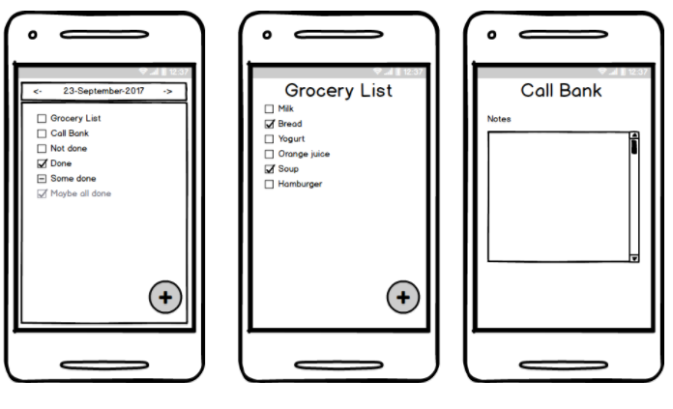

**Other Outputs**

Future iterations could include email and SMS messaging to alert users of reminder events and location based services.

**Reports**

Possible reports to include would be an opportunity for users to export their tasks to a printable report. Additional reports could include client usage information such as activity and storage consumption per user.