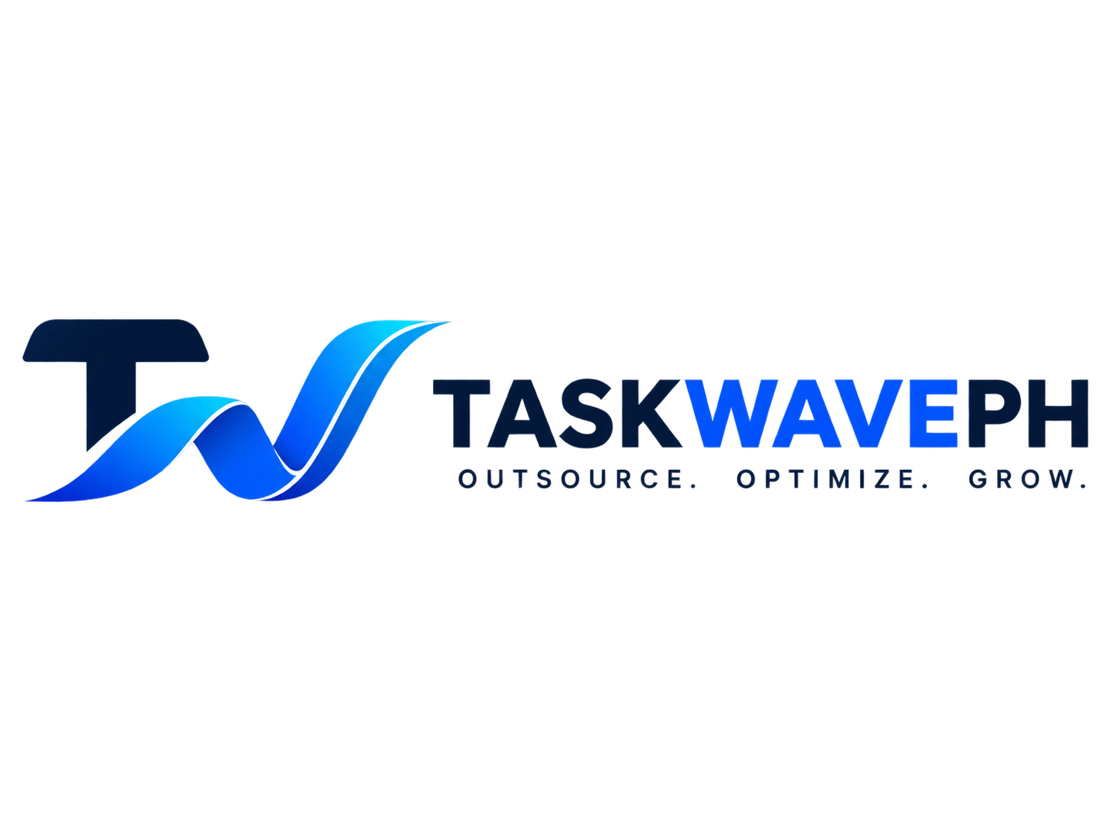 | MERCH PRODUCTION BRIEF  For quotation, sampling & production
TaskWavePH Merch Production Request
Simple production guide para aligned ang materials, print quality, at quotation before tayo mag-final production.
IMPORTANT: Please send actual material/sample photos or 1 physical sample first before mass production. Huwag muna mag-bulk print hangga’t hindi approved ang sample/proof.
1. Merch Items & Production Specs
ITEM | SPECIFICATION / QUALITY | QTY
Merch Box | Corrugated box material. Prefer clean matte finish, navy/black/white branding. Dapat sturdy enough for complete merch set and presentable for gifting/onboarding. Please recommend flute/thickness based on final contents. | TBD
Pen | Black pen, GEL TYPE only (not ballpoint). Smooth writing, clean/premium feel. TaskWavePH logo/wordmark print should be crisp and hindi madaling mabura. | TBD
Hoodie | Navy blue and black. 80% cotton / 20% polyester quality. Soft, medium-heavy feel; hindi manipis. Small TaskWavePH logo + text on front right chest only, unless otherwise shown in approved artwork. | TBD
Dry-Fit Polo | Navy blue and black. Breathable dry-fit fabric, good structure/collar, durable sublimation/print. Follow approved wave design. No unnecessary sleeve logo unless included in final artwork. | TBD
T-Shirt - Cotton | Navy blue and black. Soft, breathable cotton; good for everyday office/event use. Follow approved wave design and logo placement. | TBD
T-Shirt - Dry Fit | Navy blue and black. Lightweight, breathable, moisture-wicking. Follow approved wave design and logo placement. | TBD
Mug | White and black ceramic mug. Clean full-wrap/partial wave design based on approved artwork. Print must be sharp, even, and dishwasher-resistant if possible. | TBD
Notebook | White, navy blue and black cover options. Prefer A5 premium hard cover, elastic band + ribbon bookmark. Print should be clean and durable. | TBD
Tote Bag | White, navy blue and black. Recommended approx. 40 cm W x 35 cm H x 10 cm gusset. Durable canvas with reinforced handles/stitching. Follow approved wave design. | TBD
Sticker Pack | Die-cut vinyl stickers, preferably matte. Crisp edges, water-resistant, strong adhesive. Follow approved sticker sizes/artwork; keep white die-cut border where specified. | TBD
2. Not Included in This Order
Tumbler / Aqua Flask 22oz - please REMOVE from this quotation and production batch. We will place the tumbler as a separate order later.
3. General Quality Instructions
• Colors: please match TaskWavePH brand colors as closely as possible. Send a digital proof and actual material/color sample kapag may noticeable difference sa screen vs actual print.
• Logo & text: dapat sharp, centered/aligned, walang pixelation, stretching, typo, or distorted logo proportions.
• Print durability: use the best recommended process per item (sublimation, screen print, DTF, UV print, etc.) based on material. Please tell us kung ano ang most durable option bago production.
• Apparel stitching: clean seams, walang loose threads, uneven hems, or obvious defects. Please provide size chart before production.
• Packaging: each item should arrive clean and protected. If individually packed, please quote the additional cost separately.
• Approval: send final mockup/proof + actual sample photos before full run. Any changes after approval must be confirmed first.
4. Quotation Request
Please give us a clear price breakdown para alam namin ang cost per item at total cost per complete merch box.
ITEM | QTY | UNIT PRICE | PRINT/SETUP | SUBTOTAL
Merch Box |  | ₱ | ₱ | ₱
Pen |  | ₱ | ₱ | ₱
Hoodie |  | ₱ | ₱ | ₱
Dry-Fit Polo |  | ₱ | ₱ | ₱
T-Shirt - Cotton |  | ₱ | ₱ | ₱
T-Shirt - Dry Fit |  | ₱ | ₱ | ₱
Mug |  | ₱ | ₱ | ₱
Notebook |  | ₱ | ₱ | ₱
Tote Bag |  | ₱ | ₱ | ₱
Sticker Pack |  | ₱ | ₱ | ₱
TOTAL PRICE PER COMPLETE MERCH BOX / SET |  |  |  | ₱
Please also quote the following volume options: 10 sets / 25 sets / 50 sets (or your MOQ), including sample fee, setup fee, printing fee, and delivery if applicable.
5. Please Include in Your Reply
☐ MOQ per item / per complete merch box
☐ Lead time for sample and bulk production
☐ Available sizes and size chart for apparel
☐ Available material options (with photos if possible)
☐ Printing method per item
☐ Payment terms
☐ Delivery fee / pickup option
☐ Replacement policy for defective items

