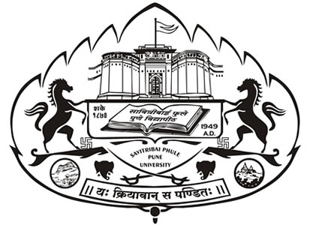

**SAVITRIBAI PHULE PUNE UNIVERSITY**

**(Formerly University of Pune)**

**Circular No. 13 / 2022**

**Dated 13/04/2022**

Under the initiative "Mission Begin Again", phase-wise unlocking process subsequent to the lockdown declared due to COVID-19 Pandemic, has begun in the State of Maharashtra and reopening of universities and colleges is a part of the same. University Departments and colleges/institutions are likely to face a number of issues after reopening. In order to facilitate successful reopening of University Departments and colleges/institutions, and smooth conduct of teaching learning we are compelled to temporarily defer the Offline Classes for the students of External M.com w.e.f. Wednesday, 4th May 2022.

Nevertheless, we expect that you will make the students realise the importance of learning, motivate them and ensure that they attend Offline Classes regularly and sincerely, abiding by all netiquettes. Attendance is mandatory in Offline Classes. The Credit Marks Will be given in learning year.

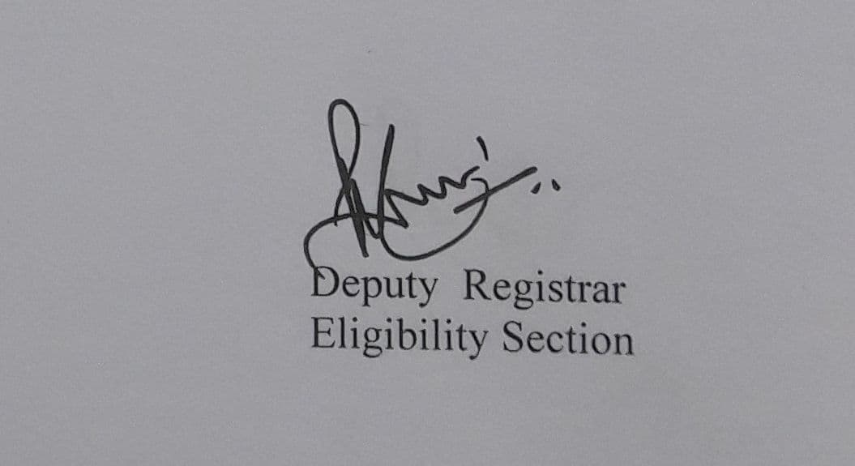Due to Vast Syllabus offline lecture are conducted