## Task 4

1.All variants by product id

[SELECT](http://localhost/phpmyadmin/url.php?url=https://dev.mysql.com/doc/refman/5.5/en/select.html) `product`.`id`as `product_id`, `variant`.`size`,`variant`.`color`,`variant`.`material` FROM `product`INNER JOIN`product_variant` ON `product`.`id`=`product_variant`.`product_id` INNER JOIN`variant` ON `product_variant`.`variant_id`=`variant`.`id`

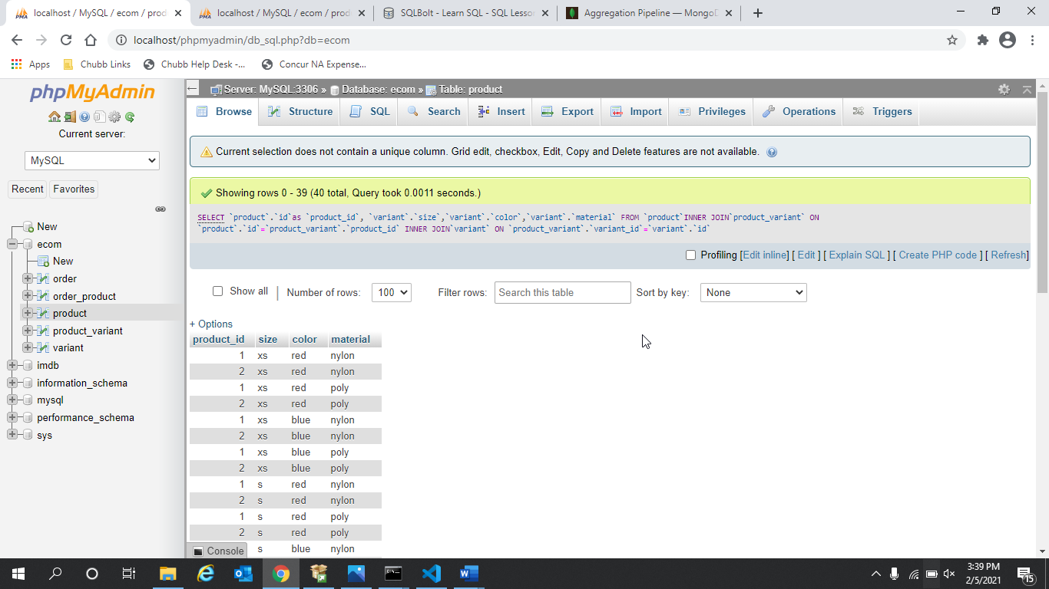

2.Product details by variant id

[SELECT](http://localhost/phpmyadmin/url.php?url=https://dev.mysql.com/doc/refman/5.5/en/select.html) `variant`.`id`as `variant_id`, `product`.* FROM `product`INNER JOIN`product_variant` ON `product`.`id`=`product_variant`.`product_id` INNER JOIN`variant` ON `product_variant`.`variant_id`=`variant`.`id`

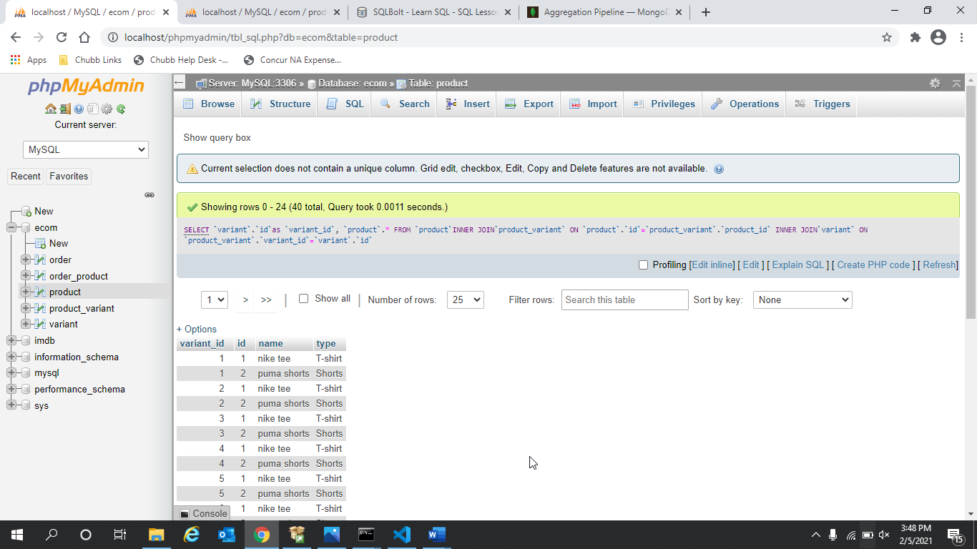

4. media of a variant

[SELECT](http://localhost/phpmyadmin/url.php?url=https://dev.mysql.com/doc/refman/5.5/en/select.html) `variant`.`media` FROM`variant`WHERE `variant`.`id`='1'

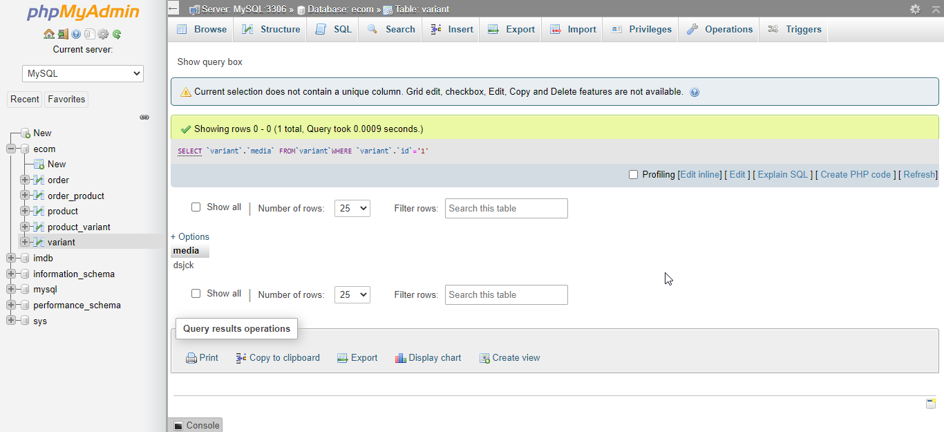

5.Avg rating of a product by id

[SELECT](http://localhost/phpmyadmin/url.php?url=https://dev.mysql.com/doc/refman/5.5/en/select.html) `product`.`id`,`product`.`avg rating` FROM `product`

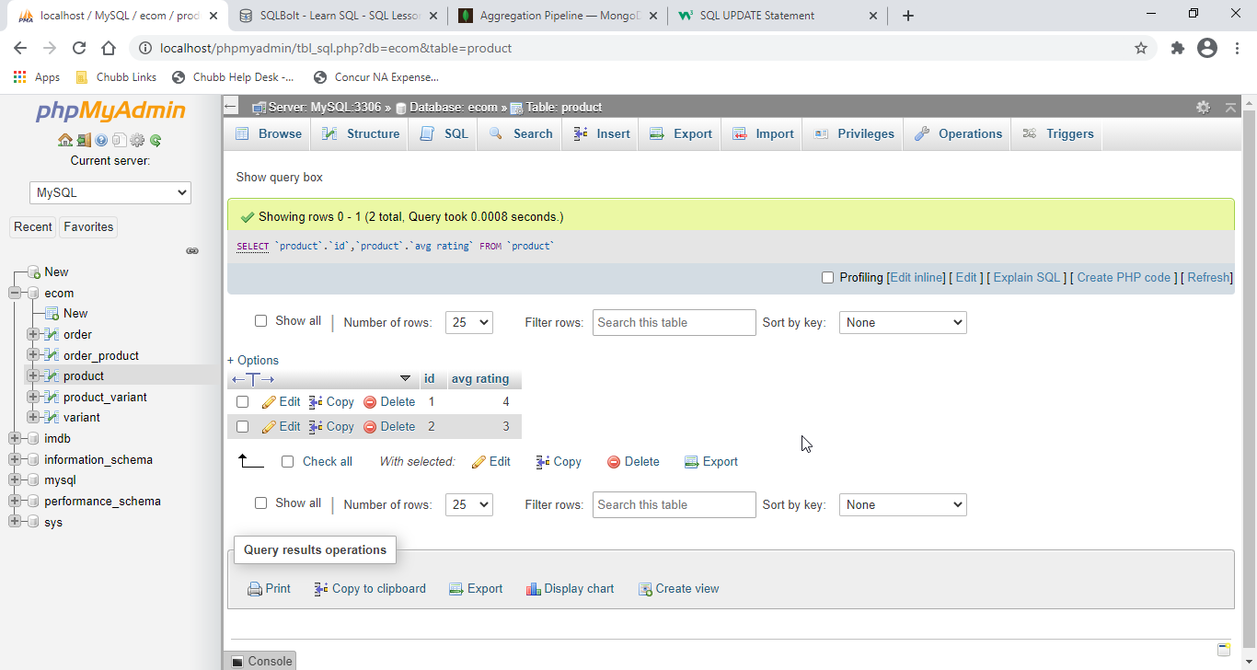

6.All orders for a customer id

[SELECT](http://localhost/phpmyadmin/url.php?url=https://dev.mysql.com/doc/refman/5.5/en/select.html) `order_id`,`order_num` FROM `order` WHERE `cust_id`=1

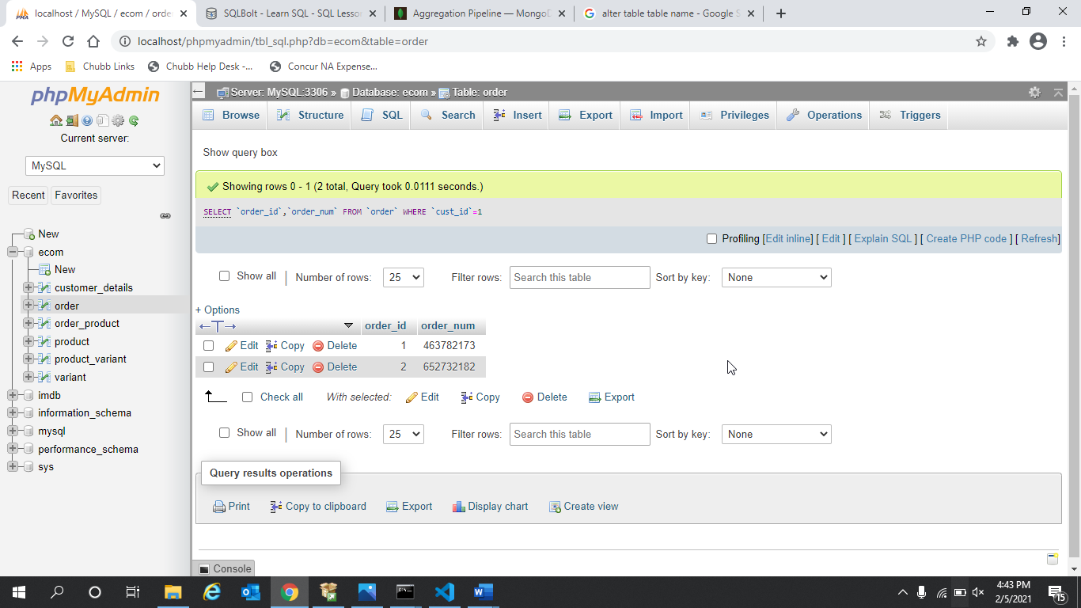

7.Total number of sale of a product by product id

[SELECT](http://localhost/phpmyadmin/url.php?url=https://dev.mysql.com/doc/refman/5.5/en/select.html) `product_id`,[sum](http://localhost/phpmyadmin/url.php?url=https://dev.mysql.com/doc/refman/5.5/en/group-by-functions.html#function_sum)(`sale`) FROM `product_variant` GROUP by `product_id`

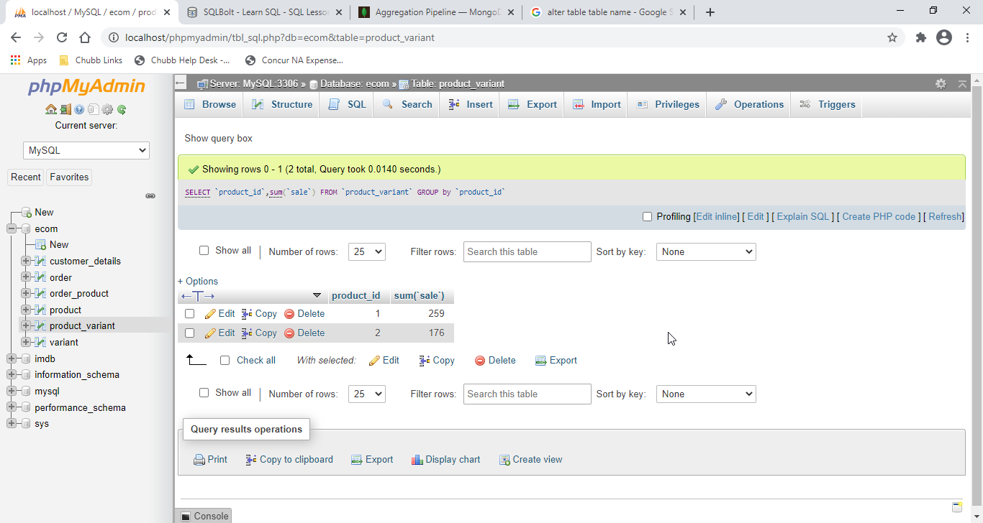

Total sales cost of a product by product id

[SELECT](http://localhost/phpmyadmin/url.php?url=https://dev.mysql.com/doc/refman/5.5/en/select.html) `product_variant`.`product_id`, `variant`.`price`*`product_variant`.`sale`AS `total sale` from `variant`INNER JOIN `product_variant`ON `variant`.`id`=`product_variant`.`variant_id`

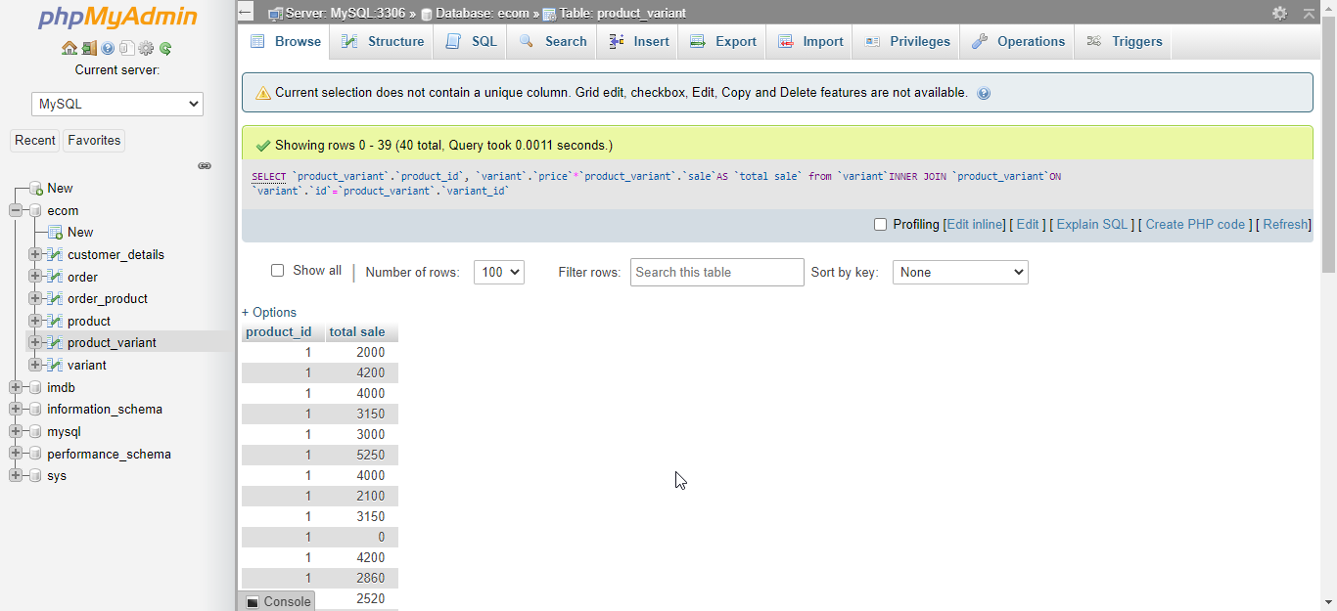

8.Total Company sales

[SELECT](http://localhost/phpmyadmin/url.php?url=https://dev.mysql.com/doc/refman/5.5/en/select.html) [Sum](http://localhost/phpmyadmin/url.php?url=https://dev.mysql.com/doc/refman/5.5/en/group-by-functions.html#function_sum)(`variant`.`price`*`product_variant`.`sale`) as `total sales`from `variant` INNER JOIN `product_variant`ON `variant`.`id`=`product_variant`.`variant_id`

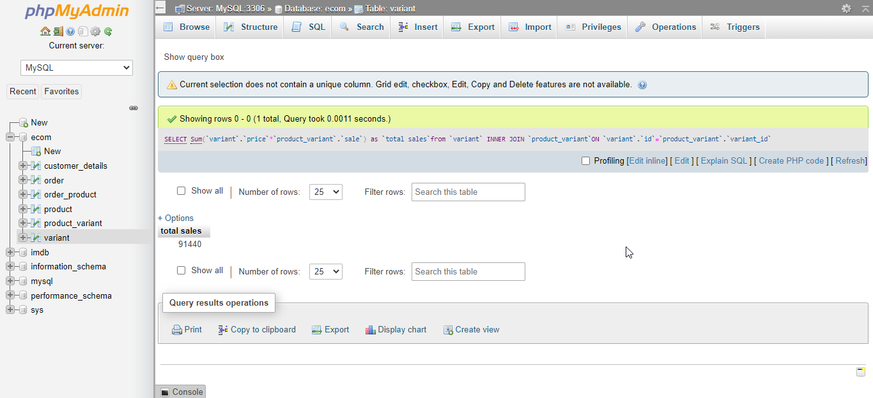

Insert into product1



Q1



Q2



Q4.



Q5.

