GOGO Kart Suspension Design
Front Suspension Config:
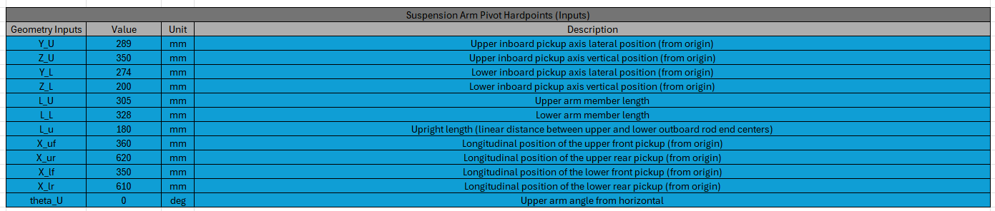
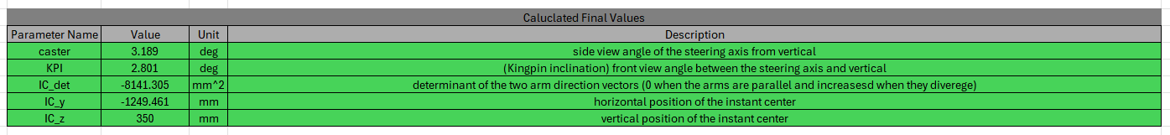
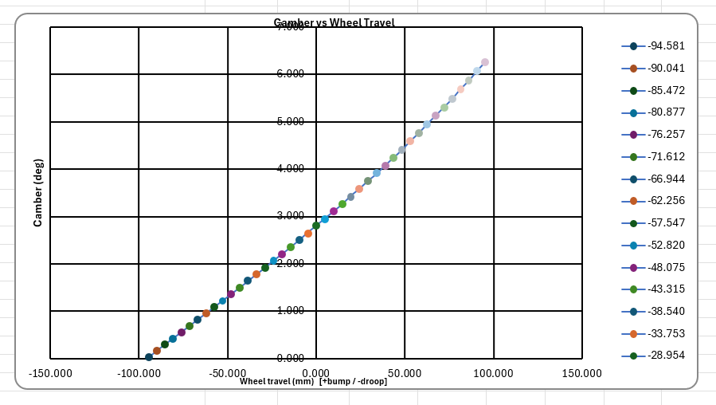
Rear Suspension Config:
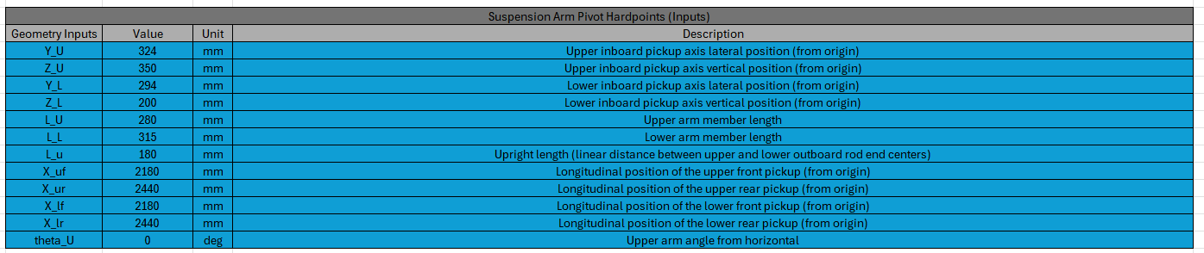
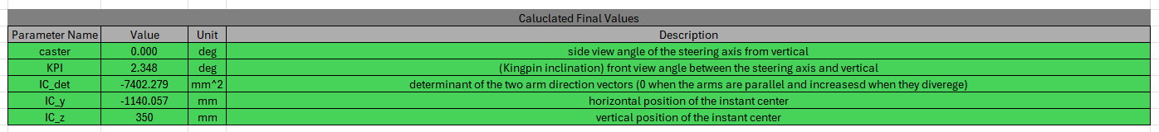

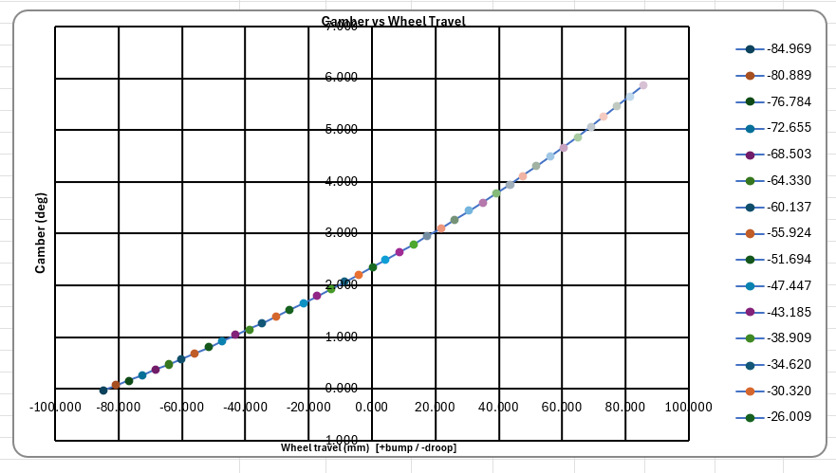
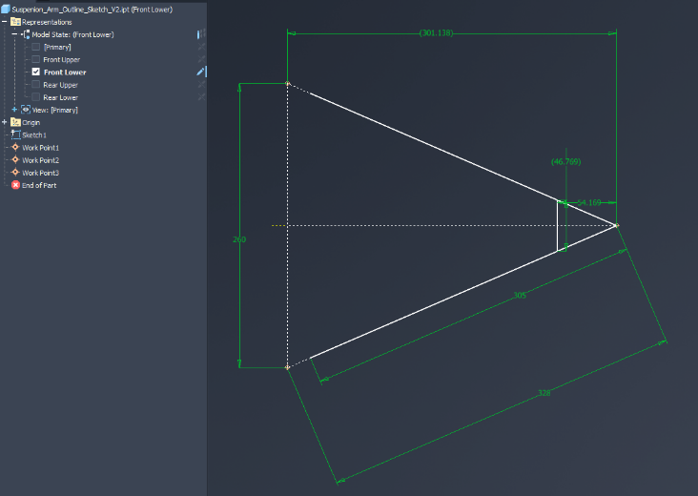
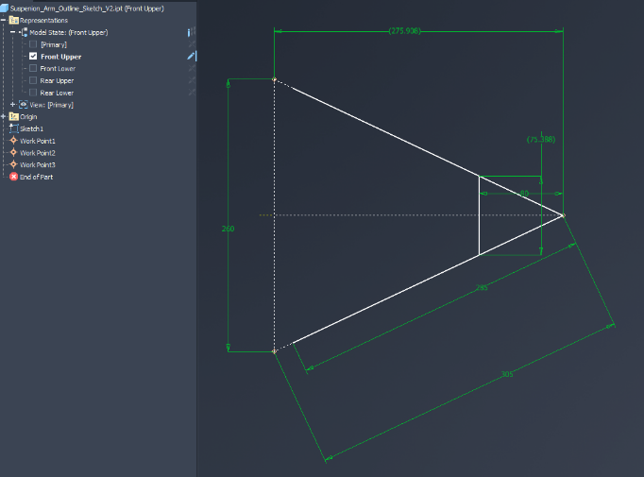
A-Arm Sketches:

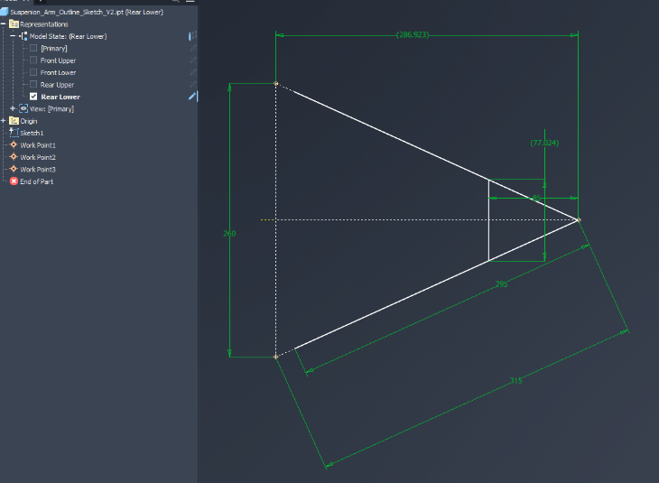
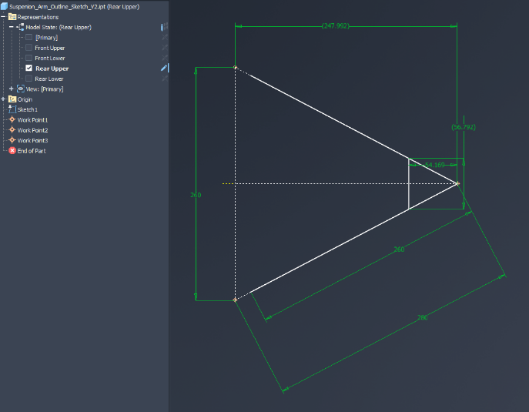

Mild Steel Rod Member Lengths (mm):
Front Upper: 285
Front Lower: 305
Rear Upper: 260
Rear Lower: 295
Suspension Kinematics Member Lengths (with rod end, mm):
Front Upper: 305
Front Lower: 328
Rear Upper: 280
Rear Lower: 315
Outboard Bearing Housing:
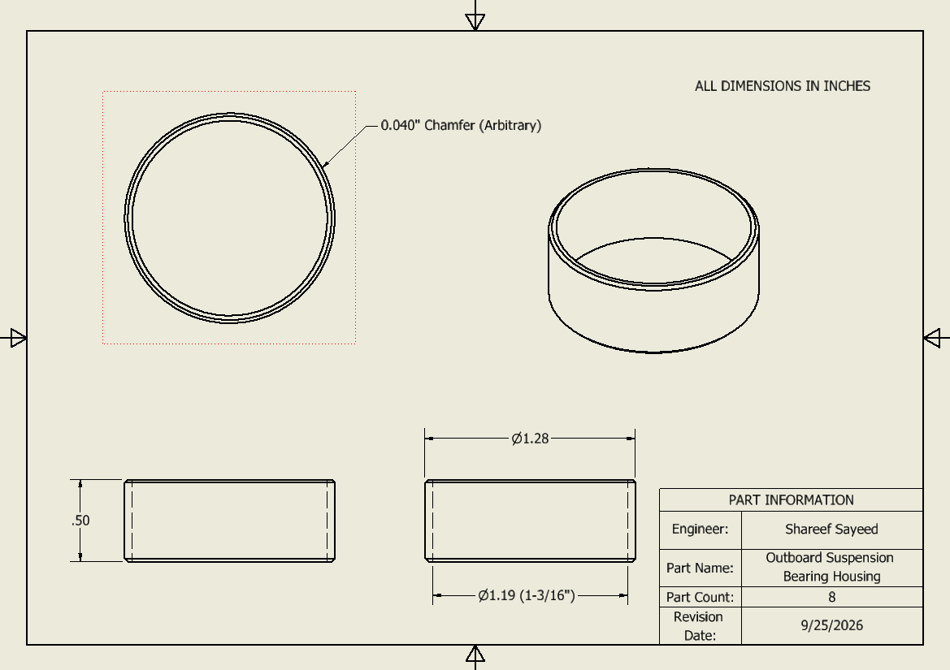

Suspension Members:
4x Front Upper Members (285mm/11.22” Length, 32.5mm/1.28” Cut Diameter)
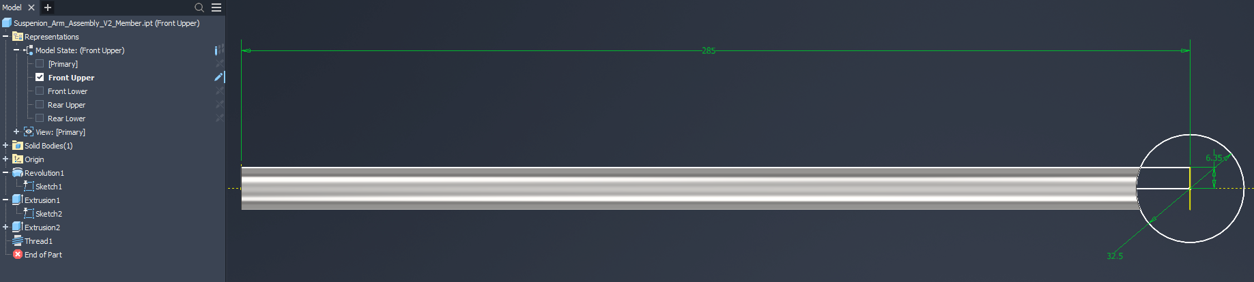
4x Front Lower Members (305mm/12.01” Length, 32.5mm/1.28” Cut Diameter)
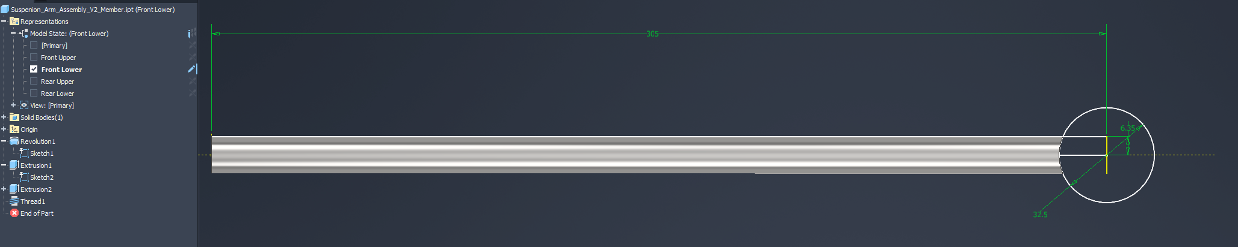
4x Rear Upper (260mm/10.02” Length, 32.5mm/1.28” Cut Diameter)
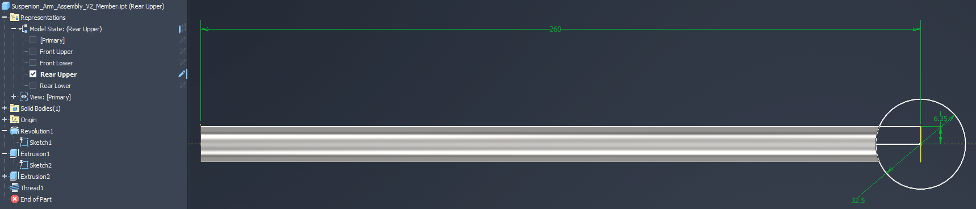
4x Rear Lower (295mm/11.61” Length, 32.5mm/1.28” Cut Diameter)
