

Final Examination
PART A
COE 312 – Software Design for Engineers

Fall 2018

Imran A. Zualkernan

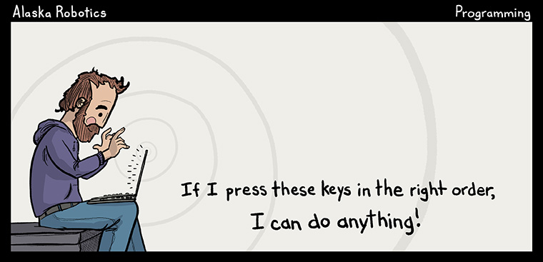

Name: __________________________________

ID:_____________________________________

Q1. (25 points). Write a monkey & toffee game where each monkey tries to grab a toffee out of a toffeebox, eats the toffee in one second, and tries to grab another one. Monkey rejects half the toffees it retrieves by returning them back to the box. Show how your classes work with two monkeys and one toffeebox with 10 toffees.

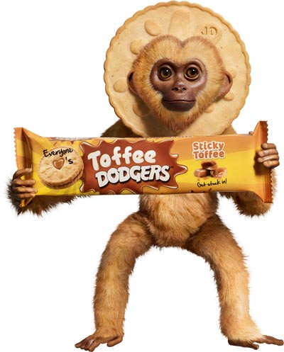

Sample Output:

Monkey@1c34796b grabbed toffee number 10
Monkey@57a6e820 grabbed toffee number 9
Monkey@57a6e820 returned toffee
Monkey@1c34796b grabbed toffee number 9
Monkey@1c34796b returned toffee
Monkey@1c34796b grabbed toffee number 9
Monkey@1c34796b returned toffee
…

Solution:

Q2. (25 points). Write a bear and river simulation. A bear is asleep until it hears a splash in the river. The bear wakes up and gets into the water. Once in the water, it tries to catch a fish. If caught, it eats the fish and goes back to sleep until it hears the next splash and the cycle continues. Multiple bears can be around the river at a time. Use all appropriate design patterns to implement this simulation. Show how the simulation works with two bears and one river.

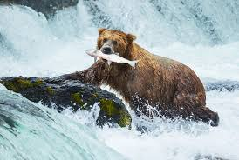

Sample Output:

…
ear@a8e33ff is in Water
Bear@449ccde is in Water
Bear@a8e33ff is in Water
Bear@449ccde is Eating Fish
Bear@a8e33ff is in Water
Bear@449ccde is Eating Fish
Bear@a8e33ff is in Water
Bear@449ccde is Eating Fish
Bear@a8e33ff is in Water
Bear@449ccde is Eating Fish
Bear@a8e33ff is in Water
Bear@449ccde is Eating Fish
Bear@a8e33ff is in Water
…

Solution:

