Practical 1: Installation of Apache Hadoop

Step1: Install Java version 1.8 then go to your local diskC. Then create a new folder with name Java then paste the java Jdk file into this folder. Now go to EDIT SYSTEM VARIABLE then set the variable path as JAVA_HOME then add the new Java folder location to it. And set the path too with \bin.

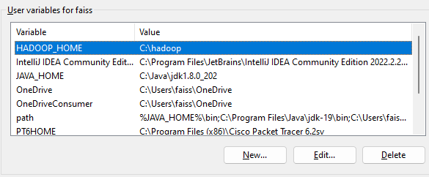

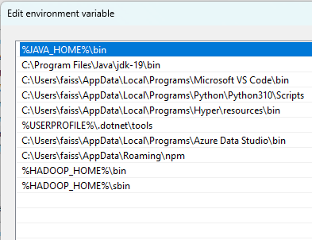

Step2: Now install the Apache Hadoop from the official website and download the latest or stable version of that and then unzip the tar file. Then create a folder in local diskC with name Hadoop and extract all the files there.

Step3: Now go to system variable again and set the Hadoop variable name with HADOOP_HOME and paste the file path as shown below and also set the path with bin and sbin as shown below:

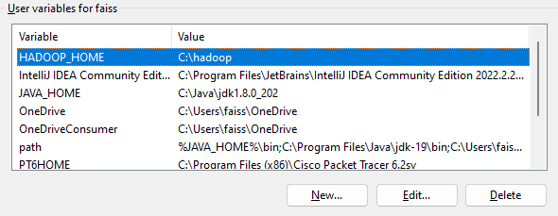

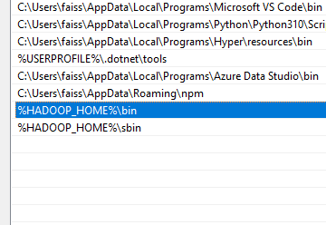

Step4: Now create a “DATA” folder in Hadoop and create 2 more folder name as “NAMENODE”, “DATANODE”.

Step5: Now the most important step is to replace the bin file of Hadoop by this file. So basically, u can get all the files from here: <https://github.com/selfgrowth/apache-hadoop-3.1.1-winutils>

Step6: Now after step 5 click on Hadoop folder > etc > Hadoop. Then open **core-site.xml** file then edit this line

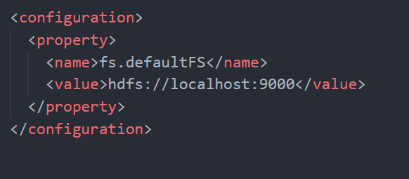

After this open **mapred-site.xml** and add this line of code:

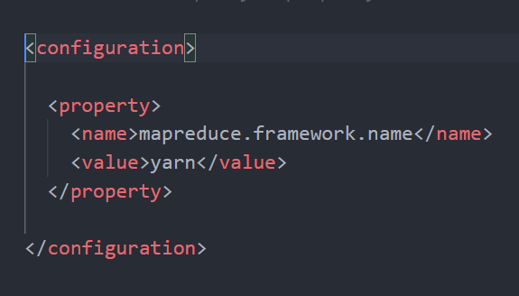

Then open **hdfs-site.xml** and edit this line of code:

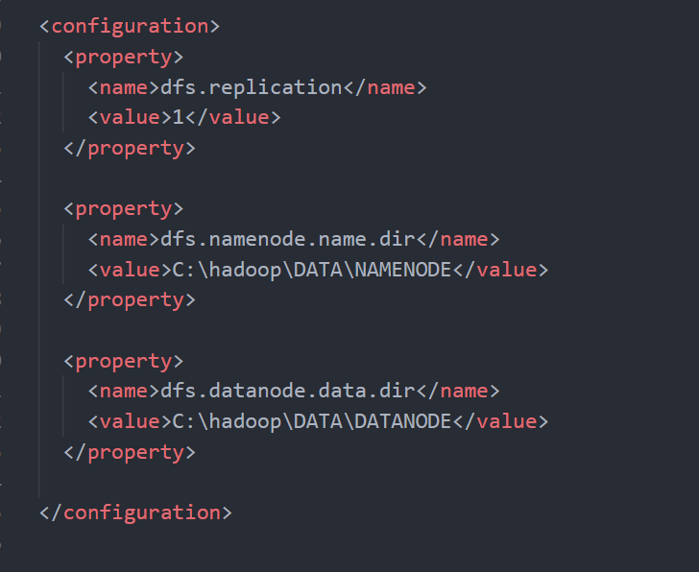

Then open **yarn-site.xml** and add this line of code:

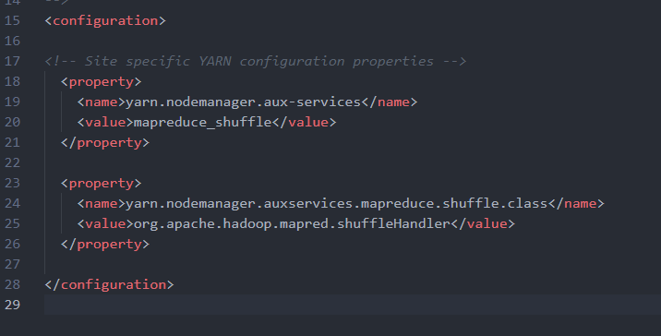

Now after that right click on “**Hadoop-env”** window command file > show more options > edit. And set the JAVA_HOME path their

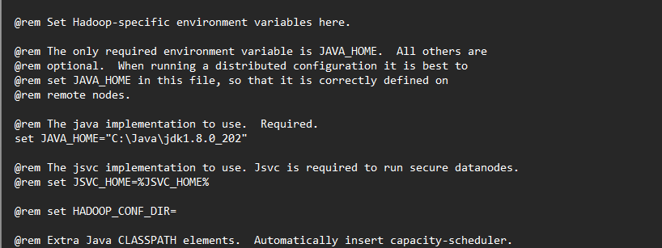

Then save all the changes and go to Hadoop > bin > click on **winutils** application file. If it opens and get close without any error then you are good to go now.

Step7: Now open **cmd** and run it as a administrator. Now type the following command:

***hdfs namenode -format***

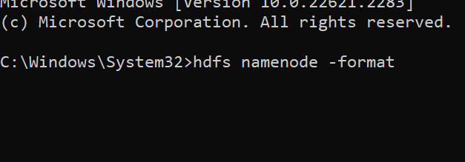

After that second command:

***Start-all.cmd***

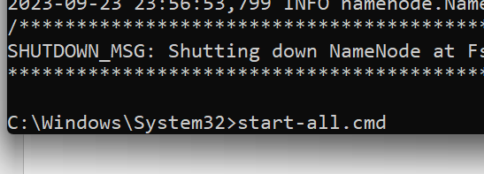

Now several cmd will opens up and boots the following package or managers you can check them by entering **jps** command

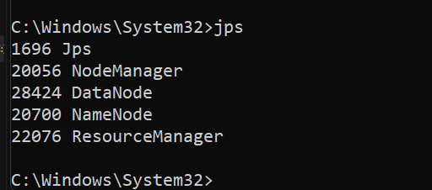

Step8: Now go to your browser and go to **localhost:9870** for Namenode information:

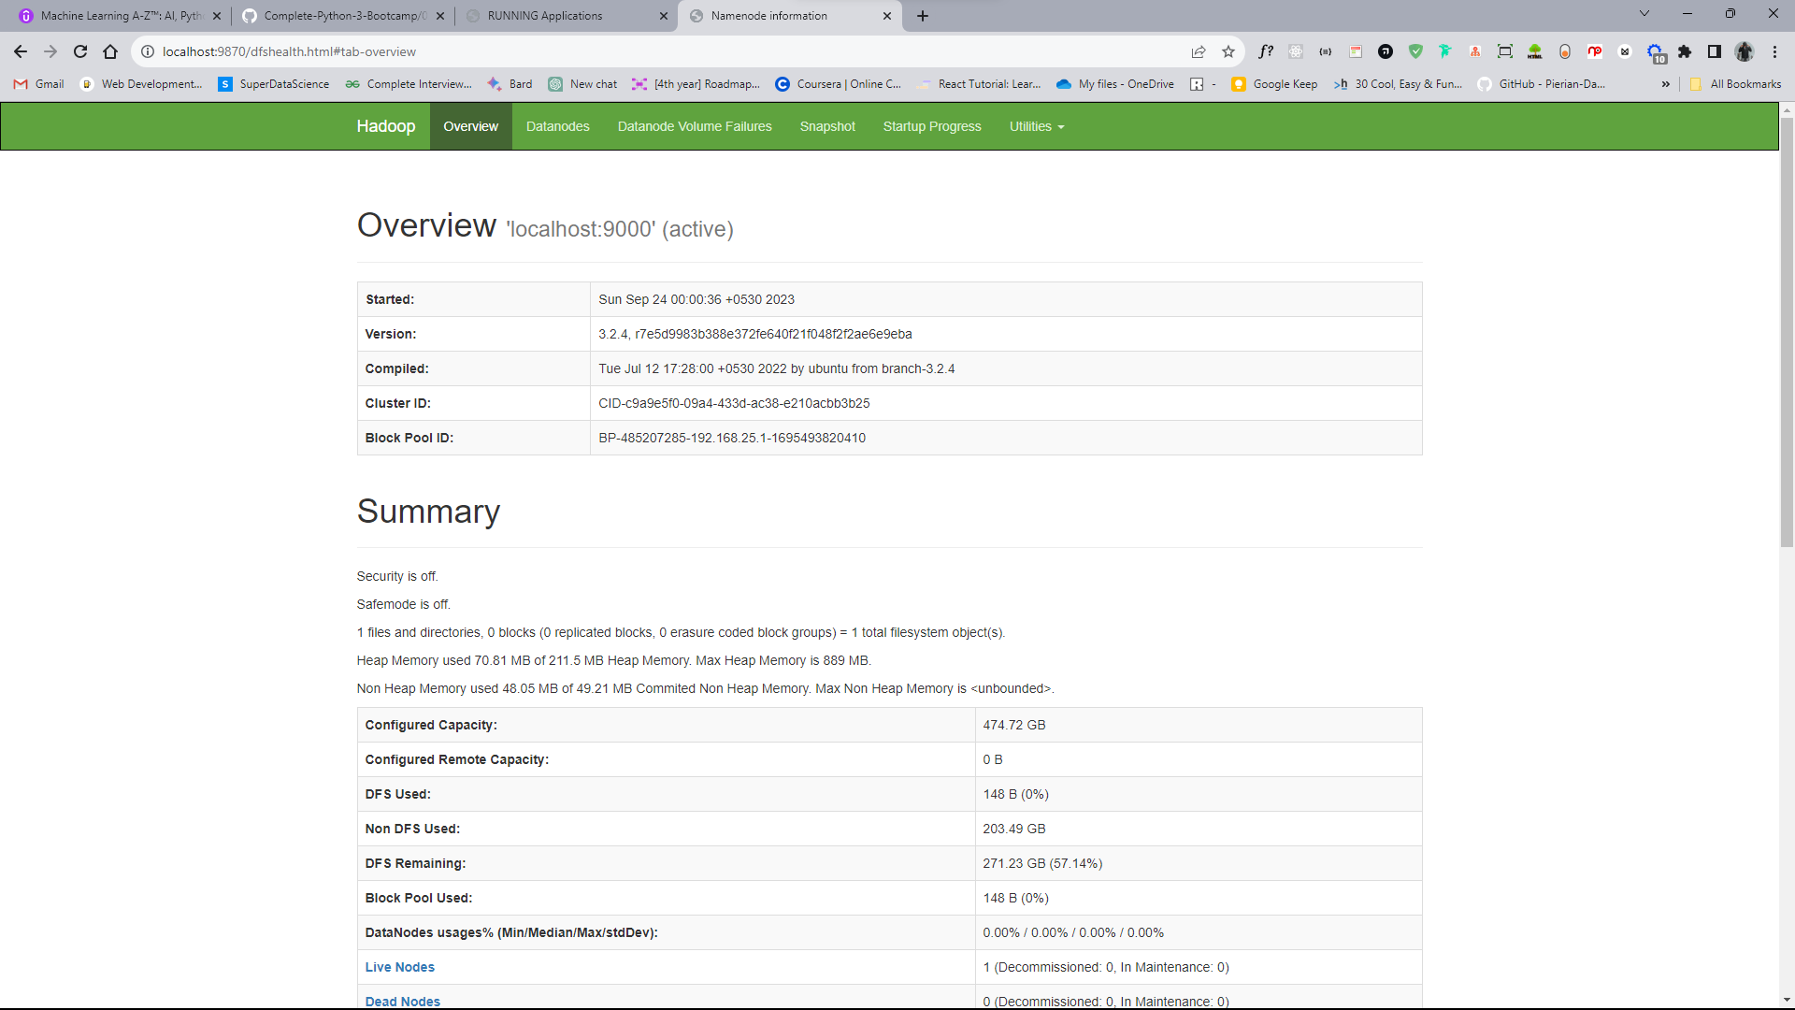

And **localhost:8088** for running applications:

