**Enterprise Task Management**

**Initiator:**

* He/she can be anyone from organization
* He/she can create tasks and assign to his/her reportee (up to two levels down)
* Default he/she is Reviewer. He can assign another reviewer from reportee (up to two levels down)

**Assignee:**

* He/she responsible for proposed completion date
* He can delegate this task to any of his/her reportee (up to two levels down)
* Default Assignee is Doer

**Doer:**

* He/she is doing task and responsible for completion of task

**Reviewer:**

* He/she will verify task and complete in system
* He/she can un-verify request and send back to Doer for rework

**Application Flow**:

**Initiator**

**Assignee**

**Complete**

**Reviewer**

**Doer**

Reminder:

* Assignee will get reminder to submit Propose date on each alternate day.
* Doer will get reminder daily before 5 days.
* Doer will get reminder with CC to initiator immediate after the propose date if task is not get completed.

Task Creation

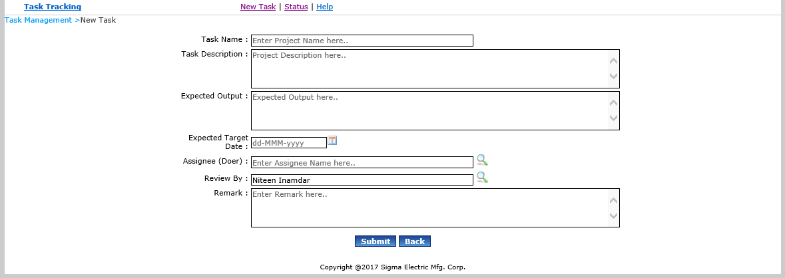

Dashboard

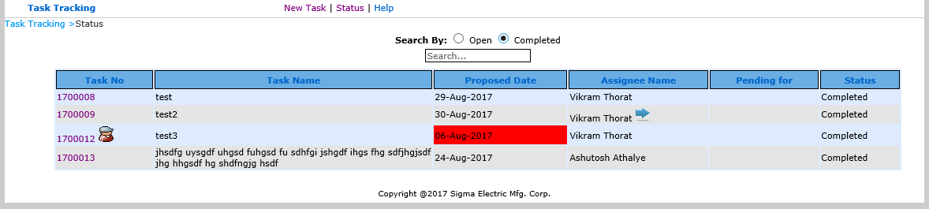

Assignee

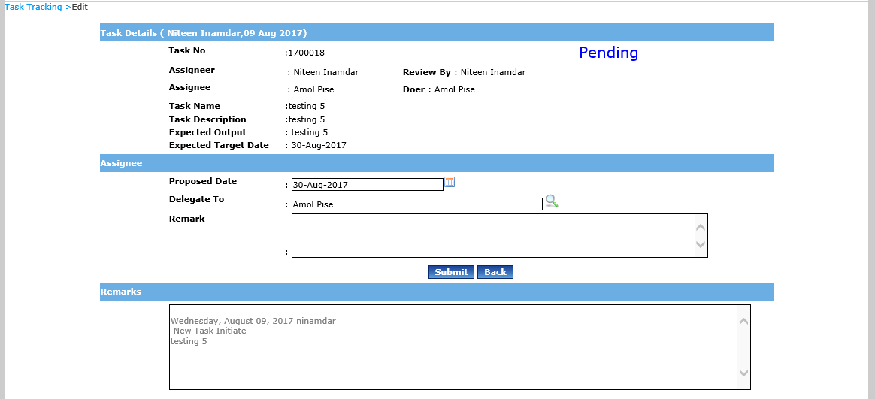

Doer

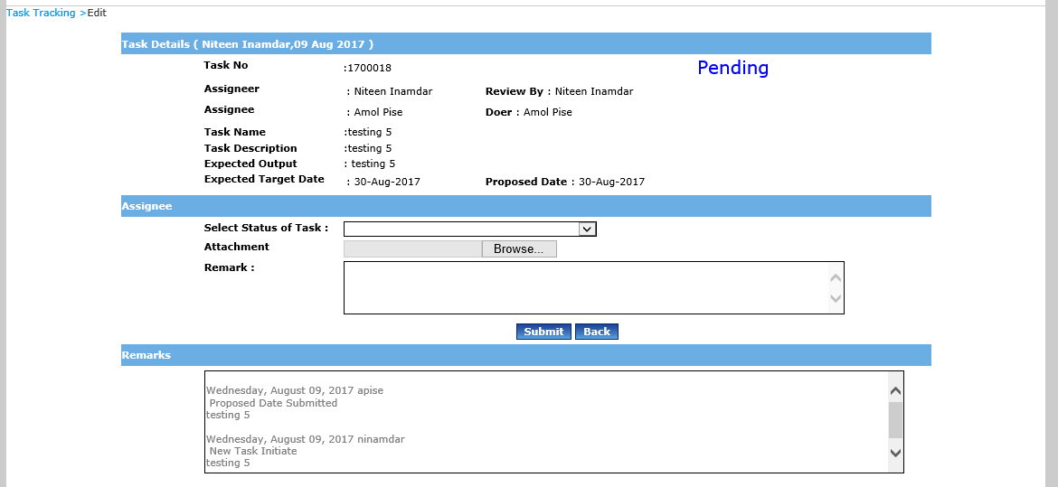

Reviewer

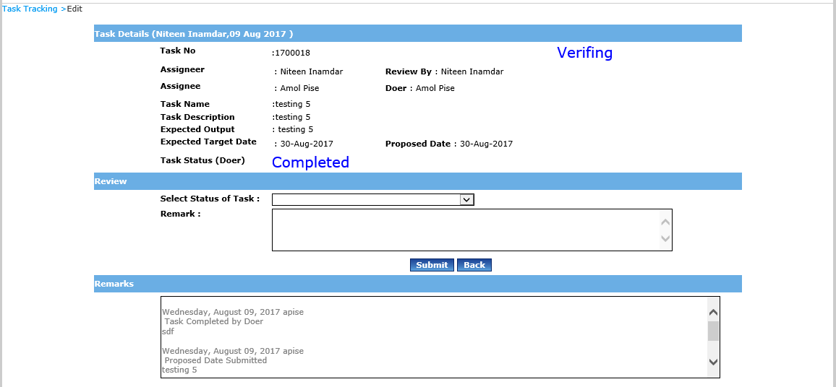

**Limitations:**

* Initiator will not able to cancel task or reassign task
* Initiator will not able to Hold Task and set other priority
* Initiator will assign task for his two levels down employees only.