Assignment 2 Monte Carlo Simulation

Monte Carlo simulation provides a number of advantages to give results to certain undetermined problems through probabilistic and graphical results .The results show the possibilites of outcome over a large range of possible option and points towards a viable option as the most probable reality.
As for the Romba Robot simulation , Monte Carlo simulation of running iteration of cleansing over a large trial number leads towards determining most realistic average time required for the action and thereby, provide a reliable data .

Problem 4 (a):

Problem Statement : How long does it take to clean 80% of a 20×20 room with each of 1-10 robots?
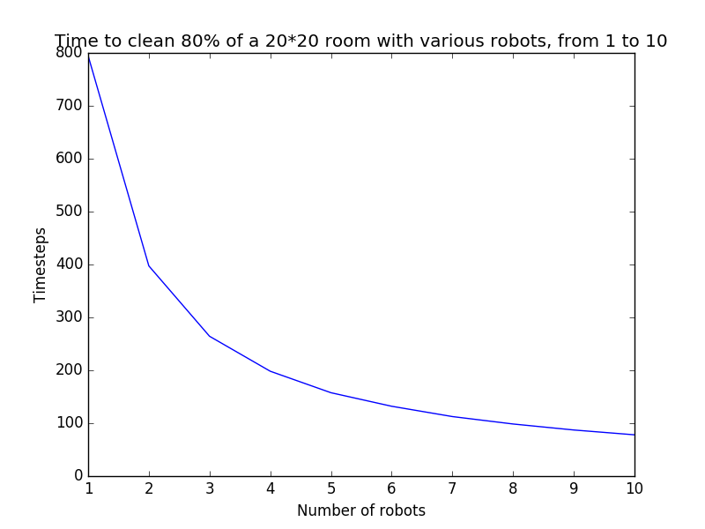

Time tends to fall as the number of robots increases after a complete loop of trial .This is obvious since in the same area of room, number of robots have increased hence the total time required to meet the target coverage reduces largely.

Number of trials : 1000

Approximate timestep required by 1 robots : 800
Approximate timestep required by 8 robots : 120(+-5% of 120 =6)
Approximate timestep required by 9 robots : 105 (+- 5% of 105 = 5.25)
Approximate timestep required by 10 robots : 100
Since the nearby values are within +-5% of the predicted value of 100 steps taken by 10 robots, it is certain that the value tends to be true.

Problem – 4(b):

Problem Statement : How long does it take two robots to clean 80% of rooms with same area but different dimensions ?
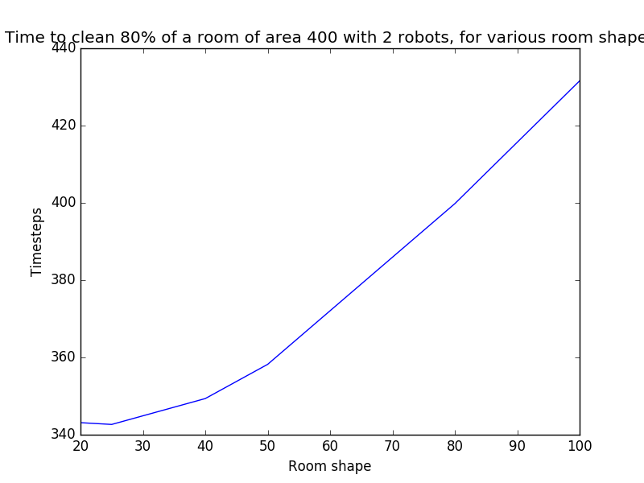
On the X axis , height(i.e length) of the rooms are presented starting from 20 to 100. As the graph suggests, required timesteps for each room with same area but increasing height increases the associated timesteps too. Hence the graph goes upward uniformly and reaches the peak when the height of room is 100.

Approximate time step required in a 20x20 room : 340
Approximate time step required in a 80x5 room : 385 (+-5% = 19.25)
Approximate time step required in a 100x4 room : 430(+_5% = 21.50)
Here , the nearby points don’t give values that are within 5% of another value’s range, hence error is more certain . More number of trials will tend to give a better value.

Number of trials : 1000

Problem 6 : Comparison of performance of two robots

Problem Statement : How much time does each of the robots take when they are about to clean a same room with same target of cleaning percentage?

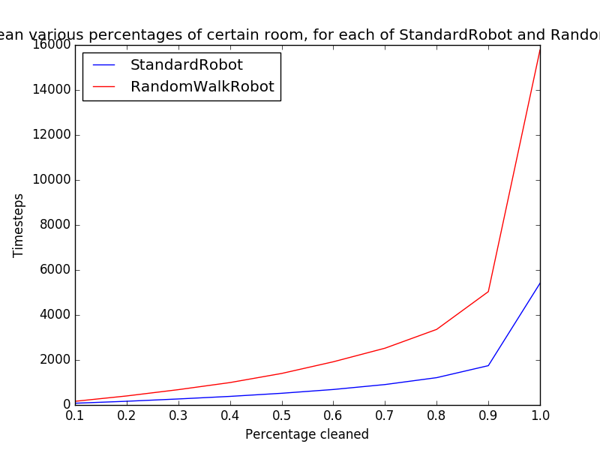

Observation : To clean up 80% of a 25x25 dimension room, RandomWalk Robot takes much more time steps than the standard Robot does.
For a number of trial : 1000
RandomWalk Robot reaches 80% cleaning percentage at a cost of : 3500steps
StandardRobot reaches 80% cleaning percentage at a cost of : 1300 steps

Question 2 : How much time is taken by a Standard robot to clean a 10x10 room ?
Problem Statement : Here, I have tried to reach a approximate accurate time taken by a Standard robot to clean a definite room through running enough trials .

Observation : The graph shows a rough upward downward behavior but most part of the graph stays within 218 steps to 220 steps.
For a cost of number of trials : 10000
Approximate time step taken by a standard robot to clean up a 10x10 room : 219

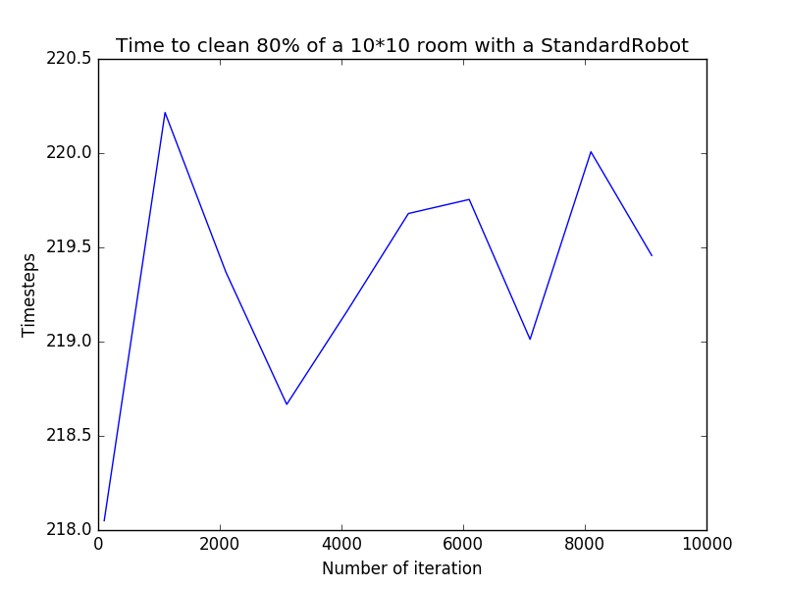

Question 3 : How much time is taken by a RandomWalk robot to clean a 10x10 room ?
Problem Statement : Here, I have tried to reach a approximate accurate time taken by a Random Walk robot to clean a definite room through running enough trials .

Observation : The graph shows a rather steady downward behavior of time step variation. At the initial trials, the value of time steps is very high (upto 460) whereas as the trials increased , the time steps got limited within range of (450 -446) steps.
For a cost of number of trials : 10000
Approximate time step taken by a standard robot to clean up a 10x10 room : 448

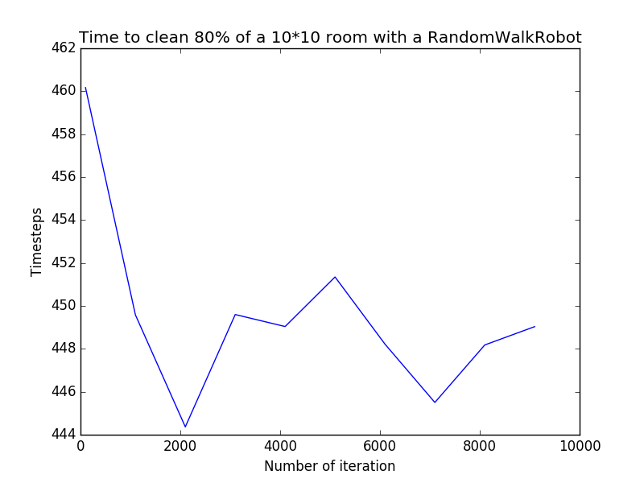

Question 4 : Compare the performance of both the robots in a graph

Solution Philosophy : I have taken a room of same dimension (10x10) , given the same number of robots(1) , provided the same target percentage to clean up for each of them . Hence, it will be easier to compare both the robots on a same platform.
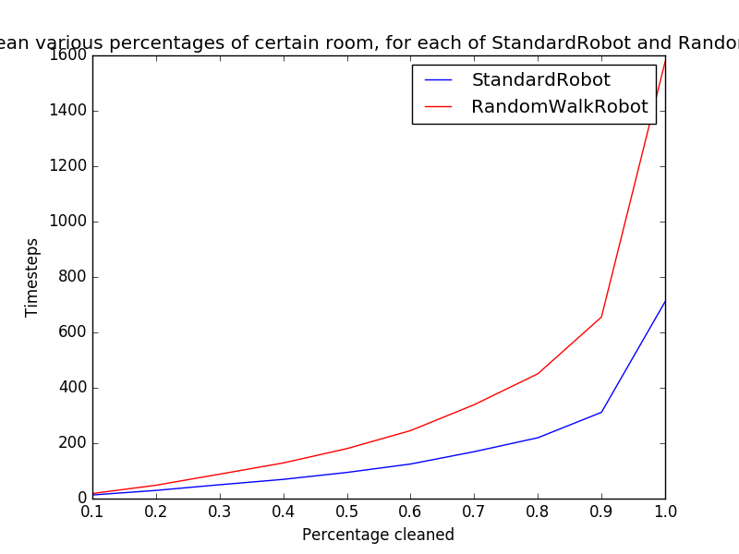
Observation : Standard robot takes less than half of the steps to clean than the RandomWalk robot does
For a number of trial : 1000
Standard robot cleans 100% of the room in : 700 steps
Random Walk Robot cleans 100% of the room in : 1580 steps

