

SWAMY VIVEKANANDA VIDYA SAMSTHE
KUMADVATHI FIRST GRADE COLLEGE SHIKARIPURA
KUVEMPU UNIVERSITY
INTERNSHIP REPORT
ON
PYTHON PROGRAMMING
Project Title
COLLEGE INTERNSHIP & PROJECT MANAGEMENT PORTAL
Submitted in partial fulfilment of the academic requirements for the degree of
BACHELOR OF COMPUTER APPLICATIONS (BCA)
Internship Organization
BEESKILLED TECH AND INTERNSHIP
Duration: Six Weeks | Mode: Online
Submitted by
TASMIYA R GHASI
UUCMS No.: U06KM24S0087
Under the Guidance of
Prashanth Kumar B
ACADEMIC YEAR: 2026 – 2027

CERTIFICATE

This is to certify that the internship report entitled “Python Programming – College Internship & Project Management Portal” is a bonafide record of the work carried out by Tasmiya R Ghasi, bearing UUCMS No. U06KM24S0087, of the Bachelor of Computer Applications (BCA) programme at Kumadvathi First Grade College, Shikaripura.
The student has completed a six-week online Python internship through BeeSkilled Tech and Internship and has prepared this report describing the learning activities and the development of the College Internship & Project Management Portal.
The report is submitted in partial fulfilment of the academic requirements of the BCA programme.

Internship Guide Principal
Mr. Prashanth Kumar B Dr. Ravindra K C

Examiner
1)…………………… 2)……………………

INTERNSHIP CERTIFICATE
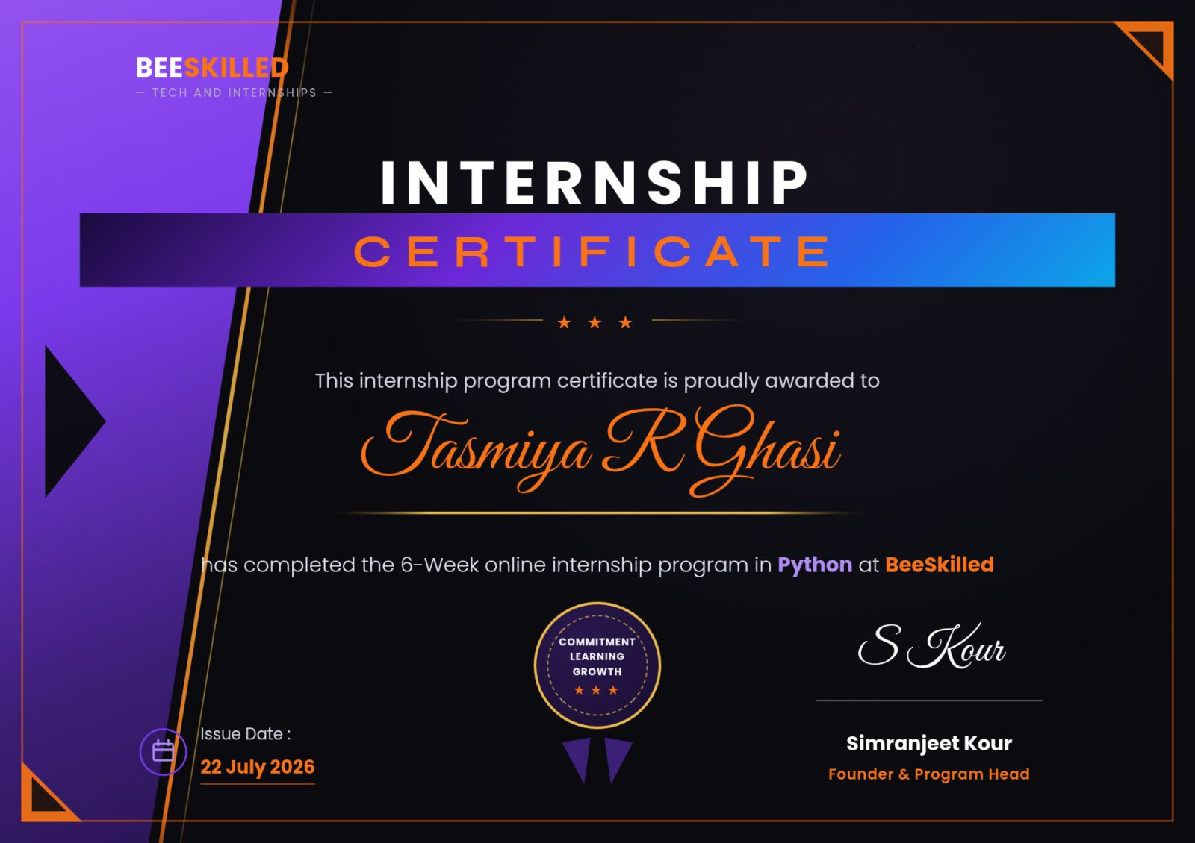

DECLARATION

I am Tasmiya R Ghasi, hereby declare that the internship report entitled “Python Programming – College Internship & Project Management Portal” is based on the learning and project work carried out by me during the six-week online Python internship through BeeSkilled Tech and Internship.
I further declare that this report has been prepared for academic submission to Kumadvathi First Grade College, Shikaripura. The project description and implementation details included in this report relate to the College Internship & Project Management Portal developed as part of my practical work. Wherever external learning resources have been used, they are acknowledged in the references.
Place: Shikaripura
Date: ____________
Signature of the Student: ____________________

ACKNOWLEDGEMENT

I express my sincere gratitude to the management and Principal of Kumadvathi First Grade College, Shikaripura, for providing the opportunity and academic support required to complete this internship and project work.
I thank the faculty members of the Department of Computer Applications and my project guide for their guidance, suggestions and encouragement throughout the learning and development process.
I also acknowledge BeeSkilled Tech and Internship for providing the opportunity to undertake a six-week online internship in Python programming. The internship helped me strengthen my understanding of Python concepts and apply them to a practical web-based application.
Finally, I thank my family, friends and everyone who directly or indirectly supported me in completing the internship and preparing this report.

ABSTRACT

This report presents the learning outcomes of a six-week online internship in Python programming completed through BeeSkilled Tech and Internship. The practical project undertaken during the internship was the “College Internship & Project Management Portal”, a web-based application designed to support the administration and monitoring of student internships and academic projects.
The portal was developed using Python with the Flask web framework and MySQL as the relational database. It provides role-based access for administrators, students and faculty members. The implemented modules include student and faculty records, internship and project information, faculty–student assignment, daily activity logs, project progress monitoring and evaluation-related reporting. Separate dashboards help each user role access the functions relevant to its responsibilities.
The project provided practical exposure to Python programming, web application routing, HTML templates, database connectivity, CRUD operations, session-based login, relational data handling, validation and debugging. The report explains the internship context, Python concepts covered, system requirements, project analysis and design, implementation modules, testing, learning outcomes and conclusion. Details such as exact internship dates, student particulars and guide names are left as editable fields where they were not supplied.

TABLE OF CONTENTS

Chapter | Title
1 | Profile of Organization
2 | Course Syllabus Covered
3 | Course Scope and Objectives of Internship
4 | Technical Aspects of Python Programming
5 | System Analysis and Project Design
6 | Project Implementation and Module Description
7 | Fifth and Sixth Week Internship Details
8 | Assessment Based on Internship
9 | Conclusion
10 | References and Bibliography

CHAPTER 1

PROFILE OF ORGANIZATION

1.1 About the Organization
BeeSkilled Tech and Internship is the internship provider through which the student completed a six-week online internship in Python programming. The internship provided an opportunity to learn Python-related concepts and apply the knowledge through a practical project. This report records the internship provider name and the duration and mode of training as supplied by the student.
A detailed official organizational profile, registered address, founding history, mission and vision statement were not available while preparing this report. Therefore, no unsupported claims about the organization have been included. The student may add the official company profile or internship certificate details in this section if required by the college.

1.2 Internship Mode and Duration
Particular | Details
Internship provider | BeeSkilled Tech and Internship
Course / domain | Python Programming
Duration | Six weeks
Mode | Online
Project undertaken | College Internship & Project Management Portal
College | Kumadvathi First Grade College, Shikaripura
Programme | Bachelor of Computer Applications (BCA)

1.3 Purpose of the Internship
The purpose of the internship was to gain practical exposure to Python programming and understand how programming concepts are used in application development. The project work provided an opportunity to apply these concepts to a web-based system that addresses internship and project coordination activities in a college environment.

1.4 Internship Objectives
- Understand the fundamentals and syntax of Python programming.
- Learn how a Python web framework can be used to develop a web application.
- Understand client–server interaction and the role of HTML templates.
- Connect a Python application with a MySQL relational database.
- Implement user authentication and role-based access for different users.
- Perform create, read, update and delete operations on application records.
- Test application workflows, identify errors and debug the code.
- Develop a functional project and document its design and implementation.

CHAPTER 2

COURSE SYLLABUS COVERED

2.1 Prerequisites
A basic understanding of computers and logical thinking is useful for learning Python. Prior programming experience is helpful but not essential. Knowledge of variables, data types, conditional statements, loops and functions makes it easier to understand Python syntax and develop application logic. Basic familiarity with files, folders, web browsers and database concepts is also useful when developing a web application.

2.2 Learning Aspects
The internship strengthened both programming knowledge and practical software development skills. The main learning aspects include:
- Python syntax, variables, data types and operators.
- Conditional statements, loops, functions and modular programming.
- Lists, tuples, dictionaries and other data structures.
- Exception handling and debugging techniques.
- Introduction to web application development using Flask.
- Routing, request handling, templates and form submission.
- Database concepts and connectivity with MySQL.
- CRUD operations and relational data management.
- Login sessions, access control and user-role separation.
- Testing, troubleshooting, documentation and project presentation.

2.3 Software and Hardware Requirements

2.3.1 Software Requirements
Software / Tool | Purpose in the project
Python | Main programming language used for application logic.
Flask | Lightweight Python web framework used for routes and request handling.
MySQL | Relational database used to store users, students, faculty, projects and logs.
Flask-SQLAlchemy / SQLAlchemy | Object-relational mapping for working with database records through Python models.
HTML | Structure of the web pages.
CSS | Presentation and styling of the user interface.
Jinja2 templates | Dynamic rendering of data in Flask HTML pages.
Visual Studio Code | Code editing and project development environment.
Web browser | Accessing and testing the web application.
PowerShell / Command Prompt | Running the application and managing the development environment.

2.3.2 Hardware Requirements
- A desktop computer or laptop capable of running Python and MySQL.
- Sufficient RAM and storage for the development tools and database.
- A keyboard, mouse and display for development and testing.
- An internet connection for online internship activities and learning resourse.

CHAPTER 3
COURSE SCOPE AND OBJECTIVES OF INTERNSHIP

3.1 Benefits of Learning Python
Python is a high-level, general-purpose programming language known for readable syntax and a large ecosystem of libraries. It is used in web development, automation, data analysis, artificial intelligence, scientific computing and software development. Its relatively simple syntax makes it suitable for beginners while its frameworks and libraries support larger applications.
Readable syntax: Python code is generally concise and readable, which helps learners focus on program logic.
Rapid development: Frameworks and reusable libraries reduce the amount of code needed for common application tasks.
Database integration: Python applications can connect to relational databases such as MySQL and work with stored records.
Large ecosystem: A wide range of libraries and frameworks supports web development, testing, data processing and automation.
Portability: Python applications can run on multiple operating systems when the required runtime and dependencies are available.
Problem-solving: Programming exercises encourage logical thinking, decomposition of tasks and systematic debugging.

3.1.1 Python Tools and Libraries Used
Technology | Role
Flask | Handles URL routes, requests, responses and application structure.
SQLAlchemy | Maps Python classes to database tables and supports database queries.
MySQL Connector / DB driver | Provides the database driver connection used by the application environment.
Jinja2 | Renders dynamic HTML templates using data supplied by Flask.
Werkzeug utilities | Supports common web application utilities, including secure password hashing when used.
HTML and CSS | Create the structure and visual presentation of pages.

3.2 Applications of Python
- Web application development
- Desktop application development
- Data analysis and visualization
- Artificial intelligence and machine learning
- Task automation and scripting
- Scientific and numeric computing
- Testing and software development tools
- Database-driven business applications

3.3 Challenges in Python Application Development
Environment setup: Installing Python, creating a virtual environment and configuring database dependencies must be done correctly.
Syntax and logic errors: Indentation, variable names, conditions and incorrect logic can prevent the application from behaving as expected.
Database errors: Incorrect connection settings, missing tables, constraints and relationships can cause database operations to fail.
Routing and template errors: A missing route, incorrect endpoint name or undefined template variable may cause a page or button to fail.
Authentication and authorization: The application must verify login status and restrict each role to permitted functions.
Testing complete workflows: Individual pages may work while a full workflow across administrator, student and faculty accounts may still contain errors.

3.4 Contribution to the Project
The practical contribution during the internship was the development and testing of a College Internship & Project Management Portal. The project focused on organizing student and faculty information, internship and project records, daily work logs and project progress information in a single web-based system. The work involved translating functional requirements into application modules, defining database models, implementing routes and templates, connecting forms to database operations and checking the application through role-based workflows.

CHAPTER 4

COURSE SCOPE AND OBJECTIVES OF INTERNSHIP

4.1 Introduction to Python
Python is an interpreted, high-level programming language. It supports procedural, object-oriented and functional programming styles. Python source files commonly use the .py extension. A Python interpreter executes the instructions and reports errors that must be corrected during development.

4.2 Variables and Data Types
Variables are names used to refer to values in a program. Python determines the type of a value at runtime. Common built-in data types include int, float, str, bool, list, tuple, set and dict. In the portal, strings are used for names and email addresses, integers for identifiers and semester values, dates for log dates, and numeric values for hours worked.

4.3 Conditional Statements and Loops
Conditional statements such as if, elif and else allow a program to select actions based on conditions. Loops such as for and while repeat instructions. These constructs are useful for validating submitted data, iterating through database results and displaying records in templates.

4.4 Functions and Modules
A function is a reusable block of code defined using the def keyword. Functions help divide an application into smaller tasks. Modules allow related functions and classes to be organized and reused. Flask route functions, helper functions and model classes contribute to a modular application structure.

4.5 Object-Oriented Programming
Object-oriented programming organizes software around classes and objects. A class defines attributes and methods, while an object is an instance of a class. In a database-backed Flask application, model classes represent entities such as users, students, faculty members, projects and daily logs.

4.6 Exception Handling and Debugging
Python uses try, except, else and finally blocks to handle exceptions. Debugging involves identifying the cause of an unexpected result, examining error messages and testing a correction. During web application development, common issues include incorrect route names, missing template variables, database integrity errors and session-related problems.

4.7 Introduction to Flask
Flask is a lightweight web framework for Python. It allows developers to define URL routes and associate them with Python functions. A route receives a browser request and returns a response, often by rendering an HTML template. Flask supports form handling, sessions, redirects and integration with database libraries.

4.8 Routing and Request Handling
A route maps a URL to a view function. Routes may accept HTTP methods such as GET and POST. GET is commonly used to display a page or retrieve information, while POST is commonly used to submit form data. After processing a form, an application may redirect the user to another route to display the updated information.

4.9 Templates and Jinja2
Flask commonly uses Jinja2 templates to generate dynamic HTML. A template can display values passed from a route and use loops or conditions to render records. This approach separates much of the page presentation from Python application logic.

4.10 MySQL and Relational Database Concepts
MySQL is a relational database management system. Data is organized into tables consisting of rows and columns. Primary keys uniquely identify records, while foreign keys represent relationships between tables. Constraints help maintain data integrity. A portal can use related tables to connect users with student or faculty profiles, projects, assignments and daily logs.

4.11 CRUD Operations
CRUD represents Create, Read, Update and Delete. These operations form the basis of many database applications. In the portal, administrators can create and maintain records, users can view information relevant to their role, and authorized users can update project-related information.
Operation | Meaning | Portal example
Create | Insert a new record | Add a student, faculty member, project or daily log.
Read | Retrieve existing records | Display student lists, assigned projects and progress reports.
Update | Modify an existing record | Edit project details or update review information.
Delete | Remove a record | Delete an authorized record while preserving database integrity.

4.12 Authentication and Session Management
Authentication verifies the identity of a user, usually through a login process. A session allows the application to remember that the user has logged in while navigating between pages. Authorization determines what an authenticated user is allowed to access. The portal separates administrator, student and faculty functions so that each role is directed to its relevant dashboard and operations.

CHAPTER 5

SYSTEM ANALYSIS AND PROJECT DESIGN

5.1 Project Introduction
The College Internship & Project Management Portal is a web-based application intended to support the management and monitoring of student internships and academic projects. It brings important records and activities into a centralized system. The portal provides separate access for administrators, students and faculty members, enabling them to perform tasks according to their responsibilities.

5.2 Problem Statement
When internship and project information is maintained through separate documents, spreadsheets or informal communication, it can become difficult to track student assignments, daily work, project completion and faculty review. Records may be duplicated, updates may be missed and progress information may be difficult to retrieve. The project addresses this administrative challenge by providing a centralized portal for maintaining records and monitoring project activities.

5.3 Objectives of the Project
- Maintain student and faculty information in a structured database.
- Manage internship and academic project details.
- Provide login-based access for administrators, students and faculty.
- Support assignment of students to faculty guides.
- Allow students to maintain daily work logs for their projects.
- Enable faculty members to review and monitor assigned students' work.
- Display project progress information and evaluation-related reports.
- Reduce manual record handling and improve access to project information.

5.4 Scope of the Project
The project scope includes administration of student and faculty records, internship and project details, faculty–student assignments, daily activity logs and project progress reporting. It is intended as a college-level management application. The exact workflow and permissions depend on the configured user roles and implemented routes. The system is not described as an enterprise placement platform or as an externally integrated university system.

5.5 Existing System
In a manual or partially computerized process, student details, guide allocation, project titles, daily work records and evaluation notes may be maintained in separate files or registers. This can require repeated data entry and manual coordination. Finding a student's complete project history may also require checking multiple records.

5.6 Proposed System
The proposed portal centralizes the relevant information in a Flask application connected to a MySQL database. It provides role-specific dashboards and modules for managing records and following project progress. The system helps authorized users retrieve information and supports a more organized workflow for internship and project supervision.

5.7 User Roles
User role | Main responsibilities
Administrator | Manage student and faculty records, internship and project details, assignments and administrative progress information.
Student | Access the student dashboard, view relevant project information, add daily logs and track project-related details.
Faculty | Access the faculty dashboard, view assigned students and projects, review daily logs and monitor project progress.

5.8 Functional Requirements
- The system shall allow an authorized user to log in.
- The system shall provide role-specific dashboard access.
- The administrator shall be able to manage student and faculty records.
- The administrator shall be able to manage internship and project information.
- The system shall support faculty–student assignment.
- Students shall be able to submit daily project activity logs.
- Faculty users shall be able to review assigned students' submitted logs.
- The system shall provide project progress information or reports to authorized users.

5.9 Non-Functional Requirements
- Usability: pages and navigation should be understandable to intended users.
- Reliability: valid operations should save and retrieve records consistently.
- Security: access to protected pages should require an authenticated session.
- Maintainability: routes, templates and models should be organized for easier updates.
- Data integrity: database keys and constraints should protect relationships between records.
- Compatibility: the application should be accessible through a supported modern web browser.

5.10 System Architecture
The application follows a basic three-part web architecture. The browser presents the user interface. The Flask application receives requests, applies business logic and renders responses. The MySQL database stores persistent records. SQLAlchemy models provide the application-level representation of database entities.
Layer | Components | Responsibility
Presentation layer | Browser, HTML, CSS, Jinja2 templates | Displays dashboards, forms, tables and reports.
Application layer | Python, Flask routes, session handling | Processes requests, validates input and applies application logic.
Data layer | MySQL database, SQLAlchemy models | Stores and retrieves users, student, faculty, project and log records.

5.11 Database Design Overview
The database contains related entities that support the portal workflow. The exact schema may be adjusted during development; the following table summarizes the principal entities represented in the project.
Entity / Model | Purpose / Typical information
User | Login identity, username or email, password hash and role.
Studen | USN or student identifier, name, email, phone, course, semester and linked user account.
Faculty | Faculty identifier, name, email, phone, department, designation and linked user account.
Internship | Internship-related details maintained by the portal.
Project | Project title, description, student association and project-related information such as a GitHub link where configured.
Faculty–Student Assignment | Relationship between faculty members and the students assigned to them.
DailyLog | Student, project, date, task, hours worked, technology used, remarks and review status.

5.12 Data Relationships
A user account may be linked to a student or faculty profile. A student may be associated with a project and may submit multiple daily log entries. Faculty members may be assigned to multiple students through the faculty–student assignment relationship. A project can be associated with activity logs that record progress over time. Primary and foreign keys are used to connect related records and maintain referential integrity.

5.13 Development Environment
The project was developed in Visual Studio Code on a Windows environment. Python was used to run the Flask application, while MySQL was used as the database management system. A virtual environment was used to manage Python dependencies. The application was tested locally through a web browser.

CHAPTER 6

PROJECT IMPLEMENTATION AND MODULE DESCRIPTION

6.1 Project Setup
The development process began with preparing the project folder, configuring the Python environment and installing the required packages. The Flask application was configured to connect to the MySQL database. The database and model definitions were then prepared to support the required portal modules.

6.2 Flask Application Structure
The main application file contains the Flask application configuration, database initialization, model definitions and route functions. HTML templates are stored separately and rendered by Flask. Static resources such as CSS files may be maintained in a static directory. This structure separates application logic from page presentation.

6.3 Login and Role-Based Dashboard
The login workflow checks the submitted credentials and establishes a session for an authenticated user. The user's role determines which dashboard and functions are available. The portal includes administrator, student and faculty dashboards. Protected routes check the session before displaying role-specific information.

6.4 Administrator Dashboard
The administrator dashboard acts as the central management area. It provides access to the major administrative modules, including students, faculty, internships, projects, daily logs, faculty–student assignments and project progress reports. The administrator can use these modules to maintain records and monitor the overall project workflow.

6.5 Student Management Module
The student management module stores student profile information such as student identifier, name, email, phone number, course and semester. The portal also supports linking a student profile to a login account so that the student can access the student dashboard. Record creation, display, editing and deletion must respect the database relationships and integrity constraints.

6.6 Faculty Management Module
The faculty management module stores faculty information such as faculty ID, name, email, phone number, department and designation. Faculty login accounts can be linked to faculty records. These records are used by the assignment module to connect faculty members with students.

6.7 Internship Management Module
The internship module maintains internship-related information for administrative reference and student coordination. The stored details depend on the fields configured in the application. The module supports viewing and maintaining the internship records used by the portal.

6.8 Project Management Module
The project module maintains student project information. Project records help connect a student with the project being carried out and provide a reference for daily activity logging and progress monitoring. Where configured, a project may include a GitHub repository link so that the source code can be accessed for review.

6.9 Faculty–Student Assignment Module
This module connects faculty members with the students they guide. The assignment relationship is important because it allows faculty dashboards and review pages to retrieve the students assigned to a particular faculty member. Correct database relationships are essential to prevent orphaned or inconsistent assignment records.

6.10 Daily Log Module
The daily log module enables students to record work completed on a particular date. The project model includes information such as the task performed, hours worked, technology used and remarks. A review status can be used to indicate whether a log has been submitted or reviewed. These records create a chronological account of project activity.

6.11 Faculty Daily Log Review
Faculty members can access the daily logs associated with their assigned students and review the submitted work. The review process supports academic supervision by allowing the guide to monitor tasks, hours and remarks recorded by students. The application must ensure that faculty members see only the records permitted by their assignment and role.

6.12 Project Progress Report
The project progress reporting module presents project-related information for monitoring and evaluation. It helps an administrator or authorized faculty member inspect progress information without manually combining data from separate records. The report view can be used during internal assessment and project review activities.

6.13 User Interface Design
The user interface is organized around dashboards, navigation links, forms and data tables. Each dashboard provides entry points to the functions available to the corresponding role. Forms are used to enter or update records, while tables present stored information. Clear labels and consistent navigation help users complete tasks with fewer errors.

6.14 Validation and Error Handling
Validation is required to ensure that mandatory information is entered and that values follow expected formats. Database constraints such as unique email addresses and identifiers prevent duplicate records. Error handling and debugging are required when invalid input, missing records, broken relationships or incorrect route references occur. User-facing messages should explain whether an operation succeeded or needs correction.

6.15 Security Considerations
- Store password hashes rather than plain-text passwords.
- Require login sessions for protected routes.
- Check the user's role before allowing access to administrative or faculty functions.
- Validate form input before inserting or updating database records.

- Use parameterized database operations or ORM query methods.
- Do not expose database credentials or secret configuration values in public source repositories.
- Back up the database before major maintenance or migration operations.

CHAPTER 7

FIFTH AND SIXTH WEEK INTERNSHIP DETAILS

7.1 Focus on Project Integration
The later stage of the internship focused on integrating the individual modules into a connected application workflow. The emphasis was on ensuring that records created by one module could be used by another module and that the administrator, student and faculty roles could complete their respective tasks.

7.2 End-to-End Workflow
- Administrator logs in to the portal.
- Administrator creates or maintains student and faculty records.
- Login access is created and linked to the appropriate student or faculty profile.
- Administrator adds internship and project information.
- Administrator assigns students to faculty guides.
- Student logs in and opens the student dashboard.
- Student views project details and submits daily activity logs.
- Faculty logs in and views assigned students and their project information.
- Faculty reviews daily logs and monitors the work submitted by students.
- Authorized users access project progress information and reports.

7.3 Testing the Application
Testing was performed by checking the major modules and their connected workflows. Each role was used to verify that the correct dashboard appeared after login and that the available links opened the intended pages. Forms and database operations were checked to confirm that records were created, displayed and updated as expected.

7.4 Debugging and Problem Solving
During development, issues can arise from missing routes, incorrect endpoint names, undefined template variables, database constraints and relationships between tables. Such issues were addressed by examining error messages, checking the relevant route or template, verifying model relationships and retesting the affected workflow. A key lesson was that fixing an isolated page is not sufficient; the complete workflow should be tested after a change.

7.5 Six-Week Learning Schedule
Week | Learning / development focus
Week 1 | Introduction to Python, development environment, syntax, variables, data types and basic programming logic.
Week 2 | Conditional statements, loops, functions, data structures and problem-solving exercises.
Week 3 | Introduction to web development, Flask setup, routes, request handling and HTML templates.
Week 4 | MySQL database concepts, SQLAlchemy models, database connectivity and CRUD operations.
Week 5 | Development and integration of portal modules, login sessions, role-based dashboards and student/faculty workflows.
Week 6 | Daily log review, project progress reporting, testing, debugging, documentation and project demonstration.

The schedule above is a report-friendly summary of the six-week learning and project progression. If the internship provider supplied an official week-wise syllabus, replace or refine these entries to match that document.

CHAPTER 8

ASSESSMENT BASED ON INTERNSHIP

8.1 Project Assessment
The practical assessment is based on the ability to develop and demonstrate a working web application that supports the intended internship and project management workflow. Assessment can consider whether the major modules function correctly, whether data is stored and retrieved consistently, whether user roles are separated and whether the application can be demonstrated from login through project progress review.

8.2 Suggested Functional Test Cases
Test ID | Test scenario | Expected result
TC-01 | Open the login page | Login page is displayed.
TC-02 | Log in with valid administrator credentials | Administrator dashboard is displayed.
TC-03 | Create a student record | Student record is saved and appears in the student list.
TC-04 | Create a faculty record | Faculty record is saved and appears in the faculty list.
TC-05 | Create/link a student login | Student can access the student dashboard with valid credentials.
TC-06 | Create/link a faculty login | Faculty can access the faculty dashboard with valid credentials.
TC-07 | Add a project record | Project information is stored and displayed.
TC-08 | Assign a student to a faculty guide | The assigned relationship is available to the relevant dashboards.
TC-09 | Submit a student daily log | The log is saved and associated with the correct student/project.
TC-10 | Review a daily log as faculty | The assigned faculty member can view and review the relevant log.
TC-11 | Open project progress report | The authorized report page displays the relevant project information.
TC-12 | Attempt to open a protected page without login | The user is redirected to the login page or denied access.

8.3 Screenshots to be Added

- Figure 8.3.1 – Login page of the College Internship & Project Management Portal.

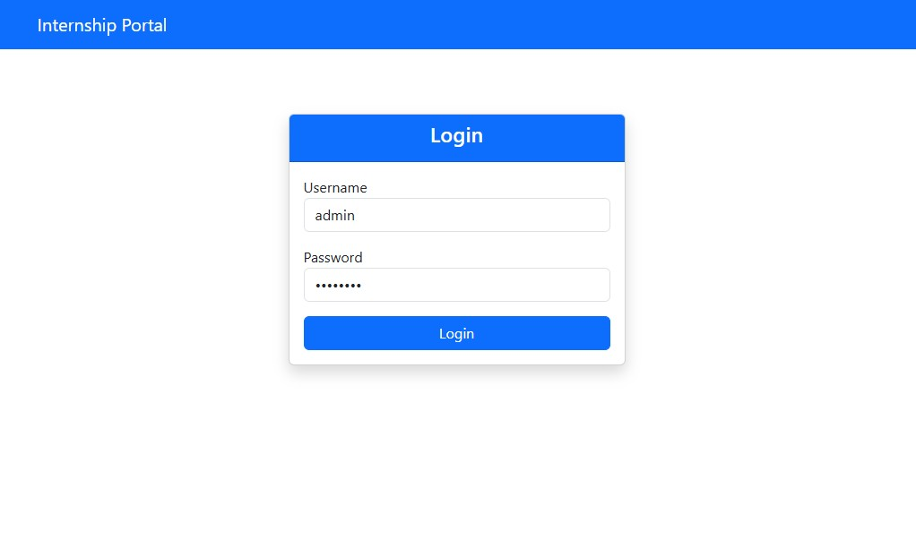

- Figure 8.3.2 – Administrator dashboard showing the available management modules.

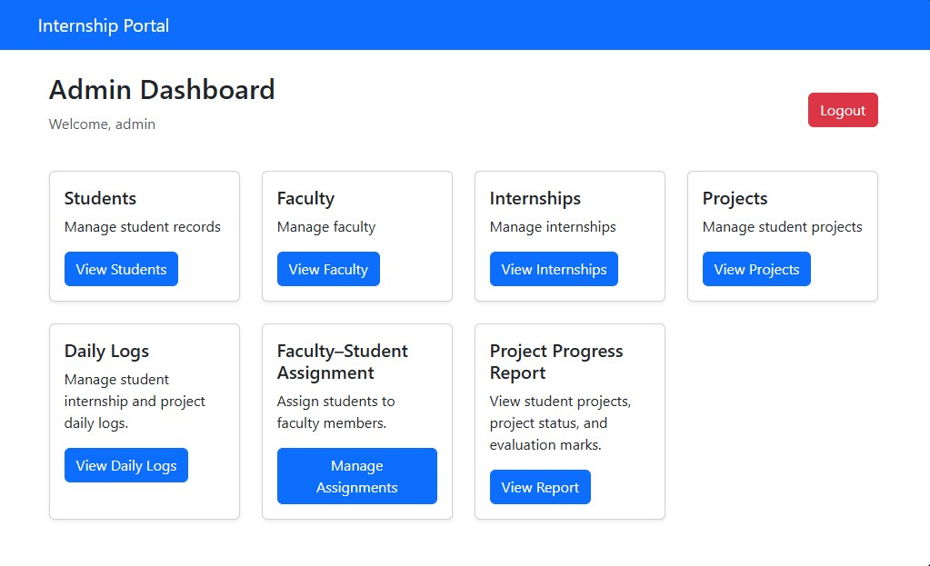

- Figure 8.3.3 – Student management page.

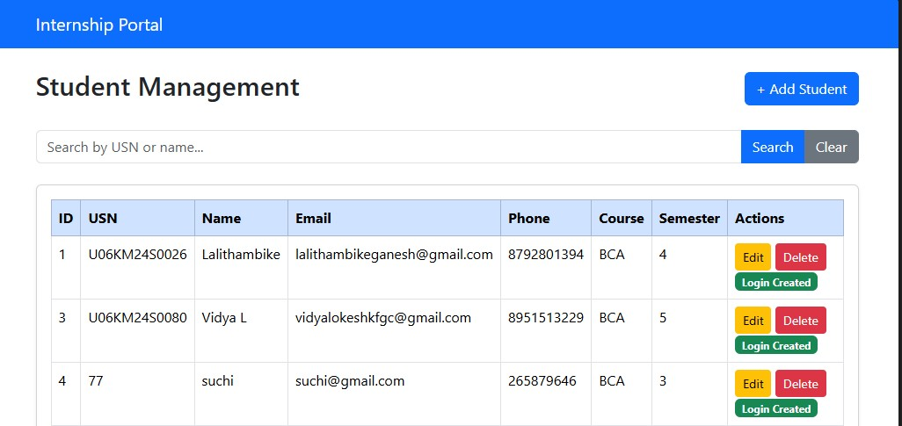

- Figure 8.3.4 – Faculty management page.

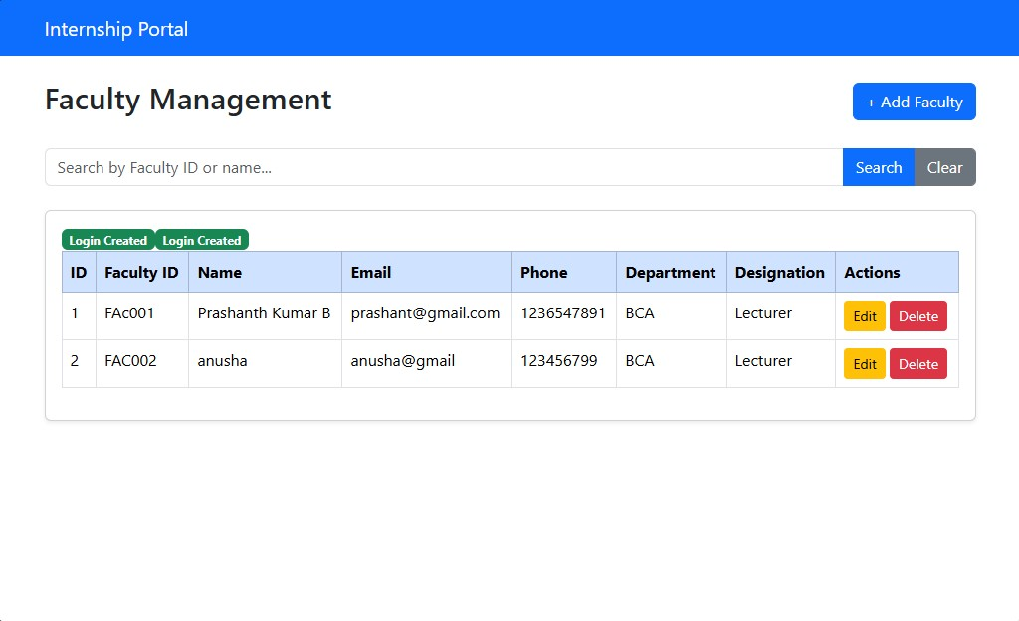

- Figure 8.3.5 – Project details page.

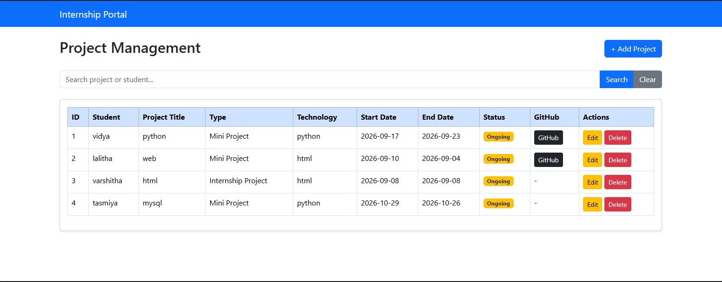

- Figure 8.3.6 – Faculty–student assignment page.

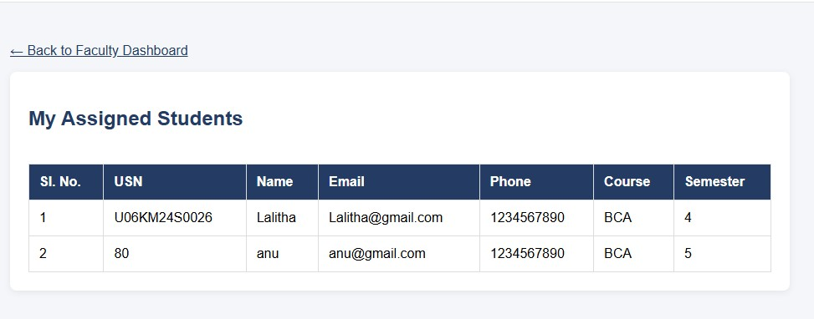

- Figure 8.3.7 – Student dashboard.

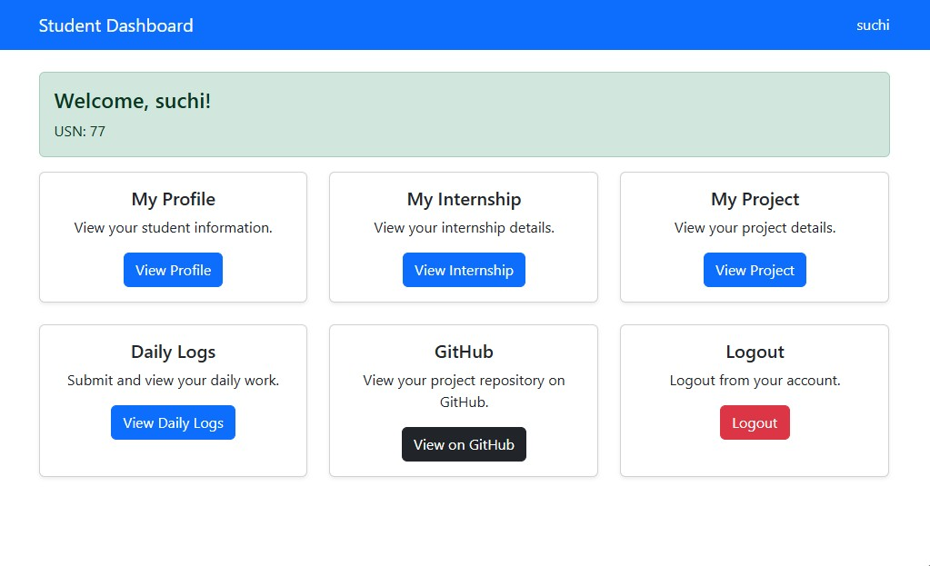

- Figure 8.3.8 – Student daily log entry page.
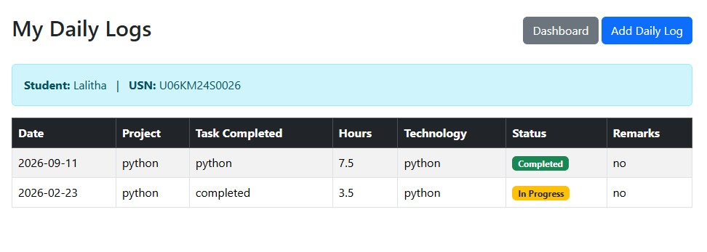

- Figure 8.3.9 – Faculty dashboard and daily log review page.

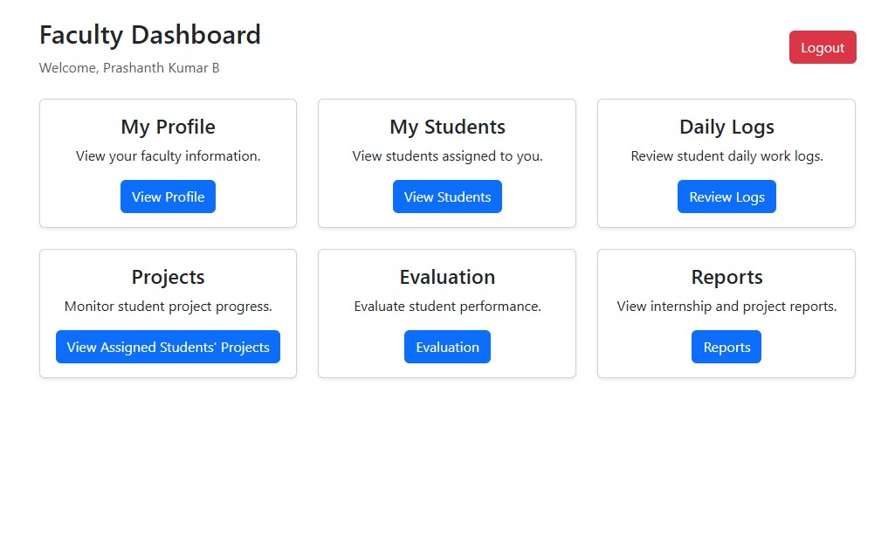
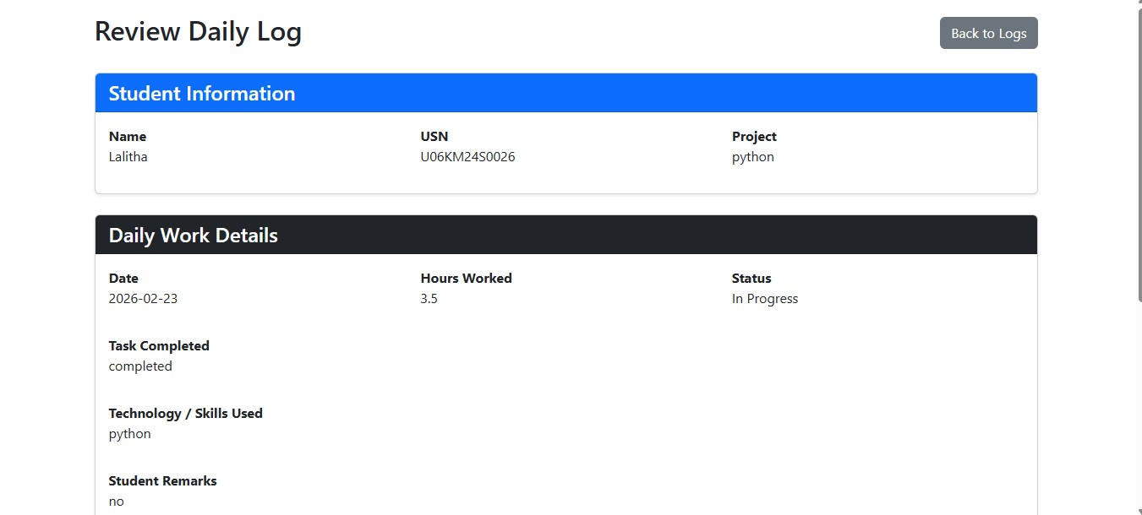

- Figure 8.3.10 – Project progress report page.

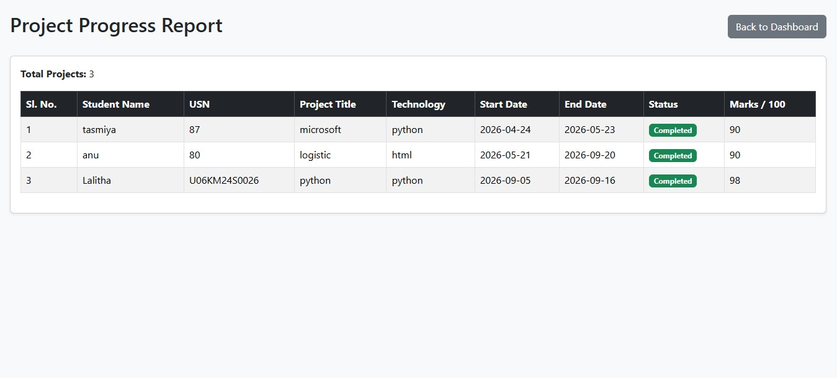

8.4 Source Code and Project Files
{% extends "base.html" %}

{% block content %}

<div class="container">

<div class="d-flex justify-content-between align-items-center mb-4">
<div>
<h2>Admin Dashboard</h2>
<p class="text-muted">
Welcome, {{ username }}
</p>
</div>

<a href="/logout" class="btn btn-danger">
Logout
</a>
</div>

<div class="row g-4">

<!-- Students -->
<div class="col-md-3">
<div class="card shadow-sm h-100">
<div class="card-body">
<h5>Students</h5>
<p>Manage student records</p>
<a href="/students" class="btn btn-primary">
View Students
</a>
</div>
</div>
</div>

<!-- Faculty -->
<div class="col-md-3">
<div class="card shadow-sm h-100">
<div class="card-body">
<h5>Faculty</h5>
<p>Manage faculty</p>
<a href="/faculty" class="btn btn-primary">
View Faculty
</a>
</div>
</div>
</div>

<!-- Internships -->
<div class="col-md-3">
<div class="card shadow-sm h-100">
<div class="card-body">
<h5>Internships</h5>
<p>Manage internships</p>
<a href="/internships" class="btn btn-primary">
View Internships
</a>
</div>
</div>
</div>

<!-- Projects -->
<div class="col-md-3">
<div class="card shadow-sm h-100">
<div class="card-body">
<h5>Projects</h5>
<p>Manage student projects</p>
<a href="/projects" class="btn btn-primary">
View Projects
</a>
</div>
</div>
</div>

<!-- Daily Logs -->
<div class="col-md-3">
<div class="card shadow-sm h-100">
<div class="card-body">
<h5 class="card-title">Daily Logs</h5>
<p class="card-text">
Manage student internship and project daily logs.
</p>
<a href="/daily-logs" class="btn btn-primary">
View Daily Logs
</a>
</div>
</div>
</div>

8.5 Learning Outcomes
- Improved understanding of Python programming and application logic.
- Practical experience with Flask routes and template rendering.
- Understanding of relational database design and MySQL connectivity.
- Experience implementing CRUD operations using an ORM.
- Understanding of login sessions and role-based access.
- Experience integrating student, faculty, project and daily log modules.
- Improved debugging, testing and documentation skills.
- Experience presenting a complete project workflow.

9. CONCLUSION

The six-week online Python internship through BeeSkilled Tech and Internship provided an opportunity to strengthen programming knowledge and apply it to a practical software development project. The College Internship & Project Management Portal was developed as a web-based application to organize student, faculty, internship and project-related activities.
Working with Python and Flask helped develop an understanding of web application routing, request processing, templates and session management. MySQL and SQLAlchemy provided practical exposure to relational database operations, data models and relationships. The implementation of role-based dashboards, student and faculty records, project information, faculty–student assignments, daily logs and project progress reporting demonstrated how separate modules can be integrated into a single application.
The project also highlighted the importance of testing complete workflows, maintaining database integrity, validating input and debugging errors systematically. Overall, the internship improved practical programming, problem-solving, application development and project documentation skills. The knowledge gained provides a useful foundation for further study and development of database-driven web applications.

10. REFERENCES AND BIBLIOGRAPHY

10.1 Books
- Downey, A. B. (2015). Think Python: How to Think Like a Computer Scientist (2nd ed.). O’Reilly Media.
- Grinberg, M. (2018). Flask Web Development: Developing Web Applications with Python (2nd ed.). O’Reilly Media.
- Ramakrishnan, R., & Gehrke, J. (2003). Database Management Systems (3rd ed.). McGraw-Hill.

10.2 Websites and Documentation
- Python Software Foundation. Python Documentation. https://docs.python.org/3/
- Pallets Projects. Flask Documentation. https://flask.palletsprojects.com/
- SQLAlchemy. SQLAlchemy Documentation. https://docs.sqlalchemy.org/
- MySQL. MySQL Reference Manual. https://dev.mysql.com/doc/
- Visual Studio Code. Documentation. https://code.visualstudio.com/docs
- W3Schools. HTML Tutorial. https://www.w3schools.com/html/
- W3Schools. CSS Tutorial. https://www.w3schools.com/css/

10.3 Bibliography
The above documentation and learning resources are listed as references for the Python language, Flask framework, SQLAlchemy, MySQL and web technologies discussed in this report. Add any official BeeSkilled course material, internship completion certificate or other resources actually used during the internship to this section.

APPENDIX A – PROJECT DEMONSTRATION CHECKLIST

- Start the MySQL service and confirm that the project database is available.
- Activate the Python virtual environment.
- Install dependencies listed in the project's requirements file.
- Run the Flask application using the documented startup command.
- Open the application in a web browser.
- Log in as administrator and demonstrate the administrative modules.
- Demonstrate student and faculty login access.
- Show faculty–student assignment and student daily log submission.
- Show faculty review of daily logs and the project progress report.
- Stop the application safely and explain the database backup procedure.

APPENDIX B – DETAILS TO COMPLETE BEFORE SUBMISSION

Field | Enter the correct information
Student name | TASMIYA R GHASI
UUCMS number | U06KM24S0087
BCA semester / academic year | 5th semester / 2026-2027
Internship start date | 09 June 2026
Internship completion date | 29 July 2026
Faculty guide | Prashanth Kumar B
Head of Department | Prashanth Kumar B
Principal | Ravindra K C

