Indexing in DBMS

What is Indexing?
An index helps in rapid access of database records by storing pointers to their actual disk location.

Indexes are created using a few database columns:
- The first column is the Search key that contains a copy of the primary key or candidate key of the table. These values are stored in sorted order so that the corresponding data can be accessed quickly.
Note: The data may or may not be stored in sorted order.
- The second column is the Data Reference or Pointer which contains a set of pointers holding the address of the disk block where that particular key value can be found.
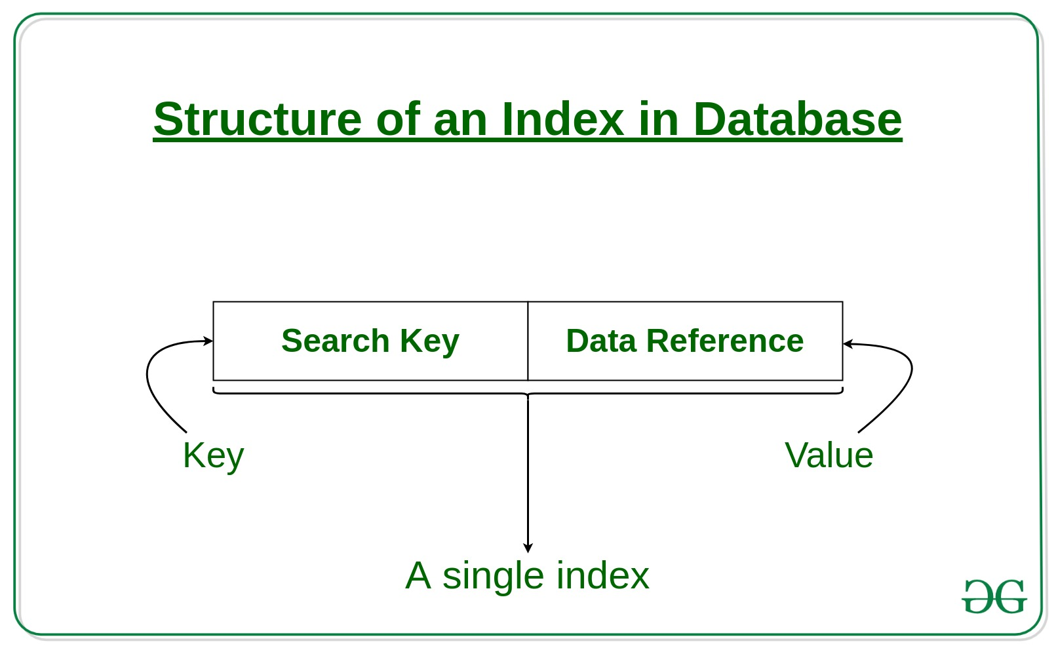

Types of Indexing in DBMS:

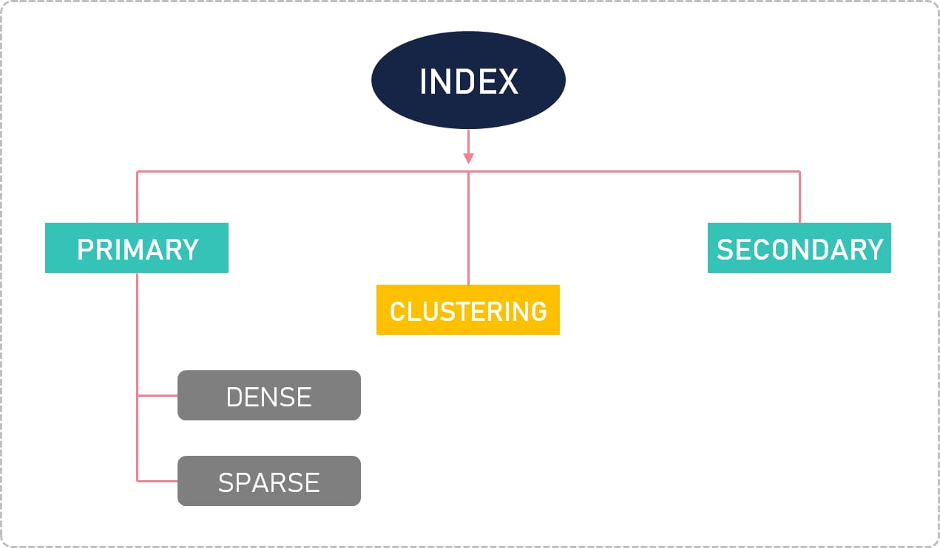
Indexing in Database is defined based on its indexing attributes. Two main types of indexing methods are:
- Primary Indexing
- Secondary Indexing

Primary Index in DBMS:
A primary index is an ordered file whose records are of fixed length with two fields: The first field is the same as the primary key of data file. The second field is a pointer to the data block where the primary key is available.

The primary Indexing in DBMS is also further divided into two types.
- Dense Index
- Sparse Index

Dense Index
In a dense index, a record is created for every search key valued in the database. This helps you to search faster but needs more space to store index records. In this Indexing, method records contain search key value and points to the real record on the disk.
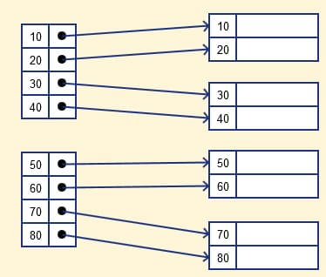

Sparse Index
It is an index record that appears for only some of the values in the file. Sparse Index helps you to resolve the issues of dense Indexing in DBMS. In this method of indexing technique, a range of index columns stores the same data block address, and w

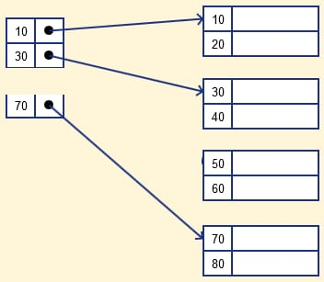

Secondary Index in DBMS:
The secondary Index in DBMS can be generated by a field which has a unique value for each record, and it should be a candidate key. It is also known as a non-clustering index.

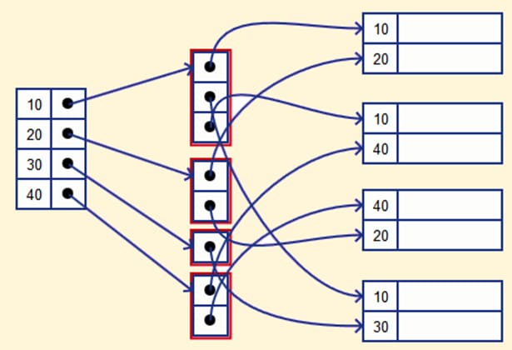

Clustering Index in DBMS:
In a clustered index, records themselves are stored in the Index and not pointers. Sometimes the Index is created on non-primary key columns which might not be unique for each record. In such a situation, you can group two or more columns to get the unique values and create an index which is called clustered Index. This also helps you to identify the record faster.
Example:
Let’s assume that a company recruited many employees in various departments. In this case, clustering indexing in DBMS should be created for all employees who belong to the same dept.
It is considered in a single cluster, and index points point to the cluster as a whole. Here, Department _no is a non-unique key.

