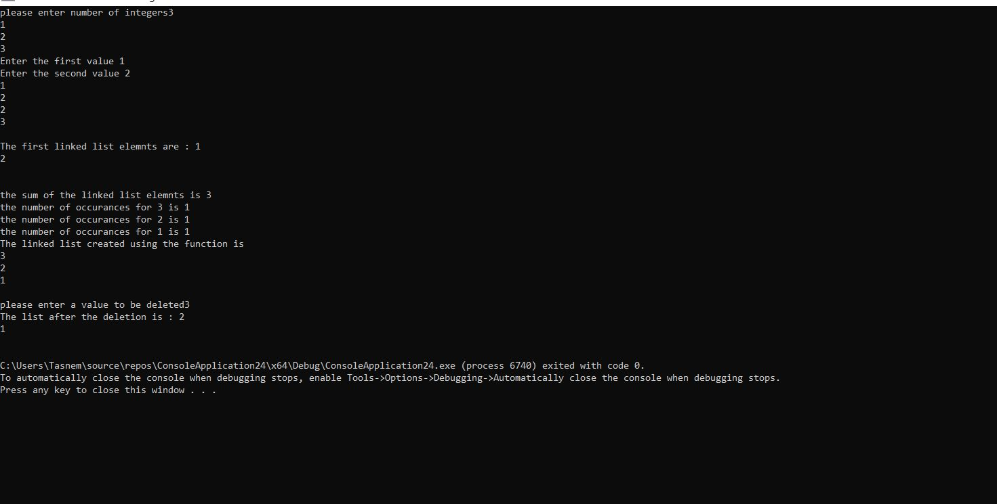

The first part is that the user was asked to enter the number of integers that will be inserted in the vector, and then the user entered the actual integers that will be inside the vector. After that, the user entered the first value and the second value which will be inserted after the second value, and then the program printed the output after the insertion of the second value after the first value.

Then in the line that follows, I created an object of the linked list class and added two elements to it and printed the elements of the linked list, and also calculated and printed the sum of the elements of the linked list.

Then I used the function that creates a linked list using a vector, so a linked list was created and it prnted the number of occurrences for each element in the linked list and then it printed its elements to the screen.

Then I asked the user to enter a value to be deleted, and when he entered the value I printed the linked list elements after the deletion.