Capstone C evidence report
Political context and study-abroad continuation
6,000 agency records, November 2023 to July 2026
Working title unchanged: A Data-Driven Model for Predicting Students' Intentions to Pursue Higher Studies Abroad. In this report, intention means the agency-recorded continuation decision: whether the student stays on the study-abroad pathway after intake.

1. Question
Political instability in Bangladesh between 2023 and 2026 changed whether students follow through on studying abroad. This work measures how much, identifies which student factors matter under each political condition, and sets the cutoff for an explainable early-warning tool counselors can use.
The classifier is the instrument. The results are the phase effect, the gap between a random split and a later political window, the drivers inside each phase, and a calibrated risk tier. Scores from Carballo-Mendívil et al. (2025) and Niyogisubizo et al. (2022) are not a leaderboard. Those methods were re-implemented on this dataset. Their published numbers use other students and other labels.
ID | Question
RQ1 | Does political phase at intake change continuation after academic and financial controls?
RQ2 | Which factors drive continuation, and do they shift across phases?
RQ3 | How well does a model trained on past periods predict an unseen later period?
RQ4 | Can a calibrated, explainable tool give counselors a usable risk tier?

H1: continuation rates differ by phase. H2: due diligence has a positive monotonic association with continuation inside every phase. H3: a random split overstates performance relative to forward-in-time validation. A drop under H3 is a finding.
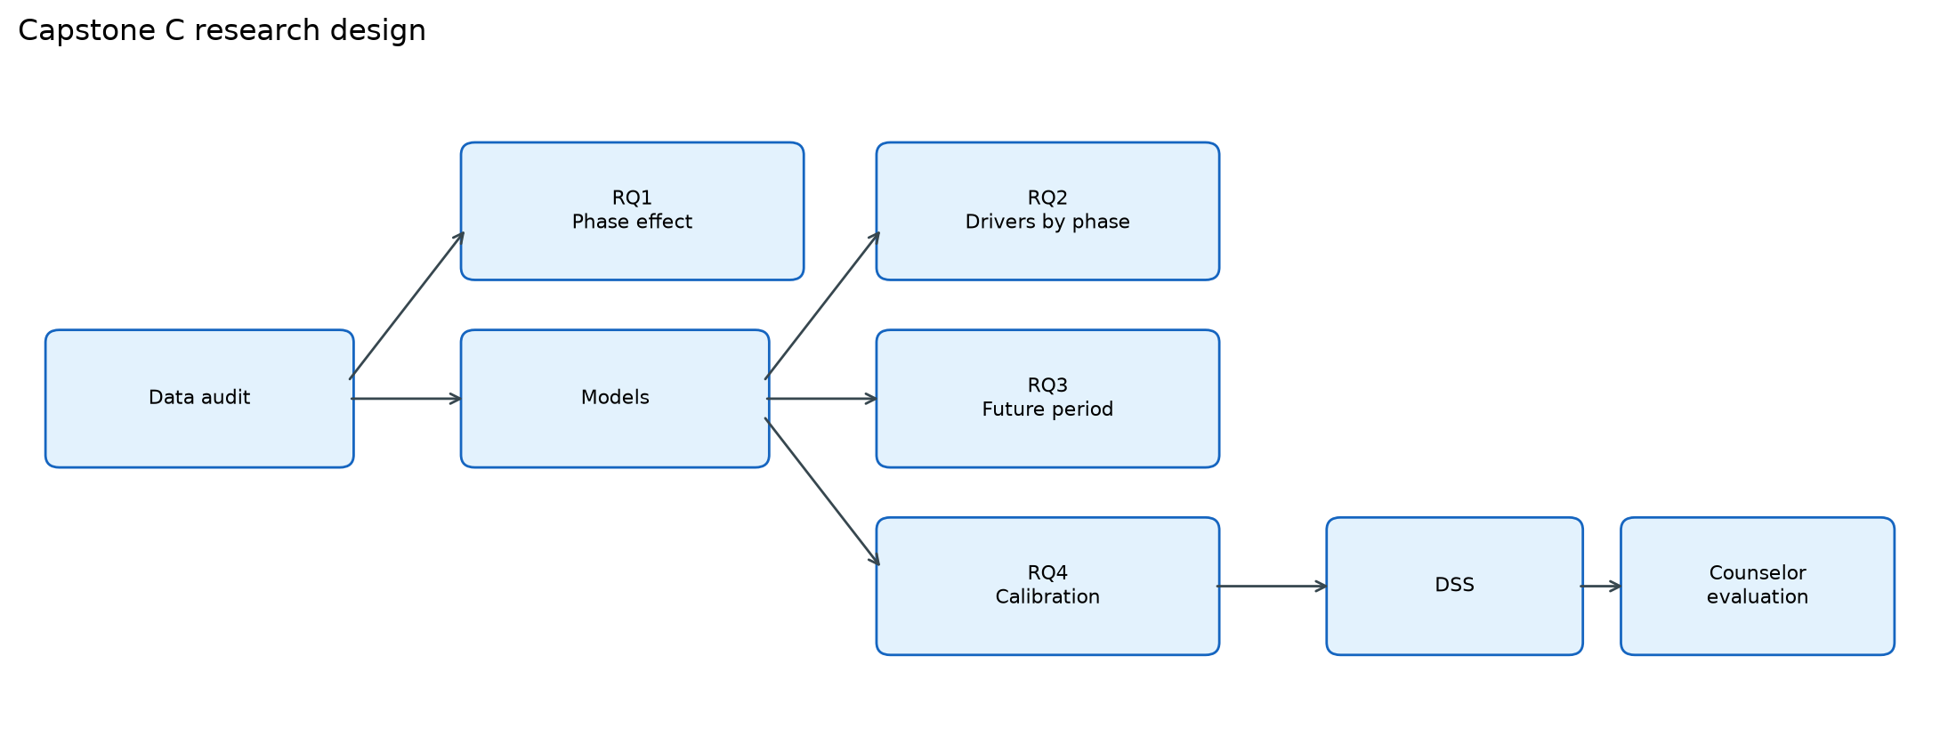
Figure 1. Research design. The audit feeds the phase test and the models. RQ4 is the only path into the tool.

2. Data
Five workbooks, 1,200 rows each, concatenated to 6,000. The modeling phase is the file period. The cell inside the workbook is wrong in two files: Stable is stored as Transitional, and Newly Elected is stored as Unstable. No missing values in the engineered table. GPA ranges from 2.00 to 3.99 (mean 3.158). Overall continuation is 52.20% (3,132 Yes, 2,868 No).
Phase | Window | Continuation
Stable | 1 Nov 2023 to 31 Mar 2024 | 63.75%
Unstable | 1 Apr 2024 to 7 Aug 2024 | 68.25%
Transitional phase 1 | 8 Aug 2024 to 30 Jun 2025 | 18.58%
Transitional phase 2 | 1 Sep 2025 to 31 Jan 2026 | 42.17%
Newly Elected | 15 Feb 2026 to 15 Jul 2026 | 68.25%

Due diligence (column Researched) is graded. Continuation is 22.20% at No (n = 2,243), 52.53% at Yes Low (1,009), 66.27% at Yes Medium (1,260), and 85.28% at Yes High (1,488).
Exact duplicate rows: 0. A fingerprint of name, result, course, country, institution, budget, due diligence, academic level, and continuation is shared by 1,004 rows. The only cross-phase overlap is Unstable with Newly Elected: 502 fingerprints. Ignoring academic level raises that overlap to 568. Names ending in a space and a number: 2,400 of 6,000. Unique names: 3,976. The modeling file stays at 6,000 rows. Dropping the 502 later copies leaves 5,498 rows, used only as the sensitivity set.

3. Phase effect (RQ1)
Continuation by phase: chi-square = 903.84, df = 4, p = 2.45e-194, Cramer's V = 0.388. H1 is supported. V sits between a medium and a large association.
Inside each phase, Spearman rank correlation of due-diligence level with continuation is positive and significant: Stable 0.249, Unstable 0.697, Transitional phase 1 0.500, Transitional phase 2 0.676, Newly Elected 0.748. H2 is supported in every phase. The Stable gradient is the shallow one, because continuation is already 53% at Due Diligence = No. In Unstable and Newly Elected the rate jumps from No to Yes Low and then sits near the ceiling.
Logistic regression, Stable as the reference, controls for z-scored GPA, due diligence (0 to 3), academic level (0 to 2), and budget level (0 to 2). Date features are excluded so phase is not a second copy of the calendar. Intervals are 400-resample bootstrap percentiles.
Term | Odds ratio | 95% CI
Due diligence, per level | 4.60 | 4.25 to 5.06
Academic level, per step | 2.77 | 2.04 to 3.79
Budget level, per step | 1.72 | 1.56 to 1.87
GPA (z) | 0.97 | 0.86 to 1.07
Unstable vs Stable | 1.42 | 1.15 to 1.75
Newly Elected vs Stable | 1.10 | 0.89 to 1.38
Transitional phase 2 vs Stable | 0.14 | 0.10 to 0.17
Transitional phase 1 vs Stable | 0.025 | 0.018 to 0.032

After the controls, both transitional windows remain far below Stable. Unstable is above Stable. Newly Elected is not distinguishable from Stable. GPA's interval includes 1. Due diligence is the largest student-level term: each step multiplies the odds of continuation by about 4.6.
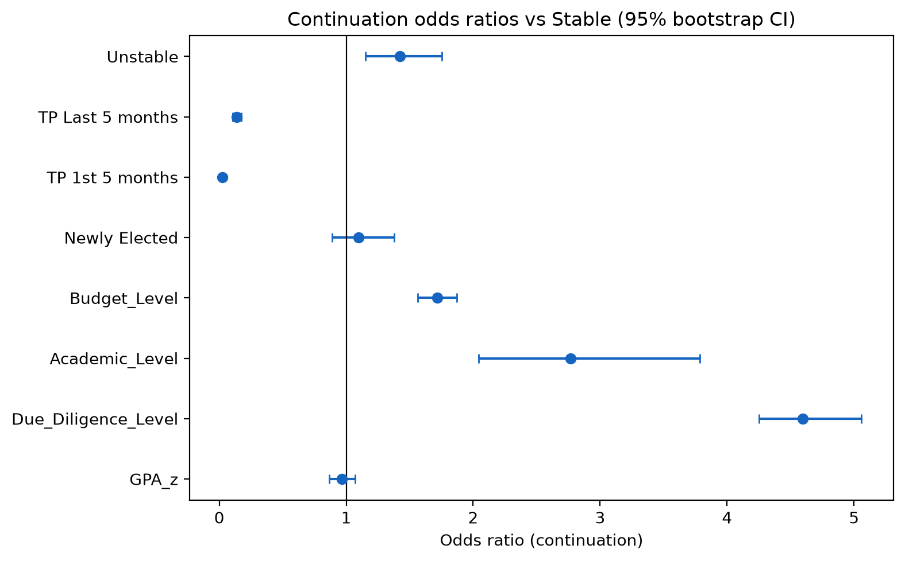
Figure 2. Odds ratios for continuation. The vertical line is 1 (same odds as the Stable reference for phase terms).

4. What the model adds
Repeated stratified cross-validation: 5 repeats x 5 folds, 95% t intervals on 25 fold F1 scores. Trees use 100 estimators. The stacking row is Random Forest + XGBoost + Gradient Boosting with a logistic meta-learner and 2-fold inner CV. It is not the single-split feedforward stack in the Paper 2 results.
Model | CV F1 | 95% CI
Gradient Boosting | 0.857 | 0.854 to 0.860
XGBoost | 0.854 | 0.851 to 0.857
Random Forest | 0.847 | 0.844 to 0.850
Logistic regression | 0.840 | 0.837 to 0.843
Stacking (RF+XGB+GB) | 0.839 | 0.835 to 0.843
Phase-only logistic | 0.714 | 0.709 to 0.719
Majority class (always Yes) | 0.686 | 0.686 to 0.686

Majority accuracy on the held-out split is 0.522. Phase alone reaches F1 0.714. The full logistic reaches 0.840. That gap is the student-feature lift on a random split. It does not replace the forward test. Nadeau-Bengio corrected resampled t-test: Gradient Boosting minus logistic, mean F1 difference 0.017, p < 0.001. Gradient Boosting minus the repeated stack, difference 0.018, p = 0.006. On the single random_state=42 holdout, McNemar agrees for GB vs logistic (p = 0.009) and does not separate GB from that stack (p = 0.185). Gradient Boosting is the deployed model because TreeExplainer SHAP applies to it.
Nine duplicate encodings were dropped (budget written four ways, due diligence written twice, phase number, academic numeric codes, result band, GPA-academic match). Held-out F1 moves from 0.868 on 22 features to 0.868 on 13. The extra columns were not buying a different decision. The production model still carries the 22, which is why SHAP splits one factor across several bars.

5. A later political window (RQ3)
Forward tests and leave-one-phase-out drop Political_Phase, Phase_Number, Year, and Days_Since_First_Intake. Those columns identify the window. The random-split model keeps them. All rows below are Gradient Boosting at a 0.50 decision threshold.
Protocol | Held out | F1 | AUC | n test
Random split | 20% mixed phases | 0.868 | 0.951 | 1,200
Train through phase 1, test phase 2 | Transitional phase 2 | 0.653 | 0.821 | 1,200
Train through phase 2, test next | Newly Elected | 0.911 | 0.973 | 1,200
Leave one phase out | Stable | 0.532 | 0.600 | 1,200
Leave one phase out | Unstable | 0.864 | 0.941 | 1,200
Leave one phase out | Transitional phase 1 | 0.468 | 0.847 | 1,200
Leave one phase out | Transitional phase 2 | 0.655 | 0.822 | 1,200
Leave one phase out | Newly Elected | 0.911 | 0.973 | 1,200

H3 is supported by Transitional phase 2: F1 falls by 0.215 relative to the random split. Quote 0.653, not 0.868, as the estimate for a later window the model has not seen. Newly Elected does not fall. Leave-one-phase-out on Stable is weak (F1 0.532), and on Transitional phase 1 the F1 is 0.468 because recall is 0.982 while precision is 0.307: the model over-calls continuation in a window whose base rate is 19%.
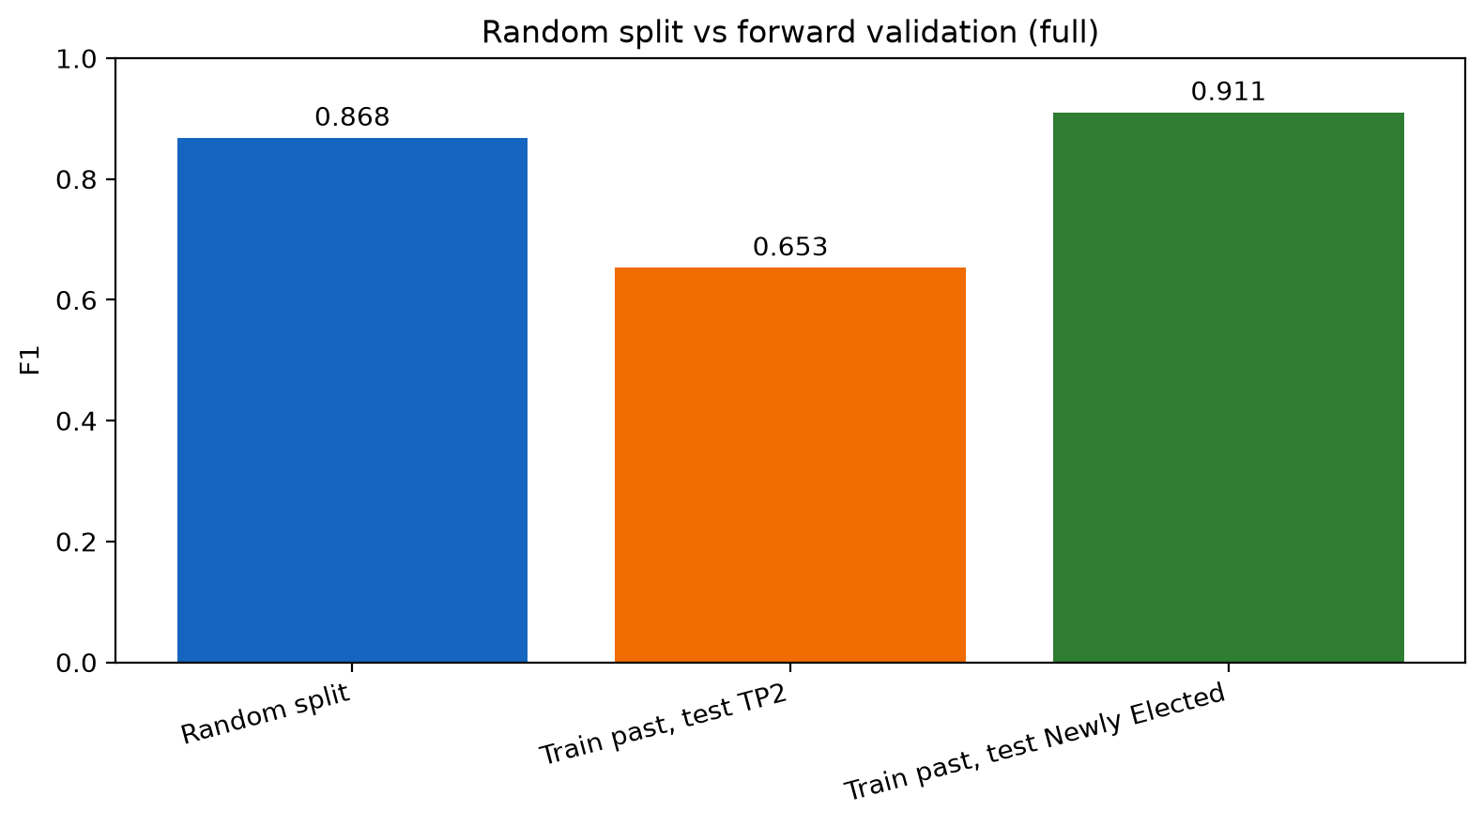
Figure 3. Random-split F1 against two forward tests on the full 6,000-row file.
Deduplicated file (5,498 rows, earliest fingerprint kept). Repeated-CV Gradient Boosting F1 is 0.849 (0.844 to 0.854), against 0.857 on the full file. Forward F1 on Transitional phase 2 is unchanged at 0.653. Forward F1 on Newly Elected is 0.932 on the 698 rows that did not match an earlier record. Identical rows in both the training window and that test window are not what holds the Newly Elected score up. Leave-one-phase-out on Unstable does move, from 0.864 to 0.775, because on the full file the Newly Elected copies sit in the training side of that split.

6. Drivers, errors, and the cutoff
On the production Gradient Boosting model, mean absolute SHAP is dominated by due diligence in every phase. The production matrix stores that factor three ways (Researched, Researched_Level, Researched_Bin), so the bars split one signal. Days since first intake is large in Stable and Newly Elected and small in Unstable. Budget appears, split across its encodings, and is smaller than due diligence in every phase. Section 4 already showed that collapsing those encodings does not change F1.
Calibration on the held-out 1,200: uncalibrated Brier 0.0904, isotonic Brier 0.0901. The probabilities were already close to the diagonal. The low-risk cutoff is the lowest calibrated threshold with precision at least 0.90. That threshold is 0.54 (precision 0.901, recall 0.800, 46% of the test set called low risk). A 0.94 precision target lands at 0.61. Medium risk stays 0.40 up to 0.54. High risk is below 0.40. The F1-max threshold, 0.33, is recorded and is not the counseling cutoff. The decision-support app reads 0.54 from results_paper1/operating_point.json.
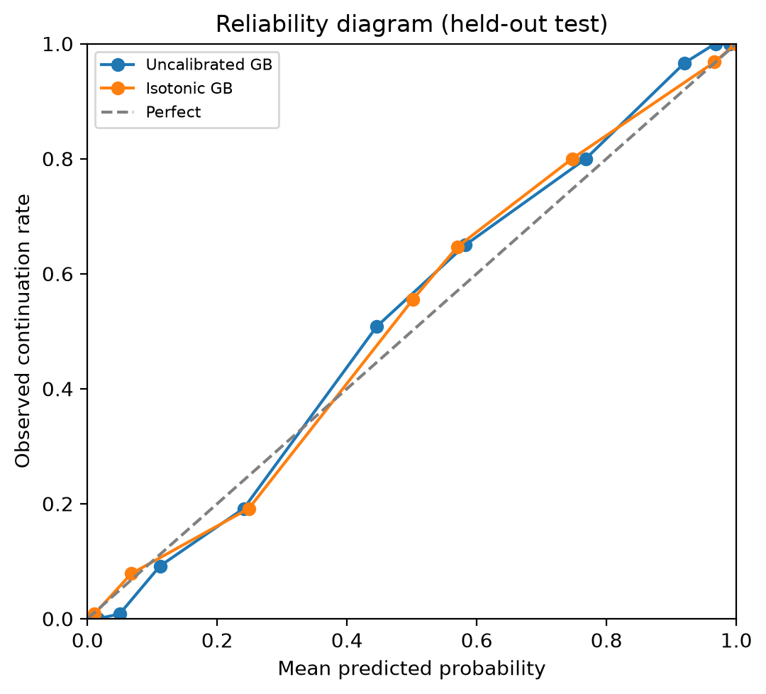
Figure 4. Reliability of the production Gradient Boosting model on the held-out test.
At cutoff 0.54 on the same holdout: 1,034 correct, 112 false negatives (continued, scored below 0.54), 54 false positives. False negatives concentrate at Due Diligence = No (74 of 112) and are highest in Stable (FN rate 0.186). Newly Elected has 12 false negatives and 0 false positives in this split. Budget band does not separate the errors (FN rate about 0.08 to 0.10 in each band).
Subgroup | n | False negatives | False positives
No due diligence | 450 | 74 | 8
Yes Low | 206 | 13 | 8
Yes Medium | 261 | 14 | 22
Yes High | 283 | 11 | 16
Stable | 204 | 38 | 36
Unstable | 248 | 23 | 1
Transitional phase 1 | 257 | 22 | 6
Transitional phase 2 | 240 | 17 | 11
Newly Elected | 251 | 12 | 0

7. Counselor check, not yet run
The protocol asks 3 to 5 counselors at the source agency to review 10 anonymized held-out cases each. Before the model, the counselor flags follow-up. After the probability, tier, and SHAP plot, they say whether the flag changed. Measures: agreement with the tier, five Likert items, and the 10-item System Usability Scale (median below 68 is a negative result and stays in the thesis). Ten cases are already written, names removed, labels held in a separate key. This is a design. It is not a completed user study.

8. Verdict
Claim | Result
H1, phase differs | Supported. V = 0.388. Transitional windows stay low after controls.
H2, due diligence | Supported in all five phases. Odds ratio 4.60 per level.
H3, random split overstates | Supported on Transitional phase 2: F1 0.868 to 0.653.
Duplicates inflate the 86% | Not in any material way. CV F1 0.857 to 0.849.
22 features needed | No. 13 features, F1 change -0.0005.
Cutoff 0.70 or 0.33 | Replaced. Low risk is calibrated probability 0.54.

Three facts are not in the spreadsheet and still need a written answer from the agency. Why Unstable and Newly Elected share fingerprints. Whether due diligence is recorded before the continuation outcome. If it is filled in afterward, it is leakage and the strongest predictor cannot be used at counseling time. What operational rule marks Continuation = Yes.
The tool does not decide continuation. A false negative is a student who continued and was not placed in the low-risk band. Older accuracy near 91% came from a file that was about 75% non-continuation. The revised file is 52% continuation, so the majority floor is about 52%, and 86% is a larger lift over that floor than 91% was over 75%.
Sources for every number: experiments/results/ (DATA_AUDIT, E2 through E8, dedup tags) and docs/THESIS_CORE.md, docs/LIMITATIONS.md, docs/COUNSELOR_EVALUATION_PROTOCOL.md.

