Supervisor update
Proposed revision for Capstone C
A Data-Driven Model for Predicting Students' Intentions to Pursue Higher Studies Abroad
8 October 2026

1. Purpose
This note asks for approval of a sharper research design for Capstone C. The topic, the title, the agency dataset, and the decision-support tool stay. What changes is the question the thesis answers, the tests used to answer it, and the claims we are willing to defend.
The analyses below have already been run on the revised 6,000-record file, so the proposal is not only a plan. Full tables and figures are in docs/CAPSTONE_C_REPORT.docx. This note is the decision document.

2. What the panel raised
Two comments. The goal was unclear. The work looked like a one-semester classifier project rather than a year-long capstone.
Our reading: Capstone B delivered a pipeline (feature engineering, two re-implemented published methods, ablation, SHAP, risk tiers, and the Streamlit tool) but presented it as a model leaderboard. The political-phase question, which is the part that is specific to this dataset, was one feature among many. Evaluation was a single random split, with no baseline, no interval, no test against a later political period, and no check that the counseling cutoff was earned.

3. What we propose to keep
Item | Position
Title | Unchanged.
Population and period | Bangladeshi applicants, five political windows, Nov 2023 to Jul 2026.
Data | The revised 6,000-row agency file. We do not collect a new dataset.
Tool | The existing explainable decision-support app. Counselors decide. The model does not.
Literature methods | Kept as re-implementations on our data. We will not claim to beat those papers.

4. What we propose to change
Problem statement, for the opening of the thesis and the defense:
Political instability in Bangladesh between 2023 and 2026 changed whether students follow through on studying abroad. We measure how much, identify which student factors matter most under each political condition, and deliver an explainable early-warning tool counselors can use.
Target. The title says intentions. The recorded outcome is Continuation: whether the student stays on the study-abroad pathway. We propose to define the target that way in the thesis, and to stop describing it as a survey of stated intention. The exact agency rule for marking Yes is still an open question for the data provider.
Research questions we want adopted:
 | Question
RQ1 | Does political phase at intake change continuation after academic and financial controls?
RQ2 | Which factors drive continuation, and do they shift across phases?
RQ3 | How well does a model trained on past periods predict an unseen later period?
RQ4 | Can a calibrated, explainable tool give counselors a usable risk tier?

Hypotheses:
 | Statement | How it is tested
H1 | Continuation rates differ by phase. | Chi-square, Cramer's V, logistic odds ratios.
H2 | Due diligence is positively associated with continuation in every phase. | Spearman within phase, plus the logistic term.
H3 | A random split overstates performance relative to a future period. | Forward validation and leave-one-phase-out. A drop is a result, not a failed model.

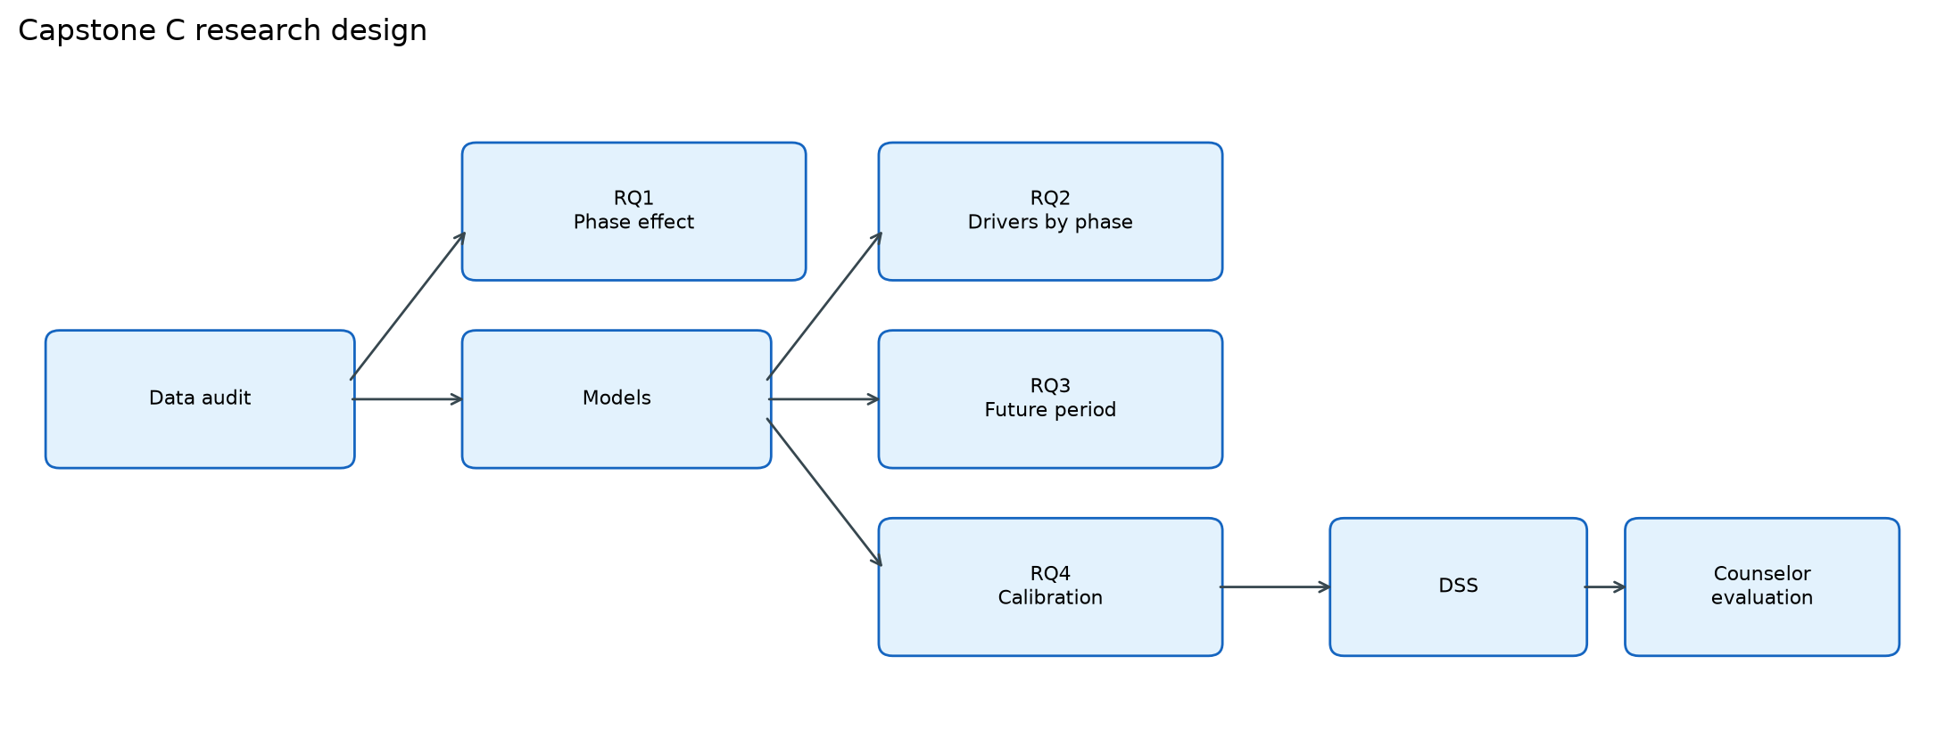
Figure 1. Proposed research design. Each block answers one question. The tool sits only on the calibrated path.

5. Method changes already implemented
These are the additions we propose to treat as part of the thesis method, not as optional appendix checks.
Change | Why it is in the thesis
Data audit | Dates, labels, missingness, and cross-file copies are documented before any score is quoted.
Phase statistics | RQ1 is a statistical claim, not a feature-importance rank.
Baselines and 5x5 cross-validation | 86% is reported against majority class and a phase-only model, with a 95% interval and a paired test.
Forward and leave-one-phase-out tests | RQ3. Window columns are removed so the model cannot read the period off the date.
Reduced feature set | Budget and due diligence were encoded more than once. We show the extras do not change F1.
Calibration | The low-risk cutoff is the lowest probability that still holds 90% precision. It replaces a judgment threshold.
Error profile and phase SHAP | Where the model fails, and whether the drivers move when the political window moves.
Deduplicated sensitivity run | The 6,000-row file is kept. Scores are also reported after later copies of an earlier fingerprint are removed.
Counselor protocol | Designed, not yet run. Ten anonymized cases, five Likert items, System Usability Scale.

6. What those tests currently show
Numbers are from the revised file. They are here so the proposed design can be judged against a result, not against a hope. Detail is in the evidence report.
Question | Current result
Does phase matter? (H1) | Yes. Chi-square p about 0, Cramer's V = 0.39. After controls, Transitional phase 1 has odds ratio 0.025 and phase 2 has 0.14 versus Stable. Newly Elected is not separable from Stable (odds ratio 1.10, interval includes 1).
Does due diligence matter in every phase? (H2) | Yes. Rank correlation is positive in all five phases. Each level multiplies the odds of continuation by about 4.6.
Is 86% above a trivial model? | Yes. Majority F1 is 0.69 (accuracy 0.52). Phase-only F1 is 0.71. Full logistic is 0.84. Gradient Boosting is 0.857 (95% CI 0.854 to 0.860) and is higher than logistic (p < 0.001).
Does a random split overstate a future window? (H3) | Yes for the next hard window. Random-split F1 is 0.868. Training on earlier periods and testing on Transitional phase 2 gives F1 0.653. Newly Elected stays high (0.911).
Do the 502 copied rows create the 86%? | No. After removing them, cross-validated F1 is 0.849. The phase 2 forward score stays 0.653. One leave-one-phase-out score does drop (Unstable, 0.864 to 0.775), because those copies were on the training side of that split.
Were 22 features required? | No. Thirteen features give held-out F1 0.868, the same as 22.
What cutoff should the tool use? | 0.54. That is the lowest calibrated threshold with held-out precision of at least 0.90. The F1-maximum threshold of 0.33 is recorded and is not the counseling cutoff.

Proposed reporting rule: the random-split score is the in-period ceiling. The forward score on an unseen window is the number used when we talk about deployment. Both appear. We do not lead with 0.868 alone.
Proposed model rule: Gradient Boosting remains the model inside the tool, because the explanation method fits it. A repeated stack of Random Forest, XGBoost, and Gradient Boosting did not beat it. The separate Paper 2 feedforward stack is a different procedure on one split, and we will describe it that way.

7. Claims we propose not to make
We will state these limits in the thesis, not only in an appendix.
We will not say | We will say instead
We outperformed the two published papers. | We re-ran their training procedures on our records. Their published scores use other students and other labels.
Accuracy near 91% from the earlier file is the current result. | That file was about 75% non-continuation. The revised file is 52% continuation. The majority floor changed, so the percentages are not comparable.
The tool decides whether a student continues. | The counselor decides. At the 0.54 cutoff the holdout has 112 false negatives and 54 false positives out of 1,200.
The counselor study is finished. | The protocol and the case sheet exist. The study has not been run.
Due diligence is known to be available at counseling time. | It is the strongest predictor. If the agency records it after the outcome, it is leakage and cannot be used in the tool.

8. Data points that still need the agency
The audit found three issues the spreadsheet cannot settle. We propose to leave them as open limitations until the agency writes back, and not to silently drop rows or silently keep the strongest predictor.
First, 502 fingerprints match between the Unstable file and the Newly Elected file (568 if academic level is ignored). Both files also show 68.25% continuation. We need a written reason. Until then, both the 6,000-row results and the 5,498-row results stay in the thesis.
Second, whether Due Diligence (No, Yes Low, Yes Medium, Yes High) is filled in before Continuation. Third, the operational rule for Continuation = Yes.
Two file labels were wrong and have already been corrected in the pipeline, not in a hidden edit: the Stable workbook stores the phase as Transitional, and the Newly Elected workbook stores it as Unstable. Modeling uses the file period.

9. Decisions requested
We are asking for a yes, a no, or a rewrite on each line before chapter drafting.
# | Proposed decision
1 | Adopt the problem statement in section 4 as the thesis question.
2 | Adopt RQ1 to RQ4 and H1 to H3.
3 | Define the target as agency-recorded continuation, and say so wherever the title says intention.
4 | Report the random-split score and the forward score together, and use the forward score as the deployment estimate.
5 | Keep Gradient Boosting as the model in the tool.
6 | Set the low-risk cutoff at calibrated probability 0.54, with medium risk from 0.40 to 0.54.
7 | Keep the full file, and also report the deduplicated sensitivity results. Do not delete the 502 rows quietly.
8 | Treat the counselor study as the remaining external piece, and do not describe it as completed.

Companion files: docs/CAPSTONE_C_REPORT.docx (numbers and figures), docs/THESIS_CORE.md (question and design), docs/LIMITATIONS.md, docs/COUNSELOR_EVALUATION_PROTOCOL.md.

