Results report
Revised 6,000-record study and the model selected for the project
Held-out test: 1,200 rows, stratified split, random_state=42

1. What these numbers are
All model scores below are on the revised agency file: four-level due diligence (No, Yes Low, Yes Medium, Yes High) and 52.2% continuation. They are not the old yes/no file, where continuation was about 25% and accuracy sat near 91%. A constant No on that old file already scored about 75%. On this file a constant Yes scores 52.2%.
Training uses 4,800 rows. The test scores use the other 1,200. Nothing here is accuracy on all 6,000 rows at once.

2. Data
Phase | Continuation | n
Stable | 63.75% | 1,200
Unstable | 68.25% | 1,200
Transitional phase 1 | 18.58% | 1,200
Transitional phase 2 | 42.17% | 1,200
Newly Elected | 68.25% | 1,200
Overall | 52.20% | 6,000

Due diligence continuation: No 22.2% (n=2,243), Yes Low 52.5% (1,009), Yes Medium 66.3% (1,260), Yes High 85.3% (1,488). Exact duplicate rows: 0. Unstable and Newly Elected share 502 fingerprints (568 if academic level is ignored). The Stable file stores the phase cell as Transitional, and the Newly Elected file stores it as Unstable. Modeling uses the file period. The 6,000-row file is kept. A sensitivity set with the 502 later copies removed has 5,498 rows.

3. Phase effect
Continuation by phase: chi-square 903.84, df 4, p = 2.45e-194, Cramer's V = 0.388. H1 is supported. Due diligence rank-correlates with continuation inside every phase (Spearman 0.25 in Stable up to 0.75 in Newly Elected). H2 is supported. In a logistic model with GPA, due diligence, academic level, and budget, and with Stable as the reference, each due-diligence step has odds ratio 4.60 (95% CI 4.25 to 5.06). Transitional phase 1 odds ratio is 0.025 and phase 2 is 0.14. Unstable is 1.42. Newly Elected is 1.10 and its interval includes 1.
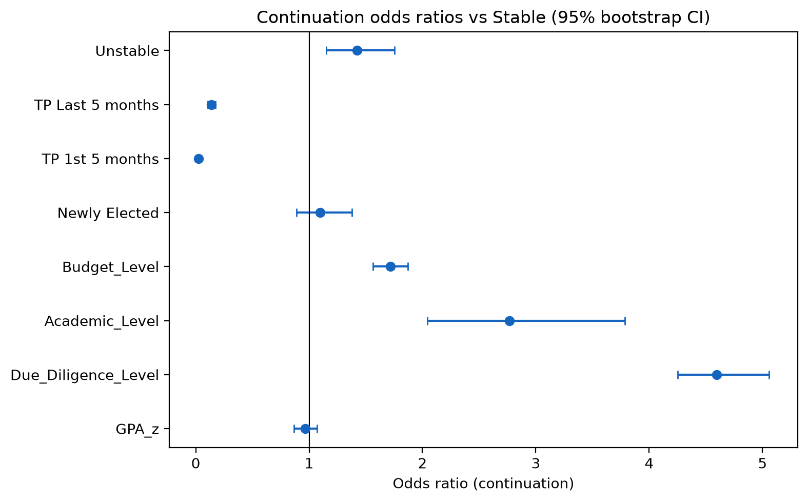
Figure 1. Continuation odds ratios versus Stable. Intervals are 400-resample bootstrap percentiles.

4. Every model on the held-out test
Paper 1 undersamples the training fold, which was built for an imbalanced target. Paper 2 does not. Threshold 0.50 unless noted. The legacy logistic row at 89.5% accuracy is the old imbalanced pipeline and is not a result on this file.
Model | Thr. | Accuracy | Precision | Recall | F1 | AUC
Stack (RF + XGB + GB, neural net) | 0.50 | 0.8683 | 0.8493 | 0.9089 | 0.8781 | 0.9501
Gradient Boosting (chosen) | 0.50 | 0.8642 | 0.8789 | 0.8578 | 0.8682 | 0.9513
XGBoost, F1-max cutoff | 0.29 | 0.8517 | 0.8035 | 0.9473 | 0.8695 | 0.9484
XGBoost tuned | 0.50 | 0.8567 | 0.8771 | 0.8435 | 0.8599 | 0.9484
XGBoost, Paper 2 defaults | 0.50 | 0.8517 | 0.8636 | 0.8498 | 0.8567 | 0.9485
Random Forest, Paper 2 | 0.50 | 0.8525 | 0.8547 | 0.8642 | 0.8594 | 0.9413
Random Forest, Paper 1 | 0.50 | 0.8475 | 0.8649 | 0.8387 | 0.8516 | 0.9409
Logistic regression, Paper 1 | 0.50 | 0.8458 | 0.8862 | 0.8083 | 0.8454 | 0.9026
LightGBM, Paper 1 | 0.50 | 0.8442 | 0.8628 | 0.8339 | 0.8481 | 0.9434

Confusion matrix, Gradient Boosting at 0.50: TN 500, FP 74, FN 89, TP 537. Stack at 0.50: TN 473, FP 101, FN 57, TP 569.
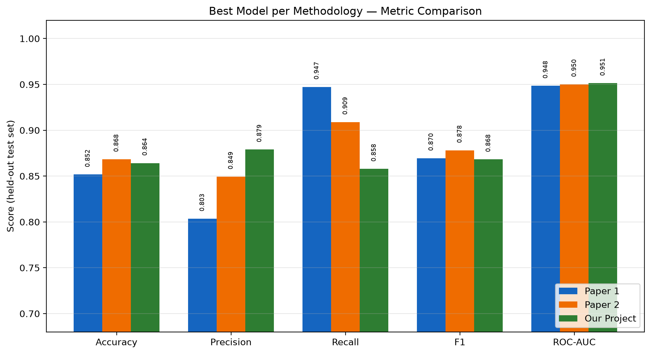
Figure 2. Best run of each procedure on the same 1,200-row test. Paper 2 is the stack. The project model is Gradient Boosting.
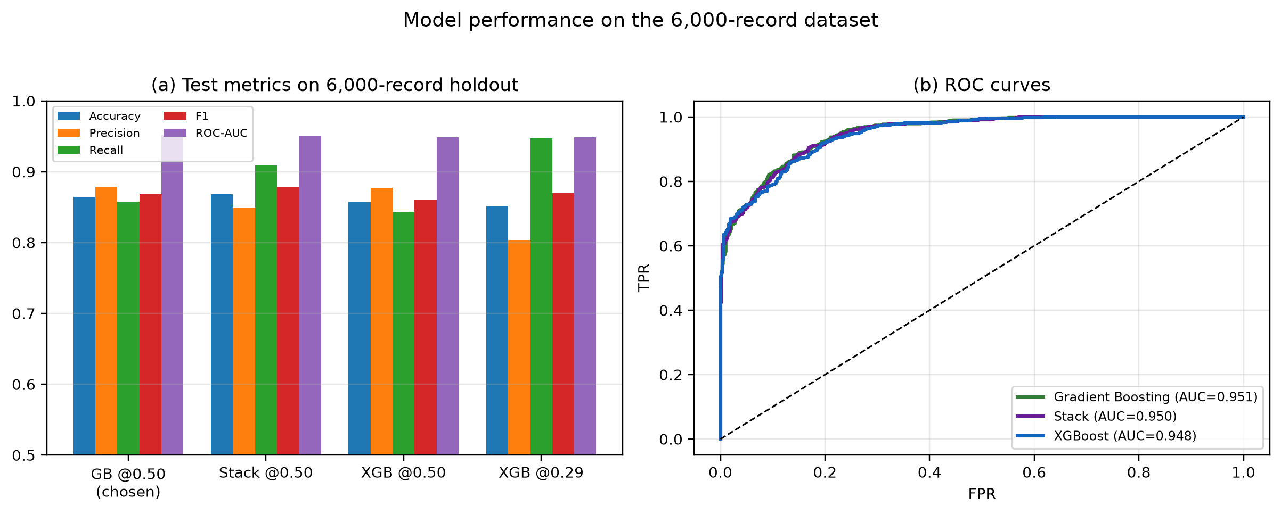
Figure 3. Held-out metrics and ROC curves for the chosen Gradient Boosting model, the stack, and XGBoost.

5. Could a different fit score higher?
Twelve candidates were ranked by 5-fold accuracy on the training split only. The test set was scored after that ranking. Differences of a few tenths of a point sit inside the fold-to-fold movement (Gradient Boosting's CV accuracy standard deviation is 0.017).
Model | CV accuracy | CV F1 | CV AUC | Locked test accuracy
GB 200 trees, depth 4 | 0.842 | 0.850 | 0.941 | 0.860
XGBoost, Paper 2 settings | 0.840 | 0.848 | 0.940 | 0.852
GB current, 100 trees, depth 3 | 0.840 | 0.848 | 0.941 | 0.864
GB 300 trees, depth 3 | 0.840 | 0.848 | 0.940 | not selected
Stack, logistic meta-learner | 0.839 | 0.848 | 0.940 | 0.863
XGBoost with Paper 1 undersampling | 0.838 | 0.843 | 0.937 | not selected
HistGradientBoosting | 0.835 | 0.842 | 0.935 | not selected
LightGBM 300 | 0.834 | 0.842 | 0.934 | not selected
Random Forest 200 | 0.834 | 0.842 | 0.931 | not selected
Logistic regression | 0.834 | 0.836 | 0.897 | not selected

The training-set winner (deeper Gradient Boosting) scored 0.860 on the locked test. The current Gradient Boosting scored 0.864, with F1 0.868, AUC 0.951, and MCC 0.728. The neural-net stack's 0.868 test accuracy is about five extra correct rows. The cross-validated stack did not beat Gradient Boosting. Undersampling XGBoost, which helped on the old 75% No file, is worse here.

6. Repeated cross-validation, baselines, and a reduced feature set
A separate 5x5 repeated CV, with lighter trees, gives Gradient Boosting F1 0.857 (95% CI 0.854 to 0.860), XGBoost 0.854, Random Forest 0.847, full logistic 0.840, a cheap stack 0.839, phase-only logistic 0.714, and majority class 0.686. Gradient Boosting beats logistic regression on that F1 (corrected resampled t-test, p < 0.001). Dropping nine duplicate encodings, from 22 features to 13, changes held-out F1 by -0.0005.
Ablation on the chosen Gradient Boosting model: removing due diligence drops F1 by 0.132, removing phase and time drops it by 0.097, budget by 0.027, academics by 0.011, and destination by 0.006.

7. A later political window
Forward tests drop the columns that identify the political window. Random-split F1 is 0.868. Train on earlier windows and test on Transitional phase 2: F1 0.653, AUC 0.821. The same protocol on Newly Elected: F1 0.911. After removing the 502 copied fingerprints, phase 2 stays at 0.653 and Newly Elected stays high (0.932 on 698 non-matching rows). Repeated-CV F1 moves from 0.857 to 0.849. The copies are not what produces the random-split score. The phase 2 drop is the deployment estimate.
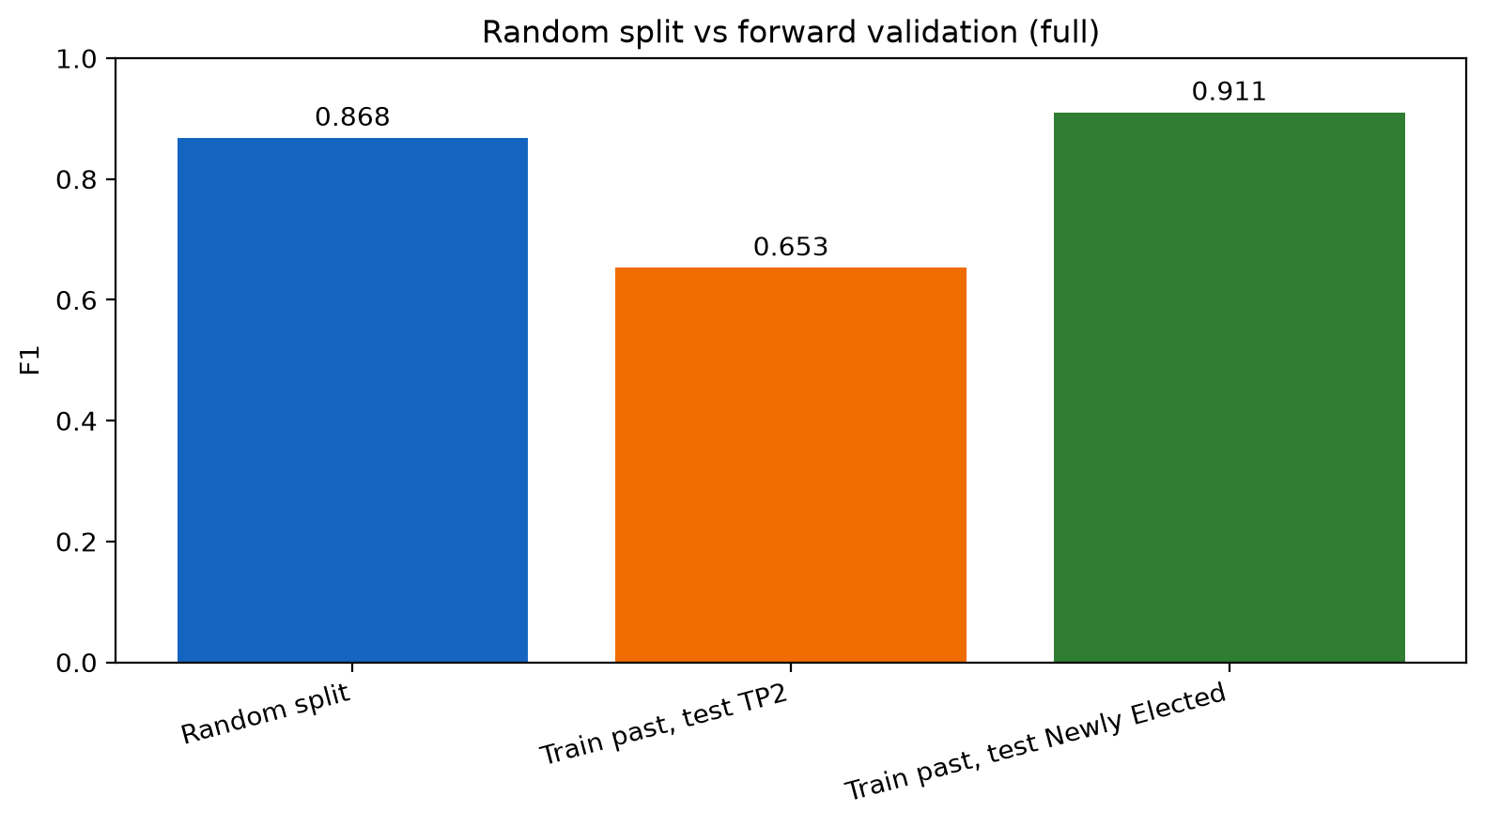
Figure 4. Random-split F1 against two forward tests. Transitional phase 2 is the drop.

8. Calibration, errors, and drivers
Uncalibrated Brier score 0.0904. After isotonic calibration, 0.0901. The low-risk cutoff is 0.54: the lowest calibrated threshold with held-out precision of at least 0.90 (precision 0.901, recall 0.800). A 0.94 precision target lands at 0.61. Medium risk is 0.40 up to 0.54. The F1-max threshold, 0.33, is recorded and is not the counseling cutoff. The old 0.73 cutoff belonged to the imbalanced file. On this file it scores about 82.5% accuracy.
At 0.54 on the holdout: 1,034 correct, 112 false negatives, 54 false positives. False negatives concentrate at Due Diligence = No (74 of 112) and in Stable (false-negative rate 0.186). SHAP is dominated by due diligence in every phase. The production matrix stores that factor three ways, so the bars split one signal.
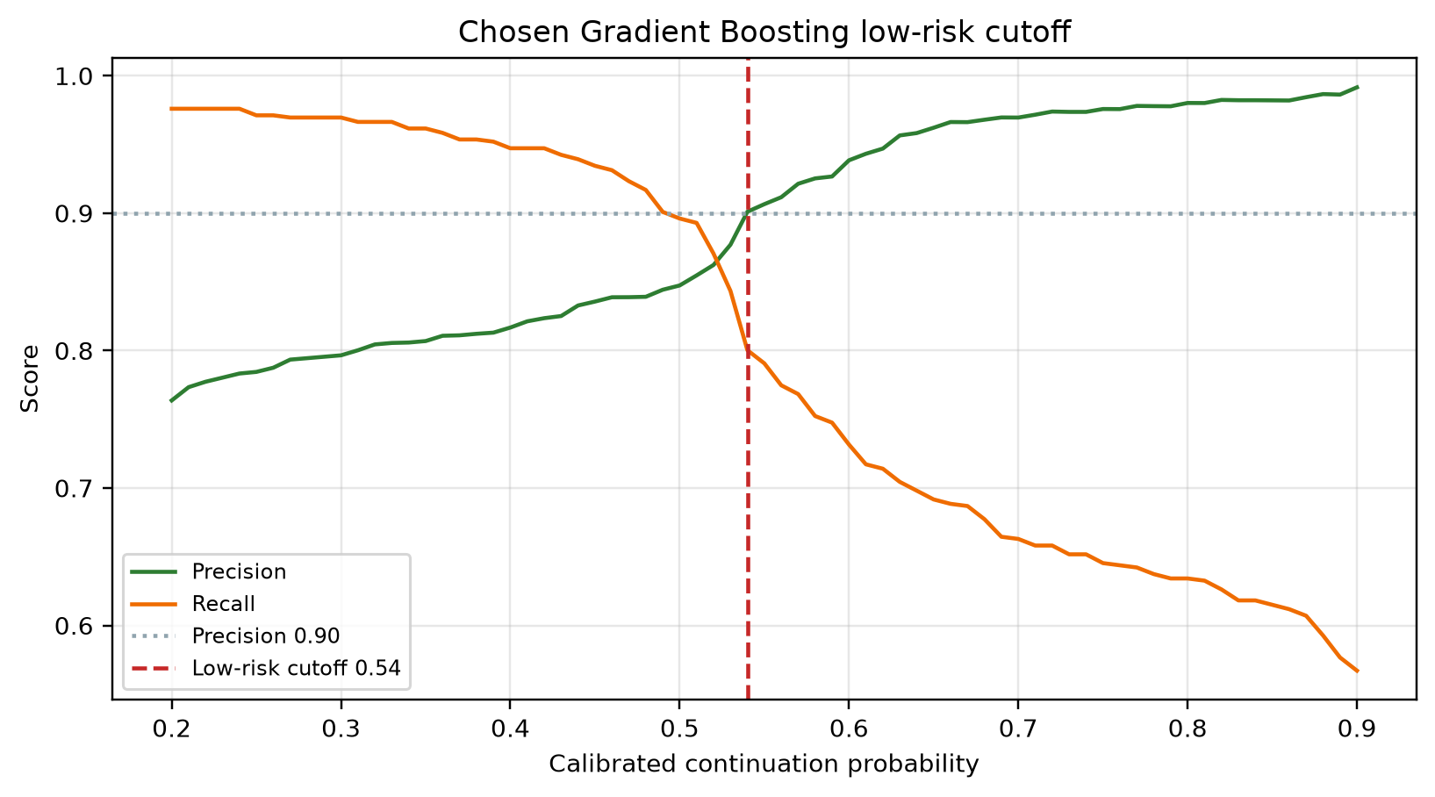
Figure 5. Calibrated precision and recall. The vertical line is the adopted 0.54 cutoff.

9. Model we chose
Gradient Boosting, 100 trees, depth 3, learning rate 0.10, decision threshold 0.50 for the reported classification metrics. Low risk in the tool starts at calibrated probability 0.54. Saved at results_paper2/gradient_boosting.joblib.
Metric | Chosen Gradient Boosting | Highest single-split alternative
Accuracy | 0.8642 | Stack 0.8683
Precision | 0.8789 | GB is higher than the stack (0.8493)
Recall | 0.8578 | Stack 0.9089
F1 | 0.8682 | Stack 0.8781
ROC-AUC | 0.9513 | GB is the highest
MCC | 0.7283 | Stack 0.7373

The stack prints the highest accuracy and F1 on one split. That lead is about five test rows and did not survive cross-validation. Gradient Boosting has the best AUC and the best precision, and TreeExplainer SHAP applies to it, which is what the counselor tool shows. XGBoost is not the preferred model on this file. Deeper trees, more trees, LightGBM, and undersampling did not raise the locked test score.
These scores re-implement two published training procedures on our records. They are not a claim that this project beats those papers on their own datasets.

