|  |  |  |
| --- | --- | --- |
| شعار جامعة بنها الجديدf |  |  |
| **Benham University** |  | **Faculty of Computers & Artificial Intelligence** |

**System for Diabetes Detection using Iridology.**

A senior project submitted in partial fulfillment of the requirements for the degree of Bachelor of Computers and Artificial Intelligence.

**“Medical Informatics” Program,**

***Project Team***

1. Aya Goda Elsayed.
2. Marwa Ashraf Ahmed.
3. Mariam Ahmed Immam.
4. Tasnim Ahmed Fathy.
5. Momen Alaa Elroweny.

***Under Supervision of***

**Dr. Hamada Nayel.**

Benha, February 2

**ACKNOWLEDGMENT**

First of all, Alhamdulillah. The final year project is almost accomplished as we decided and could as much as possible. Secondly thanks for all the professors of faculty of computers and artificial intelligence, headed by Dr. Karam Gouda, Dean of faculty of computers and artificial intelligence for being a good professor who helped us to finish our college years. Special thanks to the supervisor Dr. Hamada for the advices and effort that he spent to help us improving the graduation project. For all the participant that involve in evaluation and system testing, thank you very much.

We really appreciate your effort and time spent during that work.

**DECLARATION**

We hereby certify that this material, which we now submit for assessment on the program of study leading to the award of Bachelor of Computers and Artificial intelligence in Medical Informatics is entirely our own work, that we have exercised reasonable care to ensure that the work is original, and does not to the best of our knowledge breach any law of copyright, and has not been taken from the work of others save and to the extent that such work has been cited and acknowledged within the text of our work.

**Signed:**

**Date:**

**ABSTRACT**

Recently, many serious diseases that threaten human health and life have spread on the face of the earth, and an example of these diseases is diabetes.

Diabetes is a metabolic disease in which a person contains high blood sugar because of insufficient insulin in the body or cells in the body does not respond to the insulin produced. Diabetes is a fast-growing global problem with huge social, health, and economic consequences. According to statistics of the World Health Organization WHO 2016 report, 7% of total deaths in all age categories are due to diabetes and related complications. This number is estimated to increase in case of absence of better control or cure. Furthermore, it has been shown that almost 50% of the putative diabetics are not diagnosed until 10 years after onset of the disease, hence the real prevalence of global diabetes must be astronomically high.

# **1 PROJECT INITIATING**

# 

## **INTRODUCTION**

Diabetes is a disease whose initial symptoms are often undetectable. As a result, many cases of diabetes are not detected early. Thus, it leads to an exacerbation of the disease and the emergence of serious complications such as: weak immune system, gum disease, retinopathy, kidney disease, physical and autonomic neuropathy, cardiovascular disease, and diabetic foot. Therefore, early detection of diabetes is one of the most essential health requirements at present. The diagnosis of diabetes must always be established by a blood glucose measurement made in an accredited laboratory but it is not an effective method as it takes time for the blood to be analyzed and provide results in addition to being inaccurate in some cases. Iridology is an effective alternative method to detect diabetes early. Iridology is an alternative medical technology that examines colors, patterns and other features of the iris of the eye that can be used to determine the patient's systemic health condition. Iridologists compare their observations with iridology charts. These iridology charts contain different zones that correspond to specific parts of the human body including the pancreas, which secretes sugar into the blood .

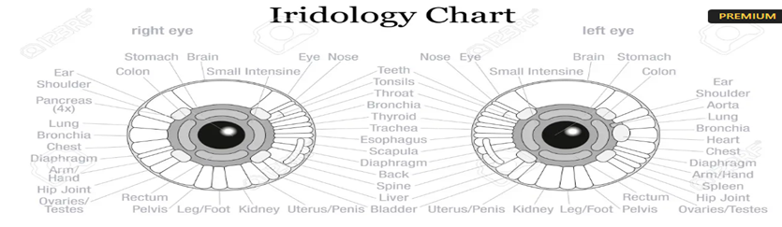

**Figure 1.1 : Iridology Chart**

Diabetes detection system based on iridology or through iris images (Which is captured by using a fundus imaging camera) is constructed using AI. By analyzing the images of human iris, a medical imaging method was explored for the identification of diabetes. By using the methodology of detecting diabetes using iridology, it is possible to detect diabetes and divide it into two types:

1. Non-Proliferative

* Normal.
* Mild.
* Moderate.
* Severe.

1. Proliferative

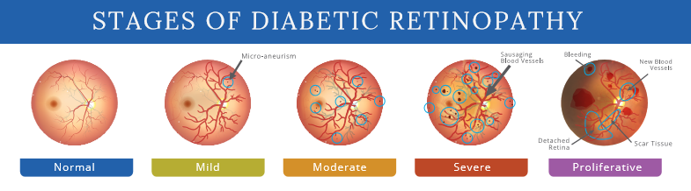

**Figure 1.2 : Stages of Diabetes**

## **PROBLEM STATEMENT**

* Title: Spread of Diabetes.
* Description: Diabetes has become a global problem due to changing lifestyles, daily eating habits, level of stress encountered by people, etc. According to statistics of the World Health Organization (WHO) in 2016, 8.5% of the adult population of the world is suffering from diabetes. Therefore, early detection of diabetes has become a global challenge. Many ways to detect diabetes, one of them is checking blood pressure, but this way is not effective, because it takes blood first and take a lot of time and it may affect Patient’s health. Therefore, we need a tool used to identify pancreatic damage as an indication of diabetes through iridology.
* Nature: Complex.
* Category: Software.
* Technology Bucket: Software-Web Development and Deep Learning

## 

## **CURRENT AND EXISTING SYSTEMS**

Early detection of diabetes is very important for timely treatment which can stop the disease progressing to such complications. A commonly used blood test may not be the best way to diagnose diabetes. But this way is not effective, because it takes blood first and takes a lot of time and it may affect Patient’s health Researchers say testing blood sugar levels for type 1 or type 2 diabetes without also testing for glucose tolerance can miss nearly three-quarters of all cases of these chronic diseases. A study indicated that a common blood sugar level test missed 73 percent of diabetes cases of type 1 and type 2 diabetes that were later picked up by a glucose monitoring test.

* 1. **PROJECT OBJECTIVES**

**Objective 1:**

* Providing an alternative to traditional diagnostic methods such as blood tests and urine tests.

**Objective 2:**

* Helping doctors in medical field by creating an efficient and accurate software that help them to detect Diabetes quickly and determine its degree.

**Objective 3:**

* Save time and effort to determine whether a person suffers from diabetes or not.

**Objective 4 :**

* Obtaining accurate results, the percentage of error is minimal.
  1. **STAKEHOLDER LIST**

**Doctors:** Doctors are the most important stakeholders in a diabetes detection system using iridology. They will be responsible for interpreting the results of the system by a specified model show the result and classify it according to the uploaded image patient and providing advice to patients on how to manage their diabetes.

* 1. **PROPOSED SCOPE**

Our project provides the following:

* **Diabetes Identification:**

We examine the fundus images (which are taken by the fundus camera) using iridology and compare the observations with the original eye map to find out whether the person suffers from diabetes or not.

* **Determine the level of sugar for the patient:**

After determining the person's suffering from diabetes, it is time to determine the person's sugar level.

* Non-Proliferative
* Normal.
* Mild.
* Moderate.
* Severe.
* Proliferative
  1. **PROJECT CONSTRAINTS**

**Financial constraints**

It is due to the high price of the fundus camera used to take images of the fundus.

**Technical constraints**

Constructing a whole system is a brand-new experience so good training must be provided for software users to avoid any errors.

* 1. **IMPACT OF SOLUTION**

**Medical impact**

By providing powerful and effective software that aims to assist doctors in diagnosing diabetes, in addition to providing accurate results that reduce the error rate.

**Social impact**

This system will be good and comfortable for patients, as they can obtain accurate results and know whether they suffer from diabetes or not without the need to conduct laboratory tests that take a long time.

**Environmental impact**

The project does not have any security risk to the computer and does not have any damage.

# **PLANNING AND REQUIREMENTS**

## **2.1 INTRODUCTION**

This chapter covers a brief background about the technologies and techniques used for developing the proposed system,

Web Development (Front-end and back-end), API, Deep learning, Flask

Tools needed and requirements gathering, and why these were selected. Finally, took a closer look to tasks that made to accomplish developing the system and how the whole teamwork was related to everyone.

## **2.2 PLANNING**

## **2.2.1 SCOPE INITIATION**

## **2.2.2 ACTIVITES DEFINITION, SEQUENCING AND DURATION ESTMATION**

Oct

14-

13-

Nov

13-

Dec

12-

Jan

11-

Feb

13-

Mar

12-

Apr

12-

May

11-

Jun

**Collect Data**

**System Requirements**

**Analysis**

**Design Processes**

**Design GUI**

**Data Base**

**Implementation**

**Data Model**

**Training Model**

**Testing Model**

**Testing App**

**Documentation**

**Delivery**

Gantt Chart

duration (Days)

**Figure 2.1 Gantt Chart**

**2.2.3 RESOURCE PLANNING, SCHEDULING AND RESOURCE DISTRIBUTION**

|  |  |  |  |
| --- | --- | --- | --- |
| **Phase** | **Start Date** | **End Date** | **Tasks** |
| Collect Data | 14/10/2022 | 25/10/2022 |  |
| System Requirements | 26/10/2022 | 14/11/2022 |  |
| Analysis | 15/11/2022 | 8/1/2023 |  |
| Design Processes | 9/1/2023 | 15/1/2023 |  |
| Design GUI | 16/1/2023 | 13/2/2023 |  |
| Data Base | 16/1/2023 | 10/2/2023 |  |
| Implementation | 14/2/2023 | 10/4/2023 |  |
| Data Model | 10/11/2022 | 15/1/2023 |  |
| Training Model | 11/4/2023 | 12/4/2023 |  |
| Testing Model | 13/4/2023 | 15/4/2023 |  |
| Testing App | 16/4/2023 | 20/4/2023 |  |
| Documentation | 21/4/2023 | 1/6/2023 |  |
| Delivery | 2/6/2023 | 14/6/2023 |  |

**2.2.4 COST ESTIMATING AND BUDGETING**

No cost or budget spent during project developing because all languages used and needed were open source and devices were the laptops we already have.

**2.2.5 RISK LIST**

* **Schedule Risk:** Managing the time given with the proposed outcome was a risk because we did not know how much time the process will take so we pressured ourselves as much as we could.
* **Technical Risk:** The technologies we use were sometimes give a bug, error and sometimes the laptops operating systems damage.
* **Management Risk:** The management of team was a load for team leader.

**2.3 REQUIREMENTS**

|  |  |  |
| --- | --- | --- |
|  | Functional Requirements | Non-Functional Requirements |
| System | * Doctors can sign up and login successfully. * The system can detect diabetes and its degree. * Detecting level of eye effect. | * Accurate * Scalable * 24-available * secure |
| User | * Diabetes detection. * Detecting Diabetes’ degree. * Level of eye effect. * Doctors can add patients and their information. | * Accurate * Scalable * 24-available * secure |

**Chapter Three**

# **3- Project Analysis and Design**

## 3.1 INTRODUCTION

**This chapter presents the analysis phase of the proposed system. In this phase, the system requirements are discussed to fulfill the feature and objectives previously mentioned in chapter 1&2. These requirements are translated to users’ interactions in the use case. These interactions are described in terms of relation between the user and the proposed system through system sequence diagrams. This chapter also focuses on the conceptual model of the proposed system, namely domain.**

# 3.2 PROJECT ANALYSIS

The analysis phase is essential because analytics assist humans in making decisions. Therefore, conducting the analysis to produce the best results for the decisions to be made is an important part of the process, as is appropriately presenting the results.

**In our system we used:**

* Use case Diagram.
* Sequence Diagram.
* Class Diagram.
* Activity Diagram.
* **Use case.**
* Which describes the user’s possible interactions with a system.
* Actors who deal with the system and they are: Doctor and admin.

Main functions of each:

* Doctor can login, add patients, upload image and logout and generate report and view patients.
* Admin can register, login, add doctors, check patient’s data and logout.
* **Sequence Diagrams**

This diagram shows the general interaction of the main system parts with each other, such that in our case show how the admin first sing in and then the admin can add doctors when they sign up and all doctor’s information is stored at doctor’s database. When the doctors sign in they can add patients and their information and then the doctor can upload an image to the Diabetic model so the model can detect if that patient has diabetes or no, and if the patient has diabetes, the model will detect the diabetes’ degree and Eye effect level and then all this information is stored on the patient’s database and the doctor can log out, the admin can log out any time after adding doctors and checking the system. A picture containing text, diagram, parallel, plan

* **Class Diagram**

Which describe:

* Classes and they are: admin, doctor, patient, and diabetic model.
* Attribute of each class
* Admin has ID, name, password, and email address.
* Doctor has ID, name, password, and email address.
* Diabetic models have image type, image size and image resolution.
* Patient has ID, name, age, gender, phone, and address.
* Operation of each class
* Admin can register, login, add doctor and logout.

Doctor can register, login, add patient, update patient, delete patient, upload image and logout.

* Patient can give his personal information and take results.
* Relationships
* Admin can add many doctors.
* Doctor can add many patients.
* Diabetic model can be used by many doctors.

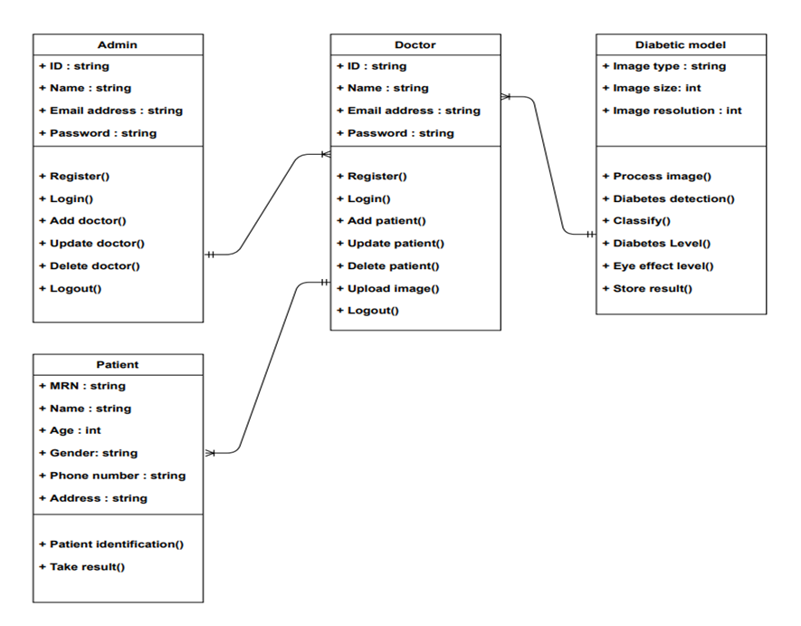

* **Activity Diagrams**

**For Doctor:**

**For admin:**

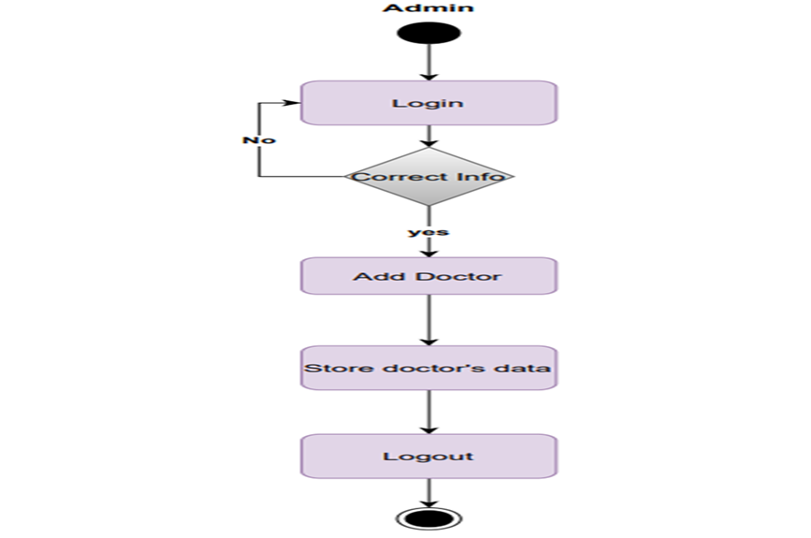

## **3.2.1) DATA SET**

To collect the data set for detecting diabetic using iridology project, we have followed these steps:

1. **Articulate the problem early.**

We want to detect diabetic first and then classify it into two types:

1. Non proliferative

* Mild
* Moderate
* severe

1. proliferative.
2. **Collect raw data.**

We collected the raw data and images of the project from the Ophthalmology Hospital in Benha by using a fundus camera.

1. **Check data quality.**

by ensuring that:

* There are no technical problems when transferring data.
* There are no omitted values in data.
* Data is adequate to our task.
* Data is balanced.

## 3.3) Project Design

## 3.3.1) Web Application Design (Frontend)

* Home page of web application

This is the home page of our web application as a view of our website from outside contains header which contain navigational buttons for pages as (about us – doctors – contact us) and drop-down menu for admin and doctor login.

* Reminder of Home page

Contains more sources and articles about this topic if any person would like to read more about this topic.

* About us page

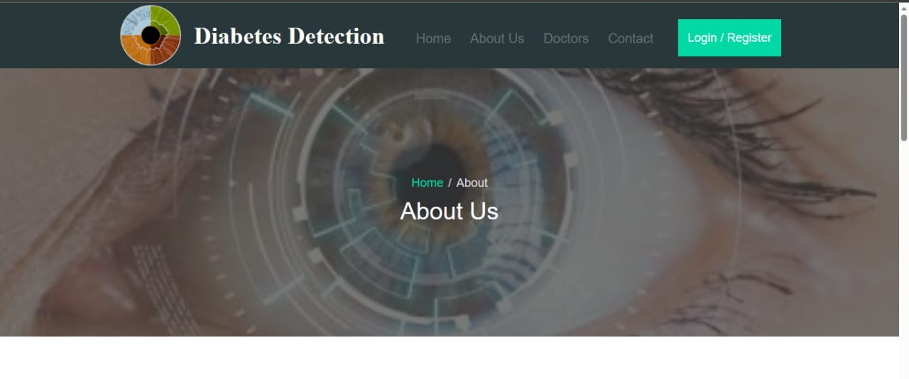

This is About us page which shows us more information and sources about this topic like this:

* Doctors page

This is doctors page which contains information about doctors in our system who are added effectively by admin.

* Contact us page.

This is the contact us page in which patients can contact us to inquire more about system and their services by contact us form.

* Registration of Admin Form.

Admin registers for first time then login by filling register form then click on login button he goes to login form to login by email and password.

* Admin dashboard

Admin dashboard after admin login to add doctor, update doctors, delete doctors by adding doctor form and shows all doctors in system.

* Add doctor form.

* Doctor login

This is doctor login form in which he logins by email and password.

* Add patient form.

Doctor adds patient by filling patient information to go by next to upload image page to upload a diabetic photo of patient to determine he has diabetes or not and to show patient result and generate him report about his/her case.

* Upload image patient.

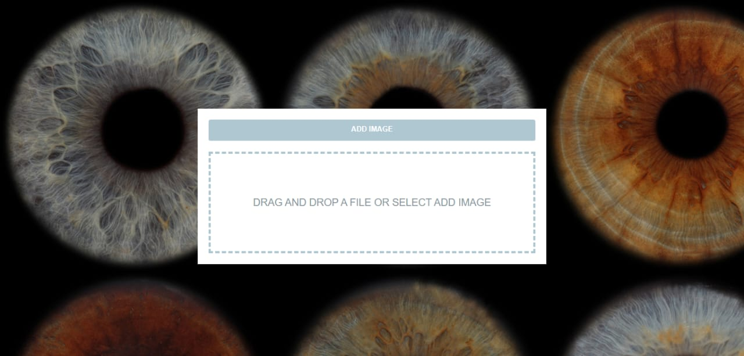

Upload image page which doctor will add patient eye image to determine his/her diabetic stage by passing the image through deep learning model.

# 4.1 INTRODUCTION

**The implementation phase comes after analysis and design phase in waterfall design model, So, this chapter focuses on implementation. The implementation is a realization of a technological specification or algorithm as a program, software component, or other computer system through programming and deployment. This chapter provides more technical details about developing previously mentioned technical issues in the previous chapters.**

**4.2 DATABASE MAPPING**

**Entity relationship diagram (ERD):**

illustrates how “entities” relate to each other within a system and most often used to design relational databases in all fields, our entities here are admin, doctors, patients, and diabetic model.

and each of them has some attributes which identify them as shown in the following figure:

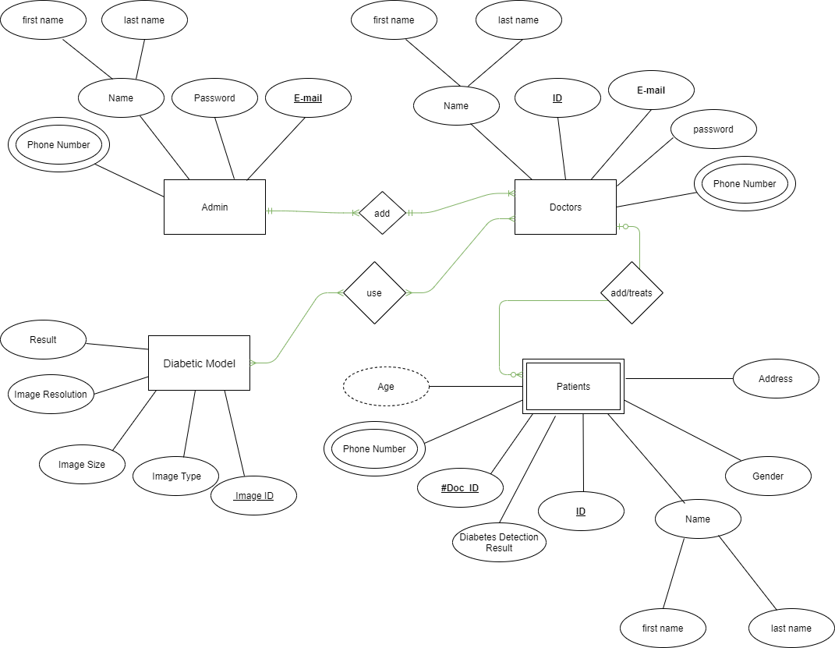

**Mapping Diagram:**

We will Create a separate relational table for each entity “introduced in Entity relationship diagram”, which contain all their attributes with a well-defined primary key:

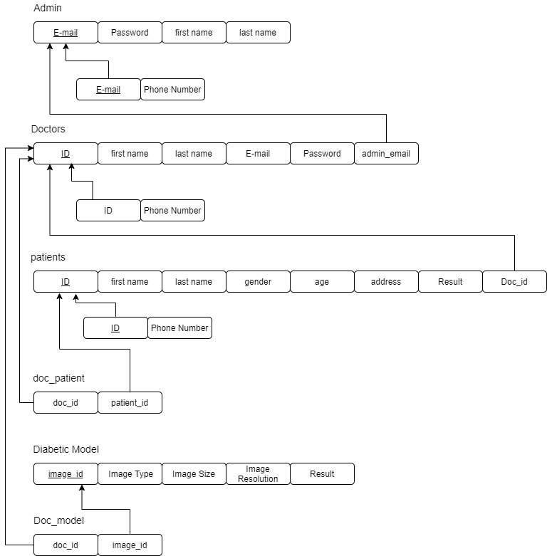

.

# 4.3-PROPOSED APPROACH

In this section, we present the general classification process for predicting skin cancer. As shown in Figure 3.1, we start by reading dataset followed by the pre-processing techniques like resizing the input images, augmentation and so on. The next step is the applying of some of the modified transfer learning algorithms.

Fig 7: block diagram of proposed work

# 4.4-Data Acquisition

**The data set we collected from ophthalmology hospital in benha provided 4581 images of both diabetic retinopathy stages: Mild, Moderate , Severe , Proliferative DR , No Diabetes.**

**The dataset was divided into three sets, including a**

**training set with 3436 images, a validation set with 687 images, and a testing set.**

**with 458 images. Each subset had the same number of images, and all the images.**

**were arranged according to how they were categorized using, ophthalmology hospital in benha.**

**Figure 8 represents samples from the dataset.**

**which consist of Mild, Moderate, Severe, Proliferative DR, No Diabetes classes.**

1-No Diabetes 2- Mild 3- Moderate

Fig 9- Sample of dataset.

# 4.2 Data preprocessing

In order to use the dataset in the pre-trained model and implement the pre-process input function for each transfer learning technique, the dataset was transformed to 224 x 224x 3 dimensions in this stage. This function scales the image. Feature extraction is the stage that follows in this phase. Transfer learning was utilized to retrieve features from pre-trained models. This comprises picking out important components in an image and drawing conclusions from them. Several CNNs are stacked on top of one another to form a model.

4.3-Transfer Learning

A ML strategy known as transfer learning repurposes a model that has been trained for

one task for another related one. When something is learned in one context and applied

to another, this is known as transfer learning or domain adaptation.

Transfer learning is not just a topic for DL study; it is also linked to problems like idea

drift and multi-task learning. Transfer learning is common in DL, despite the enormous

resources required to train DL models or the large and complex datasets used to train DL models.

.

4.4- create a model approach

* Choose the Source Task: We should select a related predictive modelling problem with a lot of data and a connection between the input and output data or other concepts discovered during the input to output data mappig.
* Create the Source Model: The next step is to build a competent model for this first task. The model must perform better than a naive model in order to demonstrate that any feature learning has taken place.
* Model Reuse: Then, a model for the second work of interest can be created using the model fit on the source job. Depending on the modelling strategy used, this can entail using the entire model or only some parts of it.
* Model Tuning: Depending on the data for the input-output pair that is available for the task at hand, the model may need to be updated or enhanced.

4.4 -Transfer Learning Algorithms

The research companies who produce models for this competition and do well often make their finished models freely reusable. On modern technology, training these models could take days or weeks. There are many transfer learning models that we can

use, some of them are listed in below:

• Inception

• Xception

* Mobile net V3
* CNN

4.4.1- Inception network

A DNN with an architectural layout made up of repeated elements known as Inception) modules is referred to as an inception network (.

The Inception network is made up of convolutional design configurations in the form of recurring patterns known as Inception modules. By pooling the input data, a down sampled output with a reduced width and height is created. To ensure that the layer in an Inception module maintains the same height and width as the other outputs (feature maps) of the convolutional layers within the same Inception module, padding (same) isa dded to the layer.

4.4.2- Xception network.

is based on the idea of using depthwise separable convolutions to improve the efficiency and accuracy of the model. This means that instead of using traditional convolutions that operate on all channels of the input tensor, Xception uses depthwise convolutions that operate on each channel separately, followed by pointwise convolutions that combine the channels.It reduces the number of parameters and computations required by the model, making it faster and more memory-efficient than traditional convolutional neural networks.

4.4.3- MobileNet v2

is a neural network model that is designed to be lightweight and optimized for mobile and embedded devices. It uses depthwise separable convolutions to reduce the number of parameters and computations required, while still maintaining high accuracy. It includes faster inference times, lower power consumption, and smaller model sizes, which allow it to run efficiently on devices with limited resources.

4.4.4- CNN

is a type of neural network that is commonly used for image recognition, object detection, and other computer vision tasks. It is designed to automatically learn features and patterns from raw image data, without the need for manual feature engineering.

are also known as Shift Invariant or Space Invariant Artificial Neural Networks (SIANN), based on the shared-weight architecture of the convolution kernels or filters that slide along input features and provide translation-equivariant responses known as feature maps.Counter-intuitively, most convolutional neural networks are not invariant to translation, due to the downsampling operation they apply to the input.

4.4.5- Accuracy of models

|  |  |
| --- | --- |
| Model | Accuracy |
| Mobile net v2 model | 89.5% |
| CNN | 76.9% |
| Xception | 76.5% |
| Inception | 75.5% |

4.4.6- Results

1- Mobile net v2

2- CNN

3- Inception

4-Xception

4.5 – Testing

We split Dataset as

|  |  |
| --- | --- |
| Training | 0.75 |
| Validation | 0.15 |
| Testing | 0.10 |

Sample image used for Training.

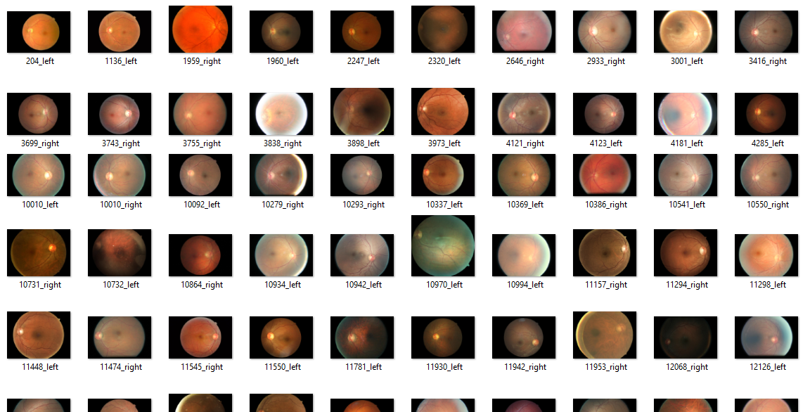

Training and validation graph for each model.

* Mobile net

* CNN model

* Inception model

* Xception

Fig 3.3: Fundus camera

Fig 3.3: Fundus camera