**When application starts:**

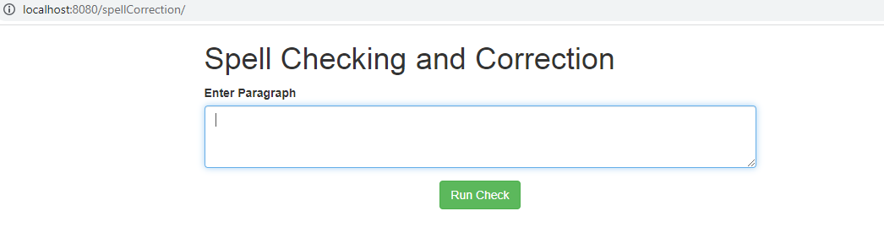

**Case 1:**

Enter sentence with incorrect words.

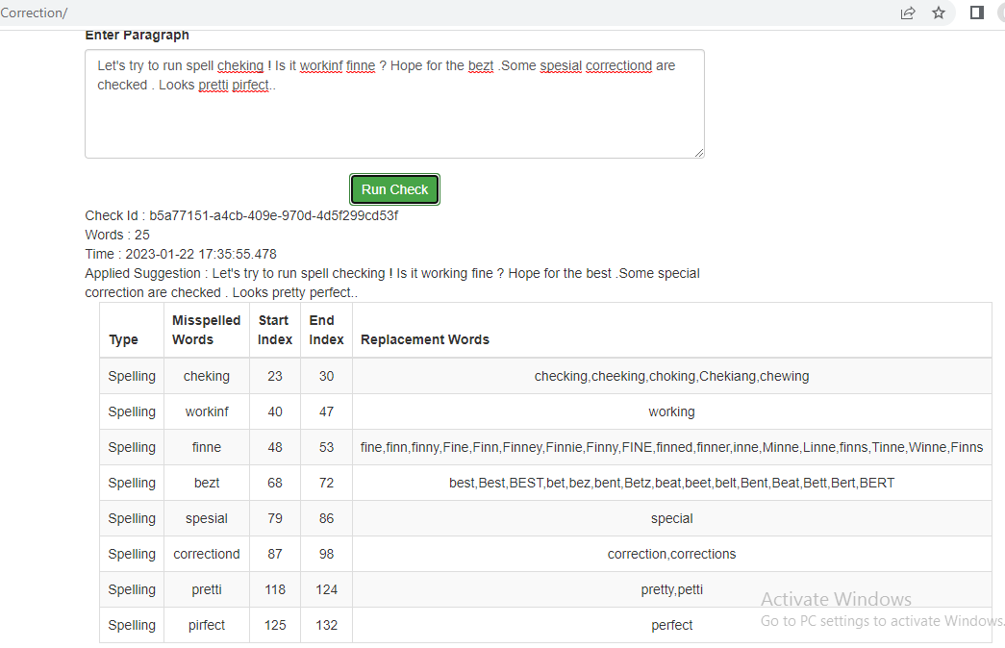

**Case 2:**

Enter sentence with single incorrect words used multiple times .

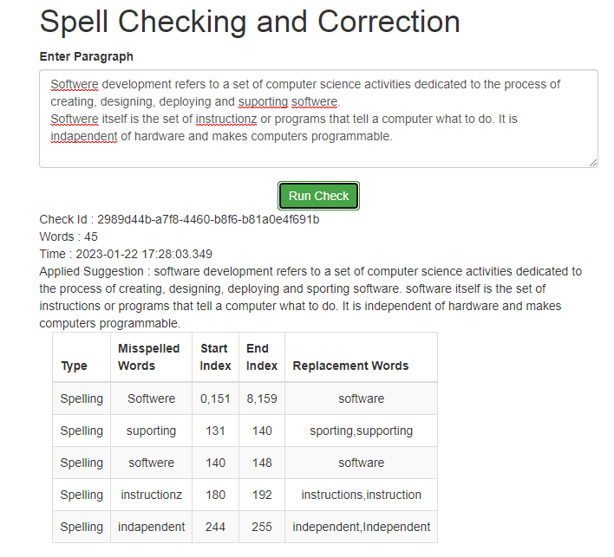

Case 3:

With correct paragraph.

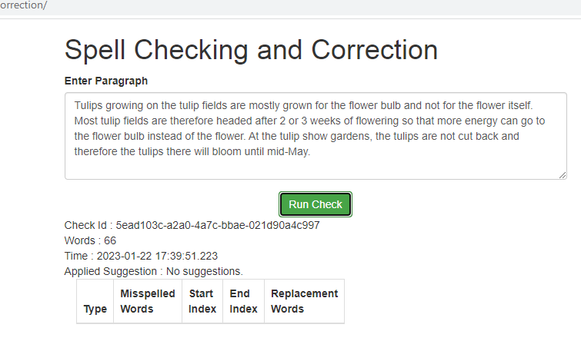

**Case 4 : For longer inputs.**

Sample input : The ultimete goal of educasion is to help an indivedual navigate life and contrebute to societz once they become older. There are varioux types of educasion but typiclly, traditional schooling dictatex the way one’s education sucess is measured. People who attended scool and attained a higher level of education are consideret more employeble and likely to earn more.

In developing, low-income countryies, for exammple, there is a projected 10 per cent increase in a person’s future income for every aditional year of education.

Education helps eradicete povertp and hunger, giving peopl the chance at betterr lives.

**Output:**

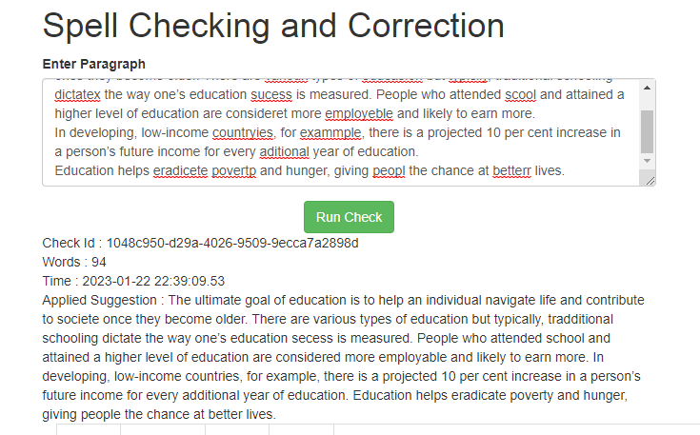

| **Type** | **Misspelled Words** | **Start Index** | **End Index** | **Replacement Words** |
| --- | --- | --- | --- | --- |
| Spelling | ultimete | 4 | 12 | ultimate |
| Spelling | educasion | 21,147 | 30,156 | education,Education |
| Spelling | indivedual | 45 | 55 | individual |
| Spelling | contrebute | 74 | 84 | contribute |
| Spelling | societz | 88 | 95 | societe,society,Societe |
| Spelling | varioux | 130 | 137 | various |
| Spelling | typiclly | 161 | 169 | typically |
| Spelling | dictatex | 194 | 202 | dictate,dictated,dictates |
| Spelling | sucess | 226 | 232 | secess,success |
| Spelling | scool | 266 | 271 | school,scowl,School,sool,cool,spool,shool,snool,stool,acool,scoot,scoop,scoon,scoog |
| Spelling | consideret | 318 | 328 | considered,considerer |
| Spelling | employeble | 334 | 344 | employable |
| Spelling | countryies | 396 | 406 | countries |
| Spelling | exammple | 411 | 419 | example |
| Spelling | aditional | 174,500 | 183,509 | additional |
| Spelling | eradicete | 547 | 556 | eradicate |
| Spelling | povertp | 557 | 564 | poverty |
| Spelling | peopl | 584 | 589 | people |
| Spelling | betterr | 605 | 612 | better,betterer,betters |