Tasneem Hossain

**Requirement #2 – Create 10 Business Reports using 10 SQL statements that a Business User would need to make BUSINESS DECISIONS (Reporting)**

1) The bank wants to know the transaction amount of a customer between 1st January 2018 to 30th January 2018, including the customer ID, account number and the date because the customer asked the bank to provide the information.

SELECT CUSTOMERID, ACCOUNTNO,TRANSACTIONAMOUNT,TRANSACTIONDATE

FROM BANKINGTRANSACTION

WHERE TRANSACTIONDATE BETWEEN '01-jan-18' and '30-jan-18';

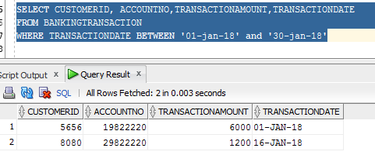

2) The bank wants to know which ATM has cash limit below 1000 because they want to change it to thousand dollars. So the query gives the atm number and the location id of those atm that has limit below 1000$.

SELECT ABLOCATIONID,ATMNUMBER

FROM ATM

WHERE ATMCASHLIMIT < 1000;

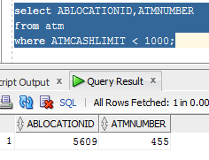

3) The bank wants to see the over draft protection limit for an account because the customer is asking to increase it. So first they need to check the over draft protection limit, which is done by this query.

SELECT OVERDRAFTPROTECTIONLIMIT

FROM CHECKING

WHERE CACCOUNTNO = 49622220;

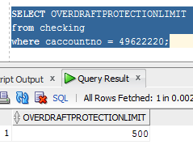

4) The bank wants to know how many atms are there in a zip code, because they are planning to install new ones for those areas that has less atms compared to other areas.

SELECT COUNT(BLOCATIONTYPE) AS NO_OF_ATM

FROM BANKINGLOCATION

WHERE ZIPCODE = '1RT5'

AND BLOCATIONTYPE = 'A'

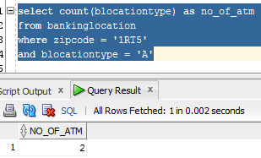

5) The bank wants to know the estimated graduation date from 15-aug-19 to 31-Dec-19 for the students who took student loan so that the bank can verify with them, if the graduation date matches with the estimated date, then the bank will send them letters 6 month ahead of their graduation time so that they can fill up the necessary forms and formalities.

SELECT LOAN.CUSTOMERID, LOAN.LOANNO, STUDENT.ESTGRADUATIONDATE

FROM LOAN, CUSTOMER, STUDENT

WHERE LOAN. CUSTOMERID = CUSTOMER. CUSTOMERID

AND LOAN.LOANNO = STUDENT.SLOANNO

AND ESTGRADUATIONDATE between '15-aug-19' and '31-Dec-19';

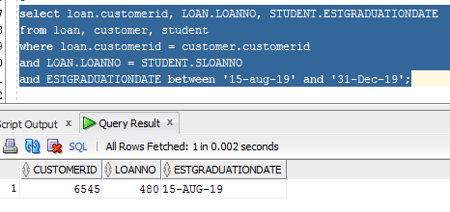

6) The bank wants to know the service charge imposed on an account because the customer is asking to waive it or lower it. Therefore this query shows the service charge for that account.

SELECT CACCOUNTNO, SERVICECHARGE

FROM CHECKING

WHERE CACCOUNTNO = 49622220;

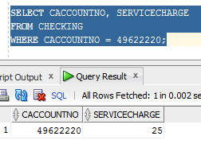

7) The bank wants to know the first name, last name and phone number of all the female customer, who took a loan because the bank want to send them text messages of women’s day.

SELECT LOAN.LOANNO, LOAN.CUSTOMERID, LOAN.LOANTYPE,PERSON.FIRSTNAME, PERSON.LASTNAME, PERSON.MOBILENUMBER

FROM LOAN, PERSON

WHERE LOAN.CUSTOMERID = PERSON.PCUSTOMERID

AND PERSON.GENDER = 'F';

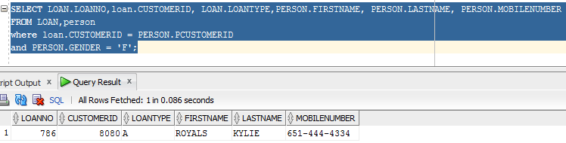

8) The bank would like to know the loan number of the loan of an auto loan where the customer had made down payment more than 5000$ and the vehicle is pre owned because the bank want to offer them low interest.

SELECT ALOANNO, DOWNPAYMENT

FROM AUTO

WHERE VEHICLEPURCHASESTATUS = 'PREOWNED'

AND DOWNPAYMENT > 5000;

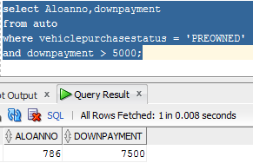

9) The bank wants to know the interest rate of a savings account because the customer is requesting to increase the interest rate.

SELECT SACCOUNTNO, INTERESTRATE

FROM SAVINGS

WHERE SACCOUNTNO = 29822220;

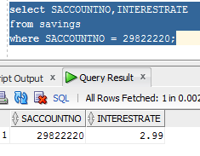

10) The bank wants to know which accounts were opened during the month of December because the bank wants to waive their service fee for the month of December as per the promotion that stated that opening account during the month of December will get waived service fees for this month.

SELECT CUSTOMER ID, ACCOUNTNO

FROM ACCOUNTCREATION

WHERE DATEOPENED between '01-DEC-18' and '31-DEC-18'

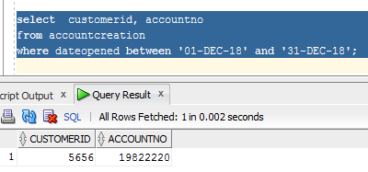

**Requirement #3 – Create/DESIGN STORED PROCEDURES for the 10 BUSINESS REPORT QUERIES from Requirement #2.**

1) The bank wants to know the transaction amount of a customer between 1st January 2018 to 28th January 2018, including the customer ID, account number and the date because the customer wants to know their the transaction amount. So the stored procedure takes the transaction date from and transaction date to and shows the transaction amount and account number.

CREATE PROCEDURE usptrndate (inp_transactiondateto in date,inp_transactiondatefrom in date) as

cursor trndate_cursor is

select CUSTOMERID, Accountno,transactionamount,transactiondate

from bankingtransaction

where transactiondate between inp_transactiondateto and inp_transactiondatefrom;

v_CUSTOMERID number;

v_Accountno number;

v_transactionamount number;

v_transactiondate date;

Begin

open trndate_cursor;

Loop

fetch trndate_cursor into v_CUSTOMERID,v_Accountno,v_transactionamount,v_transactiondate;

Exit when trndate_cursor%NOTFOUND;

DBMS_output.put_line ('CUSTOMERID: '||v_CUSTOMERID||' Accountno: '||v_Accountno ||

' transactionamount: '||v_transactionamount||' transactiondate: '||v_transactiondate);

End loop;

close trndate_cursor;

End;

EXEC usptrndate ('01-jan-18','30-jan-18');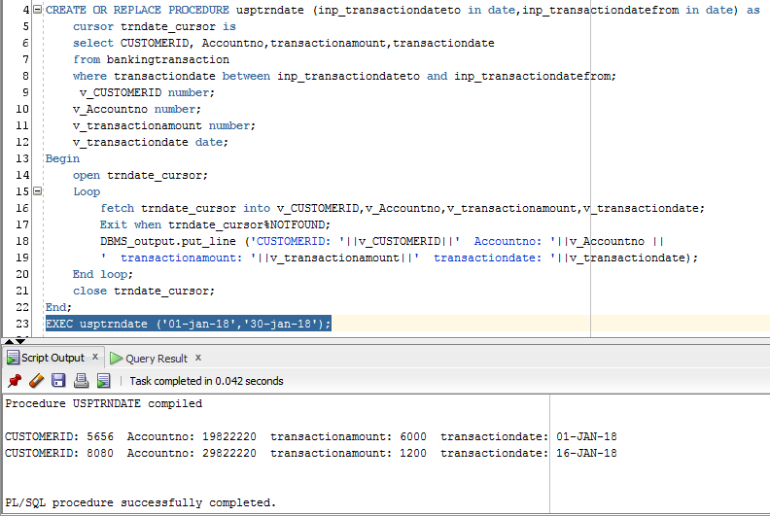

2) The bank wants to know which ATM has cash limit below 1000 because they want to change it to thousand dollars. So the stored procedure gives the atm number and the location id of those atm that has limit below 1000$. Therefore the stored procedures takes the input parameter of atm cash limit.

CREATE or replace PROCEDURE uspatmlimit (inp_ATMCASHLIMIT in number)

as

cursor cur_cursor is

select ABLOCATIONID,ATMNUMBER

from atm

where ATMCASHLIMIT < inp_ATMCASHLIMIT;

v_ablocationid number;

v_ATM_NUM number;

Begin

open cur_cursor;

Loop

fetch cur_cursor into v_ablocationid,v_ATM_NUM;

Exit when cur_cursor%NOTFOUND;

DBMS_output.put_line ('ATM ID: '||v_ablocationid||' ATM Number: '||v_ATM_NUM);

End loop;

close cur_cursor;

End;

EXEC uspatmlimit (1000);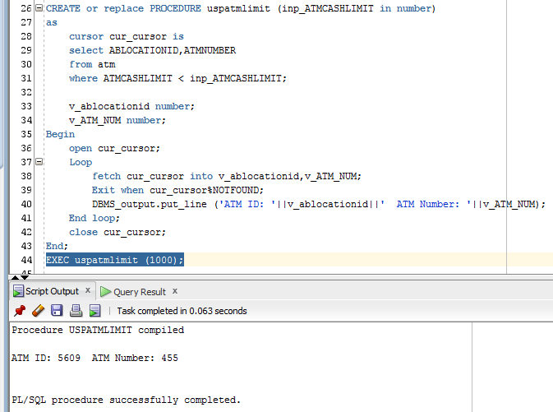

3) The bank wants to see the over draft protection limit for an account because the customer is asking to increase it. So first they need to check the over draft protection limit, which is done by this stored procedures where they just put the account number and the stored procedures shows the overdraft protection limit.

Create or replace Procedure uspgetmob (inp_CACCOUNTNO in number)

as

cursor getmob_cursor is

select OVERDRAFTPROTECTIONLIMIT

from checking

where CACCOUNTNO =inp_CACCOUNTNO;

v_OVERDRAFTPROTECTIONLIMITE NUMBER;

begin

open getmob_cursor;

loop

fetch getmob_cursor into v_OVERDRAFTPROTECTIONLIMITE;

EXIT WHEN getmob_cursor%NOTFOUND;

DBMS_OUTPUT.PUT_LINE('Over_Draft_Protection_Limit: '||v_OVERDRAFTPROTECTIONLIMITE);

end loop;

close getmob_cursor;

end;

Execute uspgetmob (49622220);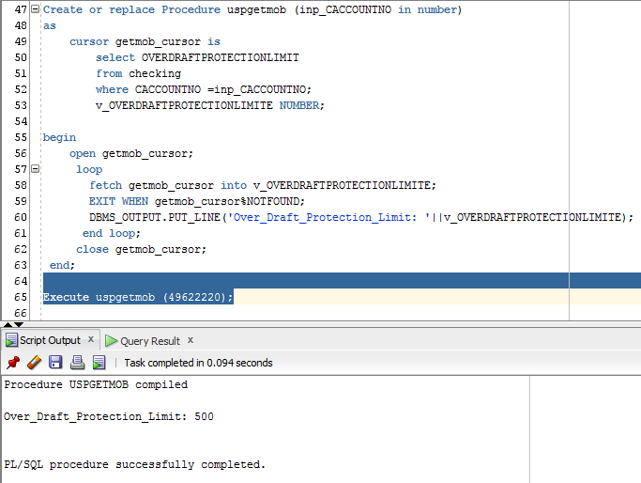

4) The bank wants to know how many atms are there in a zip code, because they are planning to install new ones for those areas that has less atms compared to other areas. So the stored procedures takes the input parameter of zip code and bank location type and shows the number of atm in that area.

CREATE or replace PROCEDURE uspcntatm (inp_zipcode in varchar2, inp_BLOCATIONTYPE in char)

as

cursor cntatm_cursor is

select count(blocationtype)

from bankinglocation

where zipcode = inp_zipcode

and blocationtype = inp_BLOCATIONTYPE;

v_blocationtype char;

Begin

open cntatm_cursor;

Loop

fetch cntatm_cursor into v_blocationtype;

Exit when cntatm_cursor%NOTFOUND;

DBMS_output.put_line ('No_Of_ATM: '||v_blocationtype);

End loop;

close cntatm_cursor;

End;

EXEC uspcntatm ('1RT5', 'A');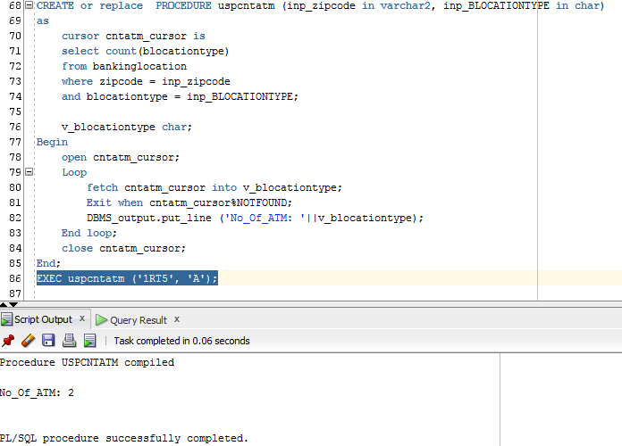

5) The bank wants to know the estimated graduation date from 15-aug-19 to 31-Dec-19 for the students who took student loan so that the bank can verify with them, if the graduation date matches with the estimated date, then the bank will send them letters 6 month ahead of their graduation time so that they can fill up the necessary forms and formalities. Therefore the stored procedures takes two dates which shows the range of graduation date.

CREATE or replace PROCEDURE uspestgradate (inp_estdateto in DATE,inp_estdatefrom in DATE) as

cursor estgradate_cursor is

select loan.customerid, LOAN.LOANNO, STUDENT.ESTGRADUATIONDATE

from loan, customer,STUDENT

where loan.customerid = customer.customerid

and LOAN.LOANNO = STUDENT.SLOANNO

and STUDENT.ESTGRADUATIONDATE between inp_estdateto and inp_estdatefrom;

v_CUSTOMERID loan.customerID%type;

v_LOANNO LOAN.LOANNO%type;

v_ESTGrad STUDENT.ESTGRADUATIONDATE%type;

Begin

open estgradate_cursor;

Loop

fetch estgradate_cursor into v_CUSTOMERID,v_LOANNO, v_ESTGrad;

Exit when estgradate_cursor%NOTFOUND;

DBMS_output.put_line ('CUSTOMERID: '||v_CUSTOMERID||' Loan no: '||v_LOANNO||' Grad Date: '||v_ESTGrad);

End loop;

close estgradate_cursor;

End;

EXEC uspestgradate ('15-aug-19' , '31-Dec-19');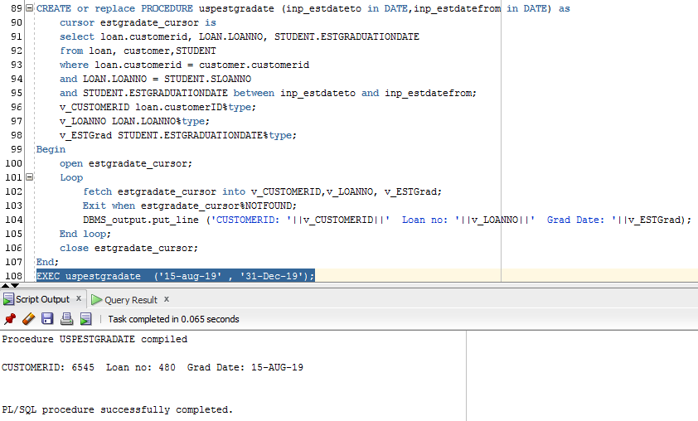

6) The bank wants to know the service charge imposed on an account because the customer is asking to waive it or lower it. Therefore this stored procedure takes the account number and shows the service charge for that account.

CREATE OR REPLACE PROCEDURE uspsercharge (inp_CACCOUNTNO in number)

as

cursor sercharge_cursor is

SELECT CACCOUNTNO, SERVICECHARGE

FROM CHECKING

WHERE CACCOUNTNO = inp_CACCOUNTNO;

v_CACCOUNTNO NUMBER;

v_SERVICECHARGE NUMBER;

Begin

open sercharge_cursor;

Loop

fetch sercharge_cursor into v_CACCOUNTNO,v_SERVICECHARGE;

Exit when sercharge_cursor%NOTFOUND;

DBMS_output.put_line ('Accountno: '|| v_CACCOUNTNO ||' ServiceCharge: '||v_SERVICECHARGE);

End loop;

close sercharge_cursor;

End;

Execute uspsercharge (49622220);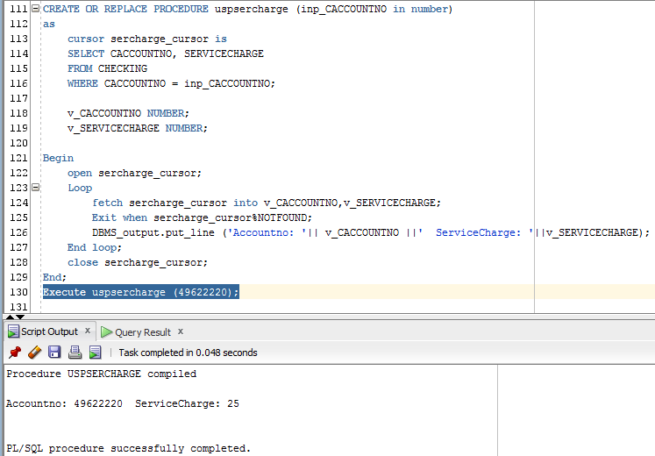

7) The bank wants to know the first name, last name and phone number of all the female customer, who took a loan because the bank want to send them text messages of women’s day.So the stored procedure takes the gender and shows the above mentioned columns.

CREATE OR REPLACE PROCEDURE uspgenln (inp_GENDER in PERSON.GENDER%type) as

cursor genln_cursor is

SELECT LOAN.LOANNO,loan.CUSTOMERID, LOAN.LOANTYPE,PERSON.FIRSTNAME, PERSON.LASTNAME, PERSON.MOBILENUMBER

FROM LOAN,person

where loan.CUSTOMERID = PERSON.PCUSTOMERID

and PERSON.GENDER = inp_GENDER;

v_LOANNO LOAN.LOANNO%type;

v_CUSTOMERID loan.CUSTOMERID%type;

v_LOANTYPE LOAN.LOANTYPE%type;

v_FIRSTNAME PERSON.FIRSTNAME%type;

v_LASTNAME PERSON.LASTNAME%type;

v_MOBILENUMBER PERSON.MOBILENUMBER%type;

Begin

open genln_cursor;

Loop

fetch genln_cursor into v_LOANNO,v_CUSTOMERID,v_LOANTYPE,v_FIRSTNAME,v_LASTNAME,v_MOBILENUMBER;

Exit when genln_cursor%NOTFOUND;

DBMS_output.put_line ('LOANNO: '||v_LOANNO||' CUSTOMERID: '||v_CUSTOMERID ||' LOANTYPE: '||

v_LOANTYPE ||' FIRSTNAME: '||v_FIRSTNAME ||' LASTNAME: '||v_LASTNAME ||' MOBILENUMBER: '||v_MOBILENUMBER);

End loop;

close genln_cursor;

End;

Exec uspgenln ('F');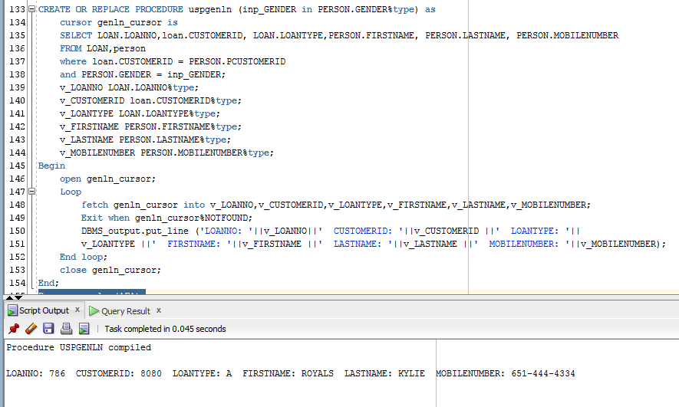

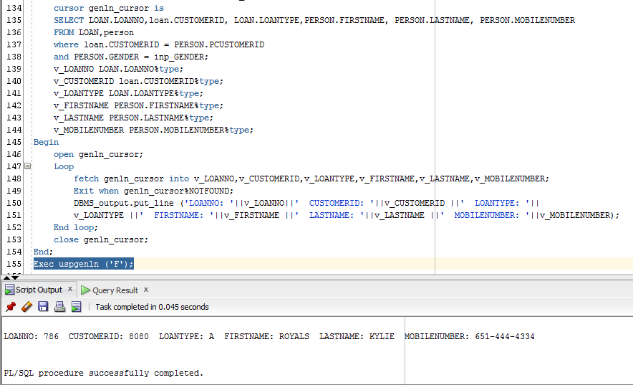

8) The bank would like to know the loan number of the loan of an auto loan where the customer had made down payment more than 5000$ and the vehicle is pre owned because the bank want to offer them low interest rates. So this stored procedure takes the vehicle purchase status and down payment amount and shows the above mentioned columns.

Create or replace procedure uspdwnpymt (inp_vehiclepurchasestatus in auto.vehiclepurchasestatus%type,inp_downpayment in auto.downpayment%type)

as

cursor dwnpymt_cursor is

select Aloanno, downpayment

from auto

where vehiclepurchasestatus = inp_vehiclepurchasestatus

and downpayment > inp_downpayment;

v_Aloanno auto.Aloanno%type;

v_downpayment auto.downpayment%type;

begin

open dwnpymt_cursor;

loop

fetch dwnpymt_cursor into v_Aloanno,v_downpayment;

EXIT WHEN dwnpymt_cursor%NOTFOUND;

DBMS_OUTPUT.PUT_LINE('Customer ID:'||v_Aloanno||' Down Payment: '|| v_downpayment);

end loop;

close dwnpymt_cursor;

end;

exec uspdwnpymt('PREOWNED',5000);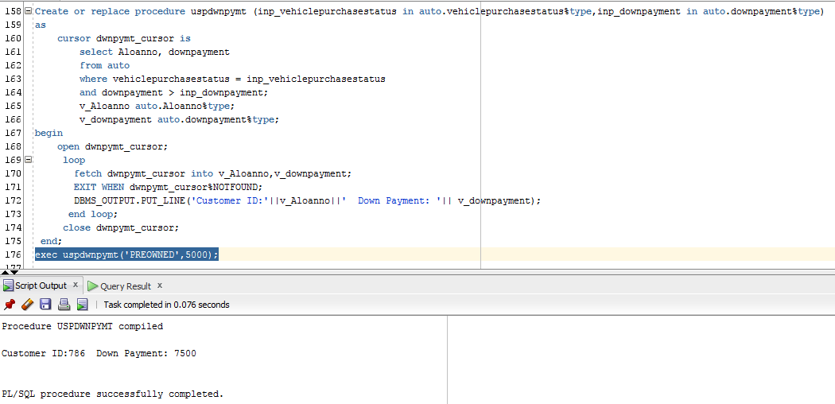

9) The bank wants to know the interest rate of a savings account because the customer is requesting to increase the interest rate. So this stored procedure takes the account number and shows the interest rate of the account.

CREATE OR REPLACE PROCEDURE uspsav_inrstrt (inp_SACCOUNTNO in number)

as

cursor sav_inrstrt_cursor is

select SACCOUNTNO,INTERESTRATE

from savings

where SACCOUNTNO = inp_SACCOUNTNO;

v_SACCOUNTNO number;

v_INTERESTRATE number;

Begin

open sav_inrstrt_cursor;

Loop

fetch sav_inrstrt_cursor into v_SACCOUNTNO,v_INTERESTRATE;

Exit when sav_inrstrt_cursor%NOTFOUND;

DBMS_output.put_line ('Accountno: '||v_SACCOUNTNO||' INTEREST_RATE: '||v_INTERESTRATE);

End loop;

close sav_inrstrt_cursor;

End;

EXEC uspsav_inrstrt (29822220);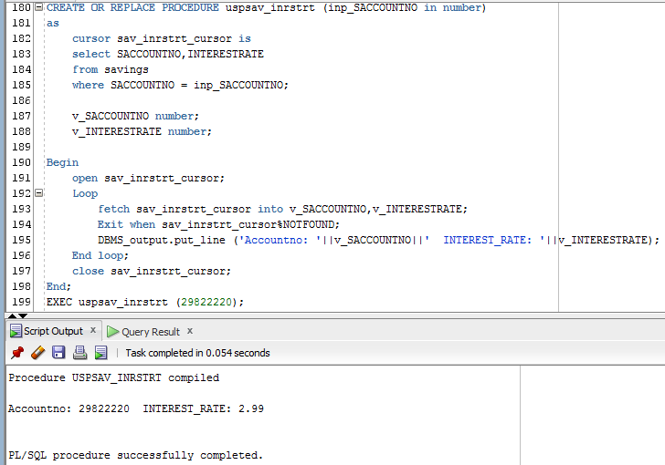

10) The bank wants to know which accounts were opened during the month of December because the bank wants to waive their service fee for the month of December as per the promotion that stated that opening account during the month of December, will get the service fee waived for this month. So the stored procedure takes the dates and provides the customer id and account number.

CREATE OR REPLACE PROCEDURE uspcraccdt (inp_accountcreatedateto in date,inp_accountcreatedatefrom in date)

as

cursor craccdt_cursor is

select customerid, accountno

from accountcreation

where dateopened between inp_accountcreatedateto and inp_accountcreatedatefrom;

v_CUSTOMERID number;

v_Accountno number;

Begin

open craccdt_cursor;

Loop

fetch craccdt_cursor into v_CUSTOMERID,v_Accountno;

Exit when craccdt_cursor%NOTFOUND;

DBMS_output.put_line ('CUSTOMERID: '||v_CUSTOMERID||' Accountno: '||v_Accountno);

End loop;

close craccdt_cursor;

End;

EXEC uspcraccdt('01-DEC-18','31-DEC-18');