Tasneem Hossain

Project 3

**Requirement #3 – Copy/Paste the EACH of the CREATE INDEXES STATEMENTS & Screen Shot of the INDEX Objects in Oracle SQL Developer to the MS Word document Design & Implementation Document to SHOW PROOF That they were CREATED & EXECUTED.**

1)

SELECT CUSTOMERID, ACCOUNTNO,TRANSACTIONAMOUNT,TRANSACTIONDATE

FROM BANKINGTRANSACTION

WHERE TRANSACTIONDATE BETWEEN '01-jan-18' and '30-jan-18';

Primary key Index is on the transactionid column on BankingTransaction table.

Secondary key Index is on Transactiondate and CustomerId.

**CREATE INDEX IDX_TRANS_DATE ON BANKINGTRANSACTION(TRANSACTIONDATE,CUSTOMERID);**

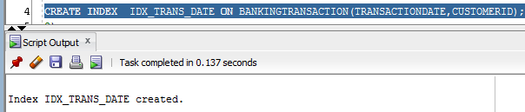

2)

select ABLOCATIONID,ATMNUMBER

from atm

where ATMCASHLIMIT < 1000;

Primary key Index is on the ablocationId column on atm table.

Secondary key Index is on ATMCASHLIMIT and ATMNUMBER.

**CREATE INDEX IDX_ATM_LIMIT ON atm(ATMCASHLIMIT,ATMNUMBER);**

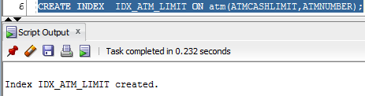

3)

SELECT OVERDRAFTPROTECTIONLIMIT

from checking

where caccountno = 49622220;

Primary key Index is on the caccountno column on checking table.

Secondary key Index is on OVERDRAFTPROTECTIONLIMIT.

**CREATE INDEX IDX_OVR_PROTECT ON checking(OVERDRAFTPROTECTIONLIMIT);**

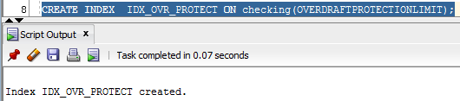

4)

select count(blocationtype) as no_of_atm

from bankinglocation

where zipcode = '1RT5'

and blocationtype = 'A'

Primary key Index is on the blocationid column on bankinglocation table.

Secondary key Index is on blocationtype and. zipcode

**CREATE INDEX IDX_ATM_COUNT ON bankinglocation(blocationtype, zipcode);**

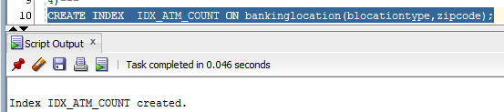

5)

select loan.customerid, LOAN.LOANNO, STUDENT.ESTGRADUATIONDATE

from loan, customer, student

where loan.customerid = customer.customerid

and LOAN.LOANNO = STUDENT.SLOANNO

and ESTGRADUATIONDATE between '15-aug-19' and '31-Dec-19';

Primary key Index is on the customerid column on customer table.

Primary key Index is on the LOANNO column on loan table.

Primary key Index is on the SLOANNO column on STUDENT table.

Secondary key Index is on ESTGRADUATIONDATE , SLOANNO

Secondary key Index is on customerid

**CREATE INDEX IDX_GRAD ON student(ESTGRADUATIONDATE,SLOANNO);**

**CREATE INDEX IDX_GRADB ON loan(customerid);**

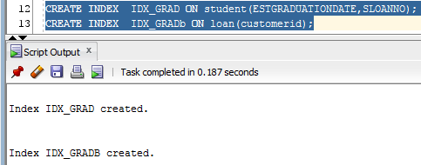

6)

SELECT CACCOUNTNO, SERVICECHARGE

FROM CHECKING

WHERE CACCOUNTNO = 49622220;

Primary key Index is on the CACCOUNTNO column on CHECKING table.

Secondary key Index is on SERVICECHARGE

**CREATE INDEX IDX_SERV ON checking(SERVICECHARGE);**

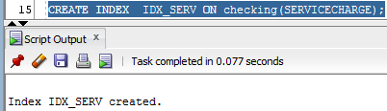

7)

SELECT LOAN.LOANNO,loan.CUSTOMERID, LOAN.LOANTYPE,PERSON.FIRSTNAME, PERSON.LASTNAME, PERSON.MOBILENUMBER

FROM LOAN,person

where loan.CUSTOMERID = PERSON.PCUSTOMERID

and PERSON.GENDER = 'F';

Primary key Index is on the LOANNO column on LOAN table

Primary key Index is on the PCUSTOMERID column on PERSON table

Secondary key Index is on GENDER

**CREATE INDEX IDX_GEN ON PERSON(GENDER,PCUSTOMERID);**

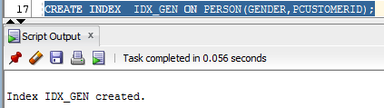

8)

select Aloanno,downpayment

from auto

where vehiclepurchasestatus = 'PREOWNED'

and downpayment > 5000;

Primary key Index is on the Aloanno column on auto table.

Secondary key Index is on vehiclepurchasestatus, downpayment

**CREATE INDEX IDX_AUTO ON auto(downpayment,vehiclepurchasestatus);**

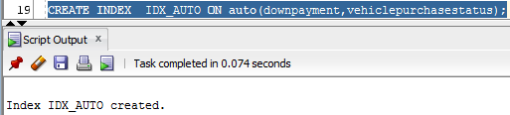

9)

select SACCOUNTNO,INTERESTRATE

from savings

where SACCOUNTNO = 29822220;

Primary key Index is on the SACCOUNTNO column on savings table.

Secondary key Index is on INTERESTRATE

**CREATE INDEX IDX_INTRST ON savings(INTERESTRATE);**

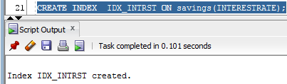

10)

select customerid, accountno

from accountcreation

where dateopened between '01-DEC-18' and '31-DEC-18';

Secondary key Index is on dateopened, customerid

**CREATE INDEX IDX_AVV ON accountcreation(dateopened,customerid);**

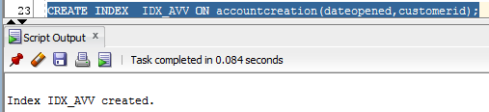

**Requirement #5 – Copy/Paste the EACH of the VIEW STATEMENTS & Screen Shot of the View Objects in Oracle SQL Developer to the MS Word document Design & Implementation Document to SHOW PROOF That they were CREATED & EXECUTED.**

1)

CREATE VIEW BANKING_TRANSACTION

AS

SELECT CUSTOMERID, ACCOUNTNO,TRANSACTIONAMOUNT,TRANSACTIONDATE

FROM BANKINGTRANSACTION

WHERE TRANSACTIONDATE BETWEEN '01-jan-18' and '30-jan-18';

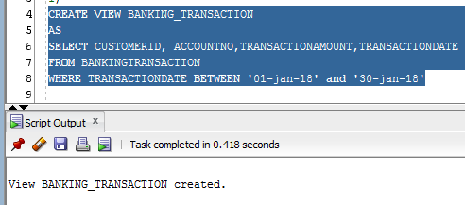

2)

CREATE VIEW ATM_LIMIT

AS

select ABLOCATIONID,ATMNUMBER

from atm

where ATMCASHLIMIT < 1000;

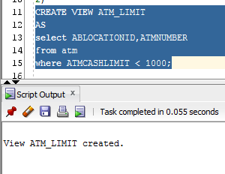

3)

CREATE VIEW OVRDRFT

AS

SELECT OVERDRAFTPROTECTIONLIMIT

from checking

where caccountno = 49622220;

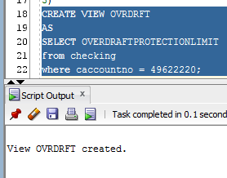

4)

CREATE VIEW ATM_NUM

AS

select count(blocationtype) as no_of_atm

from bankinglocation

where zipcode = '1RT5'

and blocationtype = 'A'

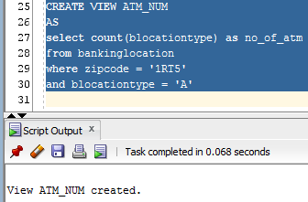

5)

CREATE VIEW EST_GRAD

AS

select loan.customerid, LOAN.LOANNO, STUDENT.ESTGRADUATIONDATE

from loan, customer, student

where loan.customerid = customer.customerid

and LOAN.LOANNO = STUDENT.SLOANNO

and ESTGRADUATIONDATE between '15-aug-19' and '31-Dec-19';

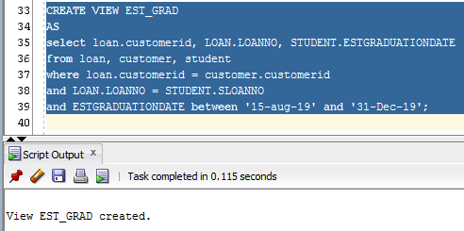

6)

CREATE VIEW SERVICE_CHARGE

AS

SELECT CACCOUNTNO, SERVICECHARGE

FROM CHECKING

WHERE CACCOUNTNO = 49622220;

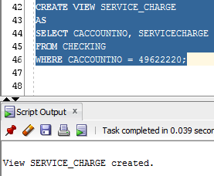

7)

CREATE VIEW CUST_FEMALE

AS

SELECT LOAN.LOANNO,loan.CUSTOMERID, LOAN.LOANTYPE,PERSON.FIRSTNAME, PERSON.LASTNAME, PERSON.MOBILENUMBER

FROM LOAN,person

where loan.CUSTOMERID = PERSON.PCUSTOMERID

and PERSON.GENDER = 'F';

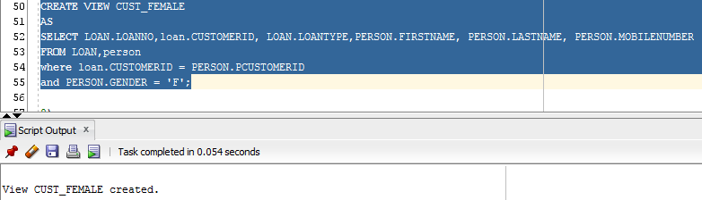

8)

CREATE VIEW PREOWND_DWNPYMNT

AS

select Aloanno,downpayment

from auto

where vehiclepurchasestatus = 'PREOWNED'

and downpayment > 5000;

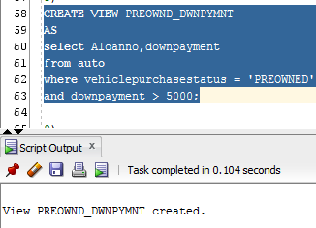

9)

CREATE VIEW INTRST_RATE

AS

select SACCOUNTNO,INTERESTRATE

from savings

where SACCOUNTNO = 29822220;

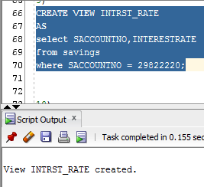

10)

CREATE VIEW ACC_OPEN

AS

select customerid, accountno

from accountcreation

where dateopened between '01-DEC-18' and '31-DEC-18';

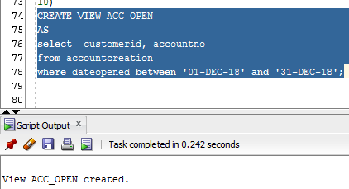

**Requirement #7 – Copy/Paste the EACH of the REPORTS & Screen Shot of the EXECUTION OF EACH REPORT in Oracle SQL Developer to the MS Word document Design & Implementation Document to SHOW PROOF That they were CREATED & EXECUTED.**

1)

SELECT CUSTOMERID, ACCOUNTNO,TRANSACTIONAMOUNT,TRANSACTIONDATE

FROM BANKING_TRANSACTION;

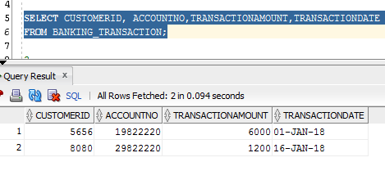

2)

select ABLOCATIONID,ATMNUMBER

from ATM_LIMIT;

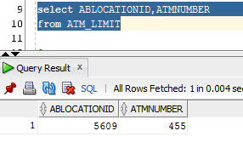

3)

SELECT OVERDRAFTPROTECTIONLIMIT

from OVRDRFT;

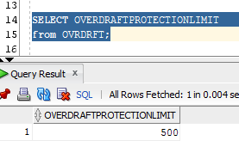

4)

select no_of_atm

from ATM_NUM;

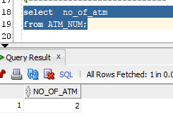

5)

select customerid, LOANNO, ESTGRADUATIONDATE

from EST_GRAD;

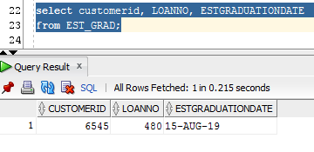

6)

SELECT CACCOUNTNO, SERVICECHARGE

FROM SERVICE_CHARGE;

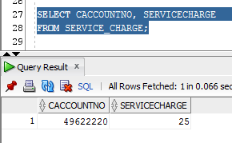

7)

SELECT LOANNO,CUSTOMERID,LOANTYPE,FIRSTNAME,LASTNAME,MOBILENUMBER

FROM CUST_FEMALE;

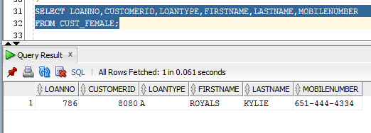

8)

select Aloanno,downpayment

from PREOWND_DWNPYMNT;

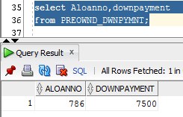

9)

select SACCOUNTNO,INTERESTRATE

from INTRST_RATE;

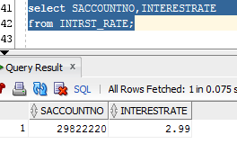

10)

select customerid, accountno

from ACC_OPEN;

