Tasneem Hossain

Project 4

**Project Requirement – Maintenance & Operations Phase**

**Requirement #3 – Create 2 new USERS in your database**

2 users are created:-

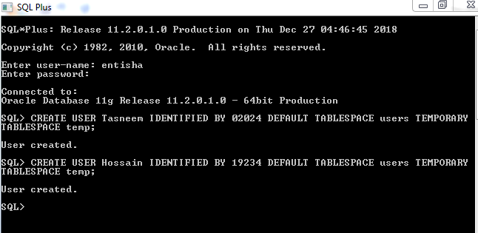

**Requirement #4 – Attempt to Connect to the Database with a new User & Correct any connectivity issues**

Connecting with a user fails as the user doesn’t have the privilege.

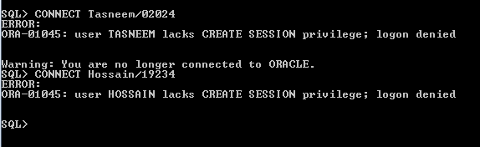

I fixed the problem by granting permission to the user.

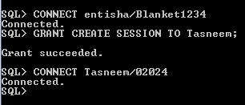

**Requirement #5 – Attempt to Execute a SELECT Statement as a new user**

Attempting to Execute a SELECT Statement failed as the user do not have the privilege

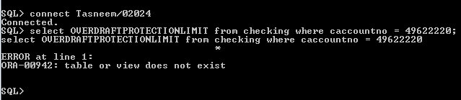

Fixing the problem by granting the permission

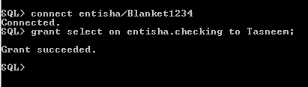

Showing proof that the problem is fixed and the user can execute select statement.

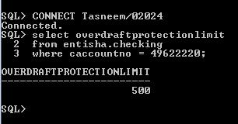

**Requirement #6 – Attempt to Execute a DELETE Statement as a new user**

Attempting to Execute a DELETE Statement by the user fails

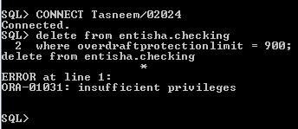

Fixing the problem by granting permission to delete.

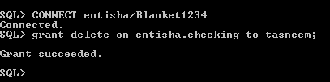

The problem is fixed and the user can delete now. Below is the proof

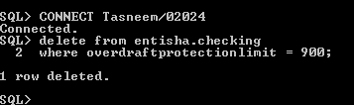

**Requirement #7 – Attempt to Execute a CREATE TABLE Statement as a new user**

Attempting to excute create table statement by the new user but it fails as no privileges.

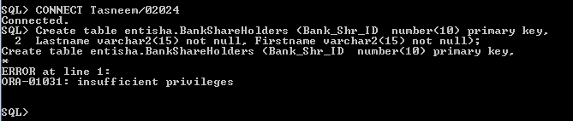

Fixing the problem by granting the permission to create table and the proof that the user created the table.

