**EDA:**

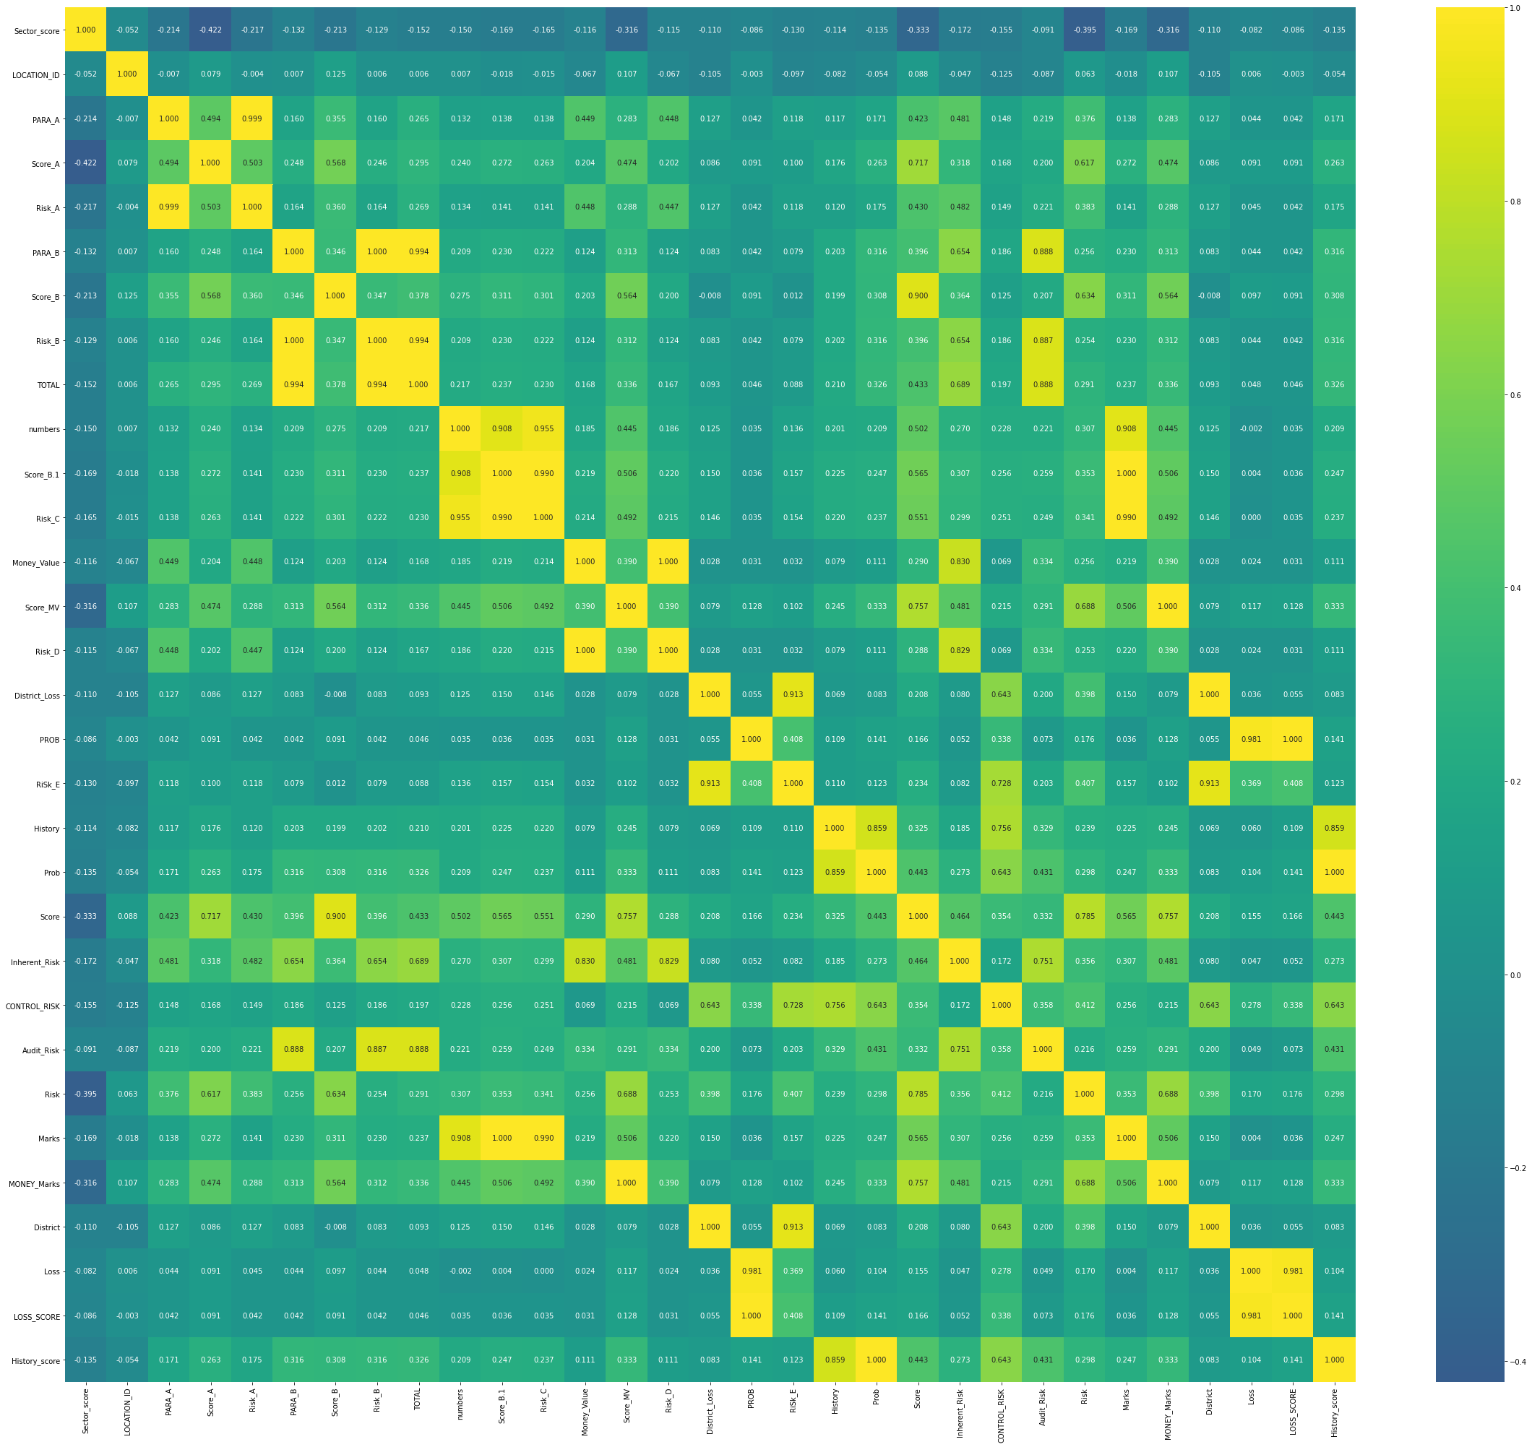

Here we have the correction matrix

**Classifiers used:**

* **SVM**

The benefit of SVM is that you can capture much more complex relationships between your datapoints without having to perform difficult transformations on your own.

* **Random Forest Classifier**

Random forest adds additional randomness to the model, while growing the trees. Instead of searching for the most important feature while splitting a node, it searches for the best feature among a random subset of features.

* **Decision Tree**

It breaks down a dataset into smaller and smaller subsets while at the same time an associated decision tree is incrementally developed. The final result is a tree with decision nodes and leaf nodes.

**Tables:**

* **SVM**

|  |  |  |
| --- | --- | --- |
|  | F1 | Accuracy |
| Training | 89.58 | 90.53 |
| Testing | 86.70 | 87.89 |

* **Random Forest Classifier**

|  |  |  |
| --- | --- | --- |
|  | F1 | Accuracy |
| Training | 100 | 100 |
| Testing | 100 | 100 |

* **Decision Tree**

|  |  |  |
| --- | --- | --- |
|  | F1 | Accuracy |
| Training | 100 | 100 |
| Testing | 100 | 100 |