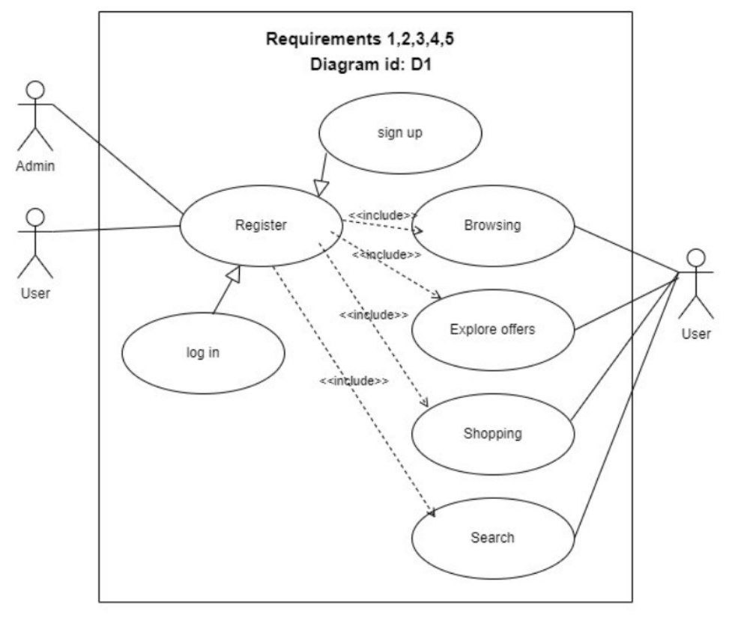

**Use Case 1: Register**

**1. Requirement number:** R1

**2. Use Case Diagram:** D1

**3. Primary Actor:** User/Admin.

**4. Trigger**: User wants to login or sign up.

**5. Preconditions:**

* The user has already an email.
* The admin has already admin email.

**6. Main Flow:**

* User/Admin Selects the (Sign up) option.
* User/Admin Selects whether to register as a regular user or an admin.
* User/Admin enters name, email and password.
* System collects and stores user information.
* If entered email matches the pre-approved admin email system recognizes the user as an admin and collects and stores admin information.
* If the entered email doesn’t match the admin email, then ((Scenario 1)).
* System Sends a verification email.
* User/Admin receives the email, clicks on the verification link.
* System verifies email and make account active.
* User/Admin selects the (log in) option.
* User/Admin enters email and password.
* System validates email and password and logs in the user.

**7. Alternative Flow:**

* **Scenario 1:** System display an error message indicating that entered email isn’t an admin email and user is prompted to enter as a user instead of admin.
* **Scenario 2:** If the user/admin attempts to register with an already used email, the system prompts the User/Admin to use a different email:
  + System displays an error massage indicating that the entered email is already associated with an existing account.
  + User/Admin is prompted to log in with the existing account.
* **Scenario 3:** if the User/Admin forgets their password during the login process, they can reset it:
  + User clicks on the (Forgot Password).
  + System prompts the user/admin to enter their registered email.
  + System sends a password reset email to the user.
  + User clicks on the link in the email , resetting the password.
* **Scenario 4:** If the entered email is in an invalid format, the system prompts the User/Admin to enter a valid email:
  + System displays an error message indicating that the entered email format is invalid.
  + User/Admin is prompted to enter a valid email address.

**8. Postconditions:**

* The User/Admin account is activated.
* The User/Admin can log in with the provider email and password.

**Use Case 2: Browsing**

**1. Requirement number:** R2

**2. Use Case Diagram:** D1

**3. Primary Actor:** User.

**4. Trigger**: User wants to explore products.

**5. Preconditions:**

* The user is logged in.

**6. Main Flow:**

* User navigates to the website.
* System display top selling products and variety of products categories.
* User selects a category for browsing.
* System presents a list of available products within the selected category.
* If the user hovers over an item, the system provides a quick preview.
* User can click on a specific item to view details (available sizes, images, description, price).

**7. Alternative Flow:**

* **Scenario 1**: if the selected category has no items, the system informs the user:
  + System displays a message indicating that there are currently no dressing items in the selected category.
  + User is prompted to explore other categories.

**8. Postconditions:**

* The user has explored products available In the website and may proceed to the shopping process.

**Use Case 3: Explore offers**

**1. Requirement number:** R3

**2. Use Case Diagram:** D1

**3. Primary Actor:** User.

**4. Trigger**: User wants explore available offers.

**5. Preconditions:**

* The user is logged in.
* There are active offers in the system.

**6. Main Flow:**

* User visits the homepage.
* System displays active offers on the homepage and product pages.
* User can accesses the dedicated offers section for explore all available offers.
* User can add products from one available offers and this offers reflect on checkout process.

**7. Alternative Flow:**

* **Scenario 1**: If there are no active offers, the system notifies the user:
  + System displays a message indicting that there are currently no active offers.

**8. Postconditions:**

* Offers applied to checkout process**.**

**Use Case 4: Shopping**

**1. Requirement number:** R4

**2. Use Case Diagram:** D1

**3. Primary Actor:** User.

**4. Trigger**: User Wants to make a purchase.

**5. Preconditions:**

* The user is logged in.
* There are products available in the system.

**6. Main Flow:**

* User browsing website.
* User select item he/she needs to add and determine numbers of pieces needed and size.
* If number of pieces determined available in the store product add to shopping cart.
* User can then reviews and edits (add, change quantity, delete) products exist in the shopping cart and he can know total price of selected products.
* User proceeds to checkout or continues browsing.

**7. Alternative Flow:**

* **Scenario 1**: If determined size doesn’t available in the store at present system displays an error message indicating that the requested size doesn’t available in the store at present.
* **Scenario 2**: If the number of pieces the user determine doesn’t available in the store, the system notifies the user:
  + System displays an error message indicating that the requested quantity exceeds the available stock.
  + User is prompted to reduce the quantity or remove items from the shopping process.

**8. Postconditions:**

* Shopping completed successfully.
* The order reflects any applied offers.

**Use Case 5: Search**

**1. Requirement number:** R5

**2. Use Case Diagram:** D1

**3. Primary Actor:** User.

**4. Trigger**: User wants to find a specific product.

**5. Preconditions:**

* The user is logged in.

**6. Main Flow:**

* User utilizes the search bar.
* System provides relevant suggestions after at least two letters are entered.
* User selects a suggested product or refines the search.
* System will display all related products based on entered search terms.

**7. Alternative Flow:**

* **Scenario 1**: If the search bar returns no results, the system suggests alternatives:
  + System displays a message indicating that no results were found for the entered search terms
  + User is prompted to modify the search items or explore different products.

**8. Postconditions:**

* The user has found the desired product.