# CF & OA

**Q1)**

***Bangladesh is a country of South Asia with an area of 1,47,570square k.m. There lived a population of 18 crores. People of various religion like Muslims,Hindus,Buddhas,Christians are living here peacefully. We love our country.***

# *Q2)*

|  |  |  |
| --- | --- | --- |
| Row 1 | Row 2 | Row 3 |
| Column 1 | Column 2 | Column 3 |
| Column 1 | Column 2 | Column 3 |

# *Q3)*

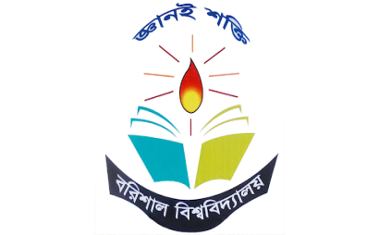

Figure : Example Image

*Insert tab

*Select picture option

* select picture from my computer

*select the image

*add a title named, “Example Image”

*Click picture tools format

*Choose shade/border

*align center from home tabs paragraph menu

**Q4)**

# Bangladesh is a country of South Asia with an area of 1,47,570square k.m. There lived a population of 18 crores. People of various religion like Muslims,Hindus,Buddhas,Christians are living here peacefully. We love our country. Bangladesh is a country of South Asia with an area of 1,47,570square k.m. There lived a population of 18 crores. People of various religion like Muslims,Hindus,Buddhas,Christians are living here peacefully. We love our country. Bangladesh is a country of South Asia with an area of 1,47,570square k.m. There lived a population of 18 crores. People of various religion like Muslims,Hindus,Buddhas,Christians are living here peacefully. We love our country. Bangladesh is a country of South Asia with an area of 1,47,570square k.m. There lived a population of 18 crores. People of various religion like Muslims,Hindus,Buddhas,Christians are living here peacefully. We love our country.

**Q5)**

**Bangladesh is a country of South Asia with an area of 1,47,570square k.m. There lived a population of 18 crores. People of various religion like Muslims,Hindus,Buddhas,Christians are living here peacefully. We love our country. Bangladesh is a country of**

**Our area South Asia with an area of 1,47,570square k.m. There lived a population of 18 crores. People of various religion like Muslims,Hindus,Buddhas,Christians are living here peacefully. We love our country.**

**Huh0iuouoio[ik[pi[poikp[o**