PROBABILITY CHECK
----------------------------------------------------------------------
Gender | original sum = 0.999900 | normalized sum = 1.000000
Age | original sum = 1.000000 | normalized sum = 1.000000
Group | original sum = 1.000000 | normalized sum = 1.000000
Vehicle | original sum = 1.000000 | normalized sum = 1.000000
Lag/Gap | original sum = 1.000000 | normalized sum = 1.000000

The gender values sum to 0.9999 because the paper reports rounded percentages.
The normalization step fixes the NumPy choice() error.

BETA vs REPORTED ODDS RATIO CHECK
----------------------------------------------------------------------
Variable Beta exp(Beta) Reported_OR Difference
Male 0.479 1.614459 1.614 0.000459
Young 0.771 2.161927 2.162 -0.000073
Middle 0.844 2.325651 2.325 0.000651
Elder 0.120 1.127497 0.872 0.255497
Path_Change 2.116 8.297879 8.300 -0.002121
Two_Pedestrians -0.540 0.582748 0.582 0.000748
More_Pedestrians -2.003 0.134930 0.135 -0.000070
Three_Wheeler 0.990 2.691234 2.691 0.000234
Four_Wheeler 0.480 1.616074 1.615 0.001074
Heavy_Vehicle 0.426 1.531121 1.531 0.000121
Vehicle_Speed 0.037 1.037693 1.037 0.000693
Vehicle_Gap 0.217 1.242344 1.242 0.000344
Pedestrian_Speed 0.295 1.343126 1.343 0.000126
Waiting_Time 0.114 1.120752 1.121 -0.000248
Lag 0.720 2.054433 2.054 0.000433
Vehicle_Encountered -0.033 0.967539 0.968 -0.000461

IMPORTANT MODEL INCONSISTENCY
Elder: beta = +0.120 gives exp(beta) = 1.127, but the paper reports OR = 0.872.
For the mathematical simulation, the beta coefficient (+0.120) is used because logistic prediction is based on beta.
The inconsistency should be reported as a limitation/possible table error in any presentation.

Synthetic population shape: (3209, 12)

First five synthetic observations:
Pedestrian_ID Gender Age Group Vehicle_Type Lag_Gap \
0 1 Male Young More Three-wheeler Lag
1 2 Male Young Two Heavy Lag
2 3 Male Middle Single Four-wheeler Lag
3 4 Male Middle Two Four-wheeler Lag
4 5 Female Middle Two Heavy Lag

Vehicle_Speed Vehicle_Gap Waiting_Time Pedestrian_Speed \
0 21.937438 2.537487 18.963078 0.629578
1 19.521543 1.102765 4.770984 2.068400
2 17.582443 2.974644 16.794219 0.952595
3 27.211828 3.580033 17.159971 1.230149
4 24.205315 5.316929 2.137616 2.007907

Vehicle_Encountered Path_Change
0 9 1
1 4 0
2 11 1
3 4 0
4 8 0

GENDER
Percent
Gender
Male 79.68
Female 20.32

AGE
Percent
Age
Young 50.95
Middle 32.32
Elder 12.56
Child 4.18

GROUP
Percent
Group
Single 44.87
Two 29.54
More 25.58

VEHICLE TYPE
Percent
Vehicle_Type
Three-wheeler 36.99
Four-wheeler 30.54
Two-wheeler 21.25
Heavy 11.22

LAG/GAP
Percent
Lag_Gap
Lag 75.6
Gap 24.4

PATH CHANGE
Percent
Path_Change
0 80.21
1 19.79

Illustrative calibrated intercept:
-6.031798

Mean predicted baseline probability: 0.3085
Published baseline prevalence: 0.3085

NOTE: This is an illustrative prevalence-calibrated intercept, NOT the original SPSS intercept.

SIMULATED BASELINE
----------------------------------------------------------------------
Simulated speed-change rate: 31.1 %
Published speed-change rate: 30.85 %
Number of simulated speed-change observations: 998 of 3209

SELECTED ODDS-RATIO INTERPRETATIONS
----------------------------------------------------------------------
Male vs Female odds multiplier: 1.614
Three-wheeler vs two-wheeler odds multiplier: 2.691
Lag vs Gap odds multiplier: 2.054
Per +1 km/h vehicle-speed odds multiplier: 1.038
Per +5 km/h vehicle-speed odds multiplier: 1.203
Per +10 km/h vehicle-speed odds multiplier: 1.448

SCENARIO RESULTS
----------------------------------------------------------------------
Scenario 3W_share_% Vehicle_speed_reduction_% Mean_predicted_probability Simulated_speed_change_rate Mean_vehicle_speed Observed_3W_share_in_synthetic_sample Change_vs_Baseline_%
Baseline 37.27 0.0 0.3160 0.3135 20.0179 37.7999 0.0000
10% speed reduction 37.27 10.0 0.2981 0.2948 18.1312 37.6130 -5.6597
20% speed reduction 37.27 20.0 0.2917 0.2836 16.1028 37.1767 -7.6992
30% speed reduction 37.27 30.0 0.2826 0.2901 13.9275 37.5506 -10.5627
20% three-wheeler share 20.00 0.0 0.2996 0.2979 20.0765 20.3802 -5.1886
20% 3W + 20% speed reduction 20.00 20.0 0.2719 0.2649 16.0570 21.7825 -13.9609
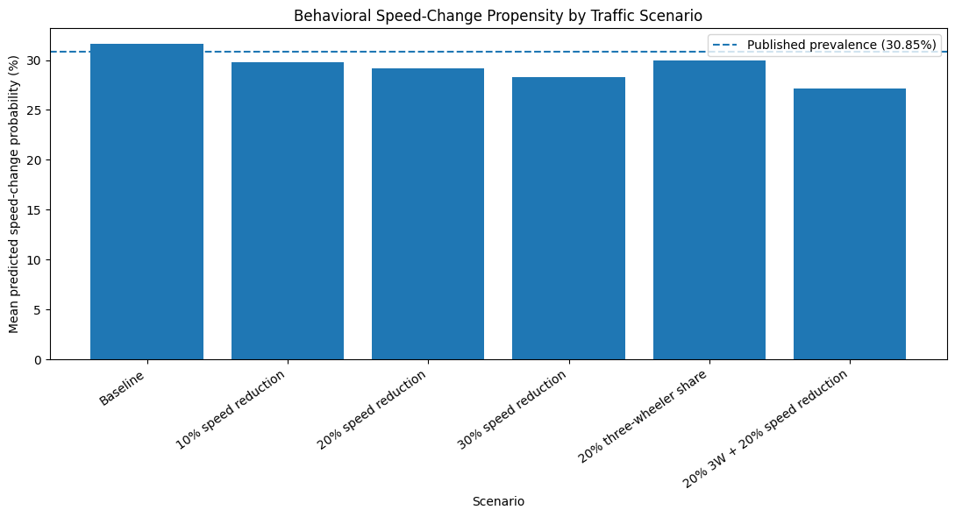
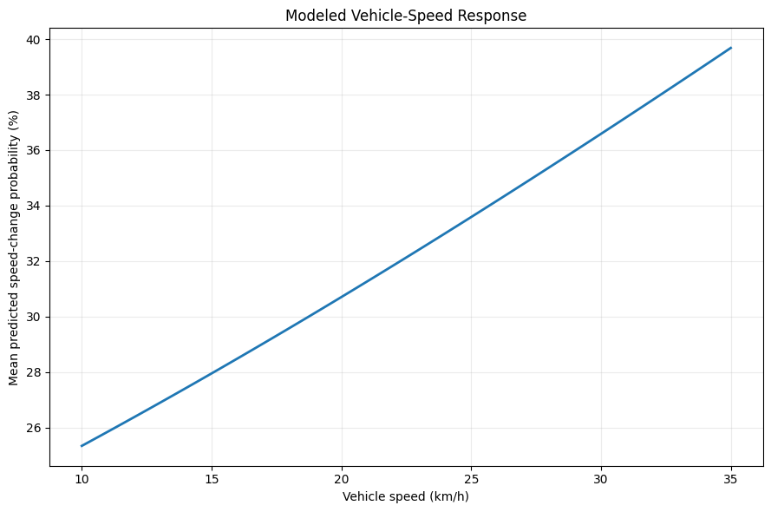
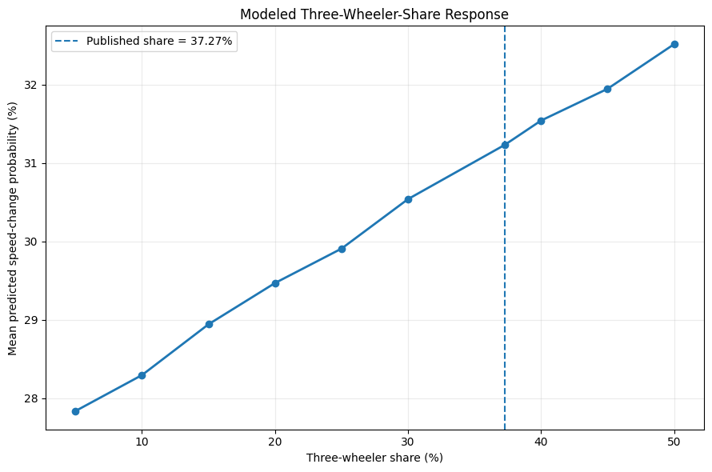

BEHAVIORAL RESPONSE SURFACE (%)
15 20 25 30 35
10.0% 25.76 29.14 31.00 34.02 36.86
20.0% 26.67 29.06 32.17 34.52 37.99
30.0% 27.25 30.23 32.76 35.99 39.25
37.3% 29.23 31.22 33.46 36.59 40.33
45.0% 29.56 32.43 35.05 37.32 41.64
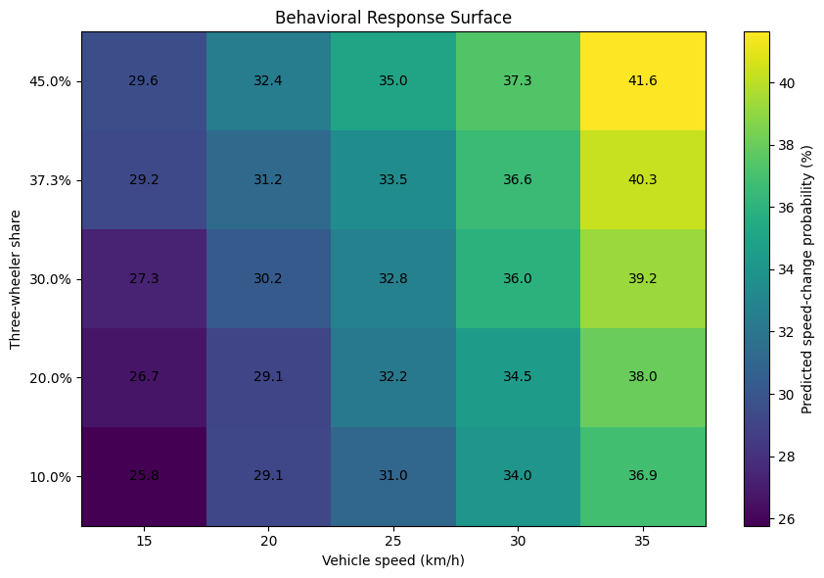

MONTE CARLO RESULTS
----------------------------------------------------------------------
Scenario Mean_rate SD Lower_95 Upper_95 Min Max
Baseline 0.3141 0.0081 0.2987 0.3303 0.2914 0.3347
10% speed reduction 0.3032 0.0080 0.2886 0.3208 0.2749 0.3266
20% speed reduction 0.2913 0.0077 0.2761 0.3052 0.2680 0.3129
30% speed reduction 0.2802 0.0075 0.2660 0.2953 0.2602 0.3010
20% 3W share 0.2959 0.0078 0.2794 0.3116 0.2752 0.3200
20% 3W + 20% speed reduction 0.2736 0.0077 0.2596 0.2894 0.2446 0.2970
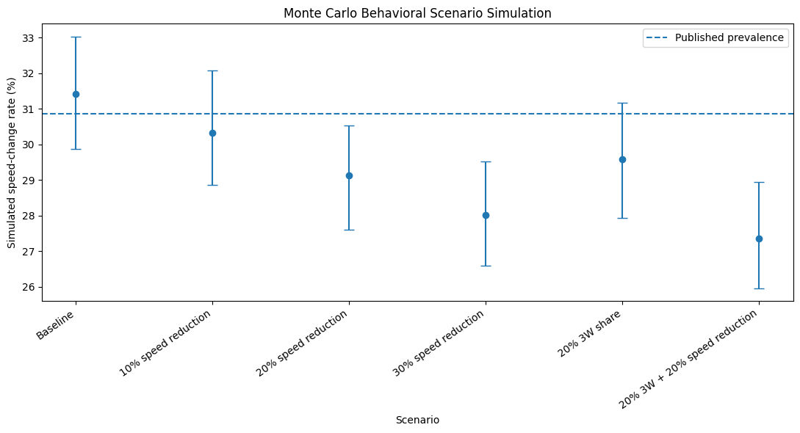

SENSITIVITY RESULTS
Variable Value Predicted_Probability
Vehicle_Speed 10.0 0.2533
Vehicle_Speed 15.0 0.2795
Vehicle_Speed 20.0 0.3070
Vehicle_Speed 25.0 0.3359
Vehicle_Speed 30.0 0.3659
Vehicle_Speed 35.0 0.3968
Vehicle_Gap 1.5 0.2419
Vehicle_Gap 2.0 0.2566
Vehicle_Gap 3.0 0.2877
Vehicle_Gap 4.0 0.3207
Vehicle_Gap 5.0 0.3555
Vehicle_Gap 6.0 0.3916
Waiting_Time 2.0 0.1582
Waiting_Time 5.0 0.1970
Waiting_Time 10.0 0.2748
Waiting_Time 15.0 0.3675
Waiting_Time 20.0 0.4702
Waiting_Time 30.0 0.6749
Waiting_Time 40.0 0.8340
Pedestrian_Speed 0.6 0.2789
Pedestrian_Speed 0.8 0.2875
Pedestrian_Speed 1.0 0.2962
Pedestrian_Speed 1.2 0.3051
Pedestrian_Speed 1.5 0.3187
Pedestrian_Speed 2.0 0.3419
Vehicle_Encountered 0.0 0.3412
Vehicle_Encountered 2.0 0.3308
Vehicle_Encountered 5.0 0.3153
Vehicle_Encountered 10.0 0.2904
Vehicle_Encountered 15.0 0.2666
Vehicle_Encountered 20.0 0.2439
Vehicle_Encountered 25.0 0.2224
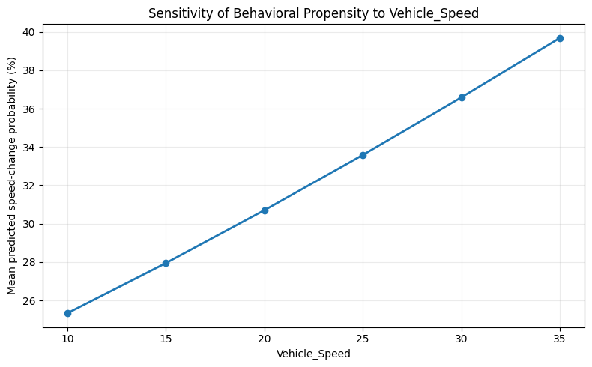
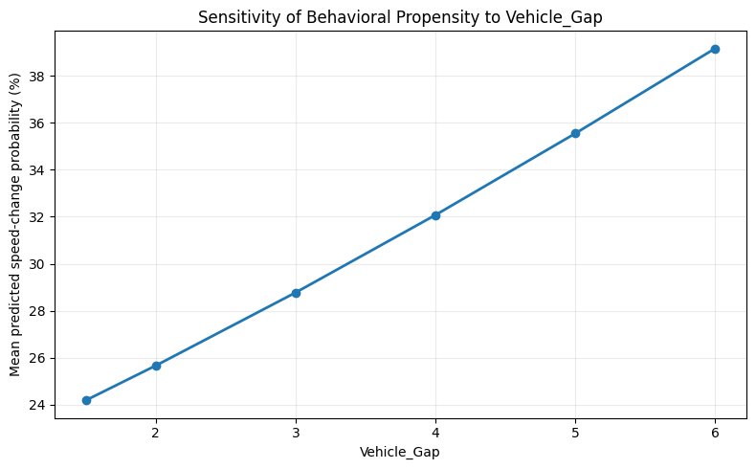
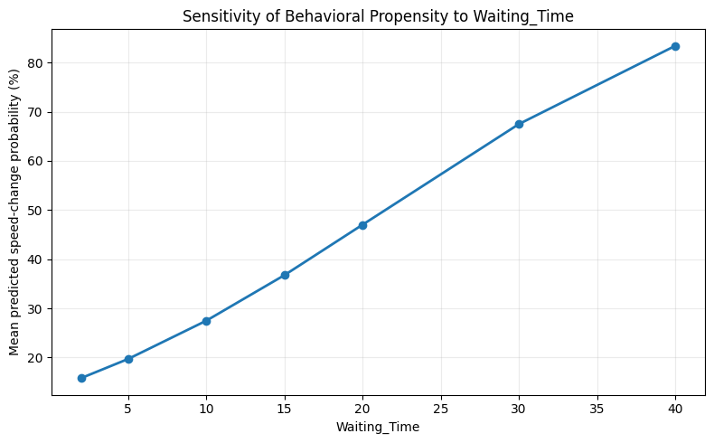
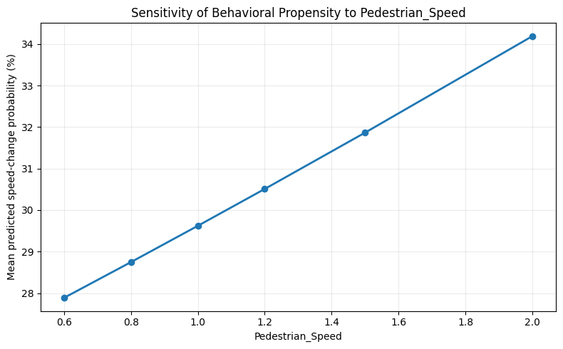
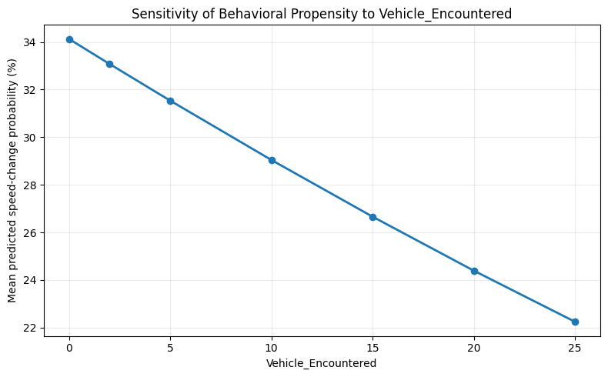

Results saved to:
/content/pedestrian_behavior_simulation_outputs

ZIP archive:
/content/pedestrian_behavior_simulation_outputs.zip

================================================================================
FINAL SUMMARY
================================================================================
Sample represented: 3,209 pedestrians
Published speed-change prevalence: 30.85%
Illustrative calibrated intercept: -6.0318
Simulated baseline rate: 31.1 %

Primary outputs:
1. Synthetic pedestrian population
2. Published beta vs OR consistency check
3. Logistic behavioral propensity
4. Traffic-scenario comparison
5. Vehicle-speed sensitivity
6. Three-wheeler-share sensitivity
7. Vehicle-speed x three-wheeler response surface
8. Monte Carlo scenario intervals

CRITICAL LIMITATIONS:
- The original 3,209 observation-level dataset is unavailable.
- The original logistic-model intercept is unavailable.
- Several continuous-variable means/distributions are assumed.
- Path-change is generated from its reported marginal prevalence.
- This is a synthetic behavioral simulation, not PTV Vissim.
- It is not a causal model and should not be presented as one.
- It does not reproduce the original SPSS analysis.

Recommended presentation wording:
A literature-derived stochastic behavioral simulation was developed using published logistic-regression coefficients and reported marginal distributions to examine counterfactual traffic scenarios.
================================================================================

