Code:

clear all
close all
clc

N = 7;

t = 0:0.001:1

p1 = deg2rad(30);

p2 = deg2rad(45);

x1 = (N+1) * sin(2*pi*((N+2)*2)*t+p1);

plot(t,x1,'r--o')

x2= (N+2) * sin(2*pi*((N+1)*0.5)*t+p2);

figure
plot(t,x2,'b--x')

x3 = x1 + x2;
figure
plot(t,x3,'m--+')

figure
subplot(311)
plot(t,x1,'r--o')
subplot(312)
plot(t,x2,'b--x')
subplot(313)
plot(t,x3,'m--+')

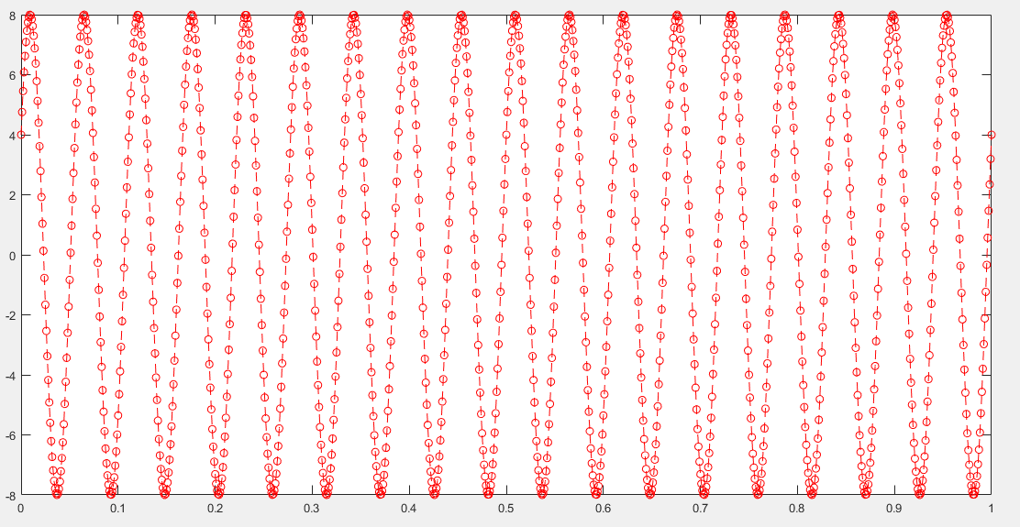
Figure 1(x1)
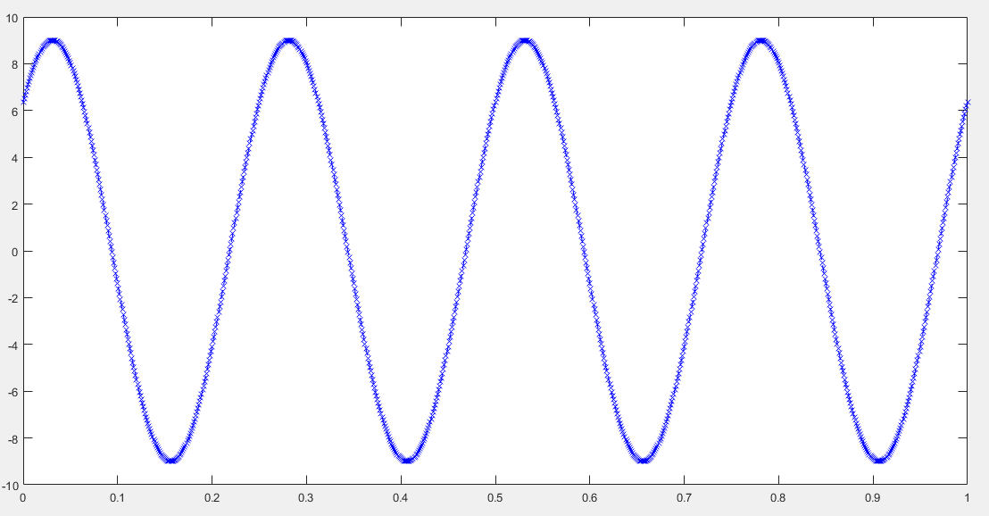
Figure 2(x2)

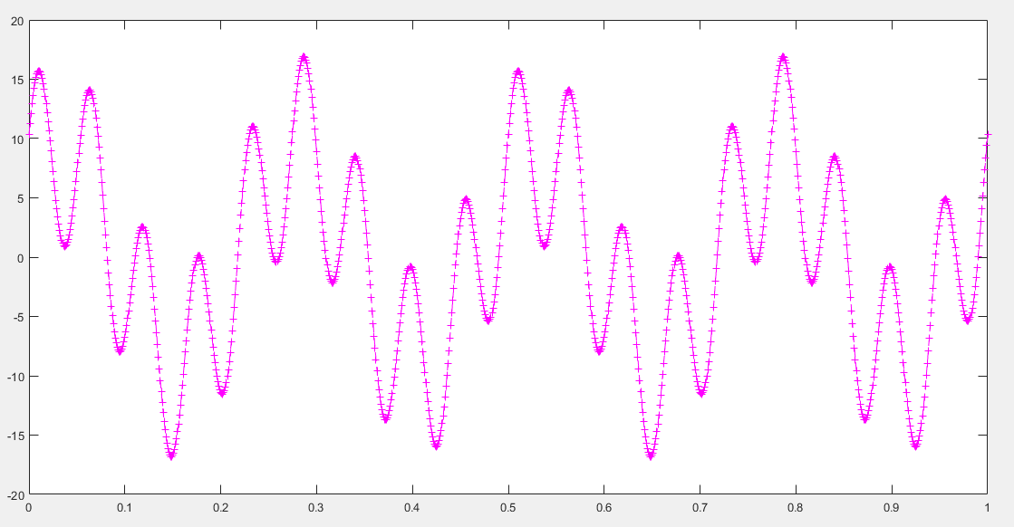
Figure 3(x3)
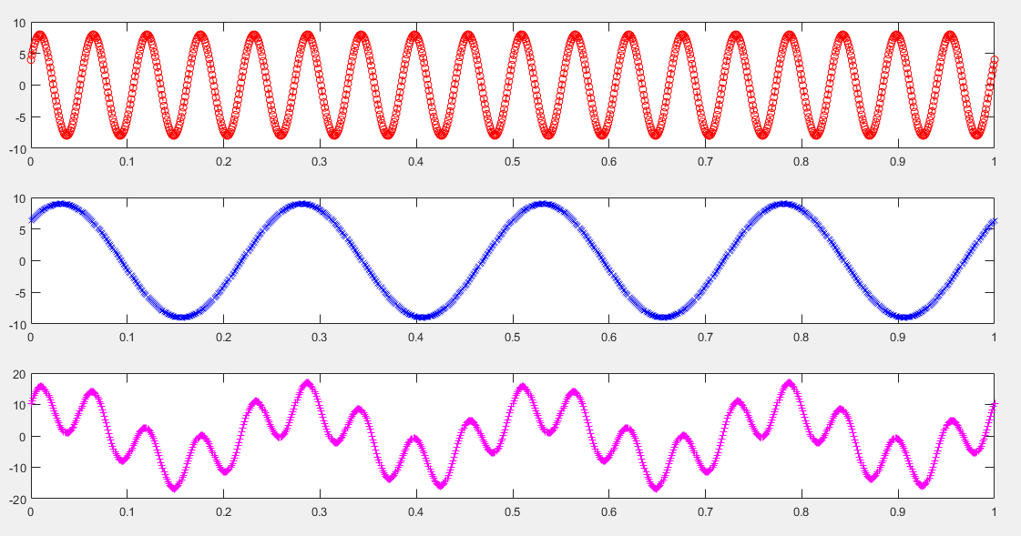
Figure 4

