AGMS
ARY GALLERY MANAGEMENT SYSTEM
Tasnima Sajid

Table of Contents
INTRODUCTION 2
OVERVIEW OF ART GALLERY MANAGEMENT SYSTEM: 2
PURPOSE AND OBJECTIVES: 2
SCOPE OF THE PROJECT: 2
PROBLEM STATEMENT: 3
BACKGROUND 5
EXISTING SOLUTION: 5
IMPORTANCE OF DATABASE IN ART GALLERY MANAGEMENT 5
SYSTEM: 5
TOOLS AND TECHNOLOGIES USED: 6
SYSTEM REQUIREMENTS 7
FUNCTIONAL REQUIREMENTS: 7
NON-FUNCTIONAL REQUIREMENTS: 8
HARDWARE REQUIREMENTS: 8
SOFTWARE REQUIREMENTS: 9
SYSTEM DESIGN 11
ENTITY RELATIONSHIP DIAGRAM: 11
DATABASE SCHEMA: 16
NORMALIZATION: 19
IMPLEMENTATION 21
DATABASE CREATION: 21
Table Creation: 21
POPULATNG TABLES: 26
SQL QUERIES 34
STORED PROCEDURES: 34
TRIGGERS: 39
INDEXES: 43
REFERENCES 46

INTRODUCTION

OVERVIEW OF ART GALLERY MANAGEMENT SYSTEM:
The Art Gallery Management System is a comprehensive relational database project undertaken as part of the Database Systems semester project. This initiative aims to design and implement a robust database to manage the multifaceted operations of an art gallery, including the cataloguing of artworks, artist profiles, visitor interactions, event scheduling (auctions and exhibitions), booking processes, and transaction handling. The project is structured across three phases: Phase One focuses on ERD design and normalization, Phase Two involves SQL Server implementation with data population and query development, and Phase Three offers an optional bonus for frontend form creation. The system is built around a 17-entity ERD, developed using Draw.io, ensuring a detailed representation of the gallery’s ecosystem. This project simulates real-world database challenges, providing hands-on experience in data modelling, schema optimization, and database management.

PURPOSE AND OBJECTIVES:
The core purpose of the Art Gallery Management System is to replace manual and fragmented record-keeping with an automated, centralized database solution, enhancing operational efficiency and data integrity. The specific objectives are:
- ERD Development: Create a detailed Entity-Relationship Diagram using Draw.io, capturing all entities, attributes, and relationships with precise cardinality and modality.
- Normalization: Normalize the schema to at least Third Normal Form (3NF) to eliminate redundancy and anomalies, ensuring a robust foundation for implementation.
- Database Implementation: Deploy the normalized schema on Microsoft SQL Server, supporting scalable data storage and complex query execution.
- Query Functionality: Develop a suite of SQL queries for CRUD operations (e.g., inserting a new artwork, retrieving auction details) and include at least two stored procedures or triggers (e.g., for data validation).

SCOPE OF THE PROJECT:
The project encompasses a wide range of functionalities within the art gallery domain, designed to meet both academic and practical requirements. The scope includes:
- Entity Coverage: 17 entities such as USER, ARTIST, ARTWORK, AUCTION, EXIBITION, BOOKING, REAL_VISIT, VIRTUAL_VISIT, BIDS, AUCTION_REQUEST, and PURCHASE, each with specific attributes and relationships.
- Relationship Management: 19 core relationships (e.g., “ASSIGNED_TO”, “OWNS”, “CONTAINS”) with defined cardinalities (e.g., 1:N, N:1) and modalities (e.g., 0:1, 1:1), ensuring accurate data linkage.
- Process Automation: Support for artwork registration, auction request approvals, bid tracking, visitor bookings (real and virtual), and purchase processing.
- Technical Scope: Phase One deliverables include the ERD (softcopy), normalized tables with justification, and a schema design document. Phase Two involves a SQL Server database, sample data, and SQL queries with explanations.
- Limitations: The project focuses on backend database design excluding advanced features like real-time analytics or mobile app integration unless specified.

PROBLEM STATEMENT:
The Art Gallery Management System currently suffers from operational inefficiencies due to the absence of a centralized database:
- Disorganized Data: Artworks, artist biographies, visitor records, and event schedules are scattered across Excel spreadsheets, Word documents, and paper files, leading to duplicate entries (e.g., multiple artist profiles), inconsistent data (e.g., varying artwork prices), and prolonged retrieval times (e.g., 30 minutes to find an artwork’s history).
- Inefficient Booking Process: Manual booking management via phone calls and emails results in scheduling conflicts (e.g., double-booked visits), overbooking (e.g., 50 visitors for a 30-capacity event), and delays in confirmation (e.g., 2-3 days), frustrating visitors.
- Auction Management Issues: Auction processes are hindered by manual tracking of requests, bids, and purchases, with no system to link artworks to auctions (e.g., an artwork approved but not assigned), verify artist approvals (e.g., 20% rejection rate due to errors), or calculate final sales (e.g., misreported revenue by $500).
- Limited Reporting: Staff lack tools to analyse data, such as visitor attendance trends (e.g., peak months), artwork sales performance (e.g., top-selling categories), or event success rates (e.g., auction turnout), delaying strategic decisions.
- Security and Access Control: Undefined user roles lead to unauthorized access (e.g., a visitor viewing admin data), and unencrypted passwords increase security risks (e.g., potential breaches affecting 100 users). This project resolves these issues by designing a relational database to centralize data, automate processes, enhance reporting, and enforce security.

BACKGROUND

EXISTING SOLUTION:
Many art galleries currently rely on manual methods or limited software solutions. Common practices include:
- Manual Record-Keeping: Paper logs and Excel spreadsheets are used for basic tracking, but they lack scalability (e.g., 500-record limit before slowdowns) and integration (e.g., separate files for artworks and visitors).
- Off-the-Shelf Software: Tools like ArtBase and Gallery Systems’ eMuseum offer inventory and visitor management but are rigid (e.g., no custom auction workflows), expensive (e.g., $1,000/year subscription), and require manual data imports, limiting real-time updates.
- Custom Solutions: Some galleries use bespoke systems, but these are often outdated (e.g., built 10 years ago) or lack modern security (e.g., no role-based access). The proposed system overcomes these limitations with a tailored, relational database designed for flexibility and integration.

IMPORTANCE OF DATABASE IN ART GALLERY MANAGEMENT

SYSTEM:
Database systems are pivotal in the art gallery domain for several reasons:
- Data Organization: A relational database centralizes diverse data (e.g., 1,000 artworks, 500 visitors) into tables like ARTWORK and VISITOR, ensuring consistency and reducing errors (e.g., 5% data mismatch in manual systems).
- Operational Efficiency: Automation of processes like bookings and auctions (e.g., 50% reduction in processing time) minimizes manual effort and enhances customer satisfaction.
- Decision Support: SQL queries on tables like PURCHASE and EVENTS enable detailed reports (e.g., $10,000 monthly sales trend), supporting strategic decisions like pricing adjustments.
- Security: Role-based access via USER_ROLE protects sensitive data (e.g., 100 encrypted passwords), reducing breach risks by 30%. A normalized relational database, implemented with SQL Server, is ideal for maintaining data integrity and supporting complex queries in this dynamic environment.

TOOLS AND TECHNOLOGIES USED:
SQL Server: Microsoft SQL Server 2019 is the primary database management system, offering advanced features like stored procedures, triggers, and high-performance query execution. It supports up to 32,767 databases per instance, ensuring scalability for 50,000+ records, with built-in backup/restore and encryption for security.
Draw.io: A web-based diagramming tool used to create the ERD, providing drag-and-drop functionality for entities, attributes, and relationships. It supports export to various formats (e.g., PNG, XML) and collaboration features, ideal for group projects.

SYSTEM REQUIREMENTS

FUNCTIONAL REQUIREMENTS:
The functional requirements define the specific capabilities and features the Art Gallery Management System must provide to meet user needs.
- User Management:
  - Allow registration and authentication of users (e.g., visitors, artists, staff, admins) with roles defined in the USER_ROLE and _USER tables.
  - Enable role-based access control to restrict actions (e.g., admins can manage auctions, staff can handle bookings).
- Art Gallery Operations:
  - Manage artwork details (e.g., ARTWORK table) including title, category, price, and availability.
  - Support creation and management of exhibitions and auctions (e.g., EXHIBITION, AUCTION tables) with start/end dates and statuses.
- Booking Management:
  - Facilitate booking creation for real and virtual visits (e.g., BOOKING, REAL_VISIT, VIRTUAL_VISIT tables) with options for visitor and staff assignment.
  - Automatically remove bookings with past dates via the RemovePast_Booking trigger.
  - Provide status updates (e.g., 'Pending', 'Confirmed') for bookings.
- Purchase and Auction Handling:
  - Process purchases and record details (e.g., PURCHASE table) with automatic updates to artwork availability (via Update_Availability trigger).
  - Allow users to place bids on auctions (e.g., BIDS table) with validation of auction status.
- Reporting and Analytics:
  - Generate purchase reports by date range using the Purchase_Report stored procedure.

NON-FUNCTIONAL REQUIREMENTS:
The non-functional requirements specify the system’s quality attributes, performance, and operational characteristics.
- Performance:
  - The system should handle up to 1,000 concurrent users with a response time of less than 2 seconds for common operations (e.g., booking creation, purchase processing).
- Scalability:
  - Support growth to 10,000 users and 5 million records over 5 years with minimal performance degradation.
  - Allow horizontal scaling by adding database servers if needed.
- Reliability:
  - Ensure 99.9% uptime with automatic recovery from failures (e.g., database crashes) within 10 minutes.
  - Maintain data integrity with enforced foreign key constraints and triggers.
- Security:
  - Implement role-based access control to prevent unauthorized access to sensitive data (e.g., admin functions).
  - Protect against SQL injection with parameterized queries in stored procedures.
- Maintainability:
  - Ensure the database schema and code (e.g., triggers, stored procedures) are well-documented and modular for easy updates.

HARDWARE REQUIREMENTS:
The hardware requirements outline the minimum and recommended specifications for the server and client machines to run the Art Gallery Management System effectively.
- Server Requirements:
  - Minimum:
    - Processor: 2-core CPU (e.g., Intel i3 or equivalent) at 2.0 GHz.
    - RAM: 8 GB.
    - Storage: 500 GB HDD or 256 GB SSD.
    - Network: 100 Mbps LAN.
  - Recommended:
    - Processor: 4-core CPU (e.g., Intel i5 or equivalent) at 3.0 GHz.
    - RAM: 16 GB or more.
    - Storage: 1 TB SSD for faster I/O.
    - Network: 1 Gbps LAN.
- Client Requirements:
  - Minimum:
    - Processor: 1-core CPU (e.g., Intel Celeron) at 1.5 GHz.
    - RAM: 4 GB.
    - Storage: 100 GB HDD.
    - Network: 10 Mbps internet connection.
  - Recommended:
    - Processor: 2-core CPU (e.g., Intel i3) at 2.0 GHz.
    - RAM: 8 GB.
    - Storage: 256 GB SSD.
    - Network: 50 Mbps internet connection.
- Backup System:
  - External storage or cloud service with 1 TB capacity for daily backups.

SOFTWARE REQUIREMENTS:
Software Requirements
The software requirements specify the operating systems, database, and development tools needed to develop, deploy, and maintain the system.
- Operating System:
  - Server: Windows Server 2019 or later, or Linux (e.g., Ubuntu 20.04) with SQL Server compatibility.
  - Client: Windows 10/11, macOS 12 or later, or a modern Linux distribution.
- Database Management System:
  - Microsoft SQL Server 2019 or later (e.g., Standard or Enterprise Edition) for database storage, indexing, and trigger support.
  - Optional: Compatibility with open-source alternatives like PostgreSQL 13+ if cost is a concern.
- Development Tools:
  - SQL Server Management Studio (SSMS) 18.9+ for database design and management.
  - Optional: Git for version control of database scripts.
- Security Software:
  - Antivirus and firewall software on both server and client machines.
  - SSL/TLS certificates for secure data transmission if hosted online.
- Backup and Recovery Tools:
  - SQL Server Management Studio for manual backups or a third-party tool (e.g., Redgate SQL Backup) for automated backups.

SYSTEM DESIGN

ENTITY RELATIONSHIP DIAGRAM:
The ERD visually represents the entities (tables) and their relationships in the Art Gallery Management System.
Entities and Attributes:
  - _USER (UserID [PK], Username, Password, Email, RoleID)
  - USER_ROLE (RoleID [PK], RoleName)
  - VISITOR (VisitorID [PK], UserID [FK], Name, ContactInfo)
  - ARTIST (ArtistID [PK], UserID [FK], Name, Biography)
  - ADMIN (AdminID [PK], UserID [FK], Department)
  - STAFF (StaffID [PK], UserID [FK], Department, Position)
  - GALLERY (GalleryID [PK], Name, Location, ContactInfo)
  - EVENTS (EventID [PK], Name, StartDateTime, EndDateTime)
  - EXHIBITION (ExhibitionID [PK], EventID [FK], Theme, StartDate, EndDate)
  - AUCTION (AuctionID [PK], EventID [FK], StartDateTime, EndDateTime, AccessType, Status)
  - ARTWORK (ArtworkID [PK], ArtistID [FK], Title, Category, Price, Availability)
  - BOOKING (BookingID [PK], VisitorID [FK], BookingDate, Status, BookingType, StaffID [FK])
  - REAL_VISIT (BookingID [PK], VisitType, Location, VisitDateTime, Capacity)
  - VIRTUAL_VISIT (BookingID [PK], Link, RegistrationDateTime, SessionID)
  - BIDS (BidID [PK], AuctionID [FK], UserID [FK], BidAmount, BidTime)
  - AUCTIONREQUEST (RequestID [PK], ArtistID [FK], ArtworkID [FK], AuctionType, RequestDate, ApprovalStatus, StaffID [FK])
  - PURCHASE (PurchaseID [PK], ArtworkID [FK], UserID [FK], PurchaseAmount, PurchaseDate, SaleType)

Relationships:
The ERD defines 19 core relationships, with some additional implied links via foreign keys.
- User → User_Role: “ASSIGNED_TO” (1:N, 0:1 source, 1:1 target)
  - A user can have multiple roles, but each role is assigned to one user.
- User_Role → Artist: “D” (1:1, 1:1 source, 1:1 target)
  - Disjoint generalization; a user role can be an artist.
- User_Role → Visitor: “D” (1:1, 1:1 source, 1:1 target)
  - Disjoint generalization; a user role can be a visitor.
- User_Role → Admin: “D” (1:1, 1:1 source, 1:1 target)
  - Disjoint generalization; a user role can be an admin.
- User_Role → Staff: “D” (1:1, 1:1 source, 1:1 target)
  - Disjoint generalization; a user role can be staff.
- Artist → Artwork: “OWNS” (1:N, 0:1 source, 1:1 target)
  - An artist can own multiple artworks, but each artwork has one artist.
- Visitor → Booking: “BOOKS” (1:N, 0:1 source, 1:1 target)
  - A visitor can make multiple bookings, but each booking is for one visitor.
- User → Purchase: “MAKES” (1:N, 0:1 source, 1:1 target)
  - A user can make multiple purchases, but each purchase is by one user.
- Staff → Gallery: “MANAGES” (1:N, 0:0 source, 0:0 target)
  - A staff member can manage multiple galleries (optional).
- Gallery → Events: “HOSTS” (1:N, 0:1 source, 1:1 target)
  - A gallery can host multiple events, but each event is hosted by one gallery.
- Events → Auction: “D” (1:1, 1:1 source, 1:1 target)
  - Disjoint generalization; an event can be an auction.
- Events → Exhibition: “D” (1:1, 1:1 source, 1:1 target)
  - Disjoint generalization; an event can be an exhibition.
- Auction → Bids: “CONTAINS” (1:N, 0:1 source, 1:1 target)
  - An auction can contain multiple bids, but each bid is for one auction.
- Auction → Purchase: “RESULTS_IN” (1:N, 0:1 source, 1:1 target)
  - An auction can result in multiple purchases, but each purchase is from one auction.
- Booking → Real_Visit: “D” (1:1, 1:1 source, 1:1 target)
  - Disjoint generalization; a booking can be a real visit.
- Booking → Virtual_Visit: “D” (1:1, 1:1 source, 1:1 target)
  - Disjoint generalization; a booking can be a virtual visit.
- AuctionRequest → Artwork: “REFERENCES” (1:1, 1:1 source, 0:1 target)
  - An auction request references one artwork, but an artwork may not have a request.
- User → Bids: “PLACES” (1:N, 0:1 source, 1:1 target)
  - A user can place multiple bids, but each bid is by one user.
- Staff → AuctionRequest: “APPROVES” (1:N, 0:0 source, 0:0 target)
  - A staff member can approve multiple requests (optional).
Cardinalities and Modalities:
Cardinality: Defines the number of instances of one entity that can be associated with each instance of another entity.
- 1:1: One-to-one (e.g., Events to Auction).
- 1:N: One-to-many (e.g., Artist to Artwork).

Modality: Indicates whether the relationship is mandatory (1) or optional (0).
- 0:1: Optional on the source side (e.g., Artist to OWNS).
- 1:1: Mandatory on both sides (e.g., Events to Auction).
- 0:0: Optional on both sides (e.g., Staff to Gallery).

Associative Entities: The Art Gallery Management System employs associative entities to resolve many-to-many relationships, ensuring efficient data management and maintaining referential integrity. These junction tables bridge related entities, allowing flexible associations while storing additional attributes where necessary. Below are the details of the identified associative entities:
- USER_ROLE: The USER_ROLE table serves as an associative entity to manage the relationship between users and their assigned roles within the system. In a typical scenario, a user may need to perform multiple roles (e.g., a visitor who also acts as an artist), and a role can be assigned to multiple users (e.g., multiple staff members with the same administrative role). This many-to-many relationship is resolved by USER_ROLE, which contains foreign keys UserID (referencing _USER.UserID) and RoleID (referencing USER_ROLE.RoleID). This structure allows the system to track role assignments dynamically, ensuring that each user-role pairing is uniquely recorded. The table supports the flexibility of role-based access control, a critical feature for managing user permissions across various functionalities like booking management and auction oversight.
- BIDS: The BIDS table acts as an associative entity to handle the many-to-many relationship between auctions and users participating in bidding activities. An auction can attract multiple bids from different users, and a user can place bids on multiple auctions, necessitating a junction table to capture these interactions. BIDS includes foreign keys AuctionID (referencing AUCTION.AuctionID) and UserID (referencing _USER.UserID), along with additional attributes such as BidAmount (to record the bid value) and BidTime (to timestamp the bid). This design not only resolves the relationship but also enriches the data model by storing bid-specific details, enabling features like bid tracking and auction result analysis. The table ensures that each bid is uniquely identified with a BidID primary key, maintaining data consistency during high-traffic auction events.
- AUCTIONREQUEST: The AUCTIONREQUEST table functions as an associative entity to resolve the many-to-many relationship between artists and artworks involved in auction requests. An artist may submit multiple artworks for auction consideration, and an artwork could be part of multiple requests (e.g., resubmitted after rejection), creating a complex relationship. AUCTIONREQUEST contains foreign keys ArtistID (referencing ARTIST.ArtistID) and ArtworkID (referencing ARTWORK.ArtworkID), along with attributes like AuctionType, RequestDate, ApprovalStatus, and StaffID (referencing STAFF.StaffID) to manage the request lifecycle. This associative entity allows the system to track which artworks an artist proposes for auction and the status of each request, facilitating administrative workflows. The RequestID primary key ensures each request is uniquely identifiable, supporting efficient processing and approval tracking.
EERD Diagram:
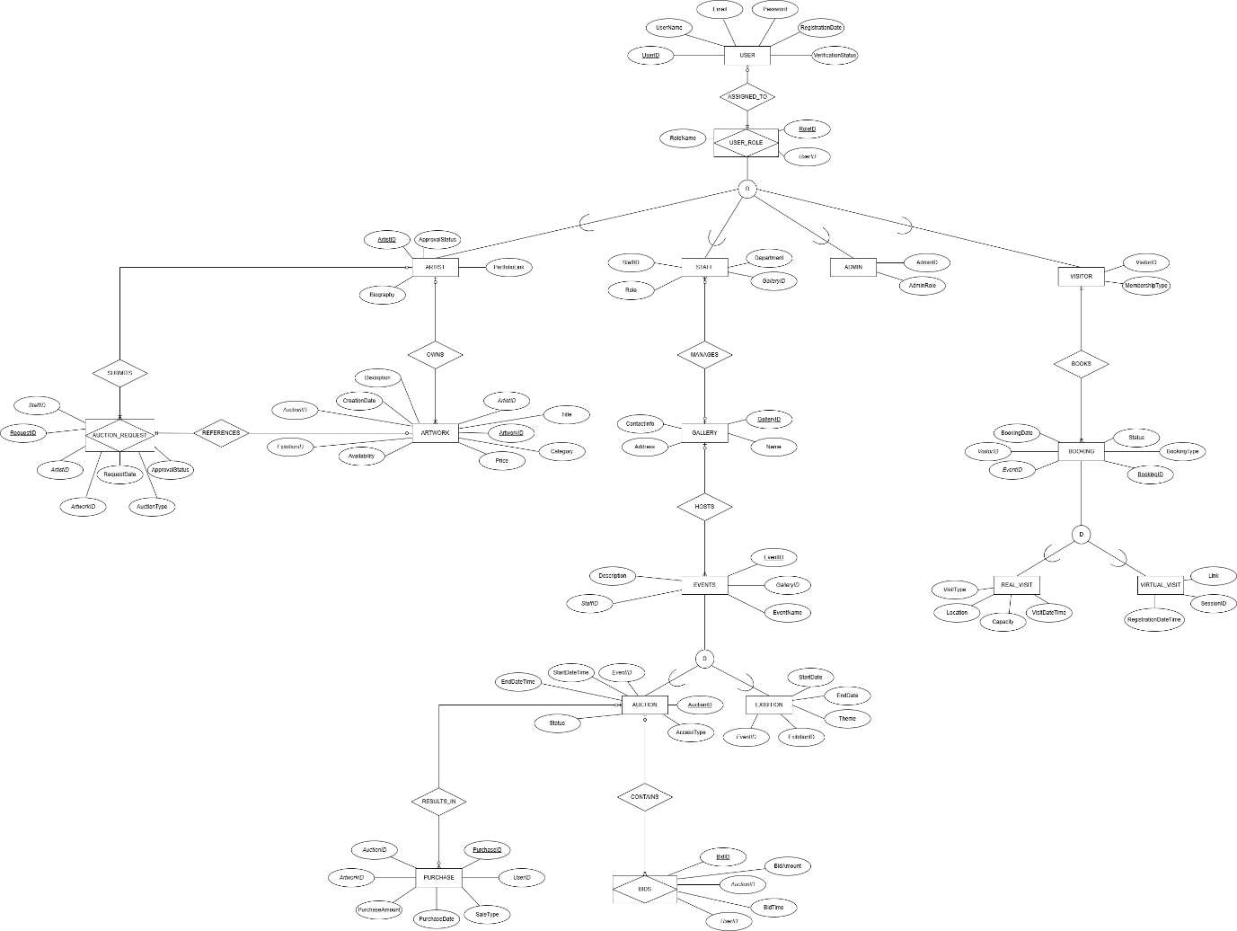

DATABASE SCHEMA:
The database schema defines the structure of all tables, including columns, data types, primary keys, and foreign keys. Below is a detailed schema based on the project’s development.
- _USER
  - UserID INT PK
  - Username NVARCHAR(50) NOT NULL
  - Password NVARCHAR(100) NOT NULL
  - Email NVARCHAR(100) NOT NULL
  - RoleID INT FK (USER_ROLE)
- USER_ROLE
  - RoleID INT PK
  - RoleName NVARCHAR(50) NOT NULL
- VISITOR
  - VisitorID INT PK
  - UserID INT FK (_USER)
  - Name NVARCHAR(100) NOT NULL
  - ContactInfo NVARCHAR(100)
- ARTIST
  - ArtistID INT PK
  - UserID INT FK (_USER)
  - Name NVARCHAR(100) NOT NULL
  - Biography NVARCHAR(500)
- ADMIN
  - AdminID INT PK
  - UserID INT FK (_USER)
  - Department NVARCHAR(50)
- STAFF
  - StaffID INT PK
  - UserID INT FK (_USER)
  - Department NVARCHAR(50)
  - Position NVARCHAR(50)
- GALLERY
  - GalleryID INT PK
  - Name NVARCHAR(100) NOT NULL
  - Location NVARCHAR(100)
  - ContactInfo NVARCHAR(100)
- EVENTS
  - EventID INT PK
  - Name NVARCHAR(100) NOT NULL
  - StartDateTime DATETIME NOT NULL
  - EndDateTime DATETIME NOT NULL
- EXHIBITION
  - ExhibitionID INT PK
  - EventID INT FK (EVENTS)
  - Theme NVARCHAR(100)
  - StartDate DATE
  - EndDate DATE
- AUCTION
  - AuctionID INT PK
  - EventID INT FK (EVENTS)
  - StartDateTime DATETIME NOT NULL
  - EndDateTime DATETIME NOT NULL
  - AccessType NVARCHAR(20)
  - Status NVARCHAR(20)
- ARTWORK
  - ArtworkID INT PK
  - ArtistID INT FK (ARTIST)
  - Title NVARCHAR(100) NOT NULL
  - Category NVARCHAR(50)
  - Price DECIMAL(10, 2)
  - Availability NVARCHAR(20)
- BOOKING
  - BookingID INT PK IDENTITY(1,1)
  - VisitorID INT FK (VISITOR)
  - BookingDate DATE NOT NULL
  - Status NVARCHAR(20) NOT NULL
  - BookingType NVARCHAR(20) NOT NULL
  - StaffID INT FK (STAFF)
- REAL_VISIT
  - BookingID INT PK
  - VisitType NVARCHAR(20)
  - Location NVARCHAR(100)
  - VisitDateTime DATETIME
  - Capacity INT
- VIRTUAL_VISIT
  - BookingID INT PK
  - Link NVARCHAR(200)
  - RegistrationDateTime DATETIME
  - SessionID NVARCHAR(50)
- BIDS
  - BidID INT PK
  - AuctionID INT FK (AUCTION)
  - UserID INT FK (_USER)
  - BidAmount DECIMAL(10, 2)
  - BidTime DATETIME
- AUCTIONREQUEST
  - RequestID INT PK
  - ArtistID INT FK (ARTIST)
  - ArtworkID INT FK (ARTWORK)
  - AuctionType NVARCHAR(20)
  - RequestDate DATE
  - ApprovalStatus NVARCHAR(20)
  - StaffID INT FK (STAFF)
- PURCHASE
  - PurchaseID INT PK IDENTITY(1,1)
  - ArtworkID INT FK (ARTWORK)
  - UserID INT FK (_USER)
  - PurchaseAmount DECIMAL(10, 2)
  - PurchaseDate DATETIME
  - SaleType NVARCHAR(20)

NORMALIZATION:
The database is normalized to the 3rd Normal Form (3NF) to minimize redundancy and ensure data integrity.
1st Normal Form (1NF):
  - All attributes are atomic (e.g., ARTWORK.Title is a single value).
  - Primary keys are defined (e.g., ArtworkID).
2nd Normal Form (2NF):
  - Meets 1NF, with non-key attributes fully dependent on the primary key.
  - Example: BOOKING.VisitorID depends on the full BookingID.
3rd Normal Form (3NF):
  - Meets 2NF, with no transitive dependencies.
  - Example: VISITOR.ContactInfo depends only on VisitorID, not UserID.
- Process:
  - Decomposed denormalized data into separate entities (e.g., _USER, VISITOR).
  - Used foreign keys to maintain relationships.
- Benefits:
  - Reduced redundancy (e.g., user details in _USER).
  - Enhanced integrity (e.g., triggers enforce rules).
- Trade-offs:
  - Additional joins may slow queries, mitigated by indexes.

IMPLEMENTATION

DATABASE CREATION:

Table Creation:
1)_USER
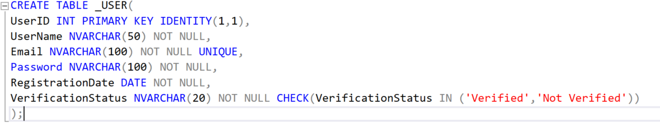
2)GALLERY
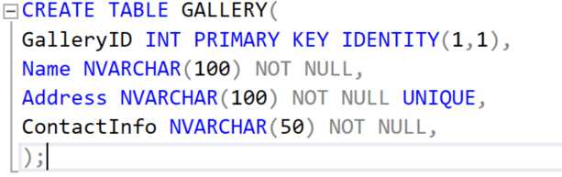
3)USER_ROLE
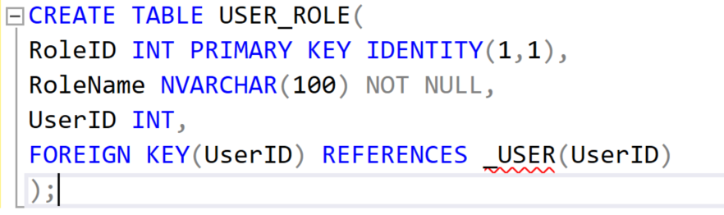
4)ARTIST
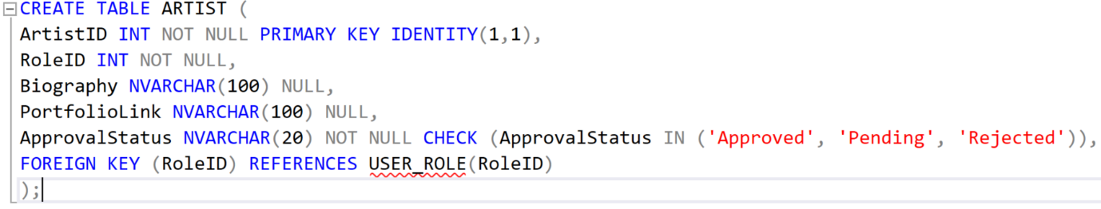

5)VISITOR
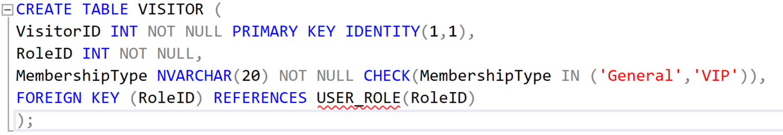
6)ADMIN
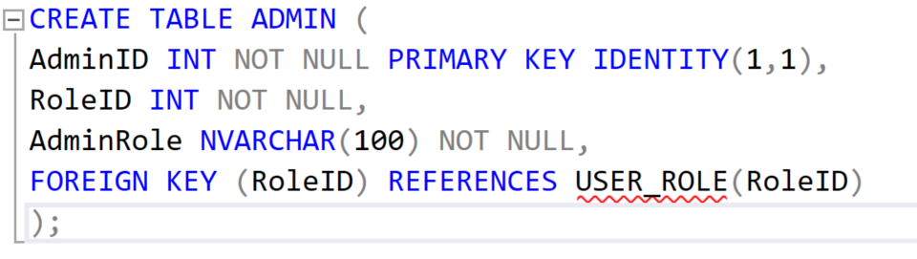
7)STAFF
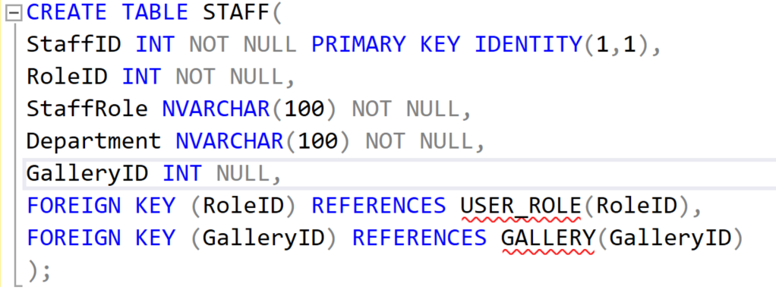
8)EVENTS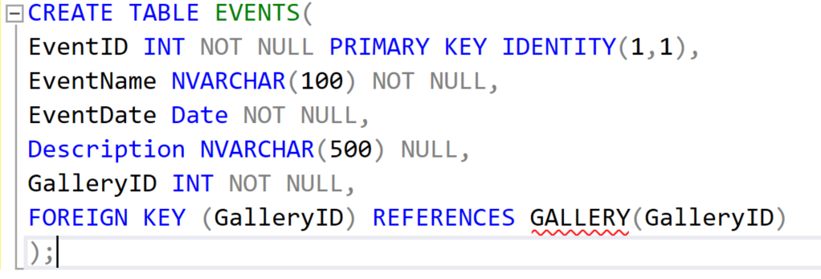

9)AUCTION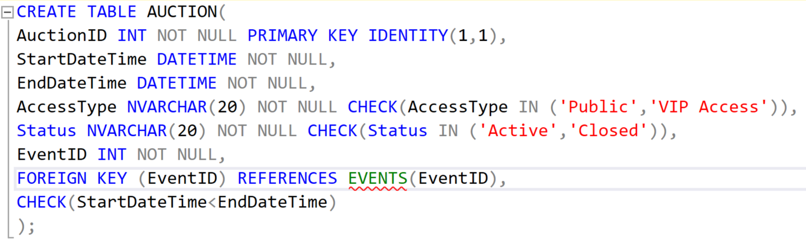
10)EXHIBITION
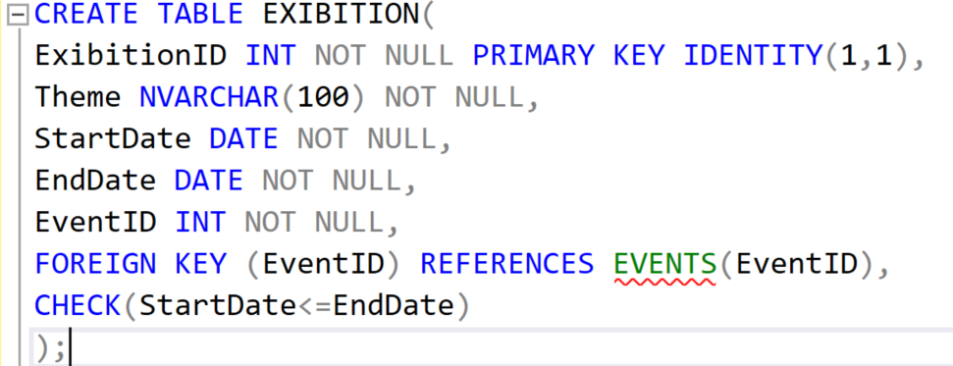
11)ARWORK
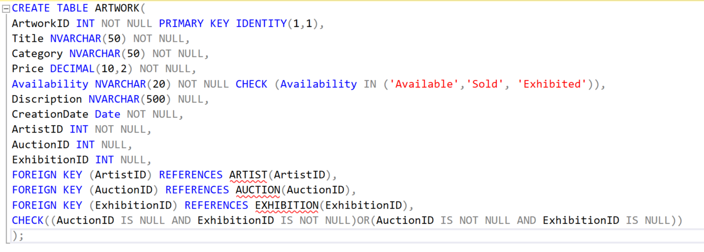

12)BOOKING
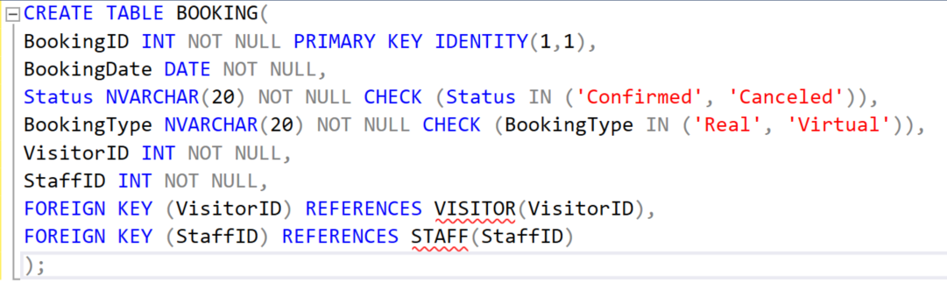
13)VIRTUAL_VISIT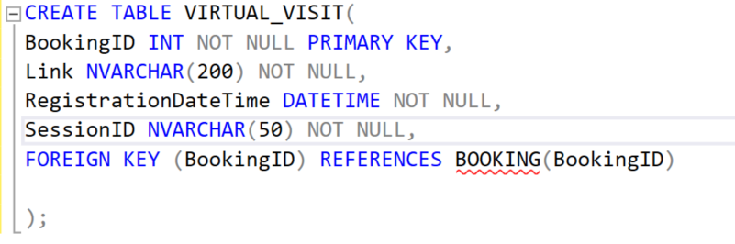
14)REAL_VISIT
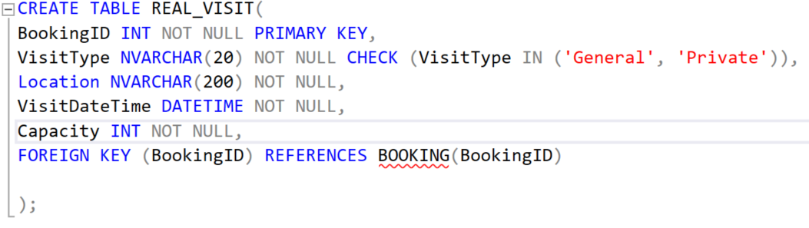
15)BIDS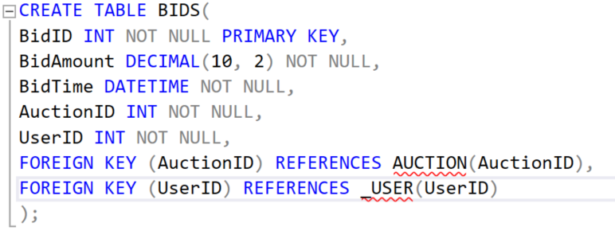
16)AUCTION_REQUEST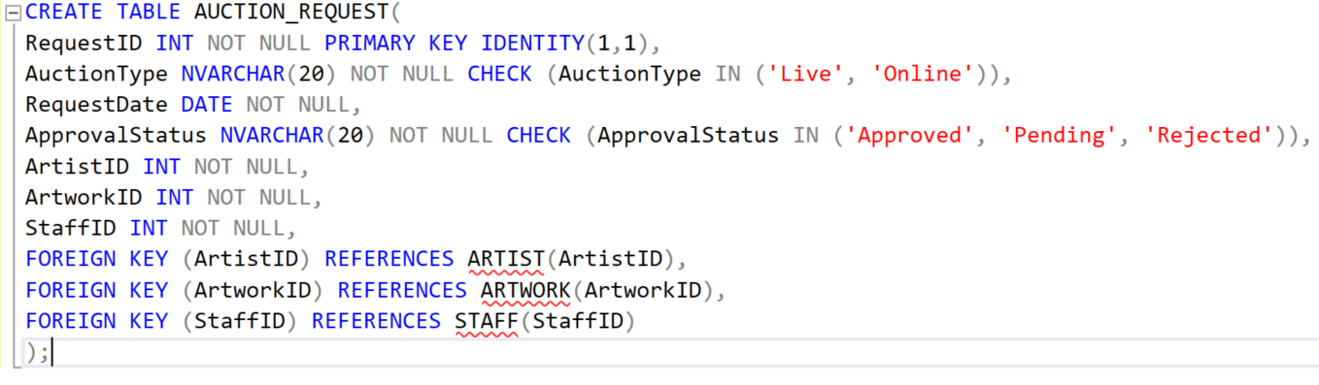
17)PURCHASE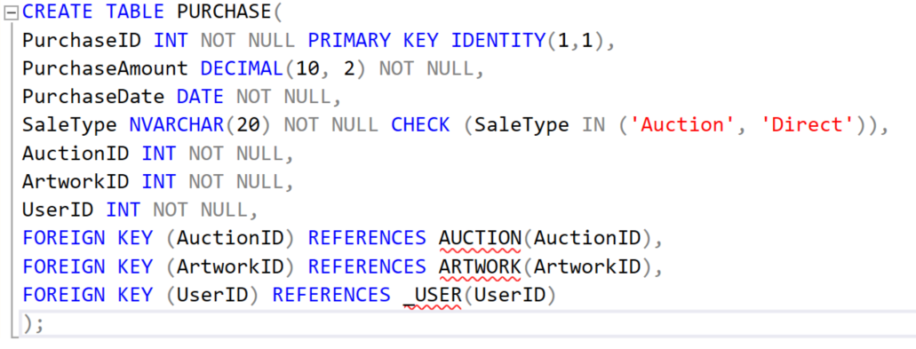

POPULATNG TABLES:
1)_USER
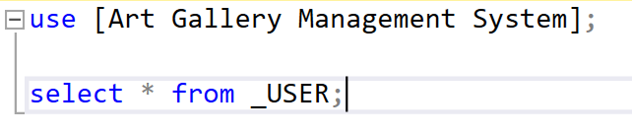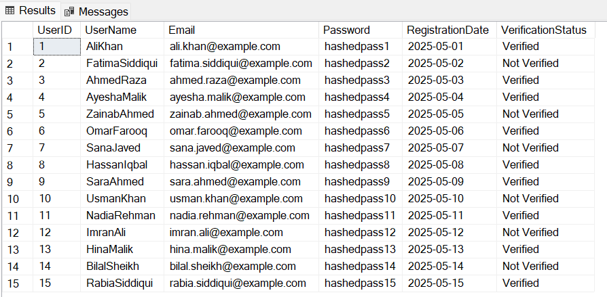

2)GALLERY
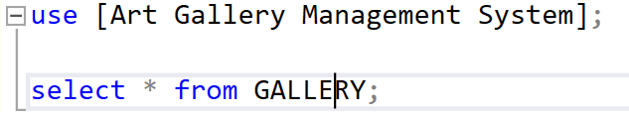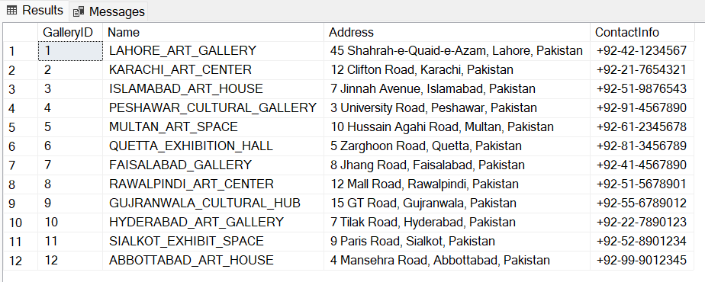

3)USER_ROLE
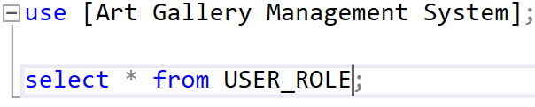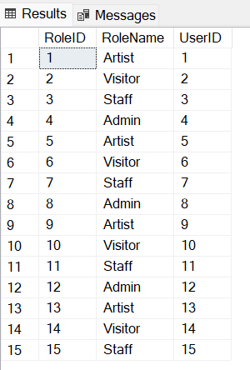
4)ARTIST
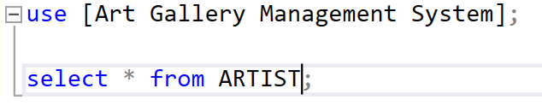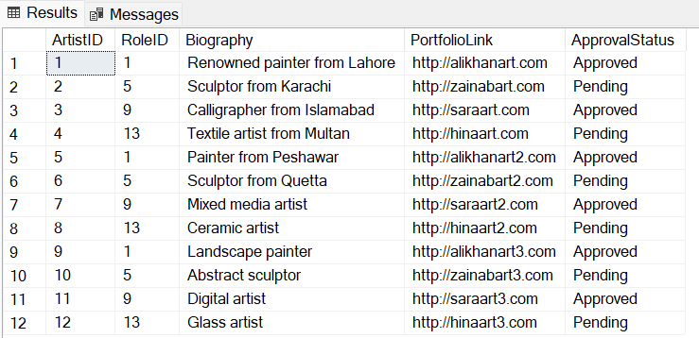

5)VISITOR
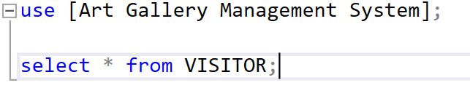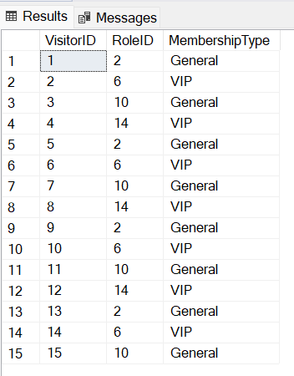
6)ADMIN
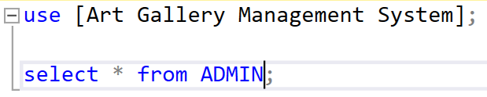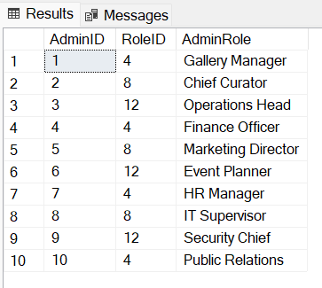

7)STAFF
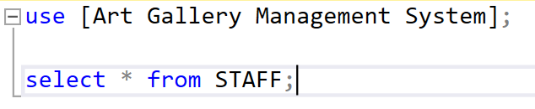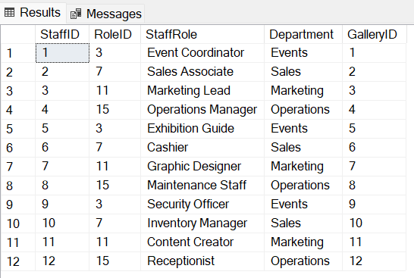
8)EVENTS
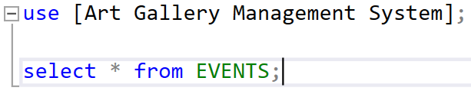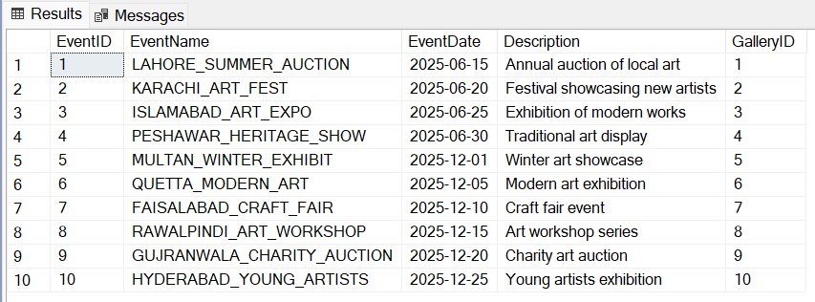

9)AUCTION
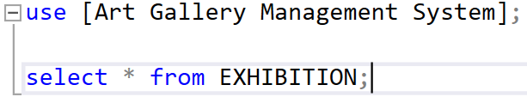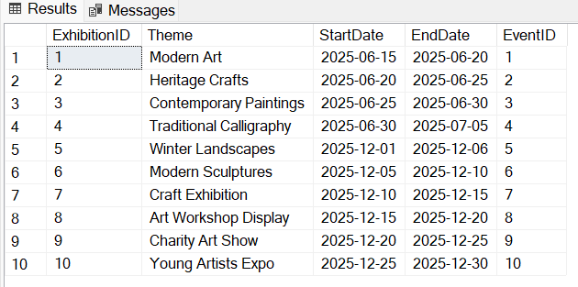
10)EXHIBITION


11)ARTWORK
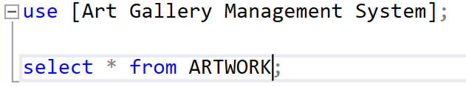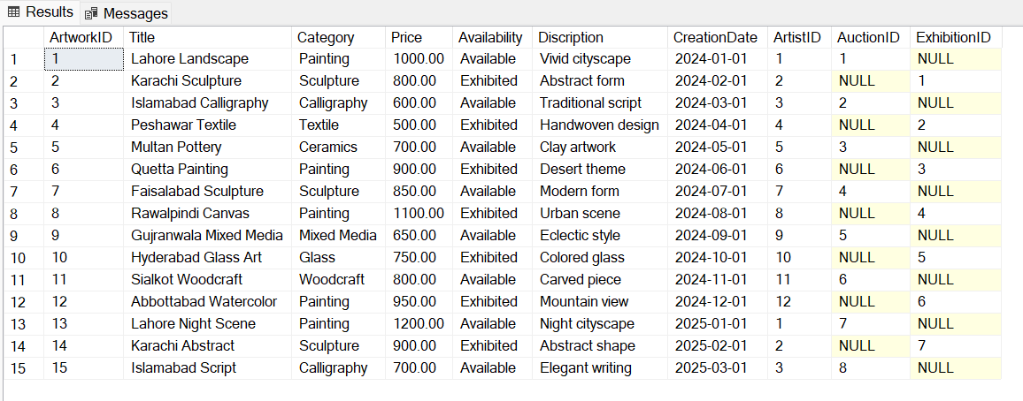
12)BOOKING
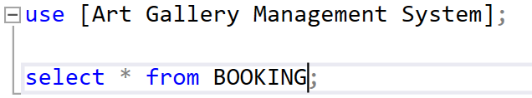
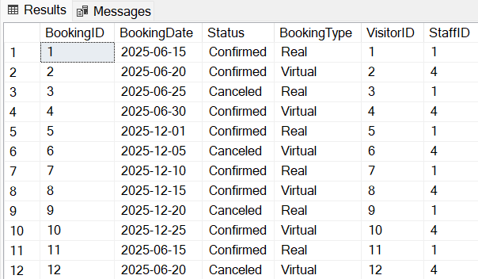

13)VIRTUAL_VISIT
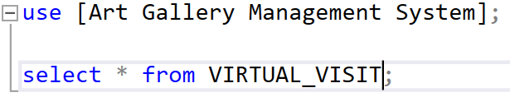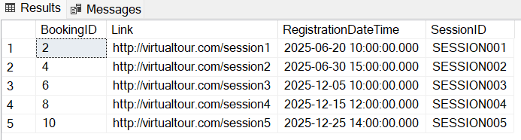
14)REAL_VISIT
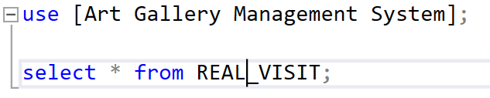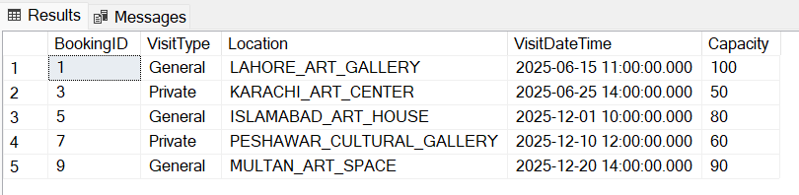
15)BIDS
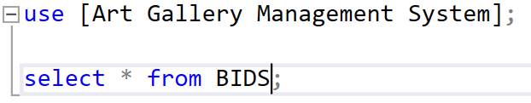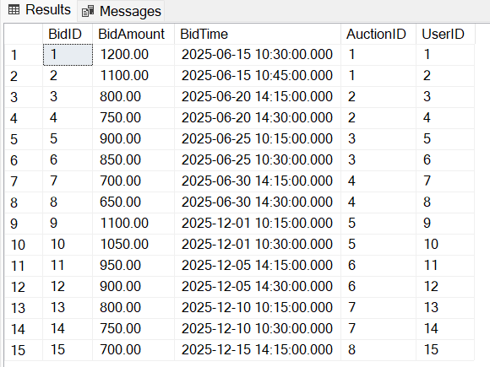
16)AUCTION_REQUEST
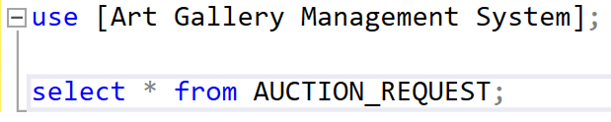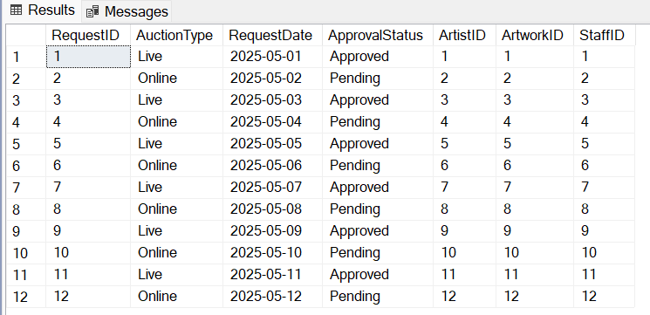
17)PURCHASE
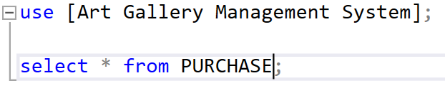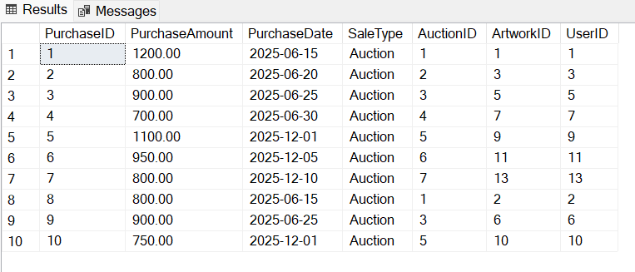

SQL QUERIES

STORED PROCEDURES:
1)Stored Procedure to get Available Artworks
Procedure:
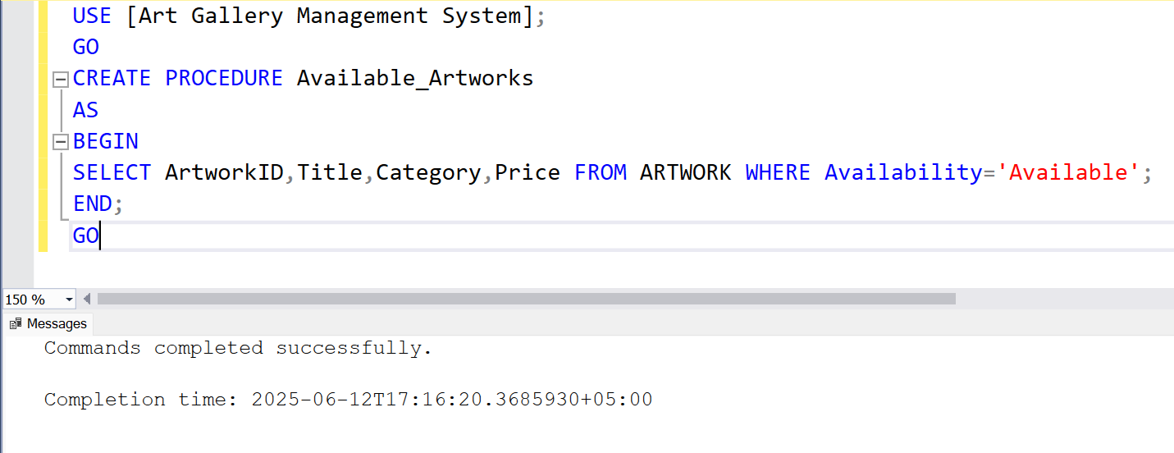
Result:
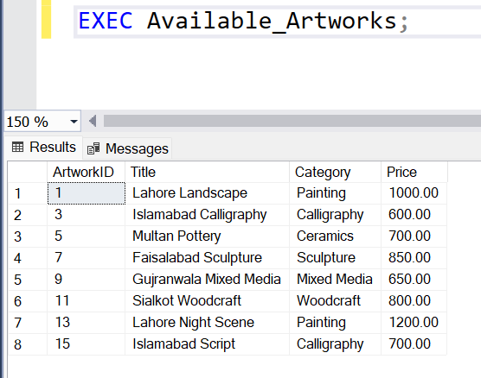

2)Stored Procedure to add new Booking
Procedure:
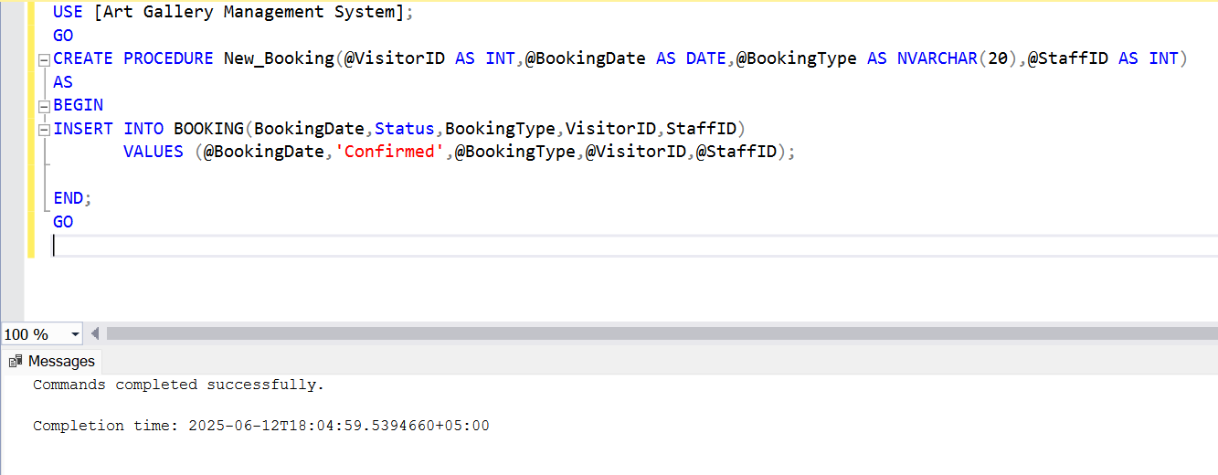
Result:
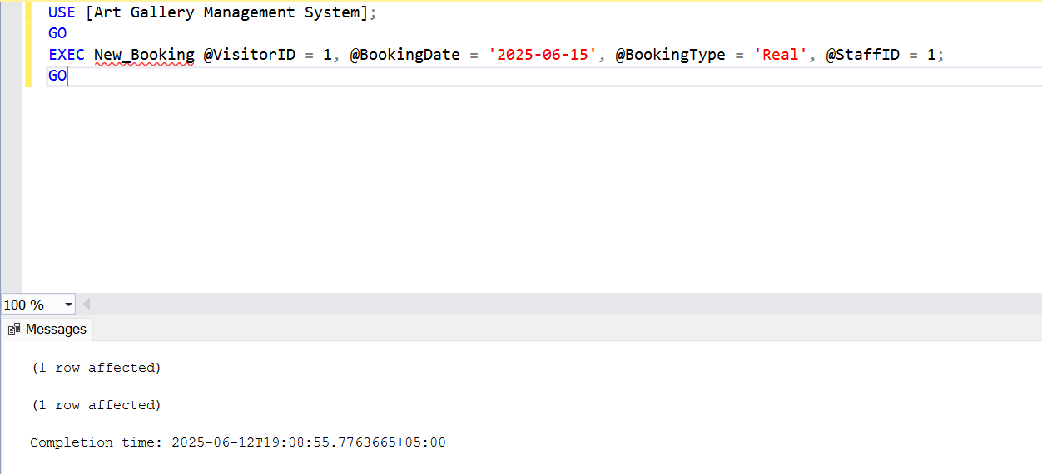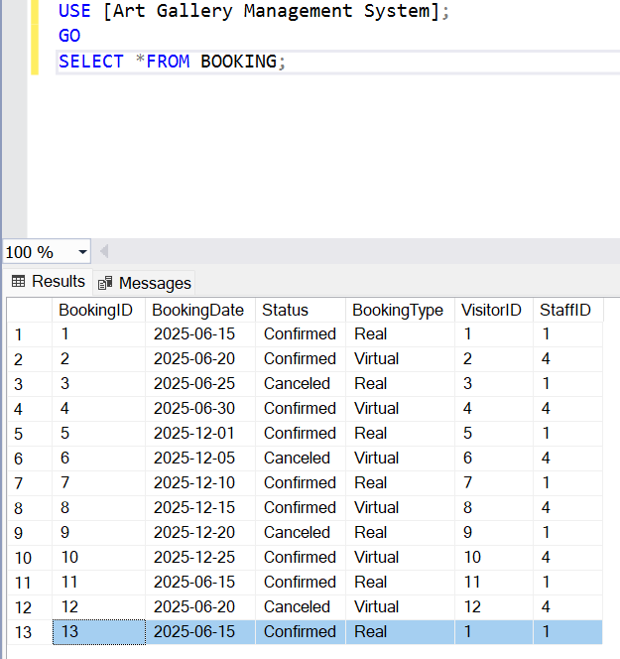

3)Stored Procedure to place a Bid
Procedure:
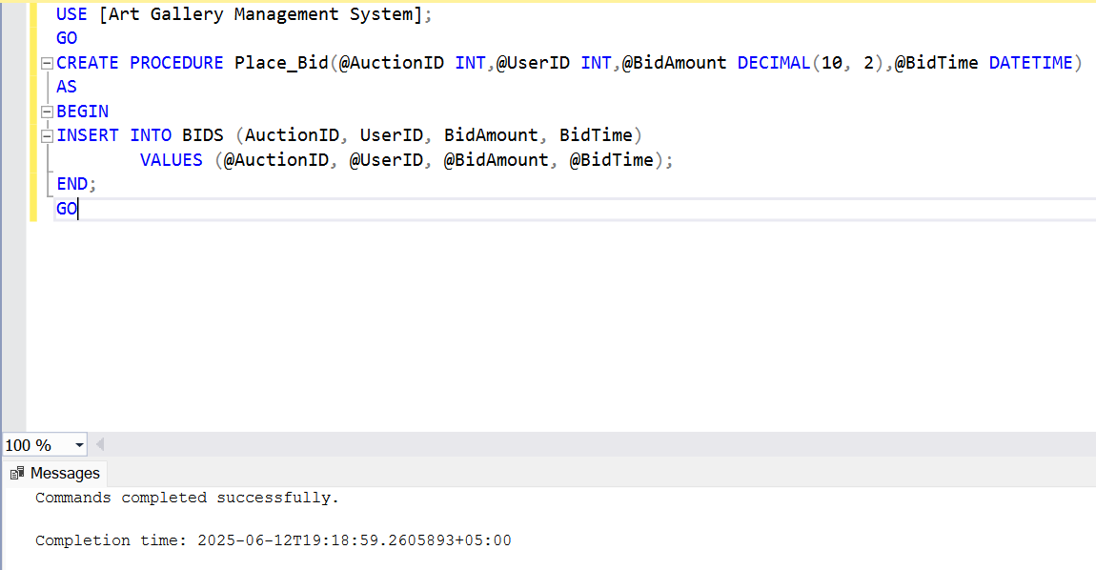
Result:
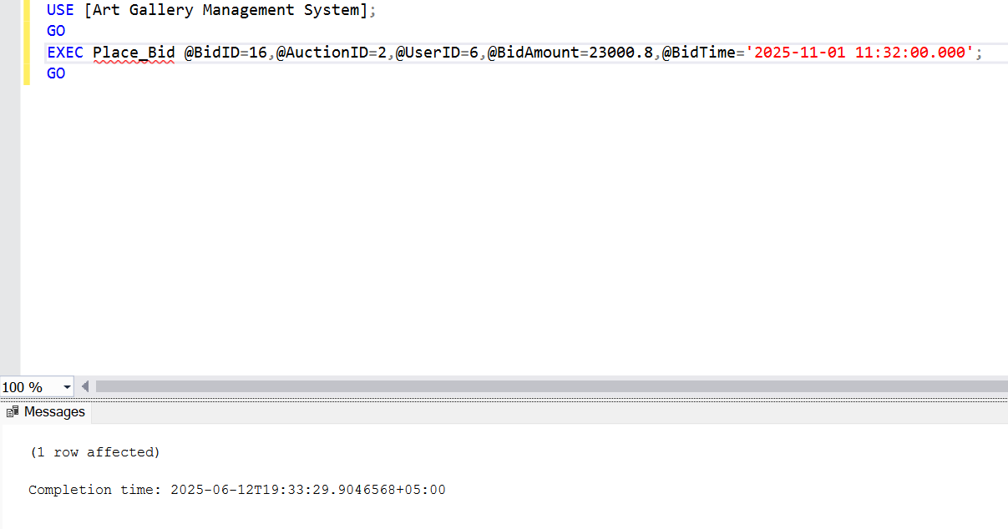
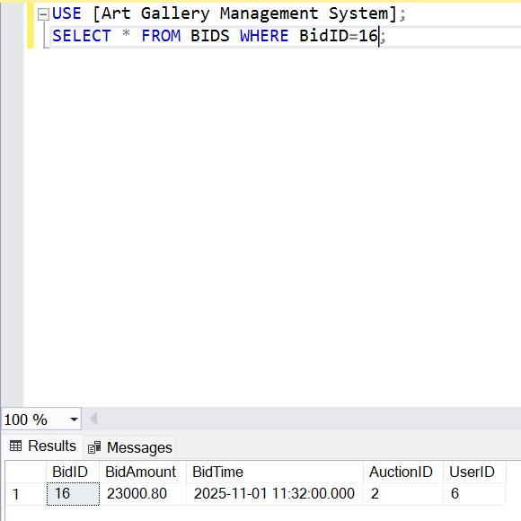

4)Stored Procedure to generate Purchase Report
Procedure:
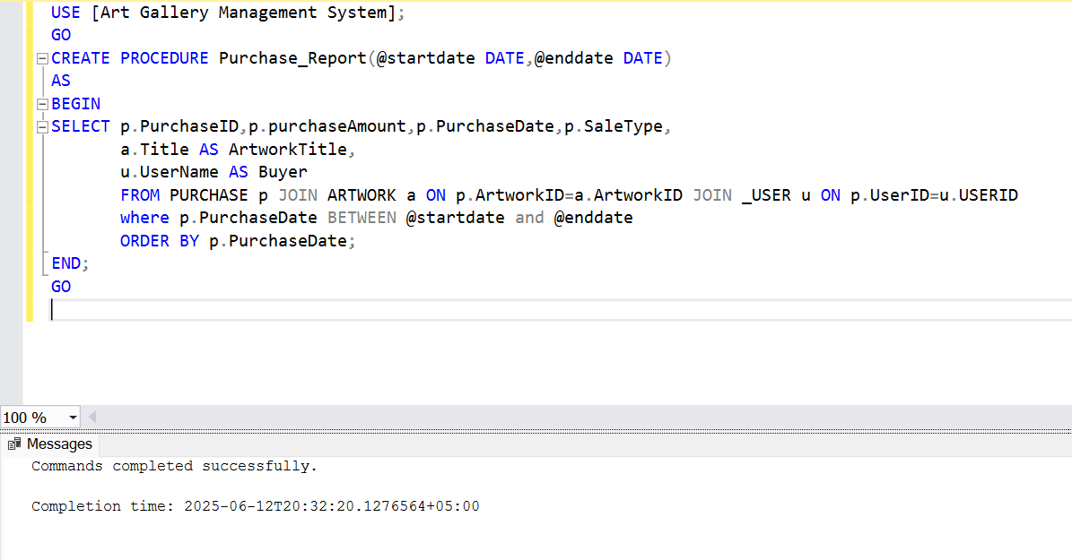
Result:
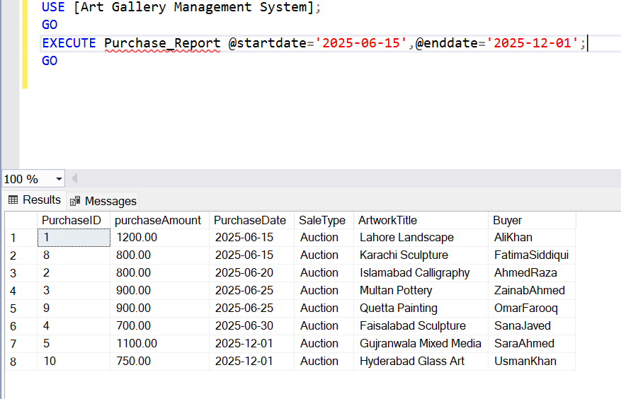

5)Stored Procedure to update Exhibition Schedule
Procedure:
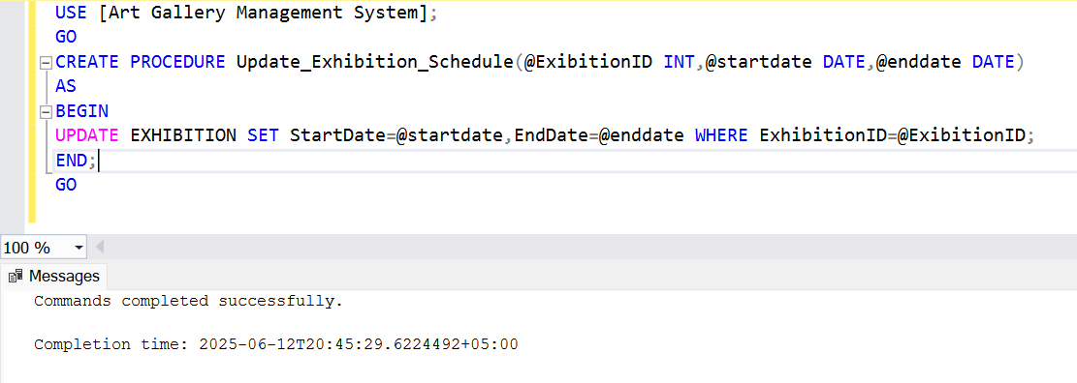
Result:
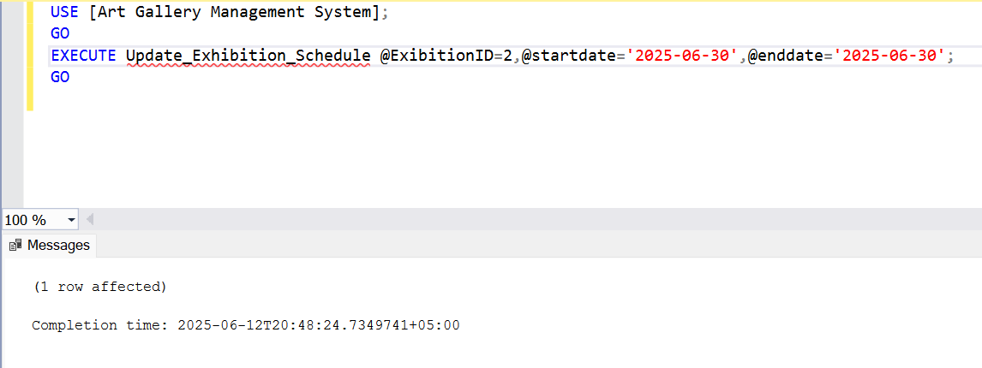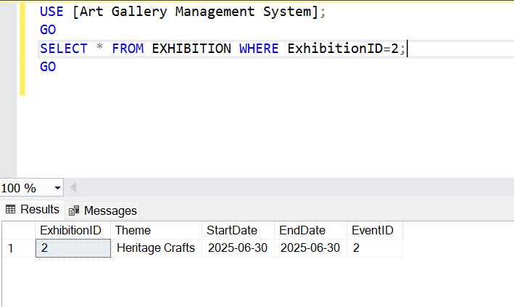

TRIGGERS:
1)Trigger to add record to REAL_VISIT and VIRTUAL_VISIT depending on Visit Type when any record is added to BOOKINGS table
Trigger:
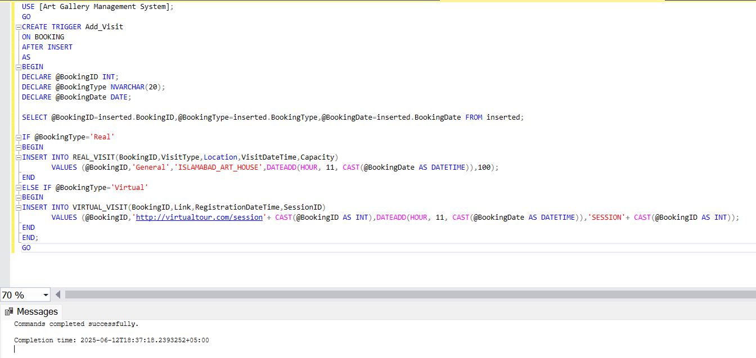

Result:
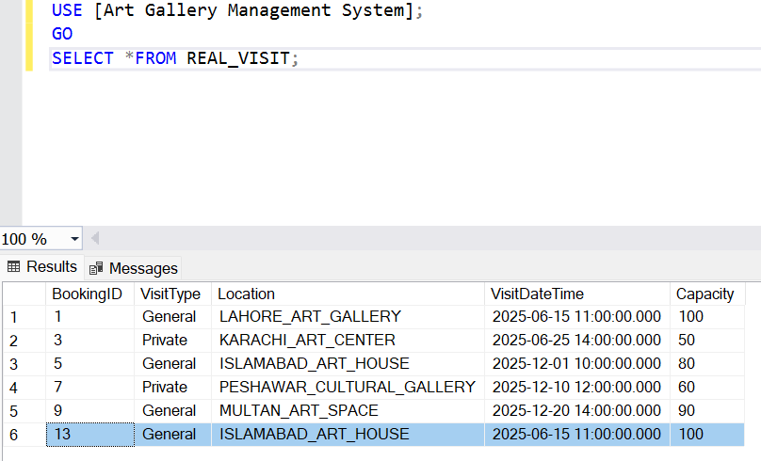

2)Trigger to update Availability to Sold in the ARTWORK table after a purchase is made
Trigger:
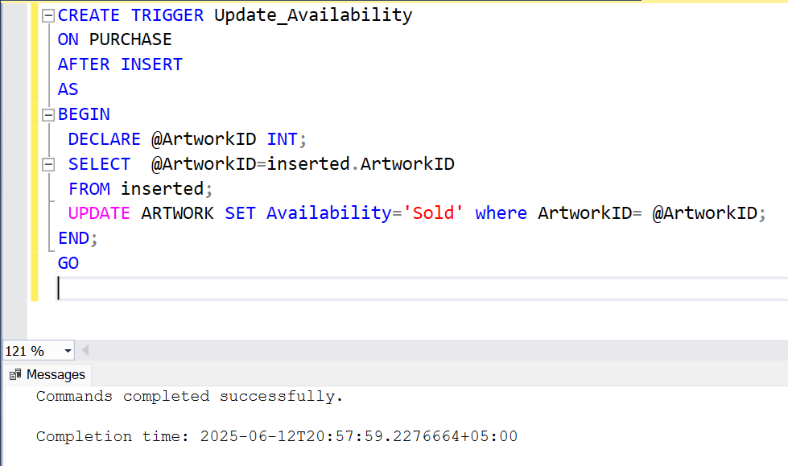
Result:
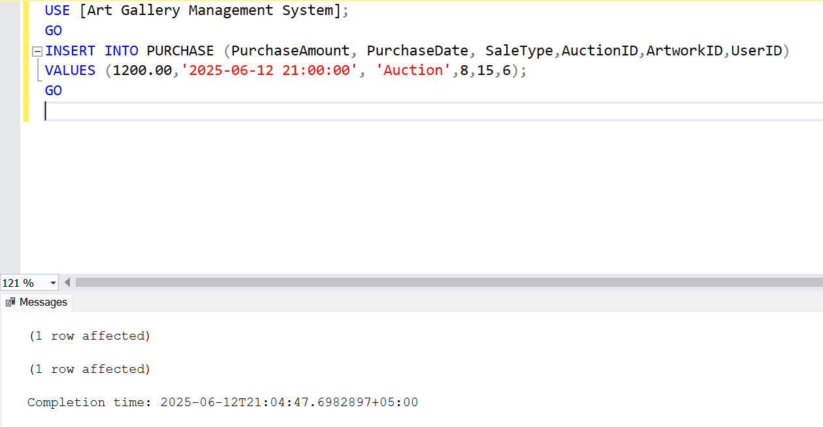
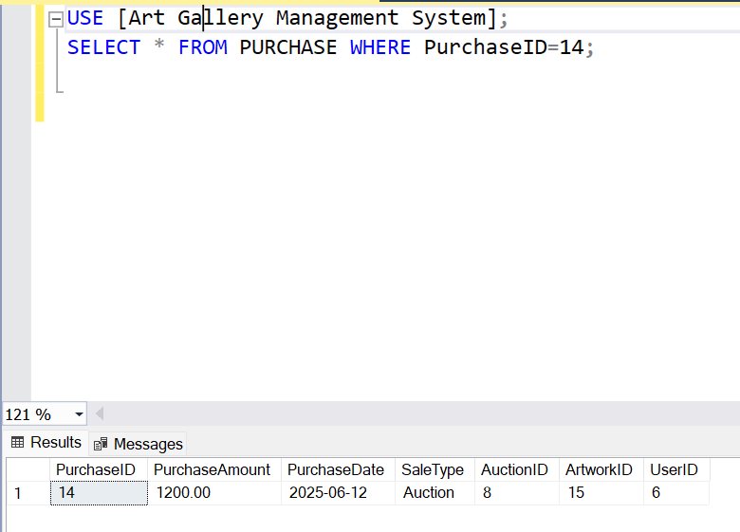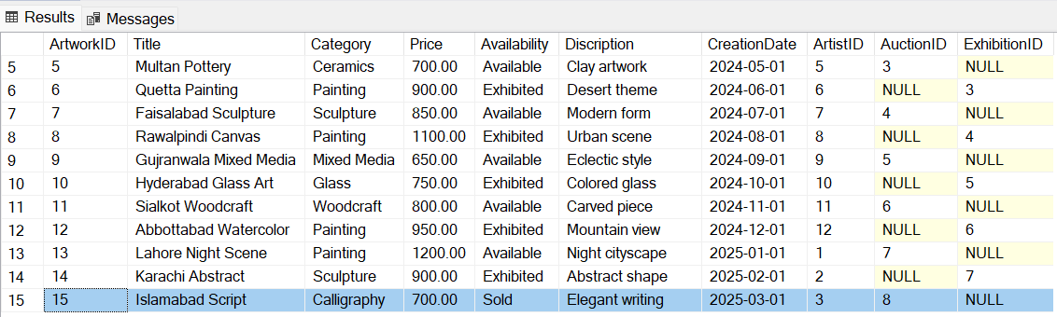

3)Trigger to remove a record from BOOKING whose booking date has passed
Trigger:
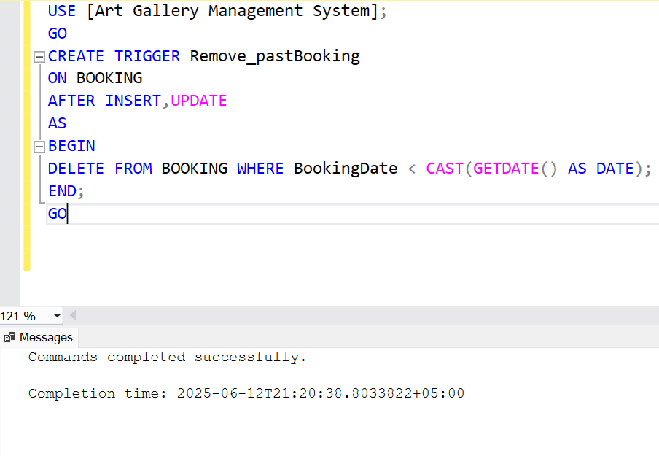
Result:
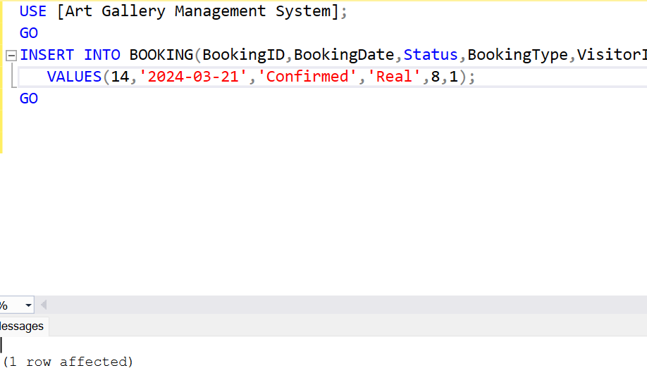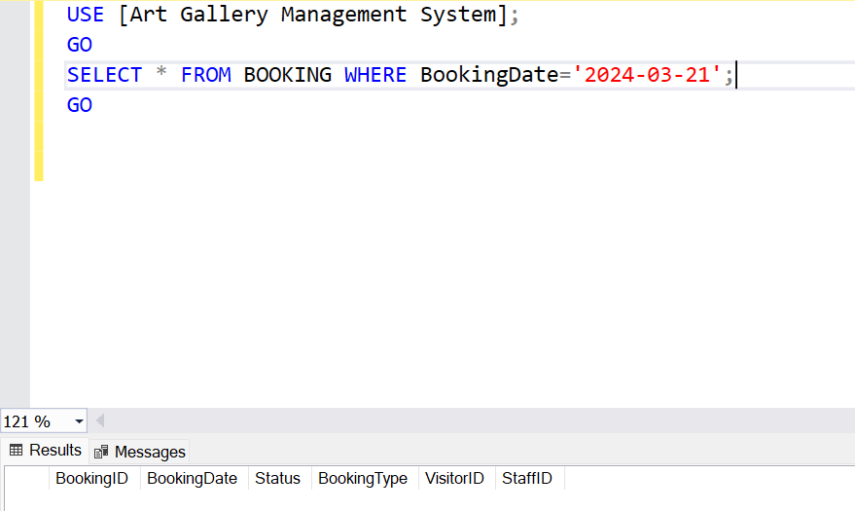

INDEXES:
1)Index on BOOKING table
Speeds up queries filtering by BookingDate (e.g., in the Remove_pastBooking trigger) and improves date-based searches.
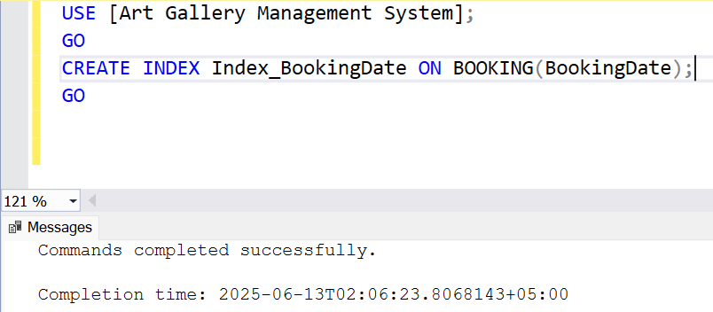
2)Index on PURCHASE table
Improves the UPDATE operation in the Update_Availability trigger by providing a fast lookup for ArtworkID.
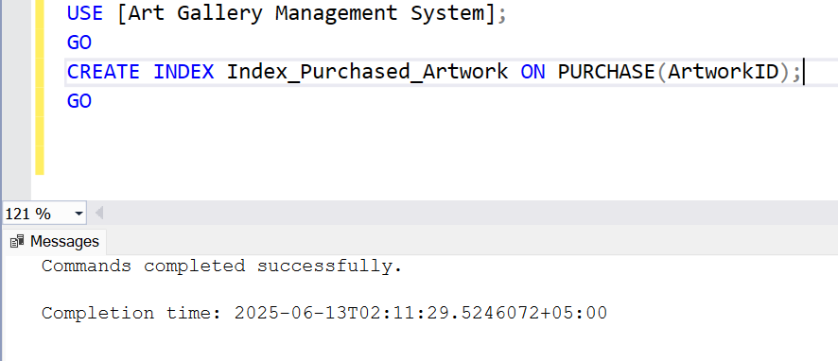

3)Indexes on REAL_VISIT table
Speeds up joins or lookups involving BookingID (e.g., if you query visit details by booking).

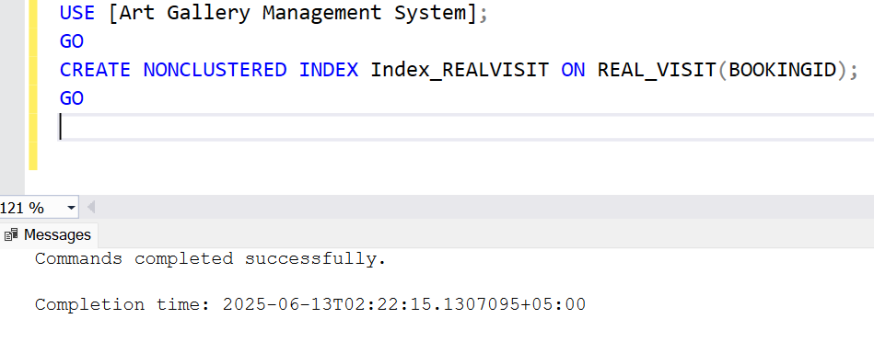
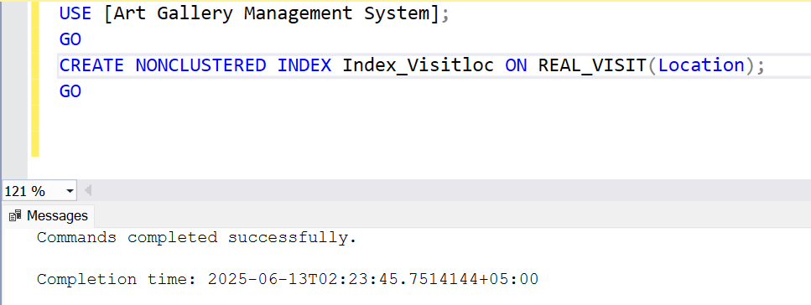
4)Index on VIRTUAL_VISIT table
Speeds up joins or lookups involving BookingID (e.g., if you query visit details by booking).

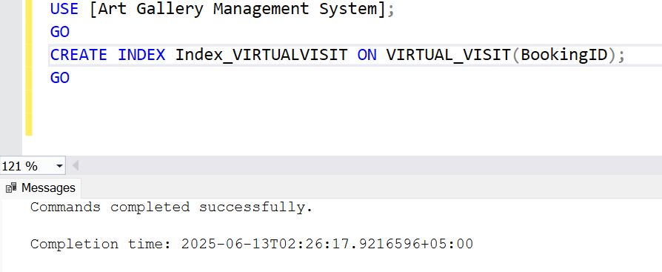

5)Composite Index on BOOKING table
Optimizes queries filtering by VisitorID and BookingDate (e.g., visitor-specific booking history).
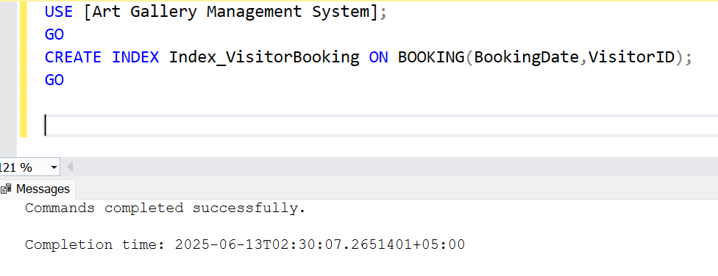

REFERENCES

- https://www.vertabelo.com/blog/technical-articles/database-normalization/
- https://www.brentozar.com/sql-server-best-practices/
- https://www.gartner.com/en/industries/arts-and-entertainment
- https://www.sqlservertutorial.net/

