LoadForge
Project Report
Computer Networks

Contents
1. TOPIC 3
LoadForge: A Multi-Subnet TCP Load Balancer with Adaptive Routing and Automatic Fault Detection 3
2. INTRODUCTION 4
2.1 The Problem 4
The Three Problems LoadForge Addresses 4
2.2 Our Solution: What LoadForge Does 4
2.3 Why This Matters 5
3. LITERATURE REVIEW 6
3.1 Load Balancing Algorithms 6
Round-Robin Distribution 6
Adaptive Response-Time Routing — Exponential Moving Average 6
NGINX: Industry Reference Implementation 6
3.2 Fault Tolerance 6
Passive Health Detection 6
Circuit Breaker Pattern 7
3.3 Socket Programming 7
Berkeley Socket API — POSIX.1-2008 7
Multi-Threading: POSIX pthreads 8
3.4 Cisco Networking 8
VLAN Architecture and Router-on-a-Stick 8
Access Control List (ACL) 8
4. PROBLEM STATEMENT 10
4.1 The Critical Gap 10
4.2 Impact Analysis 10
4.3 Why Existing Tools Are Insufficient 10
5. BLOCK DIAGRAM 11
5.1 System Architecture 11
5.2 Cisco Packet Tracer Network Topology 11
5.3 Load Balancer Processing: Step-by-Step Flowchart 12
5.4 Circuit Breaker State Diagram 12
5.5 EMA Routing: How the Algorithm Decides 13
5.6 Thread Architecture 13
5.7 Warm-Up to Adaptive Transition 14
5.8 Watchdog— Automatic Process Restart 15
5.9 Hot Reload - Adding Backends Without Restart 15
5.10 Project File Structure 16
6. KEY ALGORITHMS IN DETAIL 17
6.1 Round-Robin with Weighted Selection 17
6.2 Adaptive Softmax Selection 17
6.3 Non-Blocking Connect with Timeout 17
6.4 Dual EMA: Network vs Processing Time 18
7. BACKEND SIMULATION MODES 19
8. CONFIGURATION 19
9. HOW TO RUN THE PROJECT 21
9.1 Prerequisites 21
9.2 Build 21
9.3 Start the System 21
9.4 Send Requests — Round-Robin Phase 21
9.5 Adaptive Routing — Slow Backend Test 22
9.6 Circuit Breaker Test 23
9.7 Live Dashboard 25
10. REFERENCES 27
Networking and Standards 27
Socket Programming and Systems 27
Load Balancing and Fault Tolerance 27

1. TOPIC

LoadForge: A Multi-Subnet TCP Load Balancer with Adaptive Routing and Automatic Fault Detection
LoadForge is a TCP load balancer written completely from scratch in the C programming language. It receives incoming connections from client computers and distributes them across multiple backend servers. The load balancer is the only entry point that clients ever connect to the backend servers are hidden behind it.
When a backend server fails, LoadForge detects the failure automatically and reroutes traffic to the remaining healthy servers without any manual intervention from an administrator. The network infrastructure is designed in Cisco Packet Tracer, implementing two VLANs, inter-VLAN routing, DHCP, and access control rules that prevent clients from reaching backend servers directly.
The project demonstrates three things working together: correct socket programming in C, real-world load distribution algorithms, and a functioning network topology that enforces security boundaries between client and server subnets.

2. INTRODUCTION

2.1 The Problem
Consider a mid-sized e-commerce company. On normal days it serves 500 customers per hour. On sale days — Black Friday or Eid — traffic spikes to 5,000 customers simultaneously. With a single server, this causes an immediate crash. Every minute offline costs the company thousands in lost revenue.
Two further problems compound this. First, a hardware fault or maintenance window takes the entire service offline. Second, if clients can connect directly to database or application servers, that represents a serious security risk those servers must never be publicly reachable.
These three problems overload, no failover, and security exposure are what LoadForge is designed to solve.

The Three Problems LoadForge Addresses
- Server overload: all connections hitting one server causes it to crash under high traffic
- No failover: a single server failure takes the entire service offline with no recovery path
- Security exposure: backend servers must never be directly reachable by clients
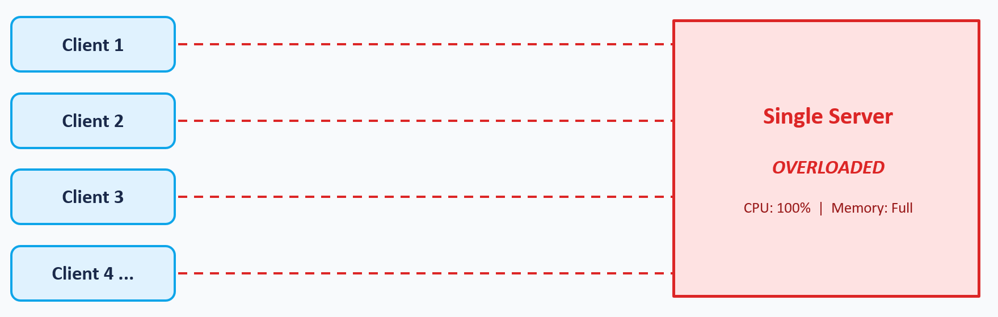

2.2 Our Solution: What LoadForge Does
LoadForge places a load balancer as the sole entry point in front of all backend servers. Clients connect only to the load balancer; it selects a backend and forwards the connection. This delivers three simultaneous benefits.
- Even distribution: connections are spread across all backend servers so none is overloaded
- Automatic failover: a failed backend is detected and removed from rotation without any client impact
- Hidden backends: clients reach only the load balancer the ACL enforces this at the network level

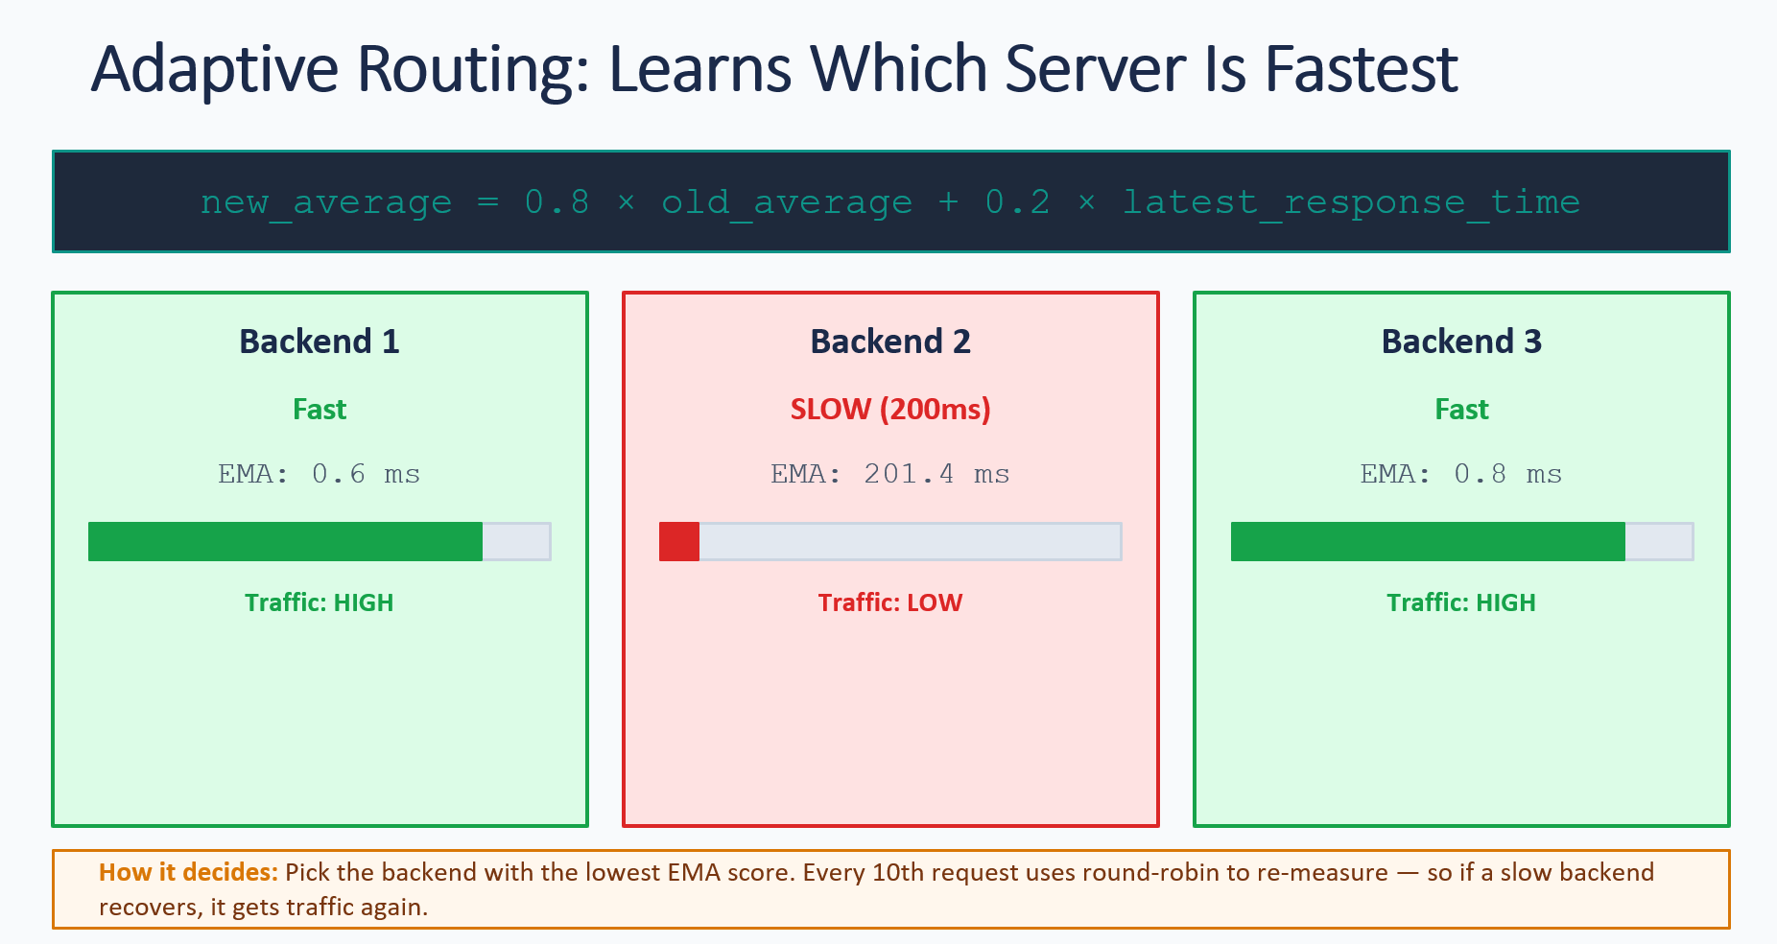

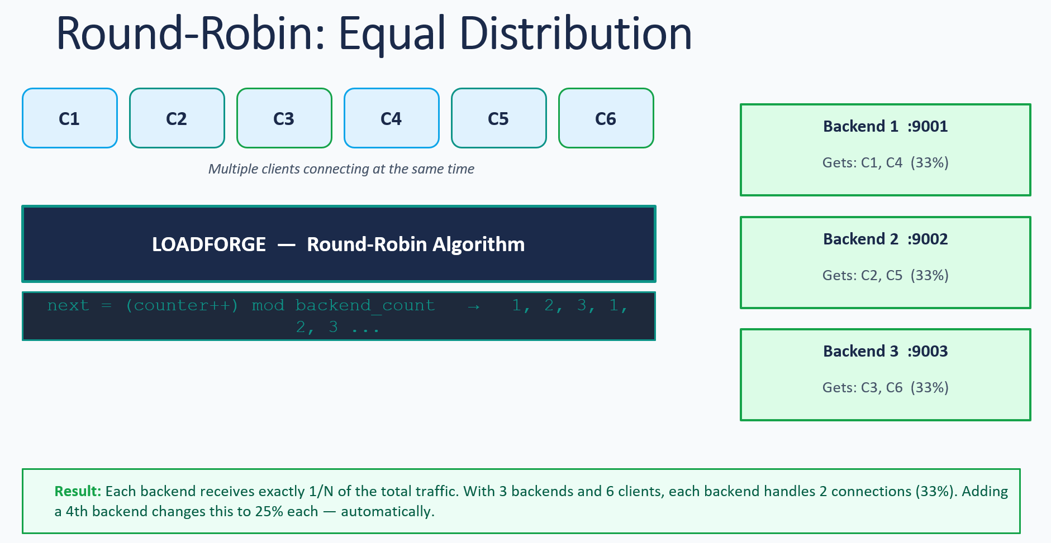

2.3 Why This Matters
This is the exact architecture used by companies such as Amazon, Google, and Netflix to serve millions of concurrent users. Most academic projects configure existing tools such as NGINX rather than building the algorithm. LoadForge is implemented from first principles in C every function, every algorithm, and every design decision belong to the team that wrote it and can be explained in full.
The project also bridges two disciplines that are usually kept separate: network design (done in Cisco Packet Tracer) and systems programming (done in C with POSIX sockets). LoadForge is tested on the actual designed topology, not on localhost under ideal conditions.

3. LITERATURE REVIEW

3.1 Load Balancing Algorithms

Round-Robin Distribution
Reference: Tanenbaum, A.S. and Wetherall, D.J. (2011). Computer Networks, 5th Edition. Prentice Hall.
- Round-robin is the simplest distribution strategy: connections cycle through servers in a fixed sequence (Server 1, Server 2, Server 3, Server 1, Server 2, Server 3, and so on).
- It is fair under uniform server capacity but does not account for varying server load or response speed.
- LoadForge implements round-robin as the default warm-up mode, cycling through all backends before any measurements are taken. This gives each backend an equal number of early connections to establish baseline EMA values.

Adaptive Response-Time Routing — Exponential Moving Average
Reference: Box, G.E.P. and Jenkins, G.M. (1976). Time Series Analysis: Forecasting and Control. Holden-Day.
- Measures actual backend response time per connection and routes preferentially to faster servers.
- Uses an Exponential Moving Average: new_avg = 0.8 × old_avg + 0.2 × latest_time. Recent measurements carry more weight, providing rapid adaptation without overreacting to a single spike.
- Deployed in production by AWS Application Load Balancer and Google Cloud Load Balancing.
- LoadForge implements this in the select_backend() function in lb.c, which uses a softmax-weighted selection combined with a minimum traffic floor so every backend receives at least 8% of traffic during observation.

NGINX: Industry Reference Implementation
Reference: NGINX Inc. (2023). NGINX Load Balancing Documentation. https://docs.nginx.com
- Market-leading open-source load balancer; used in the majority of web infrastructure deployments worldwide.
- Configuration-based: the balancing algorithm is embedded inside the product and cannot be inspected or modified by users.
- LoadForge difference: every algorithm line is written and owned by the project team, making it fully explainable at examination time.

3.2 Fault Tolerance

Passive Health Detection
Reference: Stevens, W.R. and Rago, S.A. (2013). UNIX Network Programming Vol. 1, 3rd Edition. Addison-Wesley.
- Failure is detected as a side effect of a real connection attempt — no separate health-check traffic is needed. If connect() returns ECONNREFUSED, the backend is immediately marked unavailable, and the client is rerouted transparently.
- LoadForge adds an active health check thread that pings each backend every 2 seconds with a lightweight HEALTHCHECK message, detecting failures even when no client traffic is present.

Circuit Breaker Pattern
Reference: Nygard, M.T. (2007). Release It! Design and Deploy Production-Ready Software. Pragmatic Bookshelf.
Named after the electrical device: it trips open under fault conditions, preventing further damage, and resets automatically once the fault clears. LoadForge implements three states:

State | Condition | LoadForge Behaviour
CLOSED | Normal backend is healthy | Accepts connections normally
OPEN | 3 consecutive connection failures | All connections blocked for 30 seconds
HALF-OPEN | 30-second timeout elapsed | One test connection allowed to check recovery
Table 3: Circuit Breaker State Machine

A successful HALF-OPEN test returns the backend to CLOSED fully restored. A failed test reopens the circuit for another 30 seconds. Recovery is fully automatic.

3.3 Socket Programming

Berkeley Socket API — POSIX.1-2008
Reference: Stevens, W.R. and Rago, S.A. (2013). UNIX Network Programming Vol. 1, 3rd Edition. Addison-Wesley.
All LoadForge network communication is built on six POSIX system calls:

System Call | Purpose | Where Used in LoadForge
socket() | Create a socket file descriptor | All three programs — lb, backend, and client
bind() | Attach socket to an IP address and port | Load balancer listening socket and all backend servers
listen() | Mark socket as passive — ready to accept | Load balancer and backend servers
accept() | Accept an incoming TCP connection | Load balancer accept loop and all backends
connect() | Open a connection to a remote address | Load balancer connecting to each chosen backend
send() and recv() | Transmit and receive data bytes | All programs — relay threads in lb.c
Table 4: POSIX Socket API Functions Used in LoadForge

Multi-Threading: POSIX pthreads
Reference: Butenhof, D.R. (1997). Programming with POSIX Threads. Addison-Wesley.
- One worker thread per queued connection enables simultaneous handling of multiple clients. LoadForge uses a pool of 8 worker threads that pull connections from a bounded queue of up to 100 pending connections.
- pthread_mutex_t protects all shared backend state — round-robin counter, EMA averages, circuit breaker flags, and connection counts — from concurrent modification.
- Six background threads run continuously: health checker, watchdog, dashboard renderer, control socket server, config reload watcher, and stats logger.

3.4 Cisco Networking

VLAN Architecture and Router-on-a-Stick
Reference: Cisco Systems. (2023). Cisco Packet Tracer 8.2 User Guide.
- VLAN 10 (Clients, 192.168.1.0/24): client PCs receive addresses via DHCP configured on the router.
- VLAN 20 (Servers, 192.168.2.0/24): load balancer (.10) and backends (.11 through .13) assigned static IPs.
- A single router port is split into two 802.1Q sub-interfaces to route between VLANs without needing a Layer 3 switch.

Access Control List (ACL)
Reference: Cisco Learning Network. (2023). CCNA Routing and Switching Study Guide.
- Extended ACL CLIENTS_TO_SERVERS enforces the security rule at the network level: the entire 192.168.1.0/24 subnet may reach only 192.168.2.10 (the load balancer).
- Direct client access to backends at 192.168.2.11 through .13 is dropped at the router before it can ever arrive.
- Applied inbound on the VLAN 10 sub-interface — filters client-originated traffic at the earliest possible point in the network path.

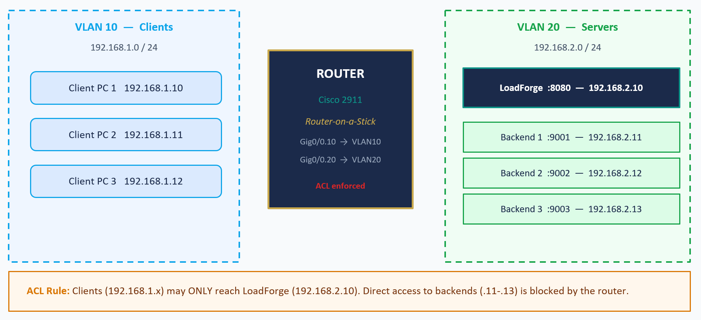

4. PROBLEM STATEMENT

4.1 The Critical Gap
Network designers use Cisco Packet Tracer to validate topologies. Software developers write socket-based applications. In most projects and in most organisations these two activities are never tested together. Applications are validated on a single machine under ideal conditions — zero latency, 100% uptime. When deployed across a real multi-server network, failures emerge that were never anticipated or tested.

4.2 Impact Analysis

Scenario | Without LoadForge | With LoadForge
High client traffic | All connections hit one server crash is inevitable | Load spread evenly, no single server is overwhelmed
Backend failure | All clients receive errors; service is entirely offline | Automatic reroute to healthy servers, zero client impact
Degraded backend | Round-robin still sends equal traffic to the slow server | EMA detects degradation, traffic share reduced automatically
Backend recovery | Manual re-insertion required — operator must intervene | Circuit breaker detects recovery, backend re-added within 30 seconds
Client to backend access | Possible — backends are exposed, security risk | Blocked by router ACL, only the load balancer is reachable

4.3 Why Existing Tools Are Insufficient
Tools such as NGINX and HAProxy solve the operational problem but are inappropriate for this project context. Their balancing algorithms are embedded and opaque there is no code to explain, no design to defend, and no learning to demonstrate.
LoadForge is implemented from zero. Every function is authored by the project team, every decision has a documented rationale, and every line can be presented and explained under examination. This is the fundamental reason for building from scratch rather than configuring an existing tool.

5. BLOCK DIAGRAM

5.1 System Architecture
LoadForge has two complementary parts that share the same IP addressing. The Cisco Packet Tracer network defines the infrastructure — VLANs, routing, DHCP, and ACLs. The C application runs on machines assigned those same addresses and provides application-layer load balancing.

Layer | Device or Component | Technology | Address and Port
Client | Client PCs (×3) | VLAN 10 — 192.168.1.0/24 | DHCP assigned
Network | Cisco Router 2911 | Router-on-a-Stick 802.1Q | 192.168.1.1 and 192.168.2.1
Network | Cisco Switch 2960 | VLAN 10 and VLAN 20 trunk | —
Load Balancer | lb.c — Adaptive Load Balancer | C / POSIX sockets / pthreads | 127.0.0.1: 8080
Backend | backend.c — Backend 1 | C / POSIX sockets / pthreads | 127.0.0.1: 9001
Backend | backend.c — Backend 2 | C / POSIX sockets / pthreads | 127.0.0.1: 9002
Backend | backend.c — Backend 3 | C / POSIX sockets / pthreads | 127.0.0.1: 9003

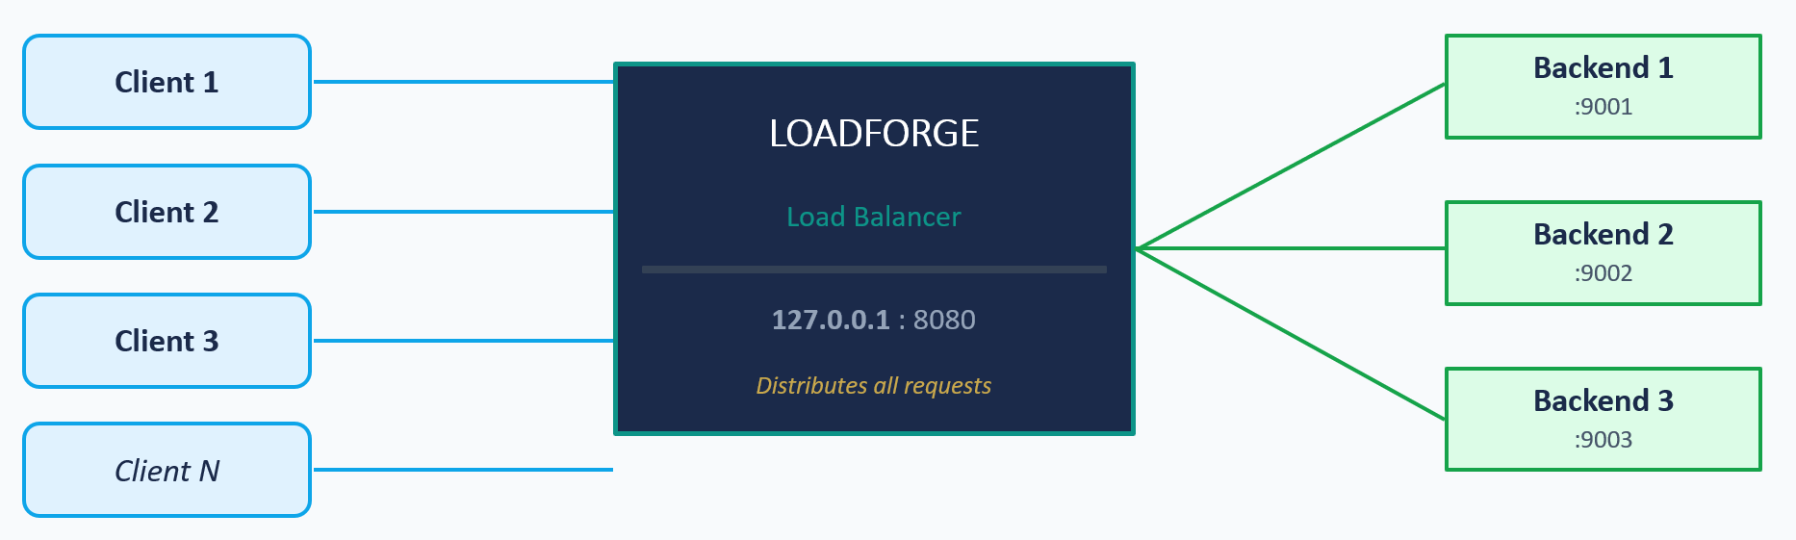
Figure 1: System Architecture — Three-Layer Overview

5.2 Cisco Packet Tracer Network Topology
The diagram below shows the two-VLAN infrastructure, the router-on-a-stick configuration, and the ACL that enforces the security boundary between clients and backend servers. The key feature of this topology is that a client machine on VLAN 10 cannot reach 192.168.2.11, 192.168.2.12, or 192.168.2.13 directly — the ACL drops those packets at the router. Only connections to 192.168.2.10 (the load balancer) are permitted.
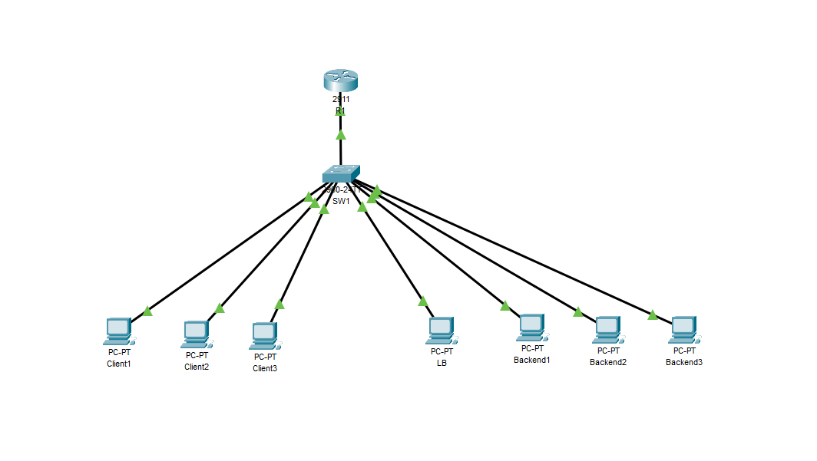
Figure 2: Cisco Packet Tracer Two-VLAN Network Topology

5.3 Load Balancer Processing: Step-by-Step Flowchart
The following sequence describes exactly what occurs inside lb.c for every incoming client connection. Each step corresponds to real code in the project.
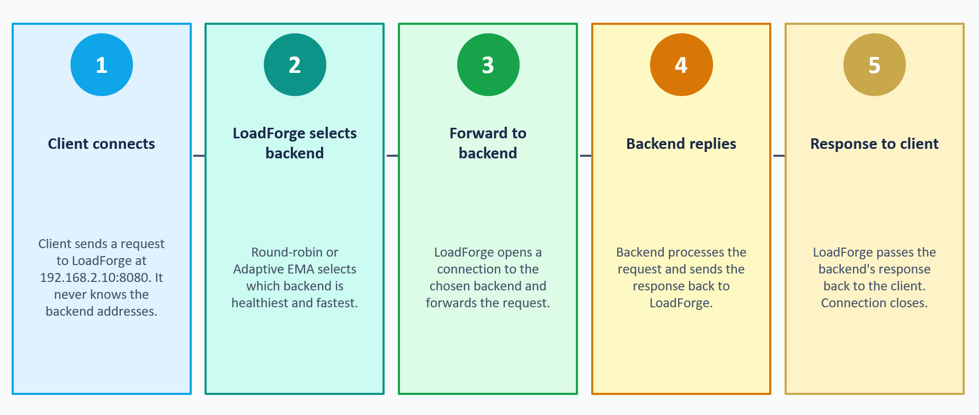

5.4 Circuit Breaker State Diagram
Transition | Trigger | Result
CLOSED → OPEN | 3 consecutive connect () failures | Backend removed from rotation for 30 seconds
OPEN → HALF-OPEN | 30-second timeout elapses | One test connection is permitted to check recovery
HALF-OPEN → CLOSED | Test connection succeeds | Backend fully restored — normal traffic resumes
HALF-OPEN → OPEN | Test connection fails | Backend still unavailable — 30-second timer resets

5.5 EMA Routing: How the Algorithm Decides
The adaptive routing algorithm uses two EMA values per backend: one for network connect time and one for backend processing time. These are weighted 30% and 70% respectively, reflecting that processing time has more impact on the user experience than connect time.

EMA Formula: new_avg = decay × old_avg + (1 - decay) × latest_sample
Decay: decay = exp(-elapsed_ms / 5000)
Combined score: score = 0.3 × net_ema + 0.7 × proc_ema + active_conns × 2.0
Softmax weight: weight = exp(-score / 50)

The softmax function converts scores into selection probabilities. A backend with a combined score of 10ms gets a much higher probability than one with 200ms. The minimum traffic floor of 8% ensures every backend continues to receive some traffic, so a recovered backend is detected quickly without having to wait for a full health-check cycle.

5.6 Thread Architecture
LoadForge is a multi-threaded application. The main thread accepts connections and enqueues them. Eight worker threads dequeue and process them. Six background threads handle monitoring and control. All shared state is protected by a single global mutex.

Thread | Count | Responsibility
Main thread | 1 | Calls accept() in a loop. Puts connections into the bounded queue.
Worker threads | 8 | Pull connections from the queue and call handle_connection(). This is where round-robin selection, connect(), relay, and EMA update happen.
Health thread | 1 | Sends a HEALTHCHECK ping to every backend every 2 seconds. Marks backends as unreachable if the connect fails.
Watchdog thread | 1 | Monitors backend process PIDs. If a backend process has died, it restarts it and transitions the circuit breaker to HALF-OPEN.
Dashboard thread | 1 | Redraws the live statistics panel every second using ANSI escape codes to overwrite the previous frame in place.
Control thread | 1 | Listens on a Unix domain socket for lf-ctl commands: STATUS, ADD, REMOVE, SET_ALGO.
Configs reload thread | 1 | Polls config.json every 5 seconds. If the file modification time changes, merges the new backend list without restarting the process.
Stats logger thread | 1 | Appends a JSON status line to /tmp/lf_stats.log every 10 seconds for offline analysis.

5.7 Warm-Up to Adaptive Transition
When LoadForge starts, it has no EMA data — every backend looks equally fast because all scores are zero. Routing adaptively on zero data would produce arbitrary results. The warm-up phase solves this by running strict round-robin for the first N × 10 connections (15 for 3 backends), giving each backend 10 measured connections before the adaptive algorithm is allowed to change the distribution.
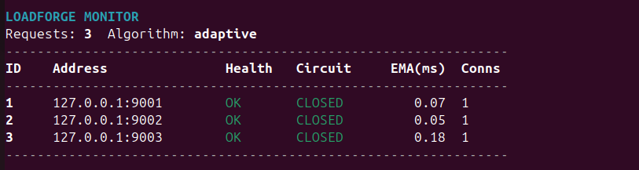
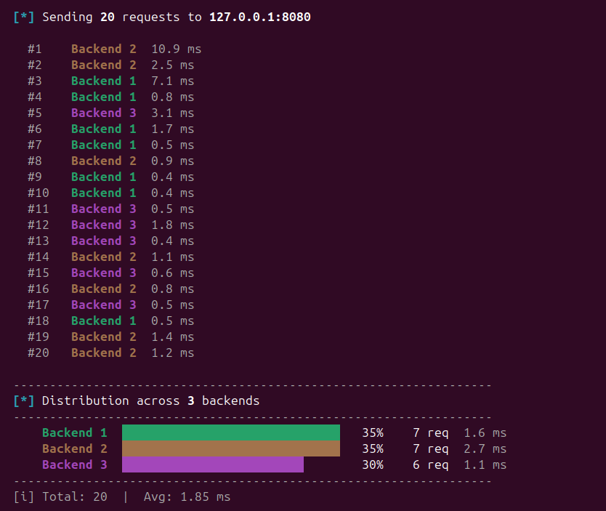

5.8 Watchdog— Automatic Process Restart
The watchdog thread monitors each backend process by PID. Every 3 seconds it calls kill(pid, 0) if this fails, the process has died. The watchdog then calls tcp_probe() to check whether the port is still responding (another process may be serving it). If not, it restarts the backend using fork() and execl() and waits up to 3 seconds for it to start listening.

5.9 Hot Reload - Adding Backends Without Restart
The config reload thread polls config.json every 5 seconds. When the file changes, merge_config_reload() is called. New backends are added live. Removed backends are marked as draining — they stop receiving new connections but existing ones complete normally. The whole process requires no restart of the load balancer.
The lf-ctl tool provides a live control interface. The command ADD 192.168.2.14 9004 can add a new backend while the system is running with active traffic.

5.10 Project File Structure
File | Component | Responsibility
src/lb.c | Load Balancer | 1,200 lines. Round-robin, adaptive EMA, circuit breaker, relay threads, health monitoring, watchdog, dashboard, hot reload, control socket, and stats logger.
src/backend.c | Backend Server | 219 lines. Multi-threaded TCP server. Accepts connections, runs load simulation, returns PROCESS_TIME_MS to the load balancer.
src/client.c | Test Client | 407 lines. Interactive CLI with burst mode and distribution bar chart. Reads config.json to display registered backends.
src/config.c | Config Loader | 139 lines. Parses config.json using libjson-c. Populates lb_config_t struct.
src/lf_ctl.c | Control Tool | Sends STATUS, ADD, REMOVE, SET_ALGO commands to the running load balancer via Unix domain socket.
include/config.h | Shared Header | All structs, constants, and function declarations shared between the programs.
config/config.json | Configuration | Listen address, backend list, algorithm selection, and simulation modes.
Makefile | Build System | Compiles all four programs with a single make command.

6. KEY ALGORITHMS IN DETAIL

6.1 Round-Robin with Weighted Selection
The round-robin selector builds a weighted round-robin table by repeating each backend index proportionally to its weight value. A backend with weight 2 appears twice in the table, so it receives double the connections of a backend with weight 1. The current position in the table is tracked by g_rr, which wraps around using modulo.

// Build the WRR table
for each backend b that is healthy and not OPEN:
w = b->weight (capped at 8)
add b's index to wrr[] table w times

// Select next
idx = wrr[g_rr % wrr_n]
g_rr = (g_rr + 1) % wrr_n

6.2 Adaptive Softmax Selection
Once warm-up is complete, the adaptive algorithm converts each backend's combined latency score into a selection probability using the softmax function. A lower score means a higher probability of being selected for the next connection.

// For each eligible backend:
score = 0.3 * ema_network_ms + 0.7 * ema_processing_ms
+ active_connections * 2.0 (penalty for busy backends)

// Convert to softmax weight:
raw_weight = exp(-score / SOFTMAX_TEMP) // SOFTMAX_TEMP = 50ms

// Normalise, apply minimum floor:
weight[i] = 0.08 + 0.92 * (raw_weight[i] / sum_raw_weights)

// Weighted random selection:
r = random number in [0, total_weight]
accumulate weights until r is exceeded -- that backend is chosen

The SOFTMAX_TEMP constant of 50ms controls sensitivity. At this value a backend at 200ms has roughly one-fiftieth of the probability of a backend at 10ms. The 8% minimum floor means a 200ms backend still gets some traffic — important for detecting when it recovers.

6.3 Non-Blocking Connect with Timeout
Standard connect() can block for over a minute if the destination is in a TIME_WAIT state. LoadForge uses the O_NONBLOCK + select() pattern to enforce a hard 2-second timeout on every backend connection attempt.

fd = socket(AF_INET, SOCK_STREAM, 0)
fcntl(fd, F_SETFL, flags | O_NONBLOCK) // make non-blocking
rc = connect(fd, &addr, sizeof(addr)) // returns -1 with EINPROGRESS

// Wait up to 2 seconds for the connection to complete:
FD_ZERO(&ws)
FD_SET(fd, &ws)
tv = { .tv_sec = 2, .tv_usec = 0 }
select(fd+1, NULL, &ws, NULL, &tv)

// Check for real success (not just writability):
getsockopt(fd, SOL_SOCKET, SO_ERROR, &err, &elen)
if (err != 0) -- connection failed

fcntl(fd, F_SETFL, flags) // restore blocking for relay phase

6.4 Dual EMA: Network vs Processing Time
The load balancer measures two separate latency values for each connection. Network time is the duration of connect() alone. Processing time comes from the PROCESS_TIME_MS value that the backend embeds in its response — this is the time the backend spent running its simulation or computation. Separating them is important because a slow network path and a slow CPU are different problems that call for different responses.

t_connect_start = now_ms()
bfd = tcp_connect_nb(ip, port)
t_connect_done = now_ms()
net_ms = t_connect_done - t_connect_start

// After relay completes, backend response contains:
// "BACKEND_ID=2 PROCESS_TIME_MS=3.45 MSG=Hello..."
proc_ms = parse_process_ms(response_buffer)

// Update both EMAs:
dt = now_ms() - b->last_ema_update_ms
decay = exp(-dt / 5000.0)
b->ema_network_ms = decay*old_net + (1-decay)*net_ms
b->ema_processing_ms = decay*old_proc + (1-decay)*proc_ms

7. BACKEND SIMULATION MODES
The backend program supports four simulation modes that create realistic workloads for testing the adaptive algorithm. Each mode consumes real system resources and reports an accurate processing time back to the load balancer.

Mode | Argument | What it does
Normal | none | Responds immediately with zero artificial delay. Represents a healthy backend under no load.
Delay | delay 200 | Sleeps for the specified number of milliseconds before responding. Simulates a backend that is slow due to database queries or I/O waits.
CPU | cpu | Runs a prime number sieve over 2 million numbers four times. Simulates CPU-intensive work such as encryption, compression, or complex calculations.
Memory | memory | Allocates and reads a 4 MB buffer. Simulates a backend that is under memory pressure or doing large buffer operations.
IO | io | Writes and reads a 1 MB temporary file. Simulates a backend performing disk access such as file uploads or database writes.

Example launch commands:
./bin/backend 127.0.0.1 9001 1 # normal, instant response
./bin/backend 127.0.0.1 9002 2 delay 200 # 200ms artificial delay
./bin/backend 127.0.0.1 9003 3 cpu # CPU-intensive simulation
./bin/backend 192.168.2.11 9001 1 io # IO simulation on real network

8. CONFIGURATION
All LoadForge parameters are set in config/config.json. The load balancer reads this file on startup and the config reload thread watches it for changes at runtime.

{
"listen_ip": "127.0.0.1",
"listen_port": 8080,
"algorithm": "adaptive",
"backend_bin": "./bin/backend",
"backends": [
{ "id": 1, "ip": "127.0.0.1", "port": 9001, "weight": 1 },
{ "id": 2, "ip": "127.0.0.1", "port": 9002, "weight": 1 },
{ "id": 3, "ip": "127.0.0.1", "port": 9003, "weight": 1 }
]
}

Parameter | Default | Description
listen_ip | 127.0.0.1 | The IP address the load balancer binds to. Change to 192.168.2.10 for Cisco Packet Tracer deployment.
listen_port | 8080 | The TCP port the load balancer listens on.
algorithm | adaptive | round_robin forces strict round-robin. adaptive uses EMA routing after warm-up. Can also be changed at runtime with lf-ctl SET_ALGO.
backend_bin | ./bin/backend | Path to the backend executable used by the watchdog for automatic restarts.
id | auto | User-visible backend identifier shown in the dashboard and logs.
weight | 1 | Weighted round-robin multiplier. A backend with weight 2 receives twice the round-robin share.
delay_ms | 0 | Artificial delay in milliseconds added to every response. Zero means no delay.
sim_mode | none | Load simulation mode: cpu, memory, or io. Takes effect when the watchdog restarts the backend.

9. HOW TO RUN THE PROJECT

9.1 Prerequisites
LoadForge runs on Ubuntu Linux 20.04 or later. The following packages are required:
sudo apt-get update
sudo apt-get install -y build-essential libjson-c-dev

9.2 Build
Navigate to the project directory and run make. This compiles all four programs with -Wall -Wextra and no warnings.
cd LoadForge
make

9.3 Start the System
Open two terminals side by side. In Terminal 1, run start.sh. This starts three backends and then the load balancer. When the LoadForge banner appears, press Enter to begin accepting connections.
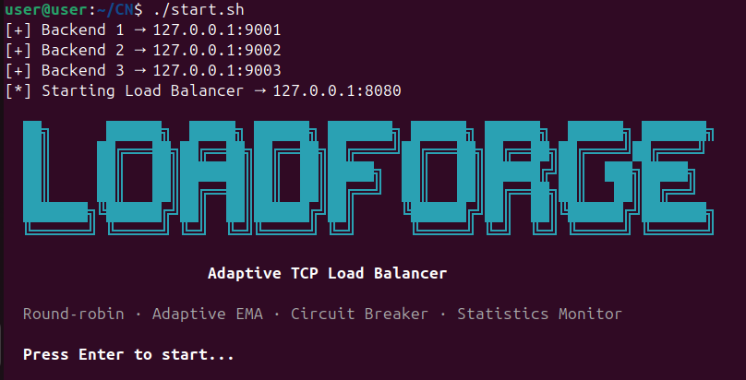

9.4 Send Requests — Round-Robin Phase
In Terminal 2, launch the client. Press 1 to send a request. During warm-up, you will see each request tagged with [round-robin] in the load balancer terminal.
# Terminal 2
./bin/client
# Press: 1
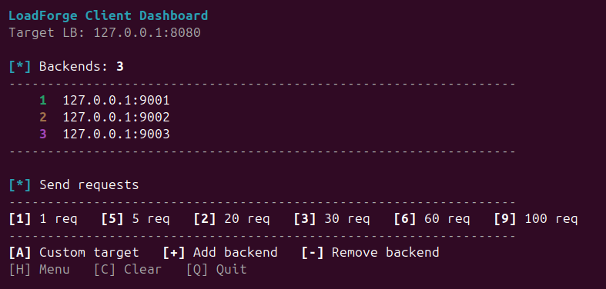
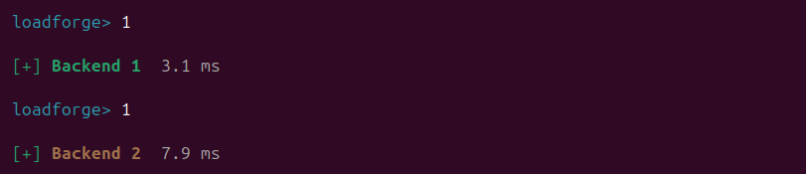
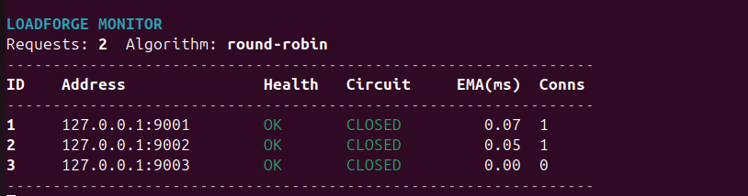

9.5 Adaptive Routing — Slow Backend Test
Open a third terminal. Kill Backend 2 and restart it with a 200ms delay. Then send 30 more requests from the client. The load balancer will detect the increase in Backend 2's EMA and shift traffic away from it.
# Terminal 3
kill $(pgrep -f "backend.*9002")
./bin/backend 127.0.0.1 9002 2 delay 200

# Terminal 2: press 3
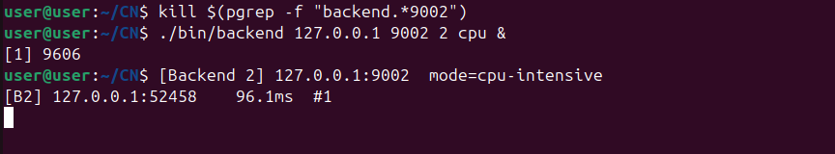
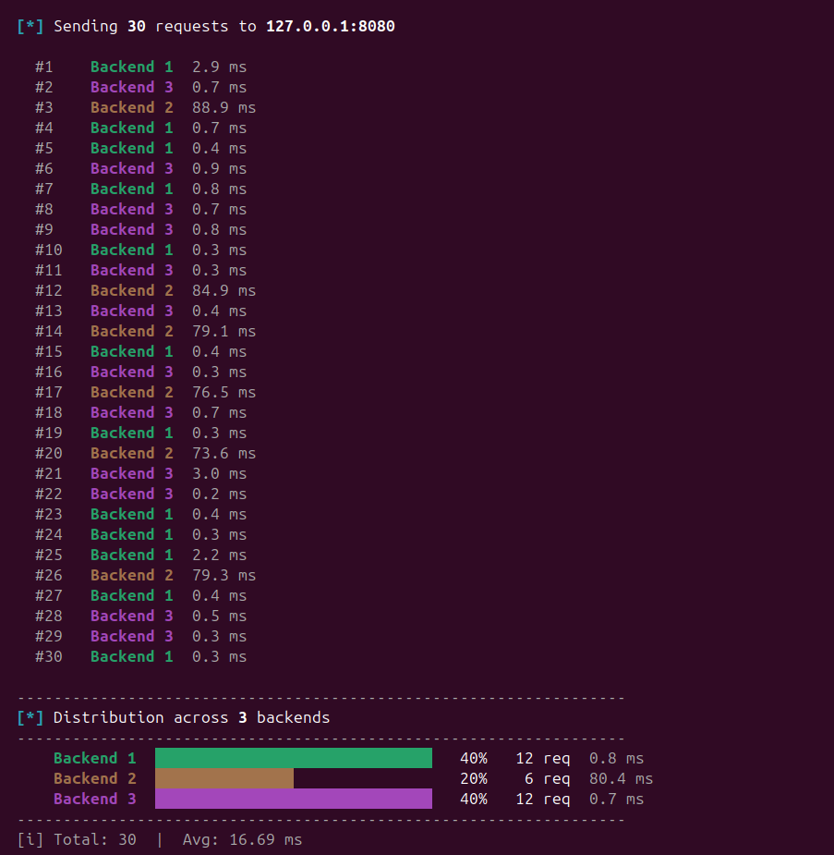

9.6 Circuit Breaker Test
Kill Backend 2 completely. Do not restart it. Send 20 requests. After 3 connection failures, the circuit breaker trips OPEN. The load balancer terminal shows the [CB] CLOSED to OPEN message and Backend 2 disappears from the distribution bar chart.
# Terminal 3
kill $(pgrep -f "backend.*9002")
# Do not restart it
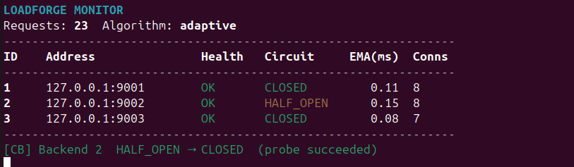
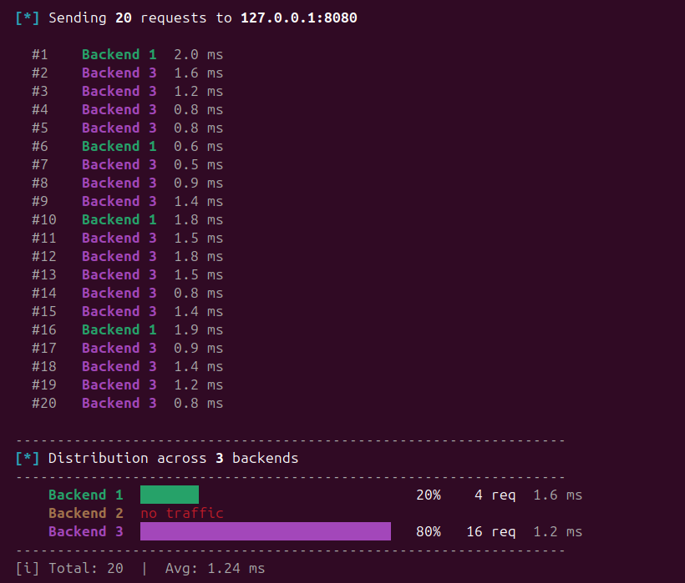

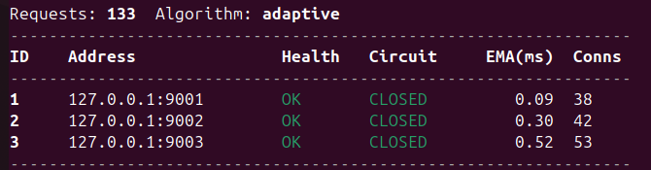
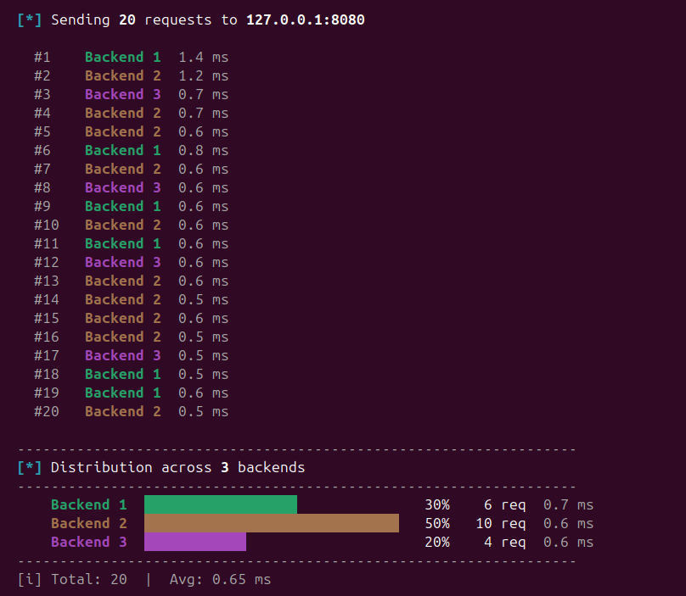

9.7 Live Dashboard
The dashboard refreshes every second in place in the Terminal 1 window. It shows each backend's health status, circuit breaker state, EMA latency values, and total connection count. The algorithm column shows whether the current request was handled in round-robin or adaptive mode.


10. REFERENCES

Networking and Standards
- Cisco Systems. (2023). Cisco Packet Tracer 8.2 User Guide. Available at: https://www.cisco.com
- Cisco Learning Network. (2023). CCNA Routing and Switching 200-125 Study Guide.
- IEEE Std 802.1Q-2018. IEEE Standard for Bridges and Bridged Networks.
- Postel, J. (1981). RFC 793: Transmission Control Protocol. https://tools.ietf.org/html/rfc793

Socket Programming and Systems
- Stevens, W.R. and Rago, S.A. (2013). UNIX Network Programming: The Sockets Networking API, Volume 1 (3rd Edition). Addison-Wesley.
- Kernighan, B.W. and Ritchie, D.M. (1988). The C Programming Language (2nd Edition). Prentice Hall.
- Butenhof, D.R. (1997). Programming with POSIX Threads. Addison-Wesley.
- The Open Group. (2018). POSIX.1-2008: System Interfaces and Headers. https://pubs.opengroup.org

Load Balancing and Fault Tolerance
- Tanenbaum, A.S. and Wetherall, D.J. (2011). Computer Networks (5th Edition). Prentice Hall.
- Nygard, M.T. (2007). Release It! Design and Deploy Production-Ready Software. Pragmatic Bookshelf.
- NGINX Inc. (2023). NGINX Load Balancing Documentation. https://docs.nginx.com
- Box, G.E.P. and Jenkins, G.M. (1976). Time Series Analysis: Forecasting and Control. Holden-Day.

