EgFWD

Advanced Embedded Systems

Project (3) | System Design

Automotive Door Control System Design Report

**Dynamic Design**

**For ECU 1:**

1. Draw a state machine diagram for each ECU component
2. 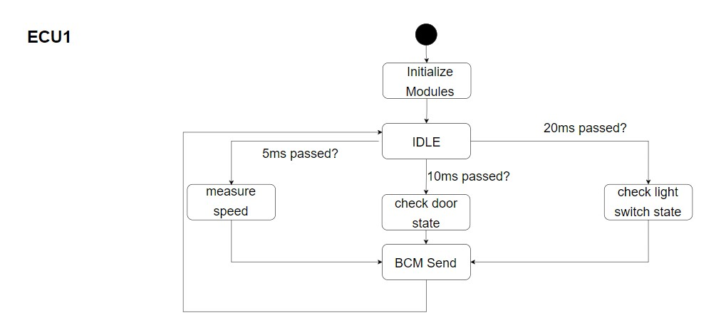Draw a state machine diagram for the ECU operation
3. 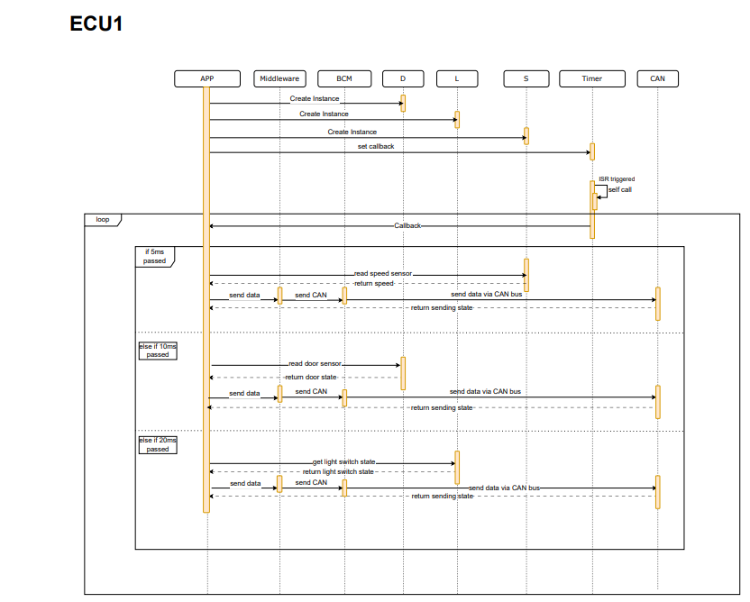Draw the sequence diagram for the ECU
4. Calculate CPU load for the ECU

- Assuming each task executes in 2milliseconds as a worst case scenario and priorities’ order from highest to lowest is as follows-> S, D, L.

- Hyperperiod = LCM(5, 10, 20) = 20milliseconds.

- CPU load = (2*4 + 2*2 + 2*1) / 20 = 0.7 (70%), approximately.

**For ECU 2:**

1. Draw a state machine diagram for each ECU component
2. 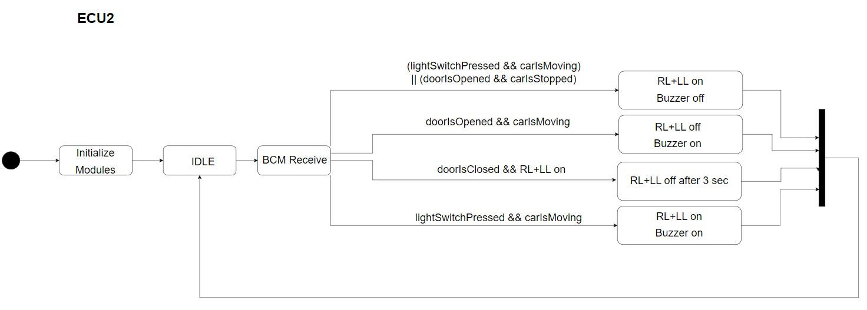Draw a state machine diagram for the ECU operation
3. 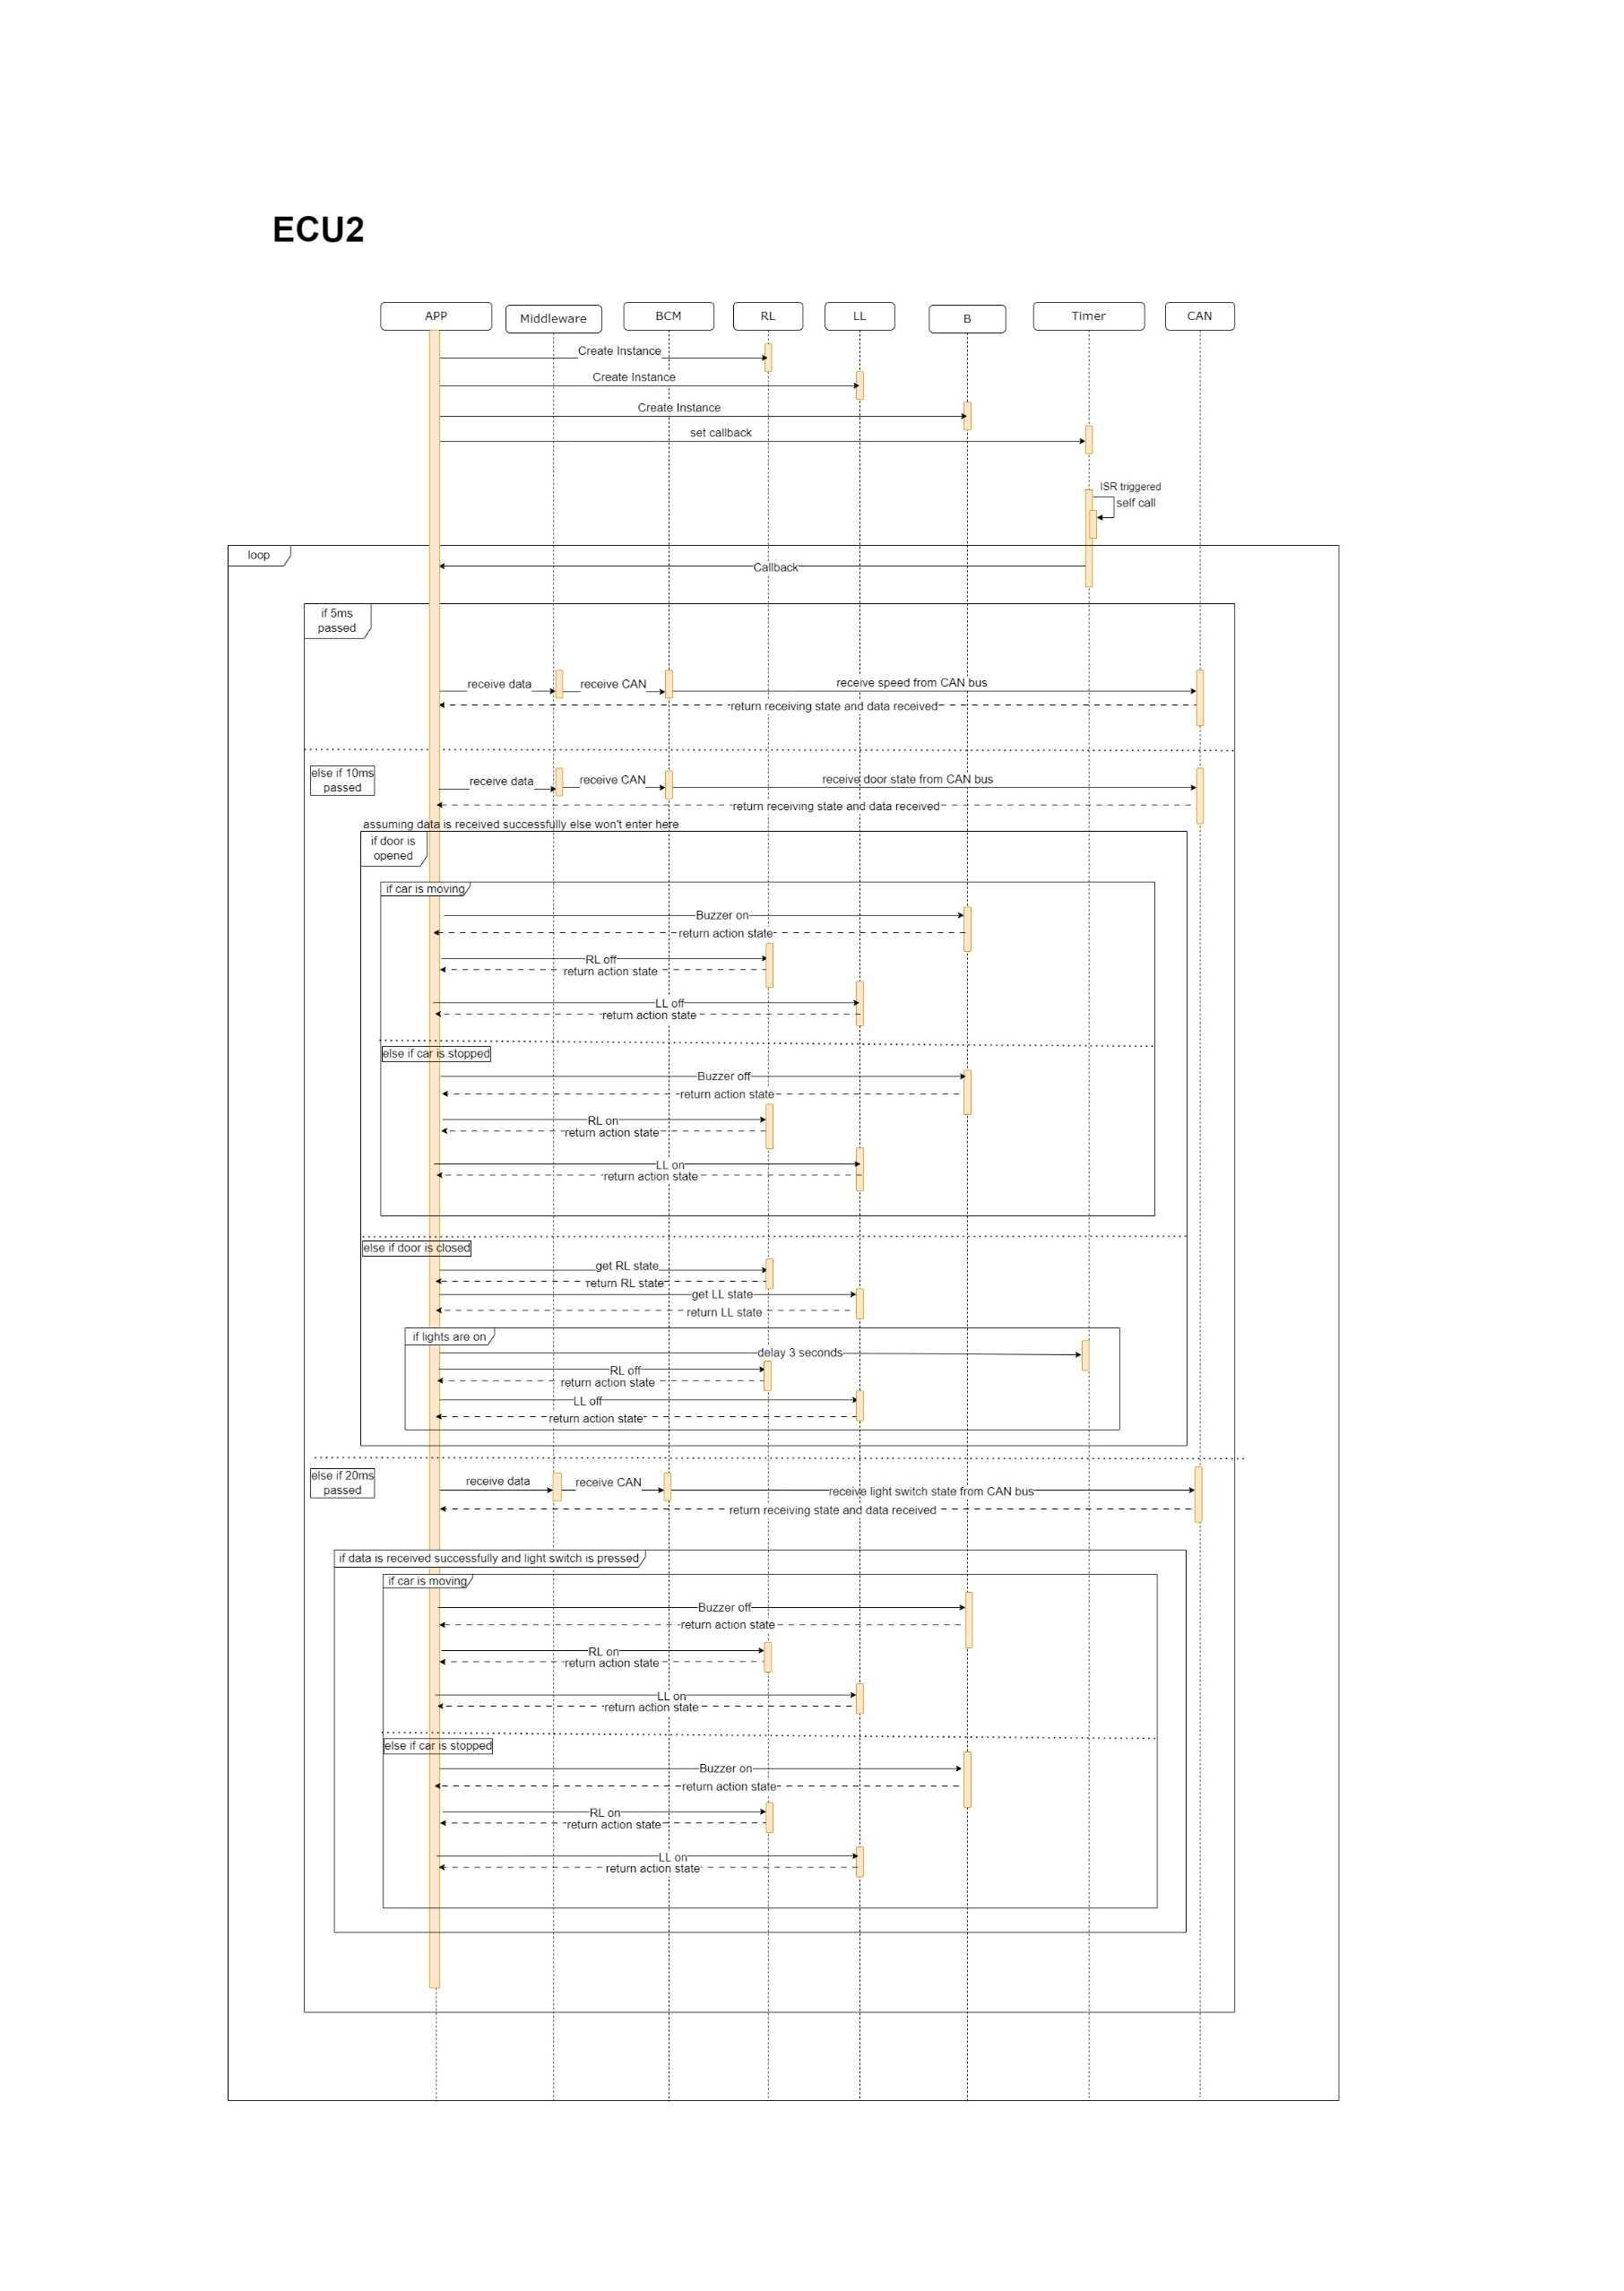Draw the sequence diagram for the ECU
4. Calculate CPU load for the ECU

- Assuming each task executes in 2milliseconds as a worst case scenario and priorities’ order from highest to lowest is as follows-> S, D, L. Receiving data and taking action accordingly is considered a task for ECU2.

- Hyperperiod = LCM(5, 10, 20) = 20milliseconds.

- CPU load = (2*4 + 2*2 + 2*1) / 20 = 0.7 (70%), approximately.

CAN BUS LOAD:

- 3 messages are being sent, assuming each is 255 bits and sending rate is 125kbps.

- speed message: 255 bits per 5ms = 51 kbps.

- door message: 255 bits per 10ms = 25.5 kbps.

- light switch message: 255 bits per 20ms = 12.75kbps.

CAN bus load = (51+25.5+12.75) / 125 = 0.714 (71.4%).