Name: Tasneem Mansour Mansour Mansour Farag

ID: 19015538

Professor: Dr. Ahmed Abbas Elserougi

Subject Name: HVDC

Subject Code: EEP 424

Assignment (2) | Bipolar Point-To-Point HVDC-Link | MATLAB Model

Contents

I. System Description: 3

II. Six-Pulse Model: 3

Question (A): 3

Question (B): 5

Model Screenshot: 5

Case (1): 1600MW: Power flow from (A) to (B): Net(A) is rectifier and Net(B) is inverter: 5

Case (2): 1200MW: Power flow from (B) to (A): Net(B) is rectifier (+10%) and Net(A) is inverter (-10%): 8

Case (3): 1600MW: Power flow from (A) to (B): Net(A) is rectifier (2.5% voltage swell) and Net(B) is inverter: 11

III. Twelve-Pulse Model: 14

Question (C): 14

Model Screenshot: 14

Case (1): 1600MW: Power flow from (A) to (B): Net(A) is rectifier and Net(B) is inverter: 14

Case (2): 1200MW: Power flow from (B) to (A): Net(B) is rectifier (+10%) and Net(A) is inverter (-10%): 18

Case (3): 1600MW: Power flow from (A) to (B): Net(A) is rectifier (2.5% voltage swell) and Net(B) is inverter: 21

IV. Comparison: 24

Question (D): 24

V. Attachments: 25

# I. System Description:

- A 1600MW 6-pulse bipolar point-to-point HVDC-link shown below. The link interconnects between two AC networks, (network (A): 22kV/50Hz, network (B):20kV/60Hz), through overhead transmission line with a resistance of 10 Ω. The range of firing angle at the rectifier side is (5deg-25deg), while the inverter is operated under minimum γ of 20deg. 1:10 Y-Y ideal transformers with zero leakage inductances are employed. Proper smoothing reactors (Lsr) are employed as shown.

# II. Six-Pulse Model:

## Question (A):

#### Transferring a power of 1600 MW from side (A) to side (B) during normal operating conditions. Find analytically the suitable firing angle at the rectifier side, and the corresponding dc current.

#### Transferring a power of 1200 MW from side (B) to side (A) during normal operating conditions. Find analytically the suitable firing angle at the rectifier side, and the corresponding dc current. (Assume -10% tapping at inverter side, and +10% tapping rectifier side).

#### Transferring a power of 1600MW from side (A) to side (B) during 2.5% voltage swell at network (A).

## Question (B):

### Model Screenshot:

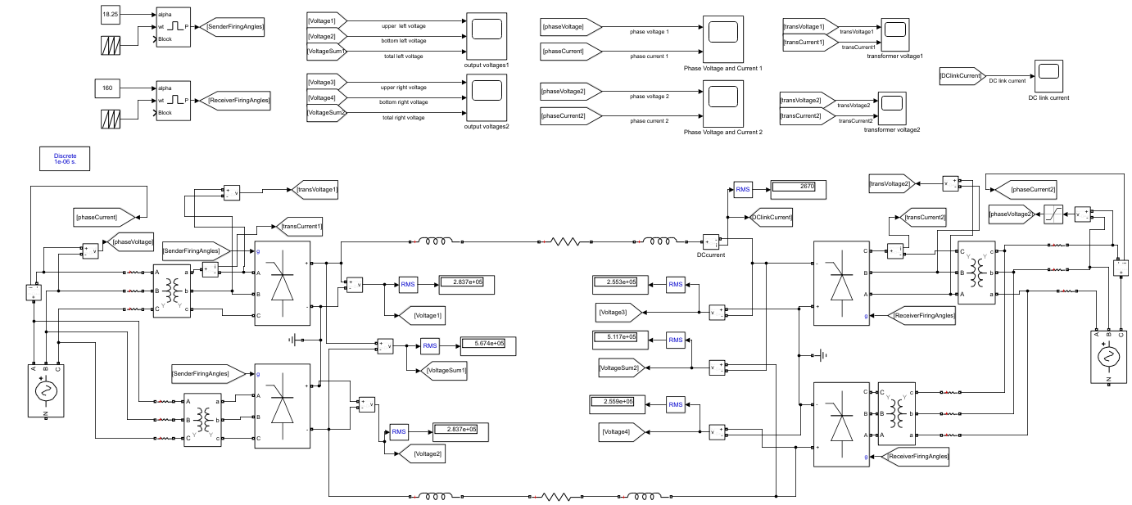

### Case (1): 1600MW: Power flow from (A) to (B): Net(A) is rectifier and Net(B) is inverter:

#### AC voltage at rectifier side:

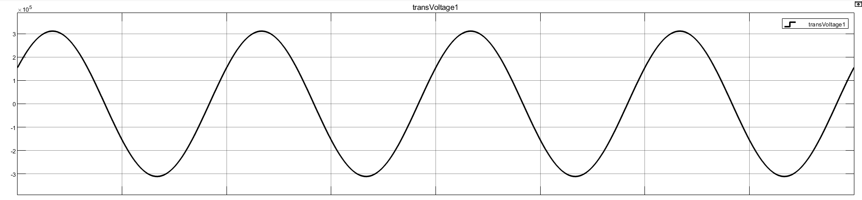

#### Vdor: DC voltage at rectifier side:

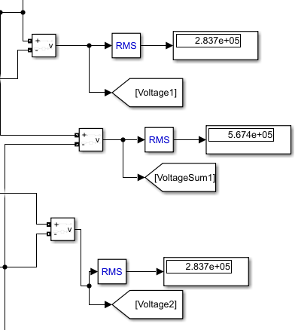

#### Grid current at rectifier side:

#### AC voltage at inverter side:

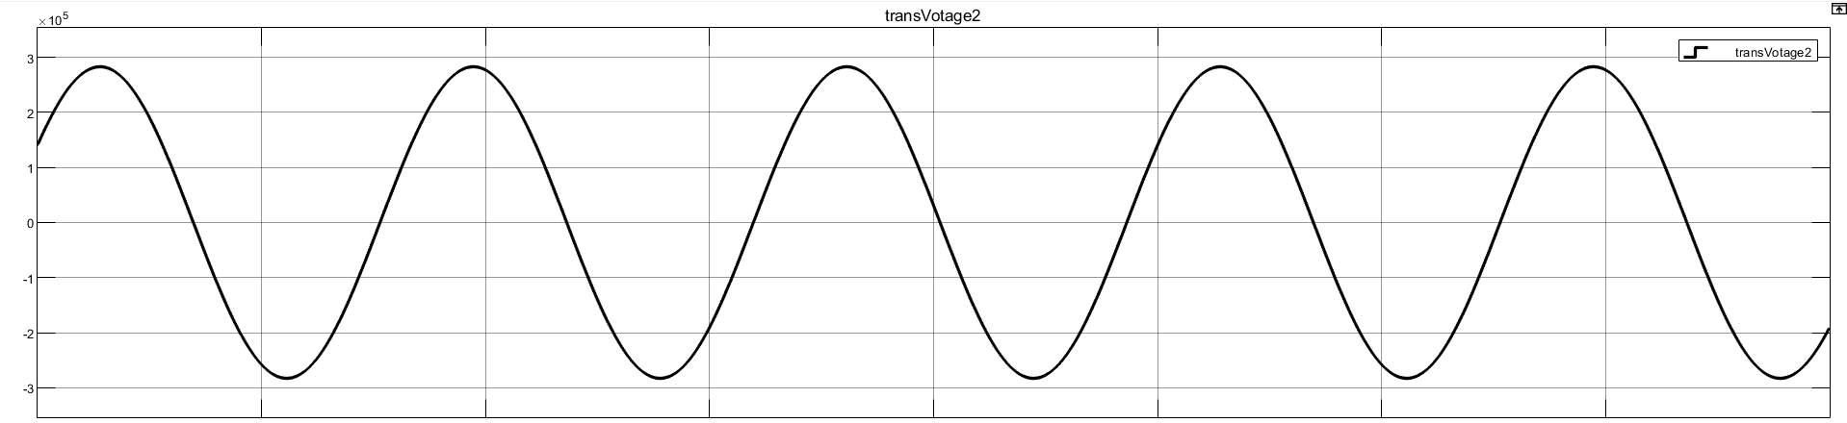

#### Vdoi: DC voltage at inverter side:

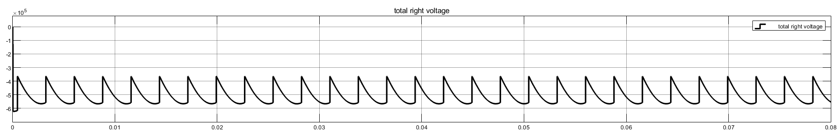

#### Grid current at inverter side:

#### DC current (L=0.1 Henry):

### Case (2): 1200MW: Power flow from (B) to (A): Net(B) is rectifier (+10%) and Net(A) is inverter (-10%):

#### AC voltage at rectifier side:

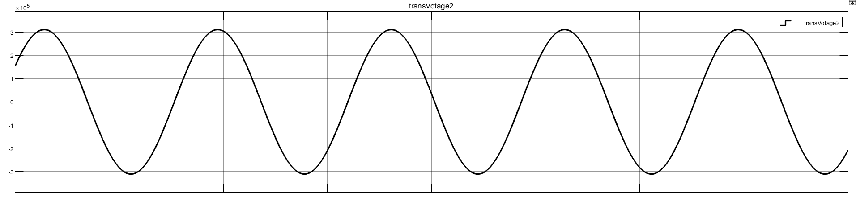

#### Vdor: DC voltage at rectifier side:

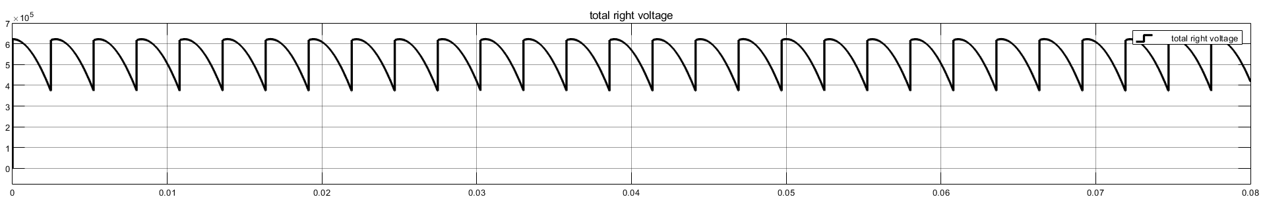

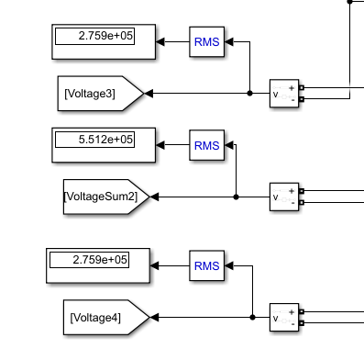

#### Grid current at rectifier side:

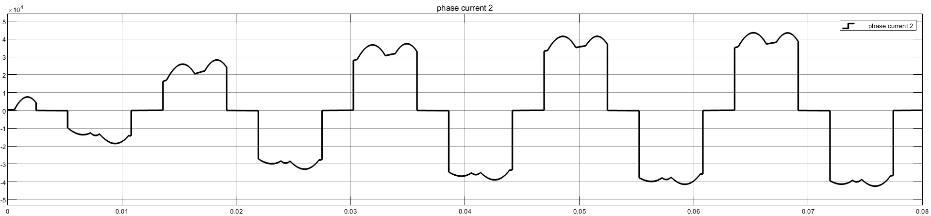

#### AC voltage at inverter side:

#### Vdoi: DC voltage at inverter side:

#### Grid current at inverter side:

#### DC current (L=0.1 Henry):

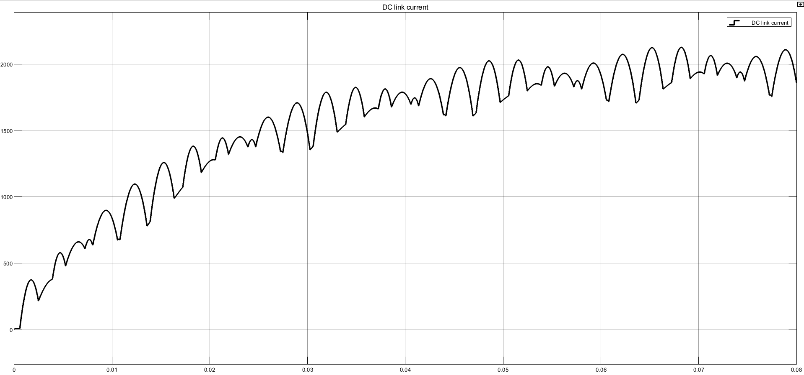

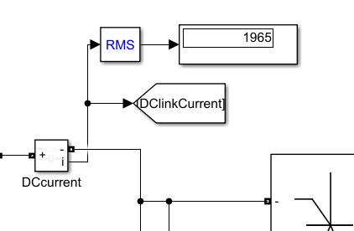

### Case (3): 1600MW: Power flow from (A) to (B): Net(A) is rectifier (2.5% voltage swell) and Net(B) is inverter:

#### AC voltage at rectifier side:

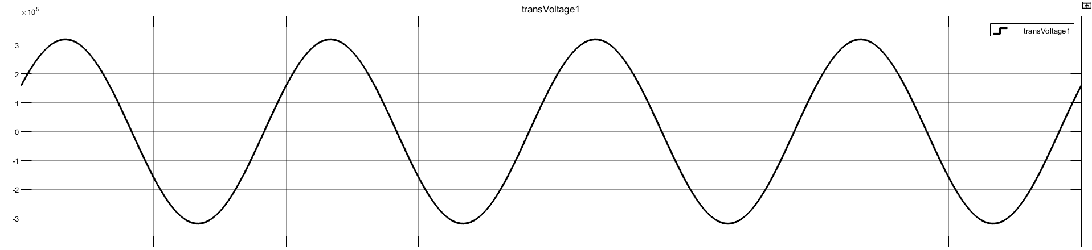

#### Vdor: DC voltage at rectifier side:

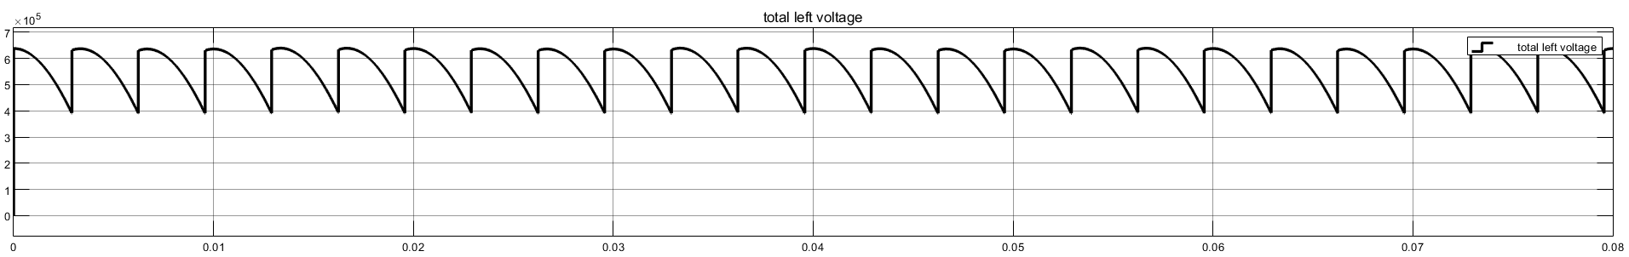

#### Grid current at rectifier side:

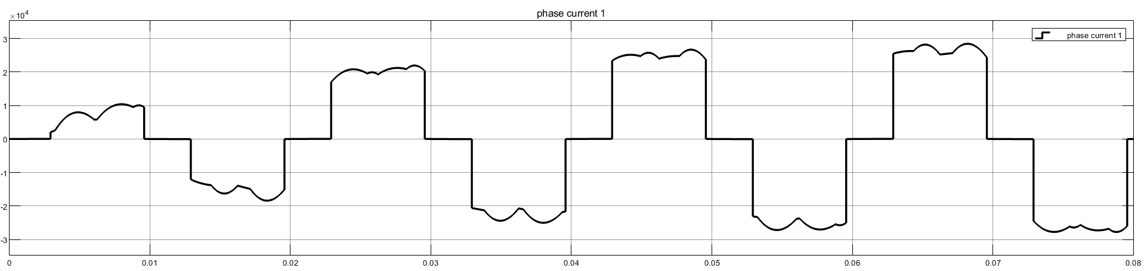

#### AC voltage at inverter side:

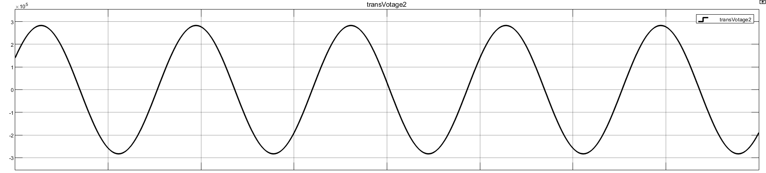

#### Vdoi: DC voltage at inverter side:

#### Grid current at inverter side:

#### DC current (L=0.1 Henry):

# III. Twelve-Pulse Model:

## Question (C):

### Model Screenshot:

### Case (1): 1600MW: Power flow from (A) to (B): Net(A) is rectifier and Net(B) is inverter:

#### Analytical Calculations:

#### AC voltage at rectifier side:

#### Vdor: DC voltage at rectifier side:

#### Grid current at rectifier side:

#### AC voltage at inverter side:

#### Vdoi: DC voltage at inverter side:

#### Grid current at inverter side:

#### DC current (L=0.1 Henry):

### Case (2): 1200MW: Power flow from (B) to (A): Net(B) is rectifier (+10%) and Net(A) is inverter (-10%):

#### Analytical Calculations:

#### AC voltage at rectifier side:

#### Vdor: DC voltage at rectifier side:

#### Grid current at rectifier side:

#### AC voltage at inverter side:

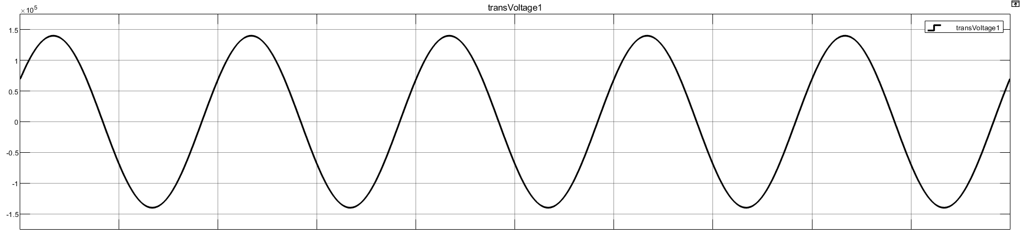

#### Vdoi: DC voltage at inverter side:

#### Grid current at inverter side:

#### DC current (L=0.1 Henry):

### Case (3): 1600MW: Power flow from (A) to (B): Net(A) is rectifier (2.5% voltage swell) and Net(B) is inverter:

#### Analytical Calculations:

#### AC voltage at rectifier side:

#### Vdor: DC voltage at rectifier side:

#### Grid current at rectifier side:

#### AC voltage at inverter side:

#### Vdoi: DC voltage at inverter side:

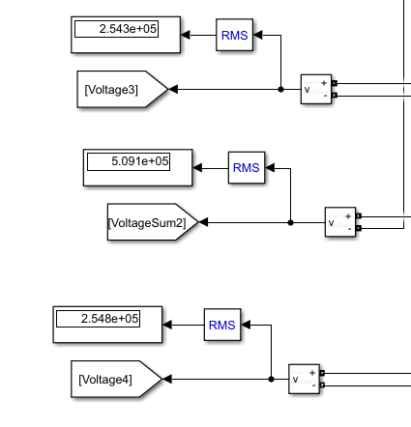

#### Grid current at inverter side:

#### DC current (L=0.1 Henry):

# IV. Comparison:

### Question (D):

#### Compare the performance of 6-pulse and 12-pulse converters. Comment.

* 12-pulse instead of 6-pulse are obtained due to the 30 degrees shift between star and delta windings and therefore a smoother ripple-less voltage is obtained. This results in smaller filters and lower cost.

* It is also observed that the grid currents at both sides (rectifier and inverter) are enhanced, now curves are closer to the sine wave in a 10-pulse shape as shown below. (sample curves from 12-pulse case (2)).

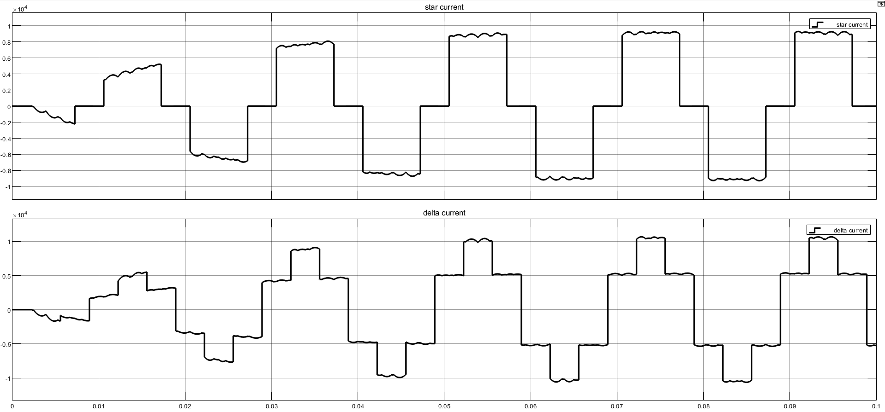

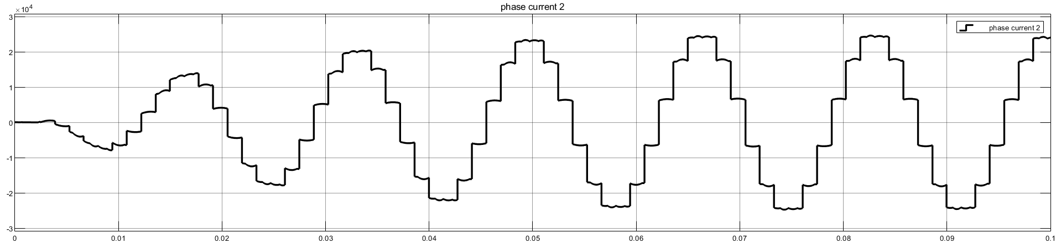

# V. Attachments:

* [GitHub repo.](https://github.com/Tasnime1/HVDC-model)