**SQL PROJECT**

**The database was taken from -**

**(**[**https://github.com/bbrumm/databasestar/tree/main/sample_databases/sample_db_movies/mysql**](https://github.com/bbrumm/databasestar/tree/main/sample_databases/sample_db_movies/mysql)**).**

This clean dataset has seventeen (17) tables, they are- country, department, gender, keyword, language, language_role, movie, movie_cast, movie_company, movie_crew, movie_genres, movie_keywords, movie_languages, person, production_company, and production_country.

**Queries**

# When did the latest movie release?





# When did the oldest movie release?





#what are the top 3 genres of each country that brought most profit?

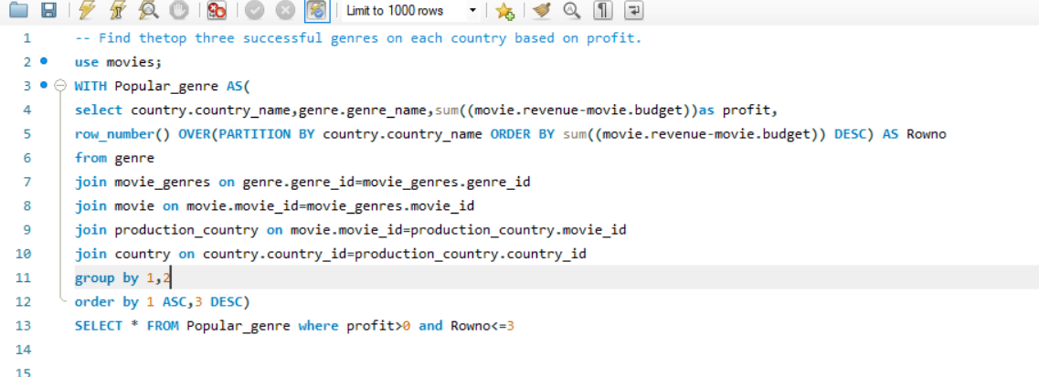

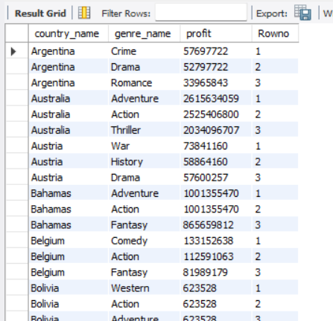

#Find the person whose acted movies made the most profit. Name the movies along with their ratings and profit.

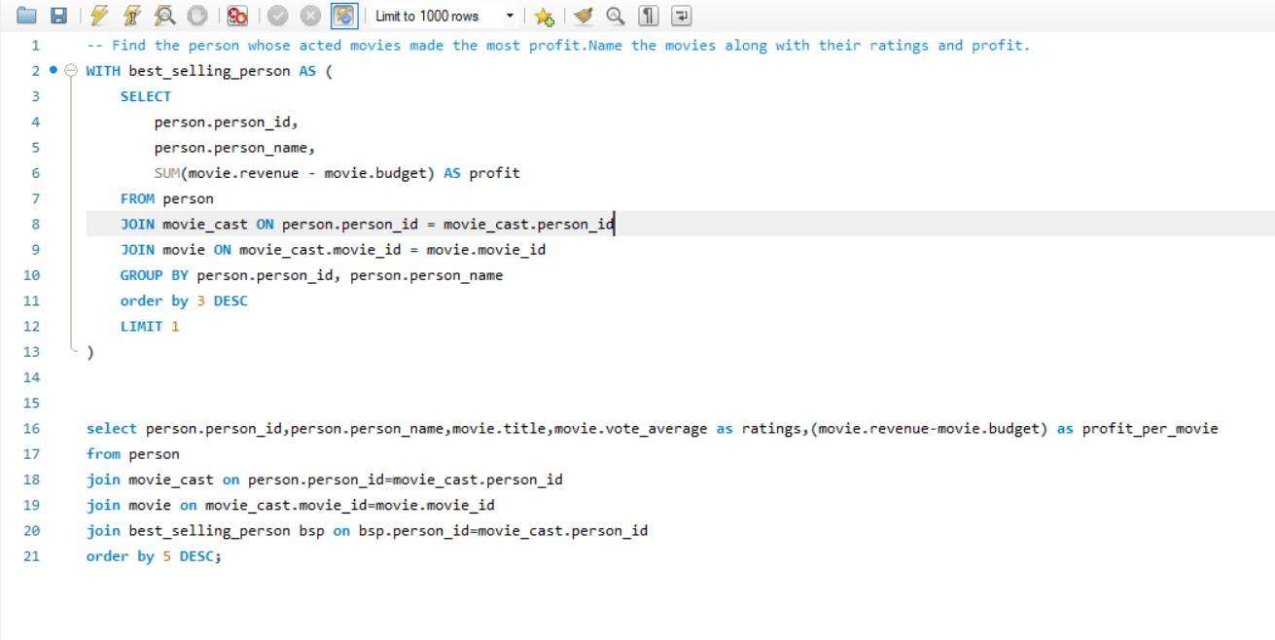

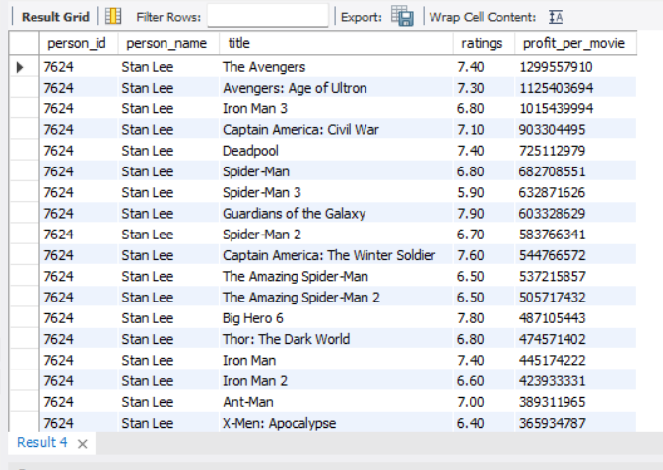

The person is called Stan Lee whose acted movies grossed the highest amount of profit. All the movie names are also shown by the highest to lowest profit.

#Find the highest rated movies given that the highest rate is 10 in this database.

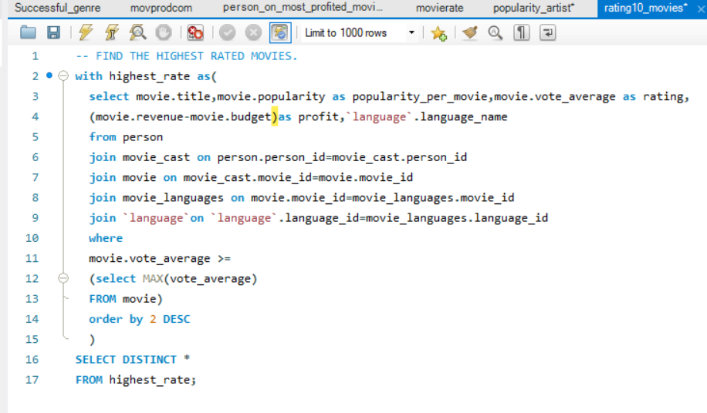



The highest rate in this dataset is 10. Among all the movies only 3 of them scored 10 that were not even popular comparatively even 2 did not make any profit regardless their languages all were English which is the top language to make profit (found in the last query).

So from this query we can say that there are movies which do not have much popularity and profit but have the highest rate that are worth watching.

#Find the movies with highest ranking then profit and popularity respectively.

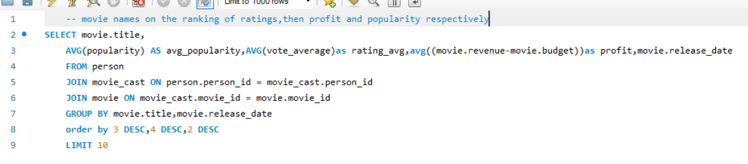

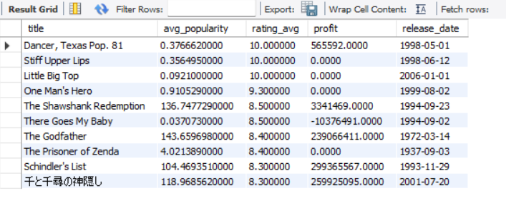

#Find the movie names on the ranking of profit then popularity and rating respectively

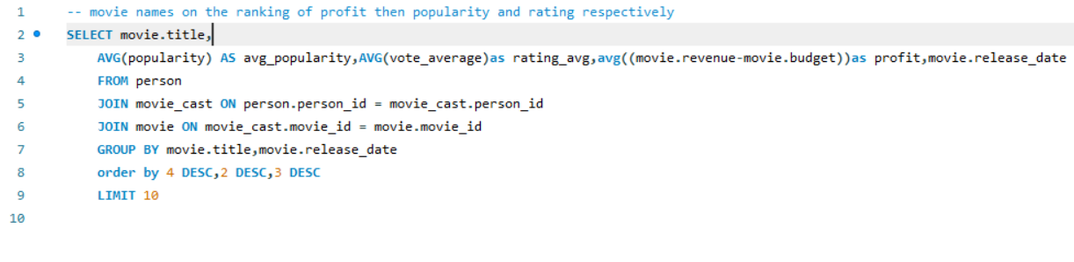

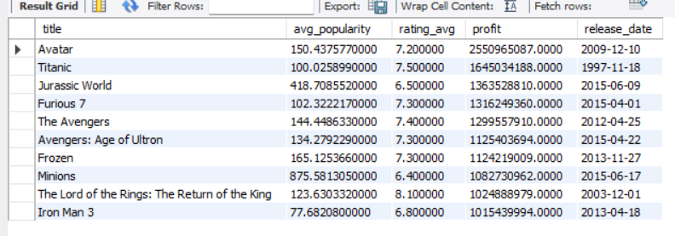

#Find the movie names on the ranking of popularity then profit and rating respectively

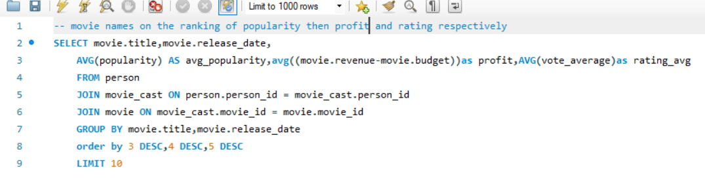

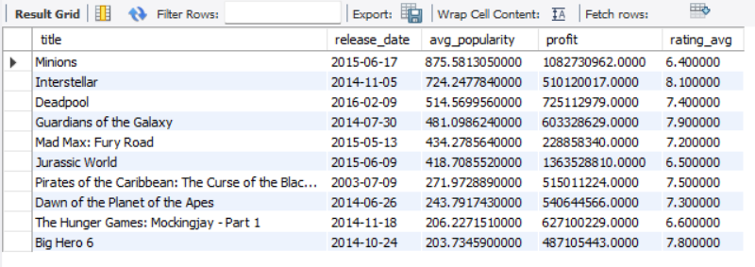

From the last 3 queries we found the movies which highest in ranking then highest in profit then the last highest in popularity. From the 3 queries we can say that-

1. There are many high rated movies that did not make big or any profit and even not that popular but they are rated high. Most of them are released in late 1900s and early 2000s.
2. Popularity and profit are kind of proportional. From the 2nd query among these 3 it is seen that high profited movies were also very popular comparatively. And the 3rd query highly popular movies earned more profit.
3. Also it is seen that highly profited and highly popular movies are released on the recent timeline or years mentioned in this dataset. This could be explained by the theory that the more we go back in time there were lesser medium of advertisement and access which resulted in lesser profit and popularity.

# Which language movies are popular? Find the top5.

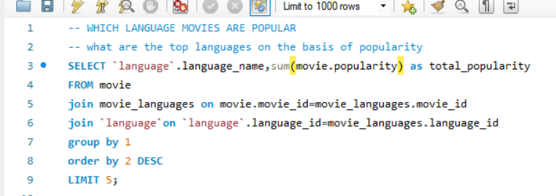

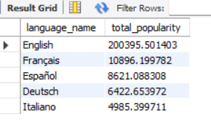

Top 5 languages are the shown.