Somsak Bounchareune

November 7, 2023

Assignment 5.2 My SQL Functions

SQL statements using MySQL syntax for the MID, LCASE, and REPEAT functions:

**MID (SUBSTRING) in MySQL:**

Explanation: The MID or SUBSTRING function is used to extract a portion of a string from a specified starting position and of a certain length.

Alias for Column Header: "SubstringResult"

SQL Statement:

Expected Output: This will extract the substring starting from the 7th character of 'Hello, World' with a length of 5 characters, which should result in 'World'.

**LCASE (LOWER) in MySQL:**

Explanation: The LCASE or LOWER function converts all characters in a string to lowercase.

Alias for Column Header: "LowercaseResult"

SQL Statement:

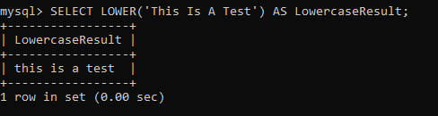

Expected Output: This will convert 'This Is A Test' to lowercase, resulting in 'this is a test'.

**REPEAT in MySQL:**

Explanation: The REPEAT function is used to repeat a string a specified number of times.

Alias for Column Header: "RepeatedResult"

SQL Statement:

Expected Output: This will repeat the string 'SQL ' three times, resulting in 'SQL SQL SQL '.