**3.1.1 Προπαρασκευαστικό κομμάτι:**

DROP DATABASE if exists travel_agency;

CREATE DATABASE travel_agency;

USE travel_agency;

CREATE TABLE branch(

br_code INT(11),

br_street VARCHAR(30) DEFAULT 'unknown' NOT NULL,

br_num INT(4) NOT NULL,

br_city VARCHAR(30) DEFAULT 'unknown' NOT NULL,

PRIMARY KEY (br_code)

);

CREATE TABLE phones(

ph_br_code INT(11) NOT NULL,

ph_number CHAR(10) NOT NULL,

PRIMARY KEY (ph_br_code, ph_number),

CONSTRAINT BRPHONE

FOREIGN KEY (ph_br_code) REFERENCES branch(br_code)

ON DELETE CASCADE ON UPDATE CASCADE

);

CREATE TABLE worker(

wrk_AT CHAR(10) NOT NULL,

wrk_name VARCHAR(20) DEFAULT 'unknown' NOT NULL,

wrk_lname VARCHAR(20) DEFAULT 'unknown' NOT NULL,

wrk_salary FLOAT(7,2) NOT NULL,

wrk_br_code INT(11) NOT NULL,

PRIMARY KEY (wrk_AT),

CONSTRAINT BRWORKER

FOREIGN KEY (wrk_br_code) REFERENCES branch(br_code)

ON DELETE CASCADE ON UPDATE CASCADE

);

CREATE TABLE admin(

adm_AT CHAR(10) NOT NULL,

adm_type ENUM('LOGISTICS','ADMINISTRATIVE','ACCOUNTING') NOT NULL,

adm_diploma VARCHAR(200) NOT NULL,

PRIMARY KEY (adm_AT),

CONSTRAINT WORKADMIN

FOREIGN KEY (adm_AT) REFERENCES worker(wrk_AT)

ON DELETE CASCADE ON UPDATE CASCADE

);

CREATE TABLE manages(

mng_adm_AT CHAR(10) NOT NULL,

mng_br_code INT(11) NOT NULL,

PRIMARY KEY (mng_adm_AT, mng_br_code),

CONSTRAINT ADMMANAGE

FOREIGN KEY (mng_adm_AT) REFERENCES admin(adm_AT)

ON DELETE CASCADE ON UPDATE CASCADE,

CONSTRAINT BRMANAGE

FOREIGN KEY (mng_br_code) REFERENCES branch(br_code)

ON DELETE CASCADE ON UPDATE CASCADE

);

CREATE TABLE driver(

drv_AT CHAR(10) NOT NULL,

drv_license ENUM('A','B','C','D') NOT NULL,

drv_route ENUM('LOCAL','ABROAD') NOT NULL,

drv_experience TINYINT(4) NOT NULL,

PRIMARY KEY (drv_AT),

CONSTRAINT WORKDRIVER

FOREIGN KEY (drv_AT) REFERENCES worker(wrk_AT)

ON DELETE CASCADE ON UPDATE CASCADE

);

CREATE TABLE guide(

gui_AT CHAR(10) NOT NULL,

gui_cv TEXT NOT NULL,

PRIMARY KEY (gui_AT),

CONSTRAINT WORKGUIDE

FOREIGN KEY (gui_AT) REFERENCES worker (wrk_AT)

ON DELETE CASCADE ON UPDATE CASCADE

);

CREATE TABLE languages(

lng_gui_AT CHAR(10) NOT NULL,

lng_language VARCHAR(30) NOT NULL,

PRIMARY KEY (lng_gui_AT, lng_language),

CONSTRAINT GUILANGUAGE

FOREIGN KEY (lng_gui_AT) REFERENCES guide(gui_AT)

);

CREATE TABLE trip(

tr_id INT(11) NOT NULL,

tr_departure DATETIME NOT NULL,

tr_return DATETIME NOT NULL,

tr_maxseats TINYINT(4) NOT NULL,

tr_cost FLOAT(7,2) NOT NULL,

tr_br_code INT(11) NOT NULL,

tr_gui_AT CHAR(10) NOT NULL,

tr_drv_AT CHAR(10) NOT NULL,

PRIMARY KEY(tr_id),

CONSTRAINT BRANCHTRIP

FOREIGN KEY (tr_br_code) REFERENCES branch(br_code)

ON DELETE CASCADE ON UPDATE CASCADE,

CONSTRAINT GUIDETRIP

FOREIGN KEY (tr_gui_AT) REFERENCES guide(gui_AT)

ON DELETE CASCADE ON UPDATE CASCADE,

CONSTRAINT DRIVERTRIP

FOREIGN KEY (tr_drv_AT) REFERENCES driver(drv_AT)

ON DELETE CASCADE ON UPDATE CASCADE

);

CREATE TABLE event(

ev_tr_id INT(11) NOT NULL,

ev_start DATETIME NOT NULL,

ev_end DATETIME NOT NULL,

ev_descr TEXT NOT NULL,

PRIMARY KEY(ev_tr_id, ev_start),

CONSTRAINT EVENTTRIP

FOREIGN KEY (ev_tr_id) REFERENCES trip(tr_id)

ON DELETE CASCADE ON UPDATE CASCADE

);

CREATE TABLE reservation(

res_tr_id INT(11) NOT NULL,

res_seatnum TINYINT(4) NOT NULL,

res_name VARCHAR(20) DEFAULT 'unknown' NOT NULL,

res_lname VARCHAR(20) DEFAULT 'unknown' NOT NULL,

res_isadult ENUM('ADULT','MINOR') NOT NULL,

PRIMARY KEY(res_tr_id, res_seatnum),

CONSTRAINT TRIPRESERV

FOREIGN KEY (res_tr_id) REFERENCES trip(tr_id)

ON DELETE CASCADE ON UPDATE CASCADE

);

CREATE TABLE destination (

dst_id INT(11) NOT NULL,

dst_name VARCHAR(50) NOT NULL,

dst_descr TEXT NOT NULL,

dst_rtype ENUM('LOCAL','ABROAD') NOT NULL,

dst_language VARCHAR(30) NOT NULL,

dst_location INT(11) ,

PRIMARY KEY(dst_id),

CONSTRAINT DESTLOCATION

FOREIGN KEY (dst_location) REFERENCES destination(dst_id)

ON DELETE CASCADE ON UPDATE CASCADE

);

CREATE TABLE travel_to(

to_tr_id INT(11) NOT NULL,

to_dst_id INT(11) NOT NULL,

to_arrival DATETIME NOT NULL,

to_departure DATETIME NOT NULL,

PRIMARY KEY(to_tr_id, to_dst_id),

CONSTRAINT TRIPTRAVEL

FOREIGN KEY (to_tr_id) REFERENCES trip(tr_id)

ON DELETE CASCADE ON UPDATE CASCADE,

CONSTRAINT TRAVELDEST

FOREIGN KEY (to_dst_id) REFERENCES destination(dst_id)

ON DELETE CASCADE ON UPDATE CASCADE

);

INSERT INTO branch VALUES

(1,'AGIOY ANDREOY','15','PATRA'),

(2,'EVELPIDWN','29','ATHINA'),

(3,'TSIMISKI','43','THESALONIKI');

INSERT INTO phones VALUES

(1,'2610659237'),

(1,'6946318647'),

(2,'2103262024'),

(2,'6932169687'),

(3,'2316052340'),

(3,'6923168945');

INSERT INTO worker VALUES

('DR423611','GIANNIS','PAPADOPOYLOS',850.00,1),

('DR383152','VASILIS','APOSTOLOY',872.25,1),

('DR521363','ANTONIA','OIKONOMOY',800.32,1),

('DR210364','MARIA','PAPANTONIOY',840.00,2),

('DR235065','ANTONIS','ALEXANDROPOYLOS',864.59,2),

('DR464236','GIANNIS','SIFAKIS',967.00,2),

('DR325067','ZOI','PAPADOPOYLOY',1053.34,3),

('DR325068','KONSTANTINA','PAPADOPOYLOY',1099.00,3),

('DR325069','LIANA','PAPAGEORGIOU',980.00,3),

('AD356581','KONSTANTINA','PATAKI',1000.00,1),

('AD736892','ALEXIS','OIKONOMOY',856.41,1),

('AD875913','ANDREAS','PAPPAS',790.36,1),

('AD512354','MARIOS','NIKOLOPOYLOS',868.53,2),

('AD321025','ANASTASIA','ALEXOPOYLOY',980.79,2),

('AD456736','GIORGOS','GEORGAKOPOYLOS',800.00,2),

('AD765667','MARINA','NINIS',832.76,3),

('AD765668','MARIA','GEORGOYLI',835.00,3),

('AD609519','ANDREAS','SOTIROPOYLOS',963.00,3),

('GU648981','DIMITRIS','PAPASTATHOPOYLOS',850.65,1),

('GU435342','VASILIS','APOSTOLOPOYLOS',852.87,1),

('GU678673','APOSTOLHS','MPOYGAS',750.87,1),

('GU768564','MANOS','KYRIAKOPOYLOS',900.50,2),

('GU128745','ALEXIS','GEORGOPOYLOS',890.70,2),

('GU986816','TASOS','GIANOYKAS',900.60,2),

('GU761207','GIORGOS','GIAMEOS',900.60,3),

('GU136088','ATHANASIA','ANTONIOY',810.00,3),

('GU394459','GEWRGIA','ATHANASOPOYLOY',785.63,3);

INSERT INTO admin VALUES

('AD356581','ACCOUNTING','DIPLOMA OIKONOMIKON'),

('AD736892','ADMINISTRATIVE','DIPLOMA DIOIKISIS EPIXEIRISEON'),

('AD875913','LOGISTICS','DIPLOMA LOGISTIKIS'),

('AD512354','ADMINISTRATIVE','DIPLOMA DIOIKISIS EPIXEIRISEON'),

('AD321025','ACCOUNTING','DIPLOMA OIKONOMIKON'),

('AD456736','LOGISTICS','DIPLOMA LOGISTIKIS'),

('AD765667','LOGISTICS','DIPLOMA LOGISTIKIS');

INSERT INTO manages VALUES

('AD356581',1),

('AD512354',2),

('AD765667',3);

INSERT INTO guide VALUES

('GU648981','cv 1'),

('GU435342','cv 2'),

('GU678673','cv 3'),

('GU768564','cv 4'),

('GU128745','cv 5'),

('GU986816','cv 6'),

('GU761207','cv 7'),

('GU136088','cv 8'),

('GU394459','cv 9');

INSERT INTO languages VALUES

('GU648981','English,Spanish'),

('GU435342','English,French'),

('GU678673','English,German'),

('GU768564','English,Spanish'),

('GU128745','English,Spanish'),

('GU986816','English,German'),

('GU761207','English,German'),

('GU136088','English,Spanish'),

('GU394459','English,French');

INSERT INTO driver VALUES

('DR423611','D','LOCAL',12),

('DR383152','A','ABROAD',24),

('DR521363','C','LOCAL',29),

('DR210364','D','ABROAD',31),

('DR235065','A','ABROAD',50),

('DR464236','B','LOCAL',48),

('DR325067','D','LOCAL',60),

('DR325068','A','ABROAD',27),

('DR325069','D','LOCAL',9);

INSERT INTO trip VALUES

(1,'2023-01-05 12:00:00','2023-01-11 14:00:00',40,60.00,1,'GU648981','DR423611'),

(2,'2022-12-22 08:30:00','2022-12-26 21:30:00',36,30.00,1,'GU435342','DR383152'),

(3,'2023-02-09 09:00:00','2023-02-17 10:00:00',40,42.63,2,'GU768564','DR210364'),

(4,'2023-02-25 10:45:00','2023-03-01 12:15:00',42,28.79,3,'GU761207','DR325067'),

(5,'2023-01-17 13:15:00','2023-01-22 15:00:00',39,40.00,3,'GU136088','DR325068');

INSERT INTO event VALUES

(1,'2023-01-06 12:00:00','2023-01-07 17:00:00','Event 1.1 description'),

(1,'2023-01-08 08:30:00','2023-01-08 22:30:00','Event 1.2 description'),

(1,'2023-01-09 10:00:00','2023-01-10 14:00:00','Event 1.3 description'),

(2,'2022-12-23 10:40:00','2022-12-24 19:15:00','Event 2.1 description'),

(2,'2022-12-25 16:00:00','2022-12-26 14:45:00','Event 2.2 description'),

(3,'2023-02-10 10:30:00','2023-02-11 02:00:00','Event 3.1 description'),

(3,'2023-02-12 08:00:00','2023-02-13 16:00:00','Event 3.2 description'),

(3,'2023-02-14 12:15:00','2023-02-15 12:00:00','Event 3.3 description'),

(3,'2023-02-15 15:30:00','2023-02-16 20:00:00','Event 3.4 description'),

(4,'2023-02-26 16:15:00','2023-02-27 19:45:00','Event 4.1 description'),

(4,'2023-02-28 08:00:00','2023-02-28 19:45:00','Event 4.2 description'),

(5,'2023-01-18 09:00:00','2023-01-19 13:00:00','Event 5.1 description'),

(5,'2023-01-20 10:00:00','2023-01-21 17:00:00','Event 5.2 description');

INSERT INTO reservation VALUES

(1,1,'Paulos','Giannopoulos','ADULT'),

(1,2,'Thodoris','Stefanopoylos','ADULT'),

(1,3,'Ioanna','Stefanopoylou','MINOR'),

(1,4,'Stefanos','Giannakis','ADULT'),

(1,5,'Petros','Giannakis','MINOR'),

(2,1,'Aggeliki','Papandreoy','ADULT'),

(2,2,'Fotini','Papandreoy','MINOR'),

(2,3,'Athanasia','Apostolopoyloy','ADULT'),

(2,4,'Stela','Apostolopoyloy','MINOR'),

(2,5,'Thanasis','Aggelopoylos','ADULT'),

(2,6,'Thodora','Mixailidi','ADULT'),

(3,1,'Apostolis','Aggelopoylos','MINOR'),

(3,2,'Alexandra','Melanidoy','ADULT'),

(3,3,'Apostolia','Melanidoy','MINOR'),

(3,4,'Tasos','Sakos','ADULT'),

(3,5,'Eleonora','Sakoy','MINOR'),

(3,6,'Dimitrhs','Papanikolaos','ADULT'),

(3,7,'Pantelis','Georgakopoylos','ADULT'),

(3,8,'Anastasia','Papanikolaou','MINOR'),

(3,9,'Menelaos','Papaloykas','ADULT'),

(4,1,'Pantelis','Giannopoulos','ADULT'),

(4,2,'Kwstas','Stefanopoylos','ADULT'),

(4,3,'Ioanna','Mixalopoyloy','ADULT'),

(4,4,'Orestis','Giannakis','ADULT'),

(4,5,'Thanasis','Giannopoulos','MINOR'),

(5,1,'Pinelopi','Papandreoy','ADULT'),

(5,2,'Fotini','Mixalopoyloy','ADULT'),

(5,3,'Athanasia','Apostoloy','ADULT'),

(5,4,'Stefania','Aggelopoyloy','MINOR'),

(5,5,'Marios','Aggelopoylos','ADULT'),

(5,6,'Domna','Mixailidi','ADULT'),

(5,7,'Apostolis','Metaxas','MINOR'),

(5,8,'Alexia','Metaxa','ADULT'),

(5,9,'Apostolia','Papadopoyloy','MINOR'),

(5,10,'Tasos','Papadopoylos','ADULT'),

(5,11,'Elenh','Papadopouloy','MINOR'),

(5,12,'Dimitra','Papanikolaoy','ADULT'),

(5,13,'Andreas','Georgakopoylos','ADULT'),

(5,14,'Anastasia','Papaloyka','MINOR'),

(5,15,'Anastasis','Papaloykas','ADULT');

INSERT INTO destination VALUES

(1,'USA','Destination 1 description','ABROAD','English',NULL),

(2,'Greece','Destination 2 description','LOCAL','Greek',NULL),

(3,'New York','Destination 3 description','ABROAD','English',1),

(4,'Los Angeles','Destination 4 description','ABROAD','English',1),

(5,'Crete','Destination 5 description','LOCAL','Greek',2);

INSERT INTO travel_to VALUES

(1,1,'2023-01-05 22:00:00','2023-01-11 04:00:00'),

(2,2,'2022-12-22 11:30:00','2022-12-26 18:30:00'),

(3,3,'2023-02-09 18:00:00','2023-02-17 01:00:00'),

(4,4,'2023-02-25 22:45:00','2023-03-01 00:15:00'),

(5,5,'2023-01-17 16:15:00','2023-01-22 12:00:00');

**3.1.2 ΝΕΕΣ απαιτήσεις**

**3.1.2.1**

**Αρχικός πίνακας worker:**

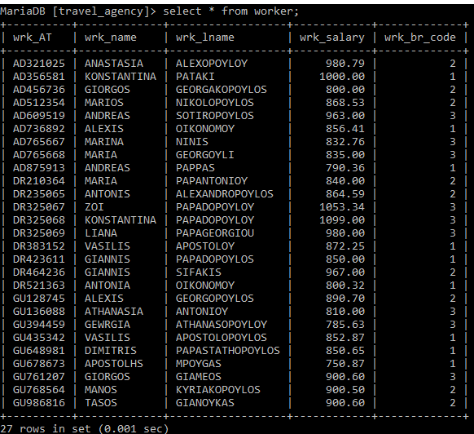

**Εισαγωγή υπεύθυνων πληροφορικής στον πίνακα worker:**

INSERT INTO worker Values

('IT326491','DIONYSIS','KALAITZAKIS', 1000.00, 1),

('IT315482','KYRIAKI','KEFALA',1125.00,2),

('IT231563','STEFANIA','KARYDI',967.56,3),

('IT497714','GIORGOS','PAPADOPOYLOS',890.50,1),

('IT234415','MANOS','PAPALIMNEOS',920.60,2),

('IT435616','VASILIS','TSIRIKOS',1000.00,3);

**Πίνακας worker μετά από εισαγωγές:**

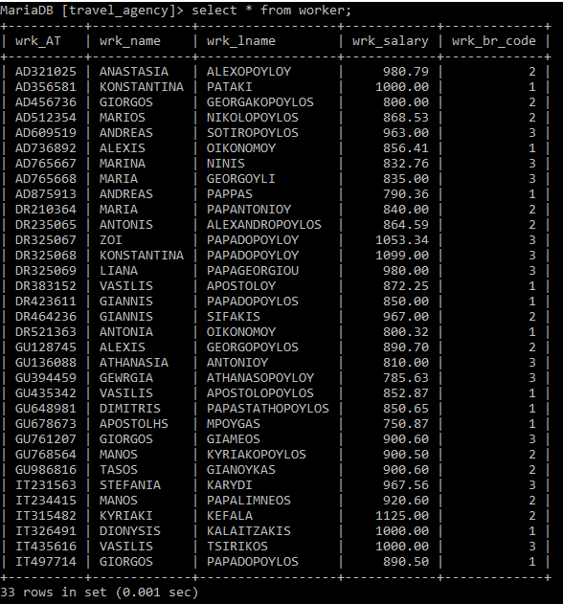

**Δημιουργία πίνακα υπεύθυνων πληροφορικής:**

CREATE TABLE it(

IT_AT CHAR(10) NOT NULL,

IT_password CHAR(10) DEFAULT 'password' NOT NULL,

IT_start_date DATETIME NOT NULL,

IT_end_date DATETIME,

PRIMARY KEY (IT_AT),

CONSTRAINT ITWORKER

FOREIGN KEY (IT_AT) REFERENCES worker(wrk_AT)

ON DELETE CASCADE ON UPDATE CASCADE

);

**Εισαγωγή δεδομένων στον πίνακα it:**

INSERT INTO it Values

('IT326491',DEFAULT,'2013-05-18 00:00',NULL),

('IT315482',DEFAULT,'2012-12-29 00:00',NULL),

('IT231563',DEFAULT,'2018-10-13 00:00',NULL),

('IT497714',DEFAULT,'2010-02-11 00:00',NULL),

('IT234415',DEFAULT,'2003-09-10 00:00',NULL),

('IT435616',DEFAULT,'2016-07-25 00:00',NULL);

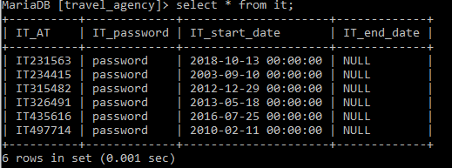

**3.1.2.2**

**Δημιουργία πίνακα log:**

CREATE TABLE log(

log_AT CHAR(10) NOT NULL,

table_trip ENUM('INSERT','UPDATE','DELETE'),

trip_last_update DATETIME,

table_reservation ENUM('INSERT','UPDATE','DELETE'),

reservation_last_update DATETIME,

table_event ENUM('INSERT','UPDATE','DELETE'),

event_last_update DATETIME,

table_travel_to ENUM('INSERT','UPDATE','DELETE'),

travel_to_last_update DATETIME,

table_destination ENUM('INSERT','UPDATE','DELETE'),

destination_last_update DATETIME,

PRIMARY KEY (log_AT),

CONSTRAINT LOGIT

FOREIGN KEY (log_AT) REFERENCES it(IT_AT)

ON DELETE CASCADE ON UPDATE CASCADE

);

**Παραδοχή: Με την χρήση της εντολής ENUM δείχνουμε ποια δεδομένα μπορούν να εισαχθούν στον πίνακα log. Η κάθε στήλη θα παίρνει το κάθε δεδομένο ανάλογα με την χρήση του υπεύθυνου πληροφορικής. Δηλαδή αν κάποιος από τους IΤs κάνει insert σε κάποιον πίνακα το αντίστοιχο γνώρισμα του log θα πάρει την τιμή “INSERT” κτλπ. Τα γνωρίσματα της μορφής “(table)_last_update” δείχνουν την τελευταία στιγμή που έγινε η κάθε είσοδος στον ανάλογο πίνακα από τον IT.** **(Η υλοποίηση θα γίνει σε επόμενο ερώτημα).**

**Εισαγωγή αρχικών δεδομένων στον πίνακα log:**

INSERT INTO log(log_AT) VALUES

(‘IT326491’),

(‘IT315482’),

(‘IT231563’),

(‘IT497714’),

(‘IT234415’),

(‘IT435616’);

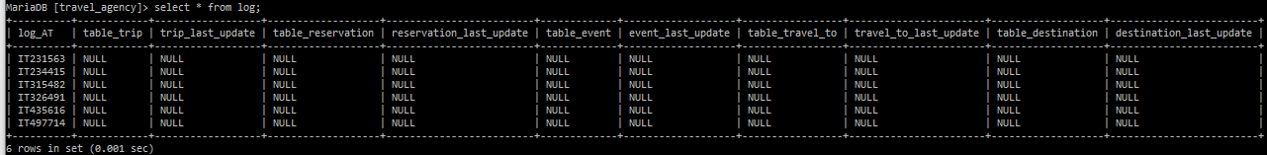

**3.1.2.3**

**Δημιουργία πίνακα offers:**

CREATE TABLE offers(

offer_id INT(11) NOT NULL,

offer_start_date DATETIME NOT NULL,

offer_end_time DATETIME NOT NULL,

offer_cost FLOAT(7,2) NOT NULL,

offer_dst_id INT(11) NOT NULL,

PRIMARY KEY (offer_id),

CONSTRAINT OFFERDESTINATION

FOREIGN KEY (offer_dst_id) REFERENCES destination(dst_id)

ON DELETE CASCADE ON UPDATE CASCADE

);

**Δημιουργία πίνακα reservation_offers:**

CREATE TABLE reservation_offers(

reservation_id INT(11) NOT NULL,

res_name VARCHAR(20) NOT NULL,

res_lastname VARCHAR(20) NOT NULL,

res_offer_id INT(11) NOT NULL,

adv_pay FLOAT(7,2) NOT NULL,

PRIMARY KEY (reservation_id),

CONSTRAINT RESOFFER

FOREIGN KEY (res_offer_id) REFERENCES offers(offer_id)

ON DELETE CASCADE ON UPDATE CASCADE

);

**Εισαγωγή προορισμών προς προσφορά στον πίνακα destination:**

INSERT INTO destination VALUES

(6,'Miami','Destination 6 description','ABROAD','ENGLISH',1),

(7,'San Francisko', 'Destination 7 description','ABROAD','ENGLISH',1),

(8,'Las Vegas','Destination 8 description','ABROAD','ENGLISH',1);

**Πίνακας destination μετά από εισαγωγές:**

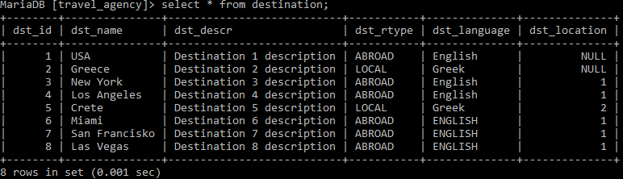

**Εισαγωγή προσφορών στον πίνακα offers:**

INSERT INTO offers VALUES

(1,’2023-6-15’,’2023-12-15’,500,6),

(2,’2024-1-27’,’2024-9-20’,450,7),

(3,’2024-2-22’,’2024-12-25’,380,8);

**Πίνακας offers μετά από εισαγωγές:**

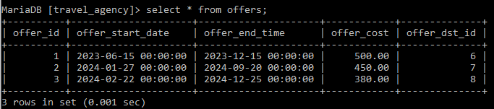

**Τελικό σχεσιακό διάγραμμα:**

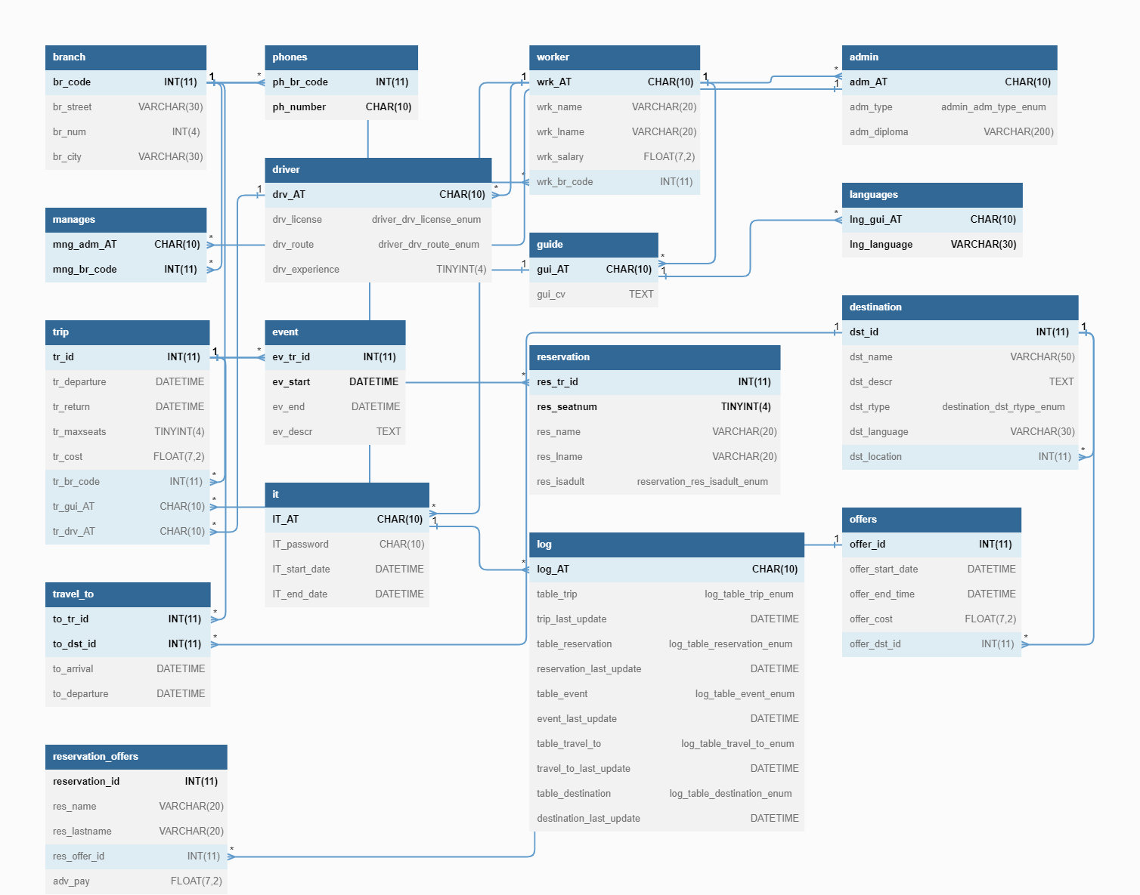

**Κώδικας σε python για υλοποίηση των εισαγωγών στον πίνακα reservation_offers:**

import random

num = 1

while num <= 60000:

namelist = ["Emily", "Madison", "Ashley", "Sarah", "Jessica", "Brianna", "Jordan", "Taylor", "Hannah", "Alexis", "Samantha", "Rachel", "Amber", "Megan", "Alyssa", "Lauren", "Victoria", "Diana", "Maria", "Evelyn", "Elizabeth", "Kayla", "Annabelle", "Mackenzie", "Nicole", "Bailey", "Paige", "Jacqueline", "Caitlin", "Jasmine", "Kaitlyn", "Savannah", "Katherine", "Sofia", "Avery", "Brooklyn", "Eleanor", "Adriana", "Gianna", "Jenna", "Kimberly", "Makayla", "Bella", "Aaliyah", "Allison", "Claire", "Mikayla", "Maria", "Aurora", "Aurora", "Isabella", "Maria", "Aurora", "Sofia", "Isabella", "Mia", "Camila", "Valentina", "Natalia", "Luciana", "Valeria", "Adriana", "Ximena", "Julieta", "Daniela", "Gabriela", "Alondra", "Brenda", "Carmen", "Gabriela", "Liliana", "Paulina", "Miranda", "Dulce", "Esperanza", "Guadalupe", "Karina", "Lourdes", "Rosa", "Salvador", "Adela", "Fatima", "Jazmin", "Jimena", "Juana", "Karen", "Leticia", "Luz", "Magdalena", "Maria", "Maya", "Mireya", "Paula", "Rebeca", "Rocio", "Sandra", "Sofia", "Teresa", "Violeta", "Ai", "Aiko", "Aileen", "Aimee", "Airi", "Akane", "Aki", "Akiko", "Akira", "Ako", "Ami", "Aya", "Ayano", "Eri", "Haruka", "Hikari", "Hina", "Hinata", "Hiroko", "Hitomi", "Honoka", "Hotaru", "Ichiro", "Ikuo", "Jiro", "Kaede", "Kaito", "Kana", "Kanako","Kazuko", "Keiko", "Kimi", "Kosuke", "Makoto", "Mami", "Masako", "Masami", "Maya", "Miyuki", "Nao", "Naoko", "Naomi", "Natsu", "Natsumi", "Noboru", "Noriko", "Reiko", "Rika", "Riku", "Rina", "Sachiko", "Saki", "Sakura", "Satomi", "Takako", "Takashi", "Taro", "Aarav", "Aryan", "Abhinav", "Aditya", "Aryan", "Amit", "Aniket", "Arnav", "Arjun", "Arvind", "Aryan", "Ashwin", "Bhavesh", "Chandan", "Devansh", "Dhruv", "Divyansh", "Gaurav", "Hrithik", "Ishaan", "Ishan", "Kunal", "Kush", "Lakshya", "Naveen", "Nimit", "Nirav", "Parth", "Pranav", "Rishabh", "Rohan", "Sahil", "Saksham", "Sarvesh", "Shivansh", "Shivendra", "Shivansh", "Shreyas", "Siddharth", "Sohan", "Sudhanshu", "Suyash", "Tushar", "Uttam", "Ved", "Vivaan", "Yash", "Yogesh", "Alexander", "Anastasia", "Andrei", "Anna", "Anton", "Dmitri", "Ekaterina", "Elena", "Evgeni", "Galina", "Igor", "Irina", "Kirill", "Konstantin", "Larisa", "Maria", "Mikhail", "Natalia", "Nikolai", "Olga", "Pavel", "Sergei", "Sofia", "Tatiana", "Vadim", "Valeria", "Vasili", "Vera", "Victor", "Vladimir", "Yaroslav", "Yulia", "Yuri", "Zhanna", "Alyona", "Anastasiya", "Andrey", "Anzhelika", "Artyom", "Darya", "Dmitriy", "Egor", "Elizaveta", "Evdokiya", "Grigory", "Inna", "Ivan", "Ksenia", "Mariya", "Maxim", "Mikhail", "Nadezhda", "Natalya", "Nikolay"]

lastnamelist = ["Smith", "Johnson", "Williams", "Jones", "Brown", "Davis", "Miller", "Wilson", "Moore", "Taylor", "Anderson", "Thomas", "Jackson", "White", "Harris", "Martin", "Thompson", "Garcia", "Martinez", "Robinson", "Clark", "Rodriguez", "Lewis", "Lee", "Walker", "Hall", "Allen", "Young", "Hernandez", "King", "Wright", "Lopez", "Hill", "Scott", "Green", "Adams", "Baker", "Gonzalez", "Nelson", "Carter", "Mitchell", "Perez", "Roberts", "Turner", "Phillips", "Campbell", "Parker", "Evans", "Edwards", "Stewart", "Flores", "Morris", "Nguyen", "Garcia", "Gonzalez", "Rodriguez", "Fernandez", "Lopez", "Martinez", "Sanchez", "Perez", "Gomez", "Martín", "Jiménez", "Hernández", "Díaz", "Moreno", "Álvarez", "Muñoz", "Romero", "Alonso", "Gutiérrez", "Navarro", "Torres", "Domínguez", "Vázquez", "Ramos", "Gil", "Ramírez", "Serrano", "Blanco", "Suarez", "Molina", "Morales", "Ortiz", "Rubio", "Marin", "Sanz", "Nuñez", "Iglesias", "Medina", "Garrido", "Cortes", "Castro", "Ortega", "Diez", "Cabrera", "Rey", "Herrera", "Victoria", "Muñoz", "Peña", "Cano", "Lozano", "Castillo", "Kim", "Lee", "Park", "Choi", "Jung", "Kang", "Hong", "Yoon", "Ahn", "Cho", "Lim", "Shim", "Shin", "Yoo", "Yoon", "Wang", "Lin", "Chen", "Chang", "Chou", "Liu", "Huang","Tsai", "Hsu", "Wu", "Lin", "Chu", "Cheng", "Chen", "Liu", "Lo", "Luo", "Zheng", "Zhang", "Zhou", "Xu", "Wu", "Tu", "Tang", "Shi", "Qin", "Pan", "Liang", "Jiang", "Hu", "Feng", "Dong", "Cao", "Chen", "Kumar", "Sharma", "Gupta", "Singh", "Patel", "Kapoor", "Chauhan", "Verma", "Yadav", "Jha", "Ahuja", "Nayar", "Rao", "Khan", "Mehra", "Reddy", "Das", "Malik", "Chopra", "Gandhi", "Bose", "Bhat", "Varma", "Bhushan", "Mahajan", "Prakash", "Seth", "Mathur", "Shankar", "Srivastava", "Agarwal", "Agrawal", "Nair", "Menon", "Shukla", "Tiwari", "Dutt", "Jain", "Dasgupta", "Kaul", "Saraf", "Sarin", "Sethi", "Somaiya", "Suri", "Swamy", "Vaidya", "Vyas", "Mehta", "Tandon", "Nagpal", "Ivanov", "Smirnov", "Kuznetsov", "Popov", "Vasiliev", "Sokolov", "Mikhailov", "Lebedev", "Kovalev", "Grigoriev", "Egorov", "Pavlov", "Morozov", "Zhukov", "Fedorov", "Kozlov", "Novikov", "Konovalov", "Tkachev", "Shchukin", "Shapovalov", "Rozhkov", "Krylov", "Korolev", "Belov", "Volkov", "Solovyev", "Bogdanov", "Andreyev", "Polyakov", "Vinogradov", "Medvedev", "Kozhin", "Lisitsyn", "Koshelev", "Kolosov", "Kolomiytsev", "Khokhlov", "Kazakov", "Kashin", "Kapustin", "Ivanenko", "Gusev", "Danilov", "Chernyshev", "Bryzgalov", "Boyko", "Andrianov", "Aleksandrov"]

reservation_id = num

res_name = random.choice(namelist)

res_lastname = random.choice(lastnamelist)

res_offer_id = 3

adv_pay = random.randint(50, 200)

list = (reservation_id, res_name, res_lastname, res_offer_id, adv_pay)

print(list, ',')

num = num + 1

**Εισαγωγή 60000 δεδομένων στον πίνακα reservation_offers:**



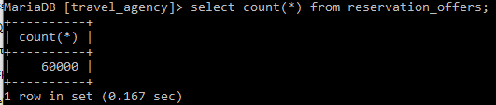

**Παρατήρηση 1: Ο κώδικας της insert για τον πίνακα reservation_offers είναι σε ξεχωριστό αρχείο για εξοικονόμηση χώρου.**

**Παρατήρηση 2: Παρατηρήσαμε ότι κάποια από τα ονόματα που βάλαμε από ένα name generator έχουν τόνους σε λατινικούς χαρακτήρες. Η mysql δεν το αναγνωρίζει αυτό και αντικαθιστά αυτούς τους χαρακτήρες με ?. Εξαιτίας έλλειψης χρόνου όμως δεν προλάβαμε να το διορθώσουμε.**

**3.1.3 Δημιουργία Stored Procedure**

**3.1.3.1**

**Κώδικας procedure για εισαγωγή νέων worker(driver):**

DROP PROCEDURE IF EXISTS new_driver;

DELIMITER $

CREATE PROCEDURE new_driver(new_AT CHAR(10),new_name VARCHAR(20),new_lastname VARCHAR(20),new_salary FLOAT(7,2),new_license ENUM('A','B','C','D'),new_route ENUM('LOCAL','ABROAD'),new_experience TINYINT(4) )

BEGIN

DECLARE num_of_drv_1 INT;

DECLARE num_of_drv_2 INT;

DECLARE num_of_drv_3 INT;

SELECT count(*) INTO num_of_drv_1

FROM driver INNER JOIN worker on

drv_AT=wrk_AT where wrk_br_code=1;

SELECT count(*) INTO num_of_drv_2

FROM driver INNER JOIN worker on

drv_AT=wrk_AT where wrk_br_code=2;

SELECT count(*) INTO num_of_drv_3

FROM driver INNER JOIN worker on

drv_AT=wrk_AT where wrk_br_code=3;

IF(num_of_drv_1<=num_of_drv_2) THEN

IF(num_of_drv_1<=num_of_drv_3) THEN

INSERT INTO worker VALUES(new_AT, new_name, new_lastname, new_salary, 1);

INSERT INTO driver VALUES(new_AT, new_license, new_route, new_experience);

ELSEIF(num_of_drv_3<num_of_drv_1) THEN

INSERT INTO worker VALUES(new_AT, new_name, new_lastname, new_salary, 3);

INSERT INTO driver VALUES(new_AT, new_license, new_route, new_experience);

END IF;

ELSEIF(num_of_drv_2<num_of_drv_1) THEN

IF(num_of_drv_2<=num_of_drv_3) THEN

INSERT INTO worker VALUES(new_AT, new_name, new_lastname, new_salary, 2);

INSERT INTO driver VALUES(new_AT, new_license, new_route, new_experience);

ELSEIF(num_of_drv_3<num_of_drv_2) THEN

INSERT INTO worker VALUES(new_AT, new_name, new_lastname, new_salary, 3);

INSERT INTO driver VALUES(new_AT, new_license, new_route, new_experience);

END IF;

END IF;

END$

DELIMITER ;

**Παραδοχή: Όταν κάποια παραρτήματα έχουν τον ίδιο αριθμό οδηγών ο νέος οδηγός εγγράφεται στο πρώτο κατά σειρά παράρτημα. Για παράδειγμα όταν όλα τα παραρτήματα έχουν τον ίδιο αριθμό οδηγών ο νέος οδηγός εγγράφεται στο παράρτημα 1 ή όταν το παράρτημα 2 έχει ίδιους οδηγούς με το παράρτημα 3 και λιγότερους από το παράρτημα 1 ο νέος οδηγός εγγράφεται στο παράρτημα 2 κτλπ.**

**Αρχικοί πίνακες worker και driver:**

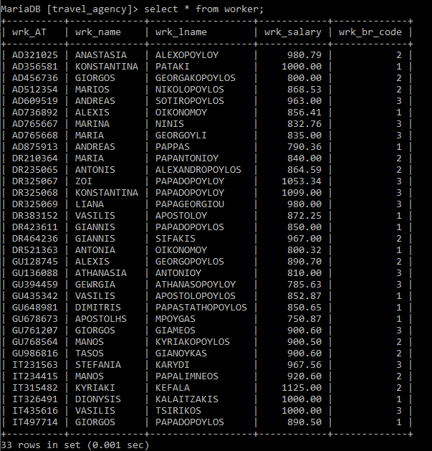

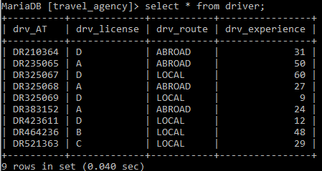

**Πίνακες worker και driver μετά από πρώτο παράδειγμα:**

**call new_driver('DR643810','MENELAOS','SIOPIS',887.5,'D','LOCAL',56);**

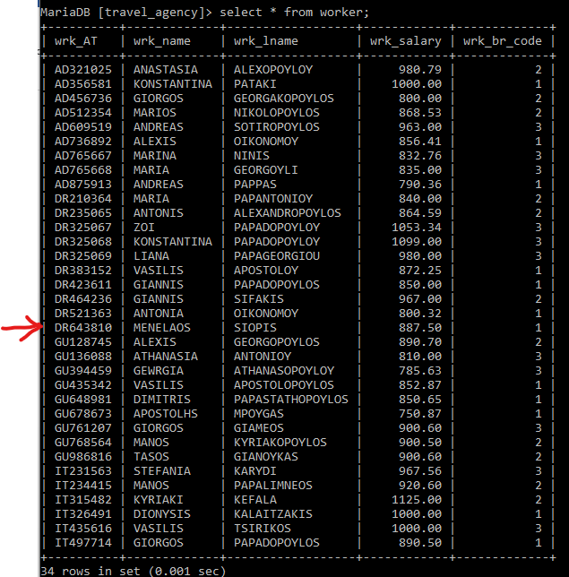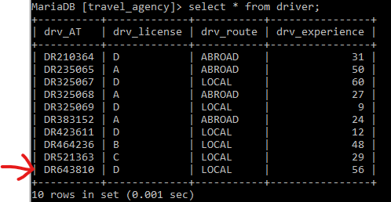

**Όπως φαίνεται αφού όλα τα παραρτήματα έχουν τον ίδιο αριθμό οδηγών, ο νέος οδηγός θα εγγραφεί στο παράρτημα 1.**

**Πίνακες worker και driver μετά από δεύτερο παράδειγμα:**

**Call new_driver('DR356811','PANAGIOTHS','LARISEOS',700.00,'A','LOCAL',26);**

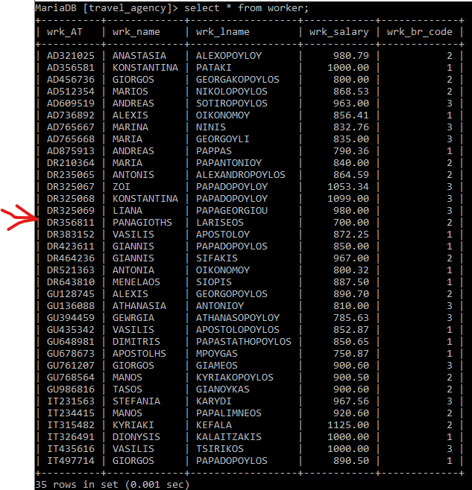

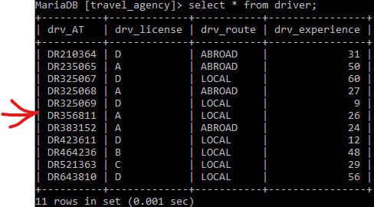

**Όπως φαίνεται αφού τα παραρτήματα 2 και 3 έχουν τον ίδιο αριθμό οδηγών και λιγότερο αριθμό οδηγών από το 1, ο νέος οδηγός θα εγγραφεί στο παράρτημα 2.**

**Πίνακες worker και driver μετά από τρίτο παράδειγμα:**

**call new_driver('DR212812','GIORGOS','LAMANIKAS',850.00,'B','ABROAD',28);**

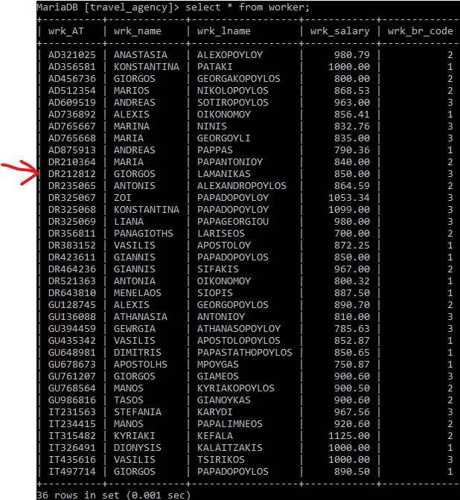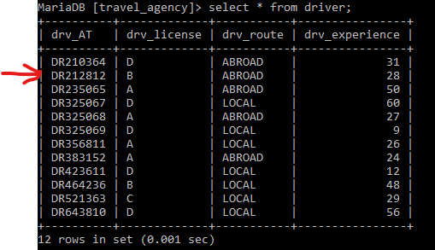

**Όπως φαίνεται αφού το παράρτημα 3 έχει λιγότερο αριθμό οδηγών από τα 1 και 2, ο νέος οδηγός θα εγγραφεί στο παράρτημα 3.**

**3.1.3.2**

**Κώδικας procedure για εμφάνιση συγκεκριμένου ταξιδιού:**

DROP PROCEDURE IF EXISTS get_trip;

DELIMITER $

CREATE PROCEDURE get_trip(br_trip INT, start_date DATETIME, end_date DATETIME)

BEGIN

DECLARE date_begin DATETIME;

DECLARE res_seats INT;

DECLARE max_seats INT;

DECLARE empty_seats INT;

DECLARE dr_name VARCHAR(20);

DECLARE dr_lname VARCHAR(20);

DECLARE gu_name VARCHAR(20);

DECLARE gu_lname VARCHAR(20);

DECLARE trip_cost FLOAT(7,2);

DECLARE date_end DATETIME;

DECLARE finishedflag INT;

DECLARE costcursor CURSOR FOR

SELECT tr_cost FROM trip WHERE

tr_br_code=br_trip;

DECLARE dateendcursor CURSOR FOR

SELECT tr_return FROM trip

WHERE tr_br_code=br_trip;

DECLARE datebegincursor CURSOR FOR

SELECT tr_departure FROM trip

WHERE tr_br_code=br_trip;

DECLARE rescursor CURSOR FOR

SELECT count(res_seatnum) FROM reservation

INNER JOIN trip ON res_tr_id=tr_id

WHERE tr_br_code=br_trip group by tr_id;

DECLARE maxcursor CURSOR FOR

SELECT tr_maxseats FROM trip

WHERE tr_br_code=br_trip;

DECLARE drcursor CURSOR FOR

SELECT wrk_name, wrk_lname FROM worker

INNER JOIN driver ON wrk_AT=drv_AT

INNER JOIN trip ON drv_AT=tr_drv_AT

WHERE tr_br_code=br_trip;

DECLARE gucursor CURSOR FOR

SELECT wrk_name, wrk_lname FROM worker

INNER JOIN guide ON wrk_AT=gui_AT

INNER JOIN trip ON gui_AT=tr_gui_AT

WHERE tr_br_code=br_trip;

DECLARE CONTINUE HANDLER FOR NOT FOUND SET finishedflag=1;

SET finishedflag=0;

OPEN costcursor;

OPEN dateendcursor;

OPEN datebegincursor;

OPEN rescursor;

OPEN maxcursor;

OPEN drcursor;

OPEN gucursor;

REPEAT

FETCH costcursor INTO trip_cost;

FETCH dateendcursor INTO date_end;

FETCH datebegincursor INTO date_begin;

FETCH rescursor INTO res_seats;

FETCH maxcursor INTO max_seats;

FETCH drcursor INTO dr_name, dr_lname;

FETCH gucursor INTO gu_name, gu_lname;

IF (finishedflag=0) THEN

IF (start_date<=date_begin AND date_begin<=end_date) THEN

SET empty_seats=max_seats-res_seats;

SELECT trip_cost AS 'trip cost', max_seats AS 'max seats', res_seats AS 'seats reserved', empty_seats AS 'seats available', dr_name AS 'driver name', dr_lname AS 'driver lastname', gu_name AS 'guide name', gu_lname AS 'guide lastname', date_begin AS 'departure date', date_end AS 'return date';

END IF;

END IF;

UNTIL (finishedflag=1)

END REPEAT;

CLOSE costcursor;

CLOSE dateendcursor;

CLOSE datebegincursor;

CLOSE rescursor;

CLOSE maxcursor;

CLOSE drcursor;

CLOSE gucursor;

END$

DELIMITER ;

**Πίνακας trip:**

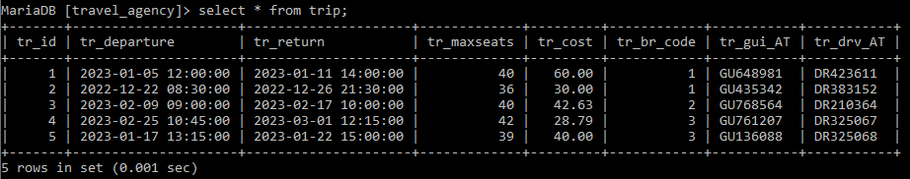

**Παράδειγμα για το branch 1 για ημερομηνίες από 2023-01-01 έως 2023-12-31:**

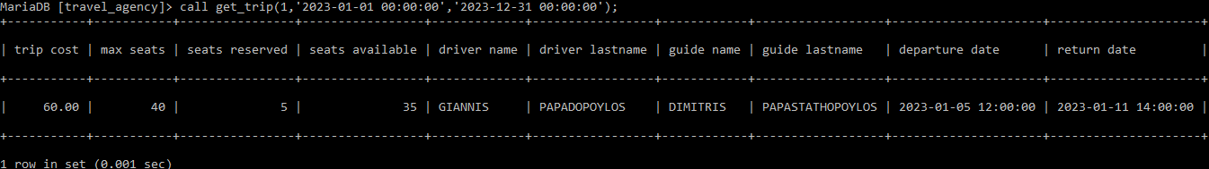

**Παράδειγμα για το branch 1 για ημερομηνίες από 2022-01-01 έως 2023-12-31:**

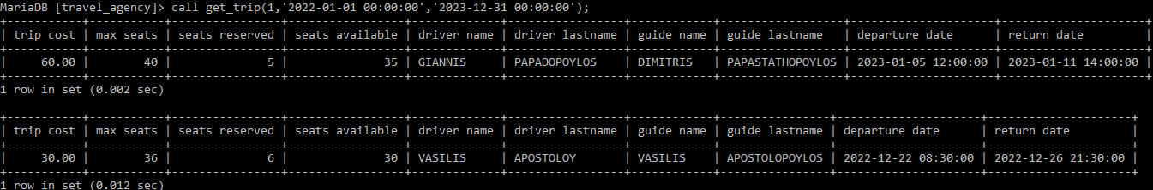

**Παράδειγμα για το branch 3 για ημερομηνίες από 2023-01-01 έως 2023-12-31:**

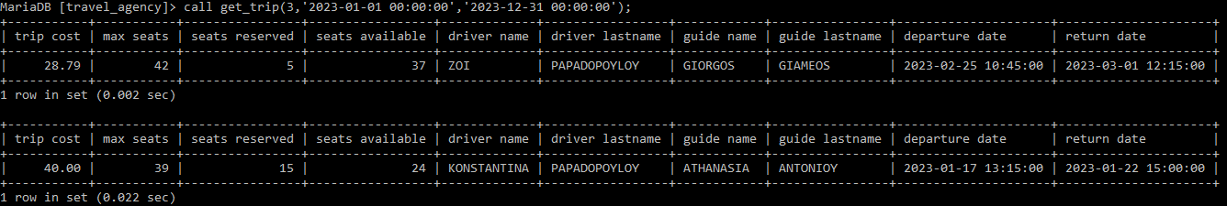

**Παράδειγμα για το branch 3 για ημερομηνίες από 2023-01-01 έως 2023-02-01:**

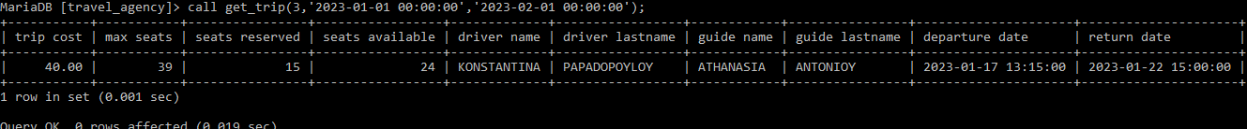

**Παράδειγμα για το branch 2 για ημερομηνίες από 2023-02-01 έως 2023-03-01:**

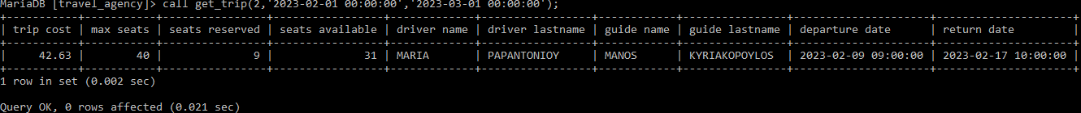

**3.1.3.3**

**Κώδικας procedure για διαγραφή admin:**

DROP PROCEDURE IF EXISTS del_admin;

DELIMITER $

CREATE PROCEDURE del_admin(ad_name VARCHAR(20), ad_lname VARCHAR(20))

BEGIN

DECLARE manager_AT CHAR(10);

DECLARE admin_AT CHAR(10);

SELECT adm_AT INTO admin_AT

FROM worker INNER JOIN admin ON wrk_AT=adm_AT

WHERE wrk_name=ad_name AND wrk_lname=ad_lname;

SELECT mng_adm_AT INTO manager_AT

FROM worker INNER JOIN admin ON wrk_AT=adm_AT

INNER JOIN manages ON adm_AT=mng_adm_AT

WHERE wrk_name=ad_name AND wrk_lname=ad_lname;

IF(admin_AT IS NOT NULL) THEN

IF(manager_AT IS NOT NULL) THEN

SIGNAL SQLSTATE VALUE '45000'

SET MESSAGE_TEXT = 'Admin given is manager and cannot be deleted';

ELSE

DELETE FROM worker WHERE wrk_AT=admin_AT;

END IF;

ELSE

SIGNAL SQLSTATE VALUE '45000'

SET MESSAGE_TEXT = 'Person given is not an admin';

END IF;

END$

DELIMITER ;

**Πίνακας worker:**

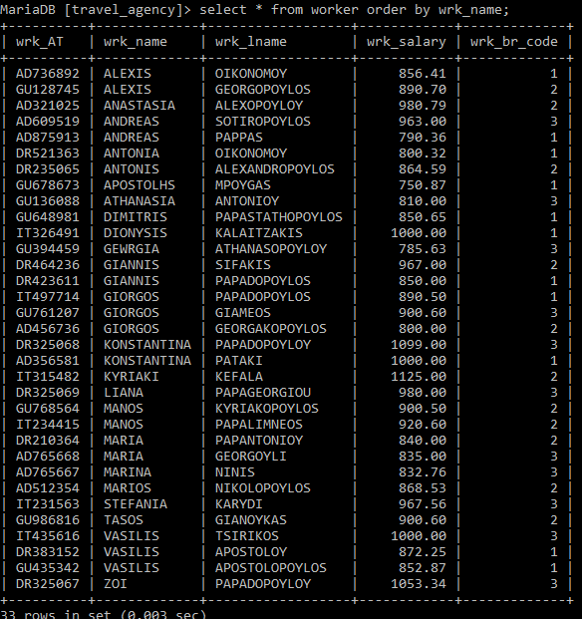

**Όνομα, επώνυμο και ΑΤ των admin:**

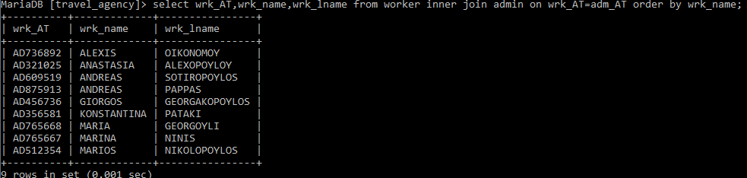

**Όνομα, επώνυμο και ΑΤ των admin που είναι manager:**

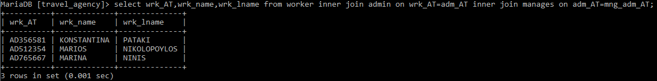

**Παράδειγμα procedure για άτομο που δεν είναι στην βάση δεδομένων:**



**Παράδειγμα procedure για άτομο που δεν είναι admin(εδώ είναι guide):**



**Παράδειγμα procedure για άτομο που είναι admin και manager:**



**Παράδειγμα procedure για άτομο που είναι admin και δεν είναι manager:**



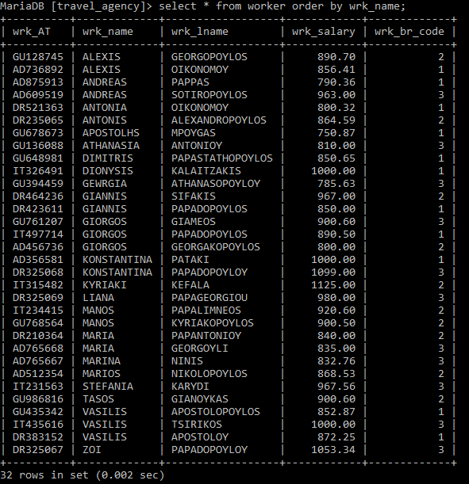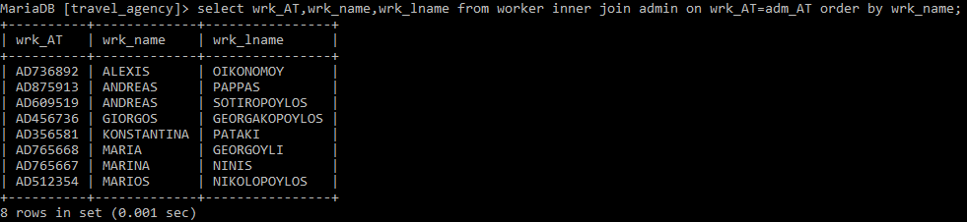

**Όπως φαίνεται η “ANASTASIA ALEXOPOYLOY” έχει διαγραφεί.**

**3.1.3.4**

**α) Κώδικας procedure για επιστροφή ονοματεπωνύμων με βάση την προκαταβολή που πλήρωσαν:**

DROP PROCEDURE IF EXISTS customer_reservation;

DELIMITER $

CREATE PROCEDURE customer_reservation(begin_cost INT,end_cost INT)

BEGIN

SELECT res_name AS name,res_lastname AS lastname

FROM reservation_offers WHERE adv_pay>=begin_cost

AND adv_pay<=end_cost;

END$

DELIMITER ;

**Παράδειγμα χωρίς ευρετήριο:**

**call customer_reservation(150,165);**

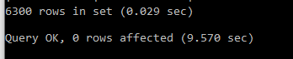

**Παράδειγμα με προσθήκη ευρετηρίου:**

**create index resoffers on reservation_offers(res_name,res_lastname);**

**call customer_reservation(150,165);**



**β) Κώδικας procedure για επιστροφή ονοματεπωνύμων και προσφορών ταξιδιού με βάση το επώνυμο:**

DROP PROCEDURE IF EXISTS same_lastname;

DELIMITER $

CREATE PROCEDURE same_lastname(person_lname VARCHAR(30))

BEGIN

DECLARE j INT;

DECLARE i INT;

SELECT count(*) INTO i FROM offers;

SET j=1;

REPEAT

SELECT res_name AS name,res_lastname AS lastname,res_offer_id,count(*) AS number_of_customers

FROM reservation_offers

WHERE res_lastname=person_lname AND res_offer_id=j

GROUP BY res_name;

SET j=j+1;

UNTIL(j=i+1)

END REPEAT;

END$

DELIMITER ;

**Παράδειγμα χωρίς ευρετήριο:**

**call same_lastname('Davis');**

**Τα αποτελέσματα θα βγουν σε διαφορετικούς πίνακες, ένας για το κάθε res_offer_id.**

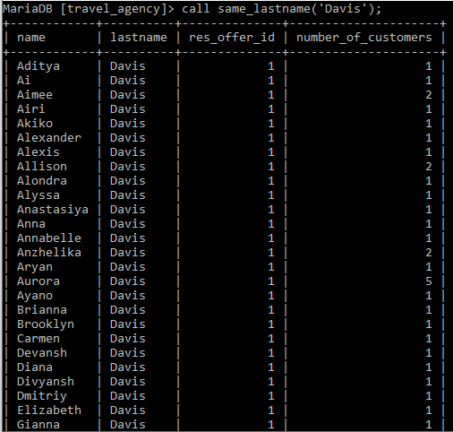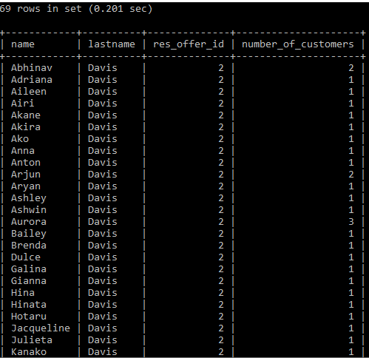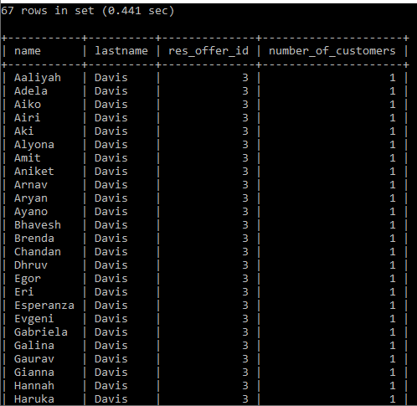

**Υποσημίωση: Οι πίνακες είναι δειγματοληπτικοί.**

**Τελικό αποτέλεσμα:**



**Παράδειγμα με προσθήκη ευρετηρίου:**

**create index resoffers on reservation_offers(res_name,res_lastname);**

**Τελικό αποτέλεσμα:**



**Υποσημείωση: Τα ευρετήρια που χρησιμοποιήσαμε δεν δουλεύουν όπως θα περιμέναμε.**

**3.1.4 Δημιουργία Trigger**

**3.1.4.1**

**Κώδικες trigger για εισαγωγή στον πίνακα log:**

**Insert για τον πίνακα trip:**

DROP TRIGGER IF EXISTS log_insert_trip;

DELIMITER $

CREATE TRIGGER log_insert_trip

AFTER INSERT ON trip

FOR EACH ROW

BEGIN

IF(new.tr_br_code=1) THEN

UPDATE log SET

table_trip='INSERT',trip_last_update=NOW()

WHERE log_AT='IT497714';

ELSEIF(new.tr_br_code=2) THEN

UPDATE log SET

table_trip='INSERT',trip_last_update=NOW()

WHERE log_AT='IT234415';

ELSEIF(new.tr_br_code=3) THEN

UPDATE log SET

table_trip='INSERT',trip_last_update=NOW()

WHERE log_AT='IT435616';

END IF;

END$

DELIMITER ;

**Update για τον πίνακα trip:**

DROP TRIGGER IF EXISTS log_update_trip;

DELIMITER $

CREATE TRIGGER log_update_trip

AFTER UPDATE ON trip

FOR EACH ROW

BEGIN

IF(old.tr_br_code=1) THEN

UPDATE log SET

table_trip='UPDATE',trip_last_update=NOW()

WHERE log_AT='IT326491';

ELSEIF(old.tr_br_code=2) THEN

UPDATE log SET

table_trip='UPDATE',trip_last_update=NOW()

WHERE log_AT='IT315482';

ELSEIF(old.tr_br_code=3) THEN

UPDATE log SET

table_trip='UPDATE',trip_last_update=NOW()

WHERE log_AT='IT231563';

END IF;

END$

DELIMITER ;

**Delete για τον πίνακα trip:**

DROP TRIGGER IF EXISTS log_delete_trip;

DELIMITER $

CREATE TRIGGER log_delete_trip

AFTER DELETE ON trip

FOR EACH ROW

BEGIN

IF(old.tr_br_code=1) THEN

UPDATE log SET

table_trip='DELETE', trip_last_update=NOW()

WHERE log_AT='IT326491';

ELSEIF(old.tr_br_code=2) THEN

UPDATE log

SET table_trip='DELETE', trip_last_update=NOW()

WHERE log_AT='IT315482';

ELSEIF(old.tr_br_code=3) THEN

UPDATE log SET

table_trip='DELETE', trip_last_update=NOW()

WHERE log_AT='IT231563';

END IF;

END$

DELIMITER ;

**Insert για τον πίνακα reservation:**

DROP TRIGGER IF EXISTS log_insert_reservation;

DELIMITER $

CREATE TRIGGER log_insert_reservation

AFTER INSERT ON reservation

FOR EACH ROW

BEGIN

DECLARE branch_code INT;

DECLARE finishedflag INT;

DECLARE brcodecursor CURSOR FOR

SELECT tr_br_code

FROM trip INNER JOIN reservation

ON tr_id=res_tr_id WHERE res_tr_id=new.res_tr_id;

DECLARE CONTINUE HANDLER FOR NOT FOUND SET finishedflag=1;

SET finishedflag=0;

OPEN brcodecursor;

REPEAT

FETCH brcodecursor INTO branch_code;

IF (finishedflag=0) THEN

IF(branch_code=1) THEN

UPDATE log SET

table_reservation='INSERT',reservation_last_update=NOW()

WHERE log_AT='IT497714';

ELSEIF(branch_code=2) THEN

UPDATE log SET

table_reservation='INSERT',reservation_last_update=NOW()

WHERE log_AT='IT234415';

ELSEIF(branch_code=3) THEN

UPDATE log SET

table_reservation='INSERT',reservation_last_update=NOW()

WHERE log_AT='IT435616';

END IF;

END IF;

UNTIL (finishedflag=1)

END REPEAT;

CLOSE brcodecursor;

END$

DELIMITER ;

**Update για τον πίνακα reservation:**

DROP TRIGGER IF EXISTS log_update_reservation;

DELIMITER $

CREATE TRIGGER log_update_reservation

AFTER UPDATE ON reservation

FOR EACH ROW

BEGIN

DECLARE branch_code INT;

DECLARE finishedflag INT;

DECLARE brcodecursor CURSOR FOR

SELECT tr_br_code

FROM trip INNER JOIN reservation

ON tr_id=res_tr_id WHERE res_tr_id=new.res_tr_id;

DECLARE CONTINUE HANDLER FOR NOT FOUND SET finishedflag=1;

SET finishedflag=0;

OPEN brcodecursor;

REPEAT

FETCH brcodecursor INTO branch_code;

IF (finishedflag=0) THEN

IF(branch_code=1) THEN

UPDATE log SET

table_reservation='UPDATE',reservation_last_update=NOW()

WHERE log_AT='IT326491';

ELSEIF(branch_code=2) THEN

UPDATE log SET

table_reservation='UPDATE',reservation_last_update=NOW()

WHERE log_AT='IT315482';

ELSEIF(branch_code=3) THEN

UPDATE log SET

table_reservation='UPDATE',reservation_last_update=NOW()

WHERE log_AT='IT231563';

END IF;

END IF;

UNTIL (finishedflag=1)

END REPEAT;

CLOSE brcodecursor;

END$

DELIMITER ;

**Delete για τον πίνακα reservation:**

DROP TRIGGER IF EXISTS log_delete_reservation;

DELIMITER $

CREATE TRIGGER log_delete_reservation

BEFORE DELETE ON reservation

FOR EACH ROW

BEGIN

DECLARE branch_code INT;

DECLARE finishedflag INT;

DECLARE brcodecursor CURSOR FOR

SELECT tr_br_code

FROM trip INNER JOIN reservation

ON tr_id=res_tr_id WHERE res_tr_id=old.res_tr_id;

DECLARE CONTINUE HANDLER FOR NOT FOUND SET finishedflag=1;

SET finishedflag=0;

OPEN brcodecursor;

REPEAT

FETCH brcodecursor INTO branch_code;

IF (finishedflag=0) THEN

IF(branch_code=1) THEN

UPDATE log SET

table_reservation='DELETE',reservation_last_update=NOW()

WHERE log_AT='IT326491';

ELSEIF(branch_code=2) THEN

UPDATE log SET

table_reservation='DELETE',reservation_last_update=NOW()WHERE log_AT='IT315482';

ELSEIF(branch_code=3) THEN

UPDATE log SET

table_reservation='DELETE',reservation_last_update=NOW()WHERE log_AT='IT231563';

END IF;

END IF;

UNTIL (finishedflag=1)

END REPEAT;

CLOSE brcodecursor;

END$

DELIMITER ;

**Insert για τον πίνακα event:**

DROP TRIGGER IF EXISTS log_insert_event;

DELIMITER $

CREATE TRIGGER log_insert_event

AFTER INSERT ON event

FOR EACH ROW

BEGIN

DECLARE branch_code INT;

DECLARE finishedflag INT;

DECLARE brcodecursor CURSOR FOR

SELECT tr_br_code FROM event

INNER JOIN trip ON ev_tr_id=tr_id

WHERE ev_tr_id=new.ev_tr_id;

DECLARE CONTINUE HANDLER FOR NOT FOUND SET finishedflag=1;

SET finishedflag=0;

OPEN brcodecursor;

REPEAT

FETCH brcodecursor INTO branch_code;

IF (finishedflag=0) THEN

IF(branch_code=1) THEN

UPDATE log SET

table_event='INSERT',event_last_update=NOW()

WHERE log_AT='IT497714';

ELSEIF(branch_code=2) THEN

UPDATE log SET

table_event='INSERT',event_last_update=NOW()

WHERE log_AT='IT234415';

ELSEIF(branch_code=3) THEN

UPDATE log SET

table_event='INSERT',event_last_update=NOW()

WHERE log_AT='IT435616';

END IF;

END IF;

UNTIL (finishedflag=1)

END REPEAT;

CLOSE brcodecursor;

END$

DELIMITER ;

**Update για τον πίνακα event:**

DROP TRIGGER IF EXISTS log_update_event;

DELIMITER $

CREATE TRIGGER log_update_event

AFTER UPDATE ON event

FOR EACH ROW

BEGIN

DECLARE branch_code INT;

DECLARE finishedflag INT;

DECLARE brcodecursor CURSOR FOR

SELECT tr_br_code FROM event

INNER JOIN trip ON ev_tr_id=tr_id

WHERE ev_tr_id=old.ev_tr_id;

DECLARE CONTINUE HANDLER FOR NOT FOUND SET finishedflag=1;

SET finishedflag=0;

OPEN brcodecursor;

REPEAT

FETCH brcodecursor INTO branch_code;

IF (finishedflag=0) THEN

IF(branch_code=1) THEN

UPDATE log SET table_event='UPDATE',event_last_update=NOW()

WHERE log_AT='IT326491';

ELSEIF(branch_code=2) THEN

UPDATE log SET table_event='UPDATE',event_last_update=NOW()

WHERE log_AT='IT315482';

ELSEIF(branch_code=3) THEN

UPDATE log SET table_event='UPDATE',event_last_update=NOW()

WHERE log_AT='IT231563';

END IF;

END IF;

UNTIL (finishedflag=1)

END REPEAT;

CLOSE brcodecursor;

END$

DELIMITER ;

**Delete για τον πίνακα event:**

DROP TRIGGER IF EXISTS log_delete_event;

DELIMITER $

CREATE TRIGGER log_delete_event

BEFORE DELETE ON event

FOR EACH ROW

BEGIN

DECLARE branch_code INT;

DECLARE finishedflag INT;

DECLARE brcodecursor CURSOR FOR

SELECT tr_br_code FROM event

INNER JOIN trip ON ev_tr_id=tr_id

WHERE ev_tr_id=old.ev_tr_id;

DECLARE CONTINUE HANDLER FOR NOT FOUND SET finishedflag=1;

SET finishedflag=0;

OPEN brcodecursor;

REPEAT

FETCH brcodecursor INTO branch_code;

IF (finishedflag=0) THEN

IF(branch_code=1) THEN

UPDATE log SET table_event='DELETE',event_last_update=NOW()

WHERE log_AT='IT326491';

ELSEIF(branch_code=2) THEN

UPDATE log SET table_event='DELETE',event_last_update=NOW()

WHERE log_AT='IT315482';

ELSEIF(branch_code=3) THEN

UPDATE log SET table_event='DELETE',event_last_update=NOW()

WHERE log_AT='IT231563';

END IF;

END IF;

UNTIL (finishedflag=1)

END REPEAT;

CLOSE brcodecursor;

END$

DELIMITER ;

**Insert για τον πίνακα travel_to:**

DROP TRIGGER IF EXISTS log_insert_travel_to;

DELIMITER $

CREATE TRIGGER log_insert_travel_to

AFTER INSERT ON travel_to

FOR EACH ROW

BEGIN

DECLARE branch_code INT;

DECLARE finishedflag INT;

DECLARE brcodecursor CURSOR FOR

SELECT tr_br_code FROM travel_to

INNER JOIN trip ON to_tr_id=tr_id

WHERE to_tr_id=new.to_tr_id;

DECLARE CONTINUE HANDLER FOR NOT FOUND SET finishedflag=1;

SET finishedflag=0;

OPEN brcodecursor;

REPEAT

FETCH brcodecursor INTO branch_code;

IF (finishedflag=0) THEN

IF(branch_code=1) THEN

UPDATE log SET

table_travel_to='INSERT',travel_to_last_update=NOW()

WHERE log_AT='IT497714';

ELSEIF(branch_code=2) THEN

UPDATE log SET

table_travel_to='INSERT',travel_to_last_update=NOW()

WHERE log_AT='IT234415';

ELSEIF(branch_code=3) THEN

UPDATE log SET

table_travel_to='INSERT',travel_to_last_update=NOW()

WHERE log_AT='IT435616';

END IF;

END IF;

UNTIL (finishedflag=1)

END REPEAT;

CLOSE brcodecursor;

END$

DELIMITER ;

**Update για τον πίνακα travel_to:**

DROP TRIGGER IF EXISTS log_update_travel_to;

DELIMITER $

CREATE TRIGGER log_update_travel_to

AFTER UPDATE ON travel_to

FOR EACH ROW

BEGIN

DECLARE branch_code INT;

DECLARE finishedflag INT;

DECLARE brcodecursor CURSOR FOR

SELECT tr_br_code FROM travel_to

INNER JOIN trip ON to_tr_id=tr_id

WHERE to_tr_id=old.to_tr_id;

DECLARE CONTINUE HANDLER FOR NOT FOUND SET finishedflag=1;

SET finishedflag=0;

OPEN brcodecursor;

REPEAT

FETCH brcodecursor INTO branch_code;

IF (finishedflag=0) THEN

IF(branch_code=1) THEN

UPDATE log SET

table_travel_to='UPDATE',travel_to_last_update=NOW()

WHERE log_AT='IT326491';

ELSEIF(branch_code=2) THEN

UPDATE log SET

table_travel_to='UPDATE',travel_to_last_update=NOW()

WHERE log_AT='IT315482';

ELSEIF(branch_code=3) THEN

UPDATE log SET

table_travel_to='UPDATE',travel_to_last_update=NOW()

WHERE log_AT='IT231563';

END IF;

END IF;

UNTIL (finishedflag=1) END REPEAT;

CLOSE brcodecursor;

END$

DELIMITER ;

**Delete για τον πίνακα travel_to:**

DROP TRIGGER IF EXISTS log_delete_travel_to;

DELIMITER $

CREATE TRIGGER log_delete_travel_to

BEFORE DELETE ON travel_to

FOR EACH ROW

BEGIN

DECLARE branch_code INT;

DECLARE finishedflag INT;

DECLARE brcodecursor CURSOR FOR

SELECT tr_br_code FROM travel_to

INNER JOIN trip ON to_tr_id=tr_id

WHERE to_tr_id=old.to_tr_id;

DECLARE CONTINUE HANDLER FOR NOT FOUND SET finishedflag=1;

SET finishedflag=0;

OPEN brcodecursor;

REPEAT

FETCH brcodecursor INTO branch_code;

IF(finishedflag=0) THEN

IF(branch_code=1) THEN

UPDATE log SET

table_travel_to='DELETE',travel_to_last_update=NOW()

WHERE log_AT='IT326491';

ELSEIF(branch_code=2) THEN

UPDATE log SET

table_travel_to='DELETE',travel_to_last_update=NOW()

WHERE log_AT='IT315482';

ELSEIF(branch_code=3) THEN

UPDATE log SET

table_travel_to='DELETE',travel_to_last_update=NOW()

WHERE log_AT='IT231563';

END IF;

END IF;

UNTIL (finishedflag=1) END REPEAT;

CLOSE brcodecursor;

END$

DELIMITER ;

**Insert για τον πίνακα destination:**

DROP TRIGGER IF EXISTS log_insert_destination;

DELIMITER $

CREATE TRIGGER log_insert_destination

AFTER INSERT ON destination

FOR EACH ROW

BEGIN

UPDATE log SET

table_destination='INSERT',destination_last_update=NOW()

WHERE log_AT='IT497714';

END$

DELIMITER ;

**Update για τον πίνακα destination:**

DROP TRIGGER IF EXISTS log_update_destination;

DELIMITER $

CREATE TRIGGER log_update_destination

AFTER UPDATE ON destination

FOR EACH ROW

BEGIN

DECLARE branch_code INT;

DECLARE finishedflag INT;

DECLARE s INT;

DECLARE brcodecursor CURSOR FOR

SELECT tr_br_code FROM destination

INNER JOIN travel_to ON dst_id=to_dst_id

INNER JOIN trip ON to_tr_id=tr_id

WHERE dst_id=old.dst_id;

DECLARE CONTINUE HANDLER FOR NOT FOUND SET finishedflag=1;

SET s=0;

SET finishedflag=0;

OPEN brcodecursor;

REPEAT

FETCH brcodecursor INTO branch_code;

IF(finishedflag=0) THEN

IF(branch_code=1) THEN

UPDATE log SET

table_destination='UPDATE',destination_last_update=NOW()

WHERE log_AT='IT326491';

SET s=1;

ELSEIF(branch_code=2) THEN

UPDATE log SET

table_destination='UPDATE',destination_last_update=NOW()

WHERE log_AT='IT315482';

SET s=1;

ELSEIF(branch_code=3) THEN

UPDATE log SET

table_destination='UPDATE',destination_last_update=NOW()

WHERE log_AT='IT231563';

SET s=1;

END IF;

END IF;

UNTIL (finishedflag=1)

END REPEAT;

CLOSE brcodecursor;

IF(s=0) THEN

UPDATE log SET table_destination='UPDATE',destination_last_update=NOW()

WHERE log_AT='IT326491';

END IF;

END$

DELIMITER ;

**Delete για τον πίνακα destination:**

DROP TRIGGER IF EXISTS log_delete_destination;

DELIMITER $

CREATE TRIGGER log_delete_destination

BEFORE DELETE ON destination

FOR EACH ROW

BEGIN

DECLARE branch_code INT;

DECLARE finishedflag INT;

DECLARE s INT;

DECLARE brcodecursor CURSOR FOR

SELECT tr_br_code FROM destination

INNER JOIN travel_to ON dst_id=to_dst_id

INNER JOIN trip ON to_tr_id=tr_id

WHERE dst_id=old.dst_id;

DECLARE CONTINUE HANDLER FOR NOT FOUND SET finishedflag=1;

SET s=0;

SET finishedflag=0;

OPEN brcodecursor;

REPEAT

FETCH brcodecursor INTO branch_code;

IF(finishedflag=0) THEN

IF(branch_code=1) THEN

UPDATE log SET

table_destination='DELETE',destination_last_update=NOW()

WHERE log_AT='IT326491';

SET s=1;

ELSEIF(branch_code=2) THEN

UPDATE log SET

table_destination='DELETE',destination_last_update=NOW()

WHERE log_AT='IT315482';

SET s=1;

ELSEIF(branch_code=3) THEN

UPDATE log SET

table_destination='DELETE',destination_last_update=NOW()

WHERE log_AT='IT231563';

SET s=1;

END IF;

END IF;

UNTIL (finishedflag=1)

END REPEAT;

CLOSE brcodecursor;

IF(s=0) THEN

UPDATE log SET table_destination='UPDATE',destination_last_update=NOW()

WHERE log_AT='IT326491';

END IF;

END$

DELIMITER ;

**Παραδοχή 1: Σε κάθε παράρτημα υπάρχουν δύο υπεύθυνοι υπολογιστών. Οπότε για να καθορίσουμε το ποιος κάνει την κάθε ενέργεια τους χωρίσαμε σε δύο κατηγορίες. Ο ένας κάνει τις εισαγωγές και ο άλλος κάνει ελέγχους. Δηλαδή ο ένας θα ασχολείται με τα insert και ο άλλος με τα update και delete.**

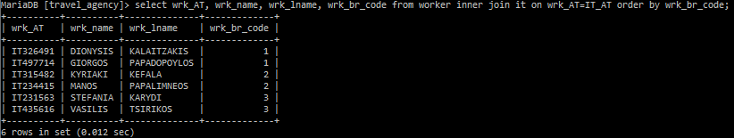

**Οι IT που θα ασχολούνται με τα insert είναι οι “GIORGOS PAPADOPOYLOS IT497714”(branch 1), “MANOS PAPLIMNEOS IT234415”(branch 2), “VASILIS TSIRIKOS IT435616”(branch 3).**

**Οι IT που θα ασχολούνται με τα update και delete είναι οι “DIONYSIS KALAITZAKIS IT326491”(branch 1), “KYRIAKI KEFALA IT315482”(branch 2), “STEFANIA KARYDI IT231563”(branch 3).**

**Παραδοχή 2: Ο πίνακας destination δεν συνδέεται με τον πίνακα trip αν δεν υπάρχουν δεδομένα στον πίνακα travel_to. Οπότε κάναμε την παραδοχή ότι κάθε καινούργιο destination θα εισάγεται από τον IT του branch 1 και οι αντίστοιχες αναβαθμίσεις ή διαγραφές θα γίνονται από το branch που ανέλαβε τελικά αυτό το ταξίδι. Επίσης αν κάποιο destination χρειάζεται αναβάθμιση ή διαγραφή και δεν αντιστοιχίζεται με κάποιο travel_to, η ενέργεια θα γίνεται από τον IT του branch 1.**

**Παραδείγματα για τον πίνακα trip:**

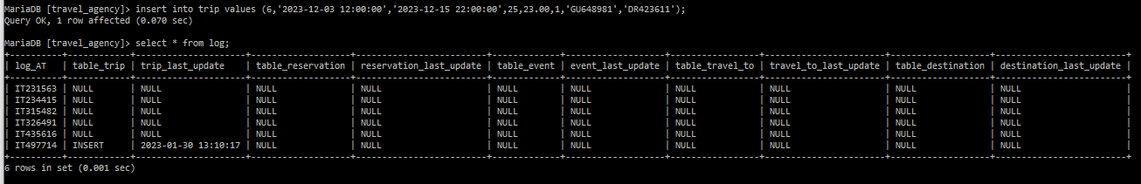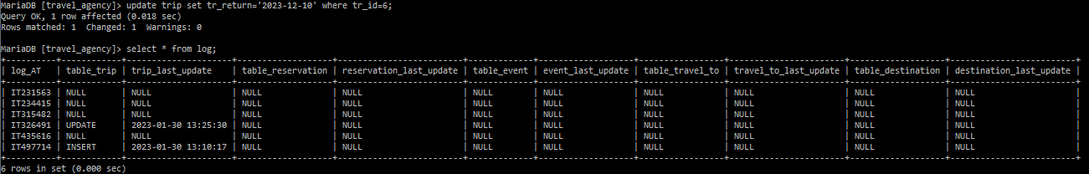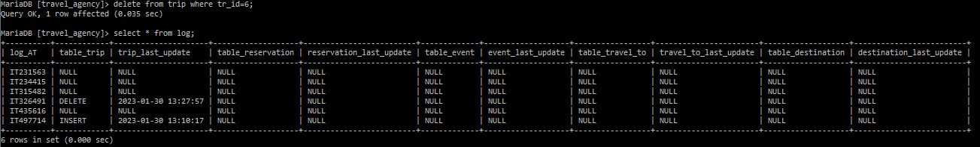

**Παραδείγματα για τον πίνακα reservation:**

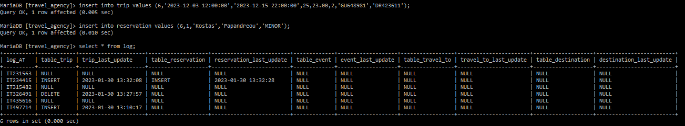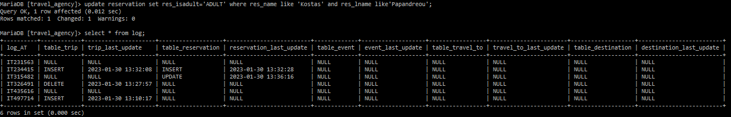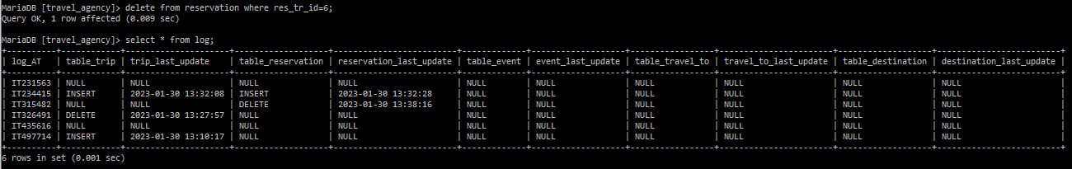

**Παρόμοια θα είναι τα αποτελέσματα και για τις στήλες που αφορούν τους πίνακες event και travel_to.**

**Παραδείγματα για τον πίνακα destination χωρίς σύνδεση με τον πίνακα travel_to:**

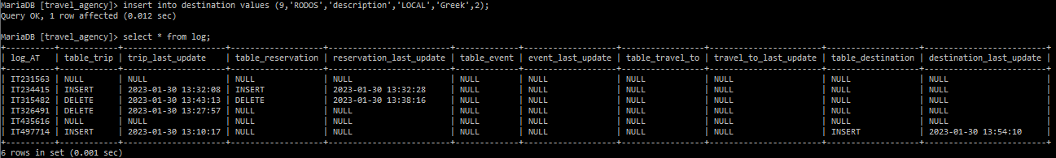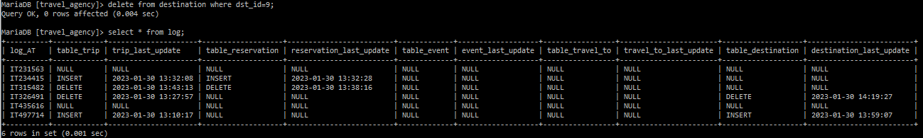

**Παραδείγματα για τον πίνακα destination με σύνδεση με τον πίνακα travel_to:**

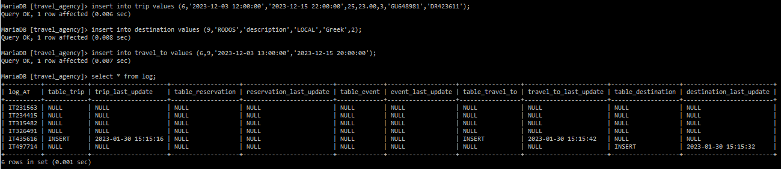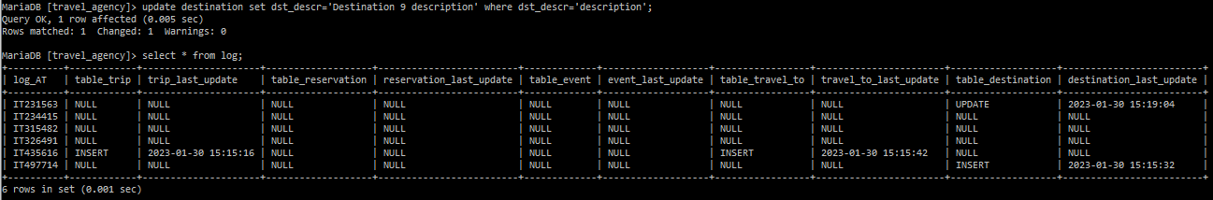

**3.1.4.2**

**Κώδικας για αποτροπή διαγραφής ημερομηνίας αναχώρησης και επιστροφής και κόστους:**

DROP TRIGGER IF EXISTS prevent_trip_update;

DELIMITER $

CREATE TRIGGER prevent_trip_update

BEFORE UPDATE ON trip

FOR EACH ROW

BEGIN

DECLARE tr_res INT;

SELECT count(*) INTO tr_res

FROM reservation INNER JOIN trip

ON res_tr_id=tr_id WHERE tr_id=old.tr_id;

IF(old.tr_departure!=new.tr_departure) THEN

IF(tr_res>0) THEN

SIGNAL SQLSTATE VALUE '45000'

SET MESSAGE_TEXT ='Cannot change departure because there are already reservations for this trip.';

END IF;

END IF;

IF(old.tr_return!=new.tr_return) THEN

IF(tr_res>0) THEN

SIGNAL SQLSTATE VALUE '45000'

SET MESSAGE_TEXT ='Cannot change return because there are already reservations for this trip.';

END IF;

END IF;

IF(old.tr_cost!=new.tr_cost) THEN

IF(tr_res>0) THEN

SIGNAL SQLSTATE VALUE '45000'

SET MESSAGE_TEXT ='Cannot change cost because there are already reservations for this trip.';

END IF;

END IF;

END$

DELIMITER ;

**Πίνακας trip:**

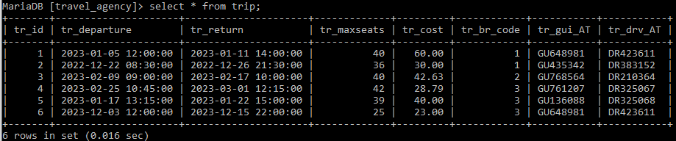

**Αριθμός κρατήσεων ανά ταξίδι:**

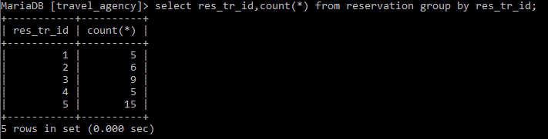

**Παράδειγμα για αλλαγή κόστους ή ημερομηνίας επιστροφής σε ταξίδι που έχει κρατήσεις:**



**Παράδειγμα για αλλαγή μεγίστων θέσεων σε ταξίδι που έχει κρατήσεις:**

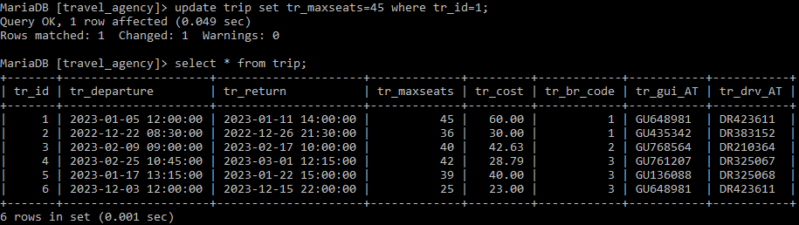

**Παράδειγμα για αλλαγή κόστους ή ημερομηνίας επιστροφής σε ταξίδι που δεν έχει κρατήσεις:**

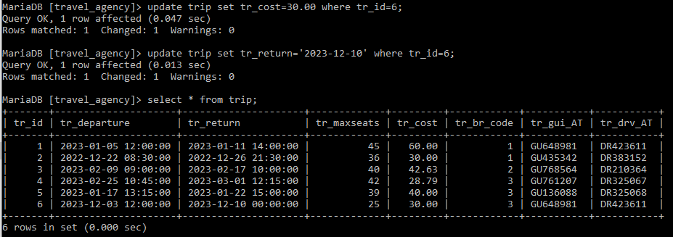

**3.1.4.3**

**Κώδικας για αποτροπή μείωσης μισθού:**

DROP TRIGGER IF EXISTS prevent_salary_decrease;

DELIMITER $

CREATE TRIGGER prevent_salary_decrease

BEFORE UPDATE ON worker

FOR EACH ROW

BEGIN

IF(new.wrk_salary<old.wrk_salary) THEN

SIGNAL SQLSTATE VALUE '45000'

SET MESSAGE_TEXT ='Cannot lower salary of worker.';

END IF;

END$

DELIMITER ;

**Πίνακας worker:**

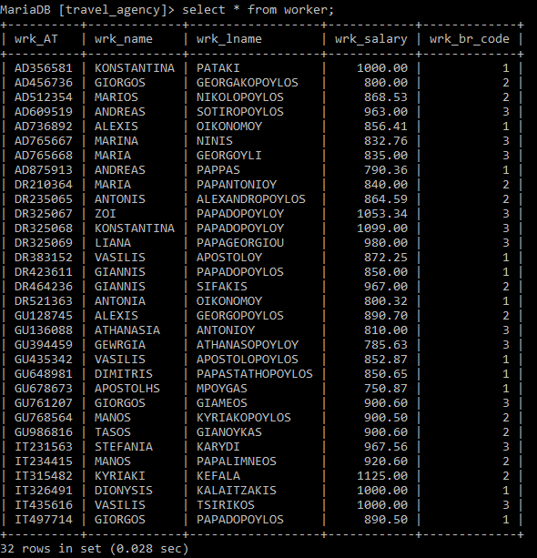

**Παράδειγμα για προσπάθεια μείωσης μισθού:**



**Παράδειγμα για προσπάθεια αύξησης μισθού:**

