Category

* Request Access to AWS
* Setup Soft Token
* Request Access to Github
* Access Amazon SageMaker
* Amazon SageMaker Overview

Request Access to AWS

<https://confluence.service.anz/display/EDA/Data+Tools>

Click Request Access to AWS

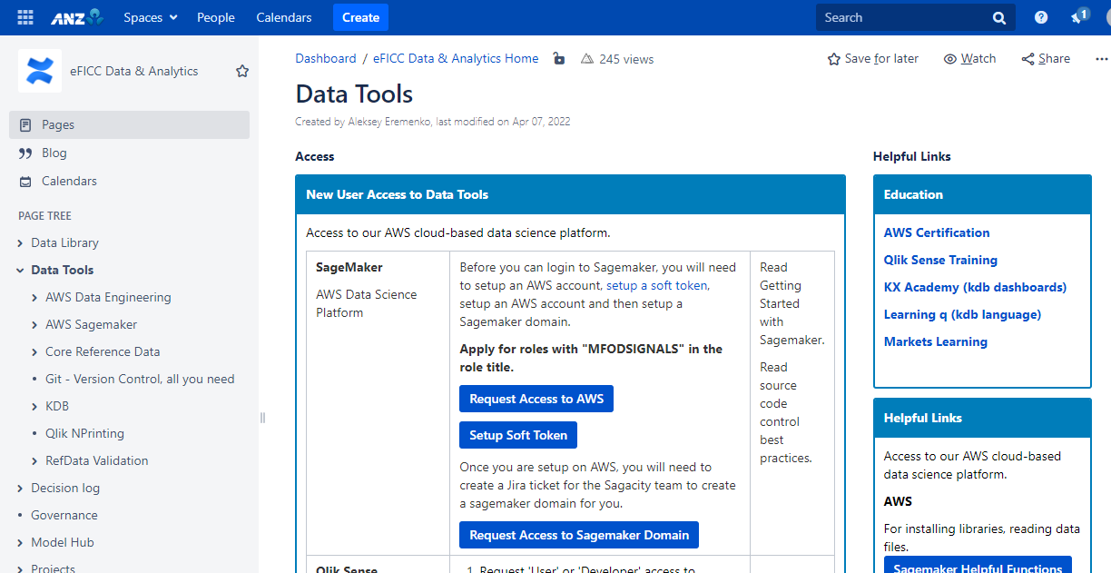

Click the Request Form link

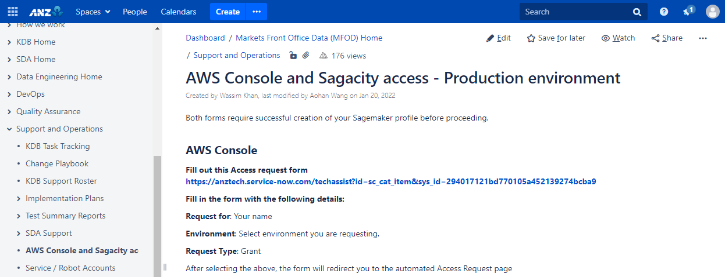

Fill in your information. Environment: **production** Request Type: **Grant**

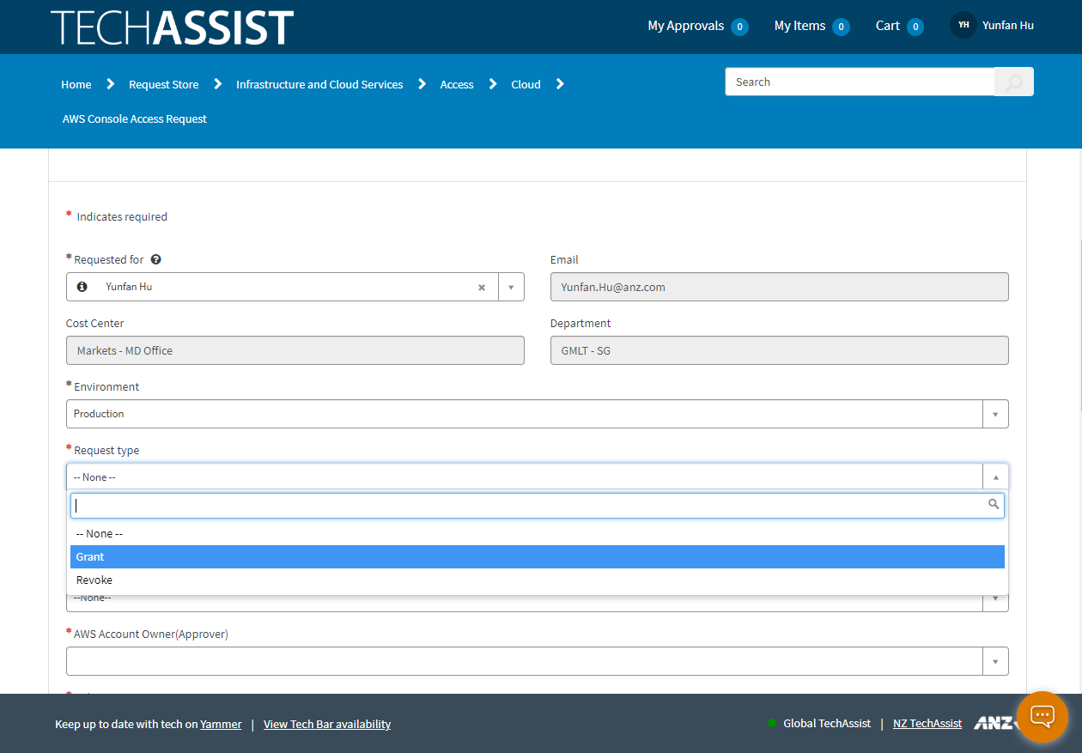

Click **Leave**

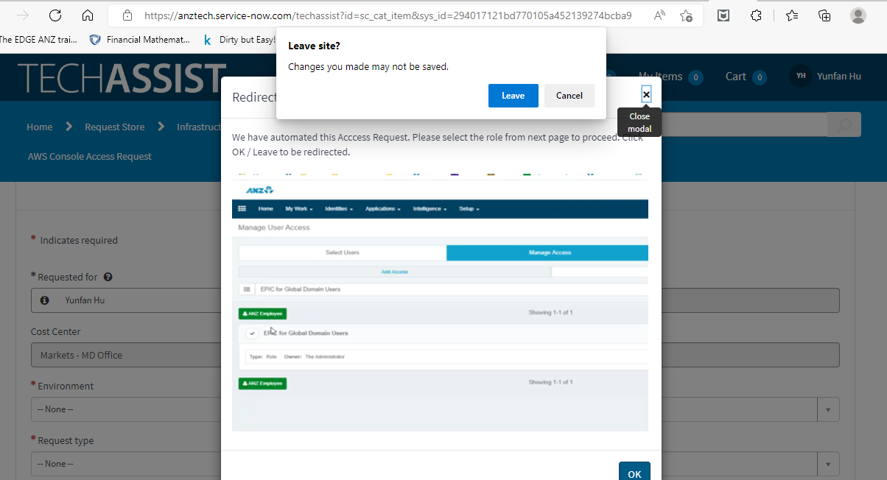

Click **Manage Access** and **Manage My Access**

Search [Global AWS 3.0 MFOD WorkloadMfodDataScienceRole on Active Directory - Global](https://user.iiq.service.anz/identityiq/identityRequest/identityRequest.jsf)

[ I applied a lot of roles and this is the only one get granted, maybe you can get different roles according to your position, please check with Aleksey]

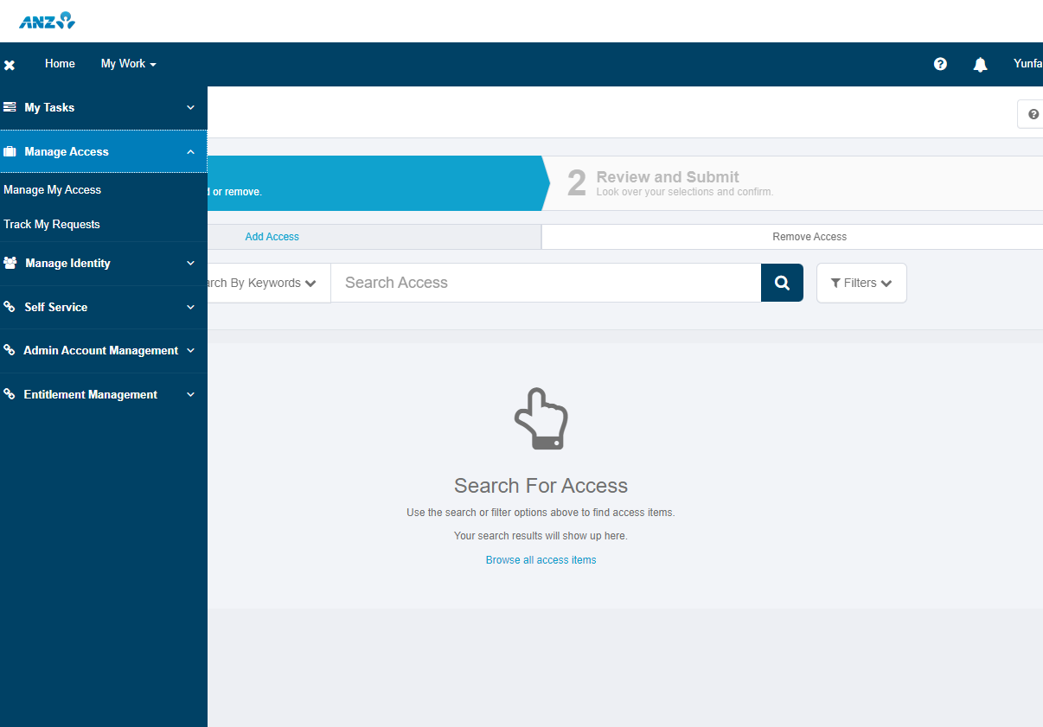

Tick the role and click “Next” -> “Submit”  [Finish]

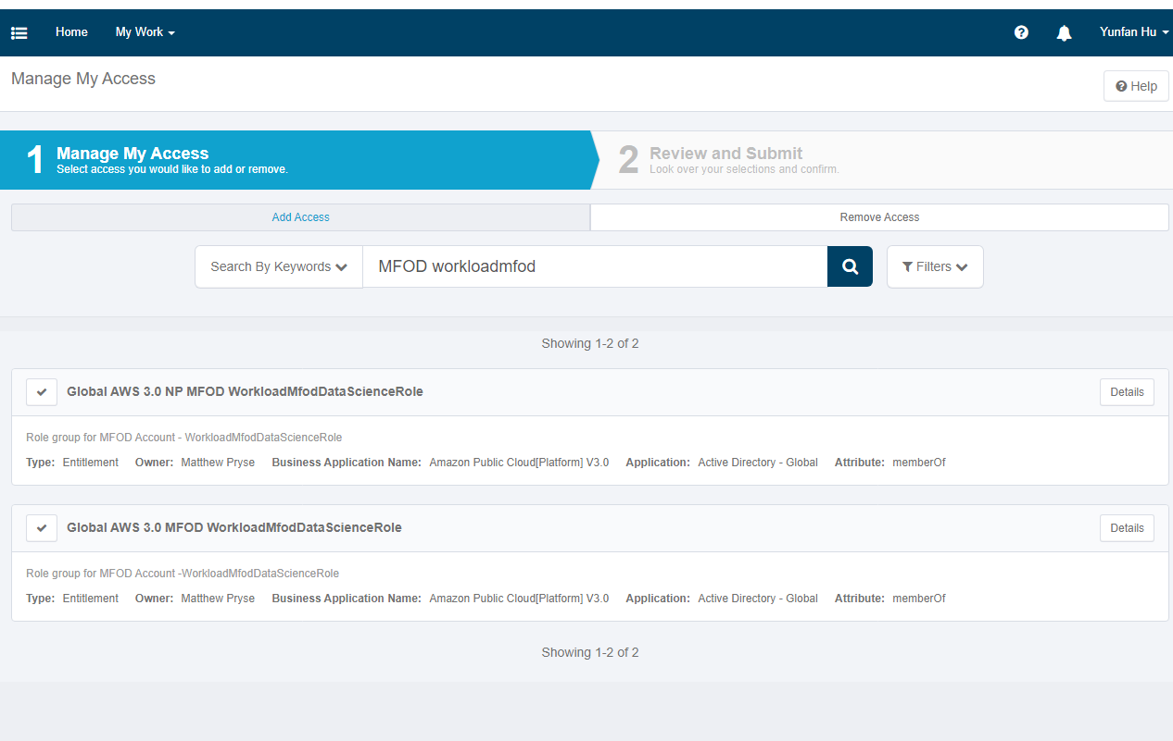

Soft Token Setup

Click **Setup Soft Token** and there’s a guide in it.

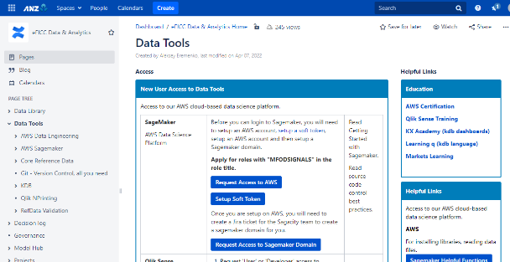

Request Access to Github

<https://anztech.service-now.com/techassist?id=sc_cat_item&sys_id=241fbfe6db6ac894433fe4e38a961991&sysparm_category=831a7cbbdb0fb2007afcde01ce961904&catalog_id=-1>

Same process as apply for AWS. Click **GITHUB – Application Access – Global**

Request to be added to the Fixed Income Organization

Detail instructions see link

<https://confluence.service.anz/display/MFD/New+Starter+Onboarding>

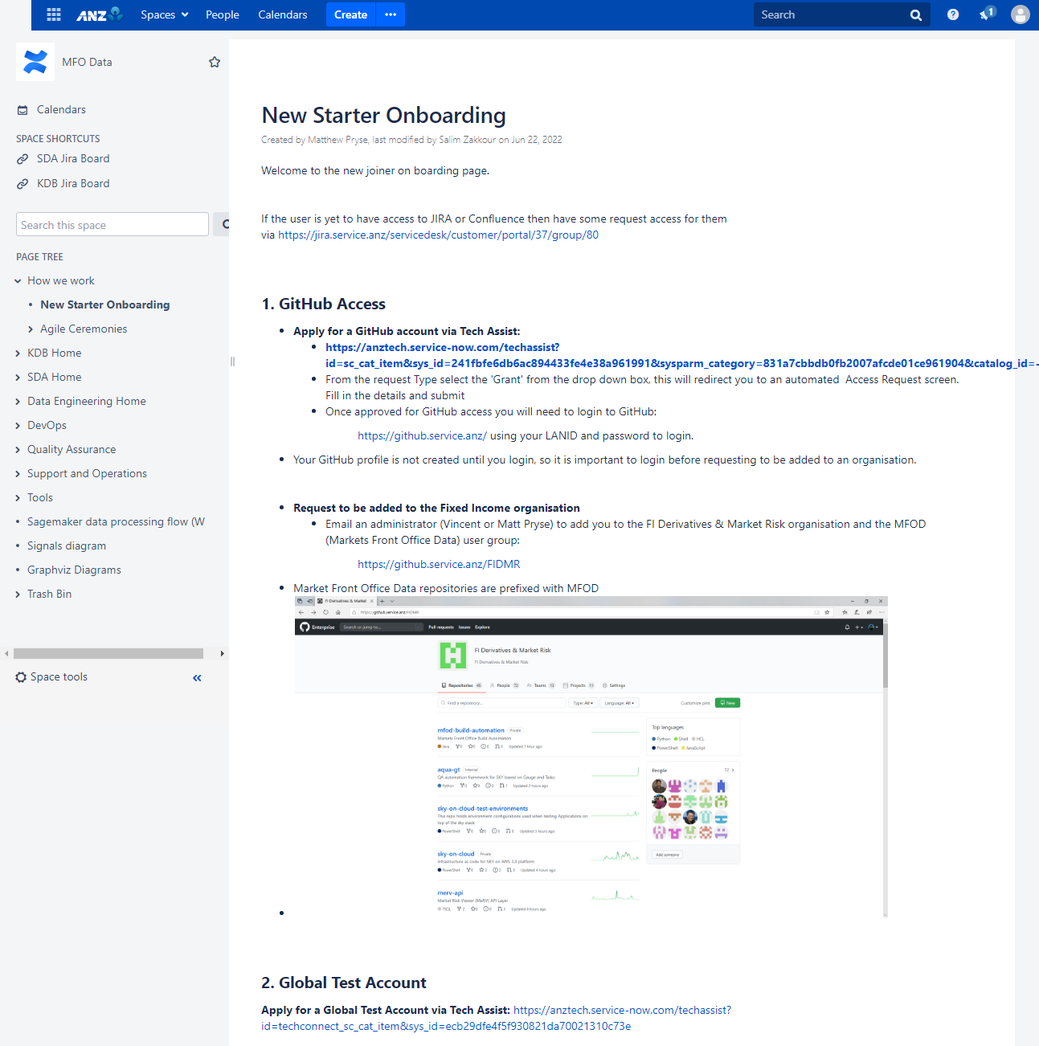

Search **RateTradingModelGUI** in the search bar

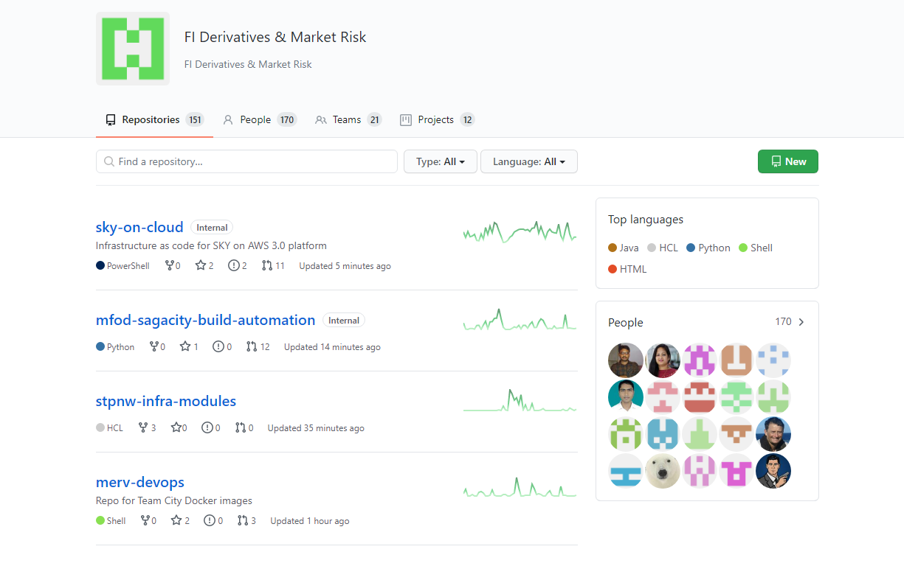

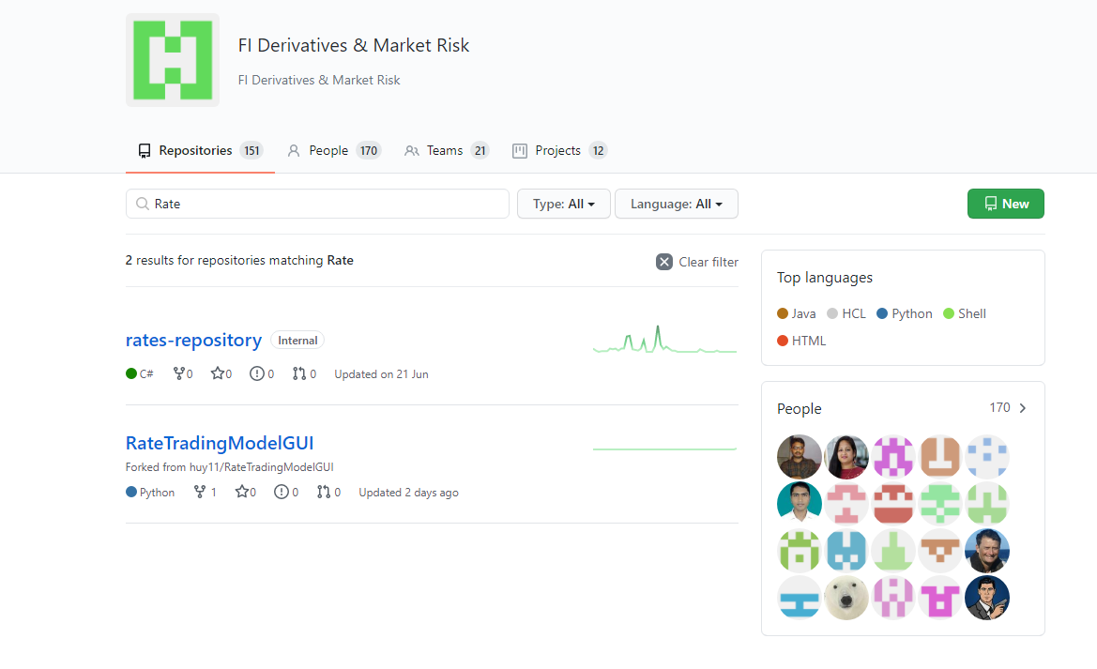

Then you can clone the files by copy this link or download as ZIP to your PC. 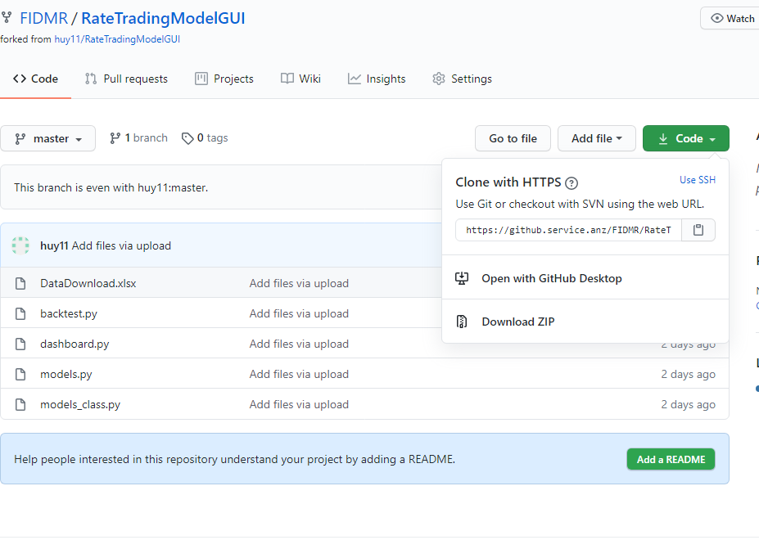

Access Amazon SageMaker

<https://confluence.service.anz/pages/viewpage.action?spaceKey=MFD&title=Tools>

Find **AWS** in Tool column and choose **AWS Login Console Non-Production**

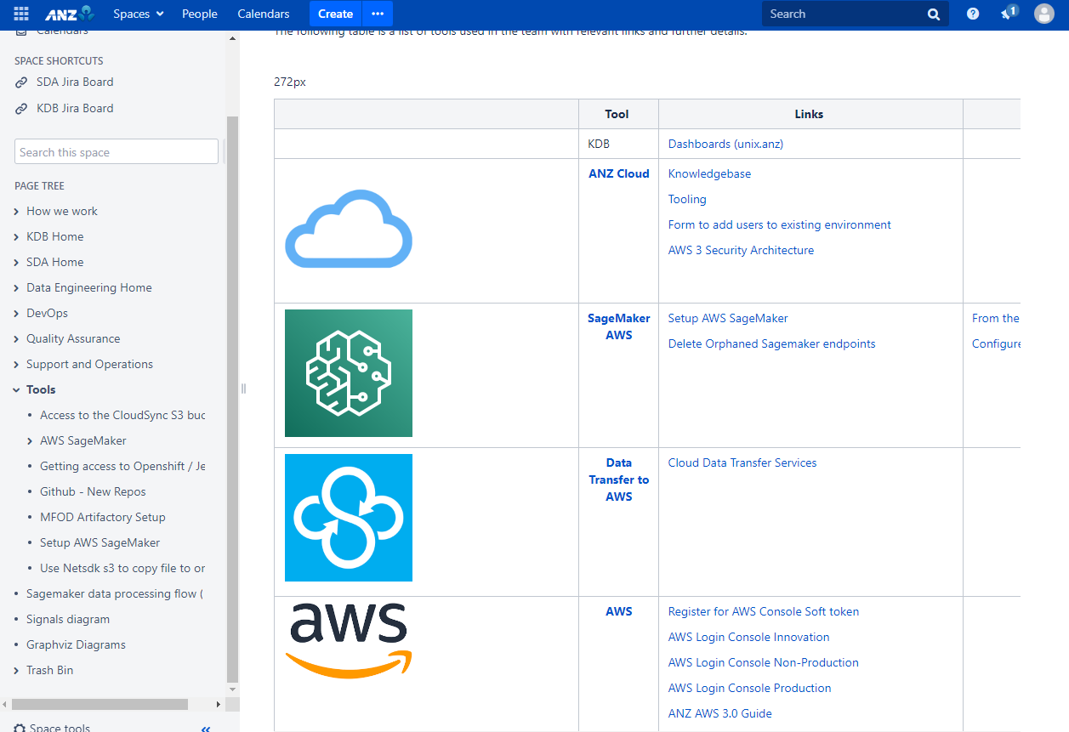

Enter the Passcode **(4 digit PIN you set + 6 digit token on your phone)** 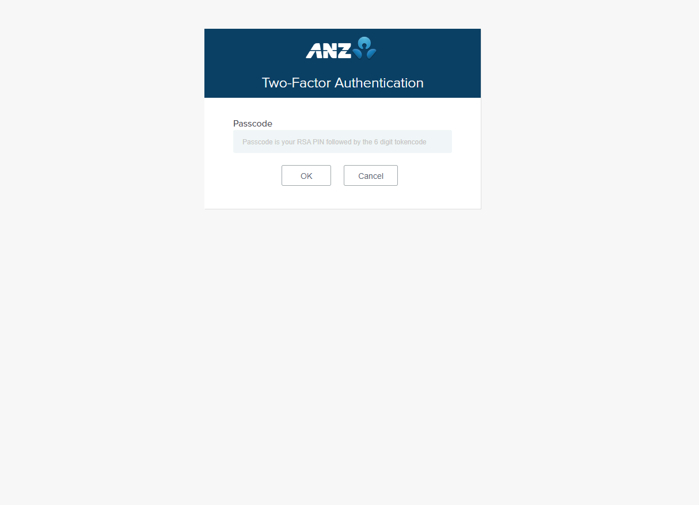

Change the time zone to **Sydney**.

Search **Amazon SageMaker** in the bar.

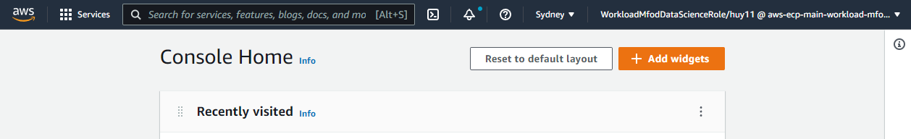

Click **Studio** in Control panel and click **Launch SageMaker Studio**

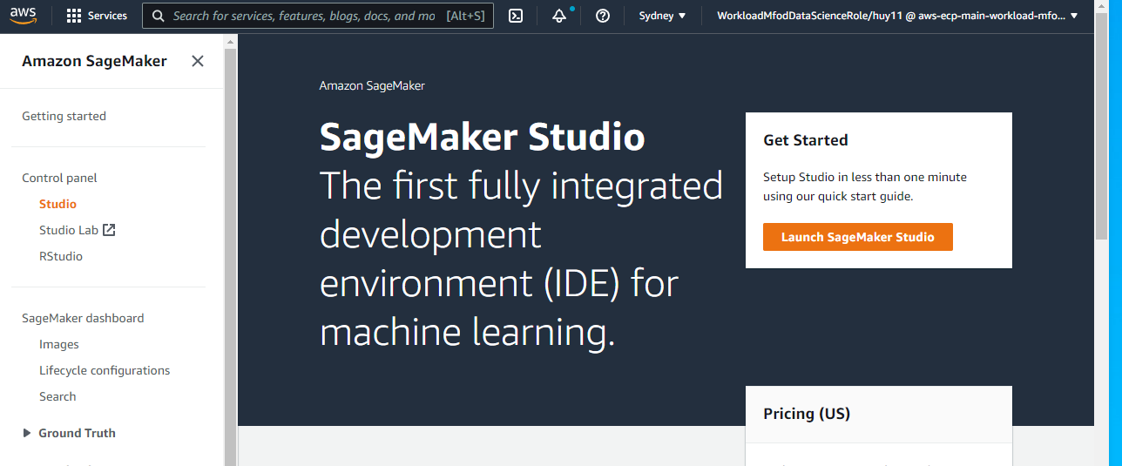

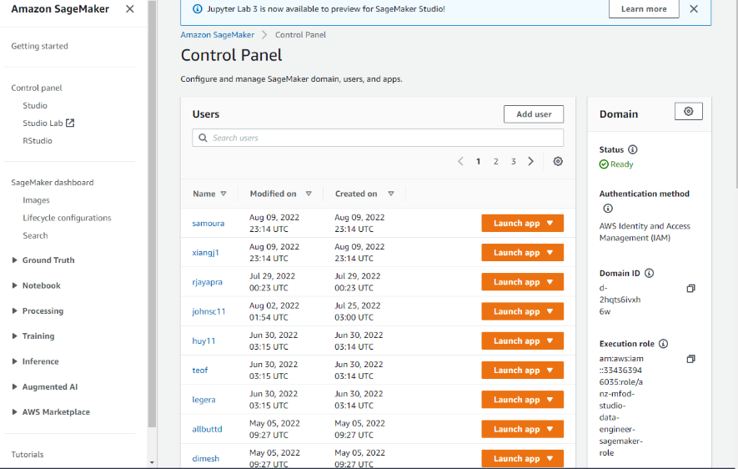Find your **Name** and **launch app**

Amazon SageMaker Studio Overview

Explanations about UI in studio please see link

https://docs.aws.amazon.com/sagemaker/latest/dg/studio-ui.html