Category

* Dashboard Guide
* Files
* Warning Page
* GUI (ipywidgets)
* Plotly

Files

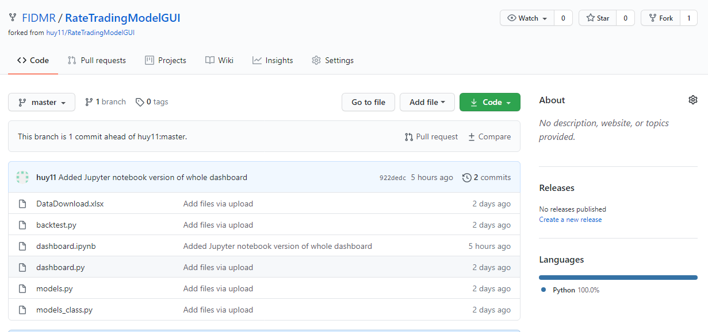

**DataDownload.xlsx**

This is the dataset of SOFR swap rates

**Dashboard.ipynb**

Combine all codes in four py files to compile in jupyter notebook. Only use this file when running the dashboard.

**Dashboard.py**

Widgets of add/remove models and scenarios, calling backtest, plot graphs

**Backtest.py**

Data cleaning, get target and hedge data from dataset, call model and return results

**Models.py**

PCA, costumed linear regression model (cost functions)

**Models_class.py**

Get parameter values from Model section and Scenario section in dashboard

**detail explanation please see comments in files

Dashboard Guide

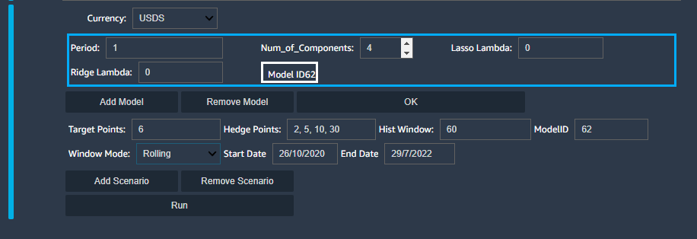

**Model Section**

**Period**: number of day you want to use for testing in a rolling window

**Num_of_Components**: number of principle components you want to use in PCA.

**Lasso Lambda**: $λ_{1}|\sum_{i=0}^{n}{β}-1|$

**Ridge Lambda**: $λ_{2}\sum_{i=0}^{n}{{β_{i}}^{2}}$

**Scenario Section**

**Target Point:** The year you want to hedge

**Hedge Points:** The liquid points you want to use for hedge

**Hist Window:** The length of time you want to use as a model training window

**ModelID:** Select the model you want to use

**Window Mode:** Rolling: Train with 60 days and test with the day after 60 days. Selected Window: regress with data between start date and end date.

**Start Date / End Date:** Set a time range for Selected Window

WARNING PAGE

**The dashboard is still in testing stage, below is the bugs found during testing. Please avoid those operations when you are using the dashboard.**

1. Please do not add Scenarios that don’t have the same Historical Window length at the same time. It will cause error because Plotly cannot plot multiple datasets that don’t have same length on the same graph.
2. Please do not add Models that don’t have the period number at the same time also. Same as reason in 1.

GUI (ipywidgets)

https://ipywidgets.readthedocs.io/en/latest/examples/Widget%20List.html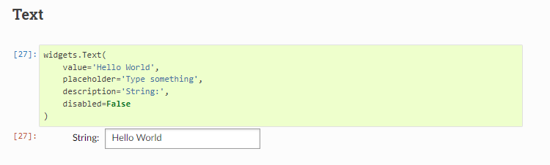

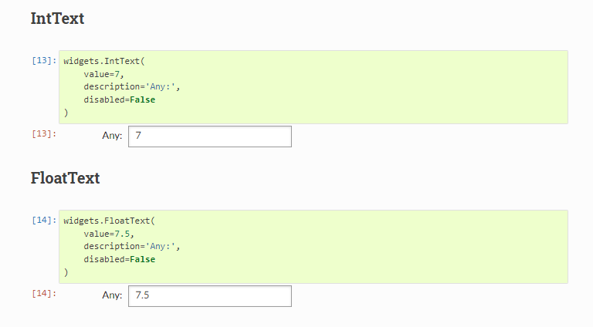

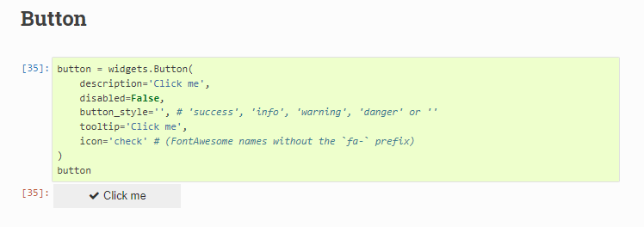

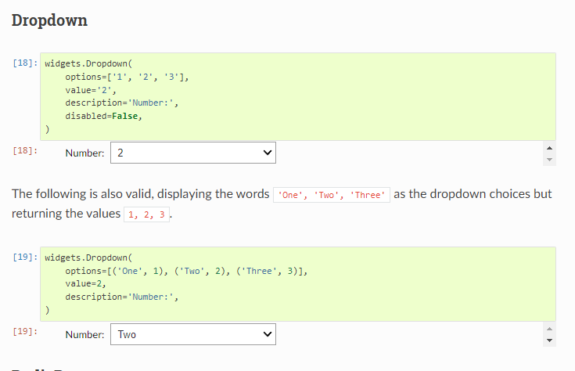

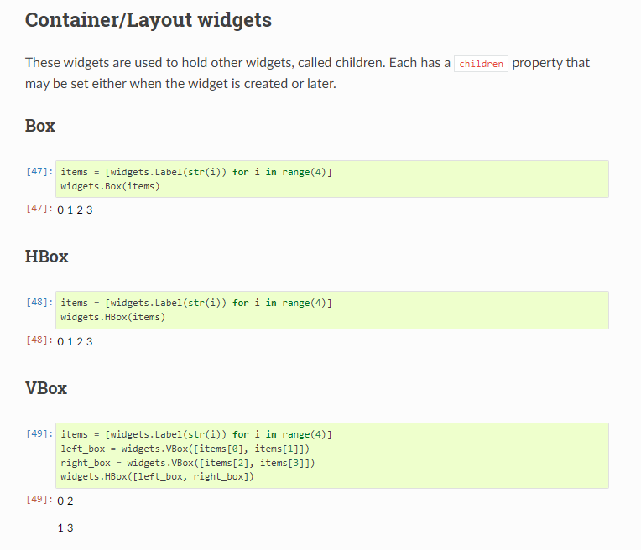

**Plotly**

Plot a table

<https://plotly.com/python/table/>

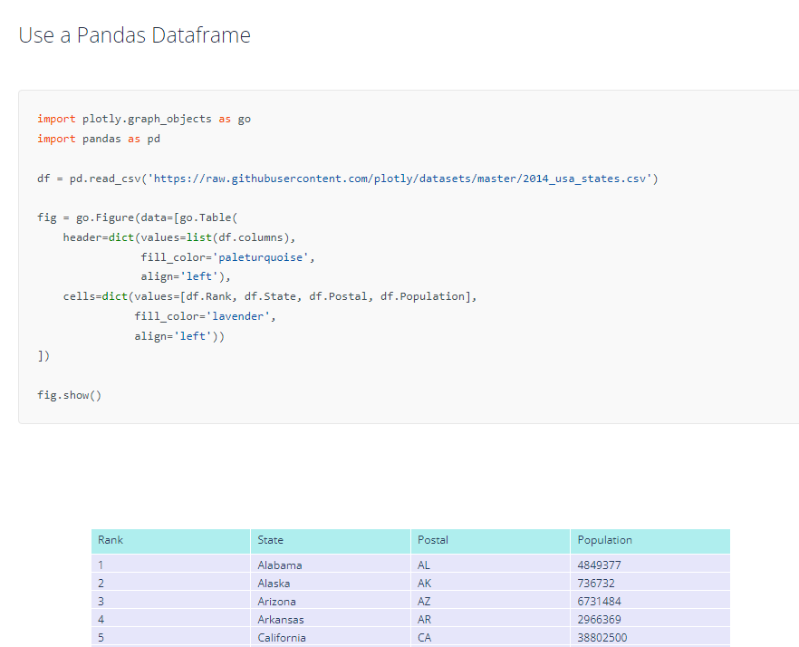

Plot a graph

<https://plotly.com/python/line-charts/>

