

**Microcontrollers- Gas Detection using PIC Microcontroller and MQ Gas Sensors**

**Dr.Raed qadi.**

**Tassneem Abu Alrob**

**11923952**

**Alaa Yamak**

**11923556**

* Introduction:

in this experiment we used MQ series Gas sensors "are very common types of sensors used in Gas Detectors to detect or measure certain types of Gases. These sensors are widely used in all Gas related devices like from simple Smoke Detectors to Industrial Air Quality Monitors. We have already used these MQ gas sensors with Arduino to measure some harmful gases like Ammonia."

and these sensors used to with PIC Microcontrollers, to measure the PPM value of the gas and display it on a 16x2 LCD.

* The Problem:

When you install a gas detection system, you can continuously monitor the dangers in your environment. This becomes vital in the right commercial or industrial setting, where you have the potential for hazards everywhere. In addition to purchasing a gas detection system, a risk assessment will normally be required to uncover the threats in both the unmanned and manned areas.

With a gas detection system, you can reduce the amount of time it takes for an assessment because you do not have to manually monitor the potential for explosion in the area. This will cut down on the number of hours spent over labor, and ultimately, that means saving money on the expenses.

* Tools and Equipment:

To design the solution, we needed a set of electronic tools, which are:

* MQ series sensor

**has a heating element and a sensing resistance. Depending on the concentration of the gas, the sensing resistance gets changed and by detecting the changing resistance.**

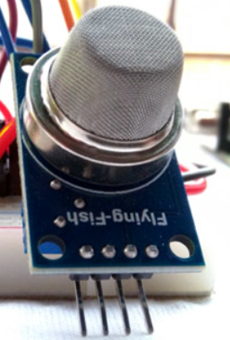

**Used to display on it ,”there is gas or non”**

* LCD

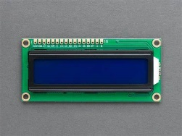

* capacitor

**Its main element in basic circuit.**



* 20Mhz crystal

**Also its an element in basic circuit.**

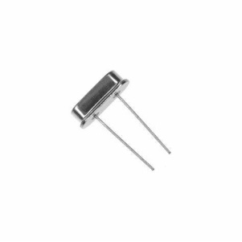

* PIC18 A microcontroller

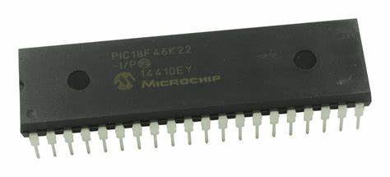

* Resistors

**Resistors are used for protection in the circuit, 1k resistor,** **4.7k resistor**

**content_copy**

**share**

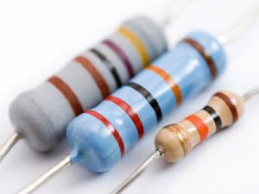

* LED

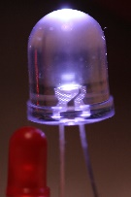

**LED to indicate gas function.**

* wires.

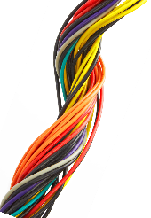

* Design Solution:

To build this circuit we traced this **Schematic**:

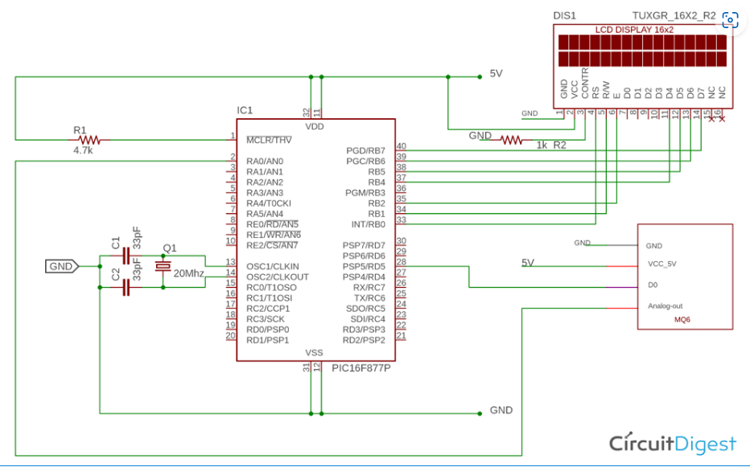

**The principle of operation of the amplifier in this circuit:**

1. Firstly, we connected the D0 the digital input with pin (B0)from port B in basic circuit.
2. The working mechanism in general is a continuation of the main circuit that was completed in the first part, in addition to a gas sensor, which senses the presence of gas when the lighter is brought close to it and thus appears as outputs on the LCD screen, whether there is gas or not, in addition to another output that is a light led

* Result:

The main electronic piece in this experiment is the gas sensor:” **MQ6 sensor”, that** interfacing with the microcontroller unit.

Pin 1 is VCC, Pin 2 is the GND, Pin 3 is the Digital out (Logic low when gas is detected.) and Pin 4 is the Analog output. The pot is used to adjust the sensitivity.

Therefore, if there is gas using the lighter, for example, near the sensor, it will sense its presence, interact with the pic, and display the output on the LCD