HealthAI: Intelligent Healthcare Assistant using IBM Granite

Team Members:

Tata .Geethika - 22HU1A4296

Thota. Pujitha -22HU1A42A4

Tadisetty . Akhila -22HU1A4293

Thota. Anuradha -22HU1A42A3

Thota. Jyothi -22HU1A42A2

Faculty Mentor: Manoj

# 1. Introduction

HealthAI is a smart healthcare chatbot assistant powered by IBM Granite, a state-of-the-art language model. This project aims to offer quick and reliable responses to health-related queries, simulate human-like medical consultation, and support users with medical insights through a web interface.

# 2. Tools & Technologies

- IBM Granite (LLM API from IBM watsonx.ai)  
- Python 3, Flask  
- HTML, CSS, JavaScript (AJAX)  
- VS Code  
- Replit / Render for deployment

# 3. Technical Architecture

The system consists of a frontend interface (HTML/CSS/JS) where the user types a query. The backend is a Flask server that sends the user query to the IBM Granite model via

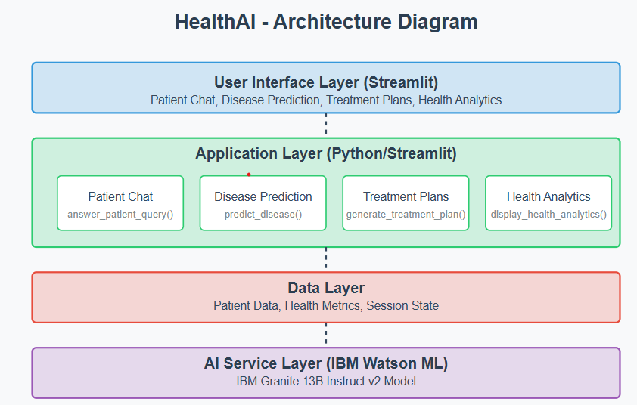

OpenAI-compatible API, fetches the response, and returns it to the user in real time.

# 4. Modules Implemented

- Model Selection and Architecture: IBM Granite 13B Chat model is used.  
- Core Functionality: Text-based question-answering system.  
- Application Logic: Flask handles the API call and response formatting.  
- UI Design: Simple chat interface for end users.  
- Deployment: Easily deployable on platforms like Render or Replit.

# 5. Sample Code Snippet

Backend logic to query IBM Granite:

response = openai.ChatCompletion.create(  
 model="ibm/granite-13b-chat-v2",  
 messages=[  
 {"role": "system", "content": "You are a helpful medical assistant."},  
 {"role": "user", "content": user_input}  
 ]  
)

# 6. Output (Demo)

Screenshot from the web interface:

[Screenshot to be pasted here manually if needed]

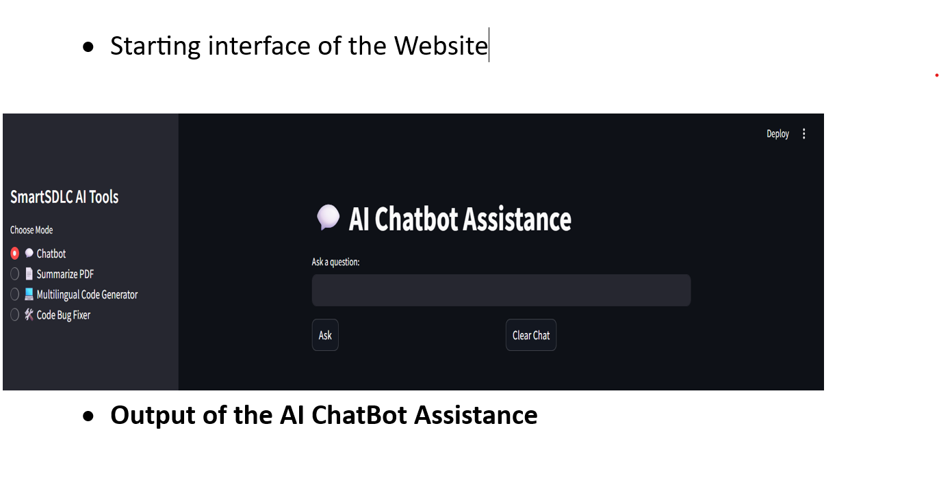

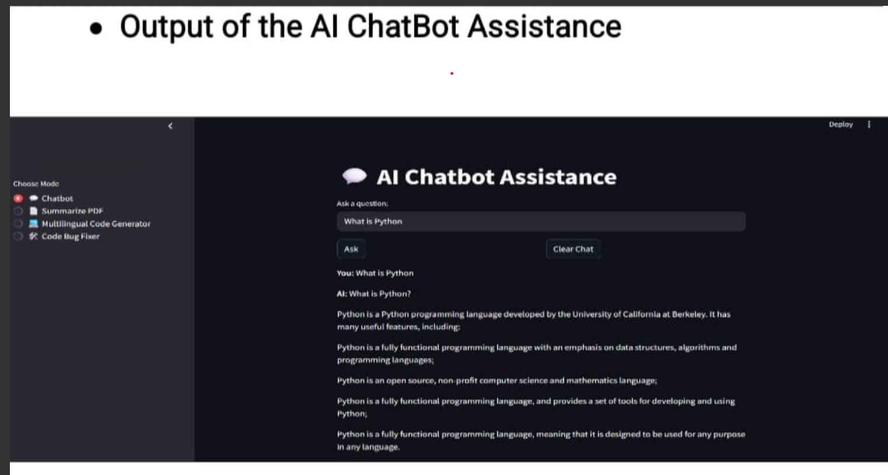

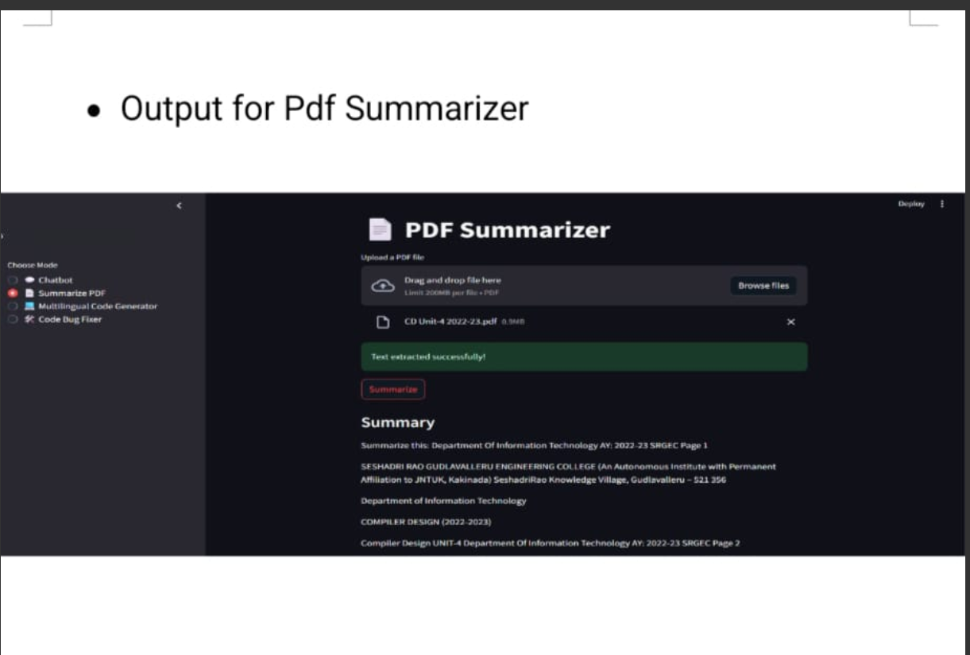

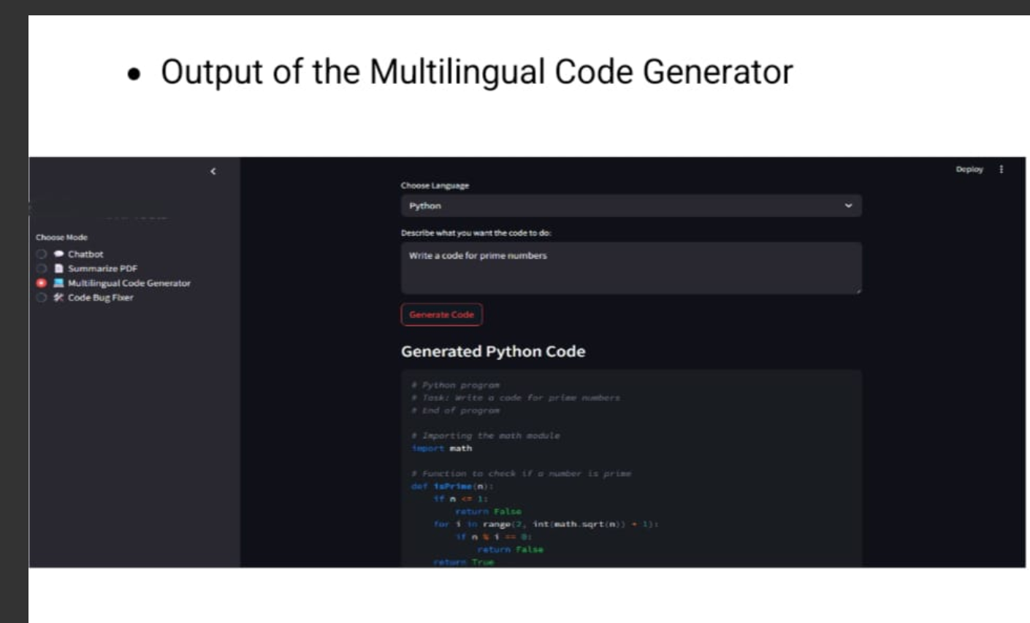

# 7.ADVANTAGES & DISADVANTAGE

Advantages:

* Fast AI health advice
* Easy to use interface
* Uses reliable IBM foundation models

Disadvantages:

* No real-time doctor verification- May need internet always
* Dependent on model accuracy

# 8. Conclusion

This project showcases how IBM can be used to develop intelligent assistants for healthcare and other domains. Future work may include integrating voice support and storing past queries for personalized experiences.

# 9.FUTURE SCOPE

* Add multilingual support
* Connect with telemedicine services
* Integrate voice input and wearable data

# 10.APPENDIX

* Source Code: Included
* Dataset Link: IBM cloud Model Documentation
* GitHub & Demo Link: GitHub.com/TataGeethika-dev/HealthAI