STUDY GUIDE
Satellite Remote Sensing of Atmospheric Composition
Trace gases • Aerosols • Radiative transfer • Retrieval theory
Version 2 — core-knowledge blocks, worked examples, Q&A and memory hooks
Đề cương ôn tập — 8 câu hỏi lý thuyết, có đáp án mẫu, phương trình và sơ đồ

How to use this guide
- Part A = core knowledge from the lectures (radiative transfer equation, photon budget, optical depth, line profiles, DOAS). Learn it first: every question reuses it.
- Part B = the 8 exam questions. Each chapter: question → model answer (English) → equations → figures → worked example → quick Q&A → memory hooks → exam checklist → Vietnamese summary.
- Part C = formula sheet and acronyms for the last-minute revision.
- The green box at the end of each chapter is a short Vietnamese summary for quick revision.
- Diagrams are simplified on purpose: they are the sketches you should be able to redraw by hand in the exam. Charts marked (schematic) are illustrative; Planck and Mie charts are computed from the real equations.
- Figures marked "Lecture slide" are your own class photos.

Contents

PART A — Core knowledge toolbox
From the lectures: radiative transfer, photon budget, optical depth, line profiles, DOAS
These blocks are used by almost every exam question. The concept map at the start of Part B shows where each block is reused.

A.1 The radiative transfer equation (lecture notation)
dI(ν̃)/dl = − k_ext(ν̃) · I(ν̃) + J(ν̃)
- I(ν̃) — spectral radiance at wavenumber ν̃ (cm⁻¹) along the path l towards the sensor.
- k_ext(ν̃) — extinction coefficient (cm⁻¹ or km⁻¹): fraction of the beam removed per unit length.
- J(ν̃) — source function: everything that adds photons into the line of sight (thermal emission, scattering from other directions).
k_ext(ν̃) = α(ν̃)^gas + s(ν̃)^gas + α(ν̃)^aerosol + s(ν̃)^aerosol extinction = absorption + scattering
α = absorption coefficient, s = scattering coefficient. Gases contribute absorption lines/bands (α) and Rayleigh scattering (s); aerosols contribute both absorption and Mie scattering.
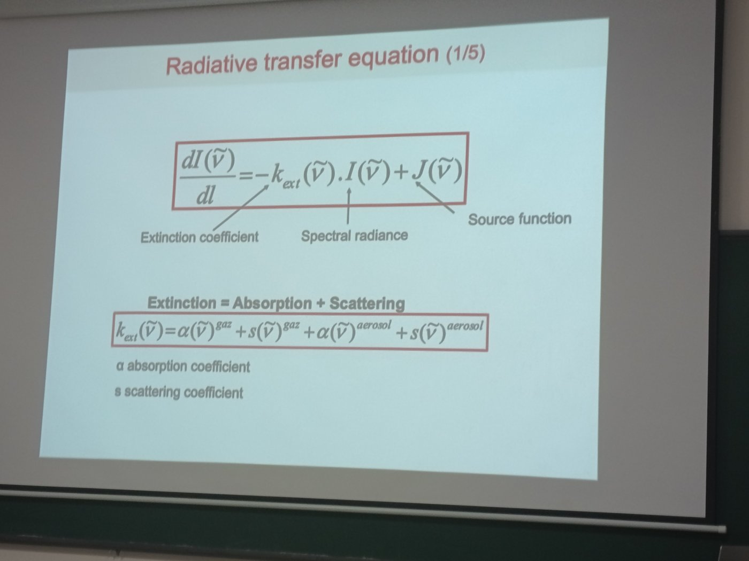
Figure 1 — Lecture slide: radiative transfer equation (1/5) — extinction = absorption + scattering, for gases and aerosols.

A.2 Photon budget along the line of sight: gains and losses
The RTE is the bookkeeping of photons on their way to the sensor (“radiative transfer budget: estimation of contributions and losses of photons to/from the line of sight”).
Process | Gain / loss | RTE term | Dominant where
Surface reflection into the line of sight | Gain | boundary: (1 − ε_s)·I_s | UV–SWIR, bright surfaces
Single scattering into the line of sight | Gain | J (scattering part) | UV–vis: Rayleigh, aerosols
Multiple scattering (≥ 2 events) | Gain | J (iterated) | clouds, thick aerosol, UV
Thermal emission (gas, particle, surface) | Gain | J = α·B(T); ε_s·B(T_s) | thermal IR, microwave
Absorption (atmosphere or surface) | Loss | − α·I | inside absorption bands
Scattering out of the field of view | Loss | − s·I | wherever molecules/particles scatter
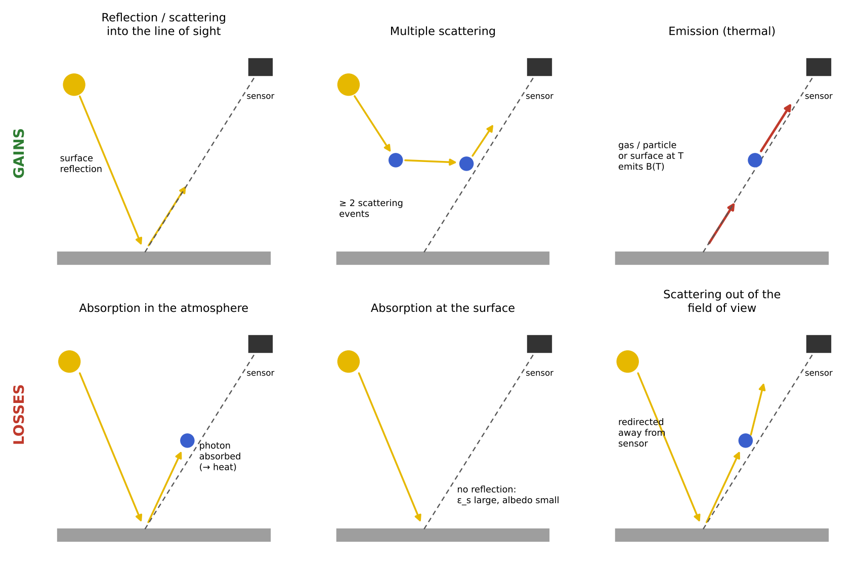
Figure 2 — Gains (top) and losses (bottom) of photons along the line of sight to the sensor.
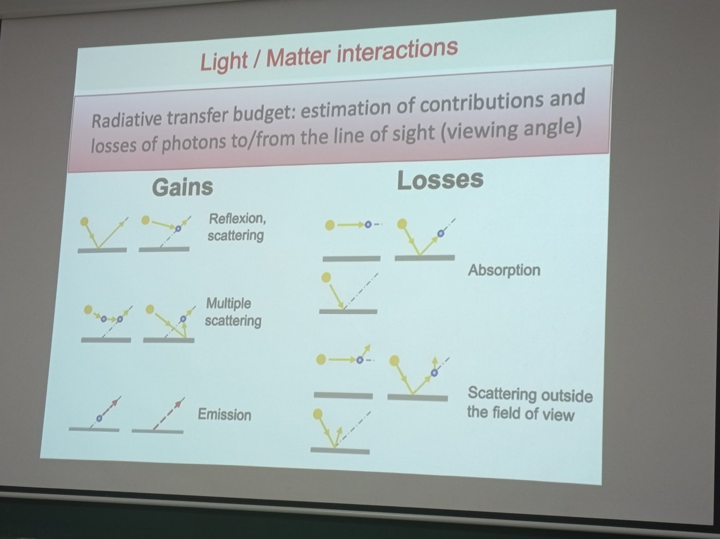
Figure 3 — Lecture slide: light/matter interactions — gains and losses.

A.3 A layer of gas without scattering (thermal infrared)
In local thermodynamic equilibrium and without scattering, the source function is the black-body emission weighted by absorption:
J(ν̃) = α(ν̃) · B(ν̃, T) emission coefficient = absorption coefficient (Kirchhoff)
I(ν̃,L) = I(ν̃,0)·e^(−τ(0,L)) + ∫₀^τ(0,L) B(ν̃, T(l))·e^(−τ(l,L)) dτ integrated RTE
τ_ν̃(l,L) = ∫ₗᴸ α_ν̃(l′) dl′ absorption optical depth from l to the sensor
- Term 1 — background (surface) radiance, attenuated by the whole layer.
- Term 2 — each slab dτ emits B(T(l)) and is attenuated by the gas between it and the sensor. The factor e^(−τ(l,L)) is what makes the weighting functions of Q3 and Q5.
- Surface boundary (blackboard): I(ν̃,0) = ε_s·B(ν̃,T_s) + (1 − ε_s)·I_s, with 0 ≤ ε_s ≤ 1. The term (1 − ε_s)·I_s is the surface reflection of solar (or downwelling) radiation, and 1 − ε_s = ω_s is the surface albedo.
- Limits: transparent gas (τ ≪ 1) → I ≈ I(0) + τ·B, a small emission added to the background; opaque gas (τ ≫ 1) → I ≈ B(T) of the top layers only: the sensor sees high altitudes (saturation).
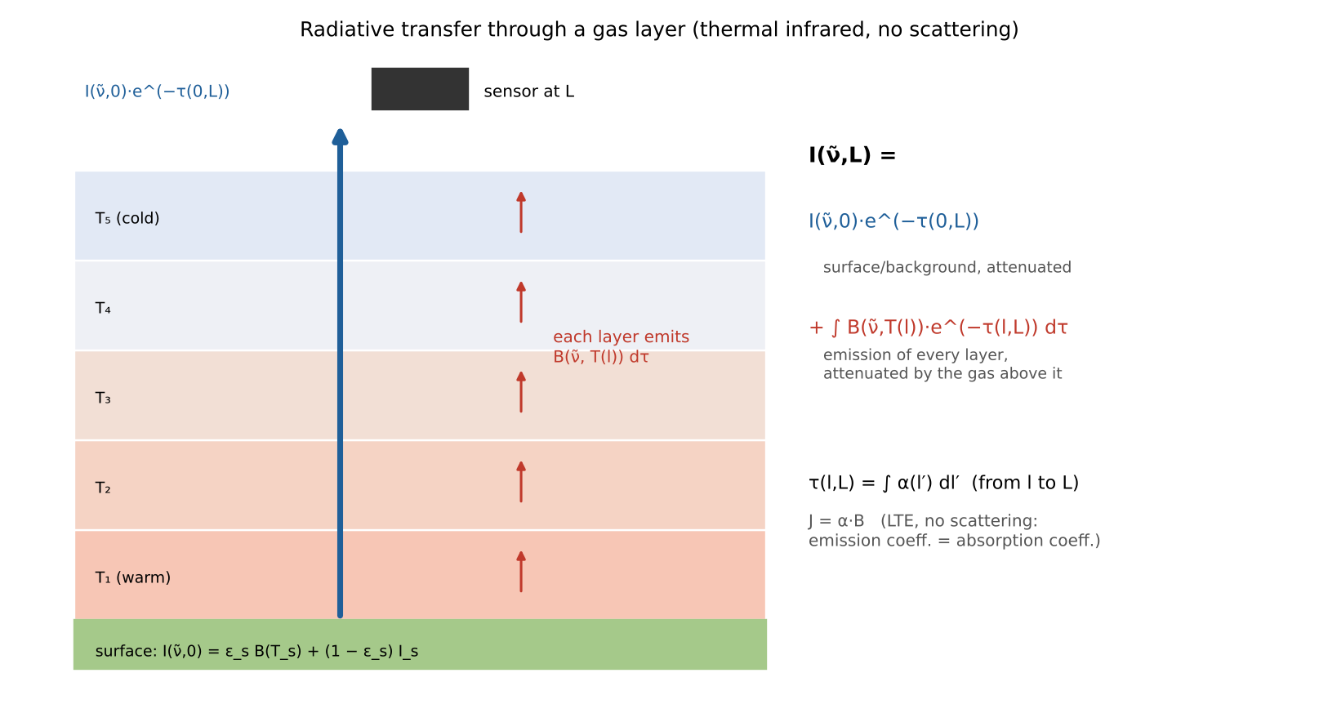
Figure 4 — Integrated RTE for a gas layer: attenuated background + emission of each layer.
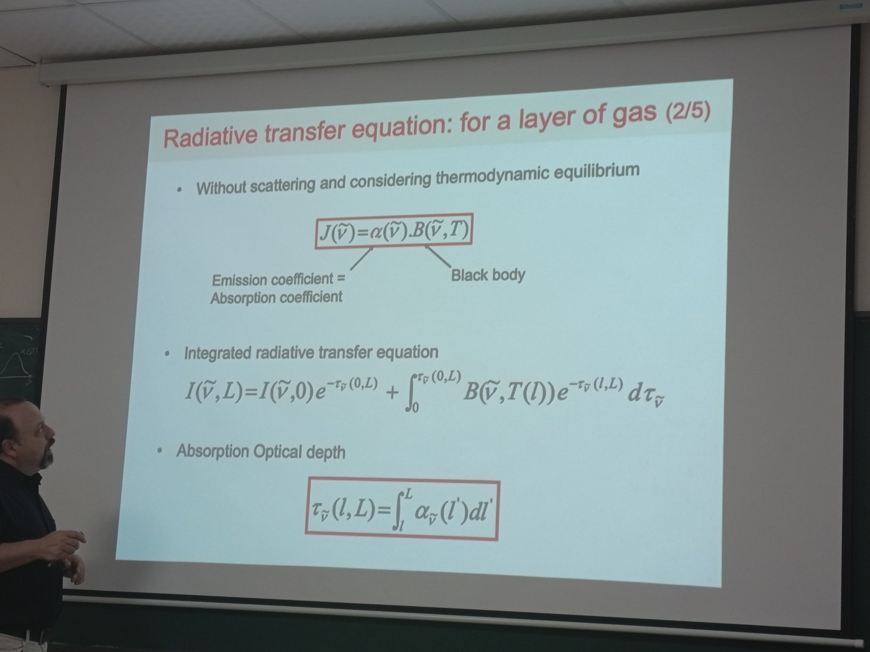
Figure 5 — Lecture slide: radiative transfer equation for a layer of gas (2/5).

A.4 Optical depth and spectroscopy
τ_ν̃(L) = Σᵢ ∫₀ᴸ σᵢ(ν̃, P(l), T(l)) · Nᵢ(l) dl continuous spectrum (UV–vis bands)
τ_ν̃(L) = Σᵢ Σⱼ ∫₀ᴸ kⁱ_ν̃ⱼ(T(l)) · Φ(ν̃ − ν̃ⱼ, P(l), T(l)) · Nᵢ(l) dl line spectrum (IR, microwave)
τᵢ = σᵢ · L · Nᵢ ; t = e^(−τ) ; τ = α·l = σ·N·l homogeneous layer
- σᵢ — absorption cross-section (cm² molecule⁻¹), known from laboratory spectroscopy (databases such as HITRAN).
- kⁱ_ν̃ⱼ — intensity of line j of species i (depends on T); Φ — line profile (shape, area normalised to 1).
- Nᵢ — number concentration of the absorber — is OUR GOAL (blackboard): σ comes from spectroscopy, L from geometry, so measuring τ gives N.
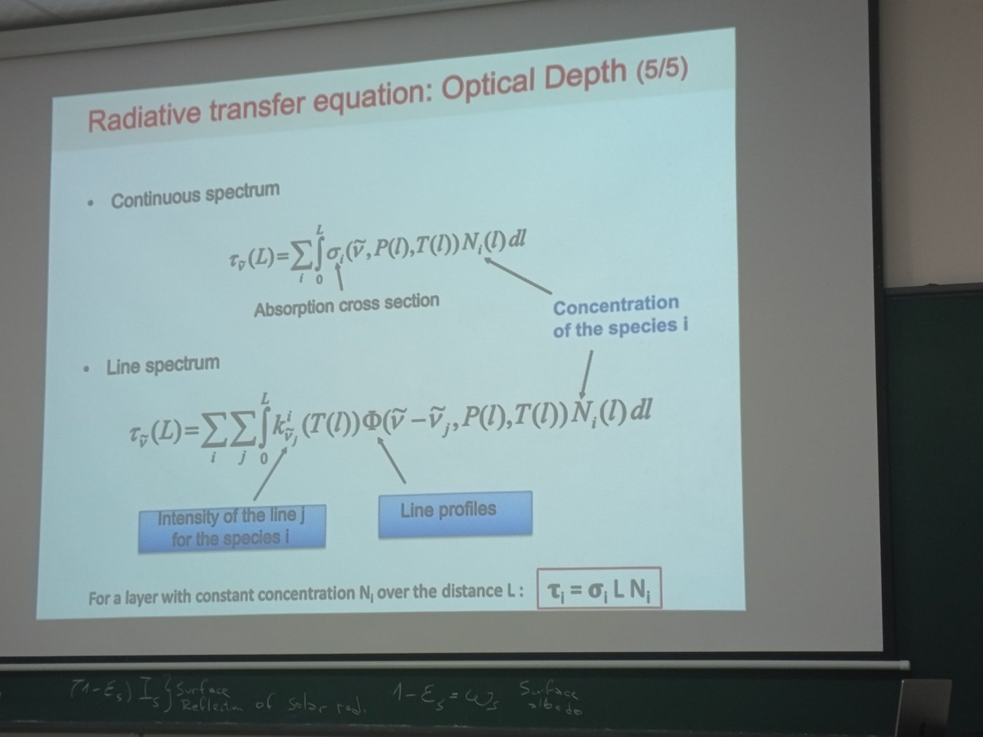
Figure 6 — Lecture slide: optical depth for continuous and line spectra (5/5).
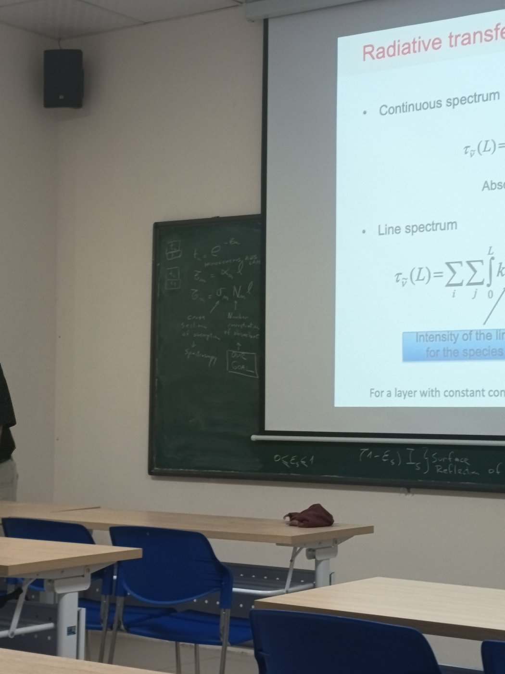
Figure 7 — Blackboard: t = e^(−τ), τ = α·l = σ·N·l — cross-section from spectroscopy, concentration N is the goal.

A.5 Line profiles as a function of altitude
- Doppler broadening (thermal motion, Gaussian): HWHM_D = (ν̃/c)·√(2 ln2·k_B·T/m). Depends on T only: ≈ 0.004 cm⁻¹ for CH₄ at 2927 cm⁻¹.
- Lorentz (pressure) broadening (collisions): HWHM_L = γ₀·(P/P₀)·(T₀/T)ⁿ, γ₀ ≈ 0.07 cm⁻¹ atm⁻¹. Proportional to pressure → ten times narrower every ~16 km.
- Voigt profile = convolution of both: Lorentz dominates in the troposphere, Doppler above ≈ 20–30 km.
- Key message (lecture): with known profiles of pressure and temperature, the variation of line widths with altitude gives information on the vertical distribution of the absorbing species. Line centre ↔ high altitudes, line wings ↔ low altitudes.
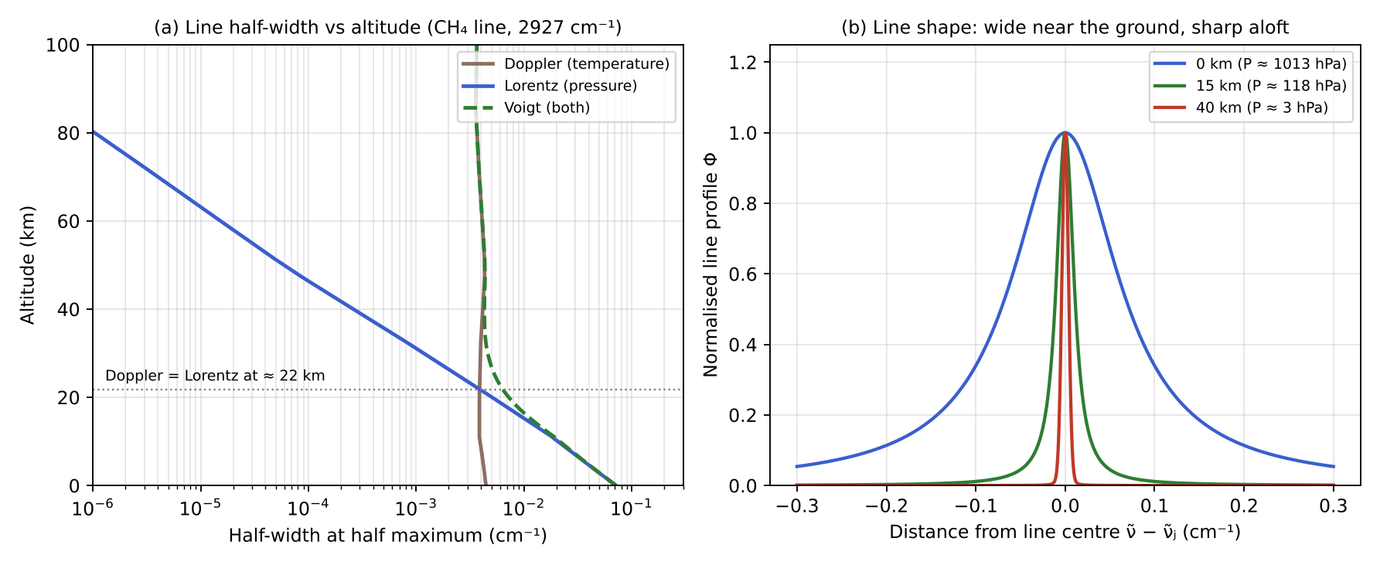
Figure 8 — Computed Doppler, Lorentz and Voigt half-widths vs altitude, and line shapes at 0, 15 and 40 km.
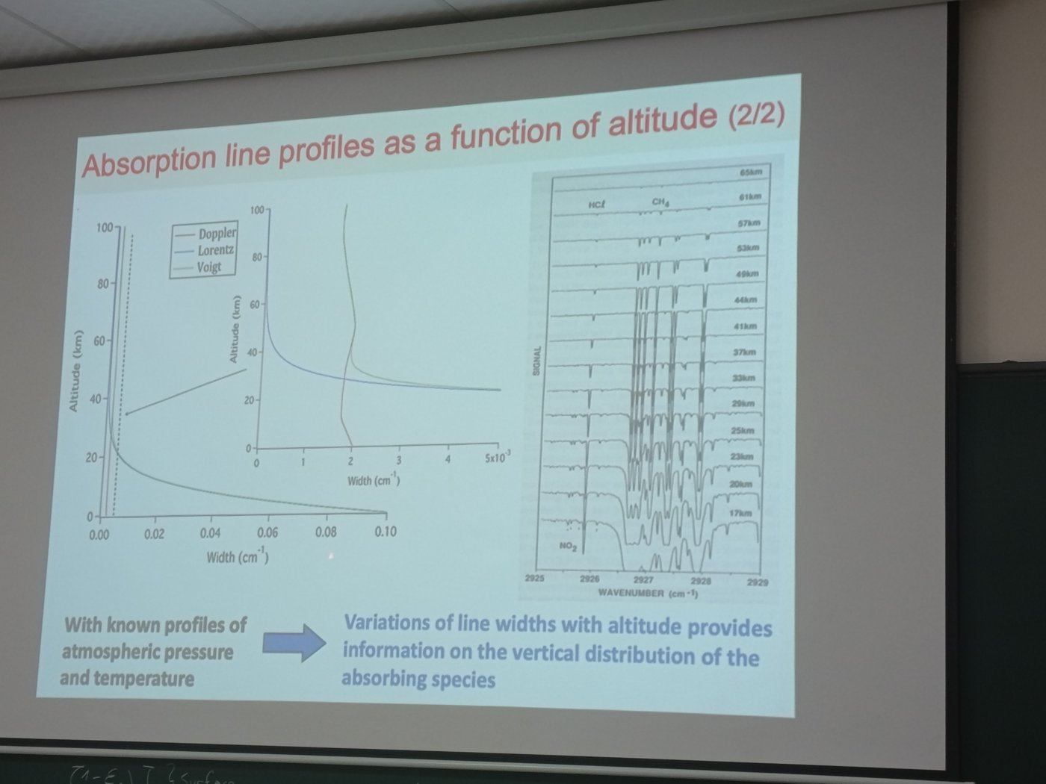
Figure 9 — Lecture slide: line widths vs altitude, and limb spectra (HCl, CH₄, NO₂) for tangent heights 17–65 km.

A.6 DOAS — separating slow and fast spectral structures
I(λ) = I₀(λ) · exp(−σ(λ) · c · L) Lambert–Beer
σ(λ) = σ_b(λ) + σ′(λ) ; D = ln(I′₀ / I) = σ′ · c · L
- High-frequency part (narrow structures) = the gas fingerprint σ′ → fitted with laboratory cross-sections.
- Low-frequency part = Rayleigh, Mie, surface reflectance and the broad part σ_b → absorbed by a low-order polynomial.
- Several gases are fitted at the same time (NO₂, O₃, HCHO, SO₂, BrO…). Output: c·L = slant column; dividing by the AMF gives the vertical column (Q3).
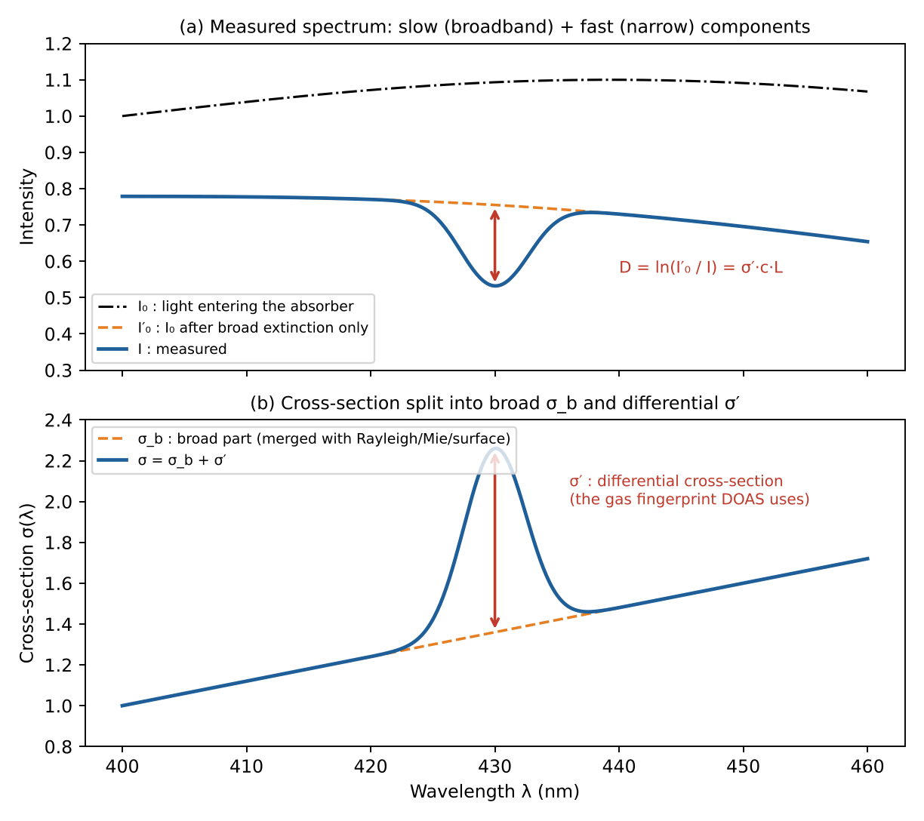
Figure 10 — DOAS principle (redrawn from the lecture): I₀, I′₀ and the differential absorption D.
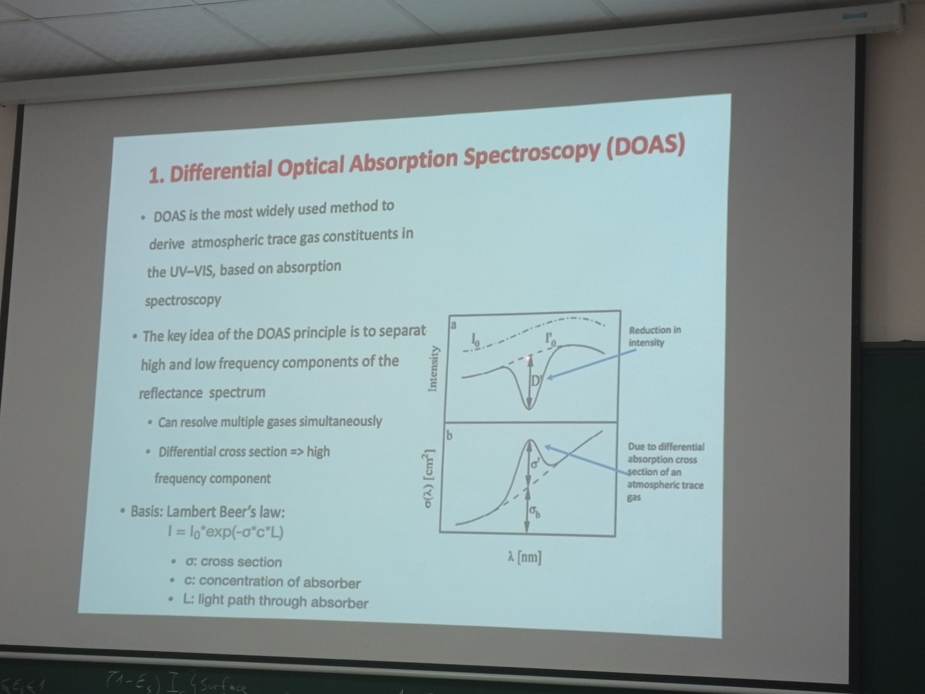
Figure 11 — Lecture slide: Differential Optical Absorption Spectroscopy (DOAS).

Worked example — optical depth of a polluted NO₂ layer
- Boundary layer 1 km thick (L = 10⁵ cm), NO₂ ≈ 20 ppb → N ≈ 20×10⁻⁹ × 2.5×10¹⁹ = 5×10¹¹ molecules cm⁻³.
- Differential cross-section σ′ ≈ 1.5×10⁻¹⁹ cm² (≈ 440 nm) → τ = σ′·L·N = 1.5×10⁻¹⁹ × 10⁵ × 5×10¹¹ ≈ 7.5×10⁻³.
- Transmission e^(−τ) ≈ 99.3 %: the NO₂ signature is < 1 % of the signal → DOAS needs very high signal-to-noise and an accurate I₀.

Quick Q&A — hỏi nhanh, đáp nhanh
- Q: What does J contain in the RTE? → A: All photons added into the line of sight: thermal emission α·B and scattering from other directions.
- Q: Why is the emission coefficient equal to the absorption coefficient? → A: Kirchhoff's law, valid in local thermodynamic equilibrium.
- Q: For an opaque gas, which layers does the sensor see? → A: Only the top layers: e^(−τ(l,L)) is small for everything deeper.
- Q: In τ = σ·N·L, what is unknown? → A: Only N: σ comes from spectroscopy, L from the geometry.
- Q: Why do line widths tell the altitude? → A: Lorentz width ∝ pressure, and pressure decreases exponentially with height.
- Q: Why does DOAS fit a polynomial? → A: To absorb all broadband effects (Rayleigh, Mie, surface) that cannot be separated from σ_b.

Liên tưởng — memory hooks
- RTE = sổ thu chi của photon trên đường tới cảm biến: thu (phản xạ, tán xạ vào, phát xạ) trừ chi (hấp thụ, tán xạ ra).
- τ = σ·N·L giống đi qua rừng: σ = độ to của mỗi thân cây, N = mật độ cây, L = quãng đường. Rừng càng dày, càng dài thì càng ít ánh sáng lọt qua.
- Vạch phổ dưới thấp “béo”, trên cao “gầy”: dưới thấp phân tử chen chúc, va chạm liên tục (như chợ đông người) nên vạch bị nhoè rộng; trên cao không khí loãng nên vạch sắc nét.
- DOAS như nghe giọng nói giữa tiếng quạt: tiếng quạt đều đều (nền trơn) bị lọc đi, chỉ giữ lại nhịp nhanh của giọng nói (cấu trúc hẹp của khí).

Ý chính (tóm tắt tiếng Việt)
- Phương trình truyền bức xạ: dI/dl = −k_ext·I + J; suy giảm = hấp thụ + tán xạ (của khí và aerosol).
- Không có tán xạ, cân bằng nhiệt động: J = α·B(T). Bức xạ tới cảm biến = nền bề mặt bị suy giảm + phát xạ của từng lớp bị suy giảm bởi phần khí phía trên.
- Độ dày quang học τ = σ·N·L: σ lấy từ phổ học, N là mục tiêu cần tìm. Bề mặt: I(0) = ε_s·B(T_s) + (1−ε_s)·I_s, với 1−ε_s là albedo.
- Độ rộng vạch: Doppler (theo nhiệt độ) và Lorentz (theo áp suất, giảm mạnh theo độ cao) → thông tin về phân bố thẳng đứng. DOAS: tách phần biến đổi nhanh (σ′) khỏi phần biến đổi chậm.

PART B — The 8 exam questions
Model answers, worked examples, Q&A and memory hooks
Read the questions in the order of the map below: what controls the amount of a pollutant (Q1) → how light carries the information (Q2, Q7, Part A) → how we invert it (Q3) and how good the result is (Q5) → geometry (Q4) → aerosols and their height (Q6, Q8).
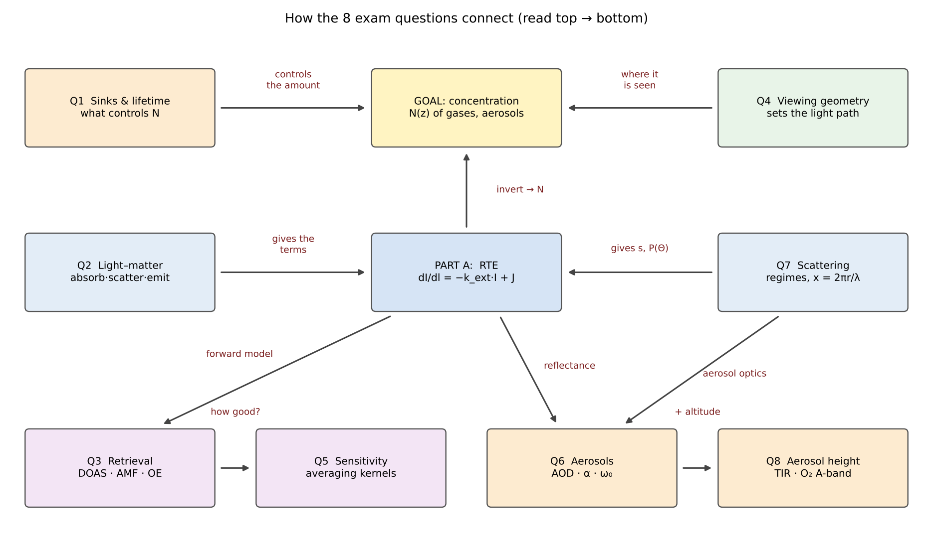
Figure 12 — Concept map: how the eight questions and Part A connect.
Question | Part A blocks reused
Q1 Sinks & lifetime | A.4 (N is the target quantity)
Q2 Light–matter interactions | A.1, A.2, A.3
Q3 Columns & profiles | A.3 (weighting functions), A.4, A.5 (vertical information), A.6 (DOAS)
Q4 Viewing geometries | A.1 (path length L), A.4 (τ grows with L)
Q5 Averaging kernels | A.3 (weighting functions)
Q6 Aerosols | A.1, A.2 (scattering s, surface albedo)
Q7 Scattering regimes | A.1 (s, phase function)
Q8 Aerosol height | A.3 (TIR emission), A.4 (O₂ absorption)

1. Sinks and lifetime of air pollutants
Question
- What are possible sinks of air pollutants in the atmosphere? How do we understand the typical lifetime of an air pollutant by inspecting its spatial distribution from space? Provide examples of typical lifetime (orders of magnitude) of air pollutants.

1.1 Sinks of air pollutants
A sink is any process that removes a species from the atmosphere (or from the air mass considered). The main sinks are:
- Chemical loss (gas-phase oxidation) — the dominant sink for most reactive gases. The main oxidant is the hydroxyl radical OH (the "detergent of the atmosphere"), plus O₃, NO₃ (at night) and halogen radicals. Example: CO + OH → CO₂ + H; CH₄ + OH → CH₃ + H₂O; NO₂ + OH + M → HNO₃.
- Photolysis — destruction by solar UV/visible photons. Example: NO₂ + hν (λ < 420 nm) → NO + O; HCHO + hν → products; CFCs photolysed by hard UV in the stratosphere.
- Dry deposition — direct uptake at the surface (vegetation stomata, soil, water, buildings) without precipitation. Described by a deposition velocity v_d (flux F = −v_d·C). Important for O₃, SO₂, NH₃, HNO₃, coarse particles (gravitational settling).
- Wet deposition — scavenging by clouds and precipitation: in-cloud (rainout, aerosols act as CCN) and below-cloud (washout). Main sink for soluble gases (HNO₃, SO₂, NH₃) and for most aerosols.
- Heterogeneous / multiphase chemistry — reactions on or inside aerosol particles and cloud droplets (e.g. N₂O₅ hydrolysis to HNO₃, aqueous oxidation of SO₂ to sulfate). Gas → particle conversion (nucleation, condensation) is a sink for the gas but a source of aerosol.
- Transport out of the domain — export to the free troposphere or stratosphere. For the global atmosphere, transport to the stratosphere (followed by photolysis) is the sink of long-lived gases (N₂O, CFCs).
If several sinks act in parallel, their first-order loss rates add up:
τ = M / L = M / (F_out + L_chem + D_dry + D_wet) (steady state: τ = M / P)
1/τ = 1/τ_chem + 1/τ_photolysis + 1/τ_dry + 1/τ_wet τ_chem = 1 / (k·[OH])
where M is the atmospheric burden (mass or number of molecules) and L the total loss rate. Example: k(CO+OH) ≈ 2×10⁻¹³ cm³ s⁻¹, [OH] ≈ 1×10⁶ cm⁻³ ⇒ τ ≈ 5×10⁶ s ≈ 2 months.

1.2 Reading lifetime from satellite maps
The key idea is the competition between lifetime τ and transport time. During its lifetime, a molecule travels a distance L ≈ U·τ (U ≈ wind speed, ~5–10 m s⁻¹ horizontally). Mixing around a latitude band takes ~weeks, inter-hemispheric mixing ~1 year. Hence:
- Short-lived species (hours–days): the satellite map looks like a map of the sources: strong hotspots over cities, power plants, ships, fires, sharply decreasing within tens–hundreds of km; high spatial variability, low background. Example: NO₂ (TROPOMI) highlights megacities and highways; SO₂ shows individual smelters/volcanoes; HCHO follows isoprene emissions.
- Medium-lived species (weeks–months): plumes and continental-scale transport become visible: CO from fires in Africa/Amazonia transported across oceans; aerosol (dust) plumes over the Atlantic. Gradient mainly between hemispheres and source continents.
- Long-lived species (years–centuries): the gas is well mixed; the map is nearly uniform (variations of only ~1 %), with a small north–south gradient and a seasonal cycle. Example: CO₂ (OCO-2, ~400+ ppm everywhere), CH₄, N₂O. Detecting sources requires very high precision.
Quantitative rule (Junge relationship): the relative spatial variability σ/mean of a species is inversely related to its lifetime, roughly σ/C ≈ 0.14/τ (τ in years). Plotting lifetime against spatial scale gives the diagram below. One can also derive τ from satellite data directly: e.g. the decay of NO₂ downwind of a point source (exponential fit, line density versus distance x: C(x) ∝ exp(−x/(U·τ))) gives τ_NO₂ ≈ 2–6 h.
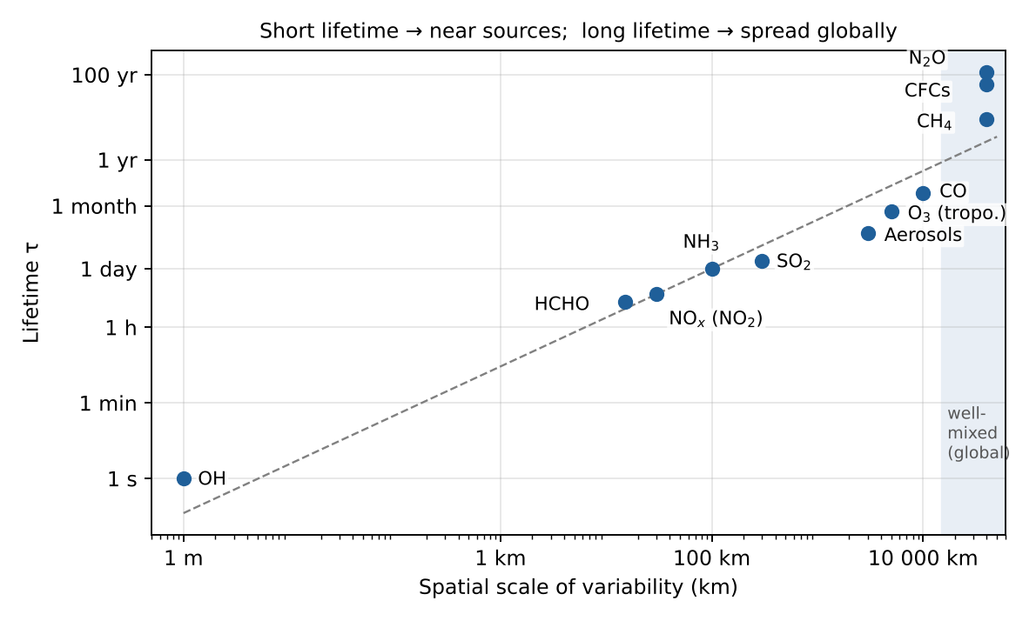
Figure 13 — Lifetime versus spatial scale of variability (order of magnitude).
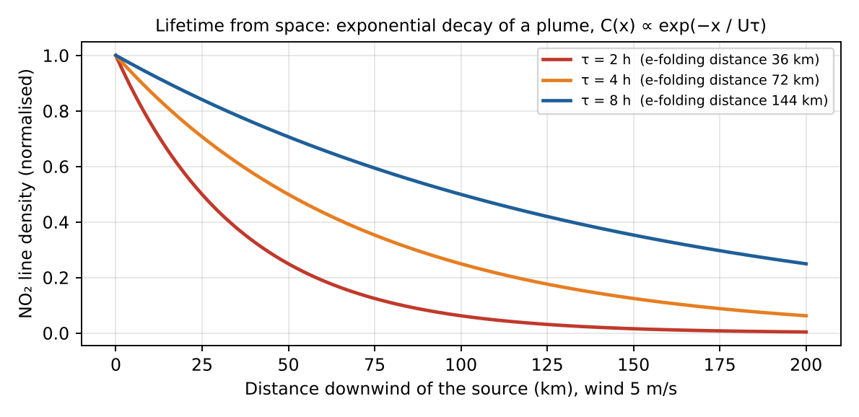
Figure 14 — Deriving a lifetime from a satellite plume: the shorter τ, the faster the decay downwind.
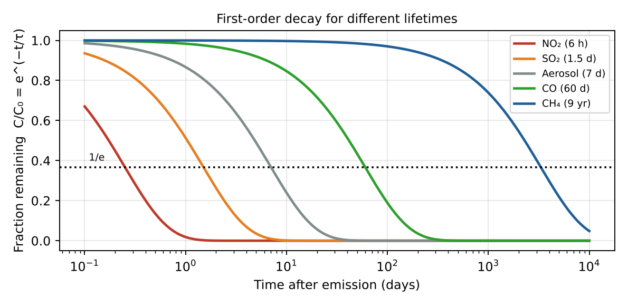
Figure 15 — First-order decay C/C₀ = e^(−t/τ) for typical air pollutants.

1.3 Typical lifetimes (orders of magnitude)
Species | Typical lifetime | Main sink | Aspect from space
OH, NO₃ | ~1 s / seconds–minutes | Fast chemistry | Not mapped directly
NO₂ / NOₓ (boundary layer) | hours (2–12 h; longer in winter) | OH → HNO₃, N₂O₅ hydrolysis | Hotspots on sources
HCHO, glyoxal | hours | Photolysis, OH | Follows VOC sources/fires
SO₂ | ~1–2 days (weeks in stratosphere) | OH, aqueous oxidation, dry deposition | Point sources, volcano plumes
NH₃ | hours–1 day | Conversion to NH₄⁺, deposition | Agricultural hotspots
Aerosols (PM, troposphere) | ~1 week (days–2 weeks) | Wet & dry deposition | Regional plumes (dust, smoke)
O₃ (troposphere) | ~3 weeks (days in BL – months in free trop.) | Photolysis + H₂O, NO, HO₂, deposition | Hemispheric background
CO | ~1–2 months | OH | Intercontinental plumes
CH₄ | ~9–12 years | OH, soil, stratosphere | Nearly uniform, ~1 % gradients
N₂O, CFCs | ~50–120 years | Stratospheric photolysis | Well mixed
CO₂ | ~100+ years (no single lifetime) | Ocean & biosphere uptake | Well mixed (±2 %)

Worked example — lifetime of NO₂ from a satellite plume
- TROPOMI NO₂ line density downwind of a power plant decreases to 1/e at x = 72 km; wind U = 5 m/s = 18 km/h.
- τ = x / U = 72 / 18 = 4 hours — typical daytime NO₂ lifetime.
- Same SO₂ molecule: ~1–2 days in the boundary layer but months in the stratosphere after a volcanic eruption (no rain, little cloud chemistry) → lifetime depends on where the molecule is.

Quick Q&A — hỏi nhanh, đáp nhanh
- Q: Why does SO₂ live longer in the stratosphere? → A: No wet deposition, no clouds for aqueous oxidation, slower OH reaction.
- Q: Can a short-lived species appear everywhere on a map? → A: Only if its sources are everywhere (e.g. HCHO over all forests): the map still shows sources.
- Q: What is steady state? → A: Production = loss, burden constant, so τ = M/P = M/L.
- Q: Why is CO a good tracer of long-range transport? → A: τ ≈ 2 months: longer than intercontinental transport (1–2 weeks) but shorter than hemispheric mixing, so plumes stay visible.

Liên tưởng — memory hooks
- Giọt mực trong bể nước đang khuấy: mực phai trong 1 giây thì chỉ thấy màu ngay chỗ nhỏ (τ ngắn → thấy nguồn); mực không bao giờ phai thì cả bể đều màu (τ dài → trộn đều).
- Khói thuốc trong phòng có quạt hút: quạt hút mạnh (sink mạnh) thì khói chỉ quanh người hút; tắt quạt thì khói lan khắp phòng.

Exam checklist — must mention
- List ≥ 4 sinks: OH oxidation, photolysis, dry deposition, wet deposition (+ heterogeneous chemistry, transport).
- Define τ = burden / loss rate; combine sinks with 1/τ = Σ 1/τᵢ.
- Lifetime vs transport time: short τ → map of sources; long τ → well mixed.
- Give orders of magnitude: hours (NO₂), days (SO₂), week (aerosols), months (CO), decade (CH₄), century (N₂O, CO₂).

Ý chính (tóm tắt tiếng Việt)
- Bể chứa (sink): oxy hóa bởi OH, quang phân, lắng đọng khô, lắng đọng ướt, phản ứng dị thể trên hạt/giọt mây, vận chuyển ra khỏi vùng.
- Thời gian sống τ = lượng tồn trữ / tốc độ mất; nhiều quá trình song song: 1/τ = Σ 1/τᵢ.
- So sánh τ với thời gian vận chuyển: τ ngắn → bản đồ vệ tinh trùng với nguồn phát thải (NO₂ ở đô thị); τ dài → phân bố đồng đều toàn cầu (CO₂, CH₄).
- Bậc độ lớn: giờ (NO₂), ngày (SO₂), tuần (aerosol, O₃), tháng (CO), chục năm (CH₄), trăm năm (N₂O, CO₂).

2. Interaction between light and matter
Question
- Describe the main physical mechanisms of interaction between light and matter that modify the intensity of radiation reaching a radiometric sensor. Provide a clear description, the main equations, and schematics of each of these mechanisms.
Radiation travelling from the source (Sun or Earth surface) to the sensor is modified by three processes: absorption and scattering (which together form extinction) remove energy from the beam, while emission and scattering into the beam add energy. Surface reflection also matters for the radiance seen from space.
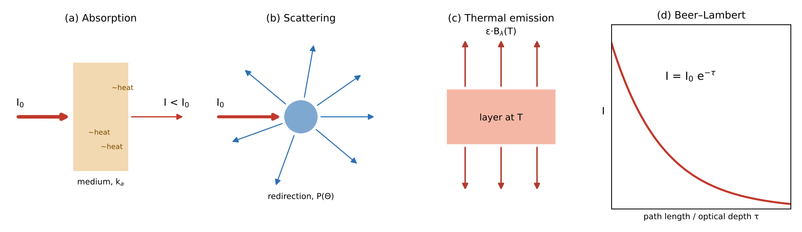
Figure 16 — The three mechanisms and the Beer–Lambert law of extinction.

2.1 Absorption
A photon is absorbed by a molecule or particle if its energy matches a transition: E = hν = E₂ − E₁. The energy is converted into internal energy (and finally heat).
- Electronic transitions — UV/visible (e.g. O₃ Hartley–Huggins bands 250–350 nm, NO₂ 400–450 nm, SO₂ 300–320 nm).
- Vibrational–rotational transitions — infrared (CO₂ 15 µm and 4.3 µm, O₃ 9.6 µm, CH₄ 7.7 µm and 2.3 µm, CO 4.6 µm and 2.3 µm, H₂O).
- Pure rotational transitions — microwave / far-IR (H₂O, O₂ 60 GHz, ClO).
Each gas therefore has a spectral fingerprint (absorption cross-section σ(λ)) — this is what makes gas identification possible. Line shape depends on pressure (Lorentz broadening, dominant in the low atmosphere) and temperature (Doppler broadening, dominant at high altitude). The absorption coefficient is:
k_a(λ) = σ_a(λ) · n n = number density (molec. cm⁻³)

2.2 Scattering
The photon is redirected without change of wavelength (elastic scattering) by molecules or particles; it is removed from the direct beam but may be added to another direction. Its angular distribution is the phase function P(Θ). The regime depends on the size parameter x = 2πr/λ (see Chapter 7):
- Rayleigh scattering (molecules, x ≪ 1): σ_R ∝ λ⁻⁴, symmetric phase function P(Θ) = ¾(1 + cos²Θ) — blue sky.
- Mie scattering (aerosols, cloud droplets, x ~ 1): weaker spectral dependence (Ångström law τ ∝ λ^−α), strong forward peak.
- Inelastic Raman scattering (rotational Raman by N₂, O₂): causes the Ring effect (filling-in of Fraunhofer lines) important in UV-vis DOAS retrievals.
The single scattering albedo ω₀ = σ_s / (σ_s + σ_a) tells which fraction of the extinction is scattering (ω₀ = 1 for non-absorbing particles, ~0.85 for smoke).
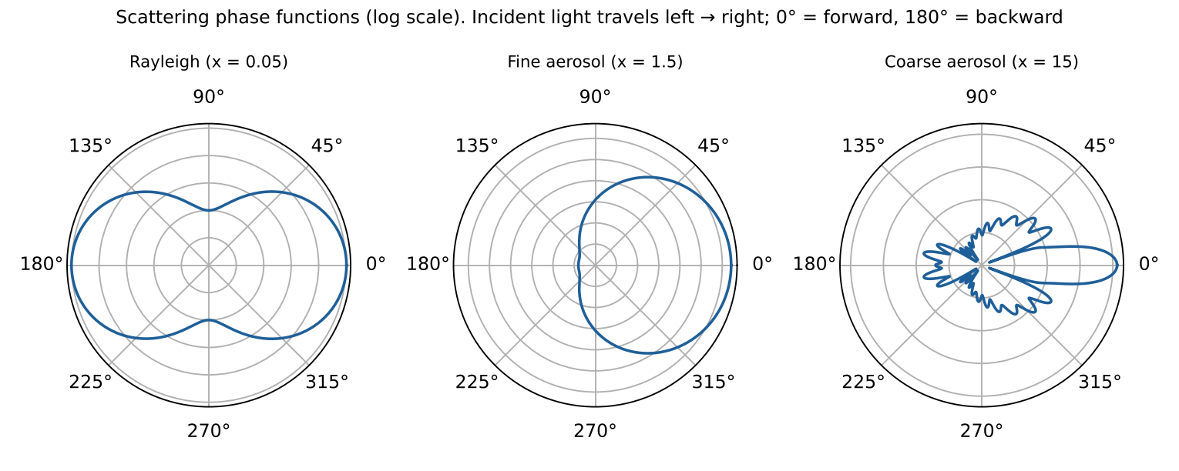
Figure 17 — Phase functions computed with Mie theory: symmetric for molecules, strongly forward-peaked for large particles.

2.3 Emission
Any body at temperature T > 0 K emits radiation. For a black body the spectral radiance is the Planck function; real media emit ε·B with emissivity ε. In local thermodynamic equilibrium (Kirchhoff's law) emissivity equals absorptivity: ε_λ = α_λ — a gas that absorbs at a wavelength also emits at that wavelength. Emission dominates in the thermal infrared and microwave (λ > ~4 µm), while solar reflection dominates in UV–vis–NIR.
B_λ(T) = (2hc² / λ⁵) · 1 / (exp(hc / λk_BT) − 1) Planck
λ_max · T = 2898 µm·K ; M = σ_SB · T⁴ Wien ; Stefan–Boltzmann
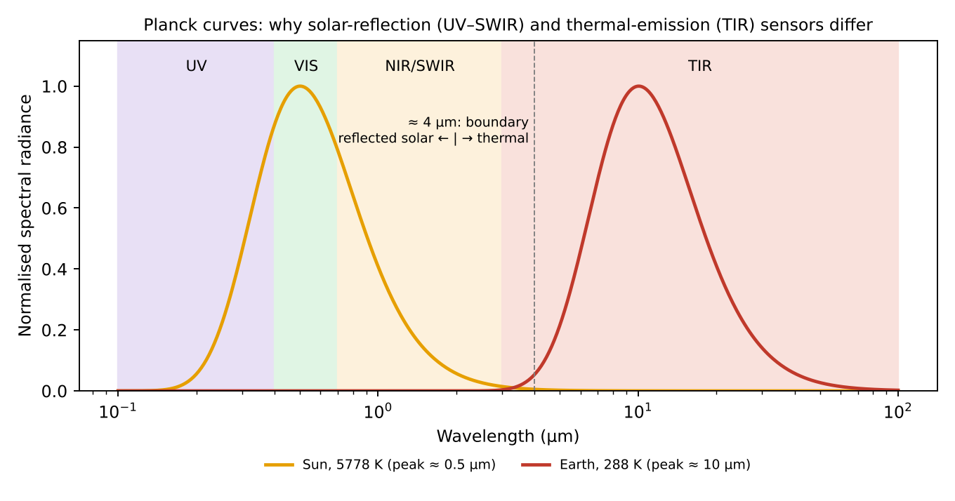
Figure 18 — Planck curves of the Sun and the Earth: solar reflection dominates below ~4 µm, thermal emission above.

2.4 Extinction — the Beer–Lambert law
Along a path ds, absorption + scattering out of the beam reduce the intensity proportionally to the intensity itself:
dI_λ = −k_e(λ) · I_λ · ds , k_e = k_a + k_s = Σ σᵢ nᵢ
I_λ(s) = I_λ(0) · exp(−τ_λ) , τ_λ = ∫ k_e(λ, s) ds optical depth
The transmittance is T = e^(−τ). For a slant path, τ_slant = τ_vertical / cos θ (air mass factor in a plane-parallel atmosphere).
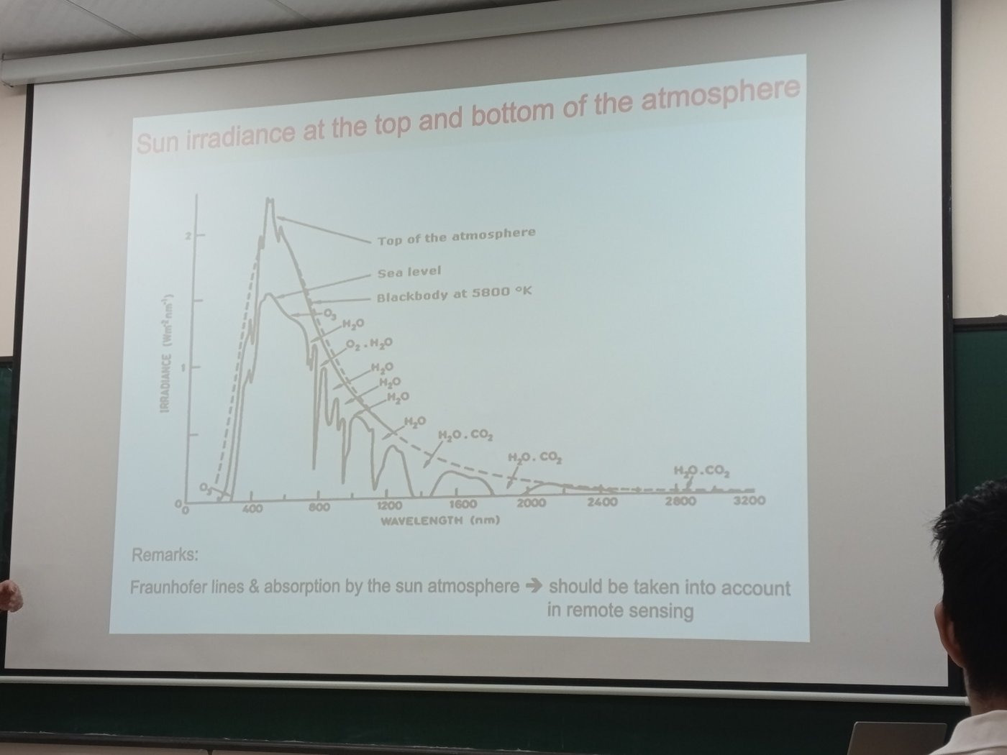
Figure 19 — Lecture slide (class photo): solar irradiance at the top of the atmosphere vs sea level — the difference is absorption (O₃, O₂, H₂O, CO₂) and scattering.

2.5 Radiative transfer equation (RTE) — putting everything together
dI_λ / ds = −k_e I_λ + k_a B_λ(T) + (k_s / 4π) ∫ P(Θ) I_λ(Ω′) dΩ′
Lecture notation (Part A.1): dI(ν̃)/dl = −k_ext(ν̃)·I(ν̃) + J(ν̃), with k_ext = α^gas + s^gas + α^aerosol + s^aerosol and, without scattering, J = α·B(T) (Part A.3).
Term 1 = extinction (loss), term 2 = thermal emission (gain), term 3 = scattering from all other directions into the line of sight (gain). Simplified cases used in remote sensing:
- Thermal IR, no scattering (Schwarzschild equation) — radiance at the top of atmosphere = surface emission attenuated + emission of each layer weighted by its transmission to space:
I_λ(TOA) = ε_s B_λ(T_s) T_λ(0,∞) + ∫₀^∞ B_λ(T(z)) · ∂T_λ(z,∞)/∂z dz
- UV–visible, solar: reflected sunlight; I/I₀ depends on Rayleigh + aerosol scattering, surface albedo and gas absorption (DOAS: ln(I₀/I) = Σ σᵢ·SCDᵢ + smooth polynomial).
- Surface reflection: characterised by albedo / BRDF; Lambertian surface: I = A·F₀·cos θ₀ / π.

Worked example — UV light through the ozone layer
- Ozone column 300 DU = 300 × 2.69×10¹⁶ ≈ 8.1×10¹⁸ molecules cm⁻²; sun at 60° + nadir view → air mass ≈ 1/cos 60° + 1 = 3.
- 310 nm: σ ≈ 1×10⁻¹⁹ cm² → τ_slant ≈ 2.4 → T = e^(−2.4) ≈ 9 %. 330 nm: σ ≈ 1×10⁻²⁰ cm² → τ ≈ 0.24 → T ≈ 79 %.
- Conclusion: wavelengths < 300 nm barely reach the ground; the strong change of σ with λ is exactly what gives altitude information (Q3).
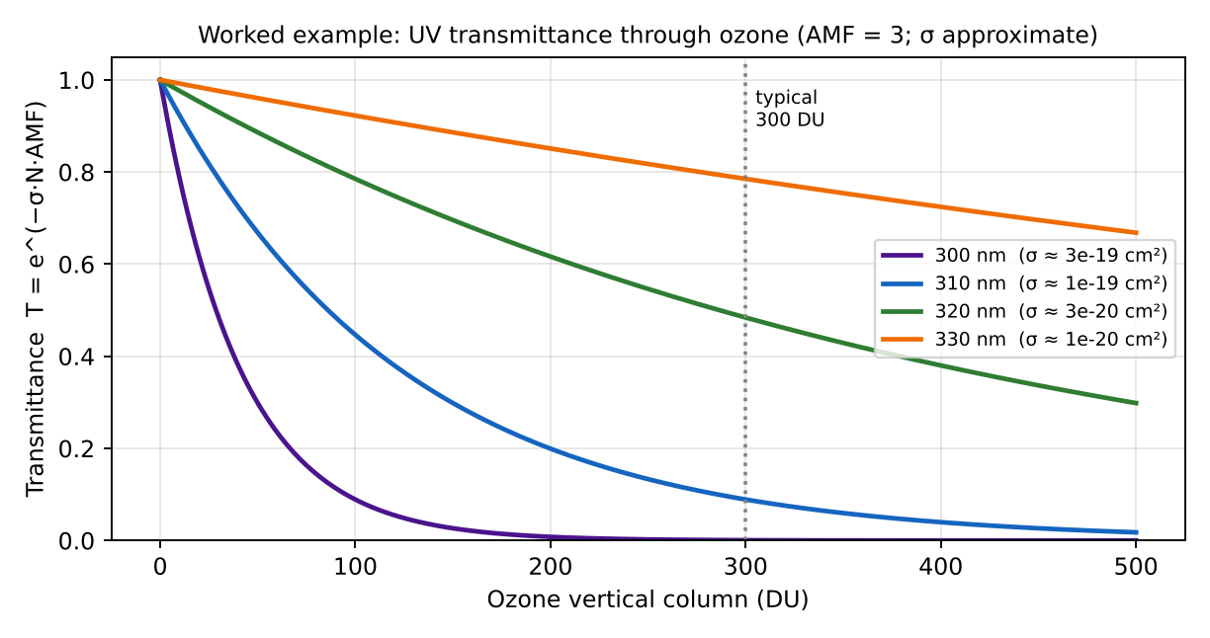
Figure 20 — Worked example: transmittance through ozone at four UV wavelengths.

Quick Q&A — hỏi nhanh, đáp nhanh
- Q: Does scattering destroy photons? → A: No: it redirects them — a loss for one direction, a gain for another (Part A.2).
- Q: Why is thermal emission negligible in the UV–visible? → A: B(λ, T ≈ 250–300 K) is practically zero below ≈ 3 µm.
- Q: Single scattering albedo of pure Rayleigh scattering? → A: ω₀ = 1 (no absorption).
- Q: Which gas dominates absorption at 9.6 µm? At 15 µm? → A: O₃ at 9.6 µm, CO₂ at 15 µm.
- Q: What does τ = 1 mean physically? → A: The beam is reduced to 1/e ≈ 37 %: the ‘depth’ from which most photons come.

Liên tưởng — memory hooks
- Hấp thụ = trạm thu phí giữ tiền lại (năng lượng biến thành nhiệt); tán xạ = cảnh sát giao thông chuyển xe sang đường khác (xe không mất); phát xạ = xe mới nhập vào từ đường nhánh.
- Beer–Lambert: mỗi km sương mù chặn cùng một tỉ lệ số xe còn lại, không phải cùng một số lượng → giảm theo hàm mũ.

Exam checklist — must mention
- Three mechanisms: absorption (quantised transitions, σ(λ) fingerprint), scattering (Rayleigh/Mie, phase function, ω₀), emission (Planck, Kirchhoff).
- Beer–Lambert: I = I₀ e^−τ, τ = ∫ k_e ds, k_e = k_a + k_s.
- Write the full RTE and identify each term; Schwarzschild for thermal IR.
- Draw: absorbing slab, scattering particle with arrows in all directions, emitting layer, exponential decay curve.

Ý chính (tóm tắt tiếng Việt)
- Ba cơ chế: hấp thụ (chuyển mức năng lượng điện tử/dao động/quay → mỗi khí có “dấu vân tay” phổ), tán xạ (đổi hướng photon: Rayleigh ∝ λ⁻⁴, Mie), phát xạ nhiệt (Planck, định luật Kirchhoff ε = α).
- Hấp thụ + tán xạ = suy giảm (extinction), tuân theo định luật Beer–Lambert I = I₀·e^(−τ).
- Phương trình truyền bức xạ: suy giảm − phát xạ + tán xạ vào hướng nhìn.

3. Passive remote sensing of trace gases: measured quantity and retrieval
Question
- What is the quantity directly measured by passive satellite sensors for remote sensing of atmospheric trace gases? Explain the principle to derive the abundance of a trace gas in terms of (i) integrated concentration over the atmospheric column and (ii) vertical profile of gas concentration. Where is the information on the vertical distribution of the gas coming from?

3.1 The measured quantity: spectral radiance
A passive sensor does not emit radiation; it measures the spectral radiance I(λ) (W m⁻² sr⁻¹ µm⁻¹ or per cm⁻¹) arriving at the instrument in a given direction, over many wavelength channels (a spectrum). Depending on the spectral range:
- UV–visible–SWIR (solar backscatter): Earthshine radiance I(λ), usually normalised by the measured solar irradiance → reflectance R(λ) = π I(λ) / (μ₀ E₀(λ)). Instruments: GOME-2, OMI, TROPOMI, OCO-2.
- Thermal infrared: radiance emitted by the surface and atmosphere, often expressed as brightness temperature T_B. Instruments: IASI, AIRS, CrIS.
- Occultation: transmission I/I₀ of the Sun (or star) through the limb (ACE-FTS, SAGE).
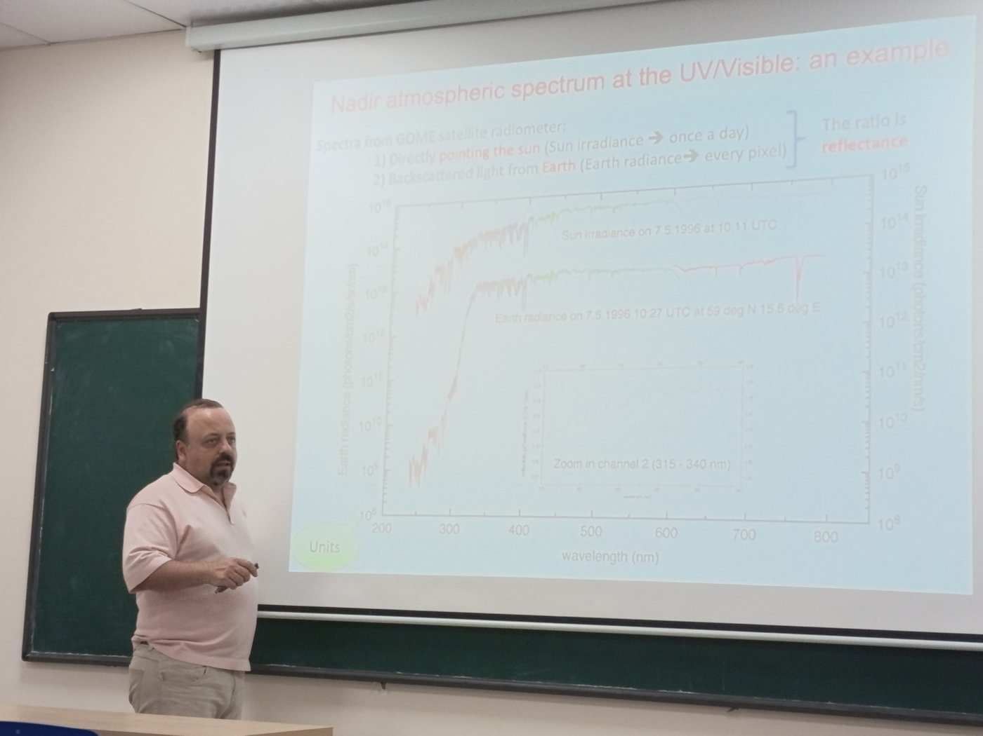
Figure 21 — Lecture slide (class photo): GOME solar irradiance and Earth radiance; their ratio is the reflectance.
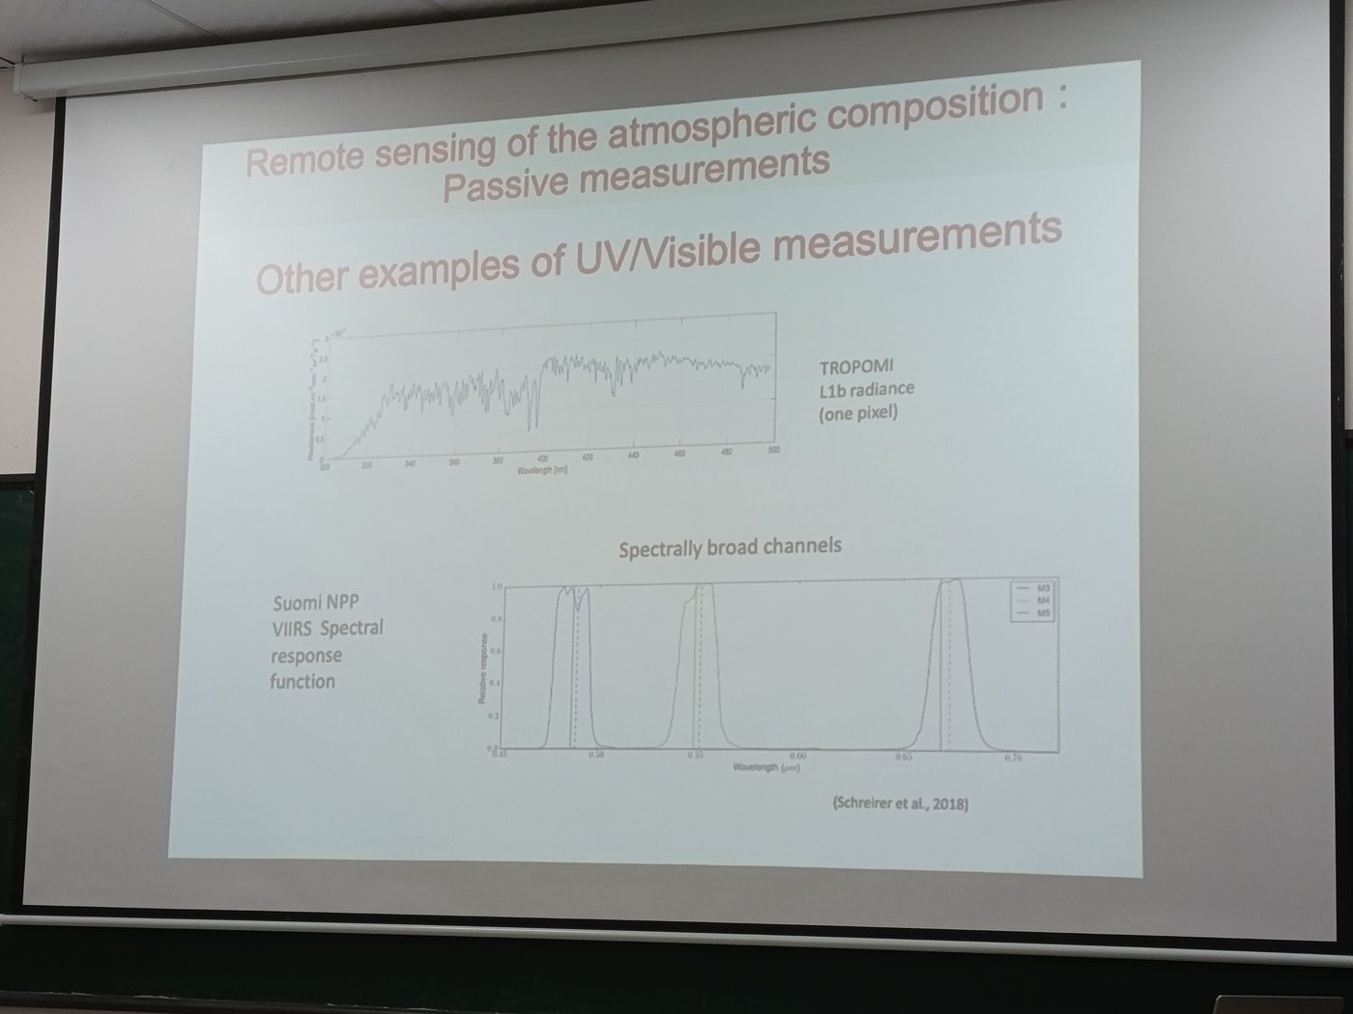
Figure 22 — Lecture slide (class photo): TROPOMI L1b radiance of one pixel (hyperspectral) vs VIIRS broad channels.
The concentration is never measured directly: it is retrieved by inverting a radiative transfer model (forward model) y = F(x, b) + ε, where y = measured spectrum, x = state (gas amounts), b = other parameters (temperature, surface, clouds, aerosols).

3.2 (i) Total / tropospheric column — integrated concentration
The vertical column density VCD = ∫ n(z) dz (molecules cm⁻², or Dobson Units for O₃: 1 DU = 2.69×10¹⁶ molec cm⁻²). Typical approach in the UV–vis: DOAS (Differential Optical Absorption Spectroscopy), in 3 steps:
- Step 1 – Spectral fit → slant column (SCD). From Beer–Lambert, the optical depth is separated into a rapidly varying part (molecular absorption structures) and a smooth part (Rayleigh, Mie, surface):
ln( I₀(λ) / I(λ) ) = Σᵢ σᵢ′(λ) · SCDᵢ + Σₚ aₚ λᵖ SCD = ∫ n ds along the light path
- The differential cross-sections σ′ are known from the lab; a least-squares fit gives SCD for each gas (NO₂, O₃, SO₂, HCHO…).
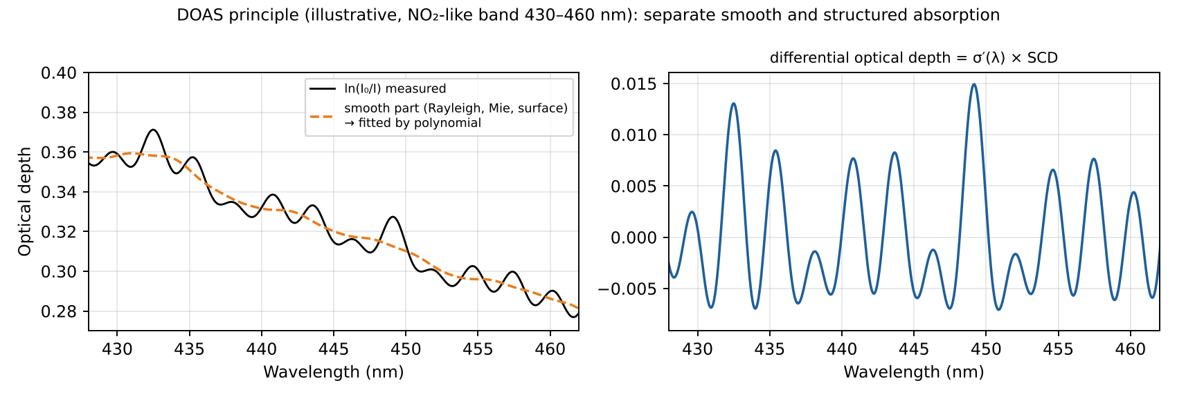
Figure 23 — DOAS: the smooth broadband part is removed; the narrow structures are fitted with lab cross-sections to obtain the slant column.
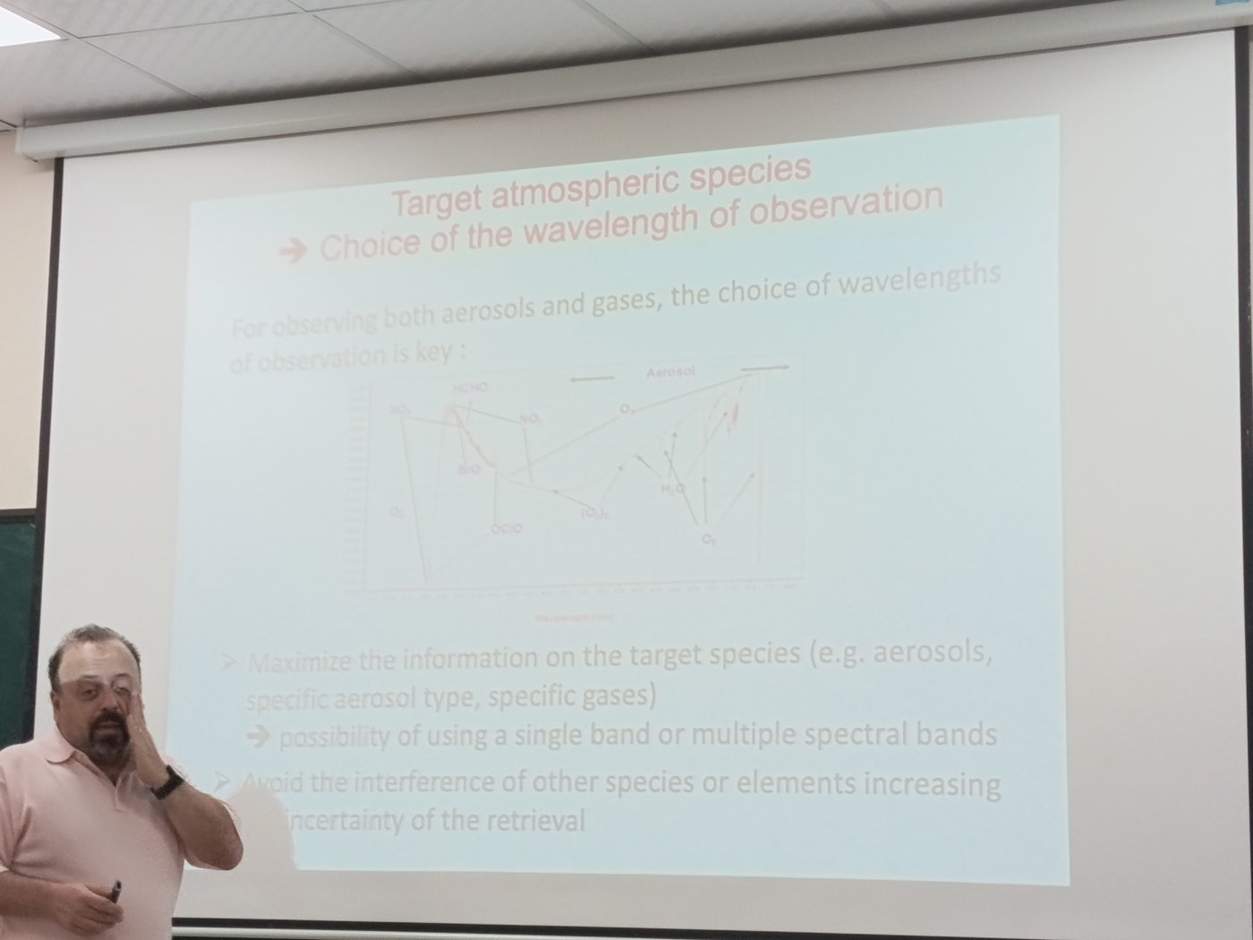
Figure 24 — Lecture slide (class photo): choice of the wavelength window for each target species (SO₂, HCHO, BrO, NO₂, O₃, OClO, O₂-O₂, H₂O, O₂, aerosol).
- Step 2 – Air Mass Factor (AMF). The SCD depends on the light path. A radiative transfer model computes AMF = SCD / VCD, which depends on viewing/solar geometry, surface albedo, clouds, aerosols and the a priori shape of the profile. Geometric approximation: AMF ≈ 1/cos θ₀ + 1/cos θ.
VCD = (SCD − SCD_strat) / AMF_trop
- Step 3 – (for tropospheric gases) stratosphere–troposphere separation (reference sector over clean ocean, chemistry-transport model assimilation).
Alternative approaches: optimal estimation with a scaling of the a priori profile (CO in SWIR/TIR), or ratio methods for greenhouse gases (XCO₂ = column CO₂ / column dry air, using O₂ A-band).

3.3 (ii) Vertical profile
Discretise the atmosphere into N layers: x = (x₁ … x_N). Linearise the forward model around a reference: y = y₀ + K(x − x₀) + ε, where K = ∂F/∂x is the Jacobian (weighting functions). The problem is ill-posed (more unknowns than independent pieces of information, noise), so it is regularised. The standard method is Optimal Estimation (Rodgers), minimising:
χ² = (y − F(x))ᵀ S_ε⁻¹ (y − F(x)) + (x − x_a)ᵀ S_a⁻¹ (x − x_a)
x̂ = x_a + (Kᵀ S_ε⁻¹ K + S_a⁻¹)⁻¹ Kᵀ S_ε⁻¹ (y − K x_a) (linear case; iterate Gauss–Newton if nonlinear)
x_a = a priori profile, S_a its covariance, S_ε measurement noise covariance. Other methods: Tikhonov regularisation, onion-peeling for limb data.

3.4 Where does the vertical information come from?
See Part A.5: computed line widths vs altitude and the lecture limb spectra.
The information comes from the fact that different measurements are sensitive to different altitudes, i.e. their weighting functions K(z) peak at different heights:
- Spectral dependence of absorption strength (nadir): at wavelengths where the gas absorbs strongly, photons do not penetrate deep → the signal comes from high altitudes; where it absorbs weakly, the radiation comes from lower layers. Example: O₃ in the UV — at 270 nm sensitivity in the upper stratosphere, at 310–330 nm down to the troposphere (backscatter Ultraviolet, BUV/SBUV method).
- Pressure and temperature dependence of line shapes (TIR): line width ∝ pressure (Lorentz); the line centre probes high altitudes, the wings probe low altitudes. The temperature profile T(z) also creates contrast: emission at a layer is B(T(z)). This is the basis of IASI O₃/CO profiles.
- Viewing geometry (limb/occultation): each line of sight has a tangent height; scanning the limb gives vertical resolution of 1–3 km directly by geometry (onion peeling).
- Temperature-dependent cross-sections, multiple angles, and Raman/Rayleigh scattering add small extra information.
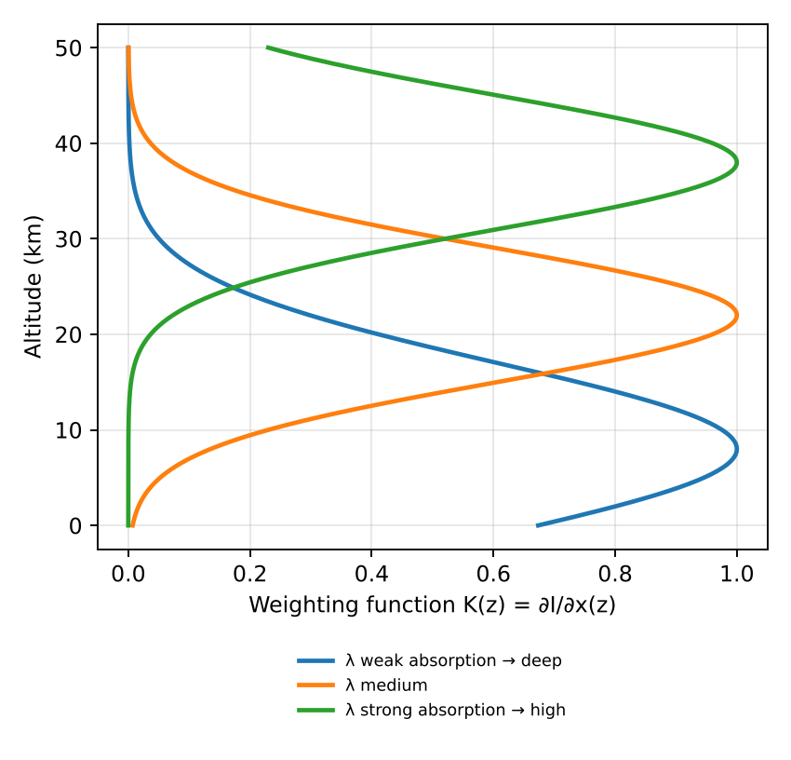
Figure 25 — Weighting functions peak at different altitudes for different absorption strengths.

Worked example — tropospheric NO₂ column over a megacity
- DOAS fit gives a tropospheric slant column SCD_trop = 2.4×10¹⁶ molecules cm⁻²; radiative transfer gives AMF_trop = 1.2.
- VCD = SCD / AMF = 2.4×10¹⁶ / 1.2 = 2×10¹⁶ molecules cm⁻² (≈ 0.74 DU) — typical of a polluted megacity.
- If clouds or a wrong profile shape change the AMF by 30 %, the VCD changes by 30 % → the AMF is usually the largest error source.

Quick Q&A — hỏi nhanh, đáp nhanh
- Q: Why measure the solar irradiance I₀ every day? → A: To remove Fraunhofer lines and instrument effects: the ratio I/I₀ is the reflectance.
- Q: Why only the differential cross-section? → A: Broad features cannot be separated from Rayleigh, Mie and surface effects; the polynomial absorbs them.
- Q: How does a limb spectrum change with tangent height? → A: Lower tangent height → more absorber and higher pressure → deeper and wider lines (lecture slide, Part A.5).
- Q: What is the Ring effect? → A: Filling-in of Fraunhofer lines by rotational Raman scattering; it must be fitted as a pseudo-absorber in DOAS.
- Q: What does an optimal estimation retrieval need besides the spectrum? → A: A forward model, the Jacobian K, an a priori profile x_a and the covariances S_a and S_ε.

Liên tưởng — memory hooks
- SCD và VCD: SCD là lượng khí dọc đường đi xiên của ánh sáng (như đi cầu thang xoắn), VCD là lượng khí theo phương thẳng đứng (đi thang máy). AMF = tỉ số giữa hai quãng đường.
- Thông tin độ cao từ phổ: bước sóng hấp thụ mạnh như đèn pin yếu trong sương dày (chỉ soi được lớp trên cùng), bước sóng hấp thụ yếu như đèn pha (soi xuống tận đáy).

Exam checklist — must mention
- Measured quantity = spectral radiance (reflectance / brightness temperature / transmission), NOT concentration.
- Column: DOAS fit → SCD; AMF from RT model → VCD = SCD/AMF.
- Profile: forward model + Jacobian K + Optimal Estimation with a priori.
- Vertical information: different penetration depths vs λ, pressure broadening of lines, temperature contrast, limb geometry.

Ý chính (tóm tắt tiếng Việt)
- Cảm biến thụ động đo bức xạ phổ (radiance) — không đo nồng độ trực tiếp; nồng độ được “truy hồi” bằng cách nghịch đảo mô hình truyền bức xạ.
- Cột tổng: DOAS → cột nghiêng SCD; hệ số khối khí AMF → cột thẳng đứng VCD = SCD/AMF.
- Profil thẳng đứng: ước lượng tối ưu (Optimal Estimation) dùng ma trận Jacobian K và profil tiên nghiệm.
- Thông tin độ cao đến từ: độ hấp thụ mạnh/yếu theo bước sóng (độ xuyên sâu khác nhau), mở rộng vạch theo áp suất, tương phản nhiệt độ, và hình học quan sát limb.

4. Pointing geometries of spaceborne sensors
Question
- What are the possible pointing geometries of spaceborne sensors for sounding the atmospheric composition? What are the advantages and disadvantages of each case?
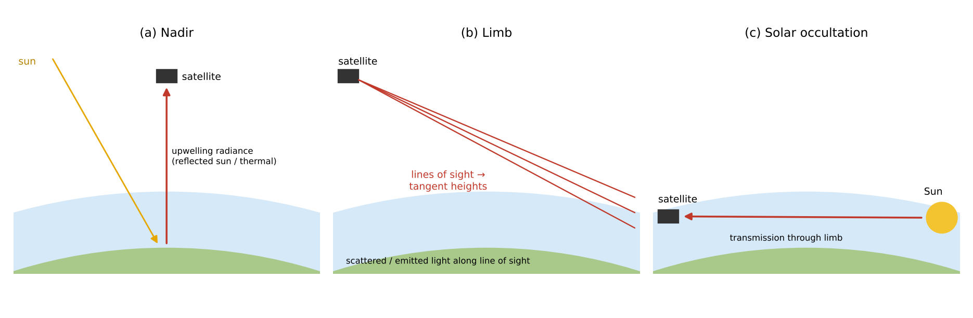
Figure 26 — Nadir, limb and occultation viewing geometries.

4.1 Nadir (and off-nadir / cross-track scanning)
The instrument looks down towards the Earth (vertically or with a swath scanning across track). It measures solar radiation backscattered by the surface/atmosphere (UV–vis–SWIR) or thermal emission (TIR). Examples: TROPOMI, OMI, GOME-2, IASI, MOPITT, OCO-2.

4.2 Limb sounding
The instrument looks tangentially through the atmosphere, above the horizon, scanning the line of sight vertically (tangent heights from ~5 to 100 km). It measures scattered sunlight (limb scattering: OSIRIS, OMPS-LP, SCIAMACHY limb) or thermal emission (MIPAS, MLS microwave).

4.3 Occultation
The instrument looks at a source (Sun, Moon, star, or GPS satellite signals) through the limb during sunrise/sunset of the orbit and measures the transmission I/I₀. Examples: SAGE II/III, ACE-FTS, GOMOS (stellar), GNSS radio occultation (temperature/humidity).

4.4 Comparison
Geometry | Advantages | Disadvantages
Nadir | • Good horizontal resolution (few km: TROPOMI 5.5×3.5 km²) and global daily coverage (wide swath)  • Sees the troposphere / boundary layer → air quality, emissions  • Works day (UV-vis) and day+night (TIR) | • Poor vertical resolution (columns or 1–6 pieces of information)  • Sensitivity to surface (albedo, emissivity), clouds and aerosols  • Short path through atmosphere → weaker absorption signal per layer
Limb (emission / scattering) | • Good vertical resolution (1–3 km) from geometry  • Long path through the atmosphere → high sensitivity, many species (stratospheric chemistry)  • No surface contribution (dark space background)  • Emission limb works day and night; good coverage | • Poor horizontal resolution along line of sight (~200–400 km)  • Cannot see below ~5–10 km (clouds, long path saturation) → not suited for boundary layer  • Complex RT (sphericity, multiple scattering), pointing must be known precisely
Occultation | • Self-calibrating: ratio I/I₀ removes instrument drift → very accurate, ideal for long-term trends  • Very strong signal (Sun), high vertical resolution (~1 km), high S/N  • Simple RT (transmission, Beer–Lambert) | • Very poor coverage: only ~30 profiles/day (2 per orbit for solar), latitude bands depend on orbit  • Poor horizontal resolution along path  • Only upper troposphere / stratosphere
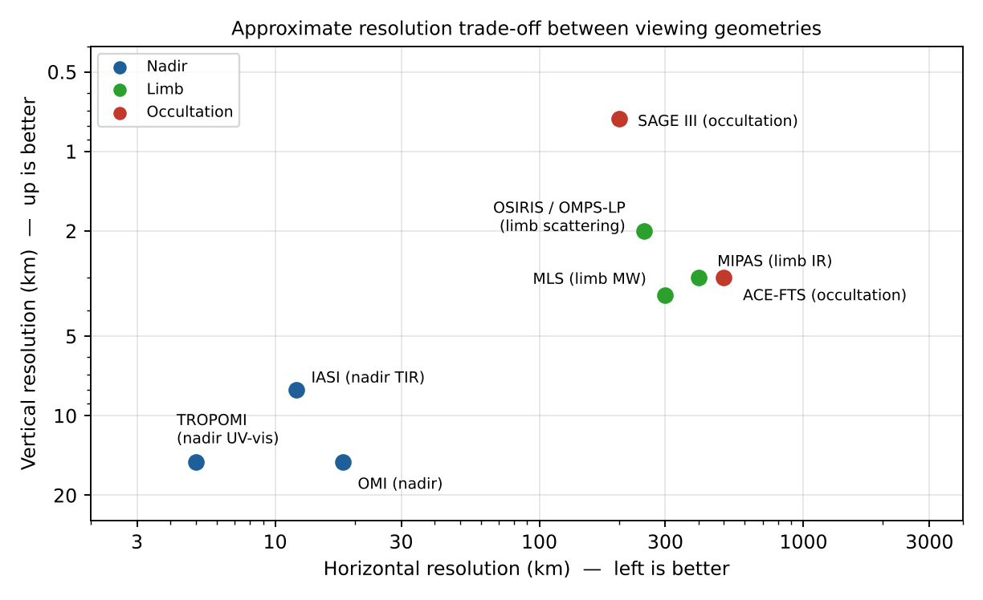
Figure 27 — Approximate horizontal vs vertical resolution of typical instruments for each geometry.
Notes: Orbit also matters — Low Earth orbit (sun-synchronous) gives global coverage once per day at fixed local time; geostationary orbit (GEMS, TEMPO, Sentinel-4) gives hourly observations of one continent in nadir geometry, allowing the diurnal cycle of pollution to be observed. Combining nadir and limb (e.g. SCIAMACHY, OMPS) allows a tropospheric column = total column (nadir) − stratospheric column (limb).

Worked example — why limb sounding has a long path and coarse horizontal resolution
- Path length through a layer of thickness H at the tangent point: L ≈ √(8·R·H). With R = 6371 km and H = 1 km → L ≈ 226 km.
- Nadir: the same 1 km layer is crossed over ≈ 1 km (× air mass factor) → limb path is ≈ 100–200 times longer → much stronger signal, but averaged over ≈ 200–300 km horizontally.
- Coverage: solar occultation gives ≈ 15 orbits × 2 = ~30 profiles/day; TROPOMI (2600 km swath, 5.5 × 3.5 km² pixels) gives millions of pixels/day.

Quick Q&A — hỏi nhanh, đáp nhanh
- Q: Why can limb sounders not see the boundary layer? → A: Clouds and the very long, opaque path in the lower troposphere block the line of sight.
- Q: Why is occultation self-calibrating? → A: The same instrument measures I₀ outside the atmosphere a few minutes earlier; only the ratio I/I₀ is used.
- Q: Which geometry for CO₂ point sources? → A: Nadir with small pixels (OCO-2, CO2M): sources need horizontal detail.
- Q: Why does a geostationary instrument need larger optics? → A: It is ≈ 36 000 km away instead of ≈ 800 km: ≈ 45 times further.

Liên tưởng — memory hooks
- Nadir như nhìn xuống đáy hồ từ thuyền: thấy rõ vị trí, khó biết cá ở độ sâu nào. Limb như nhìn ngang qua lớp sương ở chân trời: thấy rõ từng tầng, nhưng mọi thứ dọc tia nhìn bị trộn lẫn. Che khuất như nhìn mặt trời lặn qua kính râm: so độ sáng trước và trong khi lặn.

Exam checklist — must mention
- Three geometries: nadir, limb (scattering/emission), occultation (solar/stellar/lunar/GNSS).
- Trade-off: horizontal resolution & tropospheric sensitivity (nadir) ↔ vertical resolution & accuracy (limb/occultation).
- Occultation = self-calibrating, best accuracy, worst coverage.
- Draw the three geometries with Earth, atmosphere shell, lines of sight.

Ý chính (tóm tắt tiếng Việt)
- Nadir: nhìn thẳng xuống → độ phân giải ngang tốt, phủ toàn cầu hằng ngày, nhìn thấy tầng đối lưu; nhưng độ phân giải thẳng đứng kém, nhạy với mây/bề mặt.
- Limb: nhìn tiếp tuyến qua rìa khí quyển → độ phân giải thẳng đứng tốt (1–3 km), không có nền bề mặt; nhưng độ phân giải ngang kém, không xuống thấp dưới ~5–10 km.
- Che khuất (occultation): nhìn Mặt Trời/sao qua rìa khí quyển → tự hiệu chuẩn, rất chính xác; nhưng số lượng phép đo rất ít.

5. Sensitivity of passive retrievals: averaging kernels
Question
- Which magnitude is used to quantify the sensitivity of passive remote sensing methods for retrieving the concentration of trace gases? Explain the general concept and illustrate with drawings a case of ideally perfect sensitivity and a realistic case (such as the retrieval of the ozone profiles using satellite spectral measurements in nadir pointing geometry).

5.1 The averaging kernel matrix
The sensitivity is quantified by the averaging kernel (AK) matrix A, defined as the sensitivity of the retrieved state to the true state:
A = ∂x̂ / ∂x = G K , G = (Kᵀ S_ε⁻¹ K + S_a⁻¹)⁻¹ Kᵀ S_ε⁻¹ G = gain matrix
The retrieved profile is then a smoothed version of the true profile, mixed with the a priori:
x̂ = x_a + A (x_true − x_a) + G ε
- Each row of A (one per retrieval level) shows how the retrieved value at level i is a weighted average of the true profile at all levels. Its width (FWHM) = vertical resolution; the altitude of its peak shows where the information really comes from.
- The sum of the row (area) tells how much comes from the measurement: ≈1 → measurement dominates; ≈0 → retrieved value just equals the a priori.
- The trace of A = Degrees of Freedom for Signal (DOFS) = number of independent pieces of information on the vertical profile: DOFS = tr(A).
- For a total column, the column averaging kernel a(z) = ∂VCD̂/∂n(z) (e.g. AK = AMF_layer / AMF_total in DOAS) shows at which altitudes the column is sensitive; ideal = 1 at all heights.
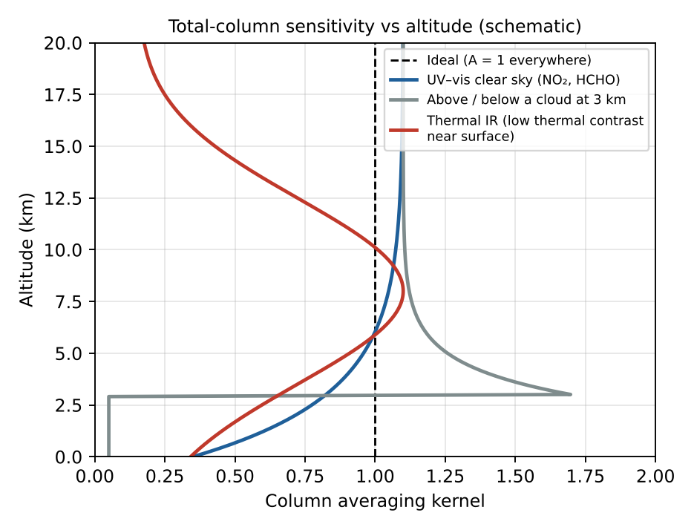
Figure 28 — Column averaging kernels: ideal (=1) vs typical UV-vis, cloudy and thermal-IR cases.
Retrieval error covariance: Ŝ = (I − A) S_a (I − A)ᵀ [smoothing error] + G S_ε Gᵀ [noise error]. Important use: to compare satellite data with a model or another instrument, apply the AKs to the model profile: x_model,smoothed = x_a + A (x_model − x_a).

5.2 Ideal case vs realistic case
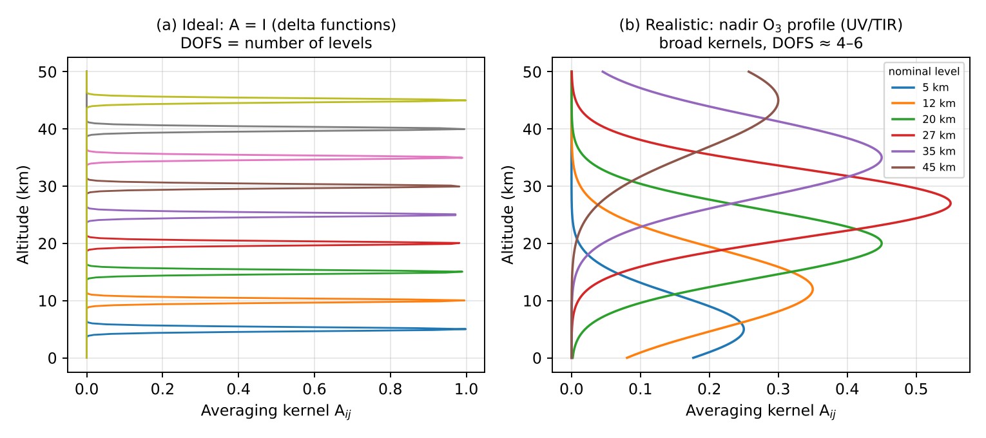
Figure 29 — (a) Perfect sensitivity: A = identity. (b) Typical nadir ozone profile retrieval.
(a) Ideal case: A = I (identity matrix). Each kernel is a delta function equal to 1 at its own level and 0 elsewhere: the retrieval reproduces the true profile exactly, without any dependence on the a priori, infinitely fine vertical resolution, DOFS = number of levels.
(b) Realistic case — nadir ozone profile (e.g. GOME-2/OMI in UV 270–330 nm, or IASI at 9.6 µm):
- Kernels are broad (FWHM ~ 7–15 km) and overlap → vertical resolution of ~6–10 km in stratosphere, poorer in troposphere.
- Peaks are shifted away from the nominal level, and amplitudes are < 1 (≈0.3–0.6).
- DOFS ≈ 4–6 in UV (≈1 for the troposphere), ≈ 3–4 for IASI; i.e. we know the stratospheric profile in ~3–4 thick layers plus roughly 1 piece of tropospheric information.
- Sensitivity is low near the surface (Rayleigh scattering, strong O₃ absorption above, clouds) → near-surface values come mostly from the a priori.
- Sensitivity is also lost at the top (>50 km) where there is little ozone.
By contrast, limb ozone retrievals have narrow kernels (~2–3 km), DOFS ≈ 20–30, close to the ideal case in the stratosphere.

Worked example — one column measurement, two layers
- State x = (x₁, x₂), measurement y = x₁ + x₂ → K = [1 1]; a priori S_a = I (variance 1), noise S_ε = 0.01.
- A = S_a Kᵀ (K S_a Kᵀ + S_ε)⁻¹ K = [1 1]ᵀ [1 1] / 2.01 ≈ [[0.50, 0.50], [0.50, 0.50]].
- DOFS = trace(A) ≈ 1.0: one column measurement gives one piece of information. Each layer retrieval = half of the total → layers cannot be separated.

Quick Q&A — hỏi nhanh, đáp nhanh
- Q: A level has an averaging-kernel row with area 0.2: meaning? → A: 80 % of the retrieved value at that level comes from the a priori.
- Q: Can an averaging kernel be negative? → A: Yes: oscillations appear when the retrieval sharpens a broad sensitivity.
- Q: Why not use a very large S_a to reduce the a-priori influence? → A: The retrieval then amplifies noise and oscillates (ill-posed problem).
- Q: What does a column averaging kernel > 1 above a cloud mean? → A: Enhanced light path above the bright cloud: the column is over-sensitive at that altitude.

Liên tưởng — memory hooks
- Averaging kernel như ảnh chụp bị nhoè: ảnh lý tưởng thì mỗi điểm rõ nét (hàm delta); ảnh thực mỗi điểm thành một vệt mờ (kernel rộng). DOFS = số điểm còn phân biệt được trong ảnh nhoè.

Exam checklist — must mention
- Name: averaging kernel matrix A = ∂x̂/∂x; DOFS = trace(A).
- x̂ = x_a + A(x − x_a) + Gε — retrieval = smoothed truth + a priori contribution.
- Row width = vertical resolution; area = measurement contribution.
- Draw delta functions (ideal) vs broad, overlapping, peak-shifted kernels (nadir O₃, DOFS ≈ 4–6).

Ý chính (tóm tắt tiếng Việt)
- Đại lượng đo độ nhạy: ma trận hạt nhân trung bình (averaging kernel) A = ∂x̂/∂x; vết của A = số bậc tự do tín hiệu (DOFS).
- Trường hợp lý tưởng: A = ma trận đơn vị → hàm delta tại mỗi độ cao, không phụ thuộc tiên nghiệm.
- Thực tế (O₃ nadir): hạt nhân rộng 7–15 km, chồng lên nhau, biên độ < 1, DOFS ≈ 4–6; gần mặt đất độ nhạy thấp → kết quả phụ thuộc nhiều vào profil tiên nghiệm.

6. Passive remote sensing of aerosols
Question
- What properties of aerosols can be measured from passive satellite sensors (mention at least 3 aerosol properties)? Explain the principle of passive remote sensing of aerosols, including the quantity directly measured and how aerosol properties are derived. What are the advantages and limitations of this passive approach as compared to active methods?

6.1 Measurable aerosol properties
- Aerosol Optical Depth (AOD, τ_a) at a given wavelength (e.g. 550 nm) — the most robust product: τ_a = ∫ k_ext,aer(z) dz. It is a proxy for the aerosol load / PM2.5.
- Ångström exponent α (spectral dependence of AOD, τ ∝ λ^−α) → particle size: α ≈ 0–0.5 coarse (dust, sea salt), α ≈ 1.5–2.5 fine (smoke, urban). Also the fine-mode fraction.
- Single Scattering Albedo ω₀ (absorption) — from UV methods (OMI UV Aerosol Index) or multi-angle polarimetry.
- Aerosol type (dust, smoke, sulfate, sea salt) and refractive index, non-sphericity — multi-angle and polarimetric sensors (MISR, POLDER/PARASOL, 3MI).
- Aerosol layer height — O₂ A-band (TROPOMI ALH), stereo (MISR), thermal IR for dust (IASI) — see Chapter 8.
- Absorbing Aerosol Index (UVAI) — qualitative detection of absorbing aerosols (smoke, dust) even above clouds.
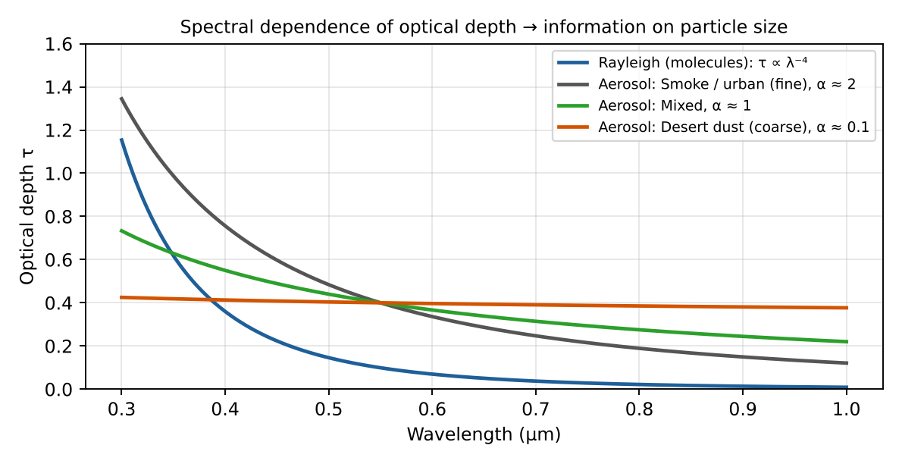
Figure 30 — Spectral dependence of optical depth: the Ångström exponent tells fine from coarse particles.

6.2 Principle
Quantity measured: the TOA spectral (and possibly angular and polarised) reflectance of sunlight, ρ(λ, θ₀, θ, φ) = π I / (μ₀ E₀). Aerosols scatter sunlight back to space, so they increase the reflectance over a dark surface. Simplified single-scattering expression:
ρ_TOA(λ) = ρ_Rayleigh + ρ_aer + T(λ) · ρ_surf / (1 − S ρ_surf)
ρ_aer ≈ ω₀ · τ_a · P(Θ) / (4 μ₀ μ) single scattering
Retrieval steps (e.g. MODIS Dark Target / Deep Blue):
- 1. Cloud screening and selection of suitable pixels (cloud-free, no sun glint, no snow).
- 2. Estimate the surface contribution: over dark ocean ρ_surf ≈ 0 in red/NIR; over vegetation, empirical relationships between 2.1 µm (aerosol-transparent) and visible bands; over bright deserts use the deep blue (412 nm) where surfaces are dark.
- 3. Look-up tables (LUT): a radiative transfer model computes TOA reflectance for a set of aerosol models (size distribution, refractive index → ω₀, P(Θ)) and AOD values, for all geometries.
- 4. Inversion: find the aerosol model + AOD that best matches the measured multi-spectral (multi-angle) reflectance (least squares / optimal estimation). Output: AOD(λ) → Ångström exponent, fine-mode fraction, (ω₀, type).
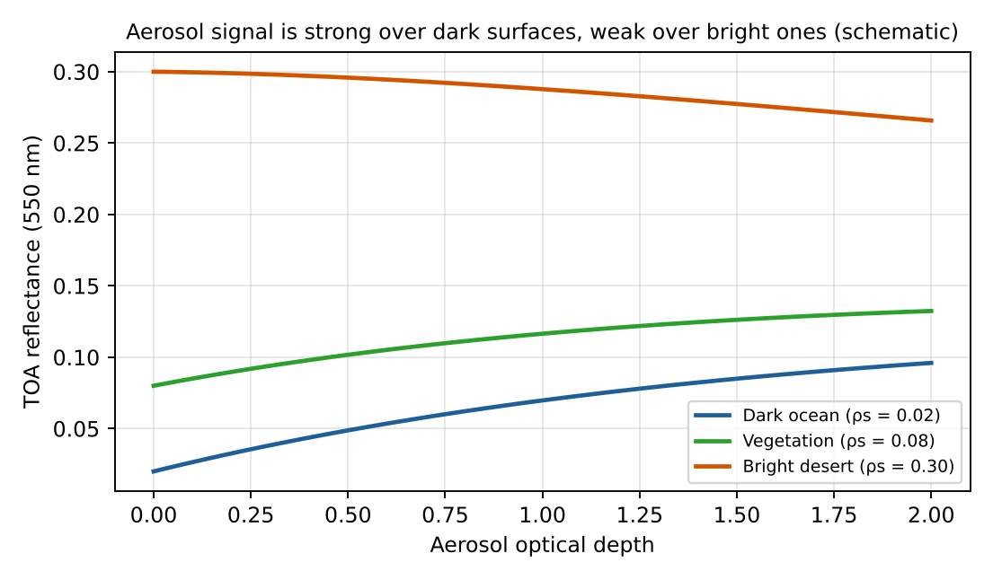
Figure 31 — TOA reflectance vs AOD: large sensitivity over dark ocean, almost none over bright desert.
Multi-angle (MISR) and polarisation (POLDER, SPEXone, HARP2 on PACE) measurements add information on phase function and refractive index, so more properties can be retrieved (ω₀, size distribution, shape).

6.3 Passive vs active (lidar) approaches
 | Passive (MODIS, VIIRS, MISR, POLDER, TROPOMI, IASI) | Active (CALIOP/CALIPSO, ATLID/EarthCARE)
Advantages | • Wide swath → global daily coverage, good horizontal resolution (km)  • Long, mature time series (since 2000), high sampling for air quality and climate  • Lower cost, low power, many spectral bands  • Column-integrated properties (AOD, α, ω₀) | • Gives vertical profile (extinction/backscatter, resolution ~30–60 m)  • Works day and night and over bright surfaces / above clouds  • Depolarisation → particle shape (dust vs spherical)  • Fewer assumptions on surface
Limitations | • Little/no vertical information (column only)  • Daytime only (solar), cloud-free only  • Strong dependence on surface reflectance (difficult over bright deserts, snow)  • Ill-posed: assumptions on aerosol model → uncertainty on type, ω₀  • Cloud contamination | • Very narrow footprint (curtain, ~100 m): poor spatial coverage, revisit ~16 days  • Lidar ratio must be assumed to get extinction → AOD uncertainty  • Low S/N in daytime; attenuation by thick layers  • Expensive, high power
Passive and active methods are complementary: passive provides the horizontal map and AOD, active provides the vertical structure (A-Train concept: MODIS + CALIOP).

Worked example — Ångström exponent from two AODs
- α = − ln(τ₁/τ₂) / ln(λ₁/λ₂).
- Smoke: AOD(440) = 0.8, AOD(870) = 0.2 → α = ln 4 / ln(870/440) = 1.386 / 0.682 ≈ 2.0 → fine particles.
- Dust: AOD(440) = 0.50, AOD(870) = 0.45 → α = ln 1.11 / 0.682 ≈ 0.15 → coarse particles.

Quick Q&A — hỏi nhanh, đáp nhanh
- Q: Why use the 2.1 µm band over land? → A: Fine aerosols are almost transparent there, and the surface reflectance at 2.1 µm predicts the visible one.
- Q: Why does polarisation help? → A: Light scattered by fine particles is strongly polarised while surfaces polarise little → separates aerosol from surface.
- Q: Can visible passive sensors retrieve aerosols at night? → A: No sunlight → no; only thermal-IR (dust) or lidar.
- Q: What is the UV Aerosol Index sensitive to? → A: Absorbing aerosols (smoke, dust), even above clouds; it increases with layer height.

Liên tưởng — memory hooks
- Tìm khói trên nền tối và nền sáng: khói trên mặt hồ tối dễ thấy, khói trên nền tuyết trắng gần như vô hình (giống tìm chữ trắng trên giấy trắng) → vì vậy AOD trên sa mạc khó đo.

Exam checklist — must mention
- ≥3 properties: AOD, Ångström exponent / size (fine-mode fraction), ω₀ / absorption, type, layer height, UV aerosol index.
- Measured: TOA spectral (multi-angle, polarised) reflectance; aerosols brighten dark surfaces.
- Method: cloud mask → surface reflectance → LUT from RT model → best-fit AOD + aerosol model.
- Passive: global coverage, no vertical info, daytime/cloud-free only. Active: profiles, day+night, narrow coverage.

Ý chính (tóm tắt tiếng Việt)
- Tính chất đo được: độ dày quang học AOD, số mũ Ångström (kích thước hạt), albedo tán xạ đơn ω₀ (hấp thụ), loại aerosol, độ cao lớp aerosol, chỉ số aerosol UV.
- Đại lượng đo: hệ số phản xạ phổ (đa góc, phân cực) ở đỉnh khí quyển; aerosol làm bề mặt tối sáng lên.
- Truy hồi: loại mây → ước lượng phản xạ bề mặt → bảng tra (LUT) từ mô hình truyền bức xạ → chọn AOD + mô hình aerosol phù hợp nhất.
- Thụ động: phủ toàn cầu, nhưng thiếu thông tin thẳng đứng, chỉ ban ngày & trời quang. Chủ động (lidar): có profil, ngày-đêm, nhưng vùng phủ rất hẹp.

7. Scattering regimes of light by particles
Question
- What are the different regimes of scattering of light by particles? Explain each of them and under which conditions they are encountered. What is the regime for coarse aerosols scattering visible light?
The regime is determined by the size parameter comparing particle size with wavelength, and by the complex refractive index m = n + ik:
x = 2π r / λ r = particle radius
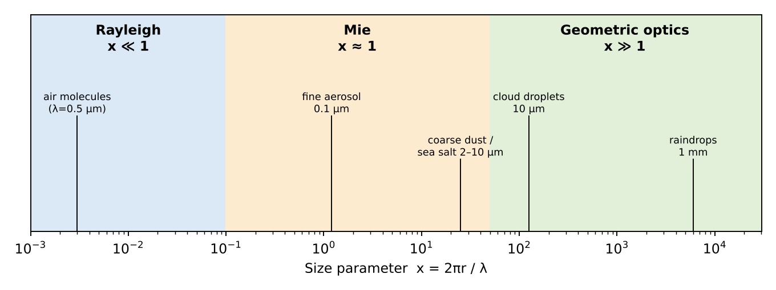
Figure 32 — Scattering regimes as a function of the size parameter (visible light, λ ≈ 0.5 µm).

7.1 Rayleigh regime (x ≪ 1, typically x < 0.1)
Particle much smaller than the wavelength: the particle behaves as an oscillating dipole in a uniform field. Encountered for air molecules (N₂, O₂) in UV–vis–IR, very fine aerosols (nucleation mode, r < 0.03 µm) in the visible, cloud droplets for microwaves/radar.
σ_s = (8π/3) · k⁴ · r⁶ · |(m² − 1)/(m² + 2)|² ∝ r⁶ / λ⁴
P(Θ) = (3/4)(1 + cos²Θ)
- Strong wavelength dependence λ⁻⁴ → blue sky, red sunsets.
- Symmetric forward/backward scattering; light scattered at 90° is fully polarised.

7.2 Mie (resonance) regime (x ≈ 0.1 – 50)
Particle size comparable to the wavelength: exact solution of Maxwell's equations for a homogeneous sphere (Lorenz–Mie theory), as an infinite series of multipoles. Encountered for accumulation-mode aerosols (0.1–1 µm) in the visible, and also coarse aerosols, cloud droplets in the IR.
- Extinction efficiency Q_ext = σ_ext / (πr²) oscillates with x and tends to 2 for large x (extinction paradox).
- Weak wavelength dependence (λ^−α, Ångström α ≈ 0–2); explains white/grey haze and clouds.
- Strong forward scattering peak (asymmetry parameter g ≈ 0.6–0.8), complex angular structure (glory, rainbow).
- Non-spherical particles (dust, ice) need T-matrix or discrete dipole methods.

7.3 Geometric optics regime (x ≫ 1, typically x > 50–100)
Particle much larger than the wavelength: light treated as rays that are reflected, refracted and diffracted (Snell, Fresnel). Encountered for raindrops, large cloud droplets, ice crystals, large dust in the visible.
- Q_ext → 2 (half by diffraction, half by reflection/refraction), independent of wavelength (grey/white).
- Optical phenomena: rainbow (42°), halos (22° for hexagonal ice), very strong forward diffraction peak.
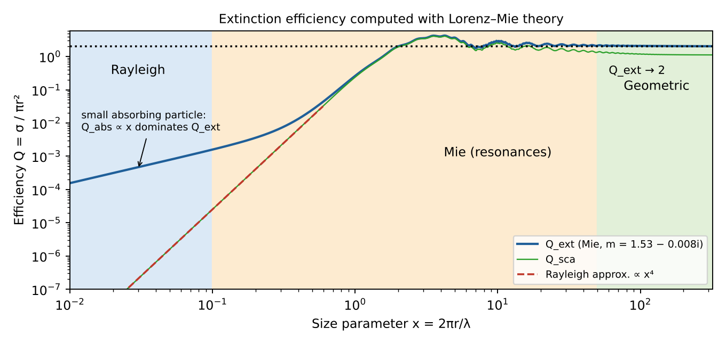
Figure 33 — Extinction efficiency vs size parameter (Lorenz–Mie calculation): x⁴ growth (Rayleigh), resonances (Mie), limit Q_ext → 2 (geometric).

7.4 Coarse aerosols in visible light
Coarse aerosols (mineral dust, sea salt, r ≈ 1–10 µm) at λ ≈ 0.55 µm give x ≈ 11–110. They are thus in the upper Mie regime, approaching geometric optics (Mie theory still applies, geometric optics becomes a good approximation for the largest ones). Consequences: AOD nearly independent of wavelength (Ångström exponent ≈ 0–0.5), strong forward scattering, Q_ext ≈ 2. Dust is non-spherical → Mie for spheres is only an approximation (use spheroids/T-matrix).

Worked example — the same particle in different regimes
- Cloud droplet r = 10 µm: visible (λ = 0.55 µm) → x ≈ 114 → geometric optics (white clouds).
- Same droplet seen by a cloud radar (λ = 3 mm) → x ≈ 0.02 → Rayleigh → radar reflectivity ∝ r⁶ (∝ D⁶).
- Lesson: the regime depends on the ratio r/λ, not on the particle alone.

Quick Q&A — hỏi nhanh, đáp nhanh
- Q: Why are sunsets red? → A: The long slant path removes blue light by Rayleigh scattering (λ⁻⁴).
- Q: Why is polluted haze white-grey? → A: Mie scattering by fine particles depends weakly on λ.
- Q: What is the extinction paradox? → A: For x ≫ 1, Q_ext → 2: a large particle removes twice its geometric cross-section (diffraction + geometric part).
- Q: Can Mie theory be used for dust? → A: Only approximately: dust is non-spherical → spheroids or T-matrix.

Liên tưởng — memory hooks
- Sóng biển gặp vật cản: cọc tre nhỏ (Rayleigh) thì sóng vòng qua gần như không đổi; tảng đá cỡ bước sóng (Mie) tạo giao thoa phức tạp; con đê dài (quang hình) tạo vùng “bóng” rõ ràng phía sau.

Exam checklist — must mention
- Size parameter x = 2πr/λ (+ refractive index m).
- Rayleigh x ≪ 1 (molecules), λ⁻⁴, symmetric P(Θ).
- Mie x ~ 1 (fine aerosols), Lorenz–Mie theory, forward peak, Q_ext oscillates → 2.
- Geometric optics x ≫ 1 (raindrops, ice), wavelength-independent.
- Coarse aerosol in visible: x ~ 10–100 → Mie (large-particle limit, near geometric optics), α ≈ 0.

Ý chính (tóm tắt tiếng Việt)
- Chế độ tán xạ phụ thuộc thông số kích thước x = 2πr/λ.
- Rayleigh (x ≪ 1): phân tử khí, ∝ λ⁻⁴, trời xanh. Mie (x ≈ 1): aerosol mịn, tán xạ mạnh về phía trước. Quang hình (x ≫ 1): giọt mưa, tinh thể băng, không phụ thuộc bước sóng.
- Aerosol thô (bụi, muối biển, r ≈ 1–10 µm) với ánh sáng khả kiến: x ≈ 10–100 → chế độ Mie (phần trên, tiến gần quang hình), số mũ Ångström ≈ 0.

8. Retrieving aerosol altitude with passive sensors
Question
- Explain the principle to derive the altitude of aerosols employing passive remote sensing from space: (i) in the thermal infrared and (ii) in the near infrared.
Aerosol height matters for air quality (surface PM vs elevated transport), long-range transport, radiative effects and aviation safety (volcanic ash). Passive sensors obtain it indirectly, by exploiting a physical effect that depends on altitude.
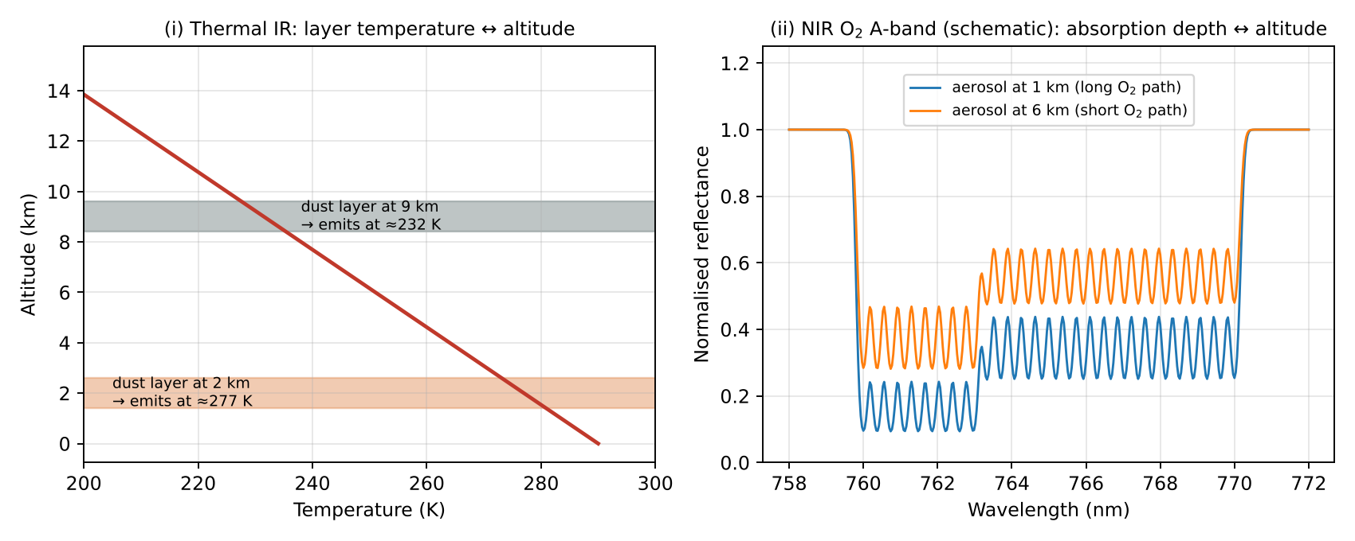
Figure 34 — (i) Thermal IR: layer emits at its own temperature. (ii) O₂ A-band: higher layer → less O₂ absorption.

8.1 (i) Thermal infrared (e.g. IASI, AIRS — mainly desert dust, volcanic ash)
Principle: in the TIR the radiance is dominated by emission. Coarse aerosols (dust, ash) absorb and emit in the atmospheric window 8–12 µm (silicate band near 9–10 µm). A dust layer replaces part of the warm surface emission by its own emission at the temperature of the layer:
I ≈ B(T_s) · e^(−τ_aer) + B(T_layer) · (1 − e^(−τ_aer))
- Because temperature decreases with altitude (≈ −6.5 K km⁻¹ in the troposphere), the higher the layer, the colder it is, the lower the TOA brightness temperature (larger brightness-temperature depression vs. clear sky).
- The signal depends on τ_aer × (T_s − T_layer): the thermal contrast. So the same depression can be produced by a thin high layer or a thick low layer — AOD and height must be retrieved together, using the spectral shape in the window (dust spectral signature) and simultaneous temperature profile information (from CO₂ bands).
- Retrieval: radiative transfer forward model (or LUT / neural network) with aerosol optical properties in the IR; fit IASI spectra → 10 µm AOD + mean layer altitude (e.g. ULB/LMD IASI dust products).
- Pros: day and night, over bright deserts (where visible methods fail), sensitive to coarse particles. Cons: needs thermal contrast (fails if layer T ≈ surface T, e.g. low layers, night-time inversions), sensitive to surface emissivity, mainly for coarse absorbing particles (dust/ash), not for fine smoke/sulfate.
- Related technique: CO₂ slicing / brightness temperature differences (11–12 µm) for volcanic ash and cloud top height.

8.2 (ii) Near infrared — O₂ A-band (e.g. TROPOMI ALH, EPIC, GOSAT, OCO-2)
Principle: oxygen is well mixed with known vertical distribution (21 %, follows pressure). In the O₂ A-band (759–771 nm) the absorption by O₂ depends on the photon path length through the atmosphere. Aerosols scatter photons back to space before they reach the lower atmosphere:
- Elevated aerosol layer → photons are reflected high up → shorter path through O₂ (less O₂ above the layer) → weaker absorption in the A-band (shallower lines).
- Low aerosol layer → photons travel deep → stronger O₂ absorption.
- The ratio of radiance inside the band to the continuum outside (e.g. 755 nm), or a full spectral fit of the band, depends on the scattering layer pressure. Different lines/wavelengths with different absorption strength give different penetration depths, so the band shape carries information on the vertical distribution.
R(λ) ≈ R_aer(λ) · exp( −σ_O₂(λ) · N_O₂(above layer) · AMF ) + …
- Retrieval: optimal estimation with a full RT model including multiple scattering, retrieving aerosol layer height (or pressure) and AOD (assumed aerosol model, layer thickness ~1 km). TROPOMI ALH: accuracy ~0.5–1 km, over ocean (and dark land).
- Pros: well-known O₂ distribution (no a priori on gas), high spatial resolution, works for all aerosol types including smoke and sulfate. Cons: daytime only; needs sufficient AOD (> ~0.3–0.5); very sensitive to surface albedo (bright land surfaces mask the aerosol signal); clouds must be excluded (cloud O₂ A-band height method uses the same principle); assumes a single layer.
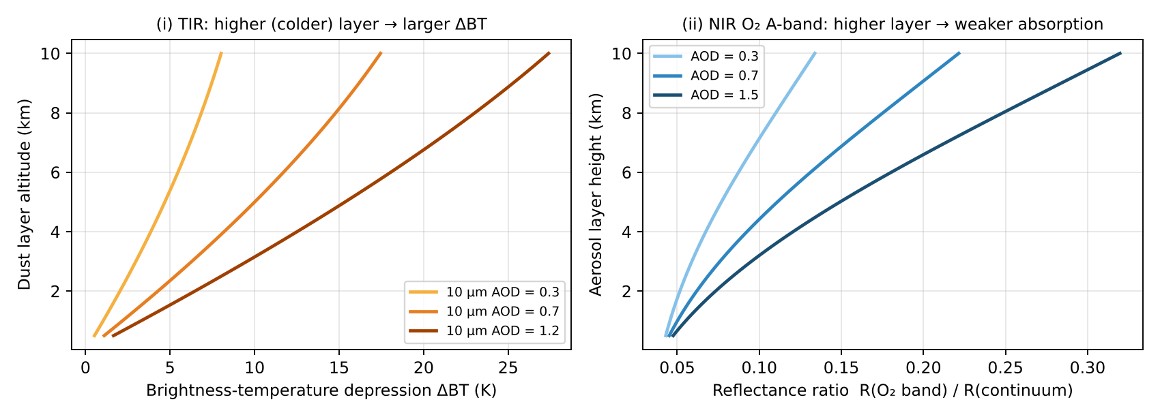
Figure 35 — Simple-model sensitivity of the TIR and O₂ A-band signals to aerosol layer height.
Other passive methods (useful to cite): stereo/multi-angle parallax (MISR, plume height for fires/volcanoes), UV Rayleigh–aerosol interaction (UVAI dependence on height), O₂–O₂ collision complex at 477 nm (OMI).

Worked example — thermal contrast and O₂ path
- TIR: surface 310 K, dust layer at 4 km → T ≈ 310 − 6.5×4 ≈ 284 K → contrast ≈ 26 K. With 10 µm AOD = 0.7 the brightness-temperature depression is ≈ 7 K (see the TIR sensitivity figure in this chapter).
- Same layer at 1 km → contrast ≈ 6.5 K → depression ≈ 2 K: low layers are hard to detect.
- O₂ A-band: fraction of the O₂ column above a layer at z ≈ e^(−z/8 km): 6 km → 0.47, 1 km → 0.88 → a higher layer roughly halves the O₂ absorption seen.

Quick Q&A — hỏi nhanh, đáp nhanh
- Q: Why the O₂ A-band and not a H₂O band? → A: O₂ is well mixed with a known profile; H₂O is highly variable.
- Q: Why does the TIR method fail at night over deserts? → A: Surface cooling and inversions make the layer as warm as the surface → no thermal contrast.
- Q: How does a bright surface affect the O₂ A-band method? → A: Many photons reach the surface (long path), diluting the aerosol signal.
- Q: How can the passive results be validated? → A: With lidar profiles (CALIOP, EarthCARE, ground lidars).

Liên tưởng — memory hooks
- TIR: đoán độ cao ngọn núi bằng nhiệt độ trên đỉnh (càng cao càng lạnh). Dải O₂: đoán độ sâu nơi ánh sáng “bật lại” bằng lượng O₂ (như lượng mực) mà nó đã đi qua.

Exam checklist — must mention
- TIR: emission at layer temperature; T(z) decreases with height → higher layer = colder = lower brightness temperature; needs thermal contrast; works day/night; dust/ash.
- NIR O₂ A-band: well-mixed O₂ absorber; higher aerosol layer shortens photon path → weaker O₂ absorption; daytime, sensitive to surface albedo.
- Both retrieve height together with AOD by fitting spectra with an RT model / optimal estimation.

Ý chính (tóm tắt tiếng Việt)
- Hồng ngoại nhiệt: lớp bụi phát xạ theo nhiệt độ của chính nó; nhiệt độ giảm theo độ cao → lớp càng cao càng lạnh → nhiệt độ sáng đo được càng thấp. Cần tương phản nhiệt với bề mặt; đo được cả đêm và trên sa mạc.
- Cận hồng ngoại (dải A của O₂, 760 nm): O₂ phân bố đều và đã biết; lớp aerosol càng cao → photon bị phản xạ sớm → đường đi qua O₂ ngắn → hấp thụ O₂ yếu hơn. Chỉ ban ngày, nhạy với albedo bề mặt.
- Cả hai đều truy hồi đồng thời độ cao và AOD bằng mô hình truyền bức xạ.

PART C — Formula sheet and acronyms
Last-minute revision

C.1 Key formulas
Concept | Formula / value
RTE (lecture) | dI/dl = −k_ext·I + J ; k_ext = α_gas + s_gas + α_aer + s_aer
Gas layer, no scattering | J = α·B(T) ; I(L) = I(0)e^(−τ(0,L)) + ∫ B(T(l)) e^(−τ(l,L)) dτ
Surface boundary | I(0) = ε_s B(T_s) + (1 − ε_s) I_s ; 1 − ε_s = albedo
Optical depth | τ = Σ ∫ σᵢ Nᵢ dl ; homogeneous: τ = σ·N·L ; t = e^(−τ)
Line widths | Doppler ∝ ν̃ √(T/m) ; Lorentz ∝ P (T₀/T)ⁿ ; Voigt = both
Lifetime | τ = M / L ; 1/τ = Σ 1/τᵢ ; τ_chem = 1/(k[OH])
Beer–Lambert | I = I₀ exp(−τ), τ = ∫ (σ_a + σ_s) n ds
Planck / Wien | B_λ(T) = 2hc²/λ⁵ · 1/(e^{hc/λkT} − 1) ; λ_max T = 2898 µm K
DOAS | ln(I₀/I) = Σ σᵢ′ SCDᵢ + polynomial ; VCD = SCD / AMF
Optimal estimation | x̂ = x_a + G(y − K x_a) ; A = GK ; DOFS = tr(A)
Size parameter | x = 2πr/λ ; Rayleigh σ ∝ r⁶/λ⁴ ; Q_ext → 2
Ångström | τ(λ) = τ(λ₀)(λ/λ₀)^−α
Single scattering albedo | ω₀ = σ_s / (σ_s + σ_a)
Dobson Unit | 1 DU = 2.69 × 10¹⁶ molecules cm⁻²

Acronym | Meaning
AOD | Aerosol Optical Depth
AMF / SCD / VCD | Air Mass Factor / Slant / Vertical Column Density
AK, DOFS | Averaging Kernel, Degrees Of Freedom for Signal
DOAS | Differential Optical Absorption Spectroscopy
TOA | Top Of Atmosphere
RTE | Radiative Transfer Equation
LUT | Look-Up Table
ALH | Aerosol Layer Height
UVAI | UV Absorbing Aerosol Index
TROPOMI, OMI, GOME-2 | UV–vis–SWIR nadir spectrometers
IASI, AIRS, CrIS | Thermal IR nadir sounders
MLS, MIPAS, OSIRIS | Limb sounders
SAGE, ACE-FTS | Solar occultation
CALIOP, ATLID | Space lidars (active)

