STUDY GUIDE
Satellite Remote Sensing of Atmospheric Composition
Trace gases • Aerosols • Radiative transfer • Retrieval theory
Đề cương ôn tập — 8 câu hỏi lý thuyết, có đáp án mẫu, phương trình và sơ đồ

How to use this guide
- Each chapter = one exam question: the question, a model answer in English, key equations, diagrams to reproduce, and an exam checklist.
- The green box at the end of each chapter is a short Vietnamese summary for quick revision.
- Diagrams are simplified on purpose: they are the sketches you should be able to redraw by hand in the exam. Charts marked (schematic) are illustrative; Planck and Mie charts are computed from the real equations.
- Figures marked "Lecture slide" are your own class photos.

Contents

1. Sinks and lifetime of air pollutants
Question
- What are possible sinks of air pollutants in the atmosphere? How do we understand the typical lifetime of an air pollutant by inspecting its spatial distribution from space? Provide examples of typical lifetime (orders of magnitude) of air pollutants.

1.1 Sinks of air pollutants
A sink is any process that removes a species from the atmosphere (or from the air mass considered). The main sinks are:
- Chemical loss (gas-phase oxidation) — the dominant sink for most reactive gases. The main oxidant is the hydroxyl radical OH (the "detergent of the atmosphere"), plus O₃, NO₃ (at night) and halogen radicals. Example: CO + OH → CO₂ + H; CH₄ + OH → CH₃ + H₂O; NO₂ + OH + M → HNO₃.
- Photolysis — destruction by solar UV/visible photons. Example: NO₂ + hν (λ < 420 nm) → NO + O; HCHO + hν → products; CFCs photolysed by hard UV in the stratosphere.
- Dry deposition — direct uptake at the surface (vegetation stomata, soil, water, buildings) without precipitation. Described by a deposition velocity v_d (flux F = −v_d·C). Important for O₃, SO₂, NH₃, HNO₃, coarse particles (gravitational settling).
- Wet deposition — scavenging by clouds and precipitation: in-cloud (rainout, aerosols act as CCN) and below-cloud (washout). Main sink for soluble gases (HNO₃, SO₂, NH₃) and for most aerosols.
- Heterogeneous / multiphase chemistry — reactions on or inside aerosol particles and cloud droplets (e.g. N₂O₅ hydrolysis to HNO₃, aqueous oxidation of SO₂ to sulfate). Gas → particle conversion (nucleation, condensation) is a sink for the gas but a source of aerosol.
- Transport out of the domain — export to the free troposphere or stratosphere. For the global atmosphere, transport to the stratosphere (followed by photolysis) is the sink of long-lived gases (N₂O, CFCs).
If several sinks act in parallel, their first-order loss rates add up:
τ = M / L = M / (F_out + L_chem + D_dry + D_wet) (steady state: τ = M / P)
1/τ = 1/τ_chem + 1/τ_photolysis + 1/τ_dry + 1/τ_wet τ_chem = 1 / (k·[OH])
where M is the atmospheric burden (mass or number of molecules) and L the total loss rate. Example: k(CO+OH) ≈ 2×10⁻¹³ cm³ s⁻¹, [OH] ≈ 1×10⁶ cm⁻³ ⇒ τ ≈ 5×10⁶ s ≈ 2 months.

1.2 Reading lifetime from satellite maps
The key idea is the competition between lifetime τ and transport time. During its lifetime, a molecule travels a distance L ≈ U·τ (U ≈ wind speed, ~5–10 m s⁻¹ horizontally). Mixing around a latitude band takes ~weeks, inter-hemispheric mixing ~1 year. Hence:
- Short-lived species (hours–days): the satellite map looks like a map of the sources: strong hotspots over cities, power plants, ships, fires, sharply decreasing within tens–hundreds of km; high spatial variability, low background. Example: NO₂ (TROPOMI) highlights megacities and highways; SO₂ shows individual smelters/volcanoes; HCHO follows isoprene emissions.
- Medium-lived species (weeks–months): plumes and continental-scale transport become visible: CO from fires in Africa/Amazonia transported across oceans; aerosol (dust) plumes over the Atlantic. Gradient mainly between hemispheres and source continents.
- Long-lived species (years–centuries): the gas is well mixed; the map is nearly uniform (variations of only ~1 %), with a small north–south gradient and a seasonal cycle. Example: CO₂ (OCO-2, ~400+ ppm everywhere), CH₄, N₂O. Detecting sources requires very high precision.
Quantitative rule (Junge relationship): the relative spatial variability σ/mean of a species is inversely related to its lifetime, roughly σ/C ≈ 0.14/τ (τ in years). Plotting lifetime against spatial scale gives the diagram below. One can also derive τ from satellite data directly: e.g. the decay of NO₂ downwind of a point source (exponential fit, line density versus distance x: C(x) ∝ exp(−x/(U·τ))) gives τ_NO₂ ≈ 2–6 h.
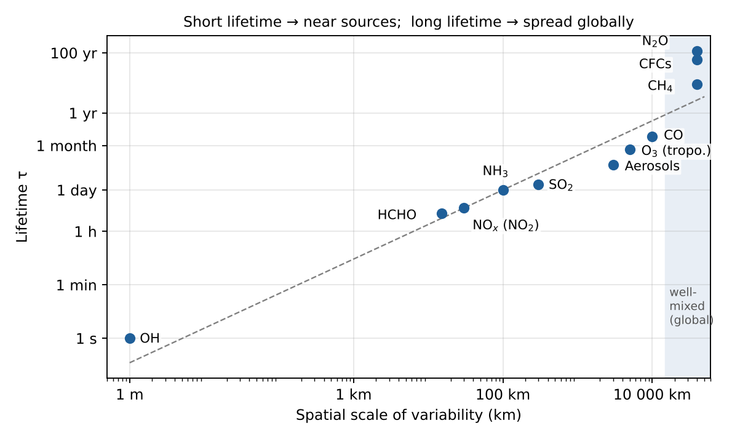
Figure 1 — Lifetime versus spatial scale of variability (order of magnitude).
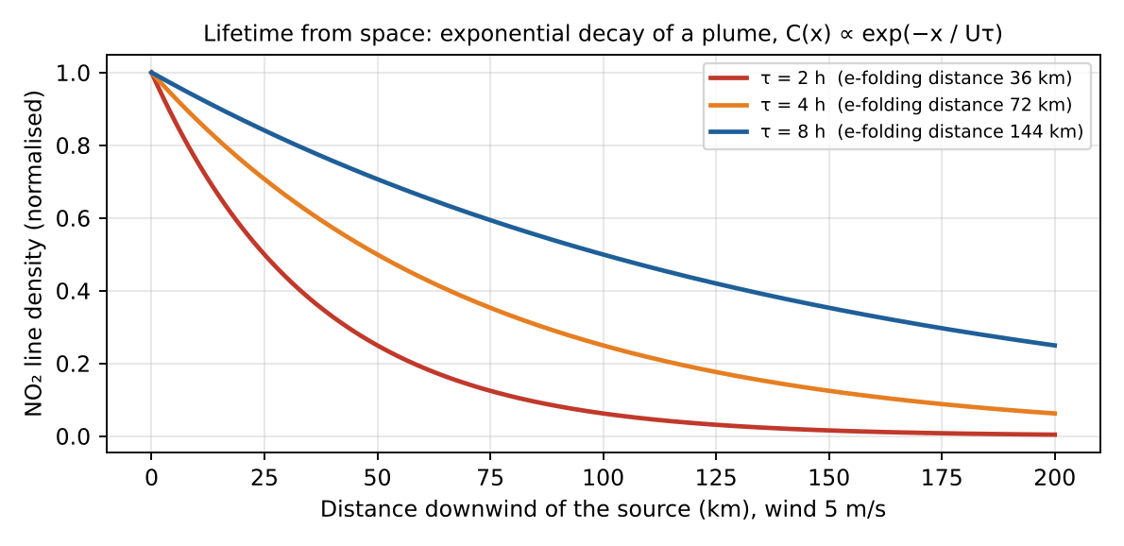
Figure 2 — Deriving a lifetime from a satellite plume: the shorter τ, the faster the decay downwind.
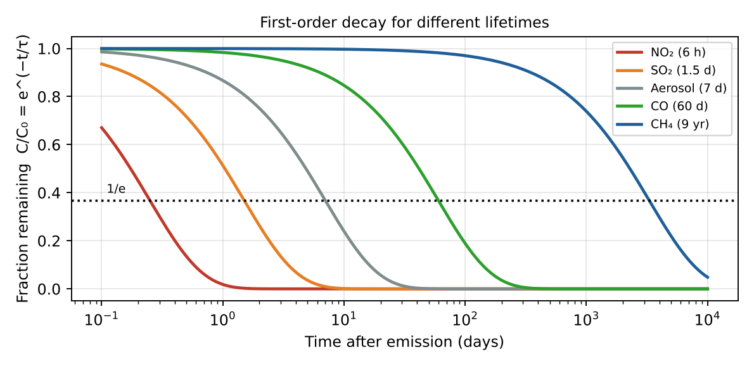
Figure 3 — First-order decay C/C₀ = e^(−t/τ) for typical air pollutants.

1.3 Typical lifetimes (orders of magnitude)
Species | Typical lifetime | Main sink | Aspect from space
OH, NO₃ | ~1 s / seconds–minutes | Fast chemistry | Not mapped directly
NO₂ / NOₓ (boundary layer) | hours (2–12 h; longer in winter) | OH → HNO₃, N₂O₅ hydrolysis | Hotspots on sources
HCHO, glyoxal | hours | Photolysis, OH | Follows VOC sources/fires
SO₂ | ~1–2 days (weeks in stratosphere) | OH, aqueous oxidation, dry deposition | Point sources, volcano plumes
NH₃ | hours–1 day | Conversion to NH₄⁺, deposition | Agricultural hotspots
Aerosols (PM, troposphere) | ~1 week (days–2 weeks) | Wet & dry deposition | Regional plumes (dust, smoke)
O₃ (troposphere) | ~3 weeks (days in BL – months in free trop.) | Photolysis + H₂O, NO, HO₂, deposition | Hemispheric background
CO | ~1–2 months | OH | Intercontinental plumes
CH₄ | ~9–12 years | OH, soil, stratosphere | Nearly uniform, ~1 % gradients
N₂O, CFCs | ~50–120 years | Stratospheric photolysis | Well mixed
CO₂ | ~100+ years (no single lifetime) | Ocean & biosphere uptake | Well mixed (±2 %)

Exam checklist — must mention
- List ≥ 4 sinks: OH oxidation, photolysis, dry deposition, wet deposition (+ heterogeneous chemistry, transport).
- Define τ = burden / loss rate; combine sinks with 1/τ = Σ 1/τᵢ.
- Lifetime vs transport time: short τ → map of sources; long τ → well mixed.
- Give orders of magnitude: hours (NO₂), days (SO₂), week (aerosols), months (CO), decade (CH₄), century (N₂O, CO₂).

Ý chính (tóm tắt tiếng Việt)
- Bể chứa (sink): oxy hóa bởi OH, quang phân, lắng đọng khô, lắng đọng ướt, phản ứng dị thể trên hạt/giọt mây, vận chuyển ra khỏi vùng.
- Thời gian sống τ = lượng tồn trữ / tốc độ mất; nhiều quá trình song song: 1/τ = Σ 1/τᵢ.
- So sánh τ với thời gian vận chuyển: τ ngắn → bản đồ vệ tinh trùng với nguồn phát thải (NO₂ ở đô thị); τ dài → phân bố đồng đều toàn cầu (CO₂, CH₄).
- Bậc độ lớn: giờ (NO₂), ngày (SO₂), tuần (aerosol, O₃), tháng (CO), chục năm (CH₄), trăm năm (N₂O, CO₂).

2. Interaction between light and matter
Question
- Describe the main physical mechanisms of interaction between light and matter that modify the intensity of radiation reaching a radiometric sensor. Provide a clear description, the main equations, and schematics of each of these mechanisms.
Radiation travelling from the source (Sun or Earth surface) to the sensor is modified by three processes: absorption and scattering (which together form extinction) remove energy from the beam, while emission and scattering into the beam add energy. Surface reflection also matters for the radiance seen from space.
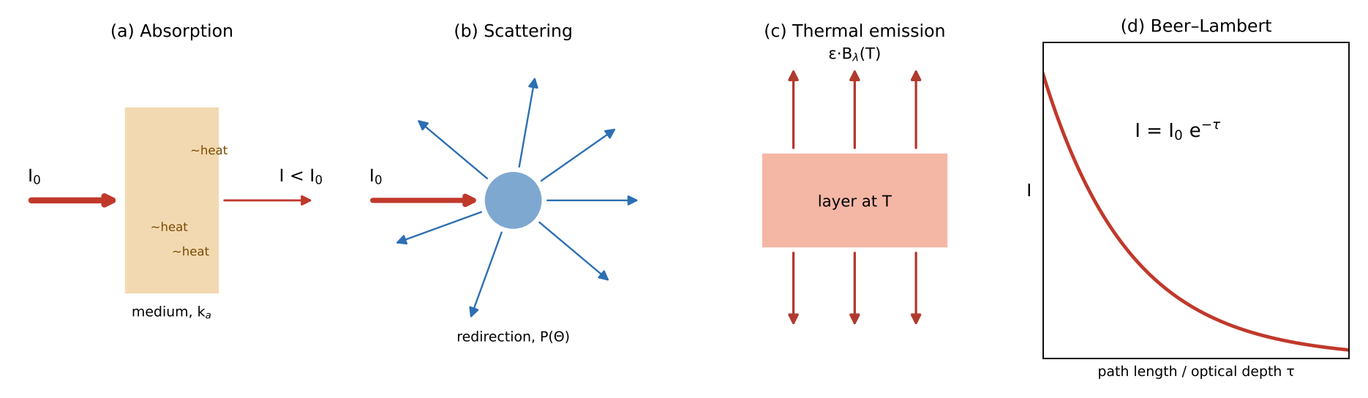
Figure 4 — The three mechanisms and the Beer–Lambert law of extinction.

2.1 Absorption
A photon is absorbed by a molecule or particle if its energy matches a transition: E = hν = E₂ − E₁. The energy is converted into internal energy (and finally heat).
- Electronic transitions — UV/visible (e.g. O₃ Hartley–Huggins bands 250–350 nm, NO₂ 400–450 nm, SO₂ 300–320 nm).
- Vibrational–rotational transitions — infrared (CO₂ 15 µm and 4.3 µm, O₃ 9.6 µm, CH₄ 7.7 µm and 2.3 µm, CO 4.6 µm and 2.3 µm, H₂O).
- Pure rotational transitions — microwave / far-IR (H₂O, O₂ 60 GHz, ClO).
Each gas therefore has a spectral fingerprint (absorption cross-section σ(λ)) — this is what makes gas identification possible. Line shape depends on pressure (Lorentz broadening, dominant in the low atmosphere) and temperature (Doppler broadening, dominant at high altitude). The absorption coefficient is:
k_a(λ) = σ_a(λ) · n n = number density (molec. cm⁻³)

2.2 Scattering
The photon is redirected without change of wavelength (elastic scattering) by molecules or particles; it is removed from the direct beam but may be added to another direction. Its angular distribution is the phase function P(Θ). The regime depends on the size parameter x = 2πr/λ (see Chapter 7):
- Rayleigh scattering (molecules, x ≪ 1): σ_R ∝ λ⁻⁴, symmetric phase function P(Θ) = ¾(1 + cos²Θ) — blue sky.
- Mie scattering (aerosols, cloud droplets, x ~ 1): weaker spectral dependence (Ångström law τ ∝ λ^−α), strong forward peak.
- Inelastic Raman scattering (rotational Raman by N₂, O₂): causes the Ring effect (filling-in of Fraunhofer lines) important in UV-vis DOAS retrievals.
The single scattering albedo ω₀ = σ_s / (σ_s + σ_a) tells which fraction of the extinction is scattering (ω₀ = 1 for non-absorbing particles, ~0.85 for smoke).
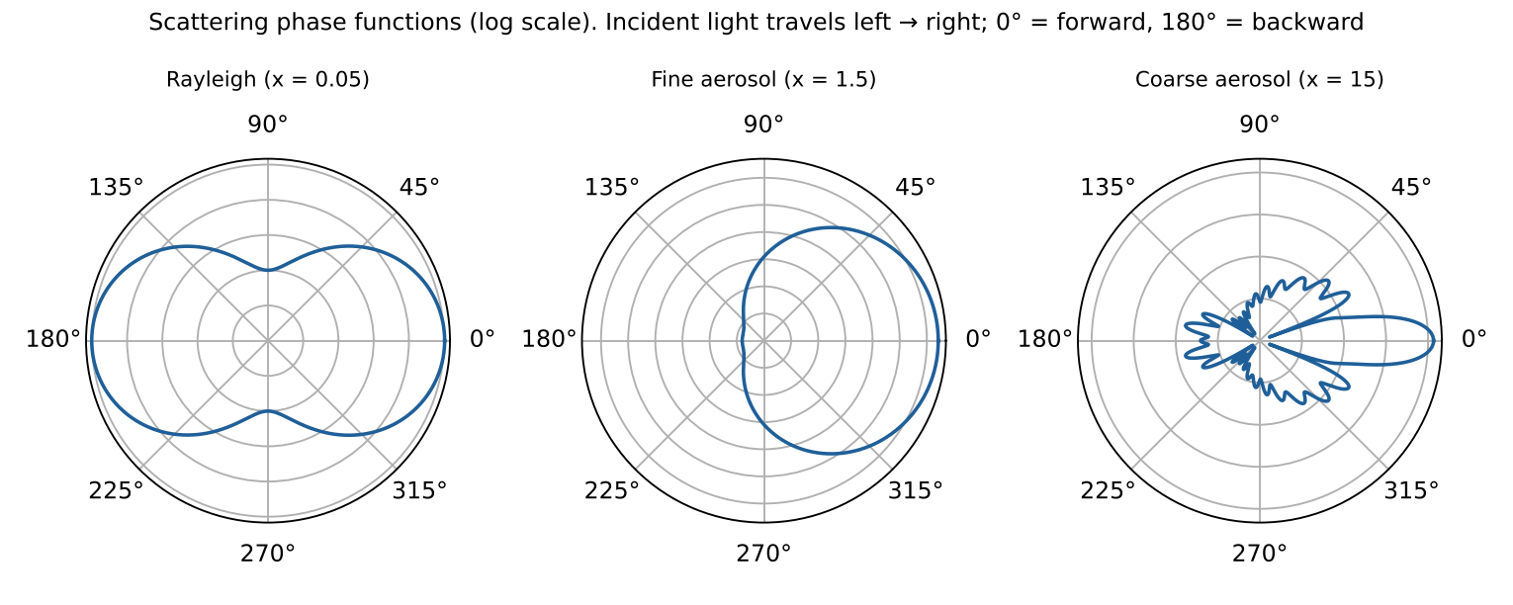
Figure 5 — Phase functions computed with Mie theory: symmetric for molecules, strongly forward-peaked for large particles.

2.3 Emission
Any body at temperature T > 0 K emits radiation. For a black body the spectral radiance is the Planck function; real media emit ε·B with emissivity ε. In local thermodynamic equilibrium (Kirchhoff's law) emissivity equals absorptivity: ε_λ = α_λ — a gas that absorbs at a wavelength also emits at that wavelength. Emission dominates in the thermal infrared and microwave (λ > ~4 µm), while solar reflection dominates in UV–vis–NIR.
B_λ(T) = (2hc² / λ⁵) · 1 / (exp(hc / λk_BT) − 1) Planck
λ_max · T = 2898 µm·K ; M = σ_SB · T⁴ Wien ; Stefan–Boltzmann
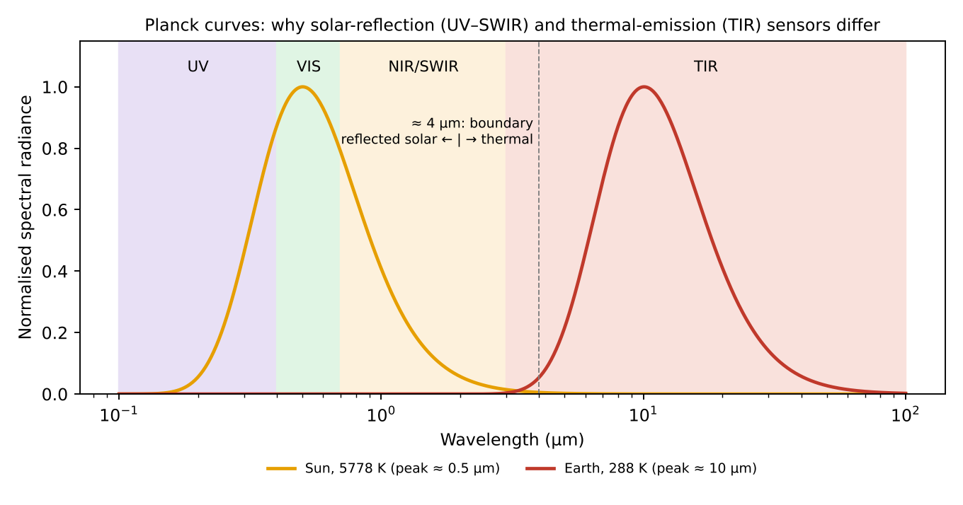
Figure 6 — Planck curves of the Sun and the Earth: solar reflection dominates below ~4 µm, thermal emission above.

2.4 Extinction — the Beer–Lambert law
Along a path ds, absorption + scattering out of the beam reduce the intensity proportionally to the intensity itself:
dI_λ = −k_e(λ) · I_λ · ds , k_e = k_a + k_s = Σ σᵢ nᵢ
I_λ(s) = I_λ(0) · exp(−τ_λ) , τ_λ = ∫ k_e(λ, s) ds optical depth
The transmittance is T = e^(−τ). For a slant path, τ_slant = τ_vertical / cos θ (air mass factor in a plane-parallel atmosphere).
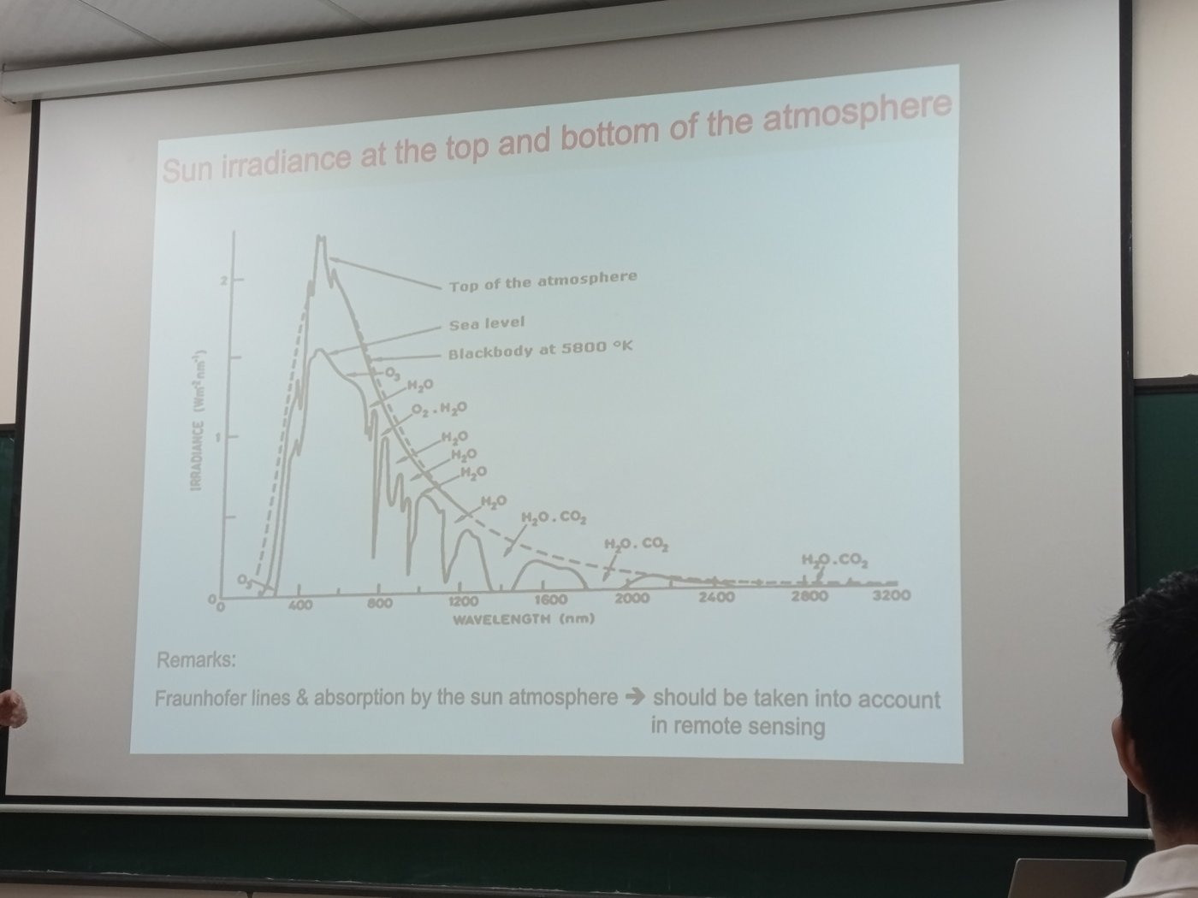
Figure 7 — Lecture slide (class photo): solar irradiance at the top of the atmosphere vs sea level — the difference is absorption (O₃, O₂, H₂O, CO₂) and scattering.

2.5 Radiative transfer equation (RTE) — putting everything together
dI_λ / ds = −k_e I_λ + k_a B_λ(T) + (k_s / 4π) ∫ P(Θ) I_λ(Ω′) dΩ′
Term 1 = extinction (loss), term 2 = thermal emission (gain), term 3 = scattering from all other directions into the line of sight (gain). Simplified cases used in remote sensing:
- Thermal IR, no scattering (Schwarzschild equation) — radiance at the top of atmosphere = surface emission attenuated + emission of each layer weighted by its transmission to space:
I_λ(TOA) = ε_s B_λ(T_s) T_λ(0,∞) + ∫₀^∞ B_λ(T(z)) · ∂T_λ(z,∞)/∂z dz
- UV–visible, solar: reflected sunlight; I/I₀ depends on Rayleigh + aerosol scattering, surface albedo and gas absorption (DOAS: ln(I₀/I) = Σ σᵢ·SCDᵢ + smooth polynomial).
- Surface reflection: characterised by albedo / BRDF; Lambertian surface: I = A·F₀·cos θ₀ / π.

Exam checklist — must mention
- Three mechanisms: absorption (quantised transitions, σ(λ) fingerprint), scattering (Rayleigh/Mie, phase function, ω₀), emission (Planck, Kirchhoff).
- Beer–Lambert: I = I₀ e^−τ, τ = ∫ k_e ds, k_e = k_a + k_s.
- Write the full RTE and identify each term; Schwarzschild for thermal IR.
- Draw: absorbing slab, scattering particle with arrows in all directions, emitting layer, exponential decay curve.

Ý chính (tóm tắt tiếng Việt)
- Ba cơ chế: hấp thụ (chuyển mức năng lượng điện tử/dao động/quay → mỗi khí có “dấu vân tay” phổ), tán xạ (đổi hướng photon: Rayleigh ∝ λ⁻⁴, Mie), phát xạ nhiệt (Planck, định luật Kirchhoff ε = α).
- Hấp thụ + tán xạ = suy giảm (extinction), tuân theo định luật Beer–Lambert I = I₀·e^(−τ).
- Phương trình truyền bức xạ: suy giảm − phát xạ + tán xạ vào hướng nhìn.

3. Passive remote sensing of trace gases: measured quantity and retrieval
Question
- What is the quantity directly measured by passive satellite sensors for remote sensing of atmospheric trace gases? Explain the principle to derive the abundance of a trace gas in terms of (i) integrated concentration over the atmospheric column and (ii) vertical profile of gas concentration. Where is the information on the vertical distribution of the gas coming from?

3.1 The measured quantity: spectral radiance
A passive sensor does not emit radiation; it measures the spectral radiance I(λ) (W m⁻² sr⁻¹ µm⁻¹ or per cm⁻¹) arriving at the instrument in a given direction, over many wavelength channels (a spectrum). Depending on the spectral range:
- UV–visible–SWIR (solar backscatter): Earthshine radiance I(λ), usually normalised by the measured solar irradiance → reflectance R(λ) = π I(λ) / (μ₀ E₀(λ)). Instruments: GOME-2, OMI, TROPOMI, OCO-2.
- Thermal infrared: radiance emitted by the surface and atmosphere, often expressed as brightness temperature T_B. Instruments: IASI, AIRS, CrIS.
- Occultation: transmission I/I₀ of the Sun (or star) through the limb (ACE-FTS, SAGE).
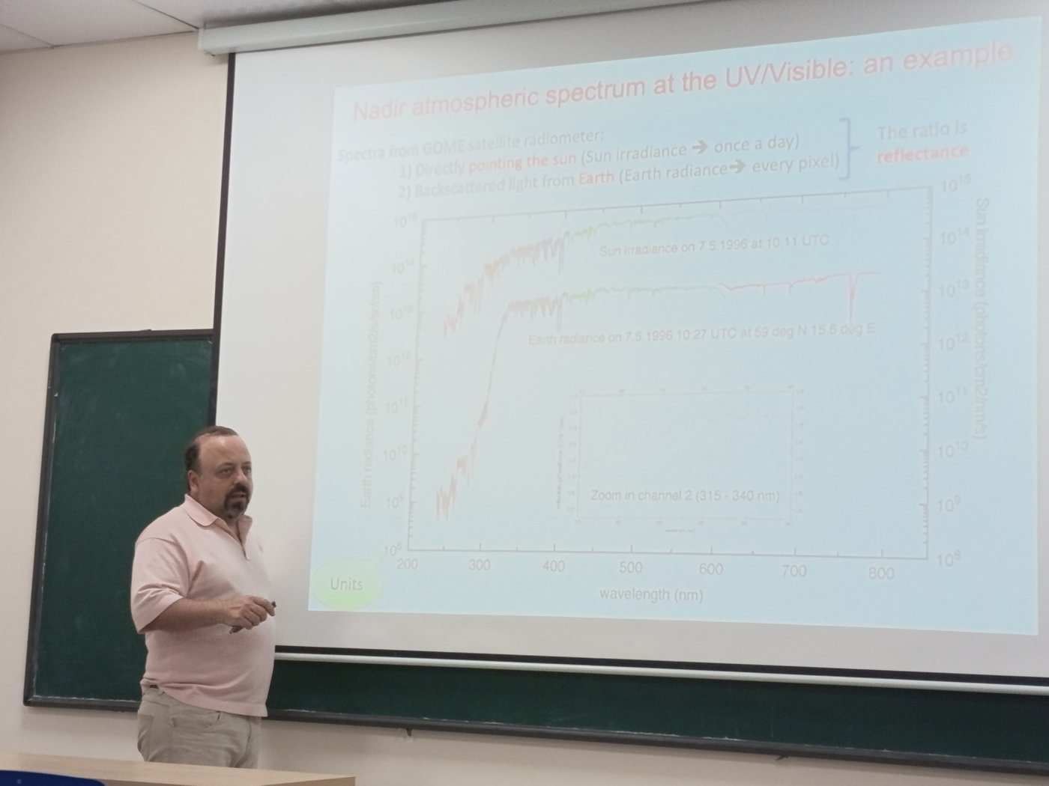
Figure 8 — Lecture slide (class photo): GOME solar irradiance and Earth radiance; their ratio is the reflectance.
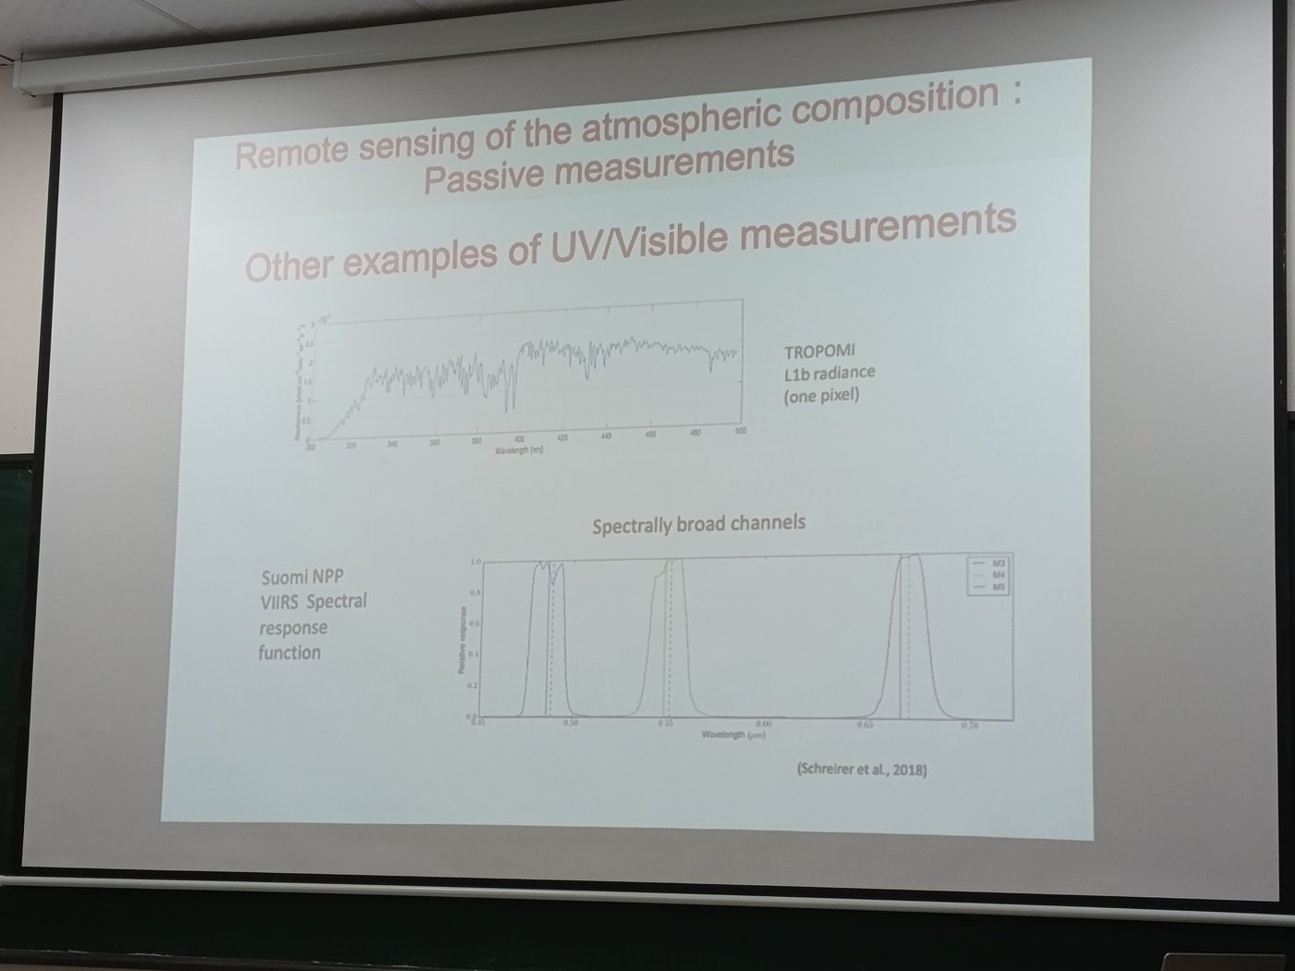
Figure 9 — Lecture slide (class photo): TROPOMI L1b radiance of one pixel (hyperspectral) vs VIIRS broad channels.
The concentration is never measured directly: it is retrieved by inverting a radiative transfer model (forward model) y = F(x, b) + ε, where y = measured spectrum, x = state (gas amounts), b = other parameters (temperature, surface, clouds, aerosols).

3.2 (i) Total / tropospheric column — integrated concentration
The vertical column density VCD = ∫ n(z) dz (molecules cm⁻², or Dobson Units for O₃: 1 DU = 2.69×10¹⁶ molec cm⁻²). Typical approach in the UV–vis: DOAS (Differential Optical Absorption Spectroscopy), in 3 steps:
- Step 1 – Spectral fit → slant column (SCD). From Beer–Lambert, the optical depth is separated into a rapidly varying part (molecular absorption structures) and a smooth part (Rayleigh, Mie, surface):
ln( I₀(λ) / I(λ) ) = Σᵢ σᵢ′(λ) · SCDᵢ + Σₚ aₚ λᵖ SCD = ∫ n ds along the light path
- The differential cross-sections σ′ are known from the lab; a least-squares fit gives SCD for each gas (NO₂, O₃, SO₂, HCHO…).
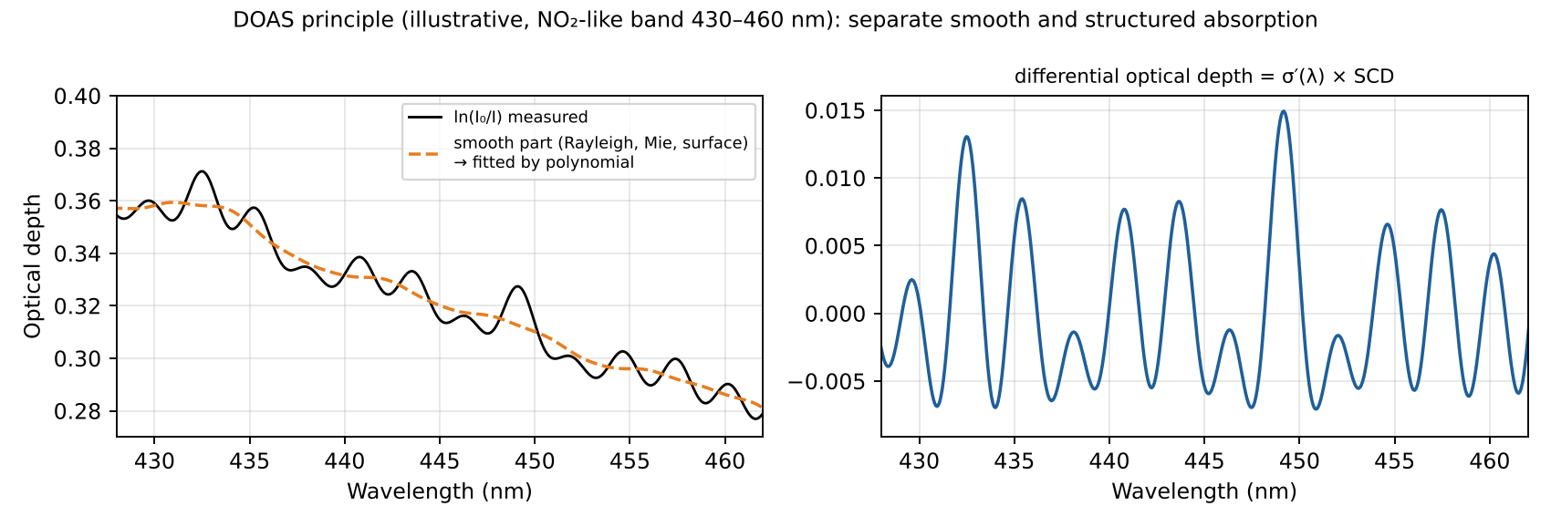
Figure 10 — DOAS: the smooth broadband part is removed; the narrow structures are fitted with lab cross-sections to obtain the slant column.
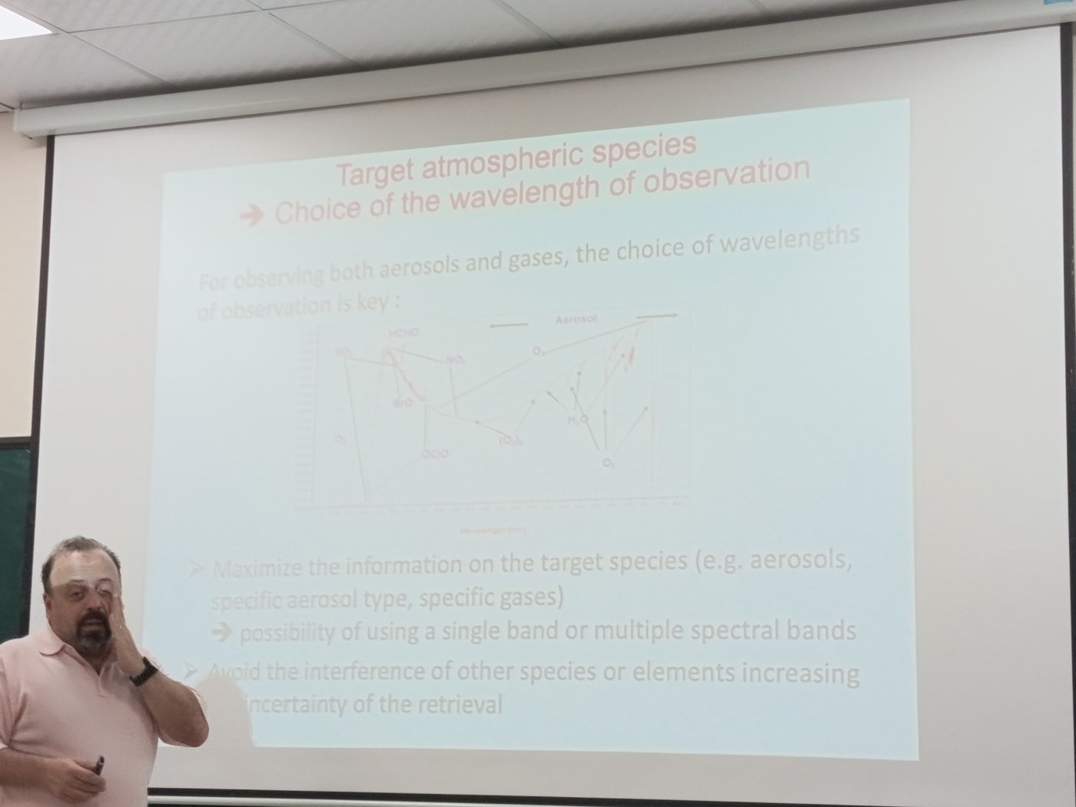
Figure 11 — Lecture slide (class photo): choice of the wavelength window for each target species (SO₂, HCHO, BrO, NO₂, O₃, OClO, O₂-O₂, H₂O, O₂, aerosol).
- Step 2 – Air Mass Factor (AMF). The SCD depends on the light path. A radiative transfer model computes AMF = SCD / VCD, which depends on viewing/solar geometry, surface albedo, clouds, aerosols and the a priori shape of the profile. Geometric approximation: AMF ≈ 1/cos θ₀ + 1/cos θ.
VCD = (SCD − SCD_strat) / AMF_trop
- Step 3 – (for tropospheric gases) stratosphere–troposphere separation (reference sector over clean ocean, chemistry-transport model assimilation).
Alternative approaches: optimal estimation with a scaling of the a priori profile (CO in SWIR/TIR), or ratio methods for greenhouse gases (XCO₂ = column CO₂ / column dry air, using O₂ A-band).

3.3 (ii) Vertical profile
Discretise the atmosphere into N layers: x = (x₁ … x_N). Linearise the forward model around a reference: y = y₀ + K(x − x₀) + ε, where K = ∂F/∂x is the Jacobian (weighting functions). The problem is ill-posed (more unknowns than independent pieces of information, noise), so it is regularised. The standard method is Optimal Estimation (Rodgers), minimising:
χ² = (y − F(x))ᵀ S_ε⁻¹ (y − F(x)) + (x − x_a)ᵀ S_a⁻¹ (x − x_a)
x̂ = x_a + (Kᵀ S_ε⁻¹ K + S_a⁻¹)⁻¹ Kᵀ S_ε⁻¹ (y − K x_a) (linear case; iterate Gauss–Newton if nonlinear)
x_a = a priori profile, S_a its covariance, S_ε measurement noise covariance. Other methods: Tikhonov regularisation, onion-peeling for limb data.

3.4 Where does the vertical information come from?
The information comes from the fact that different measurements are sensitive to different altitudes, i.e. their weighting functions K(z) peak at different heights:
- Spectral dependence of absorption strength (nadir): at wavelengths where the gas absorbs strongly, photons do not penetrate deep → the signal comes from high altitudes; where it absorbs weakly, the radiation comes from lower layers. Example: O₃ in the UV — at 270 nm sensitivity in the upper stratosphere, at 310–330 nm down to the troposphere (backscatter Ultraviolet, BUV/SBUV method).
- Pressure and temperature dependence of line shapes (TIR): line width ∝ pressure (Lorentz); the line centre probes high altitudes, the wings probe low altitudes. The temperature profile T(z) also creates contrast: emission at a layer is B(T(z)). This is the basis of IASI O₃/CO profiles.
- Viewing geometry (limb/occultation): each line of sight has a tangent height; scanning the limb gives vertical resolution of 1–3 km directly by geometry (onion peeling).
- Temperature-dependent cross-sections, multiple angles, and Raman/Rayleigh scattering add small extra information.
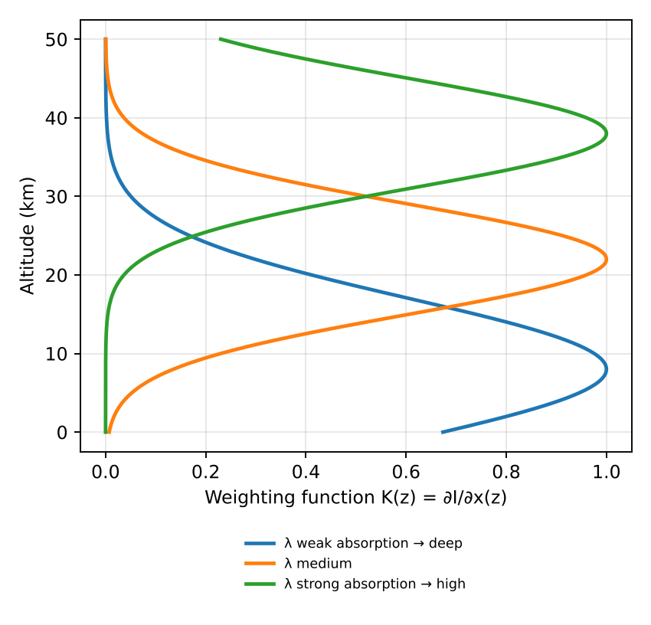
Figure 12 — Weighting functions peak at different altitudes for different absorption strengths.

Exam checklist — must mention
- Measured quantity = spectral radiance (reflectance / brightness temperature / transmission), NOT concentration.
- Column: DOAS fit → SCD; AMF from RT model → VCD = SCD/AMF.
- Profile: forward model + Jacobian K + Optimal Estimation with a priori.
- Vertical information: different penetration depths vs λ, pressure broadening of lines, temperature contrast, limb geometry.

Ý chính (tóm tắt tiếng Việt)
- Cảm biến thụ động đo bức xạ phổ (radiance) — không đo nồng độ trực tiếp; nồng độ được “truy hồi” bằng cách nghịch đảo mô hình truyền bức xạ.
- Cột tổng: DOAS → cột nghiêng SCD; hệ số khối khí AMF → cột thẳng đứng VCD = SCD/AMF.
- Profil thẳng đứng: ước lượng tối ưu (Optimal Estimation) dùng ma trận Jacobian K và profil tiên nghiệm.
- Thông tin độ cao đến từ: độ hấp thụ mạnh/yếu theo bước sóng (độ xuyên sâu khác nhau), mở rộng vạch theo áp suất, tương phản nhiệt độ, và hình học quan sát limb.

4. Pointing geometries of spaceborne sensors
Question
- What are the possible pointing geometries of spaceborne sensors for sounding the atmospheric composition? What are the advantages and disadvantages of each case?
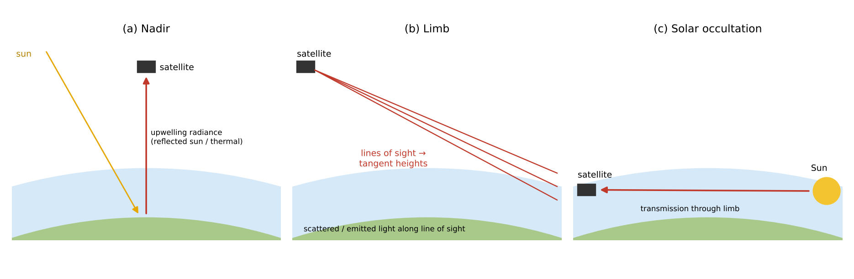
Figure 13 — Nadir, limb and occultation viewing geometries.

4.1 Nadir (and off-nadir / cross-track scanning)
The instrument looks down towards the Earth (vertically or with a swath scanning across track). It measures solar radiation backscattered by the surface/atmosphere (UV–vis–SWIR) or thermal emission (TIR). Examples: TROPOMI, OMI, GOME-2, IASI, MOPITT, OCO-2.

4.2 Limb sounding
The instrument looks tangentially through the atmosphere, above the horizon, scanning the line of sight vertically (tangent heights from ~5 to 100 km). It measures scattered sunlight (limb scattering: OSIRIS, OMPS-LP, SCIAMACHY limb) or thermal emission (MIPAS, MLS microwave).

4.3 Occultation
The instrument looks at a source (Sun, Moon, star, or GPS satellite signals) through the limb during sunrise/sunset of the orbit and measures the transmission I/I₀. Examples: SAGE II/III, ACE-FTS, GOMOS (stellar), GNSS radio occultation (temperature/humidity).

4.4 Comparison
Geometry | Advantages | Disadvantages
Nadir | • Good horizontal resolution (few km: TROPOMI 5.5×3.5 km²) and global daily coverage (wide swath)  • Sees the troposphere / boundary layer → air quality, emissions  • Works day (UV-vis) and day+night (TIR) | • Poor vertical resolution (columns or 1–6 pieces of information)  • Sensitivity to surface (albedo, emissivity), clouds and aerosols  • Short path through atmosphere → weaker absorption signal per layer
Limb (emission / scattering) | • Good vertical resolution (1–3 km) from geometry  • Long path through the atmosphere → high sensitivity, many species (stratospheric chemistry)  • No surface contribution (dark space background)  • Emission limb works day and night; good coverage | • Poor horizontal resolution along line of sight (~200–400 km)  • Cannot see below ~5–10 km (clouds, long path saturation) → not suited for boundary layer  • Complex RT (sphericity, multiple scattering), pointing must be known precisely
Occultation | • Self-calibrating: ratio I/I₀ removes instrument drift → very accurate, ideal for long-term trends  • Very strong signal (Sun), high vertical resolution (~1 km), high S/N  • Simple RT (transmission, Beer–Lambert) | • Very poor coverage: only ~30 profiles/day (2 per orbit for solar), latitude bands depend on orbit  • Poor horizontal resolution along path  • Only upper troposphere / stratosphere
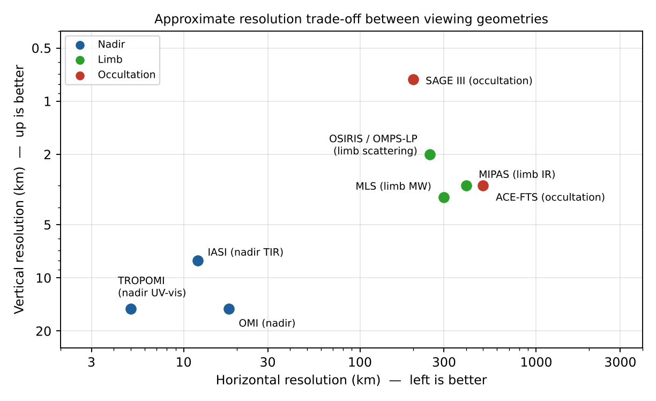
Figure 14 — Approximate horizontal vs vertical resolution of typical instruments for each geometry.
Notes: Orbit also matters — Low Earth orbit (sun-synchronous) gives global coverage once per day at fixed local time; geostationary orbit (GEMS, TEMPO, Sentinel-4) gives hourly observations of one continent in nadir geometry, allowing the diurnal cycle of pollution to be observed. Combining nadir and limb (e.g. SCIAMACHY, OMPS) allows a tropospheric column = total column (nadir) − stratospheric column (limb).

Exam checklist — must mention
- Three geometries: nadir, limb (scattering/emission), occultation (solar/stellar/lunar/GNSS).
- Trade-off: horizontal resolution & tropospheric sensitivity (nadir) ↔ vertical resolution & accuracy (limb/occultation).
- Occultation = self-calibrating, best accuracy, worst coverage.
- Draw the three geometries with Earth, atmosphere shell, lines of sight.

Ý chính (tóm tắt tiếng Việt)
- Nadir: nhìn thẳng xuống → độ phân giải ngang tốt, phủ toàn cầu hằng ngày, nhìn thấy tầng đối lưu; nhưng độ phân giải thẳng đứng kém, nhạy với mây/bề mặt.
- Limb: nhìn tiếp tuyến qua rìa khí quyển → độ phân giải thẳng đứng tốt (1–3 km), không có nền bề mặt; nhưng độ phân giải ngang kém, không xuống thấp dưới ~5–10 km.
- Che khuất (occultation): nhìn Mặt Trời/sao qua rìa khí quyển → tự hiệu chuẩn, rất chính xác; nhưng số lượng phép đo rất ít.

5. Sensitivity of passive retrievals: averaging kernels
Question
- Which magnitude is used to quantify the sensitivity of passive remote sensing methods for retrieving the concentration of trace gases? Explain the general concept and illustrate with drawings a case of ideally perfect sensitivity and a realistic case (such as the retrieval of the ozone profiles using satellite spectral measurements in nadir pointing geometry).

5.1 The averaging kernel matrix
The sensitivity is quantified by the averaging kernel (AK) matrix A, defined as the sensitivity of the retrieved state to the true state:
A = ∂x̂ / ∂x = G K , G = (Kᵀ S_ε⁻¹ K + S_a⁻¹)⁻¹ Kᵀ S_ε⁻¹ G = gain matrix
The retrieved profile is then a smoothed version of the true profile, mixed with the a priori:
x̂ = x_a + A (x_true − x_a) + G ε
- Each row of A (one per retrieval level) shows how the retrieved value at level i is a weighted average of the true profile at all levels. Its width (FWHM) = vertical resolution; the altitude of its peak shows where the information really comes from.
- The sum of the row (area) tells how much comes from the measurement: ≈1 → measurement dominates; ≈0 → retrieved value just equals the a priori.
- The trace of A = Degrees of Freedom for Signal (DOFS) = number of independent pieces of information on the vertical profile: DOFS = tr(A).
- For a total column, the column averaging kernel a(z) = ∂VCD̂/∂n(z) (e.g. AK = AMF_layer / AMF_total in DOAS) shows at which altitudes the column is sensitive; ideal = 1 at all heights.
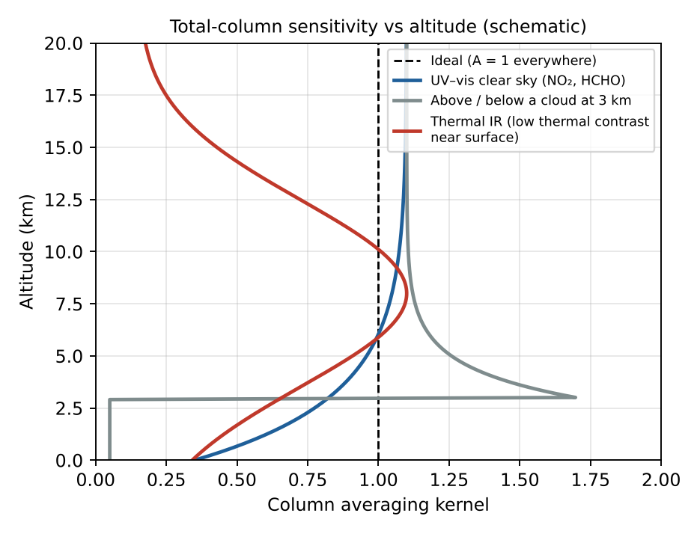
Figure 15 — Column averaging kernels: ideal (=1) vs typical UV-vis, cloudy and thermal-IR cases.
Retrieval error covariance: Ŝ = (I − A) S_a (I − A)ᵀ [smoothing error] + G S_ε Gᵀ [noise error]. Important use: to compare satellite data with a model or another instrument, apply the AKs to the model profile: x_model,smoothed = x_a + A (x_model − x_a).

5.2 Ideal case vs realistic case
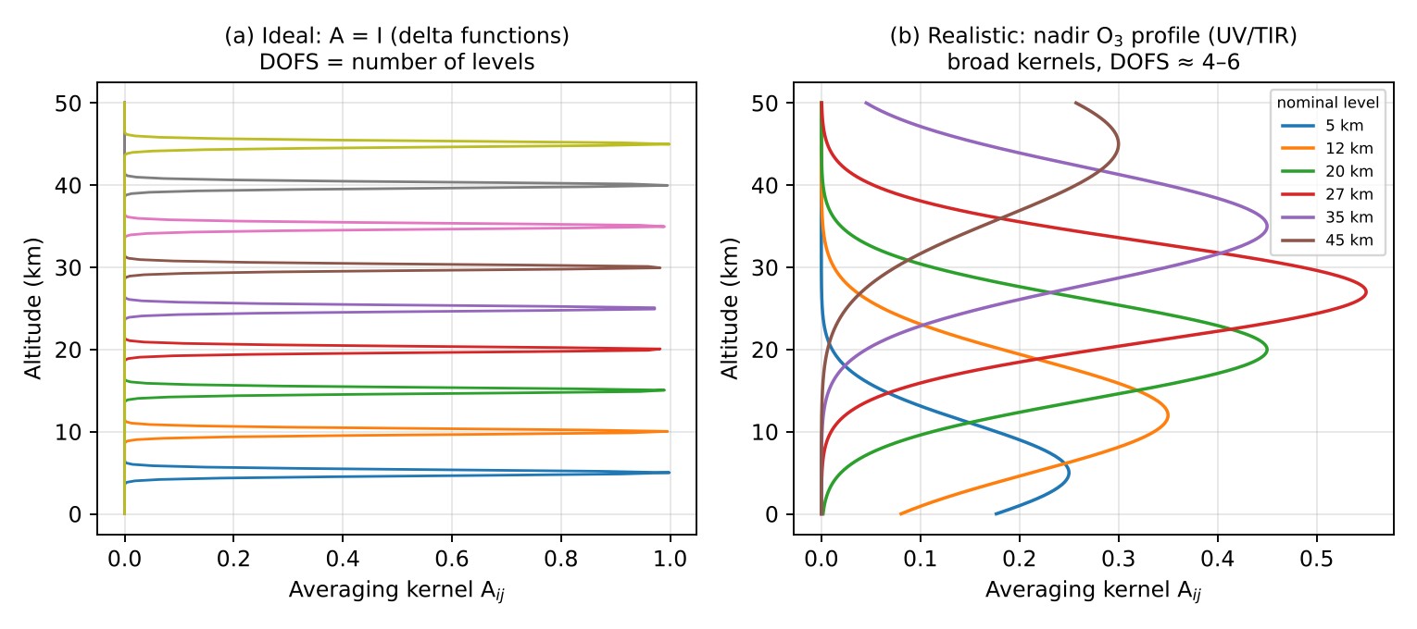
Figure 16 — (a) Perfect sensitivity: A = identity. (b) Typical nadir ozone profile retrieval.
(a) Ideal case: A = I (identity matrix). Each kernel is a delta function equal to 1 at its own level and 0 elsewhere: the retrieval reproduces the true profile exactly, without any dependence on the a priori, infinitely fine vertical resolution, DOFS = number of levels.
(b) Realistic case — nadir ozone profile (e.g. GOME-2/OMI in UV 270–330 nm, or IASI at 9.6 µm):
- Kernels are broad (FWHM ~ 7–15 km) and overlap → vertical resolution of ~6–10 km in stratosphere, poorer in troposphere.
- Peaks are shifted away from the nominal level, and amplitudes are < 1 (≈0.3–0.6).
- DOFS ≈ 4–6 in UV (≈1 for the troposphere), ≈ 3–4 for IASI; i.e. we know the stratospheric profile in ~3–4 thick layers plus roughly 1 piece of tropospheric information.
- Sensitivity is low near the surface (Rayleigh scattering, strong O₃ absorption above, clouds) → near-surface values come mostly from the a priori.
- Sensitivity is also lost at the top (>50 km) where there is little ozone.
By contrast, limb ozone retrievals have narrow kernels (~2–3 km), DOFS ≈ 20–30, close to the ideal case in the stratosphere.

Exam checklist — must mention
- Name: averaging kernel matrix A = ∂x̂/∂x; DOFS = trace(A).
- x̂ = x_a + A(x − x_a) + Gε — retrieval = smoothed truth + a priori contribution.
- Row width = vertical resolution; area = measurement contribution.
- Draw delta functions (ideal) vs broad, overlapping, peak-shifted kernels (nadir O₃, DOFS ≈ 4–6).

Ý chính (tóm tắt tiếng Việt)
- Đại lượng đo độ nhạy: ma trận hạt nhân trung bình (averaging kernel) A = ∂x̂/∂x; vết của A = số bậc tự do tín hiệu (DOFS).
- Trường hợp lý tưởng: A = ma trận đơn vị → hàm delta tại mỗi độ cao, không phụ thuộc tiên nghiệm.
- Thực tế (O₃ nadir): hạt nhân rộng 7–15 km, chồng lên nhau, biên độ < 1, DOFS ≈ 4–6; gần mặt đất độ nhạy thấp → kết quả phụ thuộc nhiều vào profil tiên nghiệm.

6. Passive remote sensing of aerosols
Question
- What properties of aerosols can be measured from passive satellite sensors (mention at least 3 aerosol properties)? Explain the principle of passive remote sensing of aerosols, including the quantity directly measured and how aerosol properties are derived. What are the advantages and limitations of this passive approach as compared to active methods?

6.1 Measurable aerosol properties
- Aerosol Optical Depth (AOD, τ_a) at a given wavelength (e.g. 550 nm) — the most robust product: τ_a = ∫ k_ext,aer(z) dz. It is a proxy for the aerosol load / PM2.5.
- Ångström exponent α (spectral dependence of AOD, τ ∝ λ^−α) → particle size: α ≈ 0–0.5 coarse (dust, sea salt), α ≈ 1.5–2.5 fine (smoke, urban). Also the fine-mode fraction.
- Single Scattering Albedo ω₀ (absorption) — from UV methods (OMI UV Aerosol Index) or multi-angle polarimetry.
- Aerosol type (dust, smoke, sulfate, sea salt) and refractive index, non-sphericity — multi-angle and polarimetric sensors (MISR, POLDER/PARASOL, 3MI).
- Aerosol layer height — O₂ A-band (TROPOMI ALH), stereo (MISR), thermal IR for dust (IASI) — see Chapter 8.
- Absorbing Aerosol Index (UVAI) — qualitative detection of absorbing aerosols (smoke, dust) even above clouds.
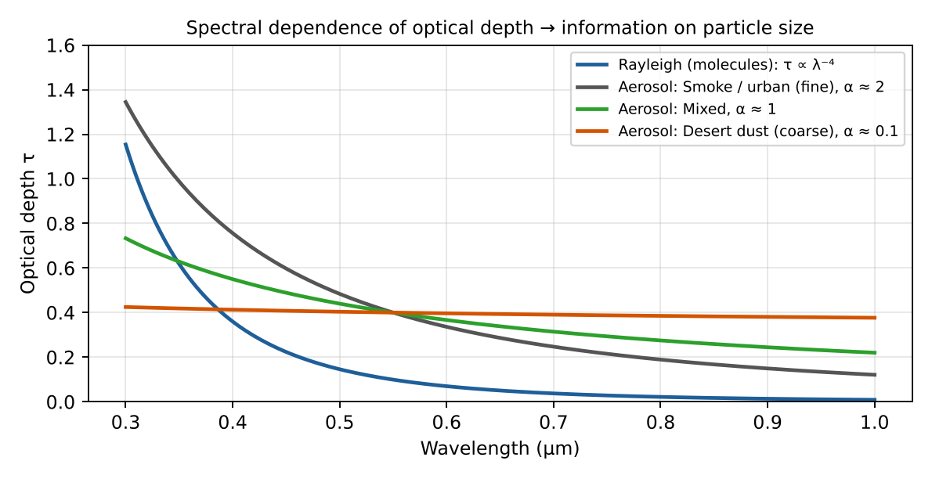
Figure 17 — Spectral dependence of optical depth: the Ångström exponent tells fine from coarse particles.

6.2 Principle
Quantity measured: the TOA spectral (and possibly angular and polarised) reflectance of sunlight, ρ(λ, θ₀, θ, φ) = π I / (μ₀ E₀). Aerosols scatter sunlight back to space, so they increase the reflectance over a dark surface. Simplified single-scattering expression:
ρ_TOA(λ) = ρ_Rayleigh + ρ_aer + T(λ) · ρ_surf / (1 − S ρ_surf)
ρ_aer ≈ ω₀ · τ_a · P(Θ) / (4 μ₀ μ) single scattering
Retrieval steps (e.g. MODIS Dark Target / Deep Blue):
- 1. Cloud screening and selection of suitable pixels (cloud-free, no sun glint, no snow).
- 2. Estimate the surface contribution: over dark ocean ρ_surf ≈ 0 in red/NIR; over vegetation, empirical relationships between 2.1 µm (aerosol-transparent) and visible bands; over bright deserts use the deep blue (412 nm) where surfaces are dark.
- 3. Look-up tables (LUT): a radiative transfer model computes TOA reflectance for a set of aerosol models (size distribution, refractive index → ω₀, P(Θ)) and AOD values, for all geometries.
- 4. Inversion: find the aerosol model + AOD that best matches the measured multi-spectral (multi-angle) reflectance (least squares / optimal estimation). Output: AOD(λ) → Ångström exponent, fine-mode fraction, (ω₀, type).
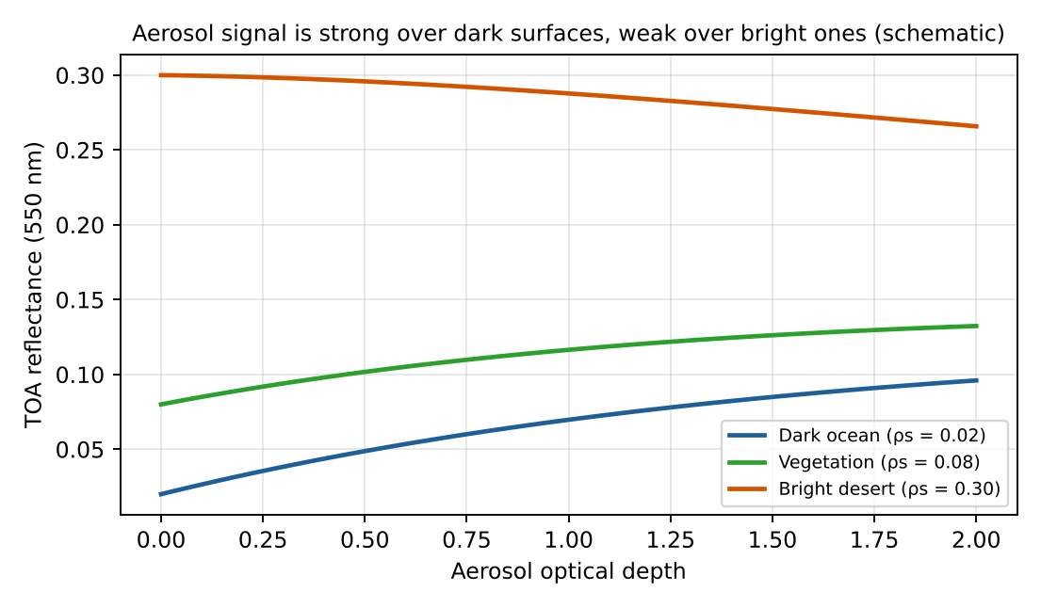
Figure 18 — TOA reflectance vs AOD: large sensitivity over dark ocean, almost none over bright desert.
Multi-angle (MISR) and polarisation (POLDER, SPEXone, HARP2 on PACE) measurements add information on phase function and refractive index, so more properties can be retrieved (ω₀, size distribution, shape).

6.3 Passive vs active (lidar) approaches
 | Passive (MODIS, VIIRS, MISR, POLDER, TROPOMI, IASI) | Active (CALIOP/CALIPSO, ATLID/EarthCARE)
Advantages | • Wide swath → global daily coverage, good horizontal resolution (km)  • Long, mature time series (since 2000), high sampling for air quality and climate  • Lower cost, low power, many spectral bands  • Column-integrated properties (AOD, α, ω₀) | • Gives vertical profile (extinction/backscatter, resolution ~30–60 m)  • Works day and night and over bright surfaces / above clouds  • Depolarisation → particle shape (dust vs spherical)  • Fewer assumptions on surface
Limitations | • Little/no vertical information (column only)  • Daytime only (solar), cloud-free only  • Strong dependence on surface reflectance (difficult over bright deserts, snow)  • Ill-posed: assumptions on aerosol model → uncertainty on type, ω₀  • Cloud contamination | • Very narrow footprint (curtain, ~100 m): poor spatial coverage, revisit ~16 days  • Lidar ratio must be assumed to get extinction → AOD uncertainty  • Low S/N in daytime; attenuation by thick layers  • Expensive, high power
Passive and active methods are complementary: passive provides the horizontal map and AOD, active provides the vertical structure (A-Train concept: MODIS + CALIOP).

Exam checklist — must mention
- ≥3 properties: AOD, Ångström exponent / size (fine-mode fraction), ω₀ / absorption, type, layer height, UV aerosol index.
- Measured: TOA spectral (multi-angle, polarised) reflectance; aerosols brighten dark surfaces.
- Method: cloud mask → surface reflectance → LUT from RT model → best-fit AOD + aerosol model.
- Passive: global coverage, no vertical info, daytime/cloud-free only. Active: profiles, day+night, narrow coverage.

Ý chính (tóm tắt tiếng Việt)
- Tính chất đo được: độ dày quang học AOD, số mũ Ångström (kích thước hạt), albedo tán xạ đơn ω₀ (hấp thụ), loại aerosol, độ cao lớp aerosol, chỉ số aerosol UV.
- Đại lượng đo: hệ số phản xạ phổ (đa góc, phân cực) ở đỉnh khí quyển; aerosol làm bề mặt tối sáng lên.
- Truy hồi: loại mây → ước lượng phản xạ bề mặt → bảng tra (LUT) từ mô hình truyền bức xạ → chọn AOD + mô hình aerosol phù hợp nhất.
- Thụ động: phủ toàn cầu, nhưng thiếu thông tin thẳng đứng, chỉ ban ngày & trời quang. Chủ động (lidar): có profil, ngày-đêm, nhưng vùng phủ rất hẹp.

7. Scattering regimes of light by particles
Question
- What are the different regimes of scattering of light by particles? Explain each of them and under which conditions they are encountered. What is the regime for coarse aerosols scattering visible light?
The regime is determined by the size parameter comparing particle size with wavelength, and by the complex refractive index m = n + ik:
x = 2π r / λ r = particle radius
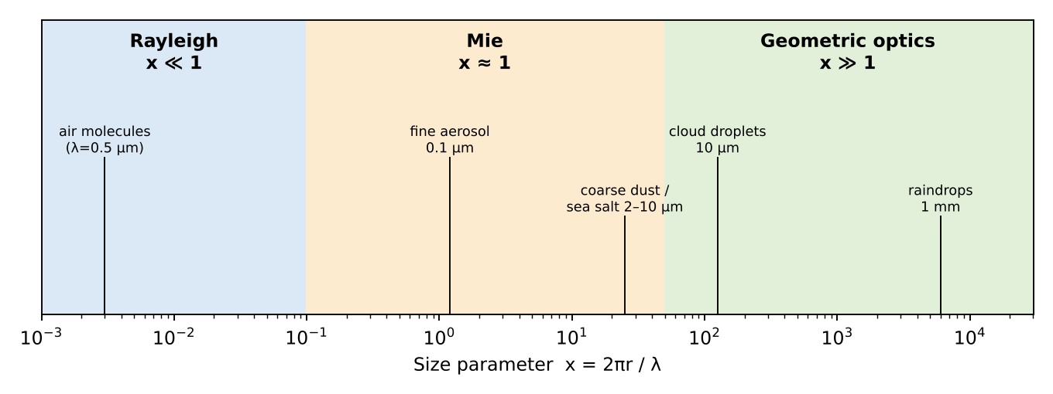
Figure 19 — Scattering regimes as a function of the size parameter (visible light, λ ≈ 0.5 µm).

7.1 Rayleigh regime (x ≪ 1, typically x < 0.1)
Particle much smaller than the wavelength: the particle behaves as an oscillating dipole in a uniform field. Encountered for air molecules (N₂, O₂) in UV–vis–IR, very fine aerosols (nucleation mode, r < 0.03 µm) in the visible, cloud droplets for microwaves/radar.
σ_s = (8π/3) · k⁴ · r⁶ · |(m² − 1)/(m² + 2)|² ∝ r⁶ / λ⁴
P(Θ) = (3/4)(1 + cos²Θ)
- Strong wavelength dependence λ⁻⁴ → blue sky, red sunsets.
- Symmetric forward/backward scattering; light scattered at 90° is fully polarised.

7.2 Mie (resonance) regime (x ≈ 0.1 – 50)
Particle size comparable to the wavelength: exact solution of Maxwell's equations for a homogeneous sphere (Lorenz–Mie theory), as an infinite series of multipoles. Encountered for accumulation-mode aerosols (0.1–1 µm) in the visible, and also coarse aerosols, cloud droplets in the IR.
- Extinction efficiency Q_ext = σ_ext / (πr²) oscillates with x and tends to 2 for large x (extinction paradox).
- Weak wavelength dependence (λ^−α, Ångström α ≈ 0–2); explains white/grey haze and clouds.
- Strong forward scattering peak (asymmetry parameter g ≈ 0.6–0.8), complex angular structure (glory, rainbow).
- Non-spherical particles (dust, ice) need T-matrix or discrete dipole methods.

7.3 Geometric optics regime (x ≫ 1, typically x > 50–100)
Particle much larger than the wavelength: light treated as rays that are reflected, refracted and diffracted (Snell, Fresnel). Encountered for raindrops, large cloud droplets, ice crystals, large dust in the visible.
- Q_ext → 2 (half by diffraction, half by reflection/refraction), independent of wavelength (grey/white).
- Optical phenomena: rainbow (42°), halos (22° for hexagonal ice), very strong forward diffraction peak.
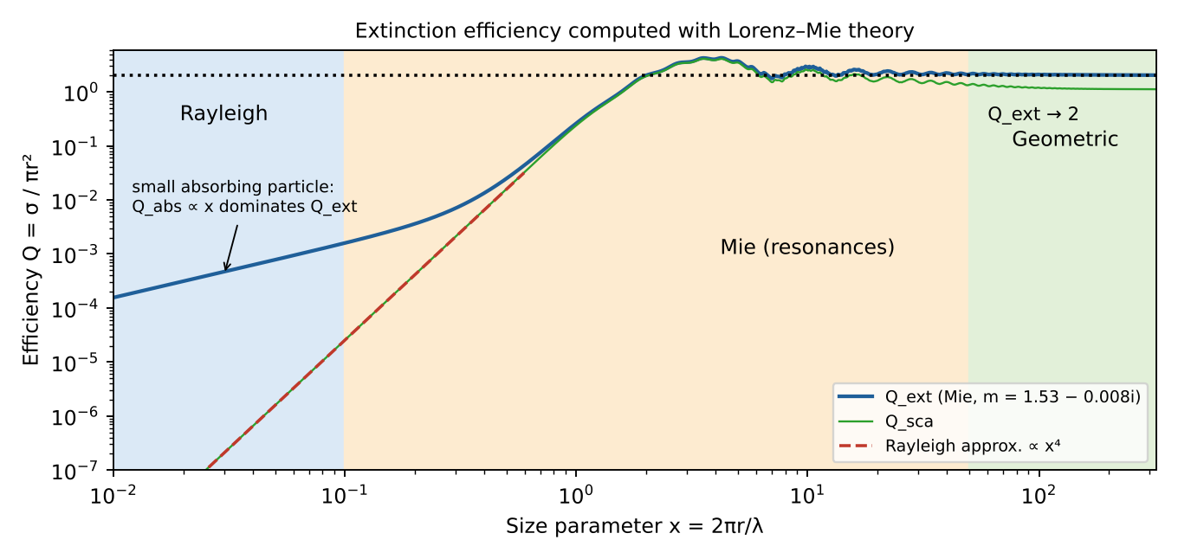
Figure 20 — Extinction efficiency vs size parameter (Lorenz–Mie calculation): x⁴ growth (Rayleigh), resonances (Mie), limit Q_ext → 2 (geometric).

7.4 Coarse aerosols in visible light
Coarse aerosols (mineral dust, sea salt, r ≈ 1–10 µm) at λ ≈ 0.55 µm give x ≈ 11–110. They are thus in the upper Mie regime, approaching geometric optics (Mie theory still applies, geometric optics becomes a good approximation for the largest ones). Consequences: AOD nearly independent of wavelength (Ångström exponent ≈ 0–0.5), strong forward scattering, Q_ext ≈ 2. Dust is non-spherical → Mie for spheres is only an approximation (use spheroids/T-matrix).

Exam checklist — must mention
- Size parameter x = 2πr/λ (+ refractive index m).
- Rayleigh x ≪ 1 (molecules), λ⁻⁴, symmetric P(Θ).
- Mie x ~ 1 (fine aerosols), Lorenz–Mie theory, forward peak, Q_ext oscillates → 2.
- Geometric optics x ≫ 1 (raindrops, ice), wavelength-independent.
- Coarse aerosol in visible: x ~ 10–100 → Mie (large-particle limit, near geometric optics), α ≈ 0.

Ý chính (tóm tắt tiếng Việt)
- Chế độ tán xạ phụ thuộc thông số kích thước x = 2πr/λ.
- Rayleigh (x ≪ 1): phân tử khí, ∝ λ⁻⁴, trời xanh. Mie (x ≈ 1): aerosol mịn, tán xạ mạnh về phía trước. Quang hình (x ≫ 1): giọt mưa, tinh thể băng, không phụ thuộc bước sóng.
- Aerosol thô (bụi, muối biển, r ≈ 1–10 µm) với ánh sáng khả kiến: x ≈ 10–100 → chế độ Mie (phần trên, tiến gần quang hình), số mũ Ångström ≈ 0.

8. Retrieving aerosol altitude with passive sensors
Question
- Explain the principle to derive the altitude of aerosols employing passive remote sensing from space: (i) in the thermal infrared and (ii) in the near infrared.
Aerosol height matters for air quality (surface PM vs elevated transport), long-range transport, radiative effects and aviation safety (volcanic ash). Passive sensors obtain it indirectly, by exploiting a physical effect that depends on altitude.
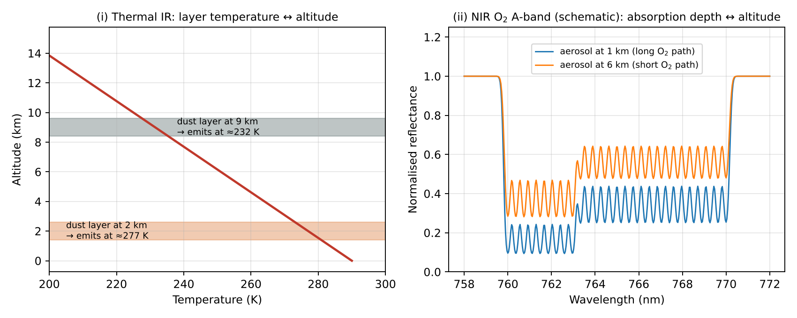
Figure 21 — (i) Thermal IR: layer emits at its own temperature. (ii) O₂ A-band: higher layer → less O₂ absorption.

8.1 (i) Thermal infrared (e.g. IASI, AIRS — mainly desert dust, volcanic ash)
Principle: in the TIR the radiance is dominated by emission. Coarse aerosols (dust, ash) absorb and emit in the atmospheric window 8–12 µm (silicate band near 9–10 µm). A dust layer replaces part of the warm surface emission by its own emission at the temperature of the layer:
I ≈ B(T_s) · e^(−τ_aer) + B(T_layer) · (1 − e^(−τ_aer))
- Because temperature decreases with altitude (≈ −6.5 K km⁻¹ in the troposphere), the higher the layer, the colder it is, the lower the TOA brightness temperature (larger brightness-temperature depression vs. clear sky).
- The signal depends on τ_aer × (T_s − T_layer): the thermal contrast. So the same depression can be produced by a thin high layer or a thick low layer — AOD and height must be retrieved together, using the spectral shape in the window (dust spectral signature) and simultaneous temperature profile information (from CO₂ bands).
- Retrieval: radiative transfer forward model (or LUT / neural network) with aerosol optical properties in the IR; fit IASI spectra → 10 µm AOD + mean layer altitude (e.g. ULB/LMD IASI dust products).
- Pros: day and night, over bright deserts (where visible methods fail), sensitive to coarse particles. Cons: needs thermal contrast (fails if layer T ≈ surface T, e.g. low layers, night-time inversions), sensitive to surface emissivity, mainly for coarse absorbing particles (dust/ash), not for fine smoke/sulfate.
- Related technique: CO₂ slicing / brightness temperature differences (11–12 µm) for volcanic ash and cloud top height.

8.2 (ii) Near infrared — O₂ A-band (e.g. TROPOMI ALH, EPIC, GOSAT, OCO-2)
Principle: oxygen is well mixed with known vertical distribution (21 %, follows pressure). In the O₂ A-band (759–771 nm) the absorption by O₂ depends on the photon path length through the atmosphere. Aerosols scatter photons back to space before they reach the lower atmosphere:
- Elevated aerosol layer → photons are reflected high up → shorter path through O₂ (less O₂ above the layer) → weaker absorption in the A-band (shallower lines).
- Low aerosol layer → photons travel deep → stronger O₂ absorption.
- The ratio of radiance inside the band to the continuum outside (e.g. 755 nm), or a full spectral fit of the band, depends on the scattering layer pressure. Different lines/wavelengths with different absorption strength give different penetration depths, so the band shape carries information on the vertical distribution.
R(λ) ≈ R_aer(λ) · exp( −σ_O₂(λ) · N_O₂(above layer) · AMF ) + …
- Retrieval: optimal estimation with a full RT model including multiple scattering, retrieving aerosol layer height (or pressure) and AOD (assumed aerosol model, layer thickness ~1 km). TROPOMI ALH: accuracy ~0.5–1 km, over ocean (and dark land).
- Pros: well-known O₂ distribution (no a priori on gas), high spatial resolution, works for all aerosol types including smoke and sulfate. Cons: daytime only; needs sufficient AOD (> ~0.3–0.5); very sensitive to surface albedo (bright land surfaces mask the aerosol signal); clouds must be excluded (cloud O₂ A-band height method uses the same principle); assumes a single layer.
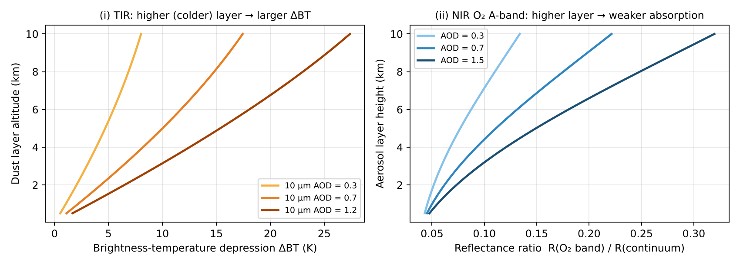
Figure 22 — Simple-model sensitivity of the TIR and O₂ A-band signals to aerosol layer height.
Other passive methods (useful to cite): stereo/multi-angle parallax (MISR, plume height for fires/volcanoes), UV Rayleigh–aerosol interaction (UVAI dependence on height), O₂–O₂ collision complex at 477 nm (OMI).

Exam checklist — must mention
- TIR: emission at layer temperature; T(z) decreases with height → higher layer = colder = lower brightness temperature; needs thermal contrast; works day/night; dust/ash.
- NIR O₂ A-band: well-mixed O₂ absorber; higher aerosol layer shortens photon path → weaker O₂ absorption; daytime, sensitive to surface albedo.
- Both retrieve height together with AOD by fitting spectra with an RT model / optimal estimation.

Ý chính (tóm tắt tiếng Việt)
- Hồng ngoại nhiệt: lớp bụi phát xạ theo nhiệt độ của chính nó; nhiệt độ giảm theo độ cao → lớp càng cao càng lạnh → nhiệt độ sáng đo được càng thấp. Cần tương phản nhiệt với bề mặt; đo được cả đêm và trên sa mạc.
- Cận hồng ngoại (dải A của O₂, 760 nm): O₂ phân bố đều và đã biết; lớp aerosol càng cao → photon bị phản xạ sớm → đường đi qua O₂ ngắn → hấp thụ O₂ yếu hơn. Chỉ ban ngày, nhạy với albedo bề mặt.
- Cả hai đều truy hồi đồng thời độ cao và AOD bằng mô hình truyền bức xạ.

Appendix — Key formulas and acronyms
Concept | Formula / value
Lifetime | τ = M / L ; 1/τ = Σ 1/τᵢ ; τ_chem = 1/(k[OH])
Beer–Lambert | I = I₀ exp(−τ), τ = ∫ (σ_a + σ_s) n ds
Planck / Wien | B_λ(T) = 2hc²/λ⁵ · 1/(e^{hc/λkT} − 1) ; λ_max T = 2898 µm K
DOAS | ln(I₀/I) = Σ σᵢ′ SCDᵢ + polynomial ; VCD = SCD / AMF
Optimal estimation | x̂ = x_a + G(y − K x_a) ; A = GK ; DOFS = tr(A)
Size parameter | x = 2πr/λ ; Rayleigh σ ∝ r⁶/λ⁴ ; Q_ext → 2
Ångström | τ(λ) = τ(λ₀)(λ/λ₀)^−α
Single scattering albedo | ω₀ = σ_s / (σ_s + σ_a)
Dobson Unit | 1 DU = 2.69 × 10¹⁶ molecules cm⁻²

Acronym | Meaning
AOD | Aerosol Optical Depth
AMF / SCD / VCD | Air Mass Factor / Slant / Vertical Column Density
AK, DOFS | Averaging Kernel, Degrees Of Freedom for Signal
DOAS | Differential Optical Absorption Spectroscopy
TOA | Top Of Atmosphere
RTE | Radiative Transfer Equation
LUT | Look-Up Table
ALH | Aerosol Layer Height
UVAI | UV Absorbing Aerosol Index
TROPOMI, OMI, GOME-2 | UV–vis–SWIR nadir spectrometers
IASI, AIRS, CrIS | Thermal IR nadir sounders
MLS, MIPAS, OSIRIS | Limb sounders
SAGE, ACE-FTS | Solar occultation
CALIOP, ATLID | Space lidars (active)

