*

* 关闭之前的窗口，为后面的图像显示做准备

dev_close_window ()

*

* 读取图像，打开窗口，并且显示图像

read_image (Image, 'D:/BaiduNetdiskDownload/1_GUI_and_Navigation_example_program/dice')

dev_open_window (0, 0, 580, 440, 'black', WindowHandle)

dev_display (Image)

stop()

*

* 通过看灰度直方图，找到图中物体的灰度阈值，然后将图像进行分割，并以其他颜色来显示

MinGray := 70

MaxGray := 255

threshold (Image, Region, MinGray, MaxGray)

dev_display (Region)

stop()

*

* 通过将阈值中的图像进行分割，分割成多个部分，然后以不同颜色进行显示

connection (Region, ConnectedRegions)

dev_display (ConnectedRegions)

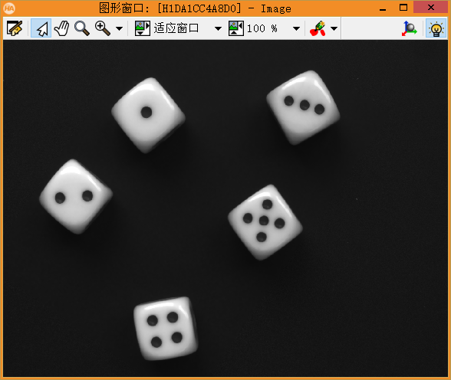 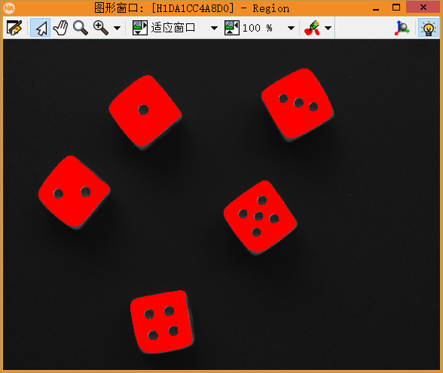

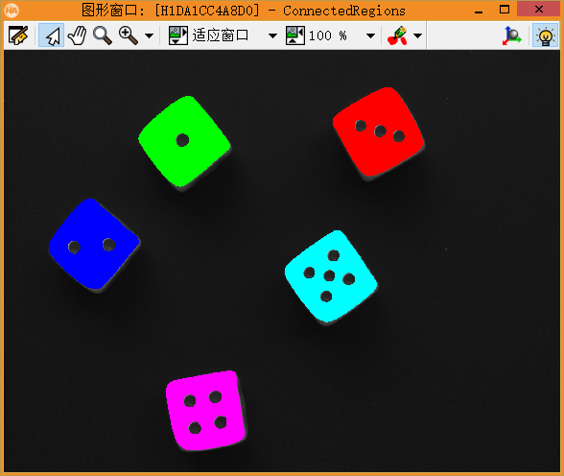

dev_close_window ()

read_image (Image, 'C:/Users/Admin/Desktop/1')

get_image_size(Image,Width, Height)

dev_open_window (0, 0, Width, Height, 'white', WindowHandle)

dev_display (Image)

stop()

MinGray := 0

MaxGray := 75

threshold (Image, Region, MinGray, MaxGray)

dev_display (Region)

stop()

connection (Region, ConnectedRegions)

dev_display (ConnectedRegions)

